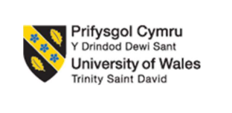
Master of Business Administration

LCMB7026
INTERNATIONAL MARKETING: PRINCIPLES AND PRACTICES

Assessment Component 1: Individual Report on Chanel in France and Japan

Student Name and ID: Patel Shubham Rakeshkumar (2531460)
Lecturer: Tushara Balendran

Words: 5443

AI Declaration
The individual report on Chanel is not done using any kinds of AI tools to support research, organise ideas or improve the clarity of this report.
Table of Contents
Section 1: Report 5
Introduction 5
1.1 Comparative Analysis of the Market in France and Japan 6
1.1.1 PESTLE Analysis 6
1.1.2 Hofstede’s Cultural Comparison 11
1.2 Comparative Analysis Based on STP and 7Ps of Marketing Mix 14
1.2.1 STP Analysis 14
1.2.2 Marketing Mix 18
1.3 Analysis of the Market Entry Strategy 24
1.3.1 Market Entry Strategy in Japan 24
1.3.2 Why Japan Was Chosen 24
1.3.3 Alternative Market Entry Strategy: Joint Venture (JV) 24
1.4 Ethical Issues Related to Chanel’s Marketing Mix in France 25
1.4.1 Issue 1: Exclusivity and Excessive Luxury Consumption 25
1.4.2 Issue 2: Environmental Sustainability and Fashion Waste 25
1.5 Recommendations 26
Section 2: Reflection 27
Reference List 31
Appendices 41
Appendix 1: STP: Similarities and Differences Between Chanel’s Strategy in France and Japan 41
Appendix 2: Comparison via 7Ps of Marketing 42

Section 1: Report

Introduction
Background
Founded by Gabrielle “Coco” Chanel back in 1910, Chanel is one of the leading luxury fashion companies based in France. The company is committed to the creation of desirable as well as innovative products of top quality with the highest level of craftsmanship (Chanel, 2023).
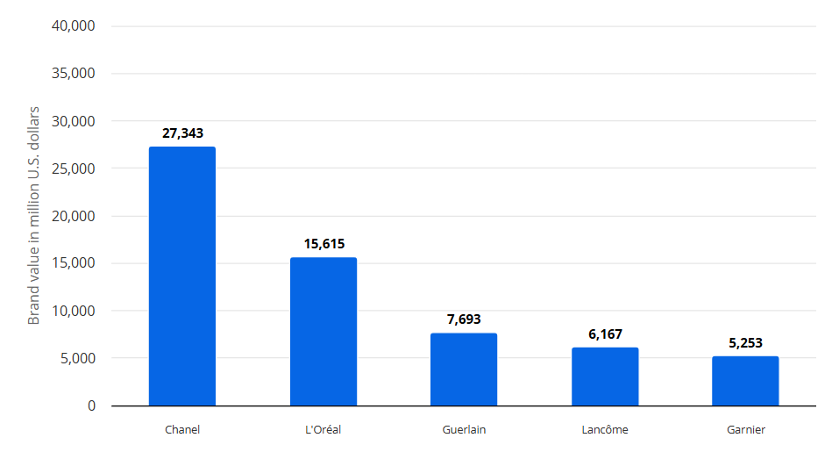
Figure 1: Chanel as the leading cosmetic brand in France in 2025
(Source: Statista, 2026)
Mission and Vision: The guiding mission of the company is to be the ultimate house of luxury, defining style. The brand concentrates on maintaining the legacy of Coco Chanel by promoting elegance as well as timeless designs for women.
This investigation examines the international marketing of Chanel, specifically in its home country France. It also considers its feasibility in Japan. It provides a detailed comparison of the market environment using PESTLE. Not only that, but it also examines the cultural differences between France as well as Japan. Apart from this, both the STP as well as the 7Ps of marketing are used to compare the two markets of Chanel. Finally, it provides a set of suggestions to improve the future global marketing efforts of the company.

1.1 Comparative Analysis of the Market in France and Japan

1.1.1 PESTLE Analysis
The table below has presented an in-depth examination of the comparison between France as well as Japan markets of Chanel:
Element | Factors | France | Japan
Political | Government and business environment | Stable democratic government  Strong support for luxury and fashion industries  EU trade policies help exports  Corporate tax rate is 25% (Business France, 2026) | Stable constitutional monarchy  Government supports innovation and global trade  Member of CPTPP and RCEP  Corporate tax rate is about 29.7% (Tax Foundation, 2026)
Economic | Income and spending power | GDP: US$3.16 trillion in 2024 (Mactrotrends, 2026a)  GDP growth: 1.2% in 2024 (Economy and Finance, 2026)  Inflation: 2.1% in July 2026 (Trading Economics, 2026a)  GDP per person: US$46,103 in 2024 (Macrotrends, 2026b)  Good demand for luxury goods | GDP: US$4.03 trillion as of 2024 (Worldmaps, 2026)  GDP growth: 0.1% in Q4 2025 (Trading Economics, 2026b)  Inflation: 2.7% (Reuters, 2026)  GDP per person: US$35,951 in 2025 (Trading Economics, 2026c)  Large luxury market despite slow growth
Social and Cultural | Population and lifestyle | Population: 68.7 million (United States Census Bureau, 2026)  Life expectancy: 83 years (OECD, 2025)  Customers value fashion and luxury brands  Strong tourism supports Chanel sales | Population: 123 million in 2025 (Kyodo News, 2026)  Life expectancy: 84 years in 2021 (WHO, 2026)  High interest in premium beauty and fashion  Ageing population changes buying behaviour
Social and Cultural | Consumer culture | Chanel is a French heritage brand (Atout France, 2025)  Customers like luxury with tradition  Fashion is part of national identity  High value placed on style and creativity | Customers value quality and craftsmanship (Asian Business Review, 2026)  Strong gift-giving culture supports luxury purchases  Respect for premium service  Limited editions are popular
Technological | Digital and innovation | High internet and smartphone use  Strong luxury e-commerce support  Chanel invests in digital marketing and online services. | One of the world's leading technology markets  Advanced digital payment systems (PCMI, 2026)  High use of mobile shopping and social media
Legal | Laws and regulations | Strong intellectual property protection  Strict consumer protection laws  Strong labour laws increase operating costs. | Strong trademark and copyright protection  Strict product quality rules  Consumer protection laws increase customer trust
Environmental | Sustainability | Net-zero and sustainability policies encourage green business  CO₂ emissions per capita in 2024: 4.12 tonnes per person (Worldometer, 2026a)  Renewable electricity share is 27% (EnergyNews, 2026) | Focus on recycling and energy efficiency  CO₂ emissions: 7.79 tonnes per person (Worldometer, 2026b)  Strong environmental awareness among consumers
Table 1: PESTLE Analysis of France versus Japan
Political:
It might be observed that both Japan as well as France have stable political climate. This makes them safer markets for a global luxury brand like Chanel. Furthermore, it has been found that France has a comparatively lower CTR of 25% as opposed to Japan’s 29.7% (Business France, 2026; Tax Foundation, 2026). This minimises the business-related expenses for France. However, at the same time, it is worth noting that Japan's robust trade agreements have the potential to improve Chanel’s access to other prominent markets in Asia. Overall, it can be justifiably stated that both countries provide a steady environment for Chanel’s prolonged luxury business.
Economic:
It has been observed that Japan has a much larger economy, with a GDP of $4.03 trillion (Mactrotrends, 2026a). On the other hand, France has a GDP of $3.16 trillion, as of 2024 (Worldmaps, 2026). However, it might be noted that France has demonstrated a more robust economic growth of 1.2% as compared to Japan's 0.1% (Economy and Finance, 2026; Trading Economics, 2026b). Apart from this, it might also be noted that France has a much higher GDP per person as compared to Japan. Finally, it is seen that France currently provides a much more robust buying power where Japan’s potential lies in its much larger luxury market.
Social:
It has been observed that Japan presently has a much larger population at 123 million in 2025, as compared to France (Kyodo News, 2026). This figure implies that Japan has the potential to provide access to more possible customers to Chanel. This might mean that Chanel has better potential to sell its products to more customers in Japan. Furthermore, it is also noted that Japan has a slightly higher rate of life expectancy at 84 years, as compared to France’s 83 years (WHO, 2026). Not only that, but Japan also has various loyal consumers of luxury products who purchase from premium brands. On the contrary, France benefits largely from global fashion tourism.
Cultural:
France happens to be the home country of Chanel. This lends the brand a long-standing heritage, along with the overwhelming trust of consumers. It has often been found that an increasing number of French consumers tend to value creativity as well as fashion. The culture is considered a global benchmark for fashion as well as luxury goods (Atout France, 2025). On the other hand, consumers in Japan put a lot of emphasis on top-notch customer service as well as high-quality craftsmanship. Convenience continues to be a top priority for at least 82% of the consumers in the country (Asian Business Review, 2026).
Technological:
It might be observed that both the countries have reported high usage of smartphones as well as the internet. This means that Chanel has ample opportunities to promote its offerings using digital marketing means. Apart from this, it has been observed that Japan has more advanced technology, especially in terms of online payment systems, as compared to France. The Japanese government has been rather active in promoting online payments as part of its wider vision of attaining a completely cashless society by the end of 2025 (PCMI, 2026). Overall, it can be stated that even though France backs luxury e-commerce, Japan has an edge with a more robust online shopping environment.
Legal:
Both countries have been found to have robust IP laws, which can go a long way in helping Chanel safeguard its luxury designs from cheap copies. For example, Japan submitted more than 9,040 patent applications in 2023 (WIPO, 2026). Similarly, France also saw a 5.6% increase in the number of patent applications in the same year. Not only that, but both the countries have rigid laws to safeguard the rights of their consumers. However, it is to be noted that France has more rigid laws to safeguard labourers. This in turn boosts employment expenses. On the other hand, Japan’s robust safeguarding laws about trademarks goes a long way in helping minimize cheap copies of premium luxury products. The Japanese government revised the “Trademark Act and the Design Act” in 2021 to recognise counterfeit products (Japan Patent Attorneys Association, 2026). This, without a doubt, boosts the confidence of consumers in luxury brands.
Environmental:
It has been observed that France performs far ahead in terms of environmental sustainability as compared to Japan. France produces only about 4.12 tonnes of CO2 per capita as compared to 7.79 tonnes in Japan (Worldometer, 2026a). Apart from this, it has also been found that France produces about 27% of its electricity from low-carbon sources. However, it needs to be understood that consumers in both the countries growingly expect Chanel to utilize sustainable packaging as well as products.
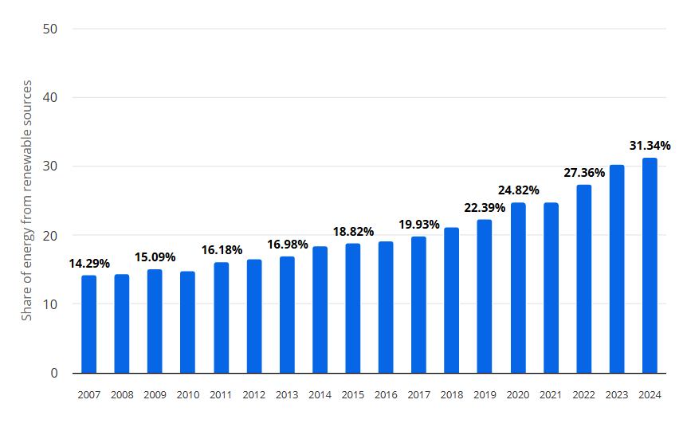
Figure 2: Share of Energy from Renewable Sources in Electricity in France from 2007 to 2024
(Source: Statista, 2026)

1.1.2 Hofstede’s Cultural Comparison
Advantages and Disadvantages of Hofstede’s Model
Advantages: Hofstede’s dimensions offer an easily accessible base for conducting a detailed comparison of national cultures in business examinations. As pointed out by Ouyang et al. (2025), its direct arrangement makes it highly accessible for inter-cultural investigation across different disciplines, not just business. By charting distinct dimensions related to culture, it goes a long way in helping multinational firms develop a firm understanding of the behaviour of regional consumers. Not only that, but it also adapts the product offerings more effectively.
Disadvantages: Hofstede's dimensions largely depend on generic national averages. This means that it overlooks individual traits of people in a country or even sub-cultures in a country. As further observed by Chun et al. (2021), Hofstede presumed that national cultures tend to be highly steady over many years, even centuries. However, it is to be noted that cultures tend to be ever-changing owing to globalisation or even generational shifts. Moreover, there is also the fact that its basic information is often outdated, failing to mirror how societies typically evolve over time. All this means that it is largely incapable of correctly guessing the individual purchasing decisions of consumers across highly diverse international markets. With respect to the cultural aspects of France as well as Japan, Hofstede’s ideas have been used to draw wide comparisons, as shown below:
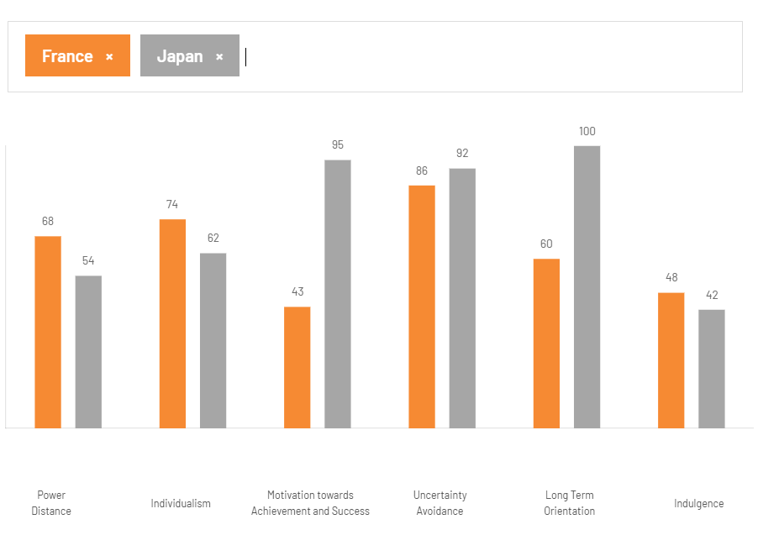
Figure 3: Hofstede’s Cultural Comparison of France vs. Japan
(Source: The Culture Factor, 2026)
Power Distance (France: 68, Japan: 54)
It can be found that France scored much higher than Japan in terms of embracing hierarchy. This goes a long way in benefitting Chanel to sell high status. On the other hand, consumers in Japan demonstrate utmost respect to authority. As pointed out by Mishra (2025), they are often influenced by values, including harmony. In return, however, they also expect polite customer service. Hence, it can be stated that Chanel needs to highlight luxury as well as exclusivity in France while concentrating on top-quality services in Japan.
Individualism (France: 71, Japan: 62)
Consumers in France stress on personal individuality. Consumers are often found to be buying products that mirror who they are. As pointed out by Tafani et al. (2024), these consumers place significant stress on exclusivity to indicate their personal distinctiveness. While Japanese consumers also do the same, they ultimately are more concerned about fitting into the wider society with their choices. In this respect, Chanel can consider selling exclusive products in France while selling the more universally accepted offerings in Japan.
Masculinity (Japan: 95, France: 43)
Japan has a higher score, which essentially means that consumers care about perfection as well as success. On the contrary, France concentrates more on personal beauty, along with healthy living. As reported by Personal Care Insights (2023), for about 67% of consumers in France, beauty is akin to pleasure, that is, taking care of oneself both inside as well as out. Chanel needs to market its offerings in Japan by shedding light on perfection. In France, the company can focus on simple elegance.
Uncertainty Avoidance (Japan: 92, France: 86)
Both the countries have scored high in this regard, implying that consumers do not like uncertainties when they are out to buy luxury products. Rather, they seek guaranteed quality. This is the reason why they prefer sticking to safe, well-reputed brands. Chanel’s global name, along with top-quality offerings, minimises uncertainties in both the markets.
Long-Term Orientation (Japan: 100, France: 63)
Japan gets a full 100, meaning that people in this country place a significant value on long-standing products. As noted by Takahashi (2024), Japan safeguards its culture in an effort to keep its history alive. The people are highly inclined towards educating future generations who they are. In comparison, France, although, has some respect for heritage, it is nowhere close to Japan in this regard. Hence, it might be stated that Chanel’s timeless, classic products are a good fit for both countries, particularly Japan where consumers are fond of purchasing long-lasting products that hold lifetime value.
Indulgence (France: 48, Japan: 42)
Both countries have scored low in terms of indulgence, thereby highlighting muted cultures wherein people prefer to spend money wisely while shopping. In particular, it can be stated that the French tend to be less relaxed as well as enjoy life that is widely expected to (Lee and Ande, 2023). Consumers in these countries do not rashly decide to buy something they like. Rather, they prefer luxury products that have depth. Chanel’s high status backs this behaviour, thereby making customers feel that their expensive purchases are indeed worth it.

1.2 Comparative Analysis Based on STP and 7Ps of Marketing Mix

1.2.1 STP Analysis
STP has been applied in the table below to compare the markets of France as well as Japan in the context of Chanel:
Element | France's Strategy | Japan's Strategy
Segmentation | Geographic  - Major cities such as Paris  - Luxury lifestyle | Geographic  - Major cities such as Tokyo, Osaka and Kyoto
Segmentation | Demographic  - High-income adults  - Men and women  - Luxury shoppers | Demographic  - High-income adults  - Men and women  - Luxury shoppers
Segmentation | Psychographic  - Fashion lovers | Psychographic  - Customers who value quality and craftsmanship
Segmentation | Behavioural  - Brand-loyal customers  - Premium quality seekers | Behavioural  - Loyal customers  - Customers buying luxury gifts and premium beauty products
Targeting | - Affluent customers  - Local and international tourists  - Customers seeking exclusive luxury products | - Affluent customers  - Luxury fashion buyers  - Premium beauty customers  - Customers seeking exclusive products
Positioning | - French luxury heritage brand  - Premium quality  - Timeless elegance  - Exclusive shopping experience | - Premium European luxury brand  - High-quality craftsmanship  - Prestige and exclusivity  - Excellent customer service
Table 2: STP comparison of France and Japan
(Source: Atout France, 2025; Glevarec 2026)
Segmentation
Chanel is found to be targeting similar income groups as well as ages of customers in both the countries (Refer to Appendix 1). However, it is to be noted that local tastes differ. For instance, in France, people typically care about personal style. The culture is considered a global benchmark for fashion as well as luxury goods (Atout France, 2025). They often lead a high-class lifestyle. As further mentioned by Glevarec (2026), the French society of today is described by the differentiation as well as cultural diversity across varied social groups.
On the other hand, in Japan, consumers are more focused on the finer details, along with careful craftsmanship (Refer to Appendix 1). As noted by Linmei (2022), craftsmanship in Japan happens to be a vital resource of the industrial culture in Japan. Irrespective of these distinctions, Chanel is primarily targeted at well-off people in both countries. These consumers have a significant amount of money to spend on premium brands.
Targeting
Chanel increasingly focuses on consumers from high-income backgrounds in both countries who can easily afford to buy luxury products. However, it is to be noted that the exact consumers tend to differ in some ways. For instance, in France, the number of wealthy foreign tourists is very high to visit Paris merely to purchase globally-renowned French products. An increasing number of foreign tourists have visited France in the first half of 2024 (World Travel & Tourism Council, 2024). This helped in bringing a huge amount of money to the country’s economy. On the other hand, in Japan, most of the sales of Chanel come from the local people who prefer purchasing high-end luxury products every day.
Positioning
Chanel presents itself as a classic symbol of pride in France. As per a report published by Vogue (2026), it is associated with youth as well as beauty. On the other hand, in Japan, the company is seen as a top-tier foreign brand from Europe. Foreign cosmetic companies are eager to gain a major foothold in the highly challenging Japanese market (Nagasawa and Irisawa, 2026). It might be observed that people in both countries look at Chanel as a mark of very high quality, along with top status. By upholding the same high standards in both countries, along with elegant layout of its stores, Chanel safeguards its robust international reputation while keeping its wide range of products desirable across the globe.
Chanel’s Current Position in France and Japan
In Figure 2, it can be found that Chanel is faced with stiff competition from other high-priced brands including Lous Vuitton.
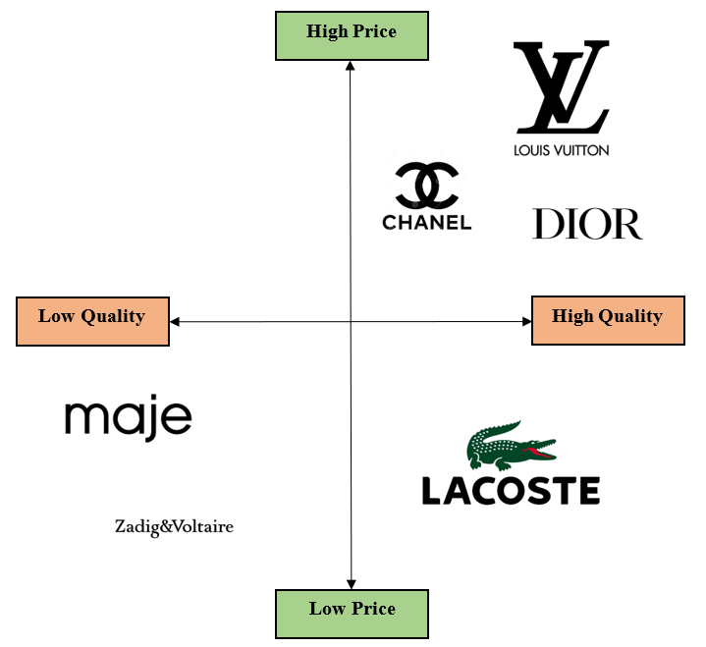
Figure 4: Positioning Map of Chanel in France
(Source: Created by the learner; Vogue, 2026)
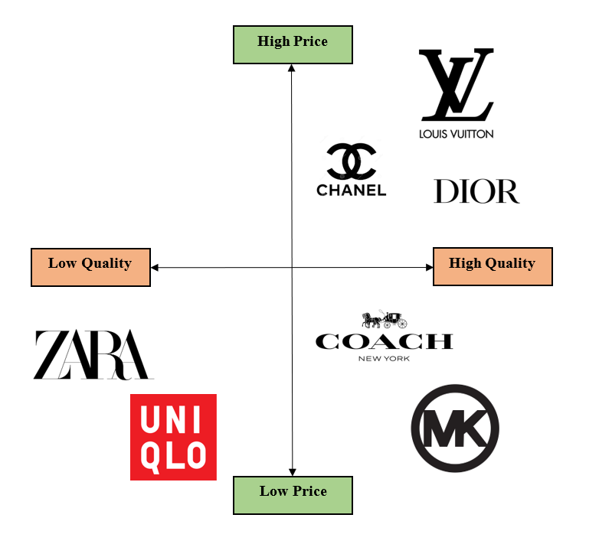
Figure 5: Positioning Map of Chanel in Japan
(Source: Created by the learner; Nagasawa and Irisawa, 2026)

1.2.2 Marketing Mix
Marketing Mix is a combination of strategies that a company uses to attract consumers to be able to stand out from its rivals in the market. As mentioned by Wichmann et al. (2022), it happens to be a key part of the marketing strategy of a firm that sits at the core of a firm as well as the market. As such, it evolves along with the marketplace as well as its stakeholders. In the context of both the countries, Chanel’s marketing tactics are elaborated below:
Product:
France: It has been found that Chanel sells a wide range of products, including fashion as well as beauty products, in France (Chanel, 2026b). The company makes sure to sell top quality products across varied sizes to cater to customers of different body types.
Japan: It has been, however, observed that while the core products are the same globally, Japanese consumers have a greater demand for skincare as well as special limited-edition products. This is primarily because skincare as well as beauty are deeply rooted in the daily life of the Japanese (Open PR, 2026).
Price:
France: Chanel makes use of high premium pricing for its products in both countries to remain exclusive (Xu, 2024). This essentially means that the company is primarily aimed at consumers who come from the well-off parts of society. Chanel never offers discounts on its products as such price cuts are likely to damage the reputation of the luxury brand. As emphasised by Kou (2024), since the target consumers of Chanel are the aristocratic generation who love fashion, Chanel does not need to attract them through price cuts. Keeping the expensive price can also boost the brand’s overall value, which is seen in the status of consumers.
Japan: However, it might be noted that Japanese prices of Chanel products are often slightly higher as compared to France owing to overseas import charges as well as taxes (Refer to Appendix 2).
Place: Chanel essentially sells products only via its flagship stores in both countries.
France: In Paris, the brand has 14 boutiques that sell ready-to-wear (Bespoke Voyage, 2026).
Japan: In comparison, Japan has about 34 Chanel boutiques, which just happens to be the highest in any country (JEF, 2026). Apart from this, some top departmental stores in major cities also sell their products.
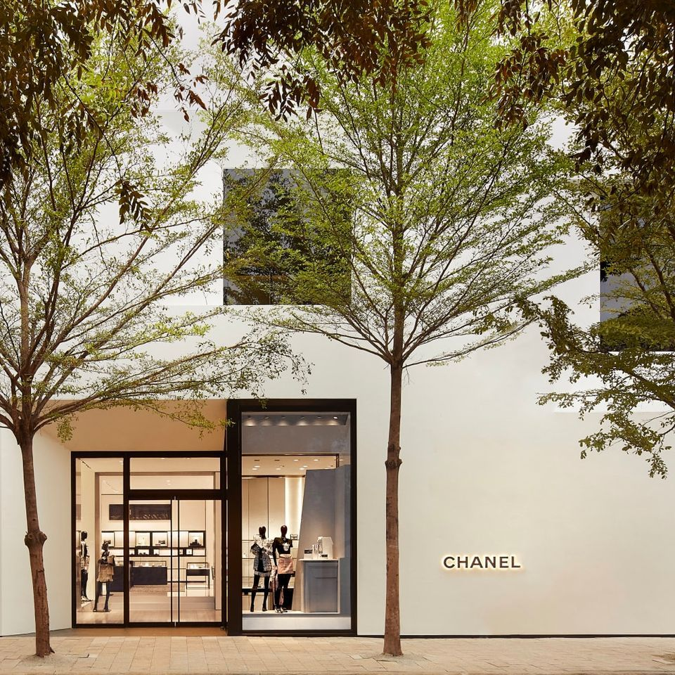
Figure 6: Chanel’s newest location in Tokyo
(Source: Architectural Digest, 2021)
Figure 3 shows Chanel’s latest location in Tokyo, which happens to be a two-story, 7,600-square-foot boutique.
Over the years, it has been fascinating to note that the company strictly capped the locations of its stores to keep the brand prestigious. As pointed out by Zihan (2021), Chanel safeguards its high-end image by using an exclusive “store model” rather than selling through third-party sellers. Chanel has about 310 stores across the world, with some of these located at airports to target wealthy travellers (The Brand Hopper, 2020). Ultimately, this strategy has helped in keeping the overall shopping experience extremely special for every customer.
Promotion:
France: Chanel makes ample use of famous global advertisements, along with high-profile fashion shows featuring global celebrities in France (Refer to Appendix 2).
Japan: The Japanese actress Nana Komatsu serves as a House Fashion Ambassador since 2015-2016 (Vogue Arabia, 2025). She was appointed as the global Chanel Beauty Ambassador in late 2025. In addition to this, Chanel makes use of clean online marketing on its social media pages to attract the attention of the younger luxury consumers across both markets.
People:
France: It is interesting to note that Chanel hires 8,500 employees in its home country, France. The French staff are trained to focus on advising customers visiting the stores on their personal style, along with classic luxury shopping.
Japan: Chanel hires 2,175 staff in Japan (WWD, 2020; Chanel, 2026a). The Japanese staff tend to place higher value on being polite with any customer who walks into the store. They have a keen eye for detail, making every visitor feel respected during their visit to the store (Refer to Appendix 2).
Physical Evidence: All Chanel boutiques are found to use the classic black-and-white designs in the stores globally (Architectural Digest, 2021).
France: In France, the stores concentrate heavily on the historic heritage of the brand, along with the conventional fashion roots in Paris.
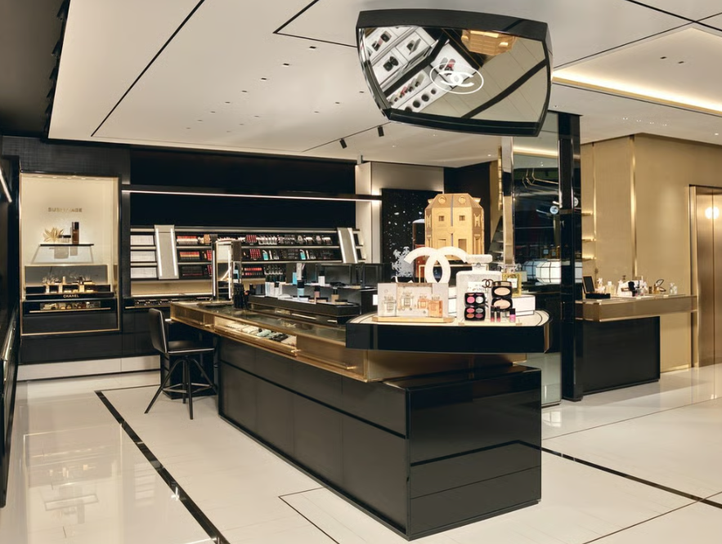
Figure 7: Chanel’s first boutique showcasing full beauty range in Paris
(Source: Fashion Network, 2024)
Figure 5 shows the boutique’s interior layout that is steeped in Chanel’s iconic visual individuality, incorporating its signature black-and-light palette.
Japan: Stores in Japan combine this classic style with modern technology, making the overall luxury buying experience feel special.
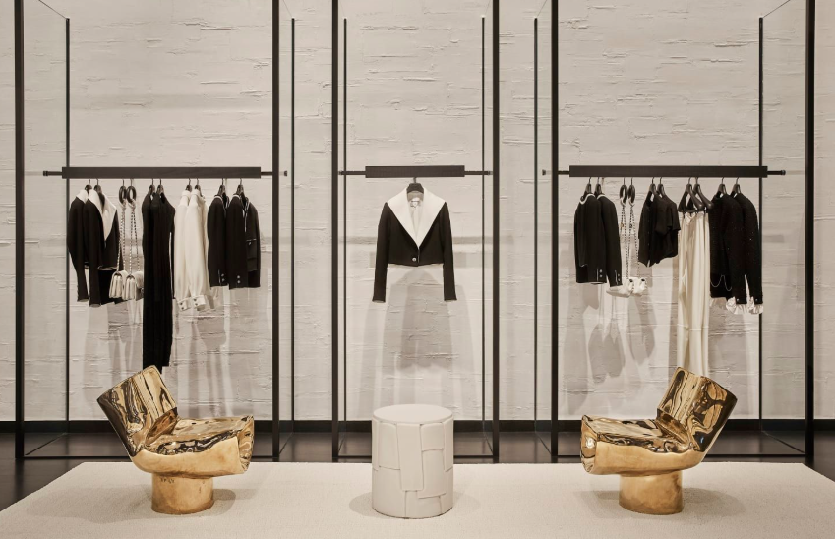
Figure 8: Inside of a Chanel store
(Source: Architectural Digest, 2021)
Figure 6 shows the black-and-white detailing, along with rich materials, that mark many of the locations of Chanel stores.
Process: It has often been stated that shopping at Chanel is a highly personalised as well as smooth experience in both countries.
France: The staff guide customers through every step, providing assistance. Even the packaging of the products is high-end (Refer to Appendix 2).
Japan: After-sales aid is also excellent, which goes a long way in keeping customers loyal to the brand for many years.

1.3 Analysis of the Market Entry Strategy

1.3.1 Market Entry Strategy in Japan
It has been observed that Chanel forayed into Japan via direct investment (DI), running its own boutiques as well as activities. This helped the brand enjoy complete authority over quality, along with its customer service. Direct investment helps safeguard the luxury image of Chanel, along with the value of its brand. As noted by Paudel, Sherm and Tehrani (2024), DI provides large MNCs full authority when launching new stores or factories in a new country. However, it might be noted that firms are nevertheless faced with major challenges in terms of local hiring as well as adapting to deep-seated cultural variations.

1.3.2 Why Japan Was Chosen
Chanel chose to enter Japan since the latter offers a steady, wealthy market with top-tier retail spaces in megacities such as Tokyo. Moreover, it has been established that in Japan, consumers are more focused on the finer details, along with careful craftsmanship. As noted by Linmei (2022), craftsmanship in Japan happens to be a vital resource of the industrial culture in Japan. The consumers in this country remain deeply loyal to well-known luxury brands.

1.3.3 Alternative Market Entry Strategy: Joint Venture (JV)
JVs go a long way in helping foreign firms enter a new country by overcoming high obstacles in the market, taking full advantage of the local channels of distribution. As noted by Muñoz de Prat, Escriva-Beltran and Gómez-Calvet (2020), this kind of way to enter a global market has significantly contributed to developing a more sustainable global market. If a JV had been used by Chanel to enter Japan, it would have significantly helped in providing different benefits to the company in this market, along with a new set of obstacles, as discussed below:
Advantages
- Local Knowledge: JVs offer a deep understanding of the culture in Japan, along with its customers as well as local market competition.
- Shared Risks: JVs minimise financial investment while splitting the business dangers between both partners.
- Network Access: It provides a quicker entry into the market via established local firms as well as distribution channels.
Disadvantages
- Loss of Control: JVs minimise Chanel’s complete authority over its quality norms as well as luxury image.
- Shared Profits: Strategic decisions as well as profits need to be divided, thereby leading to possible strategic clashes.
- Reputation Risk: Mistakes by the partner or slower process of making key decisions could damage Chanel’s brand image.

1.4 Ethical Issues Related to Chanel’s Marketing Mix in France

1.4.1 Issue 1: Exclusivity and Excessive Luxury Consumption
It might be noted that the high prices of Chanel’s products, along with its elite image, limit the access to only the wealthy people. Also, the worth of the brand is linked increasingly to excessive spending as well as the consumer’s status in society. As prices keep increasing, consumers are inspired to spend more money merely to attain this exclusivity (Xie, 2023).

1.4.2 Issue 2: Environmental Sustainability and Fashion Waste
Apart from this, it might be noted that Chanel is often accused of contributing to the alarming fashion waste. Not only that, but the brand’s plastic packaging is also widely criticised. As reported by The Korea Times (2020), in March 2018, environmental activists heavily bashed Chanel for cutting down century-old trees to develop a winter setting for the brand’s annual fashion show in Paris. Not only that, but Chanel continues to be rather reluctant to join the drift of utilizing eco-friendly materials in its fashion. It might be stated that even though its Mission 1.5⁰ program seeks to ensure sustainability, Chanel needs to ensure transparent communication to avoid misleading environmental claims.

1.5 Recommendations
- Recommendation 1: Sustainable Pricing and Heritage
Chanel can focus on safeguarding its French heritage while utilising environment-friendly materials. Additionally, it can stick to its non-discounted premium pricing to keep its products exclusive.
- Recommendation 2: Localised Digital Growth
The brand can consider expanding its online campaigns by tailoring them to the taste of the Japanese consumers. In addition to this, it can also expand storytelling on local social platforms without entirely minimizing the global distinctiveness of the Chanel brand.
- Recommendation 3: Enhanced Service and Technology
Chanel can provide training to its boutique staff to educate them about the deeper culture-based personalisation while using advanced technologies to assist the luxury interactions of real people.
- Recommendation 4: Controlled Partnerships
Chanel can maintain strict ownership of its brand to safeguard the same. It can, however, consider JVs that help Chanel to preserve complete authority over the quality of its offerings.

Section 2: Reflection
Gibbs’ Reflective Cycle
Description
I started working on this project by carefully examining all the requirements of the assessment. Using this information, I developed a clear plan to work on so that I did not miss out on any requirements. I chose Chanel’s home country, France along with Japan, which happens to be a massive market for the brand to compare how it delivers services across varied global markets. I used various commonly used business ideas, like PESTLE to examine the industry environment and how it impacts the company. I further examined the kind of customers that Chanel attracts in both the countries with the help of STP. International marketing (IM) calls for a deep examination of the environmental forces that cannot be managed by any company (Czinkota, 2011). In this respect, effective segmentation of the market goes a long way in helping MNCs group global consumers by varied cultural behaviours as well as shared characteristics (Wind and Douglas, 1972). These ideas helped me arrange my observations clearly so that I could write them down in a proper order. This ensured that my project was easy-to-read, producing the ideas that I wanted to convey with my investigation.
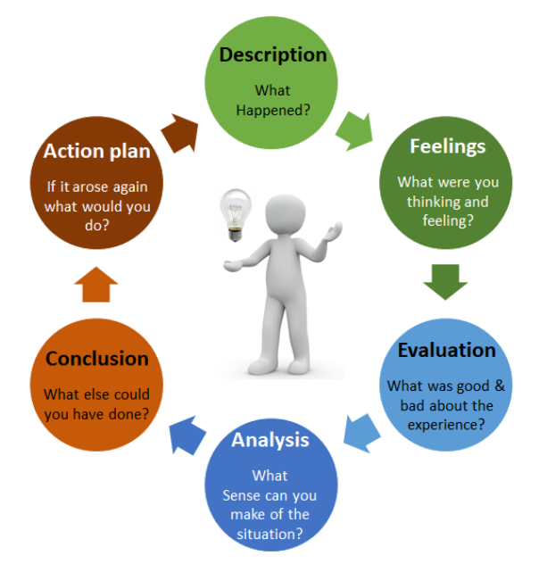
Figure 9: Gibbs’ Reflective Cycle
(Source: Dutta, He and Tsang, 2023)
Feelings
Initially, I was confused by the huge amount of information that I came across on IM online. Drawing a link between the academic ideas to a real luxury brand like Chanel was not easy. Culture has a significant part to play in influencing the core values of the society, along with the buying desires of consumers (Hofstede, 2001). Moreover, developing a firm understanding of how cultural groups work across different countries go a long way in helping marketers customize their brand messaging successfully (Kale, 1995). However, with the help of these insights, organising my notes into clear tables helped me become increasingly confident. These insights also helped me move from mere explanations to in-depth examination. I now feel much more confident about taking on other similar projects wherein the core requirement would be to investigate a company or an industry from various angles.

Evaluation
Using the commonly-used business ideas went very well as they offered a robust academic justification to my project. The number-based insights made it highly easy for me to compare the two countries easily without drowning in the vast amount of information available online. Successful IM depends heavily on the application of strategic bases to navigate the intricacies in marketing across borders (Doole and Lowe, 2012). In this respect, I have been able to develop a thorough understanding of IM in the context of one of my favourite luxury brands, Chanel.
On the downside, looking for specific country-based figures for Chanel was challenging. This is because the brand does not release such specific information to the public. Procuring correct market insights minimises the dangers of business activities when examining opportunities of attracting foreign consumers (Mathur, 2008). This lesson showed me why examining the quality of the information that I procure is so crucial in academic investigations. It can make sure that I do not write misleading information in my assignments that can affect my grades.
Analysis
This project showed me that luxury brands, like Chanel, need to strike the right balance between one global image, along with local adaptation. Harmonizing the key activities of marketing while adapting crucial aspects locally goes a long way in enhancing the overall performance of firms across international markets (Zou and Cavusgil, 2002). Comparing the cultural scores of Hofstede’s helped me understand how various cultural differences guided the decisions made by Chanel in both countries. Cross-country segmentation of the market facilitates luxury brands to target similar wealthy groups of consumers across different countries (Ko et al., 2007). This helped me link the real insights directly to the suggestions I made to Chanel. I hope that in future as well I can make recommendations to other companies to further improve their existing strategies for global marketing.

Conclusion
Overall, this introspective exercise helped me in improving my overall understanding of applying the ideas related to IM to real firms. The strategies of IM need to line up well with the capabilities of firms with demands from foreign markets to attain sustained growth (Baack, 2018). Moving forward, I must continue developing my investigative capabilities in future so that I can think deeply about the topic I work on.
I believe that I have become much better at examining various sources to compare different markets. In addition to this, maintaining robust ethical norms, along with clear communication from the brand, contributes significantly in safeguarding prolonged trust of customers in MNCs (Murphy and Laczniak, 2017). Ultimately, it can be stated that this project provided me with invaluable abilities for future examination of firms. I am now well aware of the basic ideas of how to understand how a brand is marketing its products in other countries. I can also look for the key aspects that they take into consideration to come up with their strategies to market their offerings in other countries.
Action Plan
Specific | Measurable | Achievable | Relevant | Time-bound
Improve critical analysis | Write at least 2 critical points for each major framework | Practise with past assignments and journal articles | Helps me produce stronger academic work | 3 months
Improve academic research | Use at least 5 peer-reviewed sources in each major assignment | Use university databases and Google Scholar | Improves the quality of my arguments | From the next assignment
Improve data-checking skills | Verify 100% of key statistics using reliable sources | Use official government and international databases | Reduces incorrect information | For every future assignment
Improve digital research skills | Learn at least 3 advanced search techniques | Practise online research each week | Helps me research international companies faster | months
Improve referencing skills | Check every citation before submission | Use university referencing guidance | Supports academic integrity | For the next 3 assignments
Improve confidence in analysis | Write one evidence-based analysis paragraph each week | Practise using journal articles and case studies | Builds stronger academic writing skills | 3 months
Table 3: Action Plan

Reference List
Architectural Digest (2021). Inside Peter Marino’s architecture for Chanel-and his newest building in Miami. Available at: https://www.architecturaldigest.in/story/inside-peter-marino-architecture-for-chanel-and-his-newest-building-in-miami/ (Accessed: 8 August 2026).
Asian Business Review (2026). Japanese consumers seek quality and convenience despite economic caution. Available at: https://asianbusinessreview.com/news/japanese-consumers-seek-quality-and-convenience-despite-economic-caution (Accessed: 7 August 2026).
Atout France (2025). France – the undisputed benchmark for fashion, luxury goods. Available at: https://www.atout-france.fr/en/mice/us/fashion (Accessed: 7 August 2026).
Baack, D. G. (2018). International marketing., 2nd edition. London: SAGE Publications.
Bespoke Voyage (2026). How many Chanel boutiques are in Paris?. Available at: https://bespoke-voyage.com/how-many-chanel-boutiques-are-in-paris/ (Accessed: 8 August 2026).
Business France (2026). Corporate tax. Available at: https://welcome.businessfrance.fr/en/setting-up-a-business/understanding-your-business-tax-implications/corporate-tax/ (Accessed: 7 August 2026).
Chanel (2023). Modern Slavery Statement 2023 (2022 Financial Year). Available at: https://www.chanel.com/puls-img/1730293765941-chanellimitedmodernslaveryactstatementfy2022finalukpdf.pdf (Accessed: 7 August 2026).
Chanel (2026a). 2025 GROUP TAX STRATEGY STATEMENT. Available at: https://www.chanel.com/puls-img/1780498234611-tax-strategy-document-2025-final-18-5-26.pdf (Accessed: 7 August 2026).
Chanel (2026b). CHANEL Makeup - Beauty & Makeup Products. Available at: https://www.chanel.com/gb/makeup/ (Accessed: 7 August 2026).
Chanel (2026c). GENERAL TERMS AND CONDITIONS OF SALE. Available at: https://www.chanel.com/puls-img/1730292650686-cgvchanelenemeapdf.pdf (Accessed: 7 August 2026).
Chun, D., Zhang, Z., Cohen, E., Florea, L. and Genc, O.F. (2021). Long-term orientation and the passage of time: is it time to revisit Hofstede’s cultural dimensions?. International Journal of Cross Cultural Management, 21(2), pp.353-371. https://www.researchgate.net/profile/Eric-Cohen-3/publication/352869524_Long-term_orientation_and_the_passage_of_time_Is_it_time_to_revisit_Hofstede's_cultural_dimensions/links/6876a8d13c12dc437a3f09b3/Long-term-orientation-and-the-passage-of-time-Is-it-time-to-revisit-Hofstedes-cultural-dimensions.pdf
Czinkota, M.R. (2011). International Marketing. Hampshire: Cengage Learning.
Doole, I. and Lowe, R. (2012). International marketing strategy (Vol. 7). Cengage Learning. https://images.template.net/wp-content/uploads/2015/10/09212256/international-marketing-plan-template.pdf
Dutta, S., He, M. and Tsang, D.C. (2023). Reflection and peer assessment to promote self-directed learning in higher education. Journal of Educational Research and Reviews, 11(3), pp.35-46. https://www.researchgate.net/profile/Shanta-Dutta/publication/371536633_Reflection_and_peer_assessment_to_promote_self-directed_learning_in_higher_education/links/648928519bc5e436682e1817/Reflection-and-peer-assessment-to-promote-self-directed-learning-in-higher-education.pdf
Economy and Finance (2026). Economic forecast for France. Available at: https://economy-finance.ec.europa.eu/economic-surveillance-eu-member-states/country-pages-including-country-reports/france/economic-forecast-france_en (Accessed: 7 August 2026).
EnergyNews (2026). France reached 33.2% renewable share in electricity consumption in 2025. Available at: https://energynews.pro/en/france-reached-332-renewable-share-in-electricity-consumption-in-2025 (Accessed: 7 August 2026).
Fashion Network (2024). Chanel unveils first boutique showcasing full beauty range. Available at: https://ww.fashionnetwork.com/news/Chanel-unveils-first-boutique-showcasing-full-beauty-range,1680323.html (Accessed: 8 August 2026).
Glevarec, H. (2026). The Space of French Lifestyles: Differentiation and Distinction Processes. https://hal.science/hal-05585978v1/file/Glevarec%20The%20Space%20of%20French%20Lifestyles%20HAL%2009042026.pdf
Hofstede, G. (2001). Culture's consequences: Comparing Values, Behaviors, Institutions and Organizations Across Nations. Sage publications.
Inside Retail Asia (2017). Chanel Japan launches new-look flagship. Available at: https://insideretail.asia/2017/12/04/chanel-japan-launches-new-look-flagship-2/ (Accessed: 7 August 2026).
Japan Patent Attorneys Association (2026). Trademark Overview. Available at: https://www.jpaa.or.jp/en/ip-information/trademark-overview/ (Accessed: 7 August 2026).
Japan Web Magazine (2025). 10 Best Luxury Brand Flagship Stores in Tokyo. Available at: https://jw-webmagazine.com/tips/best-luxury-brand-flagship-stores-in-tokyo/ (Accessed: 7 August 2026).
JEF (2026). Interview with Richard Collasse: President of Chanel K.K. Available at: https://www.jef.or.jp/journal/pdf/cov4_0309.pdf (Accessed: 8 August 2026).
Kale, S.H. (1995). Grouping Euroconsumers: a culture-based clustering approach. Journal of International Marketing, 3(3), pp.35-48. https://www.researchgate.net/profile/Sudhir-Kale-2/publication/235255048_Culture-specific_Marketing_Communications_An_Analytical_Approach/links/0a85e53697e8913d42000000/Culture-specific-Marketing-Communications-An-Analytical-Approach.pdf
Ko, E., Kim, E., Taylor, C.R., Kim, K.H. and Kang, I.J. (2007). Cross-national market segmentation in the fashion industry: A study of European, Korean, and US consumers. International marketing review, 24(5), pp.629-651. https://www.researchgate.net/profile/Charles-Taylor-16/publication/235273859_Cross-national_market_segmentation_in_the_fashion_industry_A_study_of_European_Korean_and_US_consumers/links/02e7e52325934b7df9000000/Cross-national-market-segmentation-in-the-fashion-industry-A-study-of-European-Korean-and-US-consumers.pdf
Kou, S. (2024). Chanel’s Global Brand Marketing Strategy: Insights from 4P and SWOT Analysis. In SHS Web of Conferences (Vol. 207, p. 01014). EDP Sciences. https://www.shs-conferences.org/articles/shsconf/pdf/2024/27/shsconf_icdeba2024_01014.pdf
Kyodo News (2026). Japan’s population falls by record amount to 123 mil. in 2025: census. Available at: https://english.kyodonews.net/articles/-/76919 (Accessed: 7 August 2026).
Lee, C.W. and Ande, T. (2023). Organizational behavior implication: HOFSTEDE'S perspectives in comparison Indonesia, Vietnam, China, Taiwan, and France. Advances in Management and Applied Economics, 13(4), pp.1-6. https://www.researchgate.net/profile/Taufiqquddin-Ande/publication/370552519_Organizational_Behavior_Implication_HOFSTEDE'S_Perspectives_in_Comparison_Indonesia_Vietnam_China_Taiwan_and_France/links/645a360e4af78873526b2b9c/Organizational-Behavior-Implication-HOFSTEDES-Perspectives-in-Comparison-Indonesia-Vietnam-China-Taiwan-and-France.pdf
Linmei, Z. (2022). The formation and development of Japanese craftsmanship. Journal of Asian Research, 6(4), pp.25-35. https://www.researchgate.net/publication/365211907_The_Formation_and_Development_of_Japanese_Craftsmanship
Macrotrends (2026a). France GDP (1960-2026). Available at: https://www.macrotrends.net/global-metrics/countries/fra/france/gdp-gross-domestic-product (Accessed: 7 August 2026).
Macrotrends (2026b). France GDP Per Capita (1960-2026). Available at: https://www.macrotrends.net/global-metrics/countries/fra/france/gdp-per-capita (Accessed: 7 August 2026).
Mathur, U.C. (2008). International marketing management: Text and cases. SAGE Publications India Pvt Ltd.
Mishra, N. (2025). How Japanese Consumer Behaviour Differs From Western Markets. Available at SSRN 6217358. https://papers.ssrn.com/sol3/papers.cfm?abstract_id=6217358
Muñoz de Prat, J., Escriva-Beltran, M. and Gómez-Calvet, R. (2020). Joint ventures and sustainable development. A bibliometric analysis. Sustainability, 12(23), p.10176. https://www.mdpi.com/2071-1050/12/23/10176
Murphy, P.E. and Laczniak, G.R. (2017). Ethics in marketing: International cases and perspectives. Routledge.
Nagasawa, S. and Irisawa, Y. (2026). Luxury Strategy of Beauty Products by Chanel. https://archives.marketing-trends-congress.com/2011/Materiali/Paper/Consumer%20Goods/Nagasawa_Irisawa.pdf
OECD (2025). Health at a Glance 2025: France. Available at: https://www.oecd.org/en/publications/health-at-a-glance-2025_15a55280-en/france_fea63dd5-en.html (Accessed: 7 August 2026).
Open PR (2026). Japan Cosmetics Products Market Size to Reach USD 51.2 Billion by 2032 as Skincare Innovation and Aging Population Support Industry Growth. Available at: https://www.openpr.com/news/4418622/japan-cosmetics-products-market-size-to-reach-usd-51-2-billion (Accessed: 8 August 2026).
Ouyang, S., Zhang, W., Xue, L., Rashid, A.M., Pyng, H.S. and Hassan, A.B. (2025). The cultural compass: A systematic review on cultural dimensions theory in educational settings. SAGE open, 15(2), p.21582440251342160. https://journals.sagepub.com/doi/pdf/10.1177/21582440251342160
Paudel, R., Sherm, A. and Tehrani, S. (2024). Strategic For Direct Investment: Market Entry Dynamics And Policy Implications For Multinational Corporations. Jurnal Ilmiah Multidisiplin Indonesia (JIM-ID), 3(02), pp.89-102. https://ejournal.seaninstitute.or.id/index.php/esaprom/article/download/4602/5219
PCMI (2026). Japan: 2025 analysis of payments and ecommerce trends. Available at: https://paymentscmi.com/insights/japan-2025-analysis-payments-ecommerce-trends/ (Accessed: 7 August 2026).
Personal Care Insights (2023). French consumer study clears clichés surrounding consumer beauty demands. Available at: https://www.personalcareinsights.com/news/french-consumer-study-clears-cliches-surrounding-consumer-beauty-demands.html (Accessed: 7 August 2026).
Pursebop (2026). What Is the Best Location For Shopping In Paris at Chanel and Goyard?. Available at: https://www.pursebop.com/dearpursebop/question/what-is-the-best-location-for-shopping-in-paris-at-chanel-and-goyard (Accessed: 7 August 2026).
Reuters (2026). Japan's corporate service inflation perks up in February. Available at: https://www.reuters.com/world/asia-pacific/japans-corporate-service-inflation-perks-up-february-2026-03-26/ (Accessed: 7 August 2026).
Statista (2026). Cosmetics market: most valuable French brands 2025. Available at: https://www.statista.com/statistics/764471/products-beauty-brands-francaises-values-world/?srsltid=AfmBOopmMFKXOF4Zb-aNsNBRP-3b1JGGqGz6QfsbKzOS-eWEzLskQCD7 (Accessed: 8 August 2026).
Statista (2026). Electricity: share of renewable energy 2007-2024. Available at: https://www.statista.com/statistics/419438/france-share-of-electricity-from-renewable-sources/?srsltid=AfmBOopT8AqREJC_Nw-80lUQ3qqbTWU6VJe6SjBKXYUa58p0w-42kxut (Accessed: 7 August 2026).
Tafani, E., Vigneron, F., Azoulay, A., Crener, S. and Zahid, A. (2024). The influence of culture and gender in luxury brand consumption: a comparison across Western and Eastern culture consumers. Journal of International Marketing, 32(4), pp.58-80. https://www.researchgate.net/publication/378223983_The_Influence_of_Culture_and_Gender_in_Luxury_Brand_Consumption_A_Comparison_Across_Western_and_Eastern_Culture_Consumers
Takahashi, S. (2024). Evolution and preservation of Japanese cultural tradition. Social Science Chronicle, 1(1), pp.01-20. https://socialsciencechronicle.com/wp-content/uploads/2024-010.pdf
Tax Foundation (2026). Japan Tax Data Explorer. Available at: https://taxfoundation.org/location/japan/ (Accessed: 7 August 2026).
The Brand Hopper (2020). Brand: Chanel - A Brand Creating Uncomplicated Luxury. Available at: https://thebrandhopper.com/brand/chanel-a-brand-creating-uncomplicated-luxury/ (Accessed: 8 August 2026).
The Culture Factor (2026). Country Comparison tool. Available at: https://www.theculturefactor.com/country-comparison-tool?countries=france%2Cjapan (Accessed: 7 August 2026).
The Korea Times (2020). Chanel shuns global sustainability trend. Available at: https://www.koreatimes.co.kr/business/companies/20200801/chanel-shuns-global-sustainability-trend (Accessed: 8 August 2026).
Trading Economics (2026a). France Inflation Rate. Available at: https://tradingeconomics.com/france/inflation-cpi (Accessed: 7 August 2026).
Trading Economics (2026b). Japan Posts Modest Growth in Q4. Available at: https://tradingeconomics.com/japan/gdp-growth/news/525878 (Accessed: 7 August 2026).
Trading Economics (2026c). Japan GDP Per Capita (1960-2025). Available at: https://www.macrotrends.net/global-metrics/countries/jpn/japan/gdp-per-capita (Accessed: 7 August 2026).
United States Census Bureau (2026). France. Available at: https://www.census.gov/popclock/world/fr (Accessed: 7 August 2026).
Vogue (2026). Chanel in Vogue charts the shared history of the French brand and the magazine. Available at: https://www.vogue.in/content/chanel-in-vogue-charts-the-shared-history-of-the-french-brand-and-the-magazine (Accessed: 7 August 2026).
Vogue Arabia (2025). Nana Komatsu Becomes a Global Ambassador of Chanel Beauty. Available at: https://www.voguearabia.com/article/nana-komatsu-global-ambassador-of-chanel-beauty (Accessed: 7 August 2026).
WHO (2026). Health Data Overview for Japan. Available at: https://data.who.int/countries/392 (Accessed: 7 August 2026).
Wichmann, J.R.K., Uppal, A., Sharma, A. and Dekimpe, M.G. (2022). A global perspective on the marketing mix across time and space. International Journal of Research in Marketing, 39(2), pp.501-521. https://www.sciencedirect.com/science/article/pii/S0167811621000665
Wind, Y. and Douglas, S.P., (1972). International market segmentation. European Journal of Marketing, 6(1), pp.17-25. https://faculty.wharton.upenn.edu/wp-content/uploads/2012/04/7213_International_Market_Segmentation.pdf
WIPO (2026). Patents Highlights. Available at: https://www.wipo.int/web-publications/world-intellectual-property-indicators-2024-highlights/en/patents-highlights.html (Accessed: 7 August 2026).
World Travel & Tourism Council (2024). France to Keep Its Crown as Most Popular Destination for International Visitors. Available at: https://wttc.org/news/2024-france-to-keep-its-crown-as-most-popular-destination-for-international-visitors (Accessed: 7 August 2026).
Worldmaps (2026). Geopolitical map of Japan. Available at: https://www.worldmaps.info/Japan/ (Accessed: 7 August 2026).
Worldometer (2026a). France CO2 Emissions. Available at: https://www.worldometers.info/co2-emissions/france-co2-emissions/ (Accessed: 7 August 2026).
Worldometer (2026b). Japan CO2 Emissions. Available at: https://www.worldometers.info/cs/emise-co2/japan-emise-co2/ (Accessed: 7 August 2026).
WWD (2020). Chanel Pledges to Maintain Employee Salaries in France for 8 Weeks. Available at: https://wwd.com/business-news/financial/feature/chanel-pledges-to-maintain-employee-salaries-in-france-weeks-1203549125/ (Accessed: 7 August 2026).
Xie, C. (2023). Analysis of Chanel Marketing Strategies in the World Luxury Fashion Market. Advances in Economics Management and Political Sciences, 17(1), pp.253-259. https://www.researchgate.net/publication/373897109_Analysis_of_Chanel_Marketing_Strategies_in_the_World_Luxury_Fashion_Market
Xu, M. (2024). Luxury Brand Marketing Strategy - Taking Chanel as an Example. Journal of Education Humanities and Social Sciences, 35, pp.722-726. https://www.researchgate.net/publication/382567971_Luxury_Brand_Marketing_Strategy_-_Taking_Chanel_as_an_Example
Zihan, W. (2021, April). Analysis on the marketing strategy of Chanel. In 2021 6th International Conference on Social Sciences and Economic Development (ICSSED 2021) (pp. 855-858). Atlantis Press. https://www.researchgate.net/publication/350907035_Analysis_on_the_Marketing_Strategy_of_Chanel
Zou, S. and Cavusgil, S.T. (2002). The GMS: A broad conceptualization of global marketing strategy and its effect on firm performance. Journal of marketing, 66(4), pp.40-56. https://www.researchgate.net/profile/S-Cavusgil/publication/247837088_The_GMS_A_Broad_Conceptualization_of_Global_Marketing_Strategy_and_Its_Effect_on_Firm_Performance/links/54049d6f0cf2bba34c1ce408/The-GMS-A-Broad-Conceptualization-of-Global-Marketing-Strategy-and-Its-Effect-on-Firm-Performance.pdf

Appendices

Appendix 1: STP: Similarities and Differences Between Chanel’s Strategy in France and Japan
Basis of Comparison | Similarities between Japan and France Strategy of Chanel | Differences
Segmentation | - Targets affluent customers  - Focuses on luxury and fashion buyers  - Uses demographic and psychographic factors | France: Strong focus on French luxury heritage and fashion  Japan: Greater focus on quality, craftsmanship and premium beauty
Targeting | - Targets high-income customers  - Targets customers seeking premium products  - Serves men and women. | France: Also benefits from international luxury tourists  Japan: Strong focus on local luxury consumers and beauty buyers
Positioning | - Premium luxury brand  - High quality and exclusivity  - Strong global brand image | France: Strongly linked with French heritage and Parisian fashion  Japan: Strongly linked with European luxury, craftsmanship and personalised service

Appendix 2: Comparison via 7Ps of Marketing
Element | France's Strategy | Japan's Strategy
Product | - Luxury fashion, handbags, shoes, watches, jewellery, perfumes and cosmetics (Chanel, 2026b)  Product width:  - Fashion, beauty, accessories and watches (Chanel, 2026b)  Product depth:  - Many styles, colours and seasonal collections  - Limited editions available  - High-quality materials | - Same global product range  Product width:  - Fashion, beauty, accessories and watches (Chanel, 2026b)  Product depth:  - Wide choice of beauty products and seasonal collections (Chanel, 2026b)  - Limited editions are popular  - High-quality craftsmanship
Price | - Premium pricing is followed by Chanel (Xu, 2024)  - Prestige pricing  - Prices rarely discounted  - Maintains luxury image | - Premium pricing  - Luxury pricing maintained  - Prices reflect import costs and exchange rates  - No regular discounts
Place | - Flagship boutiques in Paris (Pursebop, 2026)  - Luxury department stores  - Official Chanel website for selected products  - Carefully controlled distribution | - Flagship boutiques in Tokyo, Osaka and other major cities (Japan Web Magazine, 2025)  - Luxury department stores  - Official Chanel website for selected products  - Carefully controlled distribution
Promotion | Chanel promotes its products via the following channels:  - Fashion shows  - Luxury magazines  - Celebrity ambassadors  - Social media  - Brand storytelling | - Global campaigns  - Local celebrity ambassadors when appropriate (Vogue Arabia, 2025)  - Social media  - Fashion events  - Beauty campaigns
People | - 8,500 employees employed by Chanel in France (WWD, 2020)  - Boutique sales advisors  - Beauty consultants  - Personal luxury service | - 2,175 employees in Japan (Chanel, 2026a)  - Beauty consultants  - Highly trained customer service staff  - Strong focus on hospitality.
Process | - Personal shopping assistance  - Luxury packaging  - Easy returns where applicable (Chanel, 2026c)  - Professional after-sales service. | - Personal shopping assistance  - Careful product presentation  - Efficient customer service  - Professional after-sales service
Physical Evidence | - Elegant boutiques  - Black and white store design  - Premium product displays  - Luxury shopping atmosphere | - Elegant boutiques  - Modern luxury interiors (Inside Retail Asia, 2017)  - Premium displays  - Clean and sophisticated shopping environment

