The Effects of PVA on Water Quality
Jennifer Roper
1704516
Environmental Conservation
University of Wales Trinity Saint David
1st May 2020

Abstract

Rising issues with plastic pollution and climate change are putting a lot of pressure on researcher to develop new alternatives for plastics, but these alternatives should be tested for their environmental impacts before being marketed as a solution in order to avoid potential further disruption to our marine ecosystems.
PVA is an environmentally friendly, biodegradable and water-soluble substance that has long since been used in industry and for commercial use; it has been market as completely nontoxic and as having no effect on water quality. This paper investigates the relationship between PVA and water quality by completing a series of lab-based water quality tests on PVA aqueous solution in varying concentrations as compared to a reference water sample on three different qualities of water (tap, river and sea). The solutions were tested on their PH, conductivity, turbidity, total dissolved solids and salinity where applied and a dissolved oxygen test was also attempted. The research results showed that there was an obvious trend in change and clear increases in conductivity, turbidity, total dissolved solids and salinity as well as a decrease in PH in all cases.
In comparison to Yang, Cao, Li and Wang’s piece ‘Study on the Effect of PVA Aqueous Solution on Water’ published in 2018, each trend discovered matched the paper successfully and also fell within water quality standards, including the failed dissolved oxygen test which still showed a slight variance.
The research was still beneficial to do, as there is a surprising lack of data available publicly; however, the study was limited by time, budget and education of the experimenter and so testing that was completed remained simpler and more general rather than a detailed and focused experiment.
For future research, expansion on the number of tests or a focal point could be beneficial, alternatively, researching the best way to educate the public about biodegradable plastics and the conditions they usually require to decompose successfully would be beneficial in making the move towards more sustainable sources of consumption as well as encouragement of reduction of plastics rather than recycling or replacement.

Contents
Abstract 2
1.0 Introduction 7
2.0 Research Aims and Objectives 11
3.0 Dissertation Approach 12
4.0 Literature Review 15
4.1 Development 16
4.2 The Plastics Issue 17
4.3 A Reluctance for Change 18
4.4 Plastic solutions 19
4.5 Plastic Alternatives 19
4.6 Cost of Change 22
4.7 Why the Lack of Change? 22
4.8 Relevant Papers 23
5.0 Methodology 26
6.0 Results 32
6.1 Data Set – Tap Water 33
6.2 Data Set - River Water 36
6.3 Data Set - Sea Water 40
7.0 Analysis 44
7.1 Drinking Water Quality Standards – Comparison 47
8.0 Conclusion 48
9.0 Recommendations 49
References 50

Figure 1 – Tap Water PH 33
Figure 2 – Tap Water Conductivity 34
Figure 3 – Tap Water Total Dissolved Solids 35
Figure 4 – Tap Water Turbidity 36
Figure 5 – River Water PH 37
Figure 6 – River Water Conductivity 38
Figure 7 – River Water Total Dissolved Solids 38
Figure 8 – River Water Turbidity 39
Figure 9 – River Water Dissolved Oyxgen 40
Figure 10 – Sea Water PH 41
Figure 11 – Sea Water Salinity 42
Figure 12 – Sea Water Turbidity 43

Introduction

Arguably, one of the largest environmental problems currently, is the plastic waste issue. Every year around 300 million tons of plastic is produced with a massive 8 million tons of that entering the world’s oceans again as waste, often after only a single use. Of this, hundreds of thousands of tons enter as the form of harmful micro plastics, which attract toxics, and chemicals and easily bio accumulate in the food chain (POI, 2018). At this current point, research is no longer on how much plastic we are consuming this way, but on how bad it is for human health especially as micro plastics attract chemicals like PCB’s and DDT’s which have known to be linked to some cancers and endocrine disruption. Plastic has consistently made up 60-90% of all marine debris studied, and it is not just from big corporate industries, in fact, two thirds of plastic litter comes straight from the land via rivers and beaches. The rest is made up from items lost at sea, mainly fishing gear or containers. This plastic does not go away, every piece of plastic ever made is still currently with us, and something as small as a bottle can last up to 450 years in the ocean, slowly breaking down into smaller, more dangerous particles. A testament to this is the Great Pacific Garbage Patch, a swirling patch of litter the size of France, expected to double in size in the next few years. Clean up of this patch is seemingly impossible too since it is estimated that it would take around 67 ships and one year of work to clean up less than 1% of the ever-expanding patch. We are polluting at a faster rate than we can clear at this current time. (SAS, Undated).
Whilst still under EU regulations, our water bodies are currently protected by a number of different regulations, with some of the biggest being the Water Framework Directive, the EU Coastal and Marine Policy, The Integrated Maritime Policy and the Environmental Permitting Regulations 2010 which host the principle water pollution offences that used to be contained within the Water Resources Act of 1991.
Through the Environmental Agency industries can apply for environmental permits allowing wastewater discharge or ground water activity, this means that they must comply fully with the permit and will be fined if they do not. These permits allow regulation of pollution discharge although some activities are allowed exemptions, including ‘small discharges’ of sewage, often containing plastic litter, which can happen without an environmental permit so long as the activity is registered with the EA, and the person or company responsible complies to ensure no water pollution occurs. If an individual is tried and convicted in a Crown Court, they could face an unlimited fine and potentially be sentenced up to five years in prison. Tried in a Magistrates Court means that the individual could be fined any amount and face up to twelve months in prison. However, if the dump was done in an emergency as an avoidance of danger to human health, provided everything was done to minimize damage and pollution, and the EA was notified promptly, then it becomes a valid defense against the act and no fine should be instated. (EnvironmentalLaw, Undated).
PVA historically has been used widely in industry for the production of paper, plywood and even in textiles. It has also been used in pharmaceutics as a protective coating for medication, as well as being used for recreational fishing as a dissolving bait bag for catching carp. It is most commonly known to be used in glue and more recently in washing up capsule pods that can be thrown straight into the basin as they dissolve in the water, releasing the detergent in a more efficient and mess-free way than using powders.
As with many plastic alternatives, cost is the biggest issue with PVA as it is more expensive to produce, as it requires ethylene gas, produced by some plants in the ripening of their fruits; however the gas is more readily used in the production of oil due to the expense of it. It can also be produced from ethanol or oil. The cost of production makes PVA, alike many others, a less desirable substitute to plastic. PVA and other water-soluble plastics are also not a particularly desirable alternatives since, as the name suggests, they dissolve in water, causing issues particularly in rainy or humid climates, as the packaging is likely to melt, even into foods which could have an adverse effect on human health. If water soluble plastics such as PVA were to be used as food packaging, single use plastics and bags then it would likely have to be implemented in dry climates and only on foods that lack any moisture to avoid potentially causing harm to the consumers long term health. Even in this situation, things like moisture from sweat on the hands could cause a similar mishap and so must be fully evaluated before these solutions are considered as replacements for plastic.
Previous studies declare that PVA has no effect on water quality at all, but despite this it can be sensibly hypothesised that there will be a slight effect on water quality since, in large concentrations, it is near impossible to reasonably believe that PVA will have absolutely zero effect on the surrounding environment as it is a substance being dissolved into another, causing a definite change in composition and triggering potential chemical reactions between the two substances. With this in mind, the effects could be un-harmful, or even beneficial to water quality and not necessarily detrimental and as such is why tests need to be done, but an ignorance of any change whatsoever is an avoidance of potentially issues in the future. If PVA is found to enrich soil and water with additional nutrients, then this could cause issues with changes in PH levels and lead to problems such as eutrophication.
With millions of tonnes of plastics accumulating at rapid rates both on land and at sea, research alike this, is becoming increasingly more essential and beneficial to the cause. Threats of there being more plastic in the sea than fish by 2050 are unsurprisingly causing mass concern, and with the problem becoming increasingly worse daily viable solutions are needed. Although it may seem that this paper is denouncing plastic alternatives by exposing potential negative effects of them, the opposite is instead true. The aim of this study is to increase awareness of what is being put into our oceans and to encourage full understanding of the effects, both positive and negative, before making a mass change. Being fully aware of all of the properties of a plastic alternative and deepening our knowledge on them will allow for adverse effects to fully be monitored, controlled and minimised as they are implemented in order to provide the best possible future for generations to come. At this point, ignorance is simply not acceptable and environmental impacts must be considered in every restorative move that we try to make. If a study into PVA’s effects on the environment can potentially reduce the global plastic waste, then it is a study that must be completed and supported imminently.
For this study, just a simple completion of a review of previous research will not be as relevant, as rapid developments in plastic alternatives are already being made and new data is becoming increasingly more desirable. This study will not stray outside of the environmental effects of PVA and will only suggest investigating further into the effects of PVA on human health and water quality.

2.0 Research Aims and Objectives

Aim:

To investigate the relationship between the addition of PVA to a water body and the quality of that water and discover a correlation in any changes.

Objectives:

A full investigative study will see numerous tests being completed on PVA infused water
The data retrieved from the study will be compared not only against itself and the control sample but also against various other water standards.

With many new ‘plastic solutions’ coming to light in recent days it is important to remember that plastic itself once started out as a solution, with the assumption that consumption of plastic, even alternatives will not slow or change, we have to account for the effects of millions of tons being dumped into our oceans annually. Meaning that, there should be research into the potential damage that a new alternative could have on water sources. Though PVA is not branded specifically as an ‘alternative’ it is registered as being completely safe and non-toxic despite there being a surprising lack of evidence of this, since PVA is commercially available, unlike most of these newer alternatives, it seemingly is a good representative for the bigger picture of this study. With this research, it is hoped that a debate is sparked in properly evaluating new plastic alternatives before they are mass utilized to avoid further damaging our environment in ways that are invisible to the public eye. The release of this study, no matter the results of the experiment, will be beneficial in achieving the aims as increased public knowledge, perception and dedication to providing a new alternative is truly the motivation behind the study. No alternative created is ever going to have absolutely zero effect on the environment but the point is to fully understand the effects, both positive and negative, and have in place systems to manage those effects so that biodiversity can be maintained.

3.0 Dissertation Approach

This paper will navigate through six main chapters.

Introduction – The introduction will highlight the concept of the topic at hand, it will not only delve into the problems and issues with current water quality struggles, but also investigate regulations, environment and government policy surrounding both water bodies and PVA as a substance. The introduction has been designed to give a historical background to the topic but link it with relevant factors affecting us today and is necessarily highlighting the timely relevance of the study and research presented in the rest of the paper.

Research Aims and Objectives – By clearly defining what is hoped to be achieved by this study, it can hopefully be better utilized as a research resource and help to inspire other students or professionals to investigate more deeply into such a relevant topic. Undergraduate level is limited in how much depth a research project can go, as far as finances, ability and support in general go, however, this paper demonstrates that research does not need to be complex in order to achieve a meaningful and valuable result.

Literature Review – There are not many papers publicly available on the effects of PVA on water quality making supporting and comparing the research difficult. There are, however, papers on the use of PVA in medical, agriculture and commercial settings thus still being relevant to the topic and providing the paper with some basis beyond primary research. Since the introduction primarily focuses on water, the literature review is centralized around plastics, where they came from, their development, the issues that have arisen from their development and the discovery of new alternatives. From this – PVA is then studied for its potential, its cost relevant to plastic, and the reasoning behind why alternatives are not already in place. Finally, linking into the concerns of water-soluble plastics relating to water quality.

Methodology – The methodology is more expansive than simply what was done to achieve the results, it fully investigates the potential options for experiment and the choices that were made in timing, seasonality, sample sizes, sample location, exact method, chosen tests, advantages, disadvantages, how and why the experiment was designed the way it was as well as critique of the experiment and acknowledgment of error and potential flaws.

Results and Analysis – The results of the experiment have been visually compiled into various graphs and charts for ease of analyzing the results. Each chart is accompanied by a brief description of what the figure shows, and then later the results are compared to drinking water standards for context, as well as being investigated for what the changes in conditions actually mean on an environmental scale. The conditional changes are reviewed to be amplified in a ‘worst case’ scenario effect and do not necessarily reflect changes that could occur from PVA being dumped into watercourses. The background information is provided simply to give context to what extent fluctuation in things like PH level can have on a water body should an extreme be reached.

Conclusion and Recommendations – To summarize this dissertation, a conclusion of the aims and results compared to the literature studied is provided. The conclusion congratulates the achievements of the study but also provides opportunity for criticism of the work and recommendations for improvements to future researchers who will hopefully wish to continue, adapt and elevate the study to provide increasingly better data and context to such an important topic.

The research is due to be carried out in sections, a base of secondary data provided by previous research journals and papers to support the validity of the primary research that will be conducted. This will consist of mainly water quality standards and marine life standards, but also information of the use of PVA in fertilizer and its effect on soil, and the use of PVA in medicinal coatings and potential impacts on human health. Then, the primary data will provide an additional, legitimate study into the actual aim of the research.

The data collection will take place on the University of Wales Trinity Saint David SA1 campus in the IQ building’s environmental lab. This will take place under the supervision of a lecturer with experience in sample testing as to aid the experiment and provide further insight and guidance into best procedure.
The experiment is due to take place around late February to early March period as this allows enough time for background research to be collected and for a methodology and general plan of action to be obtained before starting.
Besides a control sample, it is estimated that around five samples would be sufficient in order to show a trend in change. Samples should also be collected from different water sources, such as tap, river and oceanic samples as it will provide more depth and comparability to the results and make them easier to translate when compared to relevant standards.

4.0 Literature Review

Plastic is the term commonly used to describe a wide range of synthetic or semi-synthetic materials that are used in a huge and growing range of applications, originally it meant ‘pliable and easily shaped’ derived from the Greek word ‘plastikos’. (SHI, Undated). The polymer was first invented in 1869 by John Wesley Hyatt as a substitute for ivory in order to ‘protect the natural world from the destructive forces of human need’ but has since developed rapidly over the last 50 years to be utilized as a cleaner and safer alternative. Plastics are derived from natural, organic materials such as cellulose, coal, natural gas, salt and crude oil. Crude oil is a complex mixture of thousands of compounds and needs to be processed before it can be used. The production of plastics begins with the distillation of crude oil in an oil refinery. This separates the heavy crude oil into groups of lighter components, called fractions. Each fraction is a mixture of hydrocarbon chains (chemical compounds made up of carbon and hydrogen), which differ in terms of the size and structure of their molecules. One of these fractions, naphtha, is the crucial compound for the production of plastics. The two main groups of plastics are the thermoplastics, which soften upon heating and thermosets which never soften after they have been molded. (PlasticEurope, 2020).

4.1 Development

During World War II, the production of plastics was increased greatly due to improvements in chemical technology, and this high level of production continued after the war as the economy recovered and citizens became ready to spend again. Global production was less than a million tonnes per annum, but plastics were being used widely in all types of products and predictions of the ‘plastic age’ were already being made. In ‘Plastics’ by Yarseley and Couzens (1945) it was written of how the ‘plastic man’ will live a life of ‘shining surfaces where childish hands find nothing to break, no sharp edges, or corners to cut or graze, no crevices to harbor dirt or germs’ and predicts how every aspect of modern life will be dominated by plastic, down to the pen with which we write. (Thompson et al. 2009).
The versatility, safety, low cost, lightweight nature of plastics is what makes them so attractive as a product. Most plastics have good thermal and electrical insulation properties and can even be made to conduct electricity wen required. They are corrosion resistant to many substances making them durable and suitable for use in harsh environments. They can easily be molded into complex shapes, which allows other materials to be integrated into plastic products and makes them ideal for a wide range of functions. As a result of these properties, plastics are increasingly being used in packaging, construction, transport, electronics, healthcare, sports, agriculture and much more. (PlasticEurope, 2020).

4.2 The Plastics Issue

The desirability of plastics is what has led us to such over-consumption of plastic goods, this combined with a single-use and discard behavior of a linear economy has become lethal. For more than 50 years the global production of plastics has risen rapidly and the waste that comes as a result of that has a dramatic effect on marine life both on shore and off shore. In a 2016 Greenpeace report ‘Plastic Debris in the Worlds Oceans’ it was stated that at least 267 varying species have been known to have suffered from entanglement or ingestion of plastic waste, correlating to Coastal Care’s 2009 (Republished 2020) ‘Plastic Pollution’ Article stating that 60 to 95 percent of all waste produced is plastic debris.
The durability of plastic is also its greatest downfall, it is non-biodegradable as the microbes that start the natural biodegradation process do not recognize plastic as food, meaning it can only be fragmented by UV, breaking it into smaller and more harmful micro plastics that attract harmful toxins, acting as ‘pollution sponges’. (Takada & Mato, 2002) and bio accumulate in the food chain.
The presence of plastic debris is not simply just aesthetically a problem, as said in ‘Plastic: A toxic love story’ by Susan Frienkel in 2011, it can change the entire marine ecosystems. Floating plastic debris can play host to small creatures, the slow speed at which the plastic travels allows for the species to adapt to the new climate conditions as they travel, posing a potential threat with alien and invasive species.

4.3 A Reluctance for Change

The use of single use plastics is ingrained into our everyday lives, and for the average working person, avoidance of plastic is near impossible due to the sheer convenience of it. In every grocery store, most of the produce is wrapped in plastic and so the only way to avoid it is to use local markets or farms to purchase from, which is easier for those in the countryside, or for those who have extra time and money to do so, but for people living in bustling city centers, plastic is the only option.
It's not that people don’t want to change, increased public awareness of the environmental costs of plastic, aided by David Attenborough, has seen movements like ‘save the turtles’ lead to bans on plastic straws backed by 80% of respondents. (Gov.uk, 2019) and an increased popularity in using reusable metal or bamboo alternatives. However, plastic packaging still dominates the shelves and cost and convenience will continue to be the main driving factors for the majority of consumers.
Discouragingly, for every effort made by one individual, there seems to be a counter action from another. For example, shoppers in the United States are said to use one plastic bag per resident per day, as opposed to shoppers in Denmark who use an average of four bags per year. (NationalGrographic, 2018). Bag charges implemented in Wales in 2011 saw a 71% usage drop within just 3 years of the charge being in place. (Sutherland, 2020) and the effectiveness of a small charge has translated equally well in Scotland and England too showing similar drops in usage for both.

4.4 Plastic solutions

The most efficient way to reduce plastic waste in our oceans is to, of course, reduce our plastic waste. By actively avoiding plastic products as consumers and encouraging companies to produce better alternatives, industrial production can hopefully be reduced significantly, and better and cheaper options can become more and more readily available starting a domino effect of change. Even simple changes in habits like using reusable bags and ditching plastic water bottles and to-go food packaging can help to decrease the amount of personal plastic waste annually. Increased recycling is also beneficial as it is being repurposed, but it still does not compete with a total reduction of usage and the public benefits that it can have with trend influences and peer pressure. (Rinkesh, 2020).

4.5 Plastic Alternatives

Alternatives for plastics can come in three main forms:
- Bioplastics – made from natural materials like corn starch
- Biodegradable plastics – made from petrochemicals but designed to break down faster
- Eco and recycled plastics – reused and recycled from old plastic

Bioplastics are a rising trend among alternatives, with new materials being made from walnut and seafood shells, cotton waste and even cactus juice with the premise that if plastics were made from kinder chemicals to begin with then they would break down quicker and easier when disposed of. (Steffen, 2019). Though most bioplastics can be composted, some can leave behind toxic residues or plastic fragments making them unsuitable for food composting. Bioplastics often breakdown in just a matter of weeks, but usually only under specialist conditions in industrial scale high temperature composters or digesters, not just in any conventional compost heap or landfill. These plastics are often labelled with their requirements for decomposition but can easily be missed by the average shopper. (Woodford, 2020).
However, in ‘Sustainability Metrics: Life Cycle Assessment and Green Design in Polymers’ by Tabone, Cregg, Beckman and Landis 2010, seven plastics, four bioplastics and one hybrid plastic were compared to determine that the bioplastic production actually resulted in more pollutants due to the copious amounts of pesticides and fertilizers used to grow the materials and due to the chemicals used in the transformation processes. Meaning, although bioplastics are beneficial in their decrease of fossil fuel use, the impacts increase from other categories such as eutrophication, human health impacts and eco-toxicity. PVA is not technically a ‘bioplastic’ as it is made using traditional methods but its ability to decompose in natural conditions links this study with the findings of Tabone et al. As the predictions of negative effects in these categories can be supported by these findings.
PVA is a biodegradable plastic, that is said to have no negative effects on the environment and does not bio accumulate in the body, once PVA is dissolved into water, microorganisms cause it to degrade, dependent on thickness and the temperature of the water the solubility will be effected. Higher temperatures lead to faster dissolving substance, but cold water will not completely hinder the decomposition of the material and eventually it will break down. PVA can only be dissolved in water and is insoluble in practically all other organic solvents. (Britannica, 2009). Due to the way it is produced, PVA does not take charges and has the same antistatic properties as cellophane, as well as having good tenacity, biaxial tension strength and anti-tearing strength making it more flexible at up to ten times as resistant as other films. It also has a natural gas barrier to oxygen, nitrogen, hydrogen, helium, argon, carbonic acid gasses and others but permits moisture and NH₃ to penetrate. It additionally provides fragrance-based preservation of produce and retains moisture. (PlasticIsRubbish, 2014).
Biodegradable plastics are not without their problems either, in 2014 members of the European Parliament tried to ban oxydegradable plastics due to doubts over their environmental benefits. After the blockage of the proposal, many detailed studies were done into these biodegradable plastics to confirm that they cannot successfully decompose or be anaerobically digested, in cold water they cannot break down and instead float on the surface like conventional plastics before being broken down into smaller micro-oxyplastics.
Recycling plastics is a difficult process due to the limitations on the amount of viable plastics able to be reused. There are thousands of different types of plastics, each infused with different dyes and additives and having different melting points. Plastics that are able to be recycled are usually repurposed into lower-grade items in their recycling such as fence posts and benches. (Woodford, 2020)

4.6 Cost of Change

Plastic alternatives can vary greatly in price, dependant on the materials and processes used to produce them, but as a general rule, alternatives are significantly more expensive. ‘Valuing plastics’ by Trucost in 2014 evaluates the true cost of making a switch for companies as risks from stricter legislation on plastics, emissions and other climate change impacts increase. They estimate that the cost of using alternatives is nearly four times more expensive than traditional plastic, based on natural capita accounting methods, which also value environmental impacts, as well as emissions, which are not traditionally factored into a cost. According to a set up based in Arkansas in America founded in 2010, their biodegradable bags cost 1.5 cents per unit as compared to 1.2 cents per unit for a traditional plastic bag, stating that other biodegradable plastics made from corn starch or potatoes could cost up to ten times that amount (CycleWood, 2012). (American Chemistry Council, 2020).

4.7 Why the Lack of Change?

The main motivation behind the lack of change is simply cost. Economy is key, so increasing production costs significantly out of ethical motivation is simply not viable or a smart business option given current conditions. Companies focus on profit and will not reduce the margin by switching to more sustainable forms of production unless forced to by consumers or regulation. In a 2011 survey by the European Commission, it was found that although 72% of respondents said that they were willing to pay a premium for green products, only 17% actually did in the month preceding the survey. In this context it can be assumed that cost is the motivation behind consumers purchasing too and so only when there is a significant reduction of cost in alternatives, will consumers begin to shift away from plastics.
In other cases, habit and convenience are significant factors too. With single use plastics being impossible to avoid the consumer has little choice but to conform, and recently, buying single use plastics has become the norm. (Smith, 2019).

4.8 Relevant Papers

‘Evaluation of Biodegradable Films Made of Waste Mycelium and Poly (Vinyl Alcohol) on the Yield of Pak-Choi' by Lei Shi, Lilong Ao, Hu Kang and Haijia Su. 2011.

A study completed in China saw the use of biodegradable films such as PVA and mycelium being used as protective covers for pak-choi growth, evaluating their ability to retain water and biodegrade successfully whilst also having an impact on the yield and quality of the pak-choi. The results of the experiment showed that the use of the ﬁlms compared to a control film, could result in 50% higher water retention. The films were biodegraded within 14 weeks under natural conditions, leading to mineralization, and proving to be beneﬁcial for plant growth as fertilizer. The yield of pak-choi was additionally increased in weight by 80% when using the ﬁlms.
This paper is beneficial to this study as it could support the hypothesis that PVA does cause enrichment of soil and waterbodies to a decent extent and highlights potential issues with over mineralization of soil and water, which can lead to complications with increased plant growth in marine environments and reduced oxygen availability. The study also includes use of waste mycelium which could be the cause of these changes and not necessarily related to PVA, weakening the support of this paper to this study, however the conclusions reached do correlate with the authors own findings and so the research can be considered.

‘This Plastic-Free Bag Dissolves in Water’ by Sean Fleming. 2018.

A study in Chile, researched by Roberto Astete and Christian Olivares looked into creating a soluble plastic bag from PVA, faced with many challenges in both trying to make the bags resistant to weathering but also soluble in cold water bodies, Astete managed to formulate and produce a prototype in just two months, branding it the ‘SoluBag’. The cost of the bag is about 1.5 times of that of a normal plastic bag, but he predicted for them to be as cheap as traditional plastic bags by their fifth prototype generation. He further aims to use modified PVA to make glass lids, straws and diapers, and to replace products made from petrochemical plastics in the future using similar methods.
This article tells of how PVA has been engineered to create resistant but still soluble materials that can be used for packaging or bags. The benefit of this discovery to this study is that it supports the notion that PVA can be repurposed to be more durable and could potentially be used outside of the scope of what it is capable of in its raw form.

‘Study on the Effect of PVA Aqueous Solution on Water Quality’ by MeiQui Yang, Guorong Cao, Dongli Li, Xinting Wang. 2018.

Testing the effects of PVA on water quality, several varying tests were done on the solution including PH, dissolved oxygen, colour, total phosphorus, ammonia nitrogen, sulphide, anionic surface activity of aqueous solution and others. The paper states that ‘the impact of aqueous solution of PVA on water quality has not been reported’ and concludes that the PH, colour, dissolved oxygen, total phosphorus, ammonia nitrogen, sulphide, total E. coli and suspended matter all satisfied the national values / standard, however, the total nitrogen, anionic surfactants and chemical oxygen demand did not satisfy the national standards (for China).
This research is the most relevant to the author's own as it carries out several of the same tests and receives similar results. It also reinstates the fact that reports on water quality are difficult to uncover publicly. The additional results of nitrogen, anionic surfactants and chemical oxygen demand not satisfying the national water quality standards also provides a good basis for further research into that area as to why these results have occurred and what the levels mean for the effects on the health of a marine environment.

‘Treatment of Aquarium Water by Denitrifying Photosynthetic Bacteria using Immobilized Polyvinyl Alcohol Beads’ by Hisashi Nagadomi, Takako Hiromitsu, Kenji Takeno, Masanori Watanabe and Ken Saski. 1999.

Supporting Yang & Cao et al.’s discovery of unsatisfactory total nitrogen levels, this study showed low nitrate accumulation in the alginate gel bead system tested against the PVA gel bead packed system which shows high levels of nitrate and nitrate accumulation. The results were attested to be caused by the inhibitory effect of PVA on nitrate reductase and stated that the boric acid used for hardening the PVA gel beads slightly inhibited nitrate reductase.
This research aids the preceding paper and elaborates on it by providing reasoning as to the increase in nitrate levels, further developing the study and supplying extra data for the author to research into.

5.0 Methodology

When approaching a decision for experiment choice, there are three main practical experiments available to choose from. The first being a natural experiment or a quasi-experiment, this involves forming a prediction or hypothesis and gathering data by observing a system afterwards. The field experiment, being either natural or controlled, takes place in a real world setting as opposed to under lab conditions. Then finally, controlled experiments are lab experiments although they can be performed outside of a laboratory setting. In this scenario, an experimental group is compared with a control group, ideally, the groups are identical except for the independent variable. (Helmenstine, 2018).
The method chosen for this study is a controlled experiment as an observational experiment would not be effective for determining effects on environment without having a very advanced taskforce and specific set of conditions. A field study would also not be beneficial as results would be subjective as the quantities of dissolved PVA are unknown or simply estimated in a water body and so the best method for this is to simulate an environment rather than use an existing one.
Despite this being the best method, there are advantages and disadvantages to the method chosen. On one hand, the experiment in a controlled environment can be easily replicated by others wishing to repeat the study themselves by following a specific method, it is also much easier to get more precise and accurate results in a lab study as there is a tighter control of the isolated variables involved. (Thompson, 2016). The study can be completed at any time, during any season and is not reliant on external factors to be successful, additionally, there is no delays due to completion of ethics forms and health and safety precautions are minimal in this instance. Disadvantages, however, come in the form of potential bias from experimenter effects in which the experimenter sways or interprets the data in a way that is beneficial to the study, whether they are aware of this or not. There is also a low amount of realism from the experiment as it is hosted in an artificial environment meaning the results could be unrepresentative of actual effect and results are such limited to a generalization of the situation. (Falk and Heckman, 2009).
The method chosen will best reflect the nature of the study and what it is trying to achieve whilst remaining plausible and able to be completed within a limited timeframe and budget.

Experiment
The supplies used during the experiment:
River water (Local)
Sea water (Local)
Tap water
PVA plastic ‘fishing bait’ bags
Four 500ML Pyrex beakers
A stirring rod
PH / Conductivity / TDS measuring tool
Refractometer
Turbidimeter
Distilled water
Pipette
Winkler Titration testing kit

In the University Environmental Lab, four identical beakers each filled with 200ML of tap water were introduced to varying amounts of the PVA substance. The PVA bags are industrially produced for recreational fishing use so each bag is the same 5x10cm size and weighs approximately 0.45g with limited variation, designed to dissolve in cold water within minutes. The first beaker being a control had no (known) PVA added to the water, the second had 1 strip of PVA added with the third and fourth having 3 and 5 strips added respectively. The strips were stirred individually using a different stirring rod until the PVA had dissolved entirely or until the water had become saturated and were left to rest for a few minutes to allow each to settle and assure that they had fully dissolved. Next, a PH/Conductivity/Total Dissolved Solids multi-measuring tool was placed into each beaker for a few minutes, then a reading was taken from the screen and recorded. Between each recording the meter was cleaned and reset with distilled water and a clean cloth. Then, using a new pipette for each individual sample, a small amount of sample was used to fill the vial and then wiped with a cloth to remove grease and water on the outside before being placed in the Turbidimeter for a reading, assuring that any bubbles caused by using the pipette were eliminated before use as they could reflect light, causing a false result. Between each sample the vial was rinsed with distilled water. These tests were repeated in the same manner for the river and sea water. The sea water however, had too high of a salinity for the conductivity meter to read and so in this instance a refractometer was used in its place. Using a pipette, a droplet of water was placed onto the screen of the refractometer and pressed down by the plastic panel, then it was held up to the natural light for a reading that can be converted into conductivity. Finally, a Winkler Titration test was attempted on some of the samples using the kit although the control sample and the beaker containing three strips of PVA gave results, addition of any more PVA led to the mixture becoming a deep brown color rather than an orange and the test could not be completed as a result. Due to a lack of experience on the experimenter's behalf, the testing was abandoned as the experimenter was unable to identify why the problem had occurred and what the result meant even with the input of a professional.

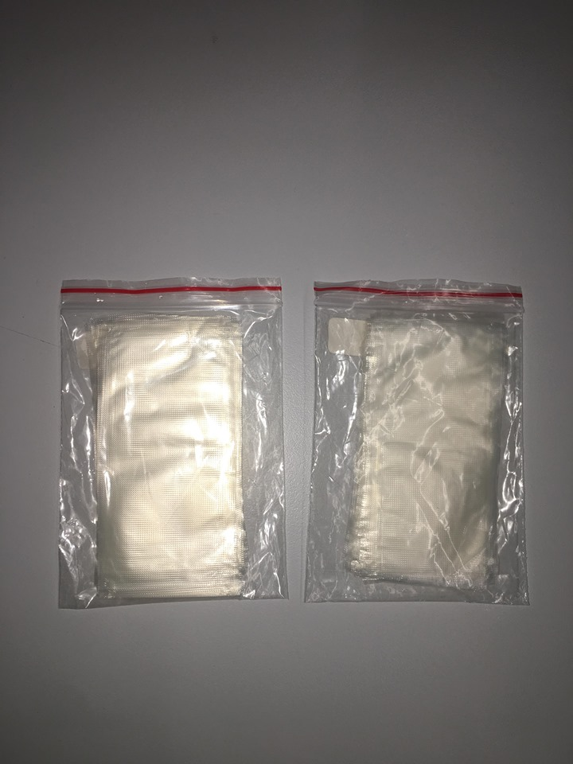
Figure 1 PVA strips used

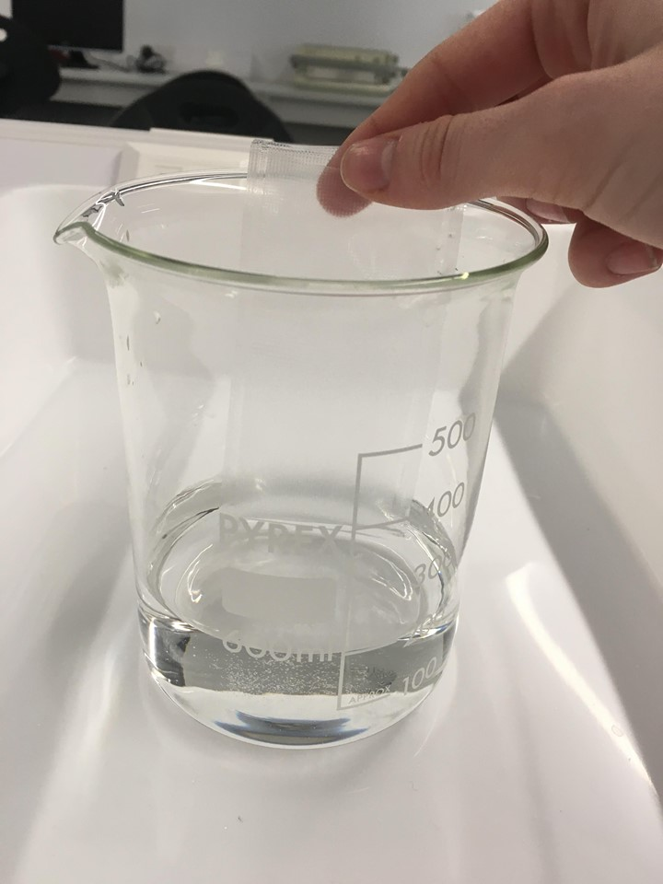
Figure 2 Dissolving PVA strips

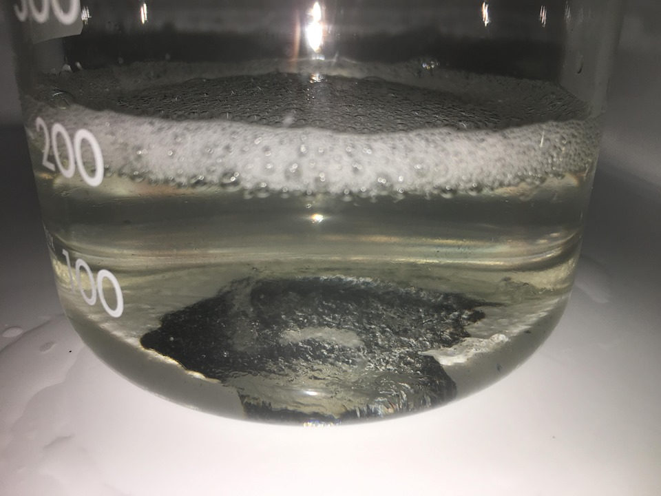
Figure 3 Sample 3 Complete Saturation

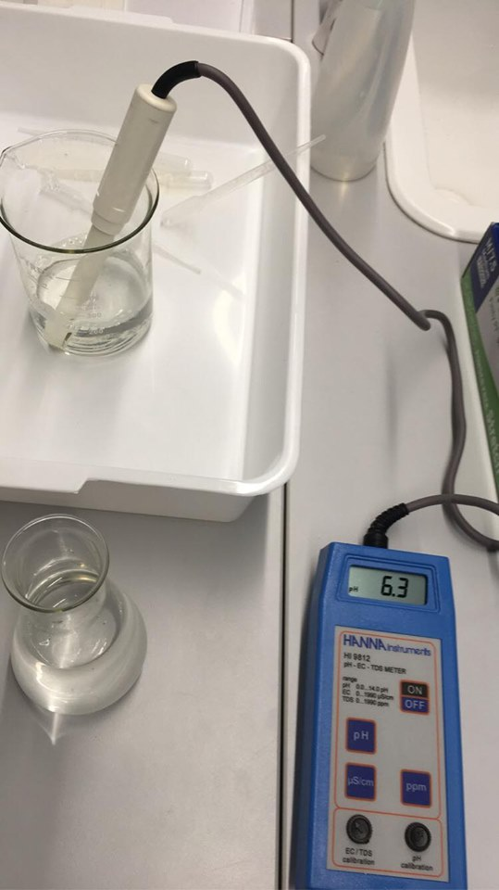
Figure 4 PH, Conductivity and TDS meter

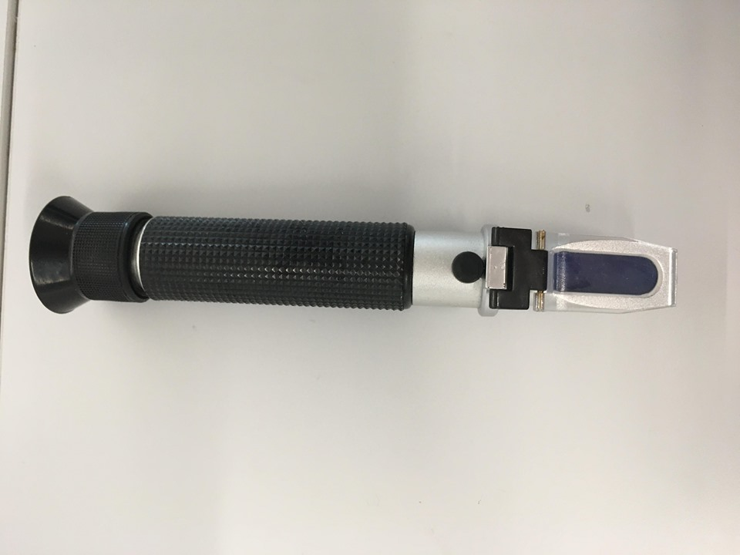
Figure 5 Testing Salinity

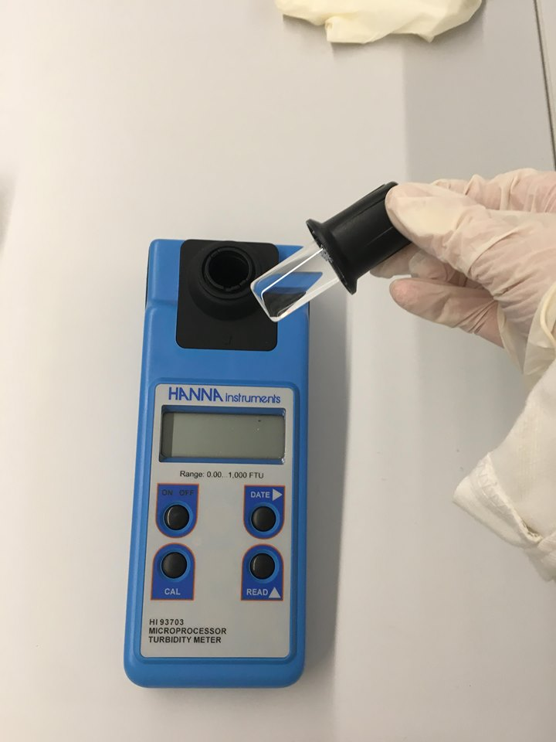
Figure 6 Turbidity meter

The methodology used, was influenced by ‘Standard Analytical Procedures for Water Testing’ by the Hydrology Project however, it had to be adjusted to not only suit the aims and the skillset of the experimenter, but because this exact experiment has no apparent record of being completed before publicly available, and so the method had to be newly designed to accommodate the needs of the researcher.
The experiment was designed in this way as, due to a lack of evidence that it had been completed before, the author wanted to give a general overview of the potential effects rather than really focusing in on one aspect of the issue. Aiming to provide a broad trend in change of results in order to spark discussion and potentially influence further investigation from those who have more facilities, resources and experience rather than really delve into minuscule changes and the influences behind them.
To support this, the sample size only had to be large enough to show a trend. Although in general a larger sample set is more beneficial, considering time, cost and apparatus limitations a sample size of four variables was deemed appropriate for this experiment and its aims.
The target of the study was to potentially show a trend in the relationship between concentration of PVA and water quality, in order to spark interest in actually fully investigating new plastic alternatives, not just PVA, to determine their effects on water quality and ensure that, assuming an alternative is utilized the same way that plastic is, in intense quantities, the alternative does not have a detrimental effect on the environment and potentially cause a larger problem than the one that was trying to be solved. It can also raise a question about honesty in industry as PVA has been branded widely as nontoxic and non-influential on water quality.
For comparability, numerous papers on water quality and drinking water standards were analyzed in order to determine how the changes could potentially affect marine life and human health in the future.
The experiment was completed on March 11th from midday – 5PM, as the experiment was done in the University Lab the only limitation was the availability of the space, the experimenter and the supervisor in order to complete it. Only one round of testing was done and although there was intention to repeat the experiment again at a later date, the unfortunate closure of the University due to a global pandemic meant that this was impossible and so the results are subject to a degree of unreliability.
The samples utilized were both collected locally, from the River Tawe (White Rock Heritage Park) and Swansea Bay, with the tap water coming from the lab. The samples were collected from these points as they are both close to the University and within close range to each other but also have safe access points to easily obtain the samples with minimal risk. The range of distance also means natural variations in water quality and pollution levels will not differ too greatly as external influences are relatively similar allowing for more reliable results and a fairer test. Using water from the Tawe also allows for the study to be linked directly to Swansea.
The study can be completed within just a few hours (5 in this case) however, repetitions of the experiment or expansion of sample numbers etc. will evidently increase the timescale needed.
The experiment is not without its faults, and so if it were to be replicated, improvements are vital to be made. Primarily, repetition of this study is key in order to provide stability and reliability to the results achieved, since it was not possible to repeat this experiment in this instance, the results could potentially be invalid, and changes shown influenced by other factors that remain unknown. Expansion of sample numbers and addition of more testing are also impactful as this experiment only provides an overview of the problem, by expanding the number of samples and delving deeper into testing using different reagents it is more likely that specific elements can be pinpointed as problematic and can reveal at what extent the concentrations levels of PVA become detrimental to the water quality. Alike this, the experimenter has little experience with completing studies like this and so the results are more prone to error by default. Although some assistance of a professional was provided, the majority of the study was completed by a student and some problems encountered, such as with the Winkler test, were not able to be solved and so the testing was abandoned.

6.0 Results

For this data set, all of the results collected have been used because there is not an abundance of data and all of the results shown provide some relevance. The results each show a trend even in tests that were not fully completed and so they still pose as valuable to the research. Each data set appears to be consistent and does not show signs of any obvious error or anomaly and so there is no valid reason to discount any set of data.

6.1 Data Set – Tap Water

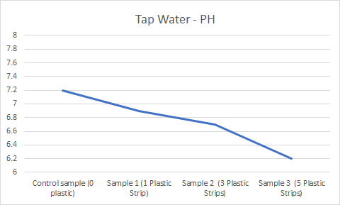
Figure 7 – Tap Water PH

The PH of the sample can be seen to decrease gradually from 7.2 in the control sample to 6.2 in the most saturated sample (3) making the sample a PH level more acidic. The method used to measure PH does have slight variance in readings even within the same sample so this must be considered, however the gradual decrease in PH across each sample suggests that this is a correlation with the PVA rather than just variance in reading, which is also supported by the 1.0 variance, which is too large to simply just be from a mis-reading by the equipment.

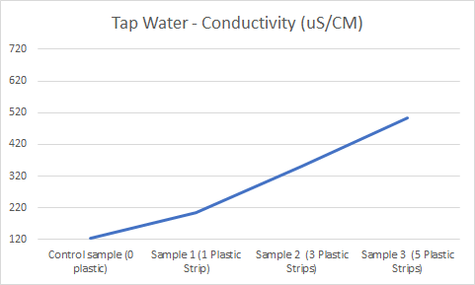
Figure 8 – Tap Water Conductivity

An extremely large variance in the conductivity shows each sample becoming increasingly more electrically conductive as the amounts of PVA is increased. The variance between samples is 80-155 uS/cm.

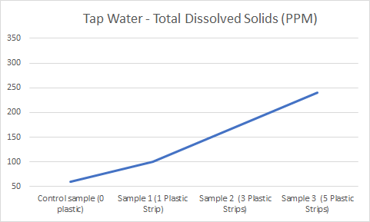
Figure 9 – Tap Water Total Dissolved Solids

The total dissolved solids also increase dramatically from 40-70 PPM per sample with a total increase of 180 PPM from the control to sample 3. Since substance is being added to the samples it is evident that the TDS would increase however it is important to have this test in order to show that there is a change in PVA levels in each sample.

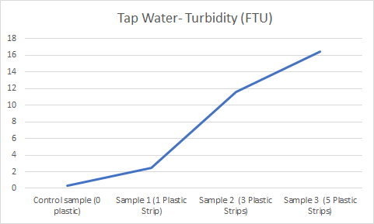
Figure 10 – Tap Water Turbidity

The increase in turbidity is severe, increasing 16.2 FTU between the control sample and the most saturated sample. This is due to the fact that sample 3 was completely saturated and still had residual PVA in the water. Although there was a best effort to remove all the bubbles from the water while testing turbidity, there is still potential that some remained, reflecting light and potentially skewing the data for this test.

6.2 Data Set - River Water

Note: Solubility of the PVA in the river water was lower. The PVA seemingly took longer to dissolve in the sample potentially due to temperature or salinity. Each sample was still allowed time to fully dissolve / saturate so the dissolve time would not have any effect on the results.

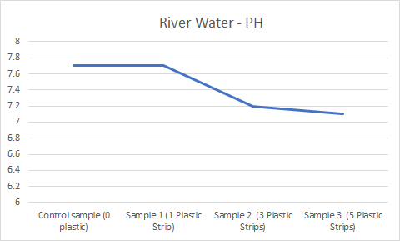
Figure 11 – River Water PH

Again, a lowered, more acidic PH can be observed between samples, although the variation is not quite as intense at 0.6 change. There is no variation observed between the control sample and sample one, this may be due to the equipment not being washed with distilled water correctly or due to a lack of time allowed for the meter to give a steady reading. If the experiment were repeated it could be expected that these results would change (potentially to around 7.5) as other results suggest a steady decrease in all cases.

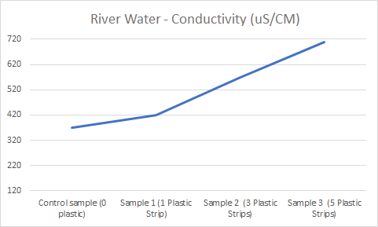
Figure 12 – River Water Conductivity

The conductivity is again increased dramatically from 50-140 uS/cm between samples.

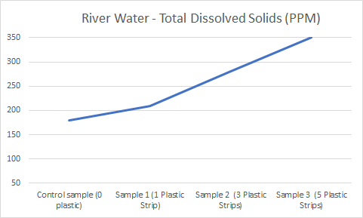
Figure 13 – River Water Total Dissolved Solids

TDS increases from 180 PPM to 350 PPM from the control sample to sample 3, an increase of 170 PPM this is similar to the increase amount for tap water suggesting reliability of results.

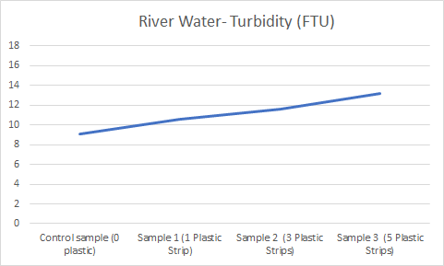
Figure 14 – River Water Turbidity

Turbidity also increases but to a lesser extent than in tap water, the change is not so severely visible here but there is still a general trend. There is a variation of 4.17 FTU between the control sample and sample 3.

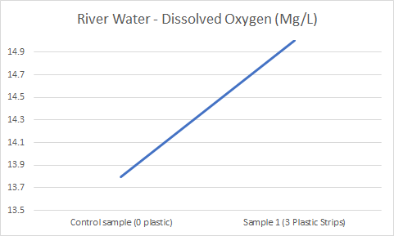
Figure 15 – River Water Dissolved Oyxgen

This testing was not completed due to complications with the experiment; however, the results have still been included as they show a potential increase in dissolved oxygen levels with increased amounts of PVA. There are not enough results for this to be validated but upon repetition of the experiment, further investigation into this testing should be completed.

6.3 Data Set - Sea Water

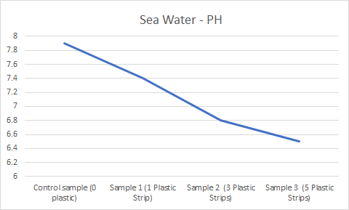
Figure 16 – Sea Water PH

For the final data set, there can again be seen a decline in PH leading to more acidic levels. The change in this instance is the most dramatic dropping 1.4 PH levels over all the samples.

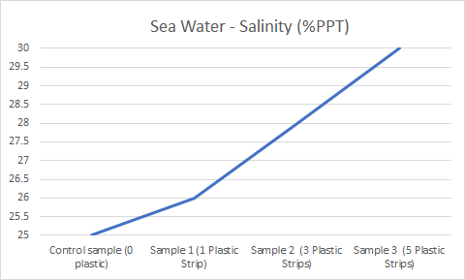
Figure 17 – Sea Water Salinity

Salinity has been measured in both DSG and %PPT so that is able to be converted into conductivity. However, there can be seen a slight increase in salinity levels across the samples which correlates to the dramatic increase in conductivity seen in other data sets.
To convert salinity to conductivity, an online tool was used to convert %PPT to mS/cm which then had to be converted to uS/cm to match the unit of the rest of the data. The results came in the form of ten thousands which did not match the hundreds that the original data showed, and so after some trouble shooting the conversion was abandoned.

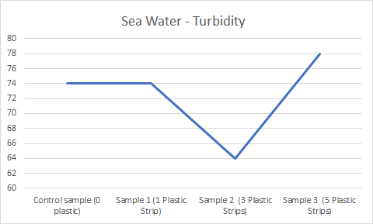
Figure 18 – Sea Water Turbidity

Turbidity does not show a clear trend in this set. This could potentially be due to the fact that the mixture was completely saturated and still had PVA floating in the sample, meaning when it was mixed it had become extremely bubbly. Although best efforts were made to remove the bubbles before being placed into the turbidimeter it is evident, especially in sample 2, that there was some form of disruption to the reading causing a result that does not match the trend of the other data sets. The data has still been included as, beside the slight anomaly, it does still show a general increase in turbidity.

The results were recorded on a notepad when taken at the time of the study and then later compiled into an excel spreadsheet. Since the data is simple it does not need to be transformed in any way and can simply be visually analyzed and turned into graphs and charts for comparability.

Unfortunately, the results are unable to be compared with any papers since there is no evidence of an experiment like this being completed beforehand, however, it is possible to compare the results with water quality and water standard regulations instead.

The results have achieved the aims of the study by showing a definite change in water quality linked to the increase of PVA in the water.

7.0 Analysis

PVA has been branded widely as completely not toxic and harmless to human health as well as being harmless to environment. The results of the study undergone however, do show a visible change in water quality in increased concentrations. Upon investigation into the effect of the oral toxicity of PVA, the substance had actually been categorized as ‘relatively harmless’ (Hodge and Sterner, 1949). By testing the PVA mixture on rats by feeding them the substance over a period of 6 weeks with increased concentrations, there was said to be ‘no gross changes’ observed, but minor cases found in those treated with the highest dosage of hydropic degeneration and eosinophilic infiltration of the submucosa of the stomach and dense myeloid marrow of the sternum. (DeMerlis and Schoneker, 2003). Despite this PVA has been approved for use as it is generally safe for consumption in mediated quantities and is currently licensed for use in medicinal coating and food packaging. (FDA, 2018).
The changes in conditions to a marine environment can be detrimental to all things living in it. Even the slightest changes can eradicate species while allowing others to thrive, while most of the tests done in this experiment are simply indicators of a bigger problem, it is still important to understand what effect these changes can have on the environment as a result of PVA usage.
A lowered PH level, being more acidic, is an indicator of a problem but not necessarily a problem in itself. Besides that, acidic water can be corrosive to metal pipes and plumbing fixtures due to the lack of carbonate minerals or higher salinity. Acidic water can also affect the performance of pesticides and herbicides potentially causing an issue with agriculture, lowering crop production and causing substantial damage to the economy as well as potential food shortages in less developed countries. This could be particularly impactful on countries that rely on agricultural exports to support their economic growth and will certainly affect the availability of range in food for developed countries.
On an environmental side, PH change can have harmful effects on marine environments with even slight variation but different species require different PH levels with some wildlife tolerating lower PH more than others, a PH of 5 is said to be too acidic as it can burn a fishes skin, but even slightly acidic water can still impact the chemical communication, reproduction and growth of marine life. Although, acidity will not kill off all marine life, it will indefinitely have an impact on some organisms. Raised acidity for coral, while not affecting their development directly, makes finding a good spot to settle as larvae difficult and prevents them from reaching adulthood. For shelled fish, such as clams, starfish, urchins and mussels, building a shell becomes difficult due to high acidity leaving them vulnerable to predators. Zooplankton, although smaller and able to adapt more rapidly to changing conditions due to a rapid reproduction rate, suffer similar issues in that their shells are dissolved rapidly by high acidity. Plants and algae, on the other hand, are due to thrive under acidic conditions, thanks to the additional carbon dioxide in the water but as plants and algae thrive, the risk of eutrophication and algal blooms is greatly increased. (Bennett, Undated).
Increases in conductivity, salinity and total dissolved solids all are linked due to the increase in sodium chloride content and can be an indication of the presence of contaminants. Water that is too saline (up to 1,000 mg/L) can also have effect on marine organisms, even being potentially lethal. Similar to the effects of saline water on humans, as consumption of large amounts of salt lead to a number of health issues including cancers, coronary heart disease, cardiovascular disease and arteriosclerotic heart disease. High TDS levels can also have scaling effects on water pipes, heaters, boilers and other household appliances such as irons and kettles drastically shortening the lives of the appliances and resulting in more waste. (Salzwedel, 2017).
Increased turbidity is due to an increased amount of organic matter in the water and so abrasion of fish's skin can occur. As well as this, more organic matter can lead to a lack of oxygen causing eutrophication. Although the turbidity levels do not have an effect on smaller, particle-feeding planktivorous fish, larger mammals and fish that feed on more visible prey could potentially suffer from an increase in turbidity. (Robertis & Ryer et al. 2003).
Finally, an increase in oxygen can often be very beneficial to marine life as it is used by fish to breathe, for plants to grow at night, and used in mass by decomposing bacteria. Too much oxygen in a water body can have negative effects, but levels must exceed 110% for this to become an issue, as the excess dissolved gas can cause ‘gas bubble disease’ in fish, although this is rare. (USU, Undated).

7.1 Drinking Water Quality Standards – Comparison

Since freshwater supplies a sparse, assuring the health of the reserves we do have is vital, which is why a comparison of the study results to the drinking water standards can provide a clarity as to the damage we can do to our environment and our own health. PVA may not be completely detrimental to the health of a water body, however, it does signify how sensitive water is to change, and how sensitive marine life is to that change, creating a chain reaction of negative effects.
There is no standard for PH level in drinking water but a gauge of around 6.5-8.5 is deemed acceptable for taste.
There is no health standard for conductivity.
Total dissolved solids standards come in categorical levels, less than 300 mg/L - excellent, between 300 and 600 mg/L - good, between 600 and 900 mg/L - fair, between 900 and 1200 mg/L - poor and greater than 1200 mg/L is unacceptable. Even with this reference the EPA recommends using water with less dissolved solids if it is available despite contents of more than 500 mg/L not being dangerous to drink.
Since turbidity of water can be filtered, drinking water should always be crystal clear for both aesthetical and health reasons. Turbid water contains suspended minerals, plankton, bacteria, organic and inorganic substances.
Annually, around 8 million tons of plastic are dumped into our oceans (plasticoceans, Undated). Compared to PVA, weighing around 0.45 grams for a 0.1 mm thick, 5 x 10 cm strip, polyethylene, the most commonly used lightweight plastic, weighs around 0.47 grams for the same dimensions. Translated, this means that around 200 trillion plastic strips the size of those being used in this experiment are being dumped into the ocean every year.

8.0 Conclusion

The aims of this study were to investigate the relationship between PVA and water quality by completing a series of lab tests and comparing the results to the limited literature available as well as to water quality standards. As well as promote awareness of upcoming plastic alternatives and their requirements to biodegrade and potential effects they can have on the environment as they decompose. This study was a huge success in its uncovering of obvious trends in deteriorating water quality despite restrictions and its links with the few papers available on the topic. Despite the difficulty that the research presented, with a lack of literature to compare to, the results showed clear increases in conductivity, turbidity, total dissolved solids and salinity and a decrease in PH which correlated perfectly with the results of Yang & Cao et al. Compared to the other sources which claimed that PVA has no effect on the environment, the results of this paper show differently (FDA, 2018). However, the results provided do not show that PVA is detrimental to the health of a water body, in fact, as even in complete saturation the test results for that sample still met water quality standards, showing that although alteration of marine environment will occur through the use of presumably any biodegradable plastic, the changes will not be devastating and will still be less extreme than those of plastic pollution.

9.0 Recommendations

Though plastic alternatives are a fantastic and innovative idea, the best course for action going forward is to attempt to reduce plastic waste rather than substitute it. Environmental NGO’s have stated that rapid introduction of plastic alternatives could actually increase plastic pollution due to the mindset that it is okay to simply discard the waste anywhere because it is biodegradable, when in reality many of these alternatives need controlled environments to decompose fully and correctly. There isn't currently the right infrastructure to support the decomposition of bioplastic waste and so the problem could be exacerbated by this shift if the time is not taken to fully accommodate for councils to expand the range of food waste collection, which currently only covers around half of UK households and educate the general population on these new types of plastic and how to dispose of them correctly (Laville, 2019). Biodegradable material ending up in landfill will biodegrade anaerobically and release the toxic greenhouse gas methane into the atmosphere. Biodegradables that end up in recycling will contaminate other plastics and lower the quality of the mixture. Ending up in river courses or oceans, means the plastics are not under the correct conditions to decompose and so will act as traditional plastic by fragmenting into (admittedly less harmful) microplastics with studies even showing that the degradation of bioplastics in the guts of turtles is no different from plastic (McCarthy and Sanchez, 2019). The same study showing that these alternatives are still ‘single-use’ products and replacing plastic with them is not really targeting the problem at the root, and there are still environmental impacts from the processing of these materials. The point of this paper, summarized well by Adam Read is ‘avoiding unintended consequences should be at the forefront of everyone’s minds’.

References

ScienceDirect . Undated. Polyvinyl Alcohol - an overview | ScienceDirect Topics. [ONLINE] Available at: https://www.sciencedirect.com/topics/earth-and-planetary-sciences/polyvinyl-alcohol. [Accessed 01 May 2020].

American Chemistry Council, I., 2020. Study from Trucost Finds Plastics Reduce Environmental Costs by Nearly 4 Times Compared to Alternatives. [Online]
Available at: https://plastics.americanchemistry.com/Study-from-Trucost-Finds-Plastics-Reduce-Environmental-Costs/
[Accessed 01 May 2020].

plasticseurope, 2020. how-plastics-are-made. [Online]
Available at: https://www.plasticseurope.org/en/about-plastics/what-are-plastics/how-plastics-are-made
[Accessed 01 May 2020].

Rinkesh, 2020. causes effects solutions of plastic pollution. [Online]
Available at: https://www.conserve-energy-future.com/causes-effects-solutions-of-plastic-pollution.php
[Accessed 01 May 2020].

Woodford, C., 2020. Bioplastics and biodegradable plastics. [Online]
Available at: https://www.explainthatstuff.com/bioplastics.html
[Accessed 01 May 2020].

FDA . 2018. GRAS Notice - Polyvinyl Alcohol. [ONLINE] Available at: https://www.fda.gov/media/128920/download. [Accessed 01 May 2020].

Chris C. DeMerlis and David Schoneker . 2003. Review of the Oral Toxicity of Polyvinyl Alcohol (PVA) . [ONLINE] Available at: https://www.researchgate.net/publication/10971837_Review_of_the_Oral_Toxicity_of_Polyvinyl_Alcohol_PVA [Accessed 01 May 2020].

Jennifer Bennett. Undated. Ocean Acidification . [ONLINE] Available at: https://ocean.si.edu/ocean-life/invertebrates/ocean-acidification
[Accessed 01 May 2020].

Sciencing. Undated. How Does Salt Affect the pH of Water? [ONLINE] Available at: https://sciencing.com/salt-affect-ph-water-5155101.html
[Accessed 01 May 2020].

Alex De Robertis, Clifford H. Ryer, Adriana Veloza, and Richard D. Brodeur. 2003. Differential effects of turbidity on prey consumption of piscivorous and planktivorous fish . [ONLINE] Available at: http://people.oregonstate.edu/~brodeuri/webpage%20pdf%20and%20docs/turbiditypaper.pdf [Accessed 01 May 2020].

OSSE. 1997. Dissolved Oxygen in Water. [ONLINE] Available at: http://osse.ssec.wisc.edu/curriculum/earth/Minifact4_Dissolved_Oxygen.pdf
[Accessed 01 May 2020].

UHU. Undated. Dissolved Oxygen . [ONLINE] Available at: https://extension.usu.edu/waterquality/learnaboutsurfacewater/propertiesofwater/dissolvedoxygen [Accessed 01 May 2020].

PlasticOceans. Undated. Facts about Plastic. [ONLINE] Available at:https://plasticoceans.org/the-facts/ [Accessed 01 May 2020].

Meiqi Yang, Guorong Cao, Dongli Li, Xinting Wang. 2018. Study on the Effect of PVA Aqueous Solution on Water Quality . [ONLINE] Available at:https://books.google.co.uk/books?id=IlNHDwAAQBAJ&pg=PA429&lpg=PA429&dq=Study+on+the+Effect+of+PVA+Aqueous+Solution+on+Water+Quality&source=bl&ots=nyNecql9YN&sig=ACfU3U3lURpL7ypXhiy5kDjw3Y6PXdYZ1g&hl=en&sa=X&ved=2ahUKEwjWsY35zI7pAhUKZcAKHSX-BF0Q6AEwDHoECAsQAQ#v=onepage&q&f=false [Page 429] [Accessed 01 May 2020].

Sandra Laville. 2019. S Plastic alternatives may worsen marine pollution, MPs warn. [ONLINE] Available at:https://www.theguardian.com/environment/2019/sep/12/plastic-alternatives-may-worsen-marine-pollution-mps-warn [Accessed 01 May 2020].

Joe McCarthy and Erica Sanchez. 2019. 5 Plastic Alternatives Doing More Harm Than Good — and What to Use Instead . [ONLINE] Available at:https://www.globalcitizen.org/en/content/plastic-alternatives-doing-harm/ [Accessed 01 May 2020].

Imogen Benson. 2020. PLASTIC ALTERNATIVES MAY CAUSE GREATER ENVIRONMENTAL HARM, SAYS NEW REPORT. [ONLINE] Available at:https://resource.co/article/plastic-alternatives-may-cause-greater-environmental-harm-says-new-report [Accessed 01 May 2020].

BioRegional. Undated. Why going plastic-free could have environmental side effects - and four ways we can prevent this. [ONLINE] Available at:https://www.bioregional.com/news-and-opinion/why-going-plastic-free-could-have-environmental-side-effects-and-four-ways-we-can-prevent-this
[Accessed 01 May 2020].

WHO. 2016. Total dissolved solids in Drinking-water. [ONLINE] Available at:https://www.who.int/water_sanitation_health/dwq/chemicals/tds.pdf[Accessed 01 May 2020].

NDSU. 2019. Drinking Water Quality: Testing and Interpreting Your Results. [ONLINE] Available at:https://www.ag.ndsu.edu/publications/environment-natural-resources/drinking-water-quality-testing-and-interpreting-your-results#section-19 [Accessed 01 May 2020].

Bryan R. Swistock, Dr. William E. Sharp and James A. Clark. 2003. Water Tests. [ONLINE] Available at:http://environmentalservicelab.com/docs/PSU%20-%20Water%20Testing%20Interpretation.pdf [Accessed 01 May 2020].

Chris Mechenich and Elaine Andrews. Undated. Interpreting Drinking Water Results. [ONLINE] Available at:https://www.uwsp.edu/cnr-ap/watershed/Documents/Interpreting%20Drinking%20Water%20Test%20Results.pdf
[Accessed 01 May 2020].

Po-Da Hong, Che-Min Chou and Chiu-Hui He. 2001. Solvent effects on aggregation behavior of polyvinyl alcohol solutions . [ONLINE] Available at:https://www.sciencedirect.com/science/article/abs/pii/S0032386101000568
[Accessed 01 May 2020].

Zainab Waheed Abdullah and Yu Dong. 2019. Biodegradable and Water Resistant Poly(vinyl) Alcohol (PVA)/Starch (ST)/Glycerol (GL)/Halloysite Nanotube (HNT) Nanocomposite Films for Sustainable Food Packaging. [ONLINE] Available at:https://www.frontiersin.org/articles/10.3389/fmats.2019.00058/full [Accessed 01 May 2020].

Hisashi Nagadomi, Takako Hiromitsu, Kenji Takeno, Masanori Watanabe and Ken Sasaki2. 1999. Treatment of aquarium water by denitrifying photosynthetic bacteria using immobilized polyvinyl alcohol beads. [ONLINE] Available at:https://www.sciencedirect.com/science/article/abs/pii/S1389172399890112 [Accessed 01 May 2020].

Hydrology Project. 1999. Standard Analytical Procedures for Water Analysis. [ONLINE] Available at:http://indiawrm.org/Website/Webpages/PDF/-download-manuals-WaterQuality-TechnicalPapers-StandardAnaly.pdf [Accessed 01 May 2020].

Juan Guo and Jin Zhang. 2011. Study of Environment Maintenance Feasibility of Polyvinyl Alcohol . [ONLINE] Available at:https://link.springer.com/chapter/10.1007/978-3-642-27452-7_21 [Accessed 01 May 2020].

SAS. Undated.Plastic Pollution Facts. [ONLINE] Available at:https://www.sas.org.uk/our-work/plastic-pollution/plastic-pollution-facts-figures/
[Accessed 01 May 2020].

EnvironmentalLaw. Undated. Water Pollution Offences
. [ONLINE] Available at:http://www.environmentlaw.org.uk/rte.asp?id=110 [Accessed 01 May 2020].

SHI. Undated. History and Future of Plastics. [ONLINE] Available at:https://www.sciencehistory.org/the-history-and-future-of-plastics[Accessed 01 May 2020].

Richard C. Thompson, Shanna H. Swan, Charles J. Moore, and Frederick S. vom SaalI. 2009. Our plastic age. [ONLINE] Available at:https://www.ncbi.nlm.nih.gov/pmc/articles/PMC2874019/
[Accessed 01 May 2020].

Yukie MATO, Hideshige TAKADA, Mohamad Pauzi ZAKARIA, Yuji KURIYAMA, Haruyuki KANEHIRO. 2002. Toxic Chemicals Contained in Plastic Resin Pellets in the Marine Environment. [ONLINE] Available at:https://www.jstage.jst.go.jp/article/sesj1988/15/6/15_6_415/_article/-char/en
[Accessed 01 May 2020].

Susan Frienkel. 2011. Plastic: A Toxic Love Story . [ONLINE] Available at: https://books.google.co.uk/books?id=9LyGHqqIKT4C&pg=PA133&lpg=PA133&dq=%E2%80%9CPlastic+is+not+just+an+aesthetic+problem,%E2%80%9D+says+marine+biologist+David+Barnes%5D&source=bl&ots=4snM1fQulU&sig=ACfU3U1CVL1k7Zoh6RAcmXdGU_-rerTxiQ&hl=en&sa=X&ved=2ahUKEwiW5qLOiJDpAhUVVRUIHX-HDY8Q6AEwAHoECAwQAQ#v=onepage&q&f=false [Accessed 01 May 2020].

Rachel Smith. 2019. We know single-use plastics are bad. Why can’t we stop using them?. [ONLINE] Available at: hhttps://eu.indystar.com/story/news/2018/07/29/plastic-waste-pollution-people-cant-resits/818703002/ [Accessed 01 May 2020].

GOV.UK. 2019. GOV Takes Action to Ban Platic Straws
. [ONLINE] Available at: https://www.gov.uk/government/news/gove-takes-action-to-ban-plastic-straws-stirrers-and-cotton-buds [Accessed 01 May 2020].

Josh Gabbatiss. 2018. Most people still do not care about buying plastic bottles, say campaigners. [ONLINE] Available at: https://www.independent.co.uk/environment/plastic-bottles-waste-recycling-pollution-single-use-keep-britain-tidy-water-a8307591.html
[Accessed 01 May 2020].

Laura Parker. 2018. Fast facts about plastic pollution . [ONLINE] Available at: https://www.nationalgeographic.com/news/2018/05/plastics-facts-infographics-ocean-pollution/ [Accessed 01 May 2020].

Lihn Do. 2019. Public reluctance impedes fight against plastic. [ONLINE] Available at:https://e.vnexpress.net/news/life/trend/public-reluctance-impedes-fight-against-plastic-4001319.html [Accessed 01 May 2020].

PlasticIsRubbish. 2014. Pva plastic. [ONLINE] Available at:http://plasticisrubbish.com/2014/07/12/whitby-goths-and-cocoa/
[Accessed 01 May 2020].

Alexandriava. Undated.Recycling Complications. [ONLINE] Available at:https://www.alexandriava.gov/uploadedFiles/tes/solidwaste/info/RecyclingPlasticComplications.pdf [Accessed 01 May 2020].

Daniel Posen, Paulina Jaramillo, Amy E Landis and W Michael Griffin. 2017. Greenhouse gas mitigation for U.S. plastics production: energy first, feedstocks later. [ONLINE] Available at:https://iopscience.iop.org/article/10.1088/1748-9326/aa60a7
[Accessed 01 May 2020].

Chris Woodford. 2020. Bioplastics and biodegradable plastics. [ONLINE] Available at: https://www.explainthatstuff.com/bioplastics.html
[Accessed 01 May 2020].

MICHAELANGELO D. TABONE, JAMES J. CREGG, ERIC J. BECKMAN AND AMY E. LANDIS. 2010. Sustainability Metrics: Life Cycle Assessment and Green Design in Polymers. [ONLINE] Available at:https://www.explainthatstuff.com/bioplastics.html
[Accessed 01 May 2020].

Alexander H. Tullo. 2016. The cost of plastic packaging. [ONLINE] Available at:https://cen.acs.org/articles/94/i41/cost-plastic-packaging.html
[Accessed 01 May 2020].

UNEP. 2014. Valuing Plastics: The Business Case for Measuring, Managing and Disclosing Plastic Use in the Consumer Goods Industry. [ONLINE] Available at:
http://wedocs.unep.org/bitstream/handle/20.500.11822/9238/-Valuing%20plastic%3a%20the%20business%20case%20for%20measuring%2c%20managing%20and%20disclosing%20plastic%20use%20in%20the%20consumer%20goods%20industry-2014Valuing%20plasticsF.pdf?sequence=8&isAllowed=y [Accessed 01 May 2020].

Sean Fleming. 2018. This plastic-free bag dissolves in water. [ONLINE] Available at:
https://www.weforum.org/agenda/2018/10/this-plastic-free-bag-can-disappear-right-before-your-eyes/ [Accessed 01 May 2020].

Emo Chiellini, Andrea Corti, Salvatore D'Antone and Roberto Solaro. 2003. Biodegradation of poly (vinyl alcohol) based materials. [ONLINE] Available at: https://www.researchgate.net/publication/222272553_Biodegradation_of_poly_vinyl_alcohol_based_materials[Accessed 01 May 2020].

Mukesh Doble and Anil Kumar. 2005. CHAPTER 9 - Degradation of Polymers. [ONLINE] Available at: https://www.frontiersin.org/articles/10.3389/fmats.2019.00058/full [Accessed 01 May 2020].

