

Master of Business Administration

Module: Dissertation

Module Code: LCMB7035

Title: The Role of AI and Automation in Warehousing: A Comparative Case Study of Amazon’s Supply Chain Strategies in the UK and India

Supervisor: Mark Piekarz
Student Name: Darvin Sabhaya
Student ID: 2505280
Word Count: 15398
Submission Date: 28th August

Declaration
I can say that it is an individual research project, and this has been completed according to the academic requirements of the programme. The sources of information that were used in this study have been duly credited and cited. The presented information was mainly primary data, which were gathered and analysed for this research.
Acknowledgement
I would like to mention that I would have appreciated the assistance of my supervisor in this research project because of their assistance, constructive comments and continuous support.
Abstract
Background
Warehousing is being transformed by artificial intelligence (AI) and automation through the integration of robotics, predictive analytics, intelligent inventory management systems and decision-making based on data. The case of Amazon is important since the model of fulfilment combines innovative technologies with the management of extensive workforce. This dissertation assesses the effects of AI-enabled warehousing on the supply-chain practices of Amazon in the UK and India, focusing on the effects on operational effectiveness, labor relationships, employment opportunities and work quality. It is significant as both markets are varying in infrastructure maturity, labour conditions, regulation, digital preparedness and e-commerce development.
Method
The research was a qualitative comparative case-study that relied on secondary evidence completely. Peer-reviewed journal articles, Amazon publications, industry reports and government sources were used as resources to obtain a Systematic Literature Review. The screening of evidence was based on PRISMA principles and was thematically analysed. There were recurring patterns which were coded and grouped into subthemes and then consolidated into three broad themes that include operational performance, strategic integration of AI and workforce and organisational preparedness. The UK and India were then contrasted on uniform technological, operation and workforce aspects.
Findings
The results show that AI and automation enhance accuracy of inventory, predictability, fulfilment time, transparency of operations and efficiency of the warehouse with the assurance of good data, integration of systems and organisational capacity. The UK activities of Amazon are characterized by more focused and robotics-heavy automation, with India moving towards the integration of AI-assisted coordination and distributed and scalable fulfilment infrastructure. Automation provides technical and digital employment opportunities and lessens some of the manual repetitive jobs. Yet, algorithmic supervision, performance stress, reskilling requirements, cybersecurity threats and employee adjustment are also major issues. The implications of automation are consequent to organisational and national setting.
Conclusion
The conclusion of the dissertation is that AI-enhanced warehousing can enhance the operational resilience and competitive power of Amazon, yet the technology adoption is not enough to ensure sustainable performance. In order to be effective, there must be alignment between technology, workforce capability, organisational readiness, responsible governance and local operating conditions. The UK and India comparison can thus show that automation is successful when it is adapted to the context, as opposed to a global model.

Keywords: “Artificial Intelligence”, “Automation”, “Warehousing”, “Amazon”, “Supply Chain Management”, “Warehouse Robotics”, “Operational Efficiency”, “Algorithmic Management”, “Workforce Adaptation”, “United Kingdom”, “India”

Table of Contents
Chapter 1: Introduction 12
1.1 Introduction to the Chapter 12
1.2 Research Background and Context 12
1.3 Research Problem 14
1.4 Research Rationale and Justification 14
1.5 Research Aim and Objectives 15
1.5.1 Research Aim 15
1.5.2 Research Objectives 15
1.6 Research Questions 16
1.7 Scope of the Study 16
1.8 Brief Methodological Overview 17
1.9 Significance and Potential Contribution 17
1.10 Structure of the Dissertation 18
Chapter 2: Literature Review 19
2.1 Introduction to the Chapter 19
2.2 Theoretical Foundations 19
2.2.1 Socio-Technical Systems Theory 19
2.2.2 Dynamic Capabilities Theory 20
2.2.3 Technology-Organisation-Environment Framework 20
2.2.4 Integrated Theoretical Lens 21
2.3 Evolution of AI-Enabled Warehousing and Warehouse Distribution Networks 22
2.4 AI-Enabled Operational Performance and Supply-Chain Control 23
2.5 Industry Benchmarking: Automation Practice in Logistics and Retail 24
2.6 AI-enabled warehousing model: Innovation, fulfilment design and algorithmic control 26
2.7 Comparative context of warehousing in the UK and India- infrastructure, regulation, labour markets and e-commerce growth 28
2.8 Workforce implications: Job redesign, skills, monitoring and quality of work-life 29
2.9 Implementation barriers, risks and responsible automation 30
2.10 Conceptual Foundation and Literature Synthesis 32
2.11 Literature Gap 34
2.12 Chapter Summary 34
Chapter 3: Research Methodology 35
3.1 Chapter Overview 35
3.2 Research Philosophy 36
3.3 Research Approach 37
3.4 Research Strategy 37
3.5 Methodological Choice 38
3.6 Data Collection 39
3.7 Data Collection Strategies 39
3.7.1 Inclusion and Exclusion Criteria 40
3.7.2 Database Selection and Screening through PRISMA 41
3.8 Data Analysis 43
3.9 Validity and Reliability 43
3.10 Ethical Consideration 44
3.11 Methodological Limitations 44
3.12 Chapter Summary 45
Chapter 4: Findings and Analysis 46
4.1 Introduction 46
4.2 Evidence Extraction and Synthesis of Selected Studies 47
4.3 Research Question-Based Coding and Findings 56
4.4 Thematic Analysis 61
4.5 Summary 66
Chapter 5: Discussion 67
5.1 Chapter Introduction 67
5.2 Discussion on Objective 1: Development and Current Application of AI and Automation in Warehouse Distribution Networks 67
5.3 Discussion on Objective 2: Amazon as an Innovator and Employer in AI-Enabled Supply Chains 68
5.4 Discussion on Objective 3: Operational Challenges and Technological Approaches Shaping Amazon’s Warehousing Strategies in the UK and India 69
5.5 Discussion on Objective 4: Operational Efficiency, Worker Conditions, Career Opportunities and Quality of Work Life 70
5.6 Integrated Theoretical Interpretation 70
5.7 Chapter Summary 71
Chapter 6: Conclusion and Recommendations 72
6.1 Overall Conclusion 72
6.2 Linking with Objectives 73
6.3 Recommendations 73
6.4 Practical and Theoretical Contribution 74
6.5 Limitations of the Research 74
6.6 Personal Reflection 75
6.7 Future Scope of the Study 75
Reference List 76
Appendices 92
Appendix 1: Thematic Development Matrix 92

List of Figures
Figure 1: Growth of the global e-commerce warehousing market, 2025–2031 8
Figure 2: Dissertation Structure 13
Figure 3: Technology–Organisation–Environment Framework 16
Figure 4: AI-enabled warehousing model 22
Figure 5: Conceptual Framework 28
Figure 6: Saunder’s Research Onion 30
Figure 7: PRISMA Flowchart 37
Figure 8: Development of Final Themes from Recuring evidence patterns 55

List of Tables
Table 1: Key metrics for evaluating AI-enabled warehouse performance 21
Table 2: Inclusion and Exclusion Criteria 36
Table 3: Evidence Extraction and Synthesis of Selected Studies 42

Chapter 1: Introduction

1.1 Introduction to the Chapter
This dissertation focuses on the integration and impact of AI and automation in Amazon's warehousing operations, particularly how supply chain strategies differ between the UK and India. Warehousing is being transformed by AI to be more robot-driven, predictive, inventory-aware and automated decision-support, enabling warehouse operations to be quicker, more precise and information-based (Ferreira and Reis, 2023). Amazon is a case in point since the fulfilment model exhibits massive automation and, at the same time, work redesign, oversight, abilities and workplace quality (Amazon, 2025). This chapter will provide the research background and problem, justify the study, outline the aim, objectives and questions and describe the scope, methodology and structure of the dissertation.

1.2 Research Background and Context
Warehousing is no longer a back-end storage activity but a strategic fulfilment activity in digital commerce. Previously used warehouse models were largely relying on manual operations, rudimentary stock management and sequential delivery operations, but e-commerce has brought warehousing closer to promises to customers, product availability and reliability in delivery. The change has prompted companies to integrate artificial intelligence with automation, since AI encompasses systems that facilitate prediction, pattern recognition and decision-making, whereas automation encompasses technologies that involve repetitive or rule-based tasks with less human participation. Robotics, automated storage and retrieval systems, computer vision, Internet of Things sensors, warehouse management systems and predictive analytics are commonly used in conjunction with each other in warehouse operations. With such technologies, warehouses can handle more orders; it is easier to monitor stock and plan labour, machines and inventory in real-time (Ferreira and Reis, 2023; Naumann et al., 2023).
Another measure of the rising importance of fulfilment infrastructure is market expansion. By 2025 and 2031, the global e-commerce warehousing market will grow to USD 49.50 billion and USD 67.96 billion respectively with a CAGR of 5.44 which implies that fulfilment infrastructure has been an important investment focus rather than a second cost of logistics (Mordor Intelligence, 2026). Amazon is an example of topicality, as its competitiveness model is based on the integration of inventory, labour, robotics, and delivery systems on a large scale. In 2025, Amazon declared that its one millionth robot was deployed and it launched DeepFleet, an AI foundation model, which is developed to boost the effectiveness of robotic travel in its fulfilment network by 10% (Amazon, 2025). The UK and India provide good comparative settings as UK is an advanced logistics setting, and regulatory environment, and India is an advancing e-commerce setting with infrastructural heterogeneity, regional heterogeneity and intricate delivery geography.
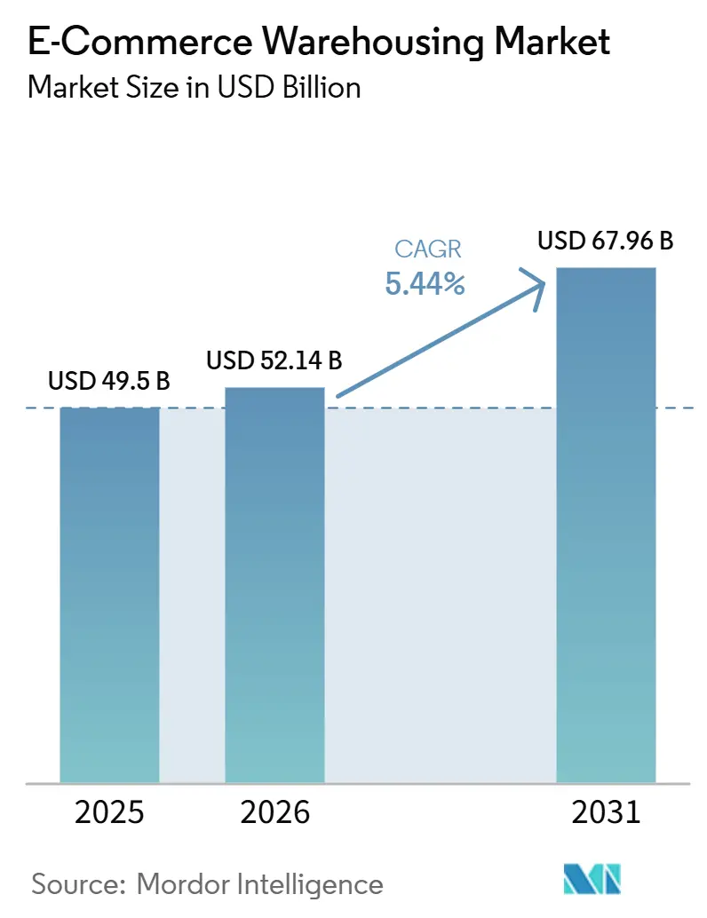
Figure 1: Growth of the global e-commerce warehousing market, 2025–2031
(Source: Mordor Intelligence, 2026)
Figure 1 shows the projected growth of the projected warehousing market. As per the report of Modor Intelligence, the e-commerce market will reach USD 49.5 billion in the year 2025 and USD 67.96 billion in the year 2031, hence becoming a huge market to consider scalable fulfilment strategies (Mordor Intelligence, 2026).

1.3 Research Problem
Despite the ever-increasing presence of AI and automation in the operations of warehouses, the impact of these two phenomena is not even or unconditionally positive. The available literature demonstrates that warehouse automation has the potential to enhance the speed of fulfilment, inventory accuracy, forecasting and operational control, but these benefits are contingent on the quality of data, the availability of infrastructure, the skills and capabilities of the workforce, and the successful combination of human labour and automated systems (Andiyappillai, 2021; Shamsuddoha et al., 2025). This poses a research problem since in the existing literature, automation is usually presented as a broad efficiency measure, and not as much focus is given to the differences in the results of automation in contrasting national settings.
The warehousing model by Amazon is especially significant since the extensive application of robotics and AI-based systems illustrates how automation can be put at the forefront of the supply-chain strategy, as opposed to a supporting feature (Amazon, 2025). Nevertheless, the technologies can work in the UK and India differently as the markets are different in terms of costs of labour, the logistics infrastructure, the expectations of the regulations, digital readiness and patterns of the e-commerce development. Simultaneously, workforce discussions are not yet concluded, as automation could both generate technical jobs and decrease repetitive labour, as well as augment algorithmic surveillance, workload, job insecurity and unequal access to reskilling (Gmyrek et al., 2023; World Economic Forum, 2025). Thus, the key issue is a poor comparative understanding of the impact of Amazon's AI-enabled warehousing and its outcome on both employees and operation in the UK and India.

1.4 Research Rationale and Justification
This research is justified by the increasing necessity to comprehend warehouse automation as a supply-chain feature and labour concern. The faster fulfilment, enhanced inventory visibility and better operational control are increasingly linked to AI-enabled warehousing, which cannot be evaluated solely based on the measures of productivity (Shamsuddoha et al., 2025). Amazon is an interesting study as its fulfilment scheme demonstrates the integration of robotics, AI, and information systems into large-scale e-commerce processes.
The UK and India, though, offer different conditions of operation, which are predetermined by different labour markets, maturity of infrastructure, requirements of the regulative system, and environment of the e-commerce development. This requires comparison as the efficiency or job performance of automation strategies may not be comparable in both the markets. The study is therefore not merely scholarly warranted by a knowledge gap in the literature regarding AI-enabled warehousing, but also viable as it offers an understanding of how the automation can be quantified regarding operational efficiency, worker well-being, job opportunities and quality of life.

1.5 Research Aim and Objectives

1.5.1 Research Aim
This research mainly aims to evaluate the integration and impact of AI and automation in Amazon’s warehousing operations through a comparative case study of its supply chain strategies in the UK and India.
In doing so, the study also aims to comprehend the role of AI-empowered warehousing in defining the operational efficiency, worker conditions, career opportunities and quality of work life in two opposite market settings.

1.5.2 Research Objectives
To achieve this aim, the study is guided by the following objectives:
- To critically examine the development and current application of AI and automation within warehouse distribution networks.
- To assess Amazon’s role as an innovator and employer in deploying AI-enabled supply chain technologies.
- To compare the operational challenges and technological approaches shaping Amazon’s warehousing strategies in the UK and India.
- To evaluate the impact of warehouse automation on operational efficiency, worker conditions, career opportunities and quality of work life.

1.6 Research Questions
The study is guided by the following research questions:
RQ1: How have AI and automation developed within Amazon's warehouse distribution networks, and how are these technologies applied in its UK and India warehousing operations?
RQ2: How does Amazon use AI-enabled warehousing technologies to improve supply-chain efficiency, fulfilment speed, inventory accuracy and operational control?
RQ3: How do Amazon’s warehouse automation strategies differ between the UK and India, and what are the implications for worker conditions, career opportunities and quality of work life?
These questions shift the dissertation from the development and deployment of AI-enabled warehousing to its operational and workforce implications. RQ1 explores the application of AI and automation in Amazon warehouses in the UK and India. RQ2 revolves around the efficiency of the supply chain, speed and control of fulfilment. RQ3 is a comparison of the two markets, evaluating the conditions of workers, career prospects and quality of work life.

1.7 Scope of the Study
This study is limited to AI and automation in warehousing and supply-chain fulfilment in the UK and India, which are applied to Amazon. The comparison is done based on warehouse distribution networks, AI-based performance of operations, fulfilment speed, inventory, algorithmic management, employee condition, career and work life quality. The article is silent about the larger corporate plan, financial performance, operations in terms of the marketplace and customer behaviour of Amazon unless it has a direct relationship with warehousing and fulfilment. It is neither founded on any Amazon data or employee secret, manager or customer evidence either. The research only uses secondary sources like academic literature, company reports, government publications, industry reports and reliable media, which are in line with the approved desk-based method.

1.8 Brief Methodological Overview
The dissertation is a qualitative comparative case-study design, which uses secondary data. In this study, AI-based warehousing activities of Amazon in the UK and India are analysed based on peer-reviewed journals, Amazon publications, government reports and reputable sources of the media. No personal or sensitive data will be obtained, no interviews, questionnaires, focus groups, observations or human participants are involved as well. This evidence will be themed around automation technologies, operational efficiency, the implications in the workforce and the UK-India contextual differences.

1.9 Significance and Potential Contribution
The importance of this study lies in the fact that AI-enabled warehousing is becoming more influential in the context of e-commerce companies in terms of speed, accuracy, inventory visibility, and fulfilment reliability. Nevertheless, its worth cannot be evaluated solely in terms of productivity because automation also impacts job design, surveillance, skills and quality of work life (Nitsche, 2021; Gmyrek et al., 2023). The research concentrates on Amazon by looking at one of the big models of fulfilment in the world, where AI, robotics and data-driven control are at the centre of the supply-chain work. The UK -India comparison contributes to it further since it reveals how the automation strategies can be influenced by the various infrastructure conditions, labour markets, regulatory expectations and e-commerce growth patterns. The study also adds to the body of literature on AI-enabled supply chains by providing an interconnection between operational performance and workforce results. In practice, it can assist in advice of responsible warehousing approaches, balancing fulfilment efficiency and worker development, fairness and sustainable automation.

1.10 Structure of the Dissertation
The dissertation is organised into six chapters. It has been presented in the following section.

Figure 2: Dissertation Structure
(Source: Self-generated)
Figure 2 shows the dissertation chapters builds on this introduction by considering the literature on AI-enabled warehousing, automation, the fulfilment model that Amazon utilises, and the contextual differences between the UK and India, as well as the operational performance and workforce outcomes. The subsequent chapters describe the research approach, report and interpret secondary evidence, comment on the results in relation to the research questions, as well as closing the research with contributions, limitations, recommendations, and future research directions.

Chapter 2: Literature Review

2.1 Introduction to the Chapter
This chapter aims to critically assess literature on AI-enabled warehousing, automation and Amazon strategies in the supply chain in the UK and India. The theoretical background is the starting point of the review since the research needs the concepts that clarify technology adoption, organisational competence and employee performance. Then it proceeds to the development of AI-driven warehousing since it determines how robotics, IoT, predictive analytics and warehouse systems have changed the distribution networks (Tubis et al., 2023). The next section of the chapter looks at operational performance indicators, broader industry benchmarking and the fulfilment model developed by Amazon to bridge the technology adoption and supply-chain efficacy and control (Shamsuddoha et al., 2025). It then contrasts the UK and India scenario then, estimating the workforce results and risk of implementation. This sequence enables the technology, context and labour discussions to lead to the logic of the literature gap.

2.2 Theoretical Foundations
The implementation of AI-enabled warehousing needs a theoretical understanding since it entails more than the deployment of robotics, software or automated handling systems. It transforms the coordination of resources, operational decisions made, worker management and adaptation of supply-chain capabilities to market contexts. The analysis of the automation of the warehousing process at Amazon in the UK and India is thus framed into three theories.

2.2.1 Socio-Technical Systems Theory
Socio-technical systems theory states that the joint design of technical and social systems determines organisational performance and not technology. It is applicable since robotics, warehouse management systems and algorithmic tools change the work organisation along with the inventory movement. Picking accuracy, stock visibility and fulfilment speed are the possible benefits of automation in the case of Amazon that should be studied in relation to work intensity, monitoring, skills, autonomy and quality of work life. The theory consequently helps the study not to consider automation just as a technical efficiency question and encourages a fair assessment of the interplay between labour and automated systems.

2.2.2 Dynamic Capabilities Theory
The Dynamic capabilities theory describes how companies are able to remain competitive by sensing opportunity, taking advantage of it by investing and reorganising resources as the external environment evolves (Teece et al., 1997; Teece, 2007). The theory is appropriate since Amazon deals in quick-paced e-commerce markets characterised by volatility in demand, expectations on delivery and technological innovation redefining the fulfilment needs. The theory assists in the analysis of the reason why the AI and automation strategy at Amazon cannot be perceived solely as the ownership of robots or data systems. It is valuable in its capacity to scale, convert and re-use those systems in various operating environments. The reason behind this is that the well-developed logistics system of the UK and the inhomogeneous regional system of India might need various types of technological adjustments.

2.2.3 Technology-Organisation-Environment Framework
The Technology-Organisation-Environment model is a framework that explains the adoption of technology in three dimensions that interact with each other, namely technological readiness, organisational capability and pressure in the external environment (Tornatzky and Fleischer, 1990).
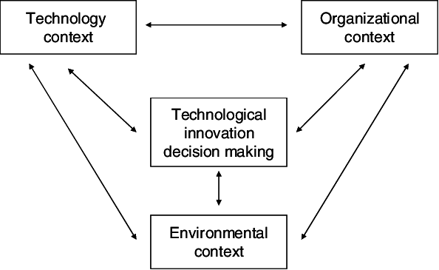
Figure 3: Technology–Organisation–Environment Framework
(Tornatzky and Fleischer, 1990)
Figure 3 shows the T-O-E framework, which is helpful since the adoption of AI is influenced by more than just robotics or analytics, as it depends on the managerial capacity, workforce preparedness, regulation, infrastructure, labour expenses and customer demand as well. A more powerful efficiency justification of automation might be supported by regulation, wage pressure, and well-developed logistics networks in the UK. The growth of e-commerce in India may be really fast, and geographical diversity and variation in infrastructure can promote a more selective or hybrid implementation. TOE then offers a contextual point of reference as to why the same technologies can lead to varying operational and workforce results.

2.2.4 Integrated Theoretical Lens
These theories combined help to justify the analytic framework of the dissertation. The worker-technology relationship is explained by the socio-technical systems theory, the strategic adaptation can be explained by the dynamic capabilities’ theory, and the TOE framework explains the contextual variation. When used together, they enable the AI-driven warehousing to be considered by Amazon through the operational, organisational and labour-based lenses instead of viewing it through a limited technological lens.

2.3 Evolution of AI-Enabled Warehousing and Warehouse Distribution Networks
As per Ferreira and Reis (2023), the distribution networks in warehouses have developed manual storage and dispatch systems to digitally coordinated fulfilment settings. In conventional warehousing, value was largely generated by stock holding, picking of goods, which was labor intensive and the sequential flow of goods. This model was no longer adequate as e-commerce brought a greater diversity of orders, demand-speed requirements and greater complexity in inventory. Intelligent warehousing is currently a symptom of the larger Industry 4.0 transformation, where cyber-physical systems, sensors, automation and real-time information exchanges bind the warehouse operations with a broader supply-chain decision-making process, as noted by Tubis and Rohman (2023).
As per Naumann et al. (2023), the evolution of AI-enabled warehousing is based on this and involves the integration of automation with data-driven intelligence. Automation systems like conveyors, automated storage and retrieval systems, autonomous mobile robots and robotic picking systems decrease reliance on manual movement. The latter is followed by the predictive and adaptive functionality of AI, machine learning and analytics, which helps to predict demand and allocate inventory, optimise routes and handle exceptions (Ferreira and Reis, 2023). Thus, the warehouse becomes not a mere storage place of goods only; it is an intelligent fulfilment network whereby robotics, warehouse management systems, predictive analytics, inventory visibility and delivery planning are linked and functioning capabilities. This difference is significant since automation can perform tasks, whilst AI assists in optimising the way, when, and location of the tasks being done.
The literature also uncovers that warehouse intelligence cannot be achieved with just one tool, but rather a combination of a number of technologies. In this respect, Naumann et al. (2023) have noted computer vision can be applied to aid object recognition, damage detection, inventory monitoring and robot manipulation, whilst IoT can give real-time visibility of where items are stored, equipment condition and equipment movement. In addition to it, as per Shamsuddoha et al. (2025) perspective, the AI-based supply-chain systems can significantly enhance the optimisation of logistics, forecasting and real-time decision-making, should the systems have the ability to flow data reliably and interoperably. AI-powered warehouses, however, shouldn't be considered as a replacement for human workers with robots. It will rely on the incorporation of its technologies into the labour process, warehouse design, management system and the outer delivery system. This is particularly applicable to Amazon, in which warehouse distribution networks need to integrate robotics, employees, algorithms and local infrastructure to fulfil the needs of fulfilment in both the UK and India.

2.4 AI-Enabled Operational Performance and Supply-Chain Control
Naumann et al. (2023) have opined that the AI-driven operational performance is based on whether the technologies used in warehouses enhance the quality of decisions in the entire supply chain, as opposed to the automation of individual warehouse functions. Cannas et al. (2024) posit that AI can facilitate operations and supply-chain management by providing forecasts, planning, scheduling and process optimisation, but also acknowledge that there exist impediments that tend to prevent firms from translating AI adoption into steady performance improvements. However, Dunn et al. (2024) states that the automation in warehouses cannot be rated by the existence of robotics or software, but the results can be measured by the shortening of the order cycle time, the productivity of picking, inventory accuracy, warehouse throughput, the cost of fulfilment per order, the accuracy of forecasting and the uptime of the system.
AI value is particularly observable in real-time control of the supply chain. Risk prediction, disruption response and inventory choices can be reinforced through AI and machine-learning solutions, which can detect patterns that the manual system might miss (Jahin et al., 2023). This could be used in warehousing to enable quicker stock distribution, improved replenishment, automated exception management and enhanced coordination between inbound inventory, warehousing, picking and dispatch. Teixeira et al. (2025) also relate AI applications to process optimisation and resilience of supply chains, indicating that AI-enabled warehouses have the potential to become more responsive if the data flows are reliable and the decisions are interconnected across functions.
Chosen literature, such as Dunn et al. (2024) may be critiqued as being focused on the efficiency gains and less on reliability with fragmented data, operational uncertainty or disparate infrastructure. Li et al. (2024) underline that data governance is the main focus of operations and supply-chain management because low data quality can undermine data-driven decision-making. This questions the effectiveness of AI-based control, were poor quality of stock information, poor system integration or distrust by the employees can diminish operational gains. As such, the AI-supported performance of Amazon needs to be measured against the efficiency metrics and the terms under which the metrics can be accomplished, particularly in the varying contexts of infrastructure, labour and fulfilment of the UK and India.

2.5 Industry Benchmarking: Automation Practice in Logistics and Retail
The practice of benchmarking in the industry proves that AI-based warehousing is to be evaluated based on quantifiable operational performance instead of the figurative implementation of innovative technologies. Dunn et al. (2024) claim that the picker-routing decisions can be better optimised through reinforcement learning, which can provide faster and more accurate choices than the heuristics, but their model-driven approach might be inadequate to account for the behaviour of labour, layout constraints or fulfilment complexity across sites. In the same line, Lorenz et al. (2024) demonstrate that order-picking and batching can be dynamically used to facilitate the performance of online warehousing, yet their focus on optimisation does not leave much space to consider the experience of workers and the readiness to implement them. In line with these studies, the evaluation of AI-enabled operations can be done based on fulfilment speed, order accuracy, inventory accuracy, throughput, cost per order, labour productivity, forecasting reliability and system uptime.
These measures are supported by company practice yet indicate that automation is situational. DHL lists orchestration, robotics and AI as 2024 priorities to enhance supply-chain efficiency, agility and sustainability (DHL, 2024). The Smart Platform is a combination of automation, AI and data science across online grocery, supply chain, fulfilment and last mile as a way of demonstrating the value of integrated fulfilment systems, not individual automation at Ocado Group (2026). According to Walmart, its high-tech perishable distribution centres are able to hold twice the number of cases and handle more than twice the number of cases as the traditional centres (Walmart, 2024). Nevertheless, these examples should be viewed with a grain of salt since the performance of automation is affected by the type of product, data infrastructure, the ability of the workforce and demand in the market. This allows the metrics to be used to compare the Amazon operations in the UK and India without making the dissertation a multi-company analysis.
Table 1: Key metrics for evaluating AI-enabled warehouse performance
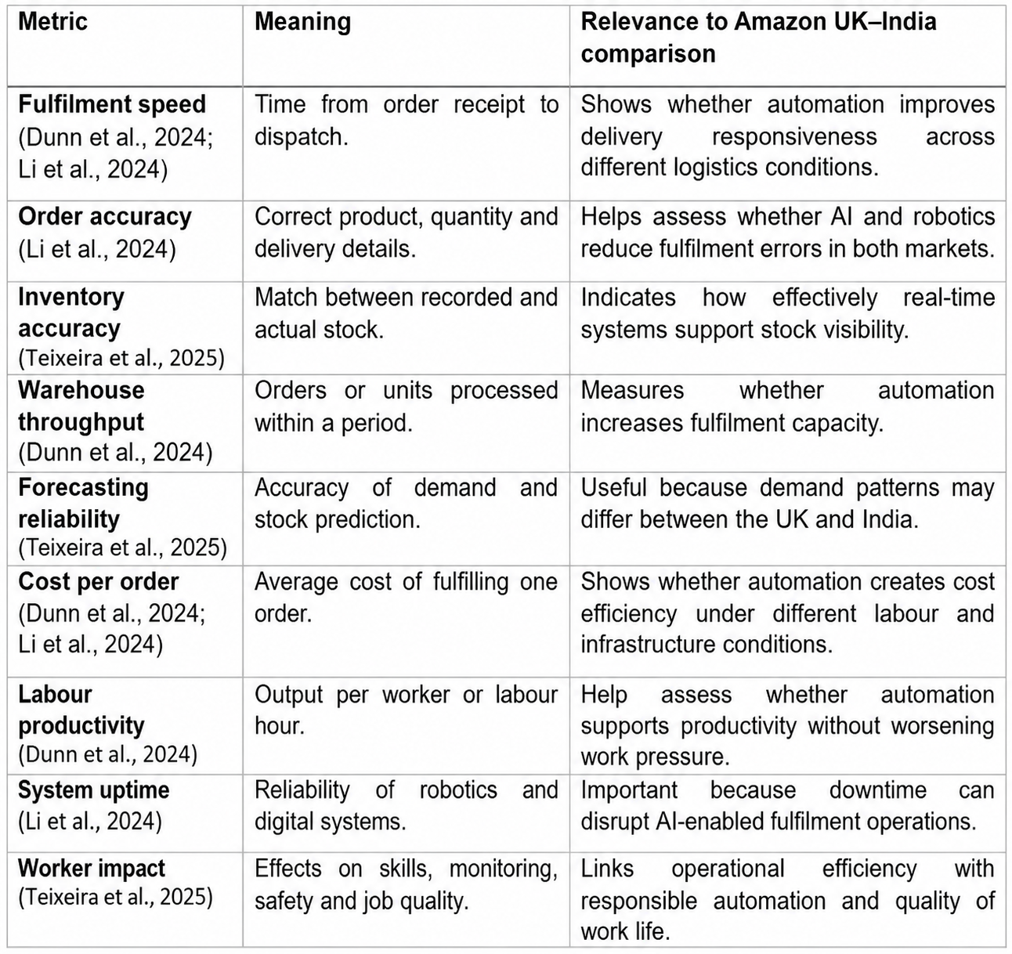
The metrics listed above [table 1] offer a viable analysis prism to be used later in analysing the warehousing operations of Amazon in the UK and India, although the performance results can differ based on the infrastructure, labour market, and fulfilment complexity.

2.6 AI-enabled warehousing model: Innovation, fulfilment design and algorithmic control
Warehousing has evolved into a smarter operation system which can facilitate real time supply-chain decisions with the use of AI which has revolutionized warehousing as a labour intensive storage role to a smarter operation system. According to Hossain (2025), machine learning, autonomous mobile robots (AMRs), automated storage and retrieval systems (AS/RS), computer vision, digital twins and Internet of Things (IoT) sensors are some of the technologies that underpin modern smart warehouses. They contribute more than automation of tasks since the integration of physical technologies with AI-enhanced analytics enhances inventory visibility, demand forecasting, replenishment and order fulfilment. Alherimi et al. (2024) also relate smart warehousing to Industry 4.0 whereby all the technologies involved continuously engage with each other to exchange information about operations in order to enhance responsiveness and coordination. This correlation between AI technologies and warehouse operations is shown in Figure 4, which offers a graphic depiction of the technological processes that intelligent warehousing is based on.
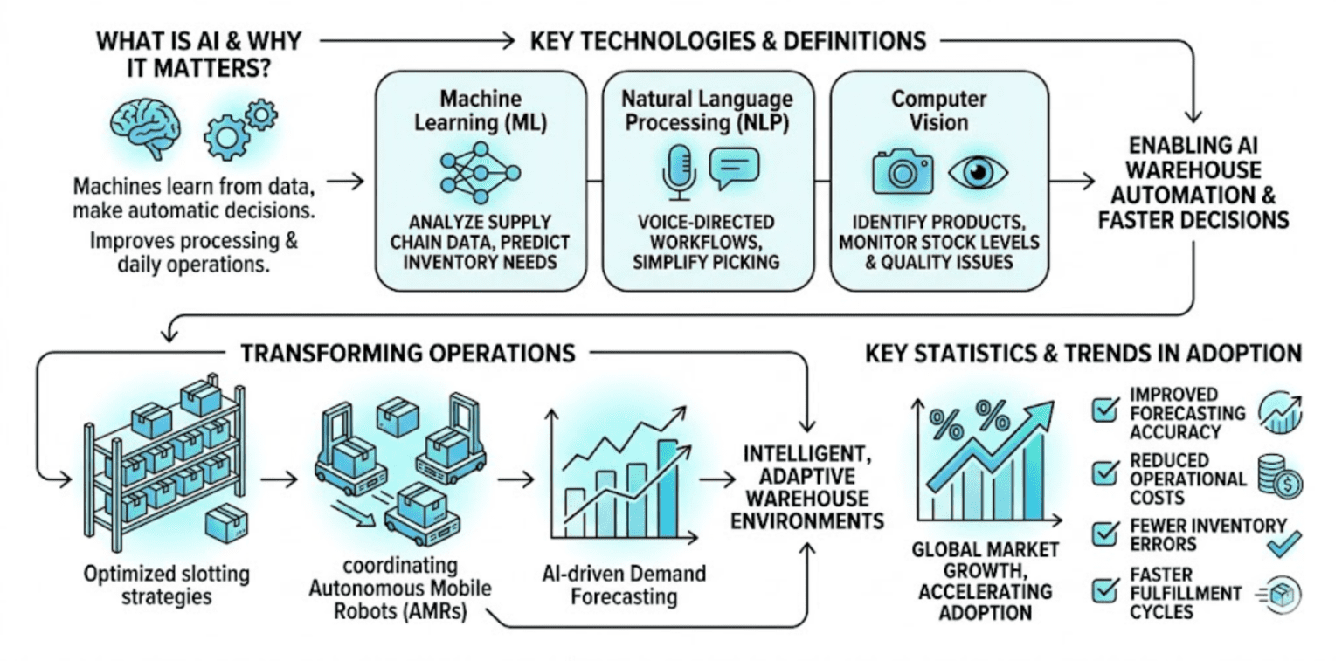
Figure 4: AI-enabled warehousing model
(Source: Phuong, 2026)
However, the level of technological sophistication does not necessarily correlate with best warehouse performance. The AI algorithms can optimise the location of items, predicting inventory, restocking and picker routing, minimising the travel distance and inventory errors, but their performance is conditional on both organisational and operational factors. Fana and Villani (2023) also show that managerial control is being reinvented with technological innovation in the form of algorithmic governance whereby digital systems are progressively assigning tasks, tracking the workflow and measuring the productivity of employees. Whereas such systems may facilitate on-going optimisation, they can also enhance issues of transparency, accountability and employee autonomy. Alherimi et al. (2024) thus warn off viewing AI as a stand-alone solution, as the operation outcomes may be undermined by ineffective systems integration, inefficient workforce engagement and inadequate managerial capacity. This means that intelligent warehousing can only be seen as a socio-technical competence and not merely as a set of sophisticated technologies. Its efficiency depends on the volatility of demand, complexity of the products, maturity of infrastructure, organisational willingness and workforce ability. These factors are especially significant in the context of analyzing Amazon since the dissimilarities between the UK and India can affect the similarity of AI and automation technologies implementation and the resulting operational and human consequences.

2.7 Comparative context of warehousing in the UK and India- infrastructure, regulation, labour markets and e-commerce growth
As per Hossain (2025), the rate of uptake of AI-led warehousing is much different in different countries as the uptake of technology is influenced by institutional, economic and infrastructural forces and not by the capacity to uptake technology. The logistics system in a country, labour markets and regulation influence the rate and efficiency of automation within the warehouse as Nataraj et al. reveal in 2025. The UK and India are two very distinct settings, which individuals can analyse to recognize the way AI can be implemented under varying economic development rates. The e-commerce sector in India is predicted to be a 200 billion market by the year 2020 and data localisation and fair competition laws are suggested by Statista Daily Data (2025). Babikian (2023) notes that organisations have been compelled to be holistic in adapting technology and legal policies in their employment rights, workplace safety and data protection laws. Although these rules may raise the cost of doing business, they enhance accountability and security of workers in an organisation.
Conversely, Das (2026) stated that the warehousing industry in India has undergone a swift change as well as an increasing e-commerce market, digitalisation processes and state investment in logistics systems. However, there are significant geographical discrepancies in terms of transportation quality, standardisation of warehouses, the reliability and digital connectivity of electricity. Thus, the adoption of AI tends to be uneven in terms of regions and industries, by installing fully automated facilities. Most organisations adopt hybrid models of operations that entail selective automation and manual work. The labour market situation serves to separate the two countries, with the UK labour costs being more expensive, which enhances the economic rationality of automation investment; however, in India, the relatively high workforce density can decrease the financial incentives to invest in full automation in the short term. Shriyam et al. (2023), however, emphasised the growing lack of specialised logistics employment and the growing demands of consumers as drivers of technological investment in both markets. Digital skills also impact the outcomes of implementation because organisations will require technologically endowed staff to work with more sophisticated technologies in warehouses. Although e-commerce in the two countries has been on the rise in the recent past and has consequently increased the need for automation, literature provides some useful information that there will be convergence in the development of warehouses.

2.8 Workforce implications: Job redesign, skills, monitoring and quality of work-life
Ning and Bhaumik (2025) however opine that the change in technology has been changing faster than the investment undertaken by organisations in employee development hence leaving enormous gaps in skills that may serve as a constraint in successful implementation of automation. Hossain (2025) state that workplace monitoring has also been redesigned following the trend of more relying on algorithmic management. AI systems monitor operational performance by wearing devices, scanning to monitor productivity, movement, and task completion, and having a digital dashboard to assess performance. Greater surveillance leads to greater openness of operations, objective performance evaluation and can make evidence-based decisions. Pandey and Pravesh (2025) on the other hand suggest that under continuous digital watch, employees are deprived of their sense of autonomy; they feel increased psychological pressure and work harder yet do not necessarily become more committed to the organisation. The Quality of Work Life (QWL) is another issue of warehouse automation, according to Gazi et al. (2024). Safety in the workplace can be improved with smart technologies that will reduce the exposure to dangerous manual activities and manual overload. Meanwhile, productivity goals that are generated by AI may increase workload, emotional stress and job insecurity. This paradox demonstrates that conditions in the workplace can be improved even with physical improvements, and that it is not always accompanied by a better psychological condition. Furthermore, there is a wide disparity in the work performance depending on the culture in the organisation and nationality. More developed economies are more likely to have a more developed vocational training system, potentially more successful in equipping workers with reskilling and upskilling, whereas emerging economies may have problems with technological access and digital literacy (Ebom-Jebose, 2025). Therefore, warehouses need to ensure that they have a plan of fostering employee education, communication and change management in the team so that they can be effective in their automation.

2.9 Implementation barriers, risks and responsible automation
Although there have been tremendous improvements in AI-enabled warehousing, there are complex organisational processes that are affected by technological, financial, ethical and institutional challenges of implementation. As stated by Rodríguez-García et al. (2026), the failures in automation of warehouses are hardly ever due to technology per se, but, to a larger extent, to the lack of organisational preparation, the lack of change management and governance frameworks. Therefore, responsible automation must involve the combination of technological innovation and organisational capability and the involvement of stakeholders. Financial investment, on the other hand, according to Selesi-Aina et al. (2024), is one of the most commonly noted implementation barriers. Warehouse systems that are AI-empowered demand considerable investment in robotics, software platforms, cloud computing, cybersecurity and employee education. Smaller organisations can find it hard to justify such investments since their operational benefits might not be realised in the short run. According to Nweje and Taiwo (2025), another vital challenge is data quality, as the AI algorithms rely on high amounts of trustworthy operational data to predict inventory, route optimisation and resource allocation. Incomplete, inconsistent or fragmented data decreases prediction and automation effectiveness. The researchers thus underline that data governance, and technological adoption should be the focal point of digital transformation. In the absence of strong data management, advanced AI systems can generate ineffective or biased business operations.
Nevertheless, Rodríguez-Garcia et al. (2026) discovered the opposite, that the subject of ethics has gained more prominence in acceptable literature on automation responsibility. The transparency of decisions and excessive surveillance in the workplace are pertinent issues that raise doubts about fairness, accountability and the rights and freedoms of workers and algorithm biasness. The black-box AI systems might come up with operation suggestions that are not easily explicable or refutable, which lessens trust among the managers and staff. Moreover, Babikian (2023) showed that persistent digital surveillance may clash with the right to privacy and cause stress in the workplace where performance indexes are one of the key decision-making instruments of the organization. The quantity of warehouses has increased, and they are getting more interdependent with the introduction of information systems into the cloud and the use of IoT devices that poses an ever-growing threat to operations in terms of cyber security. Cyberattacks, ransomware, and system failures can impact warehouse operations and the whole supply chain network. Adequate cybersecurity can be installed to facilitate AI implementation, safeguard critical operations infrastructure. Also, the implementation problem is an organisational resistance problem as described by Nweje and Taiwo (2025). Automation can create the perception among employees that their jobs are in danger or that more technology is going to remove professionalism from their jobs, which will result in a decrease in technology acceptance. Open communication, engagement of workers and continuous skills enhancement are therefore advocated as the main aspects of responsible automation in the literature on change management.

2.10 Conceptual Foundation and Literature Synthesis
The idea of this dissertation is founded on the connection between AI and automation integration, implementation potential, performance and workforce results of the operation process. Robotics, automated storage systems, warehouse management systems, computer vision, predictive analytics and algorithmic decision-support tools can be included in AI-enabled warehousing. According to the literature, such technologies have the potential to enhance the speed of fulfilment, stock accuracy, warehouse throughput, forecasting accuracy, cost management and supply-chain visibility (Naumann et al., 2023; Shamsuddoha et al., 2025). But it is not solely the technology that produces these results. They rely on the capability of implementation, such as data quality, system integration, technical maintenance, warehouse layout, employee training and human-robot coordination.
This relationship is also moderated by the UK and India context, as seen in the synthesis. The maturity of infrastructure, labour prices, labour regulation, e-readiness, e-commerce development, and the complexity of last-mile delivery could influence the success of Amazon's automation strategy in every market. Meanwhile, socio-technical theory reports that automation has an impact on employees in terms of job redesign, surveillance, skills, autonomy, safety, as well as quality of working life. Thus, the conceptual connection is between the AI-powered warehousing at Amazon and its operational efficiency, as well as the experience of the workforce, and the fact that responsible automation must be transparent, reskilled and situation-specific.
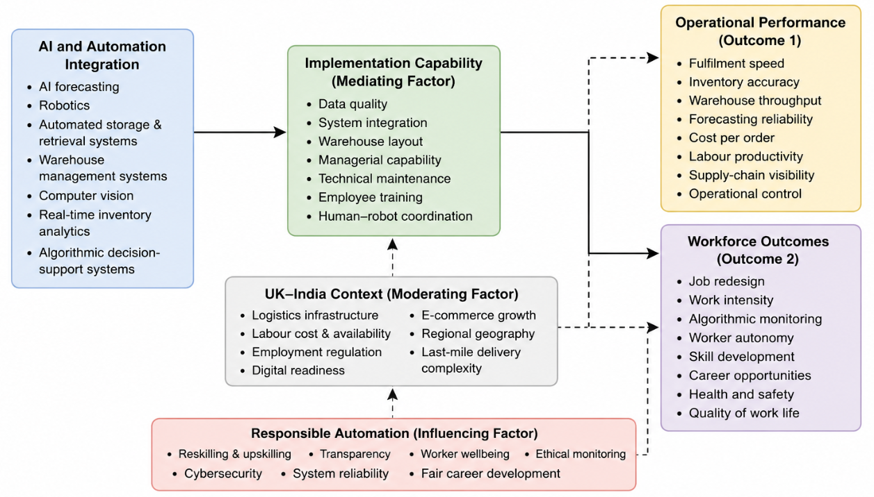
Figure 5: Conceptual Framework
(Source: Self-generate)
The figure 5 shows the conceptual framework, which was developed by synthesising a plethora of evidence found in the key literature sources that have been selected for this study. The diagram has been developed with the aid of draw.io tool. Recurring themes, concepts and relationships regarding AI/Automation Integration and operational performance has mainly been focused on this process.
The choice and positioning of each construct have been based on the integration of the theoretical perspectives mentioned above, such as STS Theory, Dynamic Capabilities Theory, and TOE model, combined with the empirical evidence of how AI-driven warehousing impacts organizational and employee performance. As a result, the framework offers a literature-based conceptual basis for analysing the AI-driven warehousing approach used by Amazon in the UK and India.

2.11 Literature Gap
The literature reviewed supports the idea that AI and automation are becoming more significant in distribution networks in warehouses, especially when it comes to fulfilment speed, inventory accuracy, forecasting and operational control (Tubis and Rohman, 2023; Shamsuddoha et al., 2025). Nevertheless, the current literature tends to analyse the automation of the warehouse either in general terms, optimisation on the technical level or talk about the labour implications with no reference to operational performance. There is a dearth of literature on how an international company can adapt AI-enabled warehousing to countries with opposite poles. This leaves a distinct gap in comprehending the difference between the automation strategies of Amazon in the UK and India and how these variations inform the effectiveness of supply-chain management and the performance of workers. Thus, the research purpose is reasonable as it bridges the gap of technology integration, operational impact and workforce experience in a comparative case study between the UK and India.

2.12 Chapter Summary
This chapter has discussed the literature on AI-warehousing, automation, performance of the supply chain, industry benchmarking, Amazon fulfilment model, context-specific issues between UK and India, workforce issues and implementation risk. This shows that although automation can be used to improve the speed of fulfilment and inventory visibility, the advantage of automation lies in the ability of implementation, the market conditions and responsible workforce management. One other gap identified in this chapter is that of comparative study of AI-warehousing at Amazon in both the UK and India. This gap will provide the basis for the methodology chapter, which discusses the way in which the research aim will be investigated through secondary data.

Chapter 3: Research Methodology

3.1 Chapter Overview
The current chapter describes the research methodology which was applied to examine the way in which artificial intelligence (AI) and automation could be utilized in the supply chain strategies of Amazon in the United Kingdom and India. This chapter contains details about research philosophy, research approach, research strategy, methodological considerations, data collection procedures, as well as inclusion and exclusion criteria, database screening with PRISMA, and data analysis procedures, all of which contribute to ensuring the validity, reliability, and ethical considerations. At the same time, this chapter also acknowledges the methodological limitations which may affect the findings of the study. All these methodological considerations make up a system of methods.
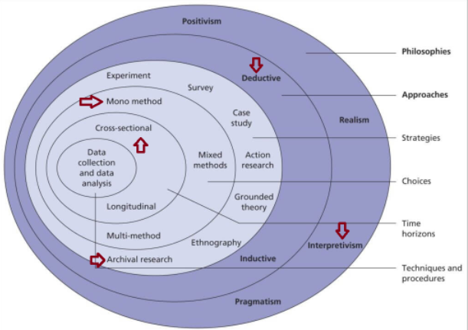
Figure 6: Saunder’s Research Onion
(Source: Saunders et al., 2023)
Figure 6 shows the methodological choices are shown with the application of the Saunder’s onion framework. The various layers of the research onion model would be presented in the following section.

3.2 Research Philosophy
Philosophy of research refers to a basic system of beliefs underlying the creation, interpretation, and use of knowledge in a research study. It is based on two dimensions: ontology that refers as what is going on and epistemology that refers to how does one know what is happening (Saunders et al., 2023). Philosophical Perspective influences the methodology used, as well as the results analysis. The figure 6 shows the research strategy selected as per the research onion.
There are three types of research philosophy; such as positivism, interpretivism and realism. The interpretivism has a relativist ontological basis that the world is socially constructed and a subjectivist epistemological basis that knowledge is acquired via interpretation of meanings, experiences, and contexts (Saunders et al., 2023).
This research adopts interpretivism research philosophy and a relativist study of being approach combined with a subjectivist epistemological approach to be able to gain a qualitative understanding of the role of AI and automation in Amazon's Supply Chain in the UK and Indian warehouses. This philosophy is appropriate as it supports to understand the different interpretation of supplier related cost and schedule problems rather than assume risk process. The reality can be measured through the qualitative relationship as the research is not testing the statistical relationships but rather interpreting the organisational practice and differences of the two national contexts (Saliya, 2023); therefore, this is the best philosophical position to meet the research objectives and to facilitate meaningful comparisons between the two national contexts is that of interpretivism.

3.3 Research Approach
Research approach is the explanation of the relationship between existing theory and the data in the research process; it is also the explanation of how the data is obtained in the research process (Bergmann, 2023). It assists in determining if research begins with a theory that is already established and tested, or if a theory is developed from a study through data collection. There are two types of approach; Deductive and Inductive.
The deductive approach starts with the existing theories, draws hypotheses, and tests them using quantitative data. It is quite common in research to test theoretically derived relationships in a statistical manner (Taherdoost, 2022).
The study has adopted an inductive approach as the study will involve qualitative secondary data sources on the impact of AI and Automation in the supply chain of Amazon within the UK and India. This is ideal for exploratory, qualitative research that needs to be interpreted within context as it addresses patterns and themes from the existing data and relating to robotics, warehouse automation and workforce changes and supply chain performance in the UK and India. The research does not seek to test specific hypotheses but rather seeks to discover emerging themes and differences in context as found in academic literature, industry reports, and organisational documents (Gamage, 2025). Therefore, by using the inductive approach, the researcher has the flexibility to gain in-depth knowledge of the research question and can gain comprehensive knowledge.

3.4 Research Strategy
A research strategy defines the manner in which evidence is systematised and analysed in order to answer the research questions in a specified empirical setting. The given study is based on a comparative case-study approach, with Amazon as its centre of interest and warehousing business in the UK and India as the contrasting countries. When organisational practices have to be studied in the context of the environmental conditions of their application and not in isolation, it is proper to use a case-study approach (Cheong et al., 2023).
The comparative design is based on the fact that Chapter 2 identified the infrastructure maturity, labour-market conditions, regulatory expectations, digital readiness and development of e-commerce as issues affecting AI-enabled warehousing. These aspects give a contextual foundation of comparing the application of automation and AI by Amazon in these two markets. The analysis does not present the UK and India as two totally different cases instead, it compares both in terms of constant dimensions: technology adoption, fulfilment and inventory performance, organisational implementation capability, workforce conditions and skills requirements. This framework allows identifying similarities and differences in a systematic manner, without assuming that the same technologies produce the same results under various operating conditions. The plan thus ties up the conceptual arguments formulated in the literature review with the secondary evidence analysed in Chapter 4. It enables the interpretation of warehousing practices of Amazon in connection with the performance of operations, the circumstances of implementation, and the implication on the workforce in two opposing national settings.

3.5 Methodological Choice
Methodological choice is to choose the type of data and research methods used to fulfill the goals of the research. It determines whether numerical evidence, non-numerical evidence, and a combination of both is used in the study. There are three major methodologies to be considered: quantitative, qualitative, and mixed methods.
The type of research that investigates the relationship between variables using surveys, experiments, or secondary numerical data is quantitative research. Mixed methods are used to gather more complete data, are more time-consuming, and require more resources (Cheong et al., 2023). Qualitative research, on the other hand, focuses more on meaning, behaviour, organizational practices, contextual factors all of which can be studied using interviews, document analysis, case studies and secondary data from the authenticated sources.
This study employs a qualitative approach, specifically a Systematic Literature Review (SLR), to explore how Artificial Intelligence (AI) and Automation are being adopted in Amazon's warehousing supply chain strategies in the UK and India. As of Cheong et al. (2023), the study has been conducted by identifying themes, the study compares operational best practices and develops a detailed understanding of the best practices, based on peer-reviewed journal articles, industry reports, and organization documents, to achieve the research objectives.

3.6 Data Collection
Data collection involves the process of collecting data that support to addressing the research goals and answering the research questions. Depending on the research design and methodological needs of the research, data may be gathered from either primary or secondary sources.
As of Ratajczak et al. (2025), secondary data collection, however, involves analysing published data to examine the already existing knowledge from a reliable source of research and practice data that the researcher may have access to. It is particularly appropriate for systematic literature reviews and comparative case studies. The study has a secondary data collection since it includes a qualitative Systematic Literature Review (SLR) to examine the role of artificial intelligence and automated warehousing supply chain strategies in Amazon's supply chain strategies in the UK and India. Sources have been procured from peer-reviewed journal articles, industry reports, well-known academic databases such as Google Scholar, ScienceDirect, Emerald Insight, Springer, Wiley, MDPI, and EBSCO, and company reports and government publications (Dubey and Kothari, 2022). They can provide detailed and accurate evidence to analyse the practices of organizations, the technology being used, and the variations in context for the research objectives.

3.7 Data Collection Strategies
The data collection strategy linked the research questions and Chapter 4 analysis. A qualitative Systematic Literature Review (SLR) found evidence on AI-enabled warehousing and the operations of Amazon supply-chain. Key themes such as AI, automation, warehouse robotics, inventory performance, algorithmic management, workforce impacts and UK-India differences, were reflected in search terms.
The keywords were artificial intelligence, automation, warehouse robots, Amazon fulfilment centres, inventory management, algorithmic management, Amazon UK logistics and Amazon India fulfilment. Key search term:
Artificial Intelligence" OR AI OR automation OR robotics) AND (warehouse OR warehousing OR inventory management) AND (supply chain" OR logistics OR fulfilment) AND (efficiency OR performance OR inventory accuracy)
Other searches were Amazon, UK, India, workforce, skills, infrastructure and regulation. Assessment of records was then done based on the predefined inclusion and exclusion criteria.

3.7.1 Inclusion and Exclusion Criteria
The inclusion and exclusion criteria are predefined when selecting the studies. The literature and research covered are limited to peer-reviewed journal articles, to English-language publications and to credible industry and government reports published between the year 2021 and 2026; but seminal studies, where these are necessary to the development of theories, are included all are mentioned in table 2. The literature should be directly relevant to one of the following: AI, Automation, Warehousing, Amazon's fulfilment operations, Supply chain management, Logistics, or Comparative evidence relevant to the UK and India.
Table 2: Inclusion and Exclusion Criteria
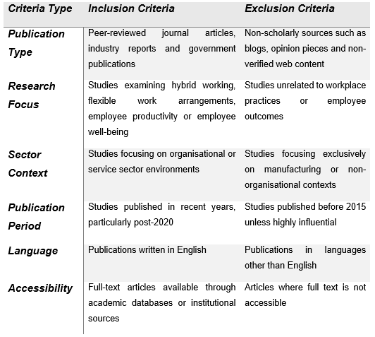

3.7.2 Database Selection and Screening through PRISMA
The literature search is done on the well-known databases such as Google Scholar, ScienceDirect, Emerald Insight, Springer, Wiley, MDPI, and EBSCO, as well as some industry and government publications. This is because the databases can provide access to peer-reviewed research in the areas of supply chain management, logistics, artificial intelligence, and automation.
To ensure the process of screening for the study is transparent and reproducible, Preferred Reporting Items for Systematic Review and Meta-Analysis (PRISMA) guidelines are followed. The four steps of PRISMA are: identification, screening, eligibility, and inclusion. Titles and abstracts are checked against the eligibility criteria prior to removing duplicate documents, seen in figure 7. Then all articles that meet the selection criteria, which are suitable to be published as full-text articles, are reviewed for inclusion in the final review. The use of PRISMA improves the transparency, decreases the selection bias, and increases the reliability and credibility of the systematic literature review.
PRISMA Flow Diagram
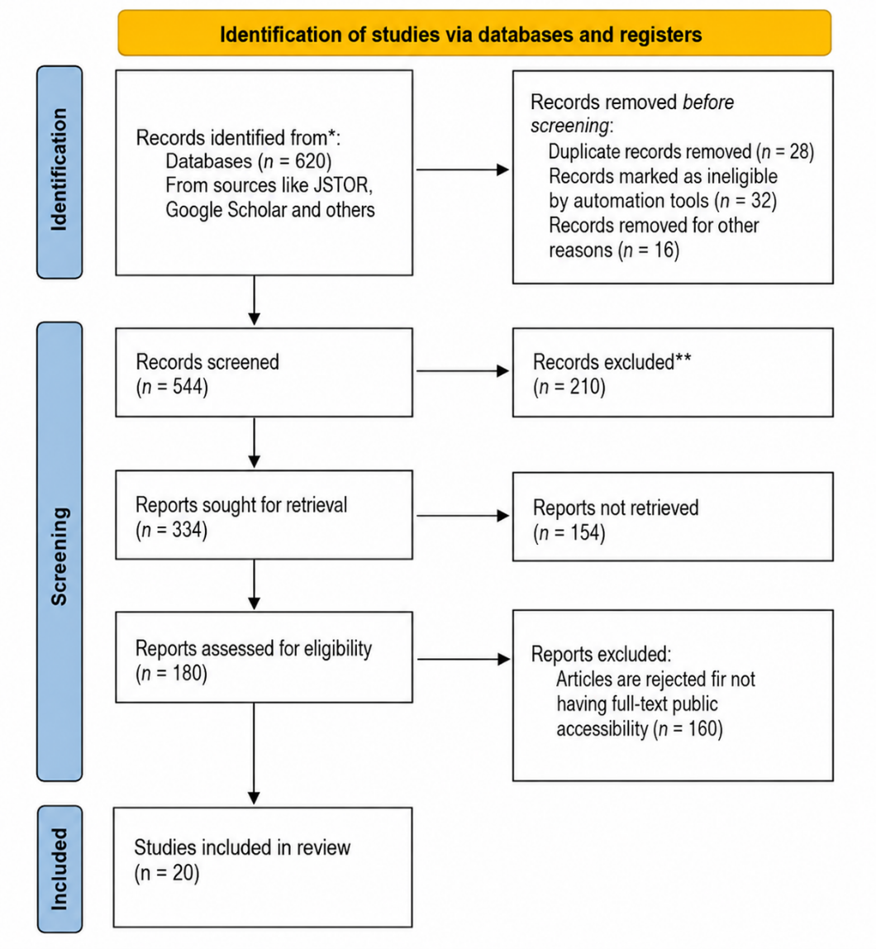
Figure 7: PRISMA Flowchart
(Source: Self-generated)

3.8 Data Analysis
Data analysis is the systematic way of analysing and interpreting collected data to answer the research questions. This study is a qualitative Systematic Literature Review (SLR), so the themes are developed and analysed in the literature selected in this study, using thematic analysis. The evidence is then coded and organized in themes: 'Adopting AI', 'Automating Warehouses', 'Improving Operations', 'Labor Impacts', 'Fulfilment Outcomes', and 'Contextual Variations between Amazon's UK and India'. Evidence is grouped together, and contrasting evidence is contrasted to establish similarities and differences (Denscombe, 2025). In practice, documents were reviewed for recurring references to robotics, AI-enabled decision-making, warehouse productivity, employee displacement and operational efficiency. These were initially coded separately before being compared across UK and Indian evidence. The themes from the interpretation are then combined with the existing literature to form comprehensive insights on Amazon's warehousing strategies. Therefore, thematic analysis is a powerful and transparent method that is suitable for sensible interpretation of qualitative data, directly addresses the aims of the research, and is comparative in nature.

3.9 Validity and Reliability
Validity and reliability are significant to ensure the results of the research are trustworthy and of high quality. Qualitative SLR has two facets of validity: capturing the evidence as relevant to the research goals; and capturing the research process in a way that would enable a similar research process to yield similar results capturing the research process in a way that would enable a similar research process to yield similar results.
The validity of the sources used in this study has been further enhanced by only using peer-reviewed journal articles, credible industry reports, government publications, and Amazon corporate documents, which directly discuss the issues of artificial intelligence, automation, warehousing, supply chain management, and Amazon's operations in the UK and India. High quality and relevant evidence are synthesized due to the clear and precise inclusion and exclusion criteria (Denscombe, 2025). Besides, data were sourced from well-known academic databases and systematically screened based on the PRISMA framework, which helps to minimize selection bias and enhance the credibility of the review.
Increasing the reliability is achieved by using a search strategy that is transparent and replicable, predetermined keywords, and screening and systematic thematic analysis. As o Dhakal et al. (2024), the documentation of the search process, the selection of the databases, and the coding procedures allows other researchers to follow the same methodological steps. Combined, these measures help to minimize researcher bias, standardize the type of evidence included and how it is interpreted, and boost general trust in the results. The procedure thus guarantees that the research output is credible, reliable, and academic in relation to the research goals.

3.10 Ethical Consideration
The ethical standards are maintained during the research activities in a responsible, transparent, and with academic integrity. As this is a secondary study, informed consent, anonymity, and confidentiality would not be issues as they would be in a primary study, as there are no humans involved in this study (Sreekumar, 2023). However, ethical practices are present at all stages of research. All sources of information are easily accessible, and credible sources of information are used, such as peer-reviewed journal articles, company reports, government documents, and good industry reports. Citation is used consistently, and referencing is appropriate to recognize other authors and to avoid plagiarism. Selection and interpretation of evidence are objective to minimize researcher bias and avoid distorting evidence. Furthermore, literature has been included based on predetermined and predefined criteria for inclusion and exclusion, and this guarantees the transparency and balance in the selection of evidence. Adhering to the research ethics guidelines from the university and the accepted academic norms further increases the credibility, integrity, and trustworthiness of the systematic literature review and results.

3.11 Methodological Limitations
The method chosen would provide an orderly and systematic approach to the procedures, but there were several things to be noted as limitations. The study only looks at secondary data, and therefore, potential insights into the organizations that would have been available through primary data, were not available. According to Bisaria et al. (2026), access to and availability of appropriate published evidence may also impact the comprehensiveness of findings. Furthermore, the findings of this study might not be easily applicable to other organizations and locations due to the focus of this study being on the Amazon warehouse operations in the UK and India. The systematic literature review ensures the credibility, reliability, and academic quality of the results.

3.12 Chapter Summary
In this chapter, the methodological framework of this research study was presented. It showed various layers of the Saunder’s onion model and the choices as per the provisions. The chapter also acknowledged the limitations of the method; therefore, it would provide a solid base for the subsequent analysis and discussion on the findings of the study.

Chapter 4: Findings and Analysis

4.1 Introduction
This chapter summarises the results of the secondary qualitative analysis of relevant academic research studies on AI and automation in warehousing. The evidence is sorted by research questions and the identified coding framework using thematic analysis. The findings are compared critically to discuss the operational, labour and technology-related aspects of the warehouse automation strategies adopted by Amazon in the UK and India and the implications of this.

4.2 Evidence Extraction and Synthesis of Selected Studies
The articles found in Table 3 form the core of the academic evidence that is kept after the search, selection and screening process outlined in the previous chapter. Every single one of the selected articles was analyzed according to the same structure for evidence extraction, which considered the author, publication date, subject matter, concept, methodology and results in relation to the research questions. The table was prepared so as to provide an audit trail between the selected literature and the following qualitative analysis, and not to serve as a descriptive bibliography. The concepts uncovered in Chapter 2, such as automation of warehouses, optimization of inventory, operational performance, algorithmic management, adjustment of the workforce and differences in context, directed the process of evidence extraction.
Table 3: Evidence Extraction and Synthesis of Selected Studies
Index (Article) | Authors | Year | Title | Key themes or Keywords | Research method | Main findings
1 | Sarkar | 2026 | Artificial Intelligence-Enabled E-Commerce Systems and Automated Warehousing: Economic Effects from Amazon FBA in the U.S. Market | AI-enabled e-commerce, Amazon FBA, automated warehousing, robotics, inventory optimisation, productivity. | Mixed-Methods secondary research on Amazon FBA, economics, and warehouse automation using AI technology. | The use of AI in the warehouse increased efficiency and accuracy in stock management as well as delivery speeds, while at the same time increasing competitiveness among small companies.
2 | Spilda et al., | 2024 | Fairwork Amazon Report 2024: Transformation of the Warehouse Sector through AI | Algorithmic management, warehouse labour, AI monitoring, worker wellbeing, fairness, automation. | Qualitative fairwork assessment through workers' testimony, company records, and labor standards evaluation. | Though AI made operations more efficient, worker surveillance, performance pressure, and algorithmic control became even stronger. Transparency, stakeholder involvement, and responsible use of AI technology were advised to ensure the right balance between production and workers' welfare.
3 | Hamilton et al., | 2024 | Adding External Artificial Intelligence into Internal Firm-Wide Smart Dynamic Warehousing Solutions | External AI, smart warehousing, sustainability, enterprise integration, decision support, interoperability. | Conceptual framework backed by case study analysis on AI integration externally. | Inclusion of AI from external sources enhanced prediction capabilities, visibility of inventory, warehouse efficiency, and decision making. Implementation of such systems required adequate measures related to cybersecurity, interoperability, governance and organizational readiness.
4 | Ozturk | 2024 | The Impact of AI on International Trade: Opportunities and Challenges | International trade, AI, logistics, competitiveness, digital economy, supply-chain optimisation. | The literature review and policy analysis of artificial intelligence use in international trading systems. | AI helped improve logistics efficiency, customs clearance, and competitiveness in trade. Some of the issues included regulatory disparity, cyber security threat, labor displacement, and disparity in technological use.
5 | Bhuvaneswari et al., | 2025 | Artificial Intelligence in Supply Chain Management: A Strategic Tool for Efficiency | Supply chain management, predictive analytics, logistics, inventory management, automation, efficiency. | Conceptual review synthesising AI applications across supply-chain functions. | The use of AI brought about better forecasts, procurement, inventory optimization, and logistics coordination. Companies needed high-quality data, digitization, and staff training for successful implementation.
6 | Rajendran et al., | 2025 | Enhancing Accuracy and Efficiency in Physical Count Processes: Leveraging AI, IoT, and Automation for Real-Time Inventory Management in Supply Chain | AI, IoT, RFID, inventory accuracy, warehouse automation, real-time monitoring. | Conference research advocating for an AI-IoT inventory framework based on practical applications. | Integration of AI with the Internet of Things and Radio-Frequency Identification greatly improved inventory management in terms of accuracy, efficiency, and decision-making time.
7 | García et al., | 2025 | Identifying the Key Vulnerabilities in the Warehouses of the Future | Warehouse resilience, cybersecurity, automation, AI, digital vulnerabilities, operational risk. | Industry research at MIT using expert interviews and systems and organisational analysis. | Smart Warehouses increased productivity yet raised concerns about cyber security risks, reliance on technology and possible vulnerabilities. Risk management and building organizational resilience became key issues to address.
8 | Sharma | 2023 | Impact of Automation on Retail Logistics: AI-Powered Solutions for Efficient Supply Chains | Retail logistics, AI, robotics, predictive analytics, transportation optimisation, warehouse management. | Conceptual review discussing AI-enabled logistics technology and warehouse automation. | Logistics via artificial intelligence resulted in decreased delivery time, increased efficiency in warehouses, higher satisfaction among customers, and increased responsiveness of supply chains. The high cost of implementation and adjustment among workers was a major organisational issue.
9 | Prasad | 2025 | Enhancing Transportation and Warehousing Consolidation Management through Technology Integration | Transportation integration, warehouse consolidation, AI, logistics coordination, digital platforms, optimisation. | Conceptual analysis of conference by logistics integration case studies. | The integration of technology in transportation planning, warehouse consolidation, inventory coordination, and customer service responsiveness was facilitated by this innovation. Information sharing in real time made the supply chain more efficient and cost-effective.
10 | Mohsen | 2023 | Impact of artificial intelligence on supply chain management performance | Artificial intelligence, supply chain, predictive analytics, warehouse automation, inventory optimisation, logistics. | Literature review on the use of AI within supply chain management through the Scopus database. | AI brought about better efficiency in operations by improving prediction, inventory management and warehousing. The sustainability of this project hinged on organizational commitment, competent workforce, IT infrastructure, and sound data management systems.
11 | Mohan Banur et al., | 2024 | Integration of Robotics and Automation in Supply Chain: A Comprehensive Review | Robotics, warehouse automation, Industry 4.0, autonomous mobile robots, logistics, productivity. | Comprehensive literature study on robotics and automation in supply chain processes. | Robotics improved the efficiency in warehouses, increased accuracy in orders, and improved material handling and employee safety. The barriers in adopting robotics included high costs of investment, difficulty in maintenance, employee training, and integration of systems; nonetheless, robotics was key to future intelligent supply chain processes.
12 | Bajpai et al., | 2023 | A Study on the Impact of Artificial Intelligence on Traditional Grocery Stores in India | Artificial intelligence, grocery retail, digital transformation, customer service, inventory management, competition. | Research that utilizes quantitative descriptive analysis and surveys. | AI enhanced inventory management, pricing, and customer service while creating competition against traditional grocery stores. The suggestions made were about digital adoption, employee development, and government backing for sustainability in competitiveness in changing retail markets.
13 | Malik et al., | 2025 | AI Markets and Competition in India | AI markets, competition policy, digital economy, governance, innovation, regulation. | Research on policy involving market research, economic evaluation, and regulation examination. | AI has driven innovation and productivity but contributed to higher market concentration amongst the dominant technology companies. Proper regulation, proper governance, proper infrastructure investment, and responsible data management was necessary for fostering competition and economic growth.
14 | Naumann et al., | 2023 | Literature Review: Computer Vision Applications in Transportation Logistics and Warehousing | Computer vision, logistics, warehouse automation, inventory monitoring, object detection, visual analytics. | Literature review focusing on computer vision technology in logistics and warehousing. | Improvements in computer vision have helped with inventory tracking, quality assurance, safety measures, and autonomous navigation. Some difficulties faced during implementation were issues regarding data quality, computation requirements, privacy concerns, and complexities in integration within warehouses.
15 | Dunn et al., | 2024 | Deep Reinforcement Learning for the Picker Routing Problem in Warehousing | Deep reinforcement learning, picker routing, warehouse optimisation, order fulfilment, intelligent algorithms. | Simulation models that apply reinforcement learning in warehouse settings. | The use of reinforcement learning led to a reduction in distances traveled by pickers as well as increasing the efficiency of order fulfillment. The application of this learning method entailed the provision of computation power and scalability.
16 | Cannas et al., | 2024 | Artificial Intelligence in Supply Chain and Operations Management: A Multiple Case Study Research | Artificial intelligence, operations management, supply chain, decision support, digital transformation, predictive analytics. | Multiple-case qualitative research in organizations adopting AI in their processes. | Advances in forecasting, production scheduling, warehousing, and customer service became possible due to AI. For organisational success, dedication of leadership, abilities of workers, collaboration across functions, quality of information, and alignment of strategies were essential.
17 | Ferreira and Reis | 2023 | A Systematic Literature Review on the Application of Automation in Logistics | Logistics automation, Industry 4.0, robotics, AI, warehouse efficiency, digital logistics. | Synthesis of scientific literature on automation within logistics systems. | However, automation increased productivity, accuracy of inventories and efficiency of transport. Costs of investment, organisational opposition, inter-operability and development of the workforce were always among the major obstacles.
18 | Lorenz et al., | 2025 | Picking Operations in Warehouses with Dynamically Arriving Orders: How Good Is Reoptimization? | Warehouse picking, dynamic orders, optimisation, fulfilment efficiency, reoptimization, logistics. | Mathematical optimization and computational modeling of warehouse picking techniques. | Reoptimization helped to enhance the effectiveness of pickers while decreasing the distances travelled and increasing the ability to respond to changing demands by customers. Intelligent optimization outperformed static approaches in warehouse activities.
19 | Tubis and Rohman | 2023 | Intelligent Warehouse in Industry 4.0-Systematic Literature Review | Intelligent warehouse, Industry 4.0, AI, IoT, cyber-physical systems, digital transformation. | A systematic literature review on technologies supporting smart warehouses. | Technology innovations like AI, IoT, robotics, cloud computing, and cyber-physical systems have revolutionized warehouses into integrated digital ecosystems. Some of the integration problems experienced were interoperability, cybersecurity, workforce readiness, and technology management.
20 | Hossain | 2025 | Smart Inventory and Warehouse Automation for Fashion Retail | Smart inventory, fashion retail, AI, RFID, IoT, predictive analytics, warehouse automation. | Technical research suggesting an inventory management system with AI, based on industrial data. | Better demand forecasts, replenishment decisions and improved warehouse operations became possible due to advanced inventory systems. It was important to create the digital infrastructure, ensure cybersecurity, collect reliable data, train employees and invest in technology.

4.3 Research Question-Based Coding and Findings
The results obtained from Section 4.2 have been categorized according to the three research questions. Repeated results have been initially coded and categorized into broader subthemes to allow for consistency across the chosen studies. RQ1 is related to the development of AI and automation, RQ2 deals with performance and supply chain management, and RQ3 looks at the differences between the UK and India.
4.3.1 Development and Application of AI and Automation in Amazon Warehousing
Selective Code | Axial Codes | Open codes | Authors
AI warehouse evolution | Automation adoption | Robotics integration, warehouse automation | Sarkar (2026); Tubis and Rohman (2023); Ozturk (2024); Bajpai et al., (2023); Dunn et al., (2024); Lorenz et al., (2025)
AI warehouse evolution | Intelligent technologies | AI forecasting, smart inventory | Hamilton et al., (2024); Cannas et al., (2024); Prasad (2025); Mohsen (2023); Ferreira and Reis (2023)
The evidence base for this thematic analysis is presented in the above table, indicating methodological approaches, main themes and key findings of the selected studies. The secondary qualitative analysis revealed that the use of AI and automation has revolutionized the distribution networks in Amazon's warehouses, as technology continues to evolve and integrate into their operations. The secondary qualitative analysis indicated that Amazon's warehouses distribution network has changed. But the top two most prevalent types of automation found were warehouse automation and robotics integration. This will contribute to improving the speed at which orders are fulfilled, improving the accuracy of stock and boosting operational productivity in the fulfilment centre. Sarkar (2026) suggests that AI in warehousing boosts economic results by improving productivity and optimising inventory, whereas Tubis and Rohman (2023) consider Industry 4.0 technologies as the foundation for a smart warehouse environment.
Also, as pointed out by Ozturk (2024), automation by way of AI assists in making logistics competitive, and it is affected by the regulatory and infrastructural factors. As such, intelligence routing and warehouse automation assist in getting rid of inefficiencies in the logistics chain while catering for the demands of various customers, according to Bajpai et al., (2023); Dunn et al., (2024); Lorenz et al., (2025). Also, the application of advanced technologies, including artificial intelligence forecasting and intelligent inventory management, is crucial in defining the company's supply chain strategy. Even though there are implementation difficulties, Cannas et al., (2024), Prasad (2025), Mohsen (2023) and Ferreira and Reis (2023) state that predictive analytics, real-time visibility of inventory and use of digital platform allow making strategic decisions, increasing the warehouse flexibility and ensuring operational sustainability in the future. Hamilton et al., (2024) note the importance of preparedness of organizations to cooperate, and Ozturk (2024) points to differences between markets in terms of regulations and technology.
4.3.2 AI-Enabled Operational Performance and Supply-Chain Control
Selective Code | Axial Codes | Open codes | Authors
AI operational performance | Inventory optimisation | Inventory accuracy, real-time visibility | Rajendran et al., (2025); Hossain (2025); Bhuvaneswari et al., (2025); Naumann et al., (2023)
AI operational performance | Supply chain optimisation | Fulfilment speed, operational control | Sarkar (2026); Sharma (2023); Cannas et al., (2024); Hamilton et al., (2024)
AI warehouse evolution and automation adoption and intelligent technologies are identified as key patterns in the evidence from the coding analysis, as reflected in the above table. Based on the secondary qualitative analysis, it has been concluded that Amazon has implemented AI-powered warehousing solutions to improve its operations. This involves using intelligent inventory management and optimisation of supply chains at its fulfillment centers. But how AI can power inventory accuracy through automated stock identification, predictive replenishment, and real-time visibility is proven time and time again. This is reducing the gap between processes and helping to optimise warehouse workflow. Rajendran et al., (2025) also emphasize on the role of AI in complementing IoT solutions for accurate physical counts and enhanced inventory visibility, while Hossain (2025) highlights the value of demand forecasting and reordering decisions. Rajendran et al., (2025) and Bhuvaneswari et al. (2025) link AI to better inventory accuracy and optimization, but Hamilton et al., (2024) notes that this requires interoperability and readiness. In a similar vein, Naumann et al., (2023) pointed out the potential of computer vision for improving the accuracy of warehouse operations and inventory management through automated inspection processes.
Besides, AI plays a vital function in the supply-chain optimisation, impacting quicker order fulfillment and better visibility in operations. On the other hand, while automation boosts productivity and optimizes warehouse fulfilment, intelligent logistics coordination reduces delivery times, as noted by Sarkar (2026) and Sharma (2023), respectively. Furthermore, cannas et al., 2024, suggest that AI contributes to better forecasting, warehouse coordination and decision-making for operations. Therefore, Hamilton et al., (2024) critically discuss the operational advantages that rely on a range of other factors, such as organisational preparedness, cybersecurity, interoperability and good governance. This indicates that sustainable performance enhancement is not just a matter of technology in the global marketplace.
4.3.3 UK–India Differences and Workforce Implications
Selective Code | Axial Codes | Open codes | Authors
Workforce implications | Worker conditions | Algorithm monitoring, performance pressure, workplace safety, labour intensity | Spilda et al., (2024); Cannas et al., (2024); Mohan Banur et al., (2024); Tubis and Rohman (2023)
Workforce implications | Career opportunities | Skill development, technical upskilling, digital roles, technology adoption | Sarkar (2026); Bhuvaneswari et al., (2025); Hamilton et al., (2024); Sharma (2023); García et al., (2025); Malik et al., (2025)
The evidence has been grouped into two main clusters: inventory optimisation, and supply-chain optimisation, as explained in the table above. Based on the analysis of the collected data, the secondary qualitative analysis indicates that Amazon is adopting AI-driven warehousing solutions to improve its operations. The secondary qualitative analysis suggests a recurring theme of workforce implications, a key differentiator between Amazon's workforce implications in the UK and India. Rajendran et al., (2025) and Bhuvaneswari et al., (2025) link AI to enhanced inventory accuracy and optimisation, but Hamilton et al., (2024) point out that this requires interoperability and organisational readiness. The evidence indicates however that highly automated UK fulfilment centres employ algorithmic monitoring and performance metrics to drive performance efficiency, whereas Indian fulfilment centres are more humanised, given the availability of labour and diversity of infrastructure. Thus, the nature of the work is different in the two contexts. For enhancing challenges in workplaces, Spilda et al. (2024) propose to use algorithmic management to create more pressure. As a result, Cannas et al. (2024) argues that there is a need for support and participation from the organisation to implement effective AI to reduce the challenge of work. This compliments the socio technical approach used in Chapter 2, that technological performance must be considered in conjunction with worker autonomy and job quality.
Mohan Banur et al., (2024) and Tubis and Rohman (2023) highlight that robotics, and intelligent warehouse technologies have the potential to improve safety conditions in the work environment while intensifying the need for technological solutions and simultaneously decreasing repetitive manual tasks. There are also some differences in the career prospects of the two markets. Sarkar (2026), and Bhuvaneswari et al., (2025) state that greater adoption of AI has resulted in a greater demand for technical skills, digital competencies, and lifelong learning. Similarly, Hamilton et al., (2024), Sharma (2023), García et al., (2025) and Malik et al., (2025) find that extending automation leads to the development of specialised digital careers. This also requires a business development investment in organisational skills development, technology preparedness as well as future work-readiness throughout the business development process.

4.4 Thematic Analysis
The following section presents the illustrative demonstration of the theme development process form the key pieces of literature that were selected in the SLR. The themes were developed form recurring patterns/clusters that were identified from the literature.
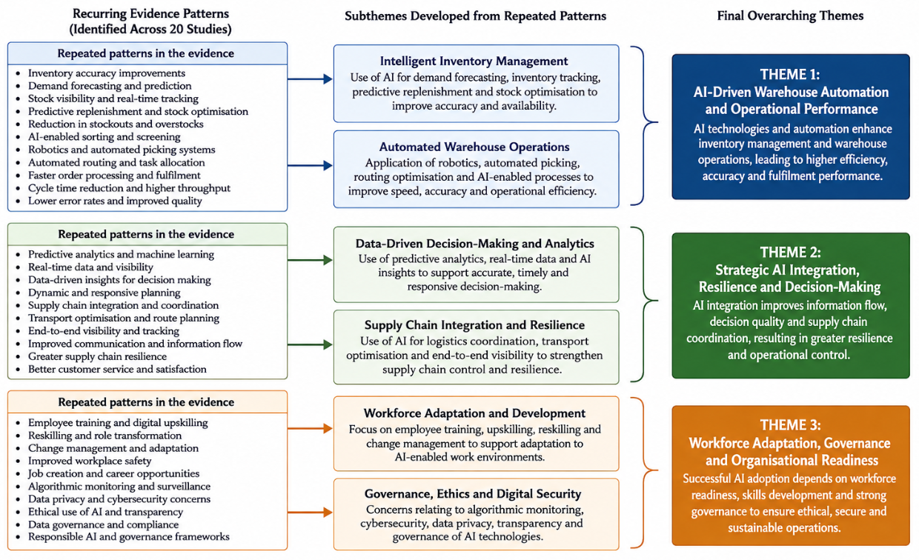
Figure 8: Development of Final Themes from Recuring evidence patterns
Figure 8 above clearly illustrates how the consistent patterns identified in the selected studies have been aggregated into subthemes and later refined into three broad themes. From the process shown above, it is clear that the themes are not pre-defined but are obtained from consistent patterns of evidence related to operations, strategic integration of AI, and adaptation of the workforce. This theme structure forms the foundation of our analysis, starting with Theme 1 below.

Theme 1: AI-Driven Warehouse Automation and Operational Performance
Table 5: Theme 1 Table
Theme | Sub themes | Codes
AI-Driven Warehouse Automation and Operational Performance | Intelligent inventory management | Inventory accuracy, demand forecasting
AI-Driven Warehouse Automation and Operational Performance | Automated warehouse operations | Robotics, order picking
The findings from this theme are valuable and noteworthy as it demonstrates the potential of warehouse automation with AI to create more efficient warehouse operations, optimize inventory management and warehouse execution, depending on the context of the business operation and supply chain practices. The codes inventory accuracy and demand forecasting under the sub-theme Intelligent Inventory Management illustrate the benefits of AI in real-time inventory visibility and predictive analytics, which help minimize inventory discrepancies and make informed inventory replenishment decisions. This not only boosts responsiveness of inventory but also reduces inventory risk for stocking and stockout (Baharudin, 2023). The second sub-theme is Automated Warehouse Operations, which includes the codes of robotics and order picking, automated picking systems, autonomous mobile robots and AI-powered routing, helping to improve processing time and fulfilment accuracy. Sodiya et al. (2024), indicates that Amazon's fulfilment centres in the UK are likely to be better equipped in terms of their automation infrastructure, while the Indian ones are increasingly adopting a blend of AI with scalable automation to cater to the rapid expansion of the market, the detailed thematic analysis table shown in Appendix 1. Automation is vital, but leveraging inventory intelligence in automated warehouse systems goes a step further in the efficiency of the supply chain and fulfilment itself as of now Nweje and Taiwo (2025).
One of the most prevalent findings across the studies reviewed was the benefits of AI-powered warehouse automation for operational efficiency, inventory management, and order fulfilment. The first sub-theme, however, intelligent inventory management, emphasized the importance of AI-powered analytics in inventory accuracy and demand prediction. This helps to increase stock visibility, reduce stockout, and make informed replacement decisions. The second sub-theme was on automated warehouse operations, featuring robotics and AI for order picking to improve material flow, enhance speed and minimise error. Combined, this indicates that AI-powered automation is helping to optimise warehouse operations and enhance supply chain agility and satisfaction (Sodiya et al., 2024). This means that it is vital to have a consistent digital infrastructure, quality organisational data, integration of systems and a team with the knowledge and skills to manage complex technology if digital implementation is to be effective. Warehouse automation is not just a technological advancement, it is a strategic capability that has the power to boost operational competitiveness and long-term organisational performance in the ever-evolving ecommerce environment.
Theme 2: Strategic AI Integration, Resilience and Decision-Making
Table 6: Theme 2 Table
Theme | Sub themes | Codes
Strategic AI Integration, Resilience and Decision-Making | Data-driven decision making | Predictive analytics, real-time data
Strategic AI Integration, Resilience and Decision-Making | Supply chain integration | Logistics coordination, transport optimisation
The results show that AI in the warehouse is not just about automating tasks, but also has a role to play in strengthening the supply chain's resilience against disruptions, by assisting with logistics and decision-making. Predictive analytics and real-time data analysis point to the potential of AI in continuous monitoring, ranging from inventory levels to demand fluctuations and operational risks, all of which can lead to quicker and more informed management decisions, explored under sub-theme Data-Driven Decision Making. AI is not only improving prediction accuracy, but it also boosts an organisation's ability to respond to disruptions in the supply chain (Riad, Naimi and Okar, 2024). The codes for logistics coordination and transport optimization under the sub-theme Supply Chain Integration highlight how AI is being used to make the supply chain more efficient and less fragmented and to give more visibility throughout the supply chain. Omitoyin and Moshood (2023), suggests that Amazon UK is embracing cutting-edge AI solutions to manage its supply chain, while Amazon India continues to leverage AI to enhance its logistics network amid a dynamic market. Finally, the synthesis highlights the importance of not replacing human functions within each stage of the supply chain, but of linking various elements of the chain through AI.
The thematic analysis revealed that the strategic use of AI plays a pivotal role in the sustainability of supply chains, in the orientation and decision-making of organisations, and in building global competitiveness. The sub theme, data-driven decision making, however, had a more practical edge with predictive analytics and real-time data helping organisations to make more accurate predictions and forecasts, optimise inventory and improve their operational responsiveness. However, these features helped them make confident decisions based on facts and minimise uncertainty throughout their goods and logistics operations (Rajendran et al., 2025). The second sub theme focused on integration in the supply chain and highlighted the importance of supply chain coordination and transport optimisation in building integrated and efficient supply chains. But the synergy strengthened by AI between warehousing and transportation and inventory management, increases the efficiency of the fulfilment and responsiveness towards the customer (Hunt and Rolf, 2022). The results demonstrate that the adoption of such AI solutions by businesses is correlated with improved operational resilience, strategic agility, and competitiveness in the ever-evolving global markets. But to make it work, digital infrastructure, data quality, organisation and continued technological investment will be required to ensure the value chain is reliable in the long-term.

Theme 3: Workforce Adaptation, Governance and Organisational Readiness
Table 7: Theme 3 Table
Theme | Sub themes | Codes
Workforce Adaptation, Governance and Organisational Readiness | Workforce and organisational readiness | Employee training, change management
 | Governance and digital security | Cybersecurity, data governance
However, the findings analysed that AI has a more technological dimension, it is also about the organization and responsible governance in the warehouse. In relation to the sub-theme Workforce and Organizational Readiness, the codes employee training and change management show that the best way to implement AI is to train employees so they can work with intelligent systems is to ensure they have the right digital skills to work with intelligent systems. Johnson (2026) suggests that absence of training and the resistance to organizational changes will lead to less technology acceptance, thus less operational benefits that may be achieved by technology automation. However, continuous training and structured change management can help the effective incorporation of AI and boost the adaptability of the workforce.
The sub-theme Governance and Digital Security addresses the aspects of cybersecurity and data governance. While AI technology is increasingly being adopted, it also presents a threat of cybersecurity and algorithmic threats and data governance issues. The evidence strongly suggests that having effective cybersecurity frameworks and sound data governance practices are critical for the proper functioning of the organization, the security of data and compliance with regulations. Egwuatu (2025), reveals that, whereas Amazon UK has come up with sophisticated digital governance and regulatory measures, Amazon India continues to add to its cybersecurity capabilities, with technology progressing. The synthesis highlights the importance of fostering a harmonious mix of technological innovation, human capabilities, ethical governance, and digital security over the use of AI, rather than automation alone, to enable a transition towards sustainable use of AI. Combined, these organizational abilities make up long-term operational resilience and competitiveness.
It was found that effective implementation of AI in warehouse is not merely a technology thing, as these identified themes have indicated. In the first sub-theme, workforce and organisational readiness, it needs to be prepared in the organisation, have ethical governance, and have secure digital infrastructure. But, it was found that the shift to using AI in the operations is a process, which starts with employee training and the effective implementation of change management. This increases acceptance and guarantees that the long-term performance is adequate. Organizations that dedicated resources to training their staff were successful in incorporating technology and had a high level of operational resilience (Adesoga et al., 2024). The second sub theme, governance and digital security, emphasised the importance of cyber security and good data governance to safeguard the intricate warehouse networks from cyber threats. This helps to build trust in the AI-driven decision-making process in this instance. Good governance structures, however, foster compliance with the rules, transparency and responsible implementation of AI (Ma and Saenz, 2025). The results indicate that advanced automation technologies will not be the only factor determining Amazon's future warehousing success; building a skilled workforce will also be important. Furthermore, it will feature digital ecosystems that are secure, as well as good organisational governance for a sustainable operational development process.

4.5 Summary
The findings conclude that it illustrates in which way AI and automation can greatly improve warehouse efficiency and provide different labour outcomes in the UK versus India. However, the work has been transformed by technological progress, which enhances work performance and creates new employment opportunities. There are still issues with workers' working conditions, technological preparedness and organisational adjustment. This reinforces the literature reviewed particularly the socio-technical argument that technological benefits depend on organisational, contextual and workforce conditions.

Chapter 5: Discussion

5.1 Chapter Introduction
The findings are described in this chapter in relation to the four research objectives, rather than restating the descriptive results. The interpretation of evidence presented in Chapter 4 is informed by the evidence presented in Chapter 2 of the literature reviewed and current company, industry and policy evidence in the UK and India. The discussion thus assesses whether the patterns discerned are either supported, or qualified or challenged by the current practice, and why similar AI-enabled technologies would produce different operational and workforce outcomes in different national settings.

5.2 Discussion on Objective 1: Development and Current Application of AI and Automation in Warehouse Distribution Networks
Chapter 4 indicated that there was a transition from isolated automation to integrated, with robotics and predictive analysis, real-time inventory visibility and intelligent decision support. This is in line with the arguments of Ferreira and Reis (2023) and Naumann et al. (2023), who contend that the automation of warehouses produces higher value when the physical technologies are interlinked with information and analytical systems. This is something that Amazon is currently practicing. The company stated in 2025 that it had deployed its first million robot and introduced a new AI foundation model called DeepFleet, which has been targeted at boosting its robot travel efficiency throughout its network by 10 percent (Amazon, 2025). Not merely the magnitude of robot implementation, but the shift towards AI controlling robotic action at the network scale is important.
The development of technology is not however homogenous. The UK network of Amazon has the most automated locations, including Leeds and Northampton, where the complex robotics will aid in picking, stowing and moving the inventory (Amazon UK, 2024; Amazon UK, 2026). India is also developing at a very fast pace in the field of automation: Amazon notes that AI-based pick paths, capacity management, inventory planning and demand forecasting are used throughout its network of operation (Amazon India, 2026a). This renders any supposition of India being a technologically primitive equivalent of the UK. The distinction is more now about configurations and size than about the availability of sophisticated technology or not.

5.3 Discussion on Objective 2: Amazon as an Innovator and Employer in AI-Enabled Supply Chains
The results leave Amazon in the paradox of being both a technology pioneer and one of the largest employers, which is a conflict between productivity increase and labour accommodation. Its position of innovation can be seen in the magnitude of robotics and AI use though the impact on employment is more complicated than technological substitution. The intended investment of 40 billion in the UK in 2025- 2027 by Amazon includes new fulfilment centres and positions of robotics technicians, safety specialists and mechatronic engineers, meaning that automation can create new more technologically specialised jobs (Amazon UK, 2025a). This is in line with the argument of George (2024) that AI will be able to change jobs instead of just removing them.
But the control of work is also transformed by innovation. Chapter 4 associated algorithmic management with performance pressure and monitoring, as well as found more demanding needs of both technical skills and constant development. This is consistent with Spilda et al. (2024). The evidence provided by the UK parliamentary confirms that Amazon applies performance targets and technology into the work of the warehouse and documents disputable statements on the intensity of work and monitoring; Amazon officials believe that the targets take into account the long-term performance, training, and operational variability (UK Parliament, 2024). Job creation alone cannot thus be considered a measure of the employer role. In 2025, over 23,000 employees in the UK had gone through Career Choice, and career options such as automation engineering, data science and cyber security are available as apprenticeship (Amazon UK, 2025a). Opportunity is brought about by innovation, but its longevity relies on the capacity of developing skills that match job redesign.

5.4 Discussion on Objective 3: Operational Challenges and Technological Approaches Shaping Amazon’s Warehousing Strategies in the UK and India
The results show that the technological strategy of Amazon is influenced by the state of operation of the respective markets and not by automation. Chapter 4 found a higher automation intensity in UK fulfilment operations whereas the operations in India were driven to a greater extent by the availability of labour, diversity of infrastructure and rapid network growth. The existing evidence confirms such distinction but complicates as well. The Northampton warehouse of Amazon is a capital-intensive strategy in the UK, which has tens of millions of products on three floors of robotics where thousands of Hercules robots pick and deliver goods to the employees (Amazon UK, 2026). The broader UK context, however, is not necessarily automation-ready; the Smart Machines Strategy 2035 recognises that the uptake of industrial robots remains several steps behind other countries in terms of investment, regulatory and adoption barriers (Department for Science, Innovation and Technology, 2025). The technological advancement of Amazon is thus above the maturity level of the overall national automation environment, which proves firm level capability and not the simple advantage of the UK.
The Indian market is a different operational problem since the fulfilment needs to address a high degree of geographical diversity, fast-growing e-commerce needs and scattered delivery needs. Amazon, however, shipped the Prime members over 55 crore items on the same day or the next day in 2025, facilitated by real-time AI-based decision-making models and a growing fulfilment network (Amazon India, 2026a). Its 2025 investment included 17 fulfilment centres, six sortation centres and 75 last-mile stations and the growth of micro-fulfilment centres (Amazon India, 2026b). This is further supported by the National Logistics Policy of India, according to which the Unified Logistics Interface Platform has allowed completing over 160 crore digital transactions by August 2025 (Press Information Bureau, 2025). As a result, it is more appropriate to consider the UK–India dichotomy as a contextual adjustment, as opposed to technological advancement: UK operations are more oriented toward focused, robotics-based automation, whereas India integrates AI-based coordination with decentralized and scalable fulfilment infrastructure.

5.5 Discussion on Objective 4: Operational Efficiency, Worker Conditions, Career Opportunities and Quality of Work Life
In terms of operation, the results are consistent whereby AI is linked to better inventory accuracy, forecasting, fulfilment speed and coordination, with emphasis on the quality of data, infrastructure and organisational preparedness facilitating the benefits. Hamilton et al. (2024) also warn against considering technology implementation as enough to perform. Modern practice is supporting. Amazon noted that over 55 crore products were shipped to the Prime members in India same or the next day in 2025, and AI was used to optimise pick-path, allocate capacity and make inventory choices (Amazon India, 2026). In the UK, employees are provided with inventory by robotics-intensive facilities and unnecessary movement is minimized. These instances uphold the operational results as well as showing that network design, data, and labour are complementary resources.
The implications of workforce are less clear. Robotics have the potential to decrease lifting, walking and repetitive handling and generate engineering, maintenance and digital jobs. However, work and perceived autonomy may be enhanced by performance measurement and algorithmic monitoring, which are agreeable with Fana and Villani (2023) and Spilda et al. (2024). Response in practice varies according to context. Amazon has increased skills programmes and apprenticeships in the UK; in India, the company projected INR 2,800 crore of investment in 2026 that includes operations expansion and associate safety, health and financial wellbeing (Amazon India, 2026). Such initiatives are a sign of understanding that sustainable automation involves investing in people. But the programmes as reported by the company themselves cannot prove better quality of work life. The key question is whether training, safety and well-being controls are adequate to counter the pressures caused by monitoring, performance expectations and unending technological change.

5.6 Integrated Theoretical Interpretation
The results are in line with the integrated theoretical framework as developed in Chapter 2. The Socio-Technical Systems Theory clarifies the reasons why the advantages of automation operation rely on its engagement with employees, skills, autonomy and job design as opposed to technology per se. The Dynamic Capabilities Theory can be used to explain why Amazon remains in the investment in robotics, AI and fulfilment infrastructure as a resource adaptation mechanism to the evolving market conditions. The following TOE framework also explains why the UK and India have different levels of implementation with infrastructure maturity, labour conditions, regulation and digital readiness playing a role in adoption. Taken together, these views suggest that AI-based warehousing can only be sustained with a value when the technological ability is streamlined with organisational preparedness, labour progression and country of operation.

5.7 Chapter Summary
The discussion shows that the AI-based warehousing of Amazon creates a lot of potential in its operations, but its advantages are conditional instead of automatic. The UK and India are two variations of the same larger automation plan, which is subjected to infrastructure, labour, policy and market conditions. The sustainable advantage is thus reliant on a balance between the scale of technology and ability of the workforce, governance and responsible implementation.

Chapter 6: Conclusion and Recommendations

6.1 Overall Conclusion
This study explored the impact and role of AI and Automation in Amazon's Warehouses in the UK and India. The results revealed that benefits resulting from the introduction of robots, algorithms, an intelligent warehouse system is not only the introduction of the technical components of the system but is a reflection of the effectiveness of embedding the above components into the processes of the operational processes, capacities in the organisational system and human work, which affect the operational progress of the organisation. From this it can be concluded that AI in the warehouse might lead to better visibility, order fulfillment, forecasting and warehouse control. They require data quality, system interoperability, infrastructure, its employees' skills, and good human–technology interaction.
The second was to evaluate the innovations and job creation as Amazon has done. In addition to innovation, the study reveals that Amazon's impact is far broader than just in the technology field automation is also changing the nature of work, how it gets measured and what skills are necessary to excel at.
The UK-India comparison also shows that automation will yield different outcomes with different country conditions. Selective and hybrid approaches are more suited to India due to better infrastructure, logistic issues in the regions and better availability of labour whereas logistics maturity and labour cost is more favourable in the UK for using intensive automation. Hence, even though Amazon's technology is worldwide, these only can work within their own respective environments. The findings also suggest that automation has an impact on the employees and operations. It can minimize repetitive tasks and cause a demand for technical skills, and algorithmic monitoring can generate performance pressure and impact worker autonomy. So, the productivity of Automation is not the only measure of its effectiveness, quality and experience of work is also an important factor for success.

6.2 Linking with Objectives
The first one reflects AI and automation application in warehouse distribution networks, was on robotics, smart stock management and forecasting and algorithmic decision making. The findings show that warehouses are increasingly becoming a ‘fulfilment place', where there is a combination of physical actions and data-driven coordination.
The third aim was to make a comparison of the operational difficulties and technology used in the UK and India. The results highlight how infrastructure, labour and market parameters influence the economic and operational rationale of automation. This enables reinforcement of the fact that technologies are not easily portable from market to market.
Ultimate outcome measured operational and workforce outcomes. The findings are mixed in that automation can be used to improve the efficiency, accuracy and safety of jobs, but can also be linked to an increased need for monitoring and reskilling. Thus, the study finds that automation is more of a process of job change rather than merely a replacement of labour.

6.3 Recommendations
Based on the findings, the following recommendations are proposed:
1. Adopt context-specific automation strategies: Amazon and other companies shouldn't use the same automation model in various countries. The decisions should be based on the local infrastructure, labour conditions, complexity of digitization and fulfilment.
2. Integrate reskilling with automation investment: Training and development of staff is part of the implementation. There should be opportunities for workers to acquire technical and digital skills such as the management of equipment, and the handling of warehouse systems and exception handling.
3. Improve transparency in algorithmic management: Organisations have to make it clear how performance is measured where AI has an impact on productivity goals or performance evaluation. There should also be adequate systems in place for employees to question or challenge automated decision making.
4. Use balanced performance measures: Warehouse performance isn't measured solely by speed, throughput and accuracy of the inventory. Furthermore, employee safety, skills development, autonomy and quality of working life should be taken into account in the assessment of employee performance.

6.4 Practical and Theoretical Contribution
Theoretically the study is related to socio-technical systems theory, dynamic capabilities theory and Technology-Organisation-Environment. Combined these views provide a rationale for the influence of the interaction between technology, organisational adaptation and the external environment on the outcomes of automation. The study, therefore, contributes to the literature in establishing a link between operational performance and the human resources implications while comparing the United Kingdom and India.
To sum up, the results of this study underscore the more than just technical nature of incorporating AI into warehouses it's about strategic investments, system integration, and preparing a workforce for a future defined by innovation. Organisations have a need to ensure that technology and infrastructure, as well as workforce capacity and readiness, are aligned.

6.5 Limitations of the Research
This research does not rely on primary evidence and the first-hand accounts of Amazon employees, managers and technology specialists, is conducted in a purely secondary, qualitative approach. Information that is relevant to the operation may also be commercially confidential and analysis is also reliant upon published evidence.
Furthermore, the study results are not generalisable to other companies and countries as its main comparisons are with Amazon and with the UK and India. The study thus offers an analytical comparison based on a specific context, and not a general model of warehouse automation.

6.6 Personal Reflection
This study has given me insight into AI and automation in Warehouse Operations. At first, I was only considering using automation to boost my speed, accuracy and productivity. I knew that operational efficiency was just one aspect. All the same technologies that enhance warehouse productivity can have a similar impact on how employees monitor, load and unload, and taste, smell and feel the jobs. In addition, the analysis of both technology and the environment enabled me to gain insight into the fact that technology cannot be judged without considering the environment. I learned to appreciate the impact of infrastructure, working conditions and organisational readiness on outcomes of similar technologies by studying the UK and India.

6.7 Future Scope of the Study
Primary data gathered from warehouse workers, managers, and technology experts in the future could be used to explore impacts on job satisfaction and career progression, autonomy, and workload due to automation. Specific technologies might be considered such as autonomous mobile robots, computer vision or artificial intelligence to manage the workforce. Additional research of the kind described might also address changes in efficiency increases and work force issues over time. Comparative studies could be expanded to other ecommerce and logistics companies in the future. This would give an indication if the trends seen are unique to Amazon's fulfilment process or are a wider trend in the field of AI-powered warehouses. The study finds that the future of warehousing will not be a function of the mere replacement of humans with machines, but a function of organisations' ability to strike a balance between technological capacity and training and adapting their workforce to local operating conditions.

Reference List
Adesoga, T. O., Ajibaye, T. O., Nwafor, K. C., Imam-Lawal, U. T., Ikekwere, E. A., and Ekwunife, D. I. (2024). The rise of the" smart" supply chain: How AI and automation are revolutionising logistics. International Journal of Science and Research Archive, 12(2), 790-798. https://www.researchgate.net/profile/Tolulope-Ajibaye/publication/382452899_The_rise_of_the_smart_supply_chain_How_AI_and_automation_are_revolutionizing_logistics/links/669e64d38dca9f441b8f1191/The-rise-of-the-smart-supply-chain-How-AI-and-automation-are-revolutionizing-logistics.pdf
Alherimi, N., Saihi, A. and Ben-Daya, M., (2024). A systematic review of optimisation approaches employed in digital warehousing transformation. IEEE Access, 12, pp.145809-145831. https://ieeexplore.ieee.org/abstract/document/10683736/
Amazon (2025) ‘Amazon deploys over 1 million robots and launches new AI foundation model’, About Amazon, 30 June. https://www.aboutamazon.com/news/operations/amazon-million-robots-ai-foundation-model
Amazon India (2026a) How Amazon is building one of India’s largest, fastest, and safest operations networks. Available at: https://www.aboutamazon.in/news/operations/amazon-india-delivery-network-explained
Amazon India (2026b) Amazon India to invest over INR 2,800 crore to advance associate safety and wellbeing and strengthen its pan-India operations network. Available at: https://press.aboutamazon.com/in/2026/4/amazon-india-to-invest-over-inr-2800-crore-usd-300m-to-advance-associate-safety-and-wellbeing-and-strengthen-its-pan-india-operations-network
Amazon UK (2024) Amazon launches £500 million state-of-the-art fulfilment centre in Leeds, creating more than 2,000 new jobs. Available at: https://press.aboutamazon.com/uk/news/workplace/2024/8/new-amazon-fulfilment-centre-in-leeds
Amazon UK (2025a) Amazon announces plans to invest £40 billion in the UK. Available at: https://press.aboutamazon.com/uk/2025/6/amazon-announces-plans-to-invest-40-billion-in-the-uk
Amazon UK (2025b) Workplace at Amazon. Available at: https://www.aboutamazon.co.uk/workplace-at-amazon (Accessed: 27 August 2026).
Amazon UK (2026) Amazon invests more than £1 billion in Northamptonshire, creating 4,000 jobs. Available at: https://www.aboutamazon.co.uk/news/job-creation-and-investment/amazon-invests-more-than-1-billion-in-northamptonshire-creating-4-000-jobs
Andiyappillai, N., (2021), February. An analysis of the impact of automation on supply chain performance in logistics companies. In IOP Conference Series: Materials Science and Engineering (Vol. 1055, No. 1, p. 012055). IOP Publishing. https://iopscience.iop.org/article/10.1088/1757-899X/1055/1/012055/pdf
Babikian, J., (2023). Securing rights: legal frameworks for privacy and data protection in the digital era. Law Research Journal, 1(2), pp.91-101. https://www.researchgate.net/profile/John-Babikian/publication/377950836_Securing_Rights_Legal_Frameworks_for_Privacy_and_Data_Protection_in_the_Digital_Era/links/65be41a31e1ec12eff6f97ef/Securing-Rights-Legal-Frameworks-for-Privacy-and-Data-Protection-in-the-Digital-Era.pdf
Baharudin, H. (2023). AI in E-Commerce Warehouse Management: Enhancing Operational Efficiency, Ensuring Inventory Precision, and Strengthening Security Measures. Ensuring Inventory Precision, and Strengthening Security Measures (October 24, 2023). https://papers.ssrn.com/sol3/papers.cfm?abstract_id=5050072
Bajpai, A. R., Shitole, M. V., and Bajpai, D. A. (2023). A study on the impact of artificial intelligence on traditional grocery stores in India. The Online Journal of Distance Education and e-Learning, 11(2). https://tojqih.net/journals/tojdel/articles/v11i02b/v11i02b-24.pdf
Bergmann, J., (2023). Research philosophy, methodological implications, and research design. In At Risk of Deprivation: The Multidimensional Well-Being Impacts of Climate Migration and Immobility in Peru (pp. 57-89). Wiesbaden: Springer Fachmedien Wiesbaden. https://link.springer.com/content/pdf/10.1007/978-3-658-42298-1_3.pdf
Bhuvaneswari, L., Natarajan, S., Painoli, G. K., Kumar, R., and Rao, D. V. M. (2025). Artificial intelligence in supply chain management: A strategic tool for efficiency. European Economics Letters, 15(2), 5025-5033. https://www.researchgate.net/profile/Sundarapandiyan-Natarajan-2/publication/393050057_Artificial_Intelligence_In_Supply_Chain_Management_A_Strategic_Tool_For_Efficiency/links/685d3e1407d6d53e82eeabd9/Artificial-Intelligence-In-Supply-Chain-Management-A-Strategic-Tool-For-Efficiency.pdf
Bisaria, C., Madhubala Kumari, D.S.S. and Patel, B.K., (2026). Research methodology: Tools and techniques. BR Publications. https://dspace.unitywomenscollege.ac.in/bitstream/123456789/157/1/RESEARCH%20METHODOLOGY%20TOOLS%20AND%20TECHNIQUES%20.pdf
Cannas, V.G., Ciano, M.P., Saltalamacchia, M. and Secchi, R., (2024). Artificial intelligence in supply chain and operations management: a multiple case study research. International journal of production research, 62(9), pp.3333-3360. https://www.tandfonline.com/doi/pdf/10.1080/00207543.2023.2232050
Cheong, H.I., Lyons, A., Houghton, R. and Majumdar, A., (2023). Secondary qualitative research methodology using online data within the context of social sciences. International Journal of Qualitative Methods, 22, p.16094069231180160. https://journals.sagepub.com/doi/pdf/10.1177/16094069231180160
Das, P.K., (2026). An Analytical Study of Digital Transformation in India’s Transportation and Logistics Sector: Drivers, Policy Integration, Operational Efficiency, and Sustainability Outcomes. Saudi J Bus Manag Stud, 11(5), pp.154-165. https://saudijournals.com/media/articles/SJBMS_115_154-165c.pdf
Denscombe, M., (2025). Decolonial research methodology: an assessment of the challenge to established practice. International Journal of Social Research Methodology, 28(2), pp.231-240. https://www.tandfonline.com/doi/pdf/10.1080/13645579.2024.2357558
Department for Science, Innovation and Technology (2025) Smart Machines Strategy 2035. Available at: https://www.gov.uk/government/publications/smart-machines-strategy-2035
Dhakal, D. R., Ojha, S. K., Sharma, L. K., Dhungana, B. R., and Chapagain, R. (2024). Employee turnover intention in a service industry: a systematic literature review. Migration Letters, 21(7), 1481-1494. https://www.researchgate.net/profile/Bharat-Dhungana/publication/383838886_Employee_Turnover_Intention_In_A_Service_Industry_A_Systematic_Literature_Review/links/66ed295fc0570c21feab2d47/Employee-Turnover-Intention-In-A-Service-Industry-A-Systematic-Literature-Review.pdf
DHL (2024) ‘DHL Supply Chain continues to innovate with orchestration, robotics and AI in 2024’, DHL Supply Chain. https://www.dhl.com/us-en/home/press/press-archive/2024/dhl-supply-chain-continues-to-innovate-with-orchestration-robotics-and-ai-in-2024.html
Dubey, U.K.B. and Kothari, D.P., (2022). Research methodology: Techniques and trends. Chapman and Hall/CRC. https://amberton.edu/wp-content/uploads/2026/01/RGS6035_E1_Spring2026.pdf
Dunn, G., Charkhgard, H., Eshragh, A., Mahmoudinazlou, S. and Stojanovski, E., (2024). Deep reinforcement learning for picker routing problem in warehousing. arXiv preprint arXiv:2402.03525. https://arxiv.org/pdf/2402.03525
Dunn, G., Charkhgard, H., Eshragh, A., Mahmoudinazlou, S., and Stojanovski, E. (2024). Deep reinforcement learning for picker routing problem in warehousing. arXiv preprint arXiv:2402.03525. https://arxiv.org/pdf/2402.03525
Ebom-Jebose, A., (2025). Enhancing digital skills education for sustainable development and unemployment reduction in the digital economy. European Journal of Innovative Studies and Sustainability, 1(1), pp.24-30. https://ejiss.com/index.php/journal/article/view/4
Egwuatu, O. V. (2025). Ethical and Governance Challenges of AI in Information Systems: Toward Responsible Adoption in Enterprise Systems. https://www.researchgate.net/profile/Osita-Egwuatu/publication/395102078_Ethical_and_Governance_Challenges_of_AI_in_Information_Systems_Toward_Responsible_Adoption_in_Enterprise_Systems/links/68eae20ff3032e2b4be85dca/Ethical-and-Governance-Challenges-of-AI-in-Information-Systems-Toward-Responsible-Adoption-in-Enterprise-Systems.pdf
Fana, M. and Villani, D., (2023). Is it all the same? Types of innovation and their relationship with direct control, technical control and algorithmic management. European Journal of Industrial Relations, 29(4), pp.367-391. https://journals.sagepub.com/doi/abs/10.1177/09596801231180399
Ferreira, B. and Reis, J., (2023). A systematic literature review on the application of automation in logistics. Logistics, 7(4), p.80. https://www.mdpi.com/2305-6290/7/4/80
Gamage, A.N.K.K., (2025). Research design, philosophy, and quantitative approaches in scientific research methodology. Sch J Eng Tech, 2(1), pp.91-103. https://www.academia.edu/download/122341245/SJET_132_91_103c_published_paper.pdf
García, M. R., Betts, K., and Ponce, E. (2025). Identifying the key vulnerabilities in the warehouses of the future. MIT’s Warehouse of the Future Initiative. https://omnichannel.mit.edu/wp-content/uploads/2025/02/MIT_OmnichannelSupplyChain_WarehouseFutureVulnerabilities_2025_FullReport.pdf
Gazi, M.A.I., Al Masud, A., Yusof, M.F., Islam, M.A., Rahman, M.K. and Wang, Q., (2024). Factors affecting the quality of work life for industrial labour force: empirical evidence from a developing country. BMC psychology, 12(1), p.589. https://link.springer.com/article/10.1186/s40359-024-02073-1
George, A.S., (2024). Artificial intelligence and the future of work: job shifting not job loss. Partners Universal Innovative Research Publication, 2(2), pp.17-37. http://www.puirp.com/index.php/research/article/view/46
Gmyrek, P., Berg, J. and Bescond, D., (2023). Generative AI and jobs: A global analysis of potential effects on job quantity and quality. https://papers.ssrn.com/sol3/Delivery.cfm?abstractid=4584219
Hamilton, J. R., Maxwell, S. J., Ali, S. A., and Tee, S. (2024). Adding external artificial intelligence (ai) into internal firm-wide smart dynamic warehousing solutions. Sustainability, 16(10), 3908. https://www.mdpi.com/2071-1050/16/10/3908
Hossain, M. T. (2025). Smart inventory and warehouse automation for fashion retail. TechRxiv. https://www.techrxiv.org/doi/pdf/10.36227/techrxiv.175987210.04689809
Hossain, M.T., (2025). Smart inventory and warehouse automation for fashion retail. Authorea Preprints. https://www.techrxiv.org/doi/full/10.36227/techrxiv.175987210.04689809
Hunt, W., and Rolf, S. (2022). Artificial intelligence and automation in retail. Friedrich Ebert Stiftung. https://uniglobalunion.org/wp-content/uploads/Artificial-Intelligence-and-Automation-in-Retail_EN.pdf
Jahin, M.A., Naife, S.A., Saha, A.K. and Mridha, M.F., (2023). Ai in supply chain risk assessment: A systematic literature review and bibliometric analysis. arXiv preprint arXiv:2401.10895. https://arxiv.org/pdf/2401.10895
Johnson, O. (2026). Developing Resilient and Risk-Aware AI-Enabled Supply Chain Systems: Challenges and Opportunities. Available at SSRN 6472341. https://papers.ssrn.com/sol3/papers.cfm?abstract_id=6472341
Li, X., Cheng, Y. and Møller, C., (2024). Data governance: A Critical Foundation for Data Driven Decision-Making in Operations and Supply Chains. arXiv preprint arXiv:2409.15137. https://arxiv.org/pdf/2409.15137
Lorenz, C., Otto, A. and Gendreau, M., (2025). Picking operations in warehouses with dynamically arriving orders: How good is reoptimization?. Networks, 86(2), pp.157-173. https://onlinelibrary.wiley.com/doi/full/10.1002/net.22281
Ma, B. J., and Saenz, M. J. (2025). AI Can Improve How Humans and Robots Work. MIT Sloan Management Review, 67(1), 79-83. https://www.researchgate.net/profile/Benedict-Ma/publication/394145882_AI_Can_Improve_How_Humans_and_Robots_Work/links/68df95fa9383755fd7090537/AI-Can-Improve-How-Humans-and-Robots-Work.pdf
Malik, P., Jain, N., Kanwar, S., Das, B., and Dhadwal, S. (2025). AI Markets and Competition in India (No. 25-r-01). Indian Council for Research on International Economic Relations (ICRIER), New Delhi, India. https://www.researchgate.net/profile/Shiva-Kanwar/publication/388554003_AI_Markets_and_Competition_in_India/links/679ca76e52b58d39f25f3e6f/AI-Markets-and-Competition-in-India.pdf
Mohan Banur, O., Patle, B. K., and Pawar, S. (2024). Integration of robotics and automation in supply chain: a comprehensive review. Robotic Systems and Applications, 4(1), 1-19. https://www.extrica.com/article/23349
Mohsen, B. M. (2023). Impact of artificial intelligence on supply chain management performance. Journal of Service Science and Management, 16(1), 44-58. https://www.academia.edu/download/111666247/PaperDownload.pdf
Mordor Intelligence (2026) ‘E-commerce warehousing market size and share analysis: growth trends and forecasts 2026–2031’, Mordor Intelligence. https://www.mordorintelligence.com/industry-reports/e-commerce-warehousing-market
Nataraj, M., Taylor, P. and Briken, K., (2025). Technology and the labour process: Insights from Indian e-commerce warehouses. The Indian Journal of Labour Economics, 68(2), pp.627-646. https://link.springer.com/article/10.1007/s41027-024-00540-2
Naumann, A., Hertlein, F., DÃķrr, L., Thoma, S. and Furmans, K., (2023). Literature review: Computer vision applications in transportation logistics and warehousing. arXiv preprint arXiv:2304.06009. https://arxiv.org/pdf/2304.06009
Ning, L. and Bhaumik, A., (2025). Organisational Change Management and Human Capital Development in AI-Driven Manufacturing Transformation: Workforce Dynamics and Skills Strategies. Journal of Reproducible Research, 1, pp.436-446. https://journalrrsite.com/index.php/Myjrr/article/view/185
Nitsche, B., (2021). Exploring the potentials of automation in logistics and supply chain management: Paving the way for autonomous supply chains. Logistics, 5(3), p.51. https://www.mdpi.com/2305-6290/5/3/51
Nweje, U., and Taiwo, M. (2025). Leveraging Artificial Intelligence for predictive supply chain management, focus on how AI-driven tools are revolutionizing demand forecasting and inventory optimization. International Journal of Science and Research Archive, 14(1), 230-250. https://www.researchgate.net/profile/Uche-Nweje/publication/387903364_Leveraging_Artificial_Intelligence_for_predictive_supply_chain_management_focus_on_how_AI-driven_tools_are_revolutionizing_demand_forecasting_and_inventory_optimization/links/6781b0ef3e33dd0be9f72b59/Leveraging-Artificial-Intelligence-for-predictive-supply-chain-management-focus-on-how-AI-driven-tools-are-revolutionizing-demand-forecasting-and-inventory-optimization.pdf
Ocado Group (2026) We're changing the way the world shops for good. https://www.ocadogroup.com/
Omitoyin, G., and Moshood, M. (2023). Strategic integration of risk management in supply chains: leveraging leadership methodologies to strengthen resilience and enhance global competitiveness. Int J Eng Technol Res Manag, 7(12), 609. https://www.researchgate.net/profile/Grace-Omitoyin/publication/396357287_STRATEGIC_INTEGRATION_OF_RISK_MANAGEMENT_IN_SUPPLY_CHAINS_LEVERAGING_LEADERSHIP_METHODOLOGIES_TO_STRENGTHEN_RESILIENCE_AND_ENHANCE_GLOBAL_COMPETITIVENESS/links/68e7c9c6ffdca73694b68174/STRATEGIC-INTEGRATION-OF-RISK-MANAGEMENT-IN-SUPPLY-CHAINS-LEVERAGING-LEADERSHIP-METHODOLOGIES-TO-STRENGTHEN-RESILIENCE-AND-ENHANCE-GLOBAL-COMPETITIVENESS.pdf
Ozturk, O. (2024). The impact of AI on international trade: Opportunities and challenges. Economies, 12(11), 298. https://www.mdpi.com/2227-7099/12/11/298
Pandey, S.K. and Pravesh, R., (2025). Workplace Surveillance and Its Psychological Impacts on Employee: A Review. OPUS: HR Journal, 16(1), p.18. https://www.researchgate.net/profile/Sandeep-Pandey-15/publication/396464544_Workplace_Surveillance_and_Its_Psychological_Impacts_of_on_Employee_A_Review/links/68ee269e02d6215259bb962b/Workplace-Surveillance-and-Its-Psychological-Impacts-of-on-Employee-A-Review.pdf
Phuong, T.T. (2026). AI Use Cases in Warehouse Management. [online] SmartDev. Available at: https://smartdev.com/ai-use-case-in-warehouse-management/.
Prasad, R. (2025, July). ENHANCING TRANSPORTATION AND WAREHOUSING CONSOLIDATION MANAGEMENT THROUGH TECHNOLOGY INTEGRATION. In Young Scientist, Conference/Jaunasis mokslininkas, konferencija (pp. 273-277). https://www.vdu.lt/cris/bitstreams/f87bfac4-3f3f-4bd6-a7cb-993d8bfcc8e8/download
Press Information Bureau, Government of India (2025) India marks three years of National Logistics Policy: Transforming India’s supply chain ecosystem. Available at: https://www.pib.gov.in/PressReleasePage.aspx?PRID=2167224&lang=2&noshow=1&reg=48
Rajendran, P., Balaraman, N. K., and Viswanathan, H. (2025). Enhancing Accuracy and Efficiency in Physical Count Processes: Leveraging AI, IoT, and Automation for Real-Time Inventory Management in Supply Chain. In IoTBDS (pp. 493-500). https://www.scitepress.org/Papers/2025/135060/135060.pdf
Ratajczak, P., Oziewicz, K., Sommer, I., Kopciuch, D., Paczkowska, A., Zaprutko, T. and Kus, K., (2025), April. The Perspective on Secondary Research Practices: A Cross-Sectional Analysis. In Healthcare (Vol. 13, No. 8, p. 927). MDPI. https://www.mdpi.com/2227-9032/13/8/927
Riad, M., Naimi, M., and Okar, C. (2024). Enhancing supply chain resilience through artificial intelligence: developing a comprehensive conceptual framework for AI implementation and supply chain optimization. Logistics, 8(4), 111. https://www.mdpi.com/2305-6290/8/4/111
Rodríguez-García, M., Kembro, J.H., Betts, K. and Ponce-Cueto, E., (2026). Managing technology-related disruptions and vulnerabilities in highly automated warehouse systems: an integrative review and research agenda. International Journal of Production Research, 64(5), pp.1676-1708. https://www.tandfonline.com/doi/abs/10.1080/00207543.2025.2552281
Saliya, C.A., (2023). Research Philosophy: Paradigms, world views, perspectives, and theories. In Social research methodology and publishing results: A guide to non-native English speakers (pp. 35-51). IGI Global Scientific Publishing. https://www.researchgate.net/profile/Candauada-Arachchige-Saliya/publication/369152900_Research_Philosophy_Paradigms_World_Views_Perspectives_and_Theories/links/678e1b3b75d4ab477e51068f/Research-Philosophy-Paradigms-World-Views-Perspectives-and-Theories.pdf
Sarkar, M. (2026). Artificial intelligence–enabled e-commerce systems and automated warehousing: Economic effects from Amazon FBA in the US market. Frontiers in Computer Science and Artificial Intelligence, 5(3), 24-34. https://www.researchgate.net/profile/Malay-Sarkar-3/publication/400673222_Frontiers_in_Computer_Science_and_Artificial_Intelligence_Artificial_Intelligence-Enabled_E-Commerce_Systems_and_Automated_Warehousing_Economic_Effects_from_Amazon_FBA_in_the_US_Market/links/698c844064ca8a38208b7d51/Frontiers-in-Computer-Science-and-Artificial-Intelligence-Artificial-Intelligence-Enabled-E-Commerce-Systems-and-Automated-Warehousing-Economic-Effects-from-Amazon-FBA-in-the-US-Market.pdf
Saunders, M.N., Lewis, P. and Thornhill, A., (2023). Research Methods
for Business Students.
Selesi-Aina, O., Obot, N.E., Olisa, A.O., Gbadebo, M.O., Olateju, O. and Olaniyi, O.O., (2024). The future of work: A human-centric approach to AI, robotics, and cloud computing. Journal of Engineering Research and Reports, 26(11), pp.10-9734. https://www.researchgate.net/profile/Oluwaseun-Olaniyi/publication/385302929_The_Future_of_Work_A_Human-centric_Approach_to_AI_Robotics_and_Cloud_Computing/links/671fa051df4b534d4efd5653/The-Future-of-Work-A-Human-centric-Approach-to-AI-Robotics-and-Cloud-Computing.pdf
Shamsuddoha, M., Khan, E.A., Chowdhury, M.M.H. and Nasir, T., (2025). Revolutionising supply chains: unleashing the power of AI-driven intelligent automation and real-time information flow. Information, 16(1), p.26. https://www.mdpi.com/2078-2489/16/1/26
Sharma, V. (2023). Impact of Automation on Retail Logistics: AI-Powered Solutions for Efficient Supply Chains. https://www.researchgate.net/profile/Vidushi-Sharma-37/publication/388757964_Impact_of_Automation_on_Retail_Logistics_AI-Powered_Solutions_for_Efficient_Supply_Chains/links/682f9444df0e3f544f578ccf/Impact-of-Automation-on-Retail-Logistics-AI-Powered-Solutions-for-Efficient-Supply-Chains.pdf
Shriyam, S., Palkar, P. and Srivastava, A., (2023). On fulfilling the exigent need for automating and modernising logistics infrastructure in india: enabling ai-based integration, digitalisation, and smart automation of industrial parks and robotic warehouses. arXiv preprint arXiv:2310.01077. https://arxiv.org/abs/2310.01077
Sodiya, E. O., Umoga, U. J., Amoo, O. O., and Atadoga, A. (2024). AI-driven warehouse automation: A comprehensive review of systems. GSC Advanced Research and Reviews, 18(2), 272-282. https://pdfs.semanticscholar.org/add6/40c121436383f1b122478d60ac8af8303d8e.pdf
Sodiya, E. O., Umoga, U. J., Amoo, O. O., and Atadoga, A. (2024). AI-driven warehouse automation: A comprehensive review of systems. GSC Advanced Research and Reviews, 18(2), 272-282. https://pdfs.semanticscholar.org/add6/40c121436383f1b122478d60ac8af8303d8e.pdf
Spilda, F. U., Brittain, L., Cant, C., Cole, M., Mozzachiodi, R., and Graham, M. (2024, June). Fairwork Amazon report 2024: Transformation of the warehouse sector through AI. In Fairwork Amazon 2024 Report Launch: How Is AI Transforming the Warehouse Sector. Fairwork. https://kclpure.kcl.ac.uk/portal/files/297095337/Fairwork-Amazon-Report_June24-2.pdf
Sreekumar, D., (2023). What is research methodology? Definition, types, and examples. Paperpal Blog-Academic Writing Guides. https://paperpal.com/blog/academic-writing-guides/what-is-research-methodology
‌Statista Daily Data, (2025). Infographic: India E-Commerce Market Anticipates First Regulations. [online] Available at: https://www.statista.com/chart/15116/india-e-commerce-market-anticipates-first-regulations/?srsltid=AfmBOorqtq0IpVr7vgIxefKhxiGNgSz9fhxaD2swydbvUBtu1KXymwIi
Taherdoost, H., (2022). What are different research approaches? Comprehensive review of qualitative, quantitative, and mixed method research, their applications, types, and limitations. Journal of management science & engineering research, 5(1), pp.53-63. https://hal.science/hal-03741840/document
Teece, D.J., (2007). Explicating dynamic capabilities: the nature and microfoundations of (sustainable) enterprise performance. Strategic management journal, 28(13), pp.1319-1350. https://escholarship.org/content/qt2k86c3mf/qt2k86c3mf.pdf
Teece, D.J., Pisano, G. and Shuen, A., 1997. Dynamic capabilities and strategic management. Strategic management journal, 18(7), pp.509-533. http://diglib.globalcollege.edu.et:8080/xmlui/bitstream/handle/123456789/775/00558.pdf?sequence=1&isAllowed=y
Teixeira, A.R., Ferreira, J.V. and Ramos, A.L., (2025). Intelligent supply chain management: A systematic literature review on artificial intelligence contributions. Information, 16(5), p.399. https://www.mdpi.com/2078-2489/16/5/399
Tornatzky, L. G., and Fleischer, M. (1990). Processes of Technological Innovation (Issues in Organization and Management Series). Lexington Books.
Tubis, A. A., and Rohman, J. (2023). Intelligent warehouse in industry 4.0—systematic literature review. Sensors, 23(8), 4105. https://www.mdpi.com/1424-8220/23/8/4105
Tubis, A.A. and Rohman, J., (2023). Intelligent warehouse in industry 4.0—systematic literature review. Sensors, 23(8), p.4105. https://www.mdpi.com/1424-8220/23/8/4105
UK Parliament, Business and Trade Committee (2024) Oral evidence: Make Work Pay: Employment Rights Bill, HC 370, 17 December. Available at: https://committees.parliament.uk/oralevidence/15150/html/
Walmart (2024) 'Walmart's grocery network transformation: the next steps on our supply chain modernisation journey', Walmart Corporate, 10 July. https://corporate.walmart.com/news/2024/07/10/walmarts-grocery-network-transformation-the-next-steps-on-our-supply-chain-modernization-journey
World Economic Forum (2025) The Future of Jobs Report 2025. Geneva: World Economic Forum. https://www.weforum.org/publications/the-future-of-jobs-report-2025/future-of-jobs-data-explorer-2025/?gad_source=1&gad_campaignid=22228224717&gbraid=0AAAAAoVy5F47awAelIAvcpTQ45ncEJ6FG&gclid=CjwKCAjw0o3SBhBVEiwAh28-jRJYySpzmoU9nyFG8QID5_OpcrHyoRibwpyTMR-ib7GlfEowrWjaCxoCmQwQAvD_BwE
Selected Articles
Bajpai, A. R., Shitole, M. V., and Bajpai, D. A. (2023). A study on the impact of artificial intelligence on traditional grocery stores in India. The Online Journal of Distance Education and e-Learning, 11(2). https://tojqih.net/journals/tojdel/articles/v11i02b/v11i02b-24.pdf
Bhuvaneswari, L., Natarajan, S., Painoli, G. K., Kumar, R., and Rao, D. V. M. (2025). Artificial intelligence in supply chain management: A strategic tool for efficiency. European Economics Letters, 15(2), 5025-5033. https://www.researchgate.net/profile/Sundarapandiyan-Natarajan-2/publication/393050057_Artificial_Intelligence_In_Supply_Chain_Management_A_Strategic_Tool_For_Efficiency/links/685d3e1407d6d53e82eeabd9/Artificial-Intelligence-In-Supply-Chain-Management-A-Strategic-Tool-For-Efficiency.pdf
Cannas, V. G., Ciano, M. P., Saltalamacchia, M., and Secchi, R. (2024). Artificial intelligence in supply chain and operations management: a multiple case study research. International journal of production research, 62(9), 3333-3360. https://www.tandfonline.com/doi/pdf/10.1080/00207543.2023.2232050
Dunn, G., Charkhgard, H., Eshragh, A., Mahmoudinazlou, S., and Stojanovski, E. (2024). Deep reinforcement learning for picker routing problem in warehousing. arXiv preprint arXiv:2402.03525. https://arxiv.org/pdf/2402.03525
Ferreira, B., and Reis, J. (2023). A systematic literature review on the application of automation in logistics. Logistics, 7(4), 80. https://www.mdpi.com/2305-6290/7/4/80
García, M. R., Betts, K., and Ponce, E. (2025). Identifying the key vulnerabilities in the warehouses of the future. MIT’s Warehouse of the Future Initiative. https://omnichannel.mit.edu/wp-content/uploads/2025/02/MIT_OmnichannelSupplyChain_WarehouseFutureVulnerabilities_2025_FullReport.pdf
Hamilton, J. R., Maxwell, S. J., Ali, S. A., and Tee, S. (2024). Adding external artificial intelligence (ai) into internal firm-wide smart dynamic warehousing solutions. Sustainability, 16(10), 3908. https://www.mdpi.com/2071-1050/16/10/3908
Hossain, M. T. (2025). Smart inventory and warehouse automation for fashion retail. TechRxiv. https://www.techrxiv.org/doi/pdf/10.36227/techrxiv.175987210.04689809
Lorenz, C., Otto, A., and Gendreau, M. (2025). Picking operations in warehouses with dynamically arriving orders: How good is reoptimization?. Networks, 86(2), 157-173. https://onlinelibrary.wiley.com/doi/full/10.1002/net.22281?utm_source
Malik, P., Jain, N., Kanwar, S., Das, B., and Dhadwal, S. (2025). AI Markets and Competition in India (No. 25-r-01). Indian Council for Research on International Economic Relations (ICRIER), New Delhi, India. https://www.researchgate.net/profile/Shiva-Kanwar/publication/388554003_AI_Markets_and_Competition_in_India/links/679ca76e52b58d39f25f3e6f/AI-Markets-and-Competition-in-India.pdf
Mohan Banur, O., Patle, B. K., and Pawar, S. (2024). Integration of robotics and automation in supply chain: a comprehensive review. Robotic Systems and Applications, 4(1), 1-19. https://www.extrica.com/article/23349
Mohsen, B. M. (2023). Impact of artificial intelligence on supply chain management performance. Journal of Service Science and Management, 16(1), 44-58. https://www.academia.edu/download/111666247/PaperDownload.pdf
Naumann, A., Hertlein, F., DÃķrr, L., Thoma, S., and Furmans, K. (2023). Literature review: Computer vision applications in transportation logistics and warehousing. arXiv preprint arXiv:2304.06009. https://arxiv.org/pdf/2304.06009
Ozturk, O. (2024). The impact of AI on international trade: Opportunities and challenges. Economies, 12(11), 298. https://www.mdpi.com/2227-7099/12/11/298
Prasad, R. (2025, July). ENHANCING TRANSPORTATION AND WAREHOUSING CONSOLIDATION MANAGEMENT THROUGH TECHNOLOGY INTEGRATION. In Young Scientist, Conference/Jaunasis mokslininkas, konferencija (pp. 273-277). https://www.vdu.lt/cris/bitstreams/f87bfac4-3f3f-4bd6-a7cb-993d8bfcc8e8/download
Rajendran, P., Balaraman, N. K., and Viswanathan, H. (2025). Enhancing Accuracy and Efficiency in Physical Count Processes: Leveraging AI, IoT, and Automation for Real-Time Inventory Management in Supply Chain. In IoTBDS (pp. 493-500). https://www.scitepress.org/Papers/2025/135060/135060.pdf
Sarkar, M. (2026). Artificial intelligence–enabled e-commerce systems and automated warehousing: Economic effects from Amazon FBA in the US market. Frontiers in Computer Science and Artificial Intelligence, 5(3), 24-34. https://www.researchgate.net/profile/Malay-Sarkar-3/publication/400673222_Frontiers_in_Computer_Science_and_Artificial_Intelligence_Artificial_Intelligence-Enabled_E-Commerce_Systems_and_Automated_Warehousing_Economic_Effects_from_Amazon_FBA_in_the_US_Market/links/698c844064ca8a38208b7d51/Frontiers-in-Computer-Science-and-Artificial-Intelligence-Artificial-Intelligence-Enabled-E-Commerce-Systems-and-Automated-Warehousing-Economic-Effects-from-Amazon-FBA-in-the-US-Market.pdf
Sharma, V. (2023). Impact of Automation on Retail Logistics: AI-Powered Solutions for Efficient Supply Chains. https://www.researchgate.net/profile/Vidushi-Sharma-37/publication/388757964_Impact_of_Automation_on_Retail_Logistics_AI-Powered_Solutions_for_Efficient_Supply_Chains/links/682f9444df0e3f544f578ccf/Impact-of-Automation-on-Retail-Logistics-AI-Powered-Solutions-for-Efficient-Supply-Chains.pdf
Spilda, F. U., Brittain, L., Cant, C., Cole, M., Mozzachiodi, R., and Graham, M. (2024, June). Fairwork Amazon report 2024: Transformation of the warehouse sector through AI. In Fairwork Amazon 2024 Report Launch: How Is AI Transforming the Warehouse Sector. Fairwork. https://kclpure.kcl.ac.uk/portal/files/297095337/Fairwork-Amazon-Report_June24-2.pdf
Tubis, A. A., and Rohman, J. (2023). Intelligent warehouse in industry 4.0—systematic literature review. Sensors, 23(8), 4105. https://www.mdpi.com/1424-8220/23/8/4105

Appendices

Appendix 1: Thematic Development Matrix


