Homelessness and the YMCA
By: Lorenzo Ramon

YMCA and their Efforts Against Homelessness
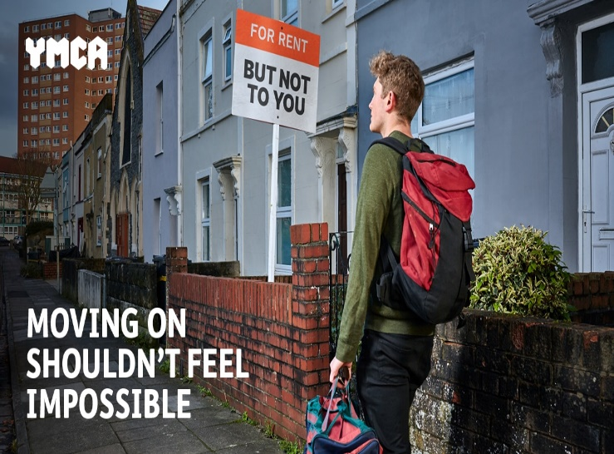
According to the YMCA's most recent research of young people's transitions from homelessness to independent living, 70% of those who were ready to move on stayed in sponsored housing. Only one out of every four people who were ready to relocate believed they would be able to do so in the next three months. At a time of unprecedented crisis and intervention, providing beds in hotels for rough sleepers has been a primary priority for the government. Young people across the country who are ready to leave assisted living and free up this much-needed space are unable to do so due to overwhelming financial and social barriers. Young homeless people were unable to move on due to their inability to save, a lack of affordable accommodation, and bias in the private rental sector, according to the findings of the YMCA's long research on their experiences.
When benefits are withdrawn, starting work usually comes with rising debt, and the situation isn't much different for people who are employed. Despite the fact that they were paid later, practically everyone the YMCA spoke to said they went into debt after commencing employment as a result of the abrupt loss of Housing Benefit or Universal Credit. For those who are able to save, private renting is not only unaffordable, but also unpredictable. Private landlords are often unwilling to rent to young people, requiring guarantors and other checks, which can be difficult for persons living in assisted housing. Young people are suffering the effects of this bias, with 41% telling the YMCA that landlords' refusal to rent to them is the main reason they are unable to move on, followed by the cost of rent and deposits at 44%.
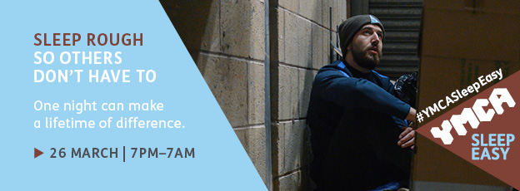
A total of 18 organisations have banded together to tackle rough sleeping and homelessness, forming the London Homeless Charities Group on Friday, December 15 with a winter campaign backed by the Mayor of London. Official figures show that rough sleeping in London has more than doubled since 2010. Changes in assistance, growing housing costs, and a dearth of affordable housing are leaving an increasing number of people without a place to call home.
The London Homeless Charities Group, which includes YMCA England & Wales, St Mungos, Crisis, and others, is partnering with the Mayor on the 'No One Needs To Sleep Rough In London' campaign, which asks the public to join the fight to ensure that people sleeping rough in London this winter have a safe place to sleep.
Since 2010, YMCA Sleep Easy has seen over 7,000 people sleep rough to raise over £1.5 million for local YMCA programmes that help young people rebuild their lives.
YMCAs across England and Wales are urging supporters to sleep rough so that others don't have to. Normally, this would have required groups and people assembling cardboard shelters at a YMCA, spending the nighttime outside, and sharing the terrible truths of living on the streets. The hurdles of planning an event like this amid the current epidemic are considerable, yet they pale in contrast to the daily struggles that young homeless people confront.
For YMCA Sleep Easy 2022, YMCAs across England and Wales will host hybrid events that will include the return of in-person gatherings as well as providing individuals, families, and organisations with the necessary support to participate at home or at a location of their choosing. The YMCA of England and Wales has also produced a briefing note summarising the current condition of homelessness in the UK, as well as new insights into how homeless young people feel the public sees them.

