Software Development
ACCB4017_LON

Student: Andreea Filip 1817999
Lecturer: Renuga Jayakumar

Variables
Variables are data values that are used to stock information to be referenced and operated in a computer program. Variables provide a way of labelling data with a name so that the reader or the programmer can understand the program more clearly. Variables can be seen as containers that store data.
Python is a strong typing programming language; however, variables types are not required to be declared but can be cast. Therefore, the following data types can be specified in Python: string, integer, and float.
Strings are sequences of characters, can be only literal or variable.
Python can use 4 types of numerical values [1]
- int (signed integers) – positive or negative whole numbers
- long (long integers) − integers followed by L.
- float (floating point real values) − real numbers, that divide the integer into fractional parts.
- complex (complex numbers) -rarely used in Python.

Python allows the programmer to find the data type using the type function.
Type function- code Type function - Output
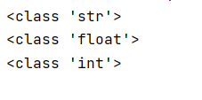
a="Dog"
print(type(a))
b=255.3
print(type(b))
c=36
print(type(c))

If/else
Decision-making is an important aspect of programming; this can be used when the program must execute a code only if certain conditions are met. To do this, in Python, if, elif, and else statements can be used.
If statement allows the program to assess the expression and will execute the statement only if the expression is true.

If statement-code If statement-output
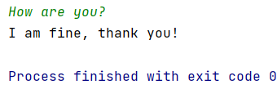
a=(input())
if a=="How are you?":
print("I am fine, thank you!")

Else statement is an optional statement and can be used only once for an if statement. Else is used to create an alternative outcome if the expression is not true.
Else statement $-code Else statement-output
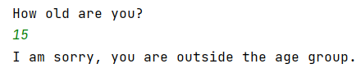
age=int(input("How old are you?\n"))
if((age >= 20) and (age <= 30)):
print('Great, you can qualify!')
else:
print("I am sorry, you are outside the age group.")

Elif is another optional statement that can be used multiple times to evaluate whether an expression is true and execute the statement.

Elif statement-code Elif statement-output
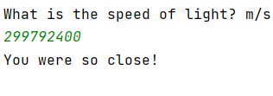
print("What is the speed of light? m/s")
ans=float(input())
if ans == 299792458:
print("You are a start!")
elif (280000000< ans >30000000):
print("You were so close!")
else:
print("Is not an easy one, maybe next time!")

Python also allows the usage of multiple conditions, for this to happened an “and” or an ”or” can be used, or even both in one if statement. Example in the Else statement code, where there are who conditions, (age >= 20) and (age <= 30). [2]

Loops
Sometimes there are situations in which the same code must be repeated multiple times, loops are a great solution for this type of issue. Loops can execute pieces of code repeatedly. Moreover, loops can also be used to validate the input from the user. Python uses two main loops for and while.

For
For loops can be utilised to iterate over a sequence, this can be for example a turtle, a string or a list. In order to stop the loop before the finish, break statement can be used. [3]
For loop with break statement-code For loop with break statement-output
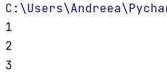
no_list=[1,2,3,4,5]
for no in no_list:
print(no)
if no == 3:
break

Continue statement is able to stop an iteration and continue from the following item.

For loop with break statement-code For loop with break statement-code
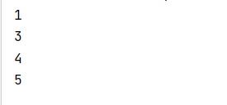
no_list=[1,2,3,4,5]
for no in no_list:
if no == 2:
continue
print(no)

Range() function can generate a specific sequence of integers, starting by default from 0 and increments by default by 1.
Range() function-code Range() function-output
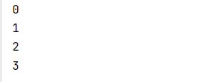
or i in range (4):
print(i)

Nested loops represent loops that are inside other loops. As in the example, I have used a for loop inside another for loop to assign each element from the first to all the elements from the list animal.
Nested for loop-code Nested for loop-output
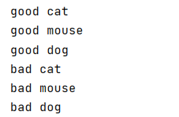
a = ["good", "bad"]
animal = ["cat", "mouse", "dog"]
for i in a:
for x in animal:
print(i, x)

While
A while loop can also use, break, and continue statements, and can incorporate another loop, creating a nested loop. Moreover, both loops can support else statement.
While loop can create indefinite iterations, as the number of times the loop must be executed is not specified in advance. The while loop will iterate over a piece of code as much as the condition is true.

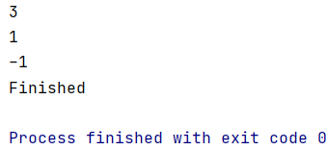
While loop-code While loop-output
n = 5
while n > 0:
n = n - 2
if n == 2:
continue
print(n)
else:
print("Finished")

First exercise
User must select a car by entering the car manufacturer, model, mileage, number of doors and see the result. The purpose of the exercise is to show the proper usage of different variable types.
The challenging part of this exercise was to validate the results. If the user is not inputting the correct type of data, a message should appear and inform the user about the mistake. For this, I have used two while loops that have been encapsulated in functions. Both functions use while loops to validate if the inputs are integers or floats, if not, will display a message and will allow the user to try again. [4]

Logical stages

- Print instruction
- User must enter the car manufacturer (string)
- User must enter the car model (string)
- User must enter the car mileage (floating point)
- Calling the function to validate the input (if is not a number, will display a message and will go back to stage 4).
- User must enter the number of doors (integer)
- Calling the function to validate the input (if is not a number, will display a message and will go back to stage 6).
- Print the selected car

Code
# Exercise 1: Allow the user to input data for a car manufacturer, model, mileage and number of doors
def miles(): # creating the function miles() to validate if the user is inputing only numbers
while True:
try:
added_miles= float(input("Please enter the car mileage: "))
except ValueError: # if other than numbers are used, the programm will display the below message
print("Only numbers accepted, please try again.")
else: # if the input is correct, will contiue the programm
return added_miles
def drs():# creating the function doors() to validate if the user is inputing only numbers
while True:
try:
added_doors= int(input("Please enter the number of doors: "))
except ValueError: # if other than numbers are used, the programm will display the below message
print("Only numbers accepted, please try again.")
else: # if the input is correct, will contiue the programm
return added_doors
print("You can select your dream car!\n") #print instruction
maker=str(input("Please enter the car manufacturer: ")) #user must input the car manufacturer
model=str(input("Please enter the car model: ")) #user must input the car model
mileage=miles() #calling function miles()
doors=drs() #calling function doors()
print("Your selection is:", maker,model,",",mileage,"miles,",doors,"doors, great choice!") #print selection

For the first exercise the main functions were print and input, in order to get information from the user and display the data. I have also use three types of variables. Additionally, I have used two functions which contains while loops in order to validate the input for the car mileage and number of doors.

Testing

- Normal Values
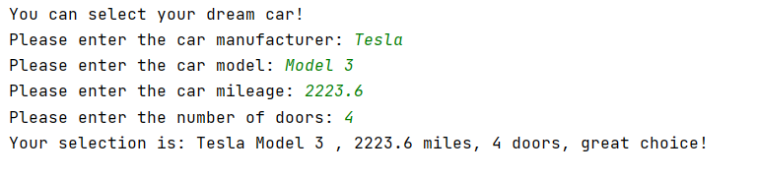
Results, as intended.
- Using letters instead of numbers when datatype should be float.
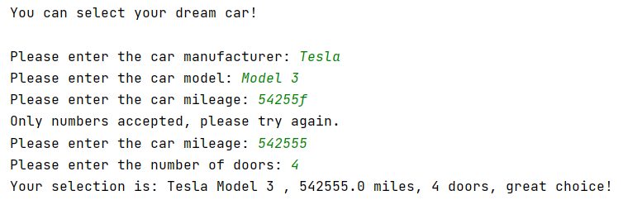
Result: The program is informing the user about the mistake and the user can try again.
- Using letters instead of numbers when datatype should be integer.
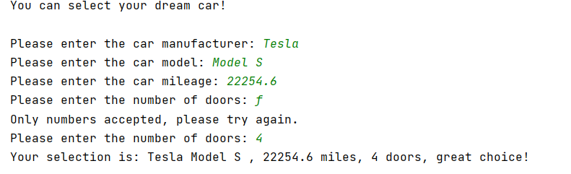
Result: The program is informing the user about the mistake and the user can try again.

Second Exercise
Must create a program that utilises user’s input to calculate how many carrots can be grown on a certain field. Each carrot needs at least 8cm in width and 8cm in height. The program should be able to show only how many whole carrots can be grown. Moreover, the user’s field should be a rectangle for the purpose of this exercise.
The challenging part of this exercise was making the program show only whole carrots. However, this has been solved by using Floor division.

Logical stages
- Print instructions
- User must enter the field’s width
- Cheeking if the user inserted a number greater than 0. If the condition is not met, will return to stage 2.
- User must enter the field’s height.
- Cheeking if the user inserted a number greater than 0. If the condition is not met, will return to stage 4.
- Calculating the area of the rectangle: height* width.
- Calculating the number of carrots that can be grown: (width//8)*( height//8).
- Printing results.

Code
# Exercise 2:
# Allowing a person to check how many carrots can grow on its field, knowing that each carror needs 64cm2 of land.
print("This program can tell how many carrots you can grow on your field") #print instructions
wid=float(input("First, please insert the field width cm: ")) #user must input field width
while wid<=0: #check if width is grater then 0
print("Field width must be grater then 0!")
wid=float(input("Now, please insert the field width cm: ")) #User must input the field wifth again
hei=float(input("Now, please insert the field height cm: ")) #user must input field height
while hei<=0: #check if height is grater then 0
print("Field height must be grater then 0!")
hei = float(input("Please insert the field height cm: ")) #User must input the field height again
area=wid*hei #Calculating area
# answer=int(wid/8)*int(hei/8) #Calculating the number of carrots using integers to obtain only whole carrots
answer=(wid//8)*(hei//8)
print("On your area of",area,"cm2,you can grow",answer,"carrots.") #Print result
For this exercise, the main functions are print and input. The two variables are “wid” and “hei” and are populated by the user’s input. To validate the input, I have added a while loop for each variable, that will check if the value is grated than 0. Moreover, the area of the field has been calculated by multiplying the floats of the variables “wid” and “hei”. To calculate the numbers of carrots I have divided each float using floor division and multiply the results.

Testing
- Testing the program with ideal values.
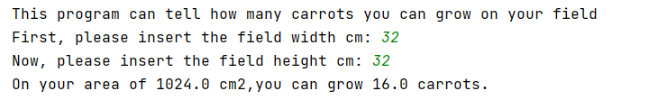
Result- the program is displaying the correct information.

2. Testing if the program shows only whole carrots
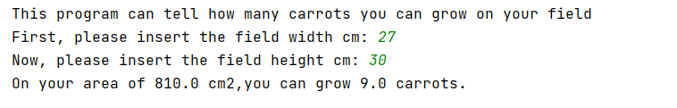
Result- the program is working properly, displaying only the number of the whole carrots.
- Testing if the program will only accept values above 0.
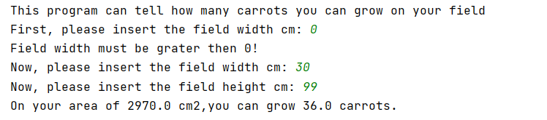
Result- the program is working properly.

3 Testing the program for negative numbers
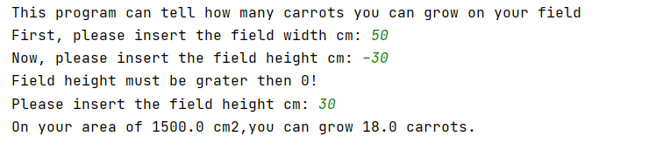
Result- the program is working properly.

Third Exercise
Must create a program that will allow the user to create a list of 5 ingredients and the correspondent price for each ingredient. The user should be able to input the data and the program should display the lists simultaneously after all 5 items and prices are entered. Additionally, the program should calculate the total cost of the items and the total price after applying the 15% discount.
For this exercise, I have created two empty lists that will be populated by the user’s input. For this, I have added a for loop with the range (0,5), as 5 ingredients are required. For the price input, a function is called that contains a while loop to validate the input. If the condition is not fulfilled, the program will display a message and will ask the user to try again. To display both lists, a for loop and a len() function have been used for the ingredients list, thus, showing the ingredients and the corresponding prices of each. To calculate the total cost, I have created the variable total_cost and I have used the sum function for the price_lst. The discounted price has been calculated using basic arithmetic operations.

Logical stages
- Print instructions
- Create a list of ingredients
- Create a list of prices
- Create a loop to populate the lists
- User must enter the first product
- User must enter the price of the first
- Calling the function to validate the input (if is not a number, will display a message and will go back to stage 6)
- Repeating stages 5,6 and 7 four more times.
- Printing the lists
- Calculating the sum of the price list: Sum (price_lst)
- Calculating the discounted price: total price-total price*0.15.
Code
# Exercise 3:
# The user should be able to input 5 ingredients and prices into a shopping list what will display the total cost, and the total cost after the 15% discount.
def price(): # creating the function price()
while True: # using while loop to check if the user is inputting numbers
try:
added_price = float(input())
price_lst.append(added_price)
except ValueError: # if numbers are not used, the below text will be display and the user will be able to try again
print("Price should have only numbers, please try again.")
else:
return added_price
print("This program will help you create a shopping list of 5 ingredients\n")
print("Please enter your ingredients and the corresponded price for each")# Printing instructions
ingredient_lst=[] # creating an empty list of ingredients that will be populated by the user
price_lst=[] # creating an empty list of prices that will be populated by the user
for x in range (0,5): # defining the range of the loop
print("Add ingredient:")
ingredient_lst.append(input()) # adding ingredients to the ingredients list
print("Add price:")
price() # calling the price() function
print() # adding space
print("This is your shopping list:")
for x in range(len(ingredient_lst)): # using a for loop to print all the elements in the lists
print(ingredient_lst[x], " ", price_lst[x])
print()
total_cost=sum(price_lst) # calculating the total price of the price list
print("The total cost of your ingredients is:£",total_cost)
price_discounted=total_cost-total_cost*0.15 # calculating the total cost by reducing the 15% discount from the total cost
print("The total cost with staff discount is:£",price_discounted) # print final price

Testing
- Testing the program using appropriate datatype
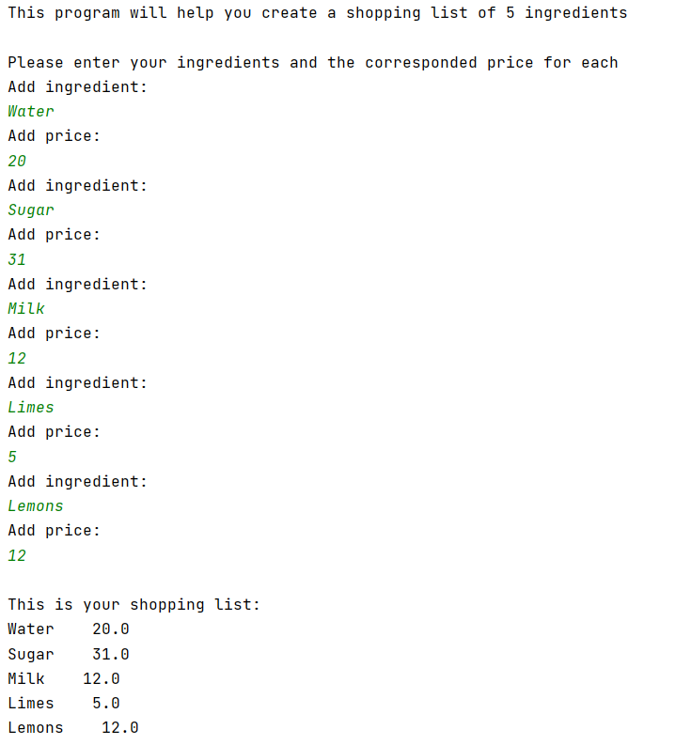
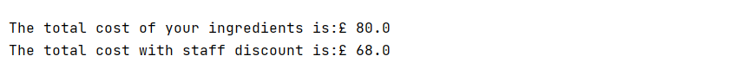
Result: The program is functioning properly, taking the input from the user, displaying the lists, and calculating the prices.

- Testing the program using inadequate datatype.
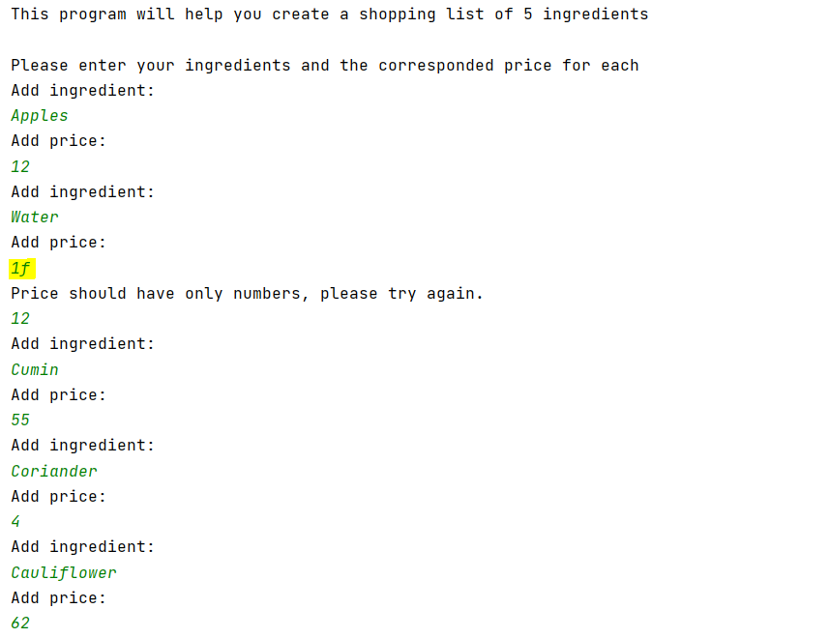
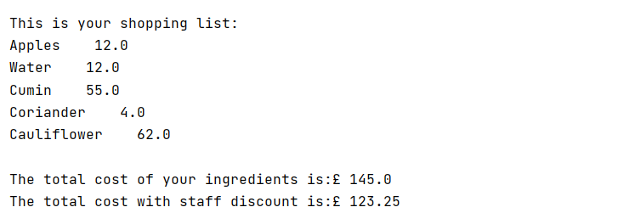
Result: As expected, the program will only accept numbers for the price and will ask the user to re-type the price.

Forth Exercise

For this exercise, the program must allow the user to guess a number that is randomly generated. The program should also display the progress of the user.
To generate the random number I have first imported the random library and use randint() function to generate a random integer between 0 and 8. Furthermore, I have created a list of 9 items that will be used to display the user’s progress. The guess variable has also been created and it will be populated by the user. I have added a while loop to make sure that user will input only numbers between 0 and 8. I have also created a variable for the number of tries. Both variables will be used with another while loop to create a maximum of 3 tries for each game and inform the user that it did not guess the number. Furthermore, three print functions have been added to the loop, to print the elements that are on the same position on the list. Moreover, an if statement is used to determine if the user has guessed and to display the message “Sorry, out of turns” after 3 turns.
All these elements have been encapsulated in a function called main1, to permit the user to play one more time, using the if statement. The condition is that the string of the variable “ans” must be yes, if the string is no, the function will not be called, thus, the game will not restart and the following message will be displayed: "It was a pleasure, see you next time!". If none of these conditions are met, then the program will print: "I presume that this is the end of the game, see you next time” and will not continue the game.

Logical stages
- Print instructions.
- User must enter the name.
- Calling the main1 function
- User must input the first guess
- Check if the user has entered the appropriate range of numbers (if not, go back to stage 4)
- Check if the input corresponds with the random number (if not, will repeat stages 4,5,6, two more times)
- Ask the user if want to continue (if yes, then the function main1 is called and the game continue one more time, if no, or anything else, the program will stop).

# Exercise 4:
# Treasure Hunt
def main1 (): # main funtion of the game
import random
number = random.randint(0, 8) # Get a random number from 0 to 8
list1 =[0,0,0,0,0,0,0,0,0] #get a list of 9 elements
print("What is your lucky number,", name, ": ")
guess = int(input()) # User must add the guess
while guess < 0 or guess > 8: # Informing the user if it is using out or range numbers
print("Only numbers between 0 and 8 are accepted")
guess = int(input()) # User must add the guess
tries = 1
while guess != number and tries < 3:# Inform the user if the number is not guessed
print("Sorry, not this time")
print("Try again: ")
list1[guess] = "X" #replace the 0 with x
print(list1[0], list1[1], list1[2])
print(list1[3], list1[4], list1[5])
print(list1[6], list1[7], list1[8])
guess = int(input()) # User must add another guess
tries += 1 # add another try
if guess == number and tries <= 3: # check that the user guessed
print("You got it!")
else:
print("Sorry, out of turns")
print("The lucky number was",number)
print("Welcome to the Treasure Hunt game!\n") # Print instructions
print("You have 3 chances to find a lucky number from 0 to 8 to win the price.")
print("What is your name?")
name = input() # Get the name of the user
main1() # calling the main funtion to start the game
print("Would you like to start again?")
ans=input()
if ans =="yes": # get another turn
main1()
elif ans == "no": # end of the name
print("It was a pleasure, see you next time!")
else:
print("I presume that this is the end of the game, see you next time!")

Testing
- Test if the numbers are generated and the list elements are replaced with x when a number is inserted.
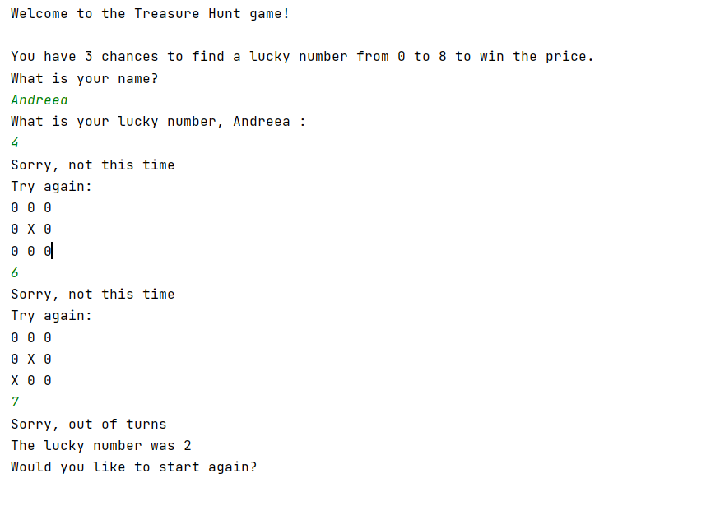
Result: The program is generating a random number and the elements of the list are replaced by x when the user makes a guess.
- Testing if the user can start again
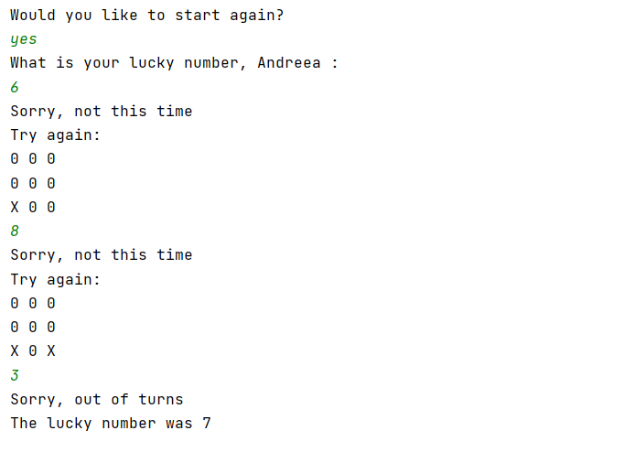
Result: The user can try one more time the game.
- Testing out of range input
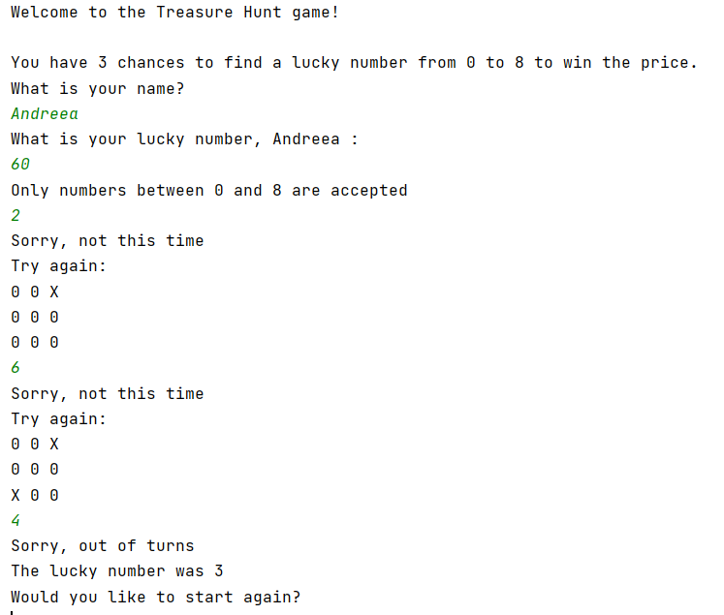
Result: User can try again, with an appropriate number.
- Testing if the condition is not met for the program to continue the game.
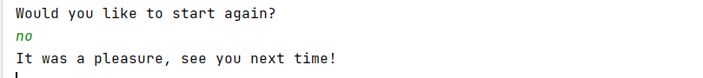
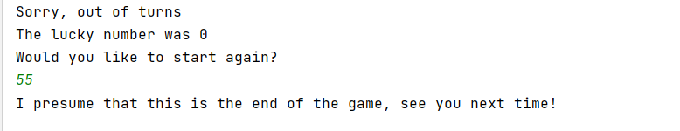

Result: The program executes the statement as expected.

References

[1] Tutorialspoint, “Python - Numbers”, Tutorialspoint, 2021. [Online]. Available: https://www.tutorialspoint.com/python/python_numbers.htm [Accessed May. 5, 2021].

[2]Geeksforgeeks, “Check multiple conditions in if statement – Python”, Geeksforgeeks, Mar. 26, 2020 . [Online]. Available: https://www.geeksforgeeks.org/check-multiple-conditions-in-if-statement-python/ [Accessed May. 5, 2021].

[31] W3schools “Python For Loops”, W3schools, 2021. [Online]. Available: https://www.w3schools.com/python/python_for_loops.asp [Accessed May. 6, 2021].

[4] Stackoverflow, “Asking the user for input until they give a valid response,” Stackoverflow, Jun. 6, 2020. [Online]. Available: https://stackoverflow.com/questions/23294658/asking-the-user-for-input-until-they-give-a-valid-response [Accessed May. 6, 2021].

