Student Name: Jean Pierre Kiangoma
Student ID:1806274
Module Title: Managing Enterprise in the 21st Century
Module Code: BMSK4006
Module Lecturer’s Name: Gregory Cowan

Contents:
Particulars | Page no.
Introduction | 03
Report | 04
Conclusion | 08
References | 09
Appendix | 11

Introduction:
Through this report, I would like to convey my understandings and learnings in the course of this module regarding business plans. I will also be writing about the developments I noticed in my personal skill sets that would facilitate self-employment opportunities for me in the future. I wish to start this report by saying that I deem it a great privilege to be given this opportunity to be a part of this module. This module helped in enriching my knowledge in the field of entrepreneurship. It gave me a totally new perspective of looking at the business world. I today am a totally different person while going through the business paper, as I now understand, better interpret and enjoy exploring this world.

Report:
I still remember the start of this amazing journey when I for the very first time encountered the basics of business. I believe business to be a system or entity where goods and services are transferred between parties for an economic resource like money (Гнатенко, 2018). The process of business starts right from the stage of idea generation, funding, product or service development, marketing and sales, and ends with after sale services (Pirijan, 2019). Since my birth, I have been noticing the various changes incorporated by businesses around me that includes usage of IT systems, emergence of not-for-profit organisations, government’s growing support for entrepreneurial talent and the increasing start-ups scenario. I personally feel today youngsters like me think very differently from our parents and grandparents. We consider starting our own business as an option right after education, whereas this was not the case during their reign. Through the course, I realised profit maximisation is no longer the only goal of an enterprise. Other factors like market growth, relative market share, customer satisfaction levels, employee productivity, quality control and environmental responsibility are some of the other contemporary business objectives (Hsieh, 2017). I also noticed that any business entity won’t exist in isolation. There are a multitude of environmental influences on a business. These include both internal environment as well as external environment (micro environment and macro environment) (Song, 2017). The various tools taught in this module to analyse the environment are extremely useful in real life scenarios like PESTLE Analysis (others being Porter’s five forces, Generic Strategies, Boston Consulting Group Matrix, etc).
The knowledge of the stages of business growth helps me analyse the characteristics of various businesses around me and the conditions restricting their performance. I still recollect the connection between Maslow’s Hierarchy and Business Development which was very clearly drawn in the module. I think there are a variety of reasons why one would want to become an entrepreneur few being the autonomy of decision making this occupation provides, financial success, hope for a better and quality life and the quest for job security (Welter, 2017). People in general believe entrepreneurs to have a common set of personality traits like vision, ambition, patience, innovation, self-confidence and high adrenaline. The course made me feel that individuals are very different from each other and the way they think and run their organisation is also different. There are no defined set of traits but are just a inclusive list of personal qualities which enhances an entrepreneur’s productivity (Wood, 2015).

A business plan is a structured written document that presents the entire business into several classified blocks the analysis of which will explain the functioning of the entire business (Mcknezie, 2015). It demands the entrepreneur to be unambiguous and crystal clear about the components of the business plan. Investors and lenders would definitely look at the business plan before lending capital. A business plan technically comprises of the following components – executive summary (though it is considered the most important part of the business plan, it should be written in the end in order to include the rest of the components of the business plan), market analysis (tools like porter’s five forces, porter’s generic strategies, PESTLE analysis, SWOT analysis, Ansoff's matrix shall be used to analyse the market), the company description (this includes the nature or type of business, the products or services involved, etc), management and organisation (the capital structure, required qualifications of the management, the experience needed, and the structure of organisation whether functional, division, or network structure shall be finalised), marketing and sales management (involves the promotional strategies, ad campaigns, target audience, distribution strategy and communication strategy), product or the service line (research and development, current product features or service provisions, how this product or service is a solution to a problem in the world, etc), funding strategies (funds can be raised from a variety of sources, each having its own merits and demerits) and financial management (this refers to the decisions regarding investments, dividends and financing). Before I start working on my business, I have to work on my business plan and ensure it is complete, clear, innovative and realistic. To my knowledge this is the statement or document that will help me impress and attract most lenders and future investors to believe in my idea.
To start with, I will have to decide the type of organisation I would like to create. Though there are many options like profit-making, not-for-profit, private sector and public sector, I personally have always been inclined towards social entrepreneurship (Hopp, 2018). The sub categories of these types of business organisations include sole proprietorship (where I will be the only owner of the organisation), partnership (where I will have to find another individual with a similar objectives and one who believes in the same cause as me), Corporation (a company form of organisation wouldn’t be useful at the starting stages of my project, as shares can be issued once general public or future shareholders have confidence in the growth of the company), Limited Liability Company (this has the characteristics of both a company and a partnership, this kind of organisation would benefit me by not burdening me with unlimited liability as a partnership would do) and a cooperative form of organisation (where I will have to find a group of similar minded individuals and shall be operated for the mutual benefit of all the members). Though I would like to earn revenue, I wouldn’t want to make a profit for myself but for expanding the organisation and reinvesting in the cause. Many individuals in my experience misconceive social entrepreneurship to be a charity-based organisation. I have always been patiently wiping this misunderstanding by telling them it is different and have its own revenue sources unlike charity based organisation which exists on the basis of donations (Huda, 2019).
According to my learning in this module, I believe it is important for the entrepreneur to have a strong stakeholder view which means he/she should believe that all stakeholders have an interest and say in the organisation to survive in the 21st century economy. The various groups of stakeholders are usually classified into internal, external and connected. Internal stakeholders refer to those who are inside the boundaries of an organisation like employees, management, etc. External stakeholders refer to those who are outside the functioning of the entity like media, government, local and national communities, etc. Connected stakeholders are those who are not internal to the organisation yet are related to its functioning like suppliers, shareholders, customers, etc (Cheung, 2015). Models like Mendelow’s stakeholder mapping personally helped me in analysing the treatment required for each group of stakeholders. It assesses groups of stakeholders on the basis of their interest in the organisation as well as the power they hold on the organisation. It classifies stakeholder groups into the following four quadrants and each of the quadrant possesses a different treatment of stakeholders. Ones with high power and high interest shall be treated as key players. Ones with high interest and low power should be kept informed about the performance of the entity. Ones with low interest and low power should not be ignored but very little effort is expected for them. Stakeholders in the last quadrant have high power but low interest in the organisation, such groups should be kept satisfied by considering their demands in the operations of the entity (Soltani, 2015)
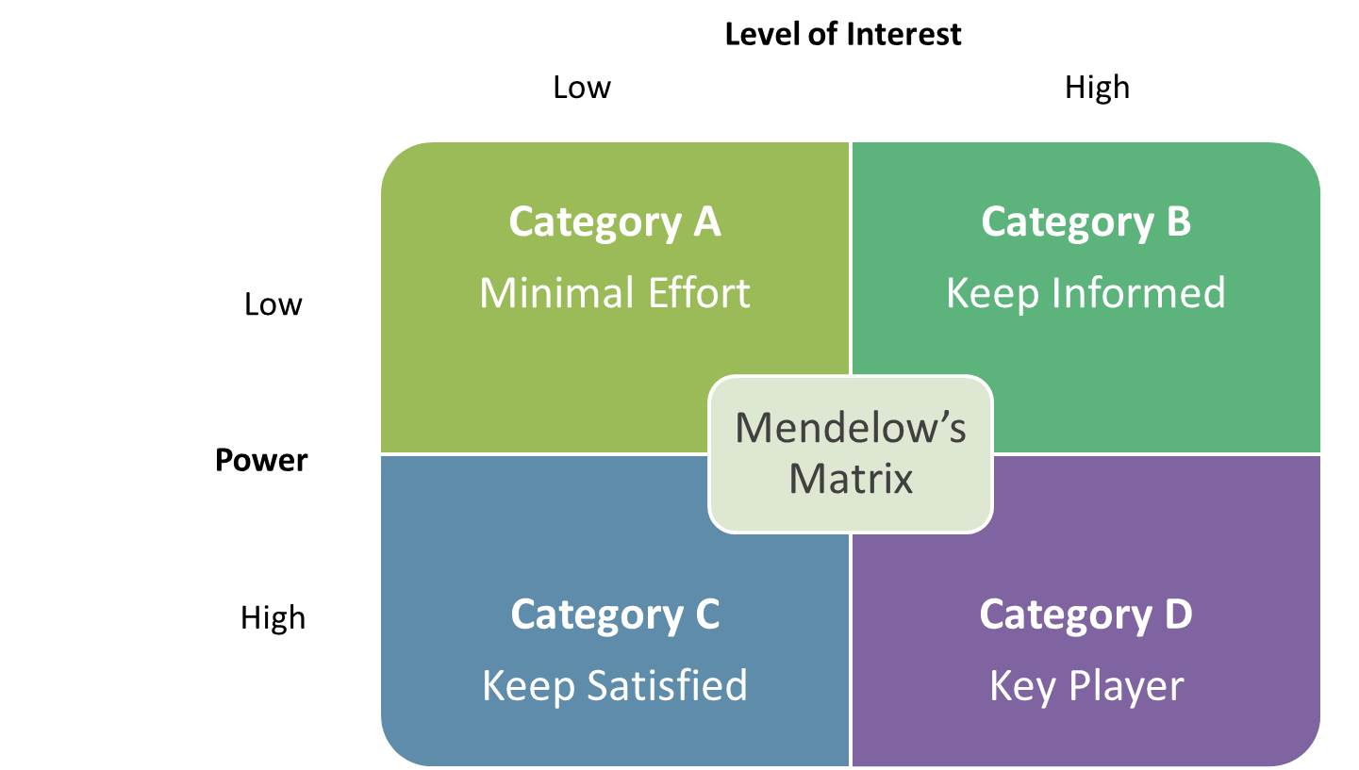
Fig: Mendelow’s stakeholder matrix (kazadi, 2016)
The course also assisted me in understanding the trends of entrepreneurship in the 21st century which includes home-based business, micropreneurs, concept of outsourcing, online business, intrapreneurs, incubators, special economic zones, and family business (Zavyalova, 2016). It is no longer a formal office environment which is a mandate for business success. Many virtual partners like logistics agents, warehousing, etc can be outsourced without any physical contact with each other. Employees today can sit at their homes, log in to the company’s website and perform their specified tasks without having to travel. The excessive reliance on information technology is looked both as a boon and bane. I personally deem it to be a boon. The emergence of information technology and its integration into the business processes have helped automate repetitive tasks, assisted in re-engineering non value adding tasks, allocate organisational wide resources efficiently using Enterprise Resource Planning Systems (ERPS) and function real-time (Seethamraju, 2015). An Information Technology software like the ERPS will manage the enterprise’s resources and automates back office functions which are usually non-skilled and are routine in nature. It is usually beneficial to medium and large sized organisations to use Enterprise Resource Planning Software as the cost of its installation and the employee training costs with relation to the use of the software is normally tremendous and the incorporation of such an Information Technology system in a small company might prove to be a burden on the financial condition of the entity. Hence, according to me it is prudent for a start-up or a small company to not go for it in the initial stages and stick to manual practices until the organisation grows in size and in number of employees.
The knowledge which this module transferred into me can never be replaced especially with reference to the sources of capital that an enterprise can raise. I always thought that bootstrapping which is the use of personal savings and money from family to be the only source of funding for an establishment. The module acquainted me to various other sources of funds including bank loans, government subsidies, angel investors, venture capitalists, bonds and shares (Ruan, 2018). Focusing this concept to the funding to be raised by my business start-up, I believe bootstrapping, financial institution borrowing (this includes bank loans – these demand a collateral to be attached to the loan i.e. have a charge on the organisation’s assets), angel investors and venture capitalists would be the only sources of funding at the initial stages.
I will also have to decide on the functional areas of my organisation. Since I plan on starting it as a small social entrepreneurship project, I prefer going with functional organisational structure amongst the other organisational structures like divisional structures, network organisations and matrix structure (Mizutani, 2015). The main functions would include production, research and development, marketing, administration, customer service, sales, human resources, finance and distribution networks (kovats, 2017) (Appendix). These functional areas will be called various departments and each department will be headed by a department heads. These department managers will be responsible for the performance of their respective functions. Such divisions won’t be independent of the company but will function in congruence with the organisational goals.

Conclusion:
Throughout the tenure of this course, I have witnessed myself to be developing as an individual who has a totally different perspective of the art of entrepreneurship today. What I earlier believed to be business was only a component of the concept of entrepreneurship. This module introduced various necessary theories, components and practicalities in the process of self-employment. I deem this course to be a great contributor to my skills and competences as a businessman. I aspire to learn quite a lot of skills which can make me prudent as a businessman It was very helpful in analysing the needs of my future social entrepreneurship project. I am confident my project is going to start with a strong base of knowledge.

References:
- Гнатенко, І.А., 2018. CONCEPTUAL APPROACHES TO SMALL BUSINESS MANAGEMENT IN TERMS OF THE CRITERIA OF ECONOMIC SECURITY AND AN ENTERPRISE LIFE CYCLE. Bulletin of the Kyiv National University of Technologies and Design. Series: Economic sciences, 123(3), pp.47-56.
- Cheung, S.K., Yuen, K.S., Li, K.C., Tsang, E.Y. and Wong, A., 2015. Open textbooks: engaging education stakeholders to share learning resources. International Journal of Services and Standards, 10(4), pp.225-239.
- Hsieh, N.H., 2017. The Responsibilities and Role of Business in Relation to Society: Back to Basics?. Business Ethics Quarterly, 27(2), pp.293-314.
- Hopp, C., Greene, F.J., Honig, B., Karlsson, T. and Samuelsson, M., 2018. Revisiting the influence of institutional forces on the written business plan: a replication study. Management Review Quarterly, 68(4), pp.361-398.
- Huda, M., Qodriah, S.L., Rismayadi, B., Hananto, A., Kardiyati, E.N., Ruskam, A. and Nasir, B.M., 2019. Towards Cooperative With Competitive Alliance: Insights Into Performance Value in Social Entrepreneurship. In Creating Business Value and Competitive Advantage With Social Entrepreneurship (pp. 294-317). IGI Global.
- Kazadi, K., Lievens, A. and Mahr, D., 2016. Stakeholder co-creation during the innovation process: Identifying capabilities for knowledge creation among multiple stakeholders. Journal of Business Research, 69(2), pp.525-540.
- Kováts, G., Heidrich, B. and Chandler, N., 2017. The pendulum strikes back? An analysis of the evolution of Hungarian higher education governance and organisational structures since the 1980s. European Educational Research Journal, 16(5), pp.568-587.
- McKenzie, D., 2015. Identifying and spurring high-growth entrepreneurship: experimental evidence from a business plan competition. The World Bank.
- Mizutani, F., Smith, A., Nash, C. and Uranishi, S., 2015. Comparing the costs of vertical separation, integration, and intermediate organisational structures in European and East Asian railways. Journal of Transport Economics and Policy (JTEP), 49(3), pp.496-515.
- Pirijan, B.A., 2019. MODERN ECONOMIC THEORY IN THE FRAMEWORK OF THE CHALLENGES OF THE XXI CENTURY. Economic and Social Development: Book of Proceedings, pp.1589-1595.
- Rao, P.S., Mellam, A.C. and Manohar, P., 2015. Contribution of Organisational Structures to Leaders’ and Followers’ Performances in Business Enterprises in Papua New Guinea. Universal Journal of Management, 3, pp.303-308.
- Ruan, Q.Z., Cohen, J.B., Baek, Y., Chen, A.D., Doval, A.F., Singhal, D., Fukudome, E.Y., Lin, S.J. and Lee, B.T., 2018. Identifying sources of funding that contribute to scholastic productivity in academic plastic surgeons. Annals of plastic surgery, 80(4), pp.S214-S218.
- Seethamraju, R., 2015. Adoption of software as a service (SaaS) enterprise resource planning (ERP) systems in small and medium sized enterprises (SMEs). Information systems frontiers, 17(3), pp.475-492.
- Soltani, A., Hewage, K., Reza, B. and Sadiq, R., 2015. Multiple stakeholders in multi-criteria decision-making in the context of municipal solid waste management: a review. Waste Management, 35, pp.318-328.
- Song, J., Sun, Y. and Jin, L., 2017. PESTEL analysis of the development of the waste-to-energy incineration industry in China. Renewable and Sustainable Energy Reviews, 80, pp.276-289.
- Welter, F., Baker, T., Audretsch, D.B. and Gartner, W.B., 2017. Everyday entrepreneurship—a call for entrepreneurship research to embrace entrepreneurial diversity.
- Wood, M.S., Bradley, S.W. and Artz, K., 2015. Roots, reasons, and resources: Situated optimism and firm growth in subsistence economies. Journal of Business Research, 68(1), pp.127-136.
- Zavyalova, A., Pfarrer, M.D., Reger, R.K. and Hubbard, T.D., 2016. Reputation as a benefit and a burden? How stakeholders’ organizational identification affects the role of reputation following a negative event. Academy of Management Journal, 59(1), pp.253-276.

Appendix:

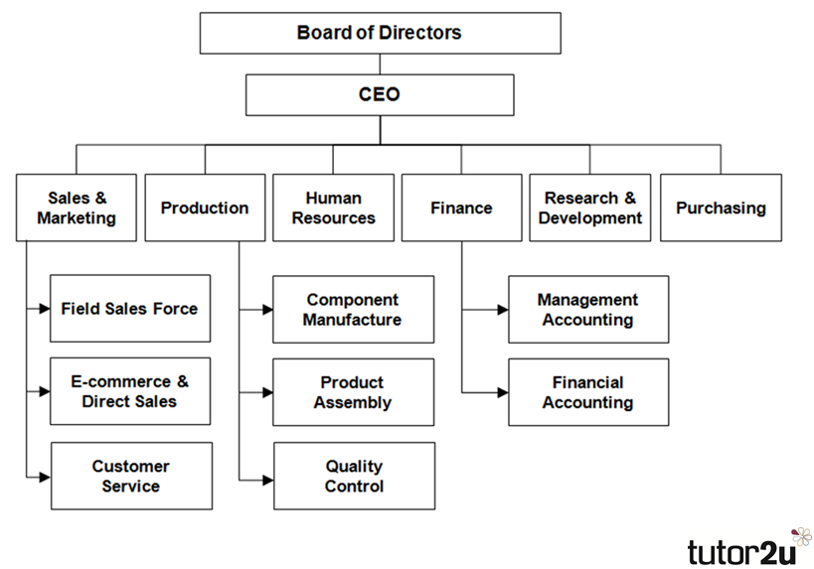
Fig. Functional structure of an organisation (Rao, 2015)

