

MARKETING MANAGEMENT (LCMB7001)
ASSESSMENT 1

SUBMITTED BY:
ERIKA MAE M. PAGADUAN
STUDENT NUMBER: 1604894

MODULE LECTURER:
TUSHARA BALENDRAN
Table of Contents
Introduction 3
Communication in Marketing 3
Communications Models 4
Integrated Marketing Communication 6
Current promotions at Marks and Spencer 6
Branding and Brand Equity 7
Promotional Strategies and Brand Awareness 7
Keller’s Brand Equity Model 9
Aaker’s Brand Equity Model 10
Customer Journey and Touchpoints 12
Conclusion 13
References 14

List of Figures
Figure 1: Linear Model of Communication 4
Figure 2: Interactive Model of Communication 5
Figure 3: Transactional Model of Communication 5
Figure 4: Keller’s Brand Equity Model 9
Figure 5: Marks and Spencer's Brand Equity using Keller's CBBE model 10
Figure 6: Aaker’s Brand Equity Model 11
Figure 7: Customer Journey with Touchpoints 12

Introduction
Organisations are faced with endless challenges in order to survive in the ever-changing business environment. Advances in technology and communication, continually rising digitalisation, information management, customer behaviour and expectations, brand awareness, reputation management, increasing competition and many more factors demand efficient strategy to achieve competitive advantage. Some organisations who maintain and continuously acquire market share despite these challenges can attribute their competitive advantage in their effective marketing strategies. According to Wind (2005), marketing is a tool for the growth and profitability of a business as it creates value by building customer relationship. Therefore, it is necessary to critically understand the needs and wants of the customers so as to create a holistic approach in terms of achieving the overall objectives and goals of the organisation.

This report will discuss the potential and innovative marketing strategy of Marks and Spencer Group PLC, most commonly known as M&S, with the aim to raise brand awareness as well as customer journey management and evaluation across different communication channels, in order to fulfil the expectations of the current and future stakeholders.

Communication in Marketing
Communication is the use of mutual systems of symbols, signs and/or behaviour with the aim of conveying information between two or more parties (Merriam-Webster Incorporated, 2021). It is important in every aspect of our daily life, be it at the comfort of our own home, while socialising outside and specially, in the workplace. Dwyer (2019) cited that business enterprises use communications so as to provide information and/or persuade its stakeholders including employees such managers, supervisors, team leaders and those in the rank-and-file as well as customers, suppliers, the public and the government agencies. Furthermore, a good communication system in the organisation allows the management to make and implement decisions. Every single stakeholder requires unique communication strategy in order to serve the purpose of transferring data and information in line with the organisation’s goals and objectives. According to Doyle (2011), most of the time, communication in marketing is the major component of the whole communication system of a company. This is due to the reason that the organisation can present their goals and objectives, values as well as the products and services to their current and potential customers, investors and even the public. Marketing communication gives emphasis on conveying customised message or information to a targeted market group in order to obtain high response from them and also to create more brand interaction.

Communications Models
Various models have been developed so as to explain the communication process. The most popular communication models are linear, interactional and transactional. Each of these models explain how communication is developed by emphasising the different parts of the process and their relationship with each other (West and Turner, 2007).

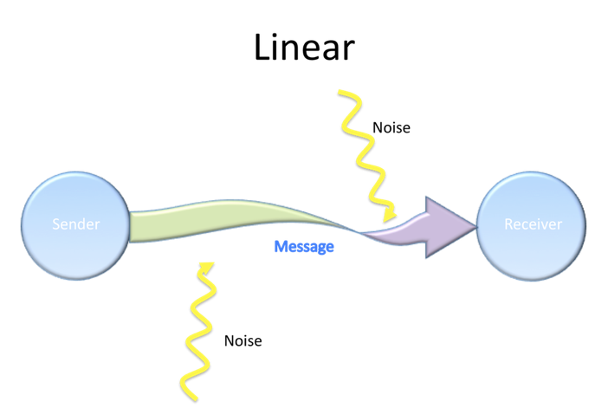
Figure 1: Linear Model of Communication
In 1948, Shannon and Weaver developed this model to explain the linear process of communication as seen in the figure above. It can be observed that a message is transmitted through a route called channel, from the source of the message which is the sender and is then received by the receiver. Any unnecessary interference which are obstacles in the communication are called noise which may or not be present during the process. Despite being popular due to its simplicity, this model is limited to a one-way communication system which meant that an individual can only be a receiver or a sender and not both.

Interactional model (Figure 2), on the other hand, presents the lacking feedback or response in the linear model. Feedback suggests that the message has been received and comprehended. Although both individuals can be both sender and receiver, they cannot do it at the same time as this can create distortion in the communication as well as conflict.
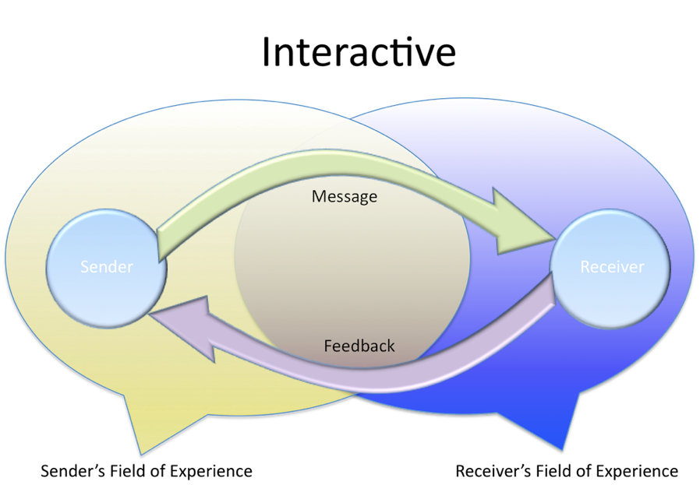
Figure 2: Interactive Model of Communication
The most dynamic model out of the three is shown in Figure 3, which is the transactional communication model where the sender and receiver can be both referred as communicators. This meant that a communication is properly taking place as the individuals involved in the process can send and receive messages at the same time (Corey, 2021).
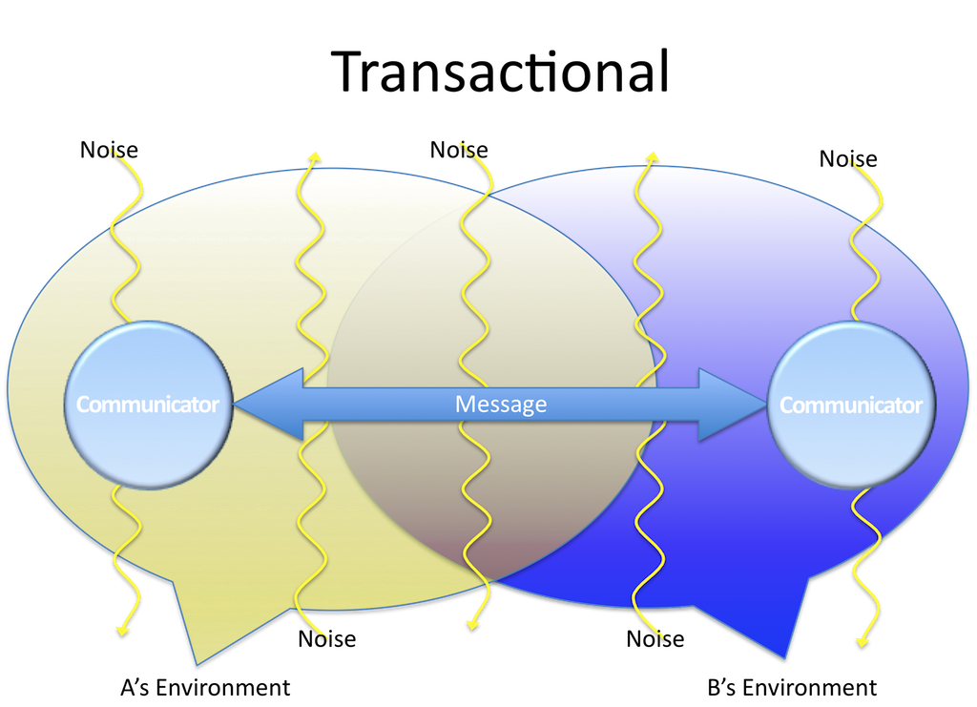
Figure 3: Transactional Model of Communication

Integrated Marketing Communication
Marketing communication is the process of efficiently and effectively introducing and providing information about the products, services and the organisation to a targeted group of people. It also focuses on the understanding of the values and interests of the customers in order to satisfy their needs and wants (Varey, 2002). Therefore, integrated marketing communication is a concept putting together all the form of communication in order to create competitive advantage, achieve profitability and manage resources efficiently. According to Kitchen and Burgmann (2015), IMC is the system of marketing strategies which aims to enhance communication to all the stakeholders about the organisation’s brand. This simply means that integrated marketing communication makes sure that the organisation’s brand is consistent with how they communicate it internally and externally. Others define IMC as the method of combining all the elements of promotional mix (Pickton and Broderick, 2005). Proper execution of IMC strategies can benefit the organisation in some ways such as better use of media, cost and operational efficiency, consistent messages and service, greater accountability and better marketing precision (Linton and Morley, 1995 cited in Pickton and Broderick, 2005).

Current promotions at Marks and Spencer
It has been mentioned that marketing is one of the key factors in obtaining strategic advantage in an intensely competitive environment. Marks and Spencer has been operating as one of the most respected brands in the UK, providing own-brand, high quality retail products ranging from clothing, home items to food. M&S boasts its responsible marketing principles with an aim to create long-term relationship with its customers (Marks and Spencer, 2021). The company practices transparency and responsibility from sourcing and producing to selling their products. M&S uses various media such as print, television, mobile and even internet, in order to reach their current and potential customers. They also maintain their website to promote its brand and products at the comfort of their customers’ homes. Aside from blogs and fashion tips on its website, they also offer seasonal special discounts, loyalty programs called Sparks which enables customers to earn reward points which they can use on future purchases.

Branding and Brand Equity
Jones (2017, p.1) defined branding as “more than just an aspect of marketing but rather a broader activity affecting most of the things an organisation does.” This means that branding extends not only to customer relationship but to internal and external stakeholders as well. Branding can sometimes be associated to visual representations such as logos and signs which are initially used to sell products or promote offered services. However, many organisations associate branding as one of the sources of the company values. As cited in Assali (2016, p. 225), “A product is something that is made in a factory; a brand is something that is bought by a customer. A product can be copied by a competitor, a brand is unique. A product can be quickly outdated, a successful brand is timeless.” This means that there are times that consumers purchase products or services because of its brand. The perception of prospective customers on a certain brand represents the brand equity of a company. It is an intangible asset and is associated in acquiring additional market share (Burger, 2012). According to Hayes (2020), brand equity refers to the additional value companies gained when customers recognise them more than its competitors. Clearly, it involves the perception of customers, positive or negative effect of their brand and the action taken by the same customers. Since companies operating on the same industry offer products with same purpose, it is important to maintain strong brand equity in order to boost their sales volume, improve their profitability and increase their competitive advantage.

Promotional Strategies and Brand Awareness
Brand equity and brand awareness are sometimes used interchangeably because both relate to the customer perception and engagement with a brand. They are equally important, but one should not be mistaken for the other. While brand equity is the concrete commercial value received from the perception of the customers in a product, brand awareness is the perception itself or the knowledge of the customers about a product or service, through its quality or the image it portrays (Siwiec, 2019). Moreover, brand awareness promotes customer loyalty and helps in planning better marketing strategies. With regard to this, it can be established that it is necessary to raise brand awareness and one of the means to do so is to be proactive in terms of promotional strategies. BBC (2021) defined promotional strategy as the combination of different promotion methods, such as radio, television, print, web and social media advertising to name a few, in order to reach a target market. Traditional promotional strategies are still working to some extent however, as the world advances to a more technology-driven environment along with the rising digitalisation, organisations like Marks and Spencer must level up their strategies in terms of promotion. With this being said, new and updated promotional strategies can be recommended in order to raise brand awareness such as the use of infographics, emotional advertisement, product placement and social media specifically social advertising and influencer marketing.
- Infographics – The world is too fast-paced nowadays that some people do not have enough time to read a full-length advertisement which is Marks and Spencer can invest in its graphic advertisements. Aside from this form of promotion being visually pleasing to the current and potential customers, it creates an impact through the brief but substantial advertisement.
- Emotional Advertisement – This strategy is not new however it still makes impact to the audience. Promotions done through this advertising technique appeals to varied human emotions for example: Disney UK’s 2020 Christmas Advert #FromOurFamilyToYours which appeals to the emotion of Overseas Filipino Workers (OFWs). Marks and Spencer can produce heart-warming advertisements as well, perhaps in a British or cross-cultural home since the products they offer caters customers of different ages, genders and cultural backgrounds.
- Product Placement – Just like emotional advertisement, this promotional strategy is no longer new in the world of marketing. However, its presence can be seen more nowadays than it ever been due to the coronavirus (CoVid-19) pandemic. Since a lot of people is staying at home for everyone’s safety, people tend to entertain themselves through films, television series and videos which is a perfect opportunity for organisations like M&S to promote its products. According to BBC News (2020), Netflix got 16 million new subscribers for the first quarter of 2020 which is twice the amount of new subscription in the few final months of 2019. The first quarter of 2020 is when the coronavirus started to reach other countries and lockdown across the world, particularly in the UK, were imposed. Since Netflix can be accessed all over the world, it is a convenient way to promote products and brand awareness because M&S operates not only in the UK but in other countries as well.
- Social Media – The rise of different social media platforms and its users can help in the promotion of brand awareness especially with the increasing numbers of bloggers, vloggers (video bloggers) and other social media influencers. May it be a free or a paid promotion, influencers can implicitly or explicitly show the products in the contents they create, and their followers can be aware of such products as well as the brand itself.

Keller’s Brand Equity Model

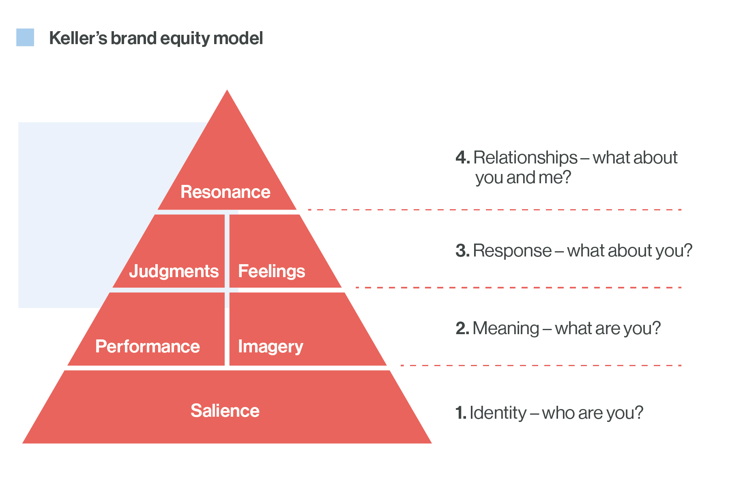
Figure 4: Keller’s Brand Equity Model
Keller’s brand equity model is commonly known as Customer-Based Brand Equity or CBBE model which is apparently focused on the customers. According to this model, customer satisfaction and customer relationship must be prioritised in building brand equity. It follows a hierarchy, as shown in Figure 4, which means there are stages that must be first fulfilled before moving to the next one. The first level is called Brand Identity which is basically the how the customers see the brand and distinguish it to others. Targeted marketing and advertisements increase awareness thus fulfilling this level and moving on to Brand Meaning. This level appeals to the customer experience of the product or service and/or how it was presented. Next is Brand Response which is essentially the judgement and feelings the customer had for the product. This is when the customers assess whether the product or service serves its purpose and was it worth it. When they have positive feelings about the product, customers become brand ambassadors where they promote the products to others. On the other hand, if they have negative feelings about the product, customers tend to discourage other people from buying them. The peak of Keller’s pyramid, Brand Resonance, is about solidifying customer relationship. It can be inferred that the customer has developed loyalty to the brand (Keller and Swaminathan, 2015).

Presented below is Marks and Spencer’s improved promotional strategy, specific to social media,
in reference to Keller’s CBBE model.

Figure 5: Marks and Spencer's Brand Equity using Keller's CBBE model

Aaker’s Brand Equity Model
Unlike Keller’s CBBE model which focuses more on the customer’s emotions, Aaker’s model focuses more on recognition. The model acknowledges brand equity as a combination of brand awareness, association and loyalty. Aaker (2009) enumerated five components of controlling brand equity such as brand loyalty, brand awareness, perceived quality, brand association and other propriety, as illustrated and explained in Figure 6 below.
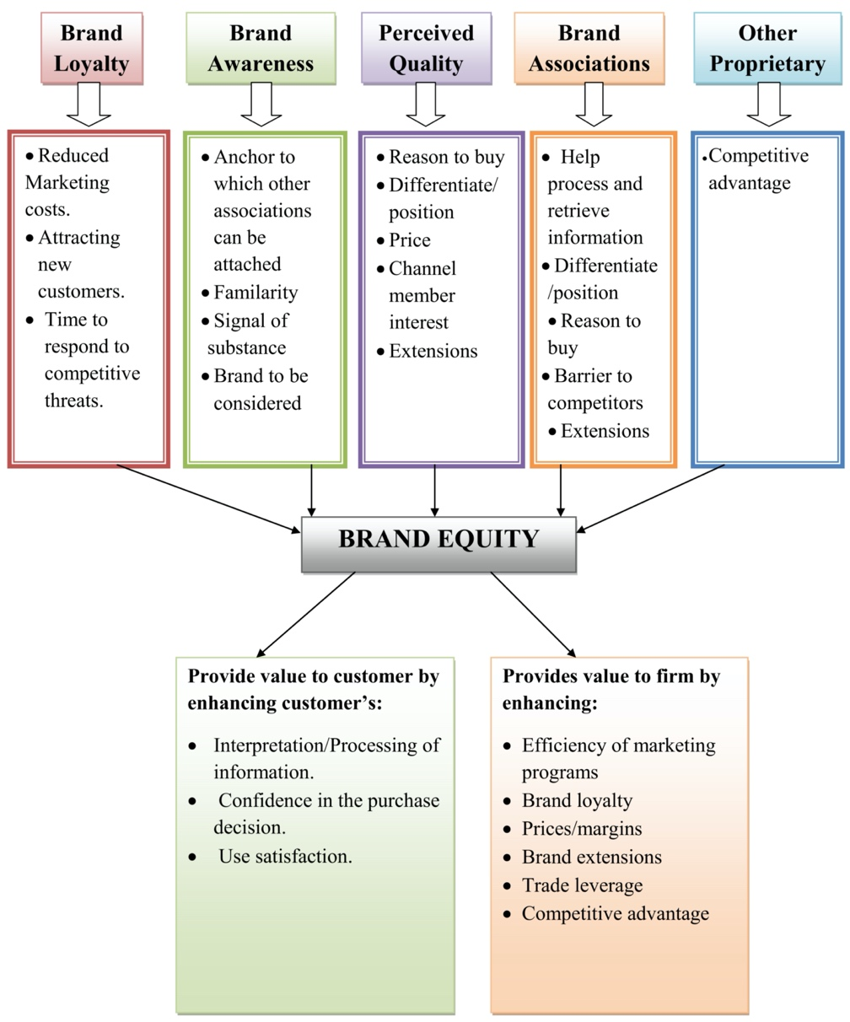
Figure 6: Aaker’s Brand Equity Model
Brand loyalty refers to the favourable response of a customer towards a brand which leads them to purchase products of the brand repeatedly and being unable to easily swayed by the competitors (Hur et al, 2011). On the other hand, brand awareness as previously explained is the initial phase of achieving brand equity. Perceived quality means the judgement of customers regarding the product quality and features while brand association is the feeling customers have when they see the brand. Lastly, brand propriety highlights that when a certain brand have propriety rights such as patents and intellectual property rights, it indicates that they possess competitive advantage than other brands. All these five components can be measured through the appropriate platforms which pinpoints what could be improved to efficiently manage brand equity. It also follows that branding requires delivery to every customer touchpoint along the customer journey in order to guarantee this recognition. Information can be gathered in different marketing stages so as to increase brand loyalty and show how the brand sets the organisation apart from its competitors (Qualtrics, 2021).

Customer Journey and Touchpoints
Maechler et al (2016) defined customer journey as the set of activities, happenings or events that happened before or the start of the product awareness, during and after receiving the product or experiencing the service. Meanwhile, touchpoints are any interaction between the customer and the business which may happen through direct or personal interactions, marketing channels such as advertisements or indirectly such as word-of-mouth. It is therefore important to highlight and outline all the touchpoints because it allows the brand to envision, enhance and improve customer experience with the business. This process is called Touchpoint Mapping which includes the process of identifying the customer touchpoints, mapping them by making customers aware of the brand, get them to buy the products and make them come back, improving customer touchpoints and reviewing them to make better marketing strategies (Spectrio, 2020).

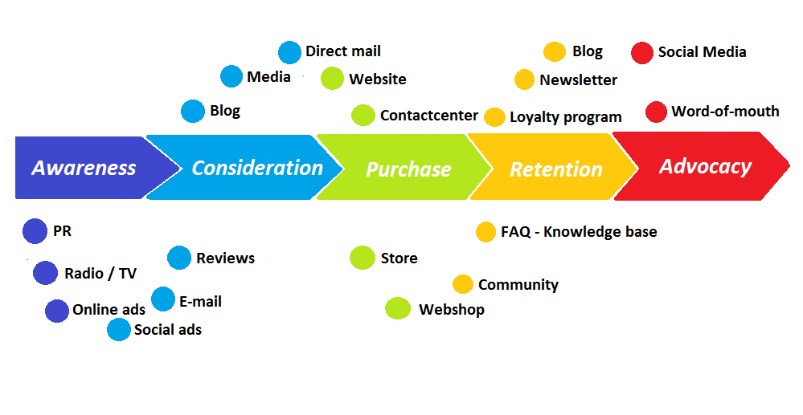
Figure 7: Customer Journey with Touchpoints
In case of Marks and Spencer, customer touch points may happen before purchase through various advertisement, word-of-mouth and in-store displays, during purchase through in-store displays and advertisements on the website and after purchase through follow-ups, customer feedback and customer services. As we go through the map, we can see how customers are starting to become aware of the brand or products. For example, an individual happens to pass by the M&S store and sees a clothing display. The interest sparked by the display can get the customer to detour and visit the store. As the person goes through the displays, he/she sees more products which initiates the sales process. After purchasing the product and having experience the quality M&S produces, the customer develops a bond with the company, repeats purchase and promotes the brand to friends and family members. In each of these touchpoints, advanced strategy must be exercised in order to establish stronger customer relationship.

Conclusion
It can be concluded that in line with the strategies implemented to combat the challenges organisations face in the ever-changing and competitive business environment, it is necessary to give importance to the customer experience throughout the journey and touchpoints. In doing so, marketing strategies can be improved to contribute in raising brand awareness thus achieving organisational goals and objectives.

References
- Aaker, D.A. (2009) Managing Brand Equity. New York: Free Press.
- Assali, I.M. (2016) ‘The Impact of Brand Name on Consumer Procurement’, International Journal of Engineering Research & Technology, Vol. 5, No. 1, pp. 225-229. ISBN: 2278-0181.
- BBC (2021) The Marketing Mix. Available at: https://www.bbc.co.uk/bitesize/guides/zj9rgwx/revision/4 (Accessed: 5th January 2021).
- BBC News (2020) Netflix Gets 16 Million New Sign-ups Thanks to Lockdown. Available at: https://www.bbc.co.uk/news/business-52376022 (Accessed: 5th January 2021).
- Burger, M. (2012) Brand Equity and Brand Value: Explanation and Measurement. Norderstedt: Books on Demand.
- Corey, A.M. (2021) The Evolution of Human Communication: From Theory to Practice. Available at: https://ecampusontario.pressbooks.pub/evolutionhumancommunication/chapter/chapter-1/#:~:text=The%20three%20most%20well%20known,parts%20of%20the%20communication%20process. (Accessed: 4th January 2021).
- Doyle, C. (2011) A Dictionary of Marketing. Oxford: Oxford University Press.
- Dwyer, J. (2019) The Business Communication Handbook. 11th edn. Victoria: Cengage.
- Hayes, A. (2020) Brand Equity. Available at: https://www.investopedia.com/terms/b/brandequity.asp (Accessed: 5th January 2021).
- Hur, W.M., Ahn, K.H. and Kim, M.S. (2011) ‘Building Brand Loyalty Thgrough Managing Brand Community Commitment’, Management Decision. Vol. 49, No. 7, pp. 1194-1213. DOI: 10.1108/00251741111151217.
- Jones, R. (2017) Branding: A Very Short Introduction. Oxford: Oxford University Press.
- Keller, K.L. and Swaminathan, V. (2021) Strategic Brand Management: Building, Measuring, and Managing Brand Equity. 5th edn. Harlow: Pearson.
- Kitchen, P. and Burgmann, I. (2015) ‘Integrated marketing communications: Making it work at a strategic level’, Journal of Business Strategy. Vol. 36, No. 4, pp. 34-39. DOI: 10.1108/JBS-05-2014-0052.
- Maechler, N., Neher, K. and Park, R. (2016) From Touchpoints to Journeys: Seeing The World as Customers Do. Available at: https://www.mckinsey.com/business-functions/marketing-and-sales/our-insights/from-touchpoints-to-journeys-seeing-the-world-as-customers-do# (Accessed: 5th January 2021).
- Marks and Spencer (2021) Responsible Marketing. Available at: https://corporate.marksandspencer.com/sustainability/business-wide/responsible-marketing (Accessed: 5th January 2021).
- Merriam-Webster Incorporated (2021) ‘Communication’ Available at: https://www.merriam-webster.com/dictionary/communication (Accessed: 4th January 2021).
- Pickton, D. and Broderick, A. (2005) Integrated Marketing Communications. 2nd edn. Harlow: Pearson.
- Qualtrix (2021) Keller Vs. Aaker customer based brand equity models. Available at: https://www.qualtrics.com/uk/experience-management/brand/keller-vs-aaker/ (Accessed: 5th January 2021).
- Siwiec, S. (2019) Brand Awareness Vs. Brand Equity? Know the Difference and How to Measure Them. Available at: https://www.latana.com/post/brand-equity-brand-awareness-guide (Accessed: 5th January 2021).
- Spectrio (2020) Improve Your Customer Journey with Touchpoint Mapping. Available at: https://blogs.spectrio.com/improve-your-customer-journey-with-touchpoint-mapping (Accessed: 5th January 2021).
- Varey, R.J (2002) Marketing Communication Principles and Practice. London: Routledge.
- West, R. and Turner, L.H. (2007) Introducing communication theories: Analysis and application. 3rd edn. New York: McGraw-Hill.
- Wind, J. (2005) ‘Marketing as an engine of business growth: a cross-functional perspective’, Journal of Business Research, Vol. 58, pp. 863-873. DOI: 10.1016/j.jbusres.2004.01.002.

