
Skills for the Workplace
Module Assignment Submission
Student Name: | Callum Jennings
Student Number: | 2007363
Module No: | BMSK5001
Module Title: | Developing Workplace Critical Thinking

Statement of Confirmation of Authenticity
By the act of making this submission, the student declares that this is the work of the student named above. The work has not, in whole or in part, been knowingly presented elsewhere for assessment, or where assessment has been built on a previous assessment, this has been identified. Where materials have been used from other sources it has been properly acknowledged. If this statement is untrue, the student acknowledges that an assessment offence has been committed.
Attention is drawn to the plagiarism and unfair practice policies of both the University and of ILM.

Table of Contents
Section 1: Introduction 3
Section 2: What is critical thinking? 3
Section 3: Beliefs, Values, Attitudes and Behaviours 4
Section 4: Personal test 5
Section 5: Identifying Beliefs values attitudes and behaviors 7
Section 6: Different schools of management 8
Section 7: Management style for my current workplace 11
Section 8: Summary 11

Section 1: Introduction
Throughout this assignment, I will discuss different models used for critical thinking. Explaining how they are used and what steps are needed to be take in order to achieve the desired result. I will then move on to explain how to identify Beliefs, Values, Attitudes and Behaviours, and explain why understanding these things allows us to see if our core values and beliefs align with our organisations. Different schools of management will also be discussed, including how the two different style compare to one another and talk about which one I prefer and why. The final section will involve the discussion of the management style that is used within my current role to manage me as a worker and how it compares to the management style I used whilst managing my own team.

Section 2: What is critical thinking?
Critical thinking is the ability to analyse and evaluate information that is given to you and being able to decide what to believe and how to act with that information. To do this you may, analyse a subject form both sides, understand the data fully in different contexts and to look at things from different angles. (Cebollero, n.d.) discusses three main characteristics of a critical thinker, these are,
- Being quick and decisive.
This is a fundamental trait that any team leader or manager needs to be able to effectively lead their team. There are times
where a decision needs to be given and to be given straight away, however, this does not mean that the decision should be made just for the sake of making it. As this leads to weak idea implementation and the decision that was made to fall flat.
- Being resourceful and creative.
Team members being able to approach their team leader with any issues and seeing their managers listen to the problem, work on analysing their dilemma and think freely will instil confidence that their manager cares.
- Being systematic and organized.
When critical thinking meets problem solving, sometimes taking a moment to stand there and take a systematic approach can make all the difference. By using critical thinking, you will be able to define the problem, write down a list of solutions, implement them and evaluate them affectively.
System thinking as explained in blog by (Davies, 2022) looks at connected wholes rather than separate parts. People who are systems thinkers are curious, have open minds, are good listeners and seek out root causes.
Systems thinking uses a similar model as seen below to see how each causing factor is connect with one another.
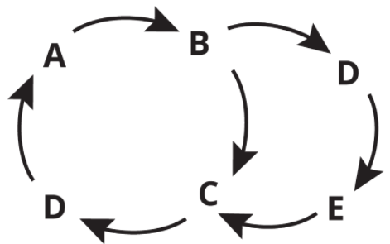

As an example, if a piece of machinery had one bad gear that kept breaking, systems thinkers, instead of continuously changing that gear, would look at what is causing that gear to constantly fail, for example, environmental factors like what temperature is the room that the machine is kept in and the sanitation of the machine, maintenance factors such as, lubrication, cleanliness.

Another common model used for critical thinking is the R.E.D Model (Talentlens, n.d.)
Which breaks down critical thinking into three separate stages.
R, stands for, Recognise assumptions. This means the critical thinker has the ability to separate facts from opinions.
E, stands for, Evaluate arguments. Which is being able to systematically walk-through various arguments and information thoroughly to get all relevant details. Being able to evaluate arguments is also the ability to step back and recognise that emotion will have an effect on one person’s opinion
D, stands for, Draw conclusions. People who possess this skill are able to bring diverse information together and arrive at a conclusion that logically follow from the available evidence.
In conclusion both of these models use the same steps in trying to get to the root cause of an issue. Systems thinking and Pearsons R.E.D model, allows the person using them to take a step back and find the underlying cause of the issue that has arisen. Thinking step by step and looking at how they got to the problem as supposed to just fixing the issue at hand.

Section 3: Beliefs, Values, Attitudes and Behaviours
Using the diagram below, which was taken from (Immigration advisers’ authority, 2018)
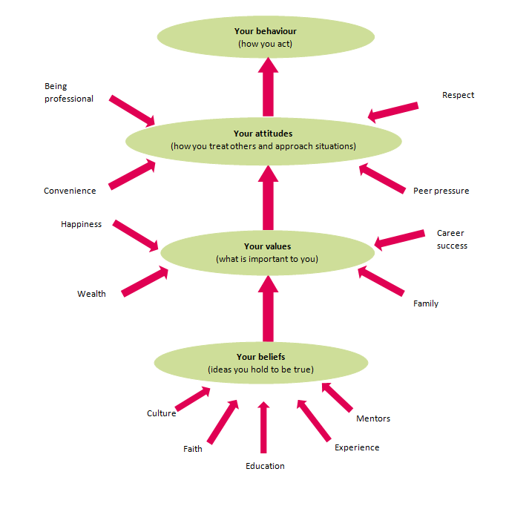
It becomes easier to see how Beliefs Values Attitudes and Behaviours impact each other.
What is a Belief?
A belief is an idea that a person holds as being true. A belief can stem from many diverse sources including:
- A person’s own experiences.
- Religion.
- What other people say, such as education or mentoring, including parents.
What is personal Value?
Values are stable and long-lasting beliefs about what is important to a person. A belief will develop into a value when the persons commitment to it grows, and they see it as being something to live by and find it especially important to them.
What is an Attitude?
Attitude is the frame of mind or mindset of someone based on their beliefs and values.
What is Behaviour?
Behaviour is the physical response to the psychological attitude of a person. (M.S, 2013) states that behaviour is an action, activity, or process that can be measured or observed.

Section 4: Personal test
One way of finding out what your own personal values is with (Barrett Values Centre, 2019)
Barret uses and talks about seven levels of consciousness and that every human develops within these seven well defined areas. Each area they talk about focuses on a particular need that is common to all people and that the level of growth and development of an individual depends on their ability to satisfy these needs. They also talk about how values can be positive in helping an individual grow or they can be fear-based or limiting. For example, honesty, trust, and accountability are positive values, whereas blame, revenge and manipulation are potentially limiting or fear-based values. These seven stages are –
- Survival – Satisfying our physical and survival needs. fear, I do not have enough.
- Relatioship – Feeling protected and loved. Fear, I am not loved enough.
- Self-esteem – feeling a sense of self-worth. Fear, I am not enough.
- Transformation – letting go of fears. The courage to develop and grow.
- Internal cohesion – finding meaning in existence.
- Making a difference – making a positive difference in the world.
- Service – selfless service.
These seven levels are then divided into three categories,
Levels one to three is category one, or self-interest. Barret talks about how Survival, Relationship and Self-esteem, focuses on our own personal self-interest. They continue to talk about how our need for love and belonging and need to feel good about ourselves through the development of a sense of pride in who we are, leads to no sense of lasting satisfaction from being able to meet these needs, but also feeling a sense of anxiety if these needs are not met.
Level four is category three, which is also known as the transformation category. This part focuses on letting go of fears. This shows that during this stage in our development we establish a sense of our personal authority and our own internal voice. This is where our values and beliefs that we choose to live by start to resonate within us.
The final category includes levels five through to seven. These three stages create the ‘common good’ levels of awareness. This section talks about internal cohesion and focuses on our need to find meaning and purpose in our lives. This category explains that we express that meaning by striving to make our world a better place and by leading a life of selfless service. Within these areas of common good, we develop our inner compass that guides us into making life affirming decisions.
This is what these seven levels and three categories looks like –
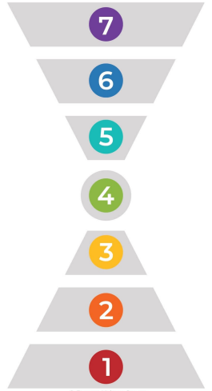
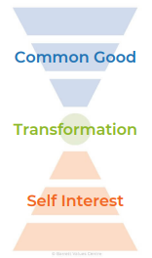
Too first start this assessment I was first asked to pick ten values/behaviours that most reflected who I am, not who I desire to become. This allows for the assessment to accurately place my values within the correct categories and make the assessment as accurate as possible.
My ten choices and their levels and categories were –
Values/Behaviours | Level | Category
Balance (Home/work) | 4 | Transformation
Entrepreneurial | 4 | Transformation
Financial stability | 1 | Self interest
Friendship | 2 | Self interest
Humour/fun | 5 | Common good
Leadership | 6 | Common good
Making a difference | 6 | Common good
Personal growth | 4 | Transformation
Wealth | 1 | Self interest
Well-being | 6 | Common Good

To visualise this easier this is how my results looked -

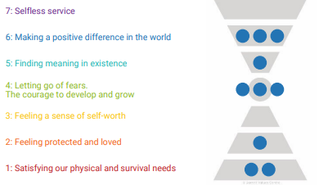
Understanding our values and beliefs helps us better understand ourselves and why we may act, react, and behave in the way that we do. An example of this would be, if someone were to undermine one of your values, it can result in feelings of hurt; you would be likely to feel upset if your value of balance (work/home) were not being met by your employer or by someone else. The same can be said if you were to make a decision which goes against one of your values, this may lead to a feeling of unease or unsettledness about the decision due to the fact that you would not be true to yourself or your core values.

Section 5: Identifying Beliefs values attitudes and behaviors
Being able to identify beliefs, values, attitudes, and behaviors within employees is crucial for mangers within the workplace. It allows for team leaders and managers to effectively and efficiently keep the workforce motivated and willing to produce the best performance possible. This is due to the fact that, having a team of people, who’s values, and beliefs align with the companies values and beliefs leads to team members with
- Motivation – the degree to which an employee directs energy towards their work.
- professionalism – employees who adhere to the norms of a profession and organization.
- Diligence – The amount of care an employee takes when executing their responsibilities and,
- Change agents – employees who embrace and create change.
One theory that is commonly used to help Identify behaviors within team members is the iceberg analysis. (OnlineTraining, 2016) talks about how Eric Schopler an American professor of psychiatry and psychology first used this theory in 1994, to help illustrate the idea that the reasons for a particular behavior in some people may be because they have autism. The theory itself as explained by (Towerstone, 2017), is that behaviors and results reflect things that can been seen with an individual or ‘above the waterline’, while ‘below the waterline’ reflects on what drives those actions, behaviors, and results. In a whole, the iceberg theory demonstrates that behaviors and results are only what can be seen and can only be taken at face value and shows that there is a much deeper meaning and reason as to why a person acts, the way that they do. The iceberg theory looks like this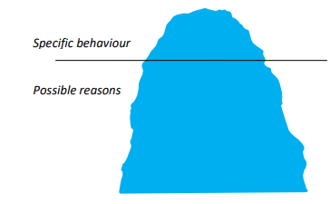

Section 6: Different schools of management
Scientific Management.
Over time, different schools of management have been developed as the way that companies work evolves. Some examples of this would be
(Taylor, 1911) – Fredrick Winsolw Taylor, was the first person to recognize and emphasize the need for adopting a systematic scientific approach to the task of managing an enterprise.
“Scientific management approach is an art of knowing exactly what you want your men to do and seeing that they do it in the best and cheapest way” ~ Fredrick W. Taylor.
In 1909, Taylor published “The principles of scientific management.” In this, he proposed that by optimizing and simplifying jobs, productivity would increase. What was different about his theory compared to others that were around at that time, was that he proposed that workers and their managers needed to communicate and cooperate with one another. This was vastly different from the way that work was typically done in business beforehand. Before this theory was introduced into the workplace, managers had no contact with their workforce and left them alone to produce the necessary product. There was no standardization and a worker’s main motivation was often continued employment, so there was no incentive to work as quickly or as efficiently as possible.
Taylor believed that all workers were motivated by money, so he promoted the idea of ‘A fairs day’s pay for a fair day’s work.’ Essentially, if a worker did not achieve enough in a day, he did not deserve to be paid as much as a worker who was achieving set targets and was highly productive. After concluding many tests within the workplace, such as, ‘Time and Motion’ testing as explained by (Time and Motion Studies to Improve Productivity, n.d.) Productivity is linked to time and motion. Excessive motion is a waste of time, its more tiring and it adds cost. One thing Taylor recognised is that improving productivity is often about reducing wasted movement and time. Nearly all human work, other than thinking time, is about motion and movement: Fingers, limbs, body movement, material movement, operating equipment etc. Taking what he learned from these workplace experiments, Taylor developed four principles of scientific management. These principles are simply known as “Taylorism”
Taylors four principles are as follows:
1) Replace working by “rule of thumb,” or simple habit and common sense, and instead use the scientific method to study work and determine the most efficient way to perform specific tasks.
2) Rather than simply assign workers to just any job, match workers to their jobs based on capability and motivation, and train them to work at maximum efficiency.
3) Monitor worker performance and provide instructions and supervision to ensure that they are using the most efficient ways of thinking.
4) Allocate the work between managers and workers so that the manager spend their time planning and training, allowing the workers to perform their tasks efficiently.
Behavioural Management.
A different school of management is known as behavioural management, and in 1924, Elton Mayo started to use behavioural management in and experiment with Western Electric Company’s Hawthorn Works in Cicero, Illinois. This was to aid their goals, which was to “Inspire company loyalty, discourage high employee turnover and unionization, and present a good face to the public.”
As explained by (Ward, 2021) these experiments were known as the Hawthorn Experiments.
The Hawthorn experiments consisted of illumination tests that set out to determine the effects of lighting on worker efficiency. Once these tests were completed in 1927, new studies began, this time examining the impact of break times or rest periods and work hours on production levels. These tests fell in line with Mayo’s management theory, as Mayo believed that workers and employees are less motivated by money, benefits, or environmental factors. Instead, Mayo believed that to create a successful workplace, an employer needs to create positive relational factors. Mayo believed that employees are more motivated by camaraderie or positive attention, rather than a nice place to work with a good paycheck. Elton Mayo created a matrix, which could be used to demonstrate how groups of people or workers react in different situations. The matrix looked like this -
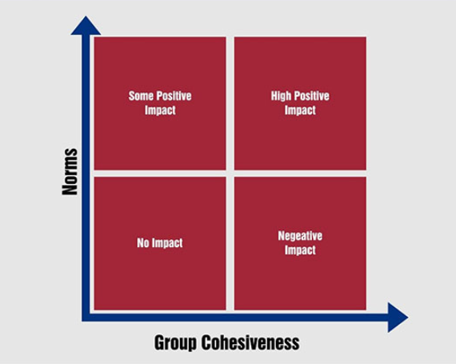
(Elton Mayo’s Theory of Management Explained - HRF, 2017) breaks down the four categories as follows –
Section one –
Groups with low cohesiveness and low norms are ineffective.
Groups like this have no impact because they have no motivation to succeed. A group within this category would not likely coexist for very long because no one in the group would be motivated to be productive in anyway
Section two –
Groups with low norms and high cohesiveness have a negative impact. This is because it is negative behaviours that are encouraged instead of positive. Within this section the terms ‘Gangs’ is often used as a typical example of this section. This can lead to doing a job poorly on purpose along with gossiping and cliques being formed.
Section three-
Groups with high norms and low cohesiveness can have a limited impact.
People who fall into this category will work well and have somewhat of a positive impact, however, the results will be limited due to individuals within the group would only focus on their own goals as supposed to focusing on the overall success of the team.
Section four –
Groups with high norms and high cohesiveness make the greatest positive impact.
This is due to the fact that group members would encourage each other to succeed, leading focus to be directed to individual responsibility to the job and the team. This teamwork would create supportive network so that everyone could excel equally.
In conclusion to the different management theories, the difference between Elton Mayo’s behavioural management and Fredrick Taylor’s Scientific management is polar opposite. One focuses on environmental factors such as, production floor layout, equipment usage and standardization, while behavioural focuses on cohesiveness and how well each member works with one another. In my opinion, I believe that both methods should be used together in order to manage a team effectively and efficiently within the modern workplace. Scientific management is a great starting point for all managers and team leaders that have control over standardization within their organization, I believe that this management style is the foundation of any strong organization. Then introducing behavioural management in order to get a compatible team that works well with one another should be the next step. Pairing these two methods I believe will lead to great production and positive results.

Section 7: Management style for my current workplace
My current role within my organisation is Quality inspector. My primary role includes and is not limited to,
1) The inspection of incoming parts.
2) The overall monitoring of processes and checking everything falls in-line with our compliance regulations.
3) Continued support throughout the organisation within different departments.
4) The checking of finished and built products and checking that they all meet customer requirements via customer work instructions.
5) Completing root cause analysis documents when finding something that is incorrect and reporting back to my manager and team leader with the relevant information. This then leads to launching an investigation into why, where, who, and what caused the issue or ‘fail.’
I also have a secondary role within the organisation that follows loosely the same requirements.
The management style that is used by my manager specifically within the Quality department I would say is more scientific, which in my opinion is only affective up to a certain point. While it is fundamental for my department to look and standardization and order within the production process. The Quality department is small team, and in my opinion, when a team is small, I believe that cohesion is fundamental to a teams success. Comparing this to my previous roll, in which I was a team leader and shift runner. I continuously used the behavioural management style by Elton Mayo. Working in a fast-paced environment where a breakdown in communication would have a detrimental impact on production, I believed that it was imperative that all team members enjoyed working together and that they all shared an end goal or target, as supposed to individual success. This method allowed me to continuously reach set targets from my supervisors.

Section 8: Summary
As stated previously, I believe that both, Scientific and Behavioural management theories should be used to continuously achieve the highest possible team efficiency. However, my personal preference for a management theory is behavioural. I am a strong believer in having a strong team that can both work individually but also together, and that it is fundamental that high cohesiveness alongside high norms is achieved and this the best way to do that. Using this theory with the Barret test to identify peoples Beliefs and Values is a strong combination to use in order to create a strong team.

Cebollero, C. (n.d.). Forbes Coaches Council Post: The Seven Key Steps Of Critical Thinking. Forbes. Retrieved March 11, 2022, from https://www.forbes.com/sites/forbescoachescouncil/2018/04/20/the-seven-key-steps-of-critical-thinking/?sh=7e4076536a52
Davies, L. (2022, March 2). What is systems thinking. Phoenix Blog. https://www.phoenix.edu/blog/what-is-systems-thinking.html#:~:text=By%20one%20definition%2C%20systems%20thinking%20is,literally%20a%20system%20of%20thinking%20about%20systems.
Talentlens, P. (n.d.). Critical Thinking is the ability to look at a situation and understand it from multiple perspectives whilst separating facts from opinions and assumptions. Www.talentlens.com. https://www.talentlens.com/uk/career-development/critical-thinking-hub.html
Immigration advisers authority. (2018, May 14). Personal beliefs, values, attitudes and behaviour - Immigration Advisers Authority Your tagline here. Immigration Advisers Authority; Immigration Advisers Authority. https://www.iaa.govt.nz/for-advisers/adviser-tools/ethics-toolkit/personal-beliefs-values-attitudes-and-behaviour/
M.S, N., Pam. (2013, April 7). What is BEHAVIOR? definition of BEHAVIOR (Psychology Dictionary). Psychology Dictionary. https://psychologydictionary.org/behavior/
Barrett Values Centre. (2019). Personal Values Assessment (PVA) - Barrett Values Centre. Barrett Values Centre. https://www.valuescentre.com/tools-assessments/pva/
OnlineTraining. (2016). The Iceberg Analysis ASD Resource Section: Assessment Specific behaviour Possible reasons. http://www.wannerooeducationnetwork.net/wp-content/uploads/2017/12/The-Iceberg-Analysis-.pdf
Towerstone. (2017, June 28). The Iceberg of Human Behaviour. TowerStone Leadership Centre. https://www.towerstone-global.com/iceberg-human-behaviour/#:~:text=The%20Iceberg%20of%20Human%20Behaviour%20Jun%2028%2C%202017
Taylor, F. W. (1911). The principles of scientific management. Createspace.
Time and motion studies to improve productivity. (n.d.). Scott-Grant Limited. Retrieved March 26, 2022, from https://scott-grant.co.uk/Productivity-explained/time-and-motion/?utm_source=bing&utm_medium=cpc&utm_campaign=AP%20%7C%20Time%20%26%20Motion&utm_term=time%20in%20motion&utm_content=Time%20%26%20Motion%20Study%20-%20Exact
Ward, P. (2021, August 29). Elton Mayo Management Theories. NanoGlobals. https://nanoglobals.com/glossary/elton-mayo-management-theories/#fn:1
Elton Mayo’s Theory of Management Explained - HRF. (2017, March 23). HRF. https://healthresearchfunding.org/elton-mayos-theory-of-management-explained/

