

Machine Learning Assignment One

Paul Newman 1805494
ACCA7025
Mark Huntly

Contents
Naïve Bayes for Efficient Sentiment Classification 5
Logistic Regression for Balanced Performance and Efficiency 7
Support Vector Machines for High Accuracy with Moderate Cost 9
Recommended Model for Sentiment Analysis 11
Support Vector Machines (SVM) 12
Detailed Implementation Workflow (SVM Sentiment Analysis) 13
Abstract 16
Bibliography 17

Figure 1 Naive Bayes [3] 5
Figure 2 Logistic Regression [3] 7
Figure 3 Support Vector Machines [7] 9

Introduction
This report investigates the use of traditional machine learning techniques for sentiment analysis in the context of a marketing company seeking a cost-effective solution. It reviews relevant literature on commonly used algorithms, including Naïve Bayes, Logistic Regression, and Support Vector Machines, and evaluates their strengths and limitations. A structured machine learning workflow is presented, covering data preprocessing, feature extraction, model training, and evaluation. The aim is to recommend a simple, efficient, and reliable model for sentiment classification without compromising predictive performance.
In today’s digital marketplace, large volumes of customer feedback are generated through online reviews, social media platforms, and e-commerce systems. This unstructured textual data provides valuable insight into customer opinions, preferences, and overall satisfaction. Sentiment analysis, also known as opinion mining, is a technique within natural language processing (NLP) that aims to automatically classify text as positive, negative, or neutral. For marketing organisations, accurate sentiment analysis can support data-driven decision making, improve customer experience, and enhance brand strategy.
Machine learning (ML) has become a key approach for sentiment classification due to its ability to learn patterns from textual data and generalise to unseen inputs. Although deep learning methods have gained popularity for their high performance, they often require significant computational resources and large datasets, making them unsuitable for smaller organisations or resource-constrained environments. In contrast, traditional machine learning algorithms offer a more efficient and interpretable alternative while still achieving competitive results in many text classification tasks.

Naïve Bayes for Efficient Sentiment Classification
Early research in sentiment analysis established the Naïve Bayes classifier as one of the most effective and computationally efficient approaches for text classification tasks. In particular, the foundational work by Bo Pang and Lillian Lee [1], demonstrated that Naïve Bayes can successfully classify movie reviews into positive and negative sentiment categories using relatively simple feature representations such as bag-of-words. Their study highlighted that even with minimal preprocessing and feature engineering, traditional machine learning models can achieve competitive performance in sentiment analysis tasks [1].
The Naïve Bayes classifier operates on the principle of conditional probability, assuming independence between features given a class label. While this “naïve” assumption does not always hold true in natural language, it significantly reduces computational complexity, making the model highly scalable and efficient. This characteristic is particularly important for applications involving large volumes of textual data, such as customer reviews, where rapid processing and low resource consumption are essential. As a result, Naïve Bayes remains a popular choice in real-world systems where computational constraints are a key consideration [2].
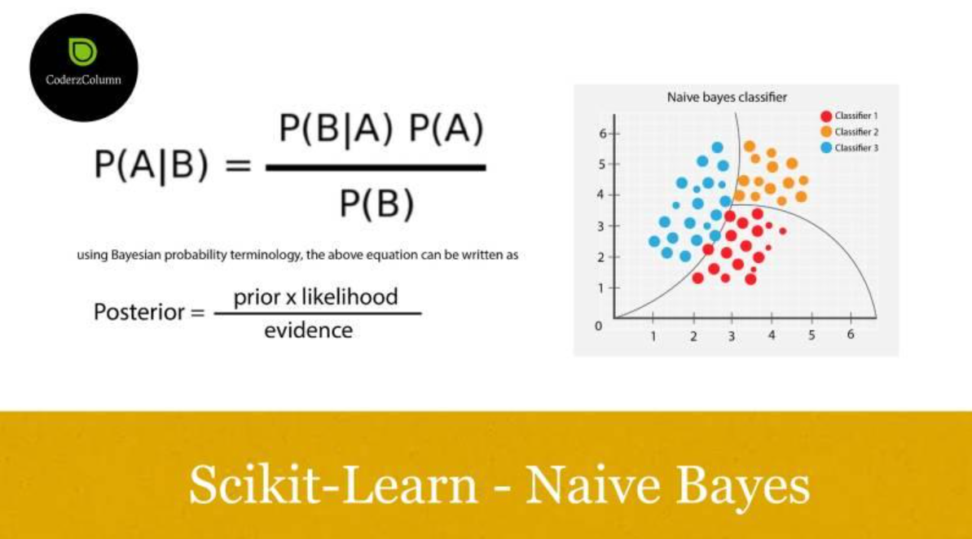
Figure 1 Naive Bayes [3]
Further research has supported the effectiveness of Naïve Bayes in sentiment classification. For example, Andrew McCallum and Kamala Nigam [2] demonstrated that probabilistic classifiers, including Naïve Bayes, perform well across a range of text categorisation problems, particularly when combined with appropriate feature selection techniques. Their findings suggest that despite its simplicity, Naïve Bayes can achieve robust performance when applied to high-dimensional text data.
In addition to binary classification, Naïve Bayes has also been extended to multi-class sentiment analysis, enabling classification into positive, negative, and neutral categories. Although the model may struggle with more nuanced language features such as sarcasm or context-dependent meanings, its speed and ease of implementation make it highly suitable as a baseline model in sentiment analysis workflows. Moreover, its interpretability allows practitioners to understand the contribution of individual features, which is beneficial in business contexts where transparency is important [2].
However, despite its advantages, Naïve Bayes is often outperformed by more sophisticated models such as Logistic Regression and Support Vector Machines in terms of predictive accuracy. This limitation is largely due to its simplifying assumptions, which may overlook complex relationships between words in a sentence. Nevertheless, its low computational cost, fast training time, and strong baseline performance ensure that it continues to play a significant role in sentiment analysis research and practical applications, particularly in scenarios where efficiency is prioritised over marginal gains in accuracy [1].

Logistic Regression for Balanced Performance and Efficiency
The Logistic Regression algorithm has been widely adopted in sentiment analysis due to its ability to provide a strong balance between predictive performance and computational efficiency. Unlike more complex models, Logistic Regression is relatively simple to implement and scales well to large datasets, making it particularly suitable for real-world applications involving large volumes of textual data such as customer reviews. Its effectiveness in text classification tasks has been extensively documented in the literature, particularly when combined with appropriate feature extraction techniques [4].
A key study by Christopher D. Manning, Prabhakar Raghavan, and Hinrich Schütze [4] highlights the importance of feature representation in natural language processing tasks. Their work demonstrates that Logistic Regression performs particularly well when used with Term Frequency–Inverse Document Frequency (TF-IDF) features, which capture the importance of words within a document relative to a corpus. This combination allows the model to effectively distinguish between positive, negative, and neutral sentiment by assigning appropriate weights to relevant terms.
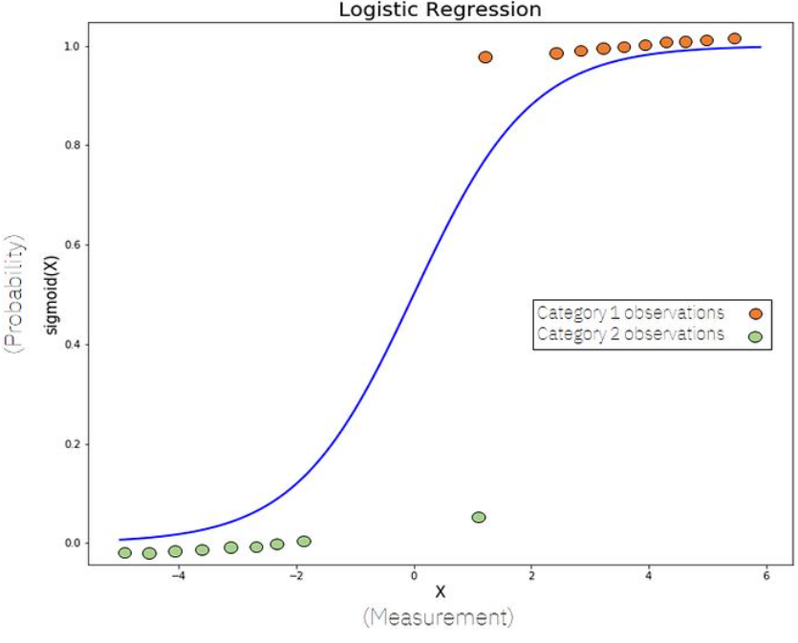
Figure 2 Logistic Regression [3]
One of the primary advantages of Logistic Regression is its ability to handle both binary and multi-class classification problems. In the context of sentiment analysis, this makes it well-suited for classifying customer reviews into multiple sentiment categories without requiring significant modifications to the model structure. Additionally, the model produces probabilistic outputs, which provide insight into prediction confidence and support more informed decision-making in business environments [4].
Further research has shown that Logistic Regression often outperforms simpler models such as Naïve Bayes in terms of accuracy, particularly when dealing with more complex or nuanced text data. For example, studies by Jason Brownlee [5]indicate that linear models like Logistic Regression can capture relationships between features more effectively than probabilistic models that rely on independence assumptions. This results in improved classification performance while maintaining relatively low computational overhead.
Another important advantage of Logistic Regression is its interpretability. The model assigns weights to each feature, allowing practitioners to identify which words or terms contribute most strongly to a given sentiment classification. This transparency is particularly valuable in marketing applications, where understanding the drivers behind customer sentiment is as important as the prediction itself [5].
Despite its strengths, Logistic Regression is not without limitations. It assumes a linear relationship between features and the log-odds of the outcome, which may not fully capture complex linguistic patterns. However, in many practical scenarios, especially those involving structured text representations such as TF-IDF, this limitation has minimal impact on performance. When considering its overall balance of accuracy, efficiency, scalability, and interpretability, Logistic Regression remains one of the most effective traditional machine learning approaches for sentiment analysis, particularly in resource-constrained environments [5].

Support Vector Machines for High Accuracy with Moderate Cost
The Support Vector Machines (SVM) algorithm is widely recognised as a powerful method for text classification and has been extensively applied in sentiment analysis. SVMs are particularly effective in handling high-dimensional data, which is a common characteristic of textual datasets where each unique word may represent a feature. This capability makes SVMs well-suited for classifying customer reviews into sentiment categories such as positive, negative, and neutral, especially when combined with feature extraction techniques like TF-IDF [6].
A foundational study by Thorsten Joachims [6] demonstrated the effectiveness of SVMs in text categorisation tasks. His work showed that SVMs often outperform traditional probabilistic models, such as Naïve Bayes, in terms of classification accuracy. This is largely due to the SVM’s ability to find an optimal decision boundary (hyperplane) that maximises the margin between different classes, leading to improved generalisation on unseen data. As a result, SVMs have become a popular choice in applications where predictive performance is a primary concern [6].
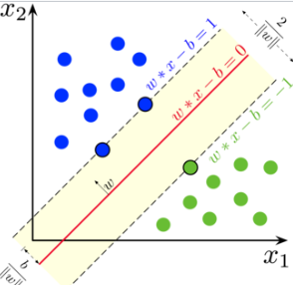
Figure 3 Support Vector Machines [7]
Further research has reinforced the suitability of SVMs for sentiment analysis. For instance, Fabrizio Sebastiani [8] highlighted that SVMs consistently deliver strong performance across a variety of text classification benchmarks. Their robustness in high-dimensional feature spaces allows them to effectively capture patterns in language, even when the number of features greatly exceeds the number of training samples. This makes them particularly advantageous when dealing with sparse text representations such as bag-of-words or TF-IDF matrices [6] [8].
Despite these advantages, SVMs come with certain limitations, particularly in relation to computational efficiency. Training an SVM model, especially with large datasets, can be significantly more resource-intensive compared to simpler algorithms like Logistic Regression or Naïve Bayes. The complexity increases further when using non-linear kernels, which are often required to capture more complex relationships in the data. This can lead to longer training times and higher memory usage, making SVMs less suitable for organisations with limited computational resources [8].
Additionally, SVMs are generally less interpretable than linear models such as Logistic Regression. While they provide strong predictive performance, understanding the contribution of individual features to the final classification can be more challenging. In business contexts, where transparency and explainability are important, this can be a disadvantage [8].
Overall, Support Vector Machines offer high accuracy and robustness in sentiment classification tasks, particularly in high-dimensional text data. However, their increased computational cost and reduced interpretability may limit their practicality in resource-constrained environments. As such, while SVMs represent a strong candidate for sentiment analysis, they may not be the most efficient choice when simplicity and scalability are key requirements [8].

Recommended Model for Sentiment Analysis
Based on the requirements of the marketing company—specifically the need for a lightweight, efficient, and reliable solution—Logistic Regression is recommended as the most suitable model for sentiment analysis. This recommendation is supported by both the literature review and the practical constraints of operating within a resource-limited environment.
Logistic Regression offers a strong balance between classification performance and computational efficiency, making it particularly well-suited for text classification tasks. When combined with feature extraction techniques such as Term Frequency–Inverse Document Frequency (TF-IDF), the model can effectively capture the importance of words within customer reviews and distinguish between positive, negative, and neutral sentiment. Unlike more complex models, Logistic Regression requires relatively low computational power, allowing it to be trained and deployed quickly without the need for specialised hardware.
In addition to its efficiency, Logistic Regression provides a high level of interpretability. The model assigns weights to individual features, enabling practitioners to identify which words or terms contribute most significantly to sentiment classification. This is particularly valuable in a marketing context, where understanding the reasoning behind predictions can inform business decisions and improve customer engagement strategies.
Furthermore, Logistic Regression supports both binary and multi-class classification, making it flexible enough to handle a range of sentiment analysis scenarios. It also demonstrates strong generalisation performance, particularly when trained on well-preprocessed text data, reducing the risk of overfitting while maintaining reliable accuracy.
As a baseline comparison, the Naïve Bayes classifier may be considered due to its extremely fast training time and simplicity. However, while Naïve Bayes is computationally efficient, it often achieves lower accuracy due to its assumption of feature independence. Similarly, Support Vector Machines offer high predictive accuracy and are effective in high-dimensional spaces, but they typically require greater computational resources and longer training times, making them less suitable for environments where efficiency is a priority.
Overall, Logistic Regression represents the most appropriate choice, providing a practical and scalable solution that meets the company’s requirements for both performance and efficiency without unnecessary complexity.

Support Vector Machines (SVM)
Support Vector Machines (SVM) are identified as the most effective model among the three evaluated algorithms due to their superior classification performance in text-based tasks. SVMs are particularly well-suited to sentiment analysis because they can handle high-dimensional feature spaces, such as those produced by TF-IDF representations, and can identify an optimal separating hyperplane that maximises the margin between sentiment classes. This results in strong generalisation and high accuracy when predicting unseen data. Compared to Logistic Regression, which offers a good balance between efficiency and performance, SVMs typically achieve better results in more complex or nuanced datasets. While Naïve Bayes provides fast computation and simplicity, its assumptions limit its accuracy. Although SVMs require greater computational resources, their robustness and predictive power make them the most suitable choice when classification accuracy is the primary objective.

Detailed Implementation Workflow (SVM Sentiment Analysis)
- Problem Definition and Objective Setting
The first stage is to clearly define the objective of the system. In this case, the goal is to develop a sentiment analysis model capable of classifying customer reviews into positive, negative, and neutral categories. The system must also meet business constraints, including low computational cost and efficient processing. Defining this objective ensures that all later stages of the workflow are aligned with the practical needs of the marketing company.
- Data Acquisition and Selection
A suitable dataset must be identified and collected. This may involve sourcing data from publicly available datasets such as IMDB or Amazon reviews, or extracting data from social media platforms. The dataset must contain labelled examples, where each text entry is associated with a sentiment category. It is important to ensure that the dataset is sufficiently large to allow the model to learn meaningful patterns, and that it represents a variety of writing styles and sentiment expressions. Additionally, the dataset should be checked for class balance, as an uneven distribution of sentiment categories may lead to biased predictions.
- Data Cleaning and Preprocessing
Raw text data is often noisy and inconsistent, so it must be preprocessed before being used for modelling. This stage includes multiple sub-steps. First, all text is converted to lowercase to ensure consistency. Next, punctuation, numbers, and special characters are removed, as they typically do not contribute to sentiment meaning. Stopwords, such as “the” and “and,” are also removed to reduce noise in the data. The text is then tokenised, meaning it is split into individual words or tokens. Optionally, lemmatisation can be applied to reduce words to their base form (e.g. “running” becomes “run”). These steps improve the quality of the data input and enhance the performance of the model.
- Feature Engineering using TF-IDF
Machine learning models cannot process raw text, so it must be converted into numerical features. This is achieved using Term Frequency–Inverse Document Frequency (TF-IDF). TF-IDF assigns a weight to each word based on its importance within a document relative to the entire dataset. Words that appear frequently in a specific review but rarely across other reviews are given higher importance. This transformation results in a high-dimensional feature space, where each dimension represents a word. This representation is particularly suitable for Support Vector Machines, as they perform well with sparse and high-dimensional data.

- Dataset Splitting and Validation Strategy
To evaluate the performance of the model, the dataset must be divided into training and testing subsets. A common approach is an 80/20 split, where 80% of the data is used to train the model and 20% is used to test it. In addition, cross-validation techniques can be applied to further improve reliability. Cross-validation involves dividing the training data into multiple subsets and training the model multiple times, ensuring that the model generalises well and is not overfitted to a specific subset of the data.
- Model Training using Support Vector Machines
At this stage, the Support Vector Machine model is trained using processed data. A linear kernel is typically selected for text classification tasks, as it provides a good balance between performance and computational efficiency. The model learns to identify a decision boundary (hyperplane) that separates the different sentiment classes while maximising the margin between them. This process allows the model to generalise effectively to new, unseen data.
- Model Evaluation and Performance Measurement
Once trained, the model must be evaluated using the test dataset. Several evaluation metrics are used to assess performance. Accuracy measures the overall correctness of the model, while precision and recall provide insight into how well the model identifies specific classes. The F1-score combines precision and recall into a single metric, providing a balanced measure of performance. A confusion matrix can also be used to visualise how well the model distinguishes between different sentiment categories. These metrics are essential for determining whether the model meets the required performance standards.
- Model Comparison and Selection
Although SVM is the primary model, it is important to compare its performance with alternative approaches such as Logistic Regression and Naïve Bayes. This comparison helps validate the choice of model and demonstrates a thorough evaluation process. Typically, SVM achieves higher accuracy, while Logistic Regression offers faster computation, and Naïve Bayes provides a simple baseline. Based on this comparison, the most suitable model is selected according to both performance and business requirements.
- Deployment Strategy
After selecting the best model, the next step is deployment. This involves integrating the trained model into an application where it can process new customer reviews in real time. The system should accept user input, apply the same preprocessing and feature extraction steps, and then use the trained model to predict sentiment. The output can be displayed as a classification label or used to generate insights for the business.

- Monitoring, Maintenance, and Updating
Finally, the system must be monitored and maintained over time. Language and customer behaviour can change, so the model should be regularly updated with new data to maintain accuracy. Performance metrics should be continuously tracked to identify any decline in effectiveness. Retraining the model periodically ensures that it remains relevant and reliable in a dynamic environment.

Abstract
This report investigates the application of traditional machine learning techniques for sentiment analysis in the context of a marketing company seeking an efficient and cost-effective solution. The study focuses on classifying customer reviews into positive, negative, and neutral sentiment categories using lightweight models that minimise computational requirements. A review of relevant literature was conducted to evaluate commonly used algorithms, including Naïve Bayes, Logistic Regression, and Support Vector Machines.
A structured machine learning workflow was developed, incorporating data preprocessing, feature extraction using Term Frequency–Inverse Document Frequency (TF-IDF), model training, and performance evaluation. The models were compared based on key metrics such as accuracy, precision, recall, and F1-score, alongside computational efficiency.
The findings indicate that Support Vector Machines (SVM) provide the highest level of predictive performance, particularly when applied to high-dimensional text data. Their ability to maximise the margin between classes results in strong generalisation and improved classification accuracy compared to the other models. In contrast, Naïve Bayes offers faster computation but achieves lower accuracy due to its simplifying assumptions, while Logistic Regression provides a balanced approach with good performance and lower computational cost. Although SVM represents the best-performing model overall, its higher computational requirements may limit its suitability in resource-constrained environments. Therefore, Logistic Regression is recommended as the most appropriate model for practical deployment, as it offers an effective compromise between accuracy and efficiency.

Bibliography

[1] | L. L. a. S. V. B. Pang, " “Thumbs up? Sentiment classification using machine learning techniques,”," Proceedings of the ACL-02 Conference on Empirical Methods in Natural Language Processing, , pp. 79–86,, 2002.
[2] | A. McCallum and K. Nigam, " “A comparison of event models for Naïve Bayes text classification,”," AAAI-98 Workshop on Learning for Text Categorization,, pp. pp. 41–48, , 1998..
[3] | Scikit-learn, "scikit-learn.org/stable/modules/naive_baye," 2023. [Online]. Available: https://scikit-learn.org/stable/modules/naive_bayes.html?utm_source=chatgpt.com. [Accessed 30 4 2026].
[4] | P. R. a. H. S. C. D. Manning, "Introduction to Information Retrieval.," Cambridge: Cambridge University Press, , 2008..
[5] | J. Brownlee, "“Logistic Regression for Machine Learning,”," Machine Learning Mastery,, 2019..
[6] | T. Joachims, " “Text categorization with Support Vector Machines: Learning with many relevant features,”," Proceedings of the European Conference on Machine Learning (ECML), , pp. pp. 137–142, , 1998..
[7] | Wikipedia, " “Support-vector machine,”," 2023. [Online]. Available: https://en.wikipedia.org/wiki/Support_vector_machine. [Accessed 30 4 2026].
[8] | F. Sebastiani, " “Machine learning in automated text categorization,”," ACM Computing Surveys, , Vols. vol. 34, , no. no. 1, , pp. pp. 1–47, ., 2002.

