Conspiracy Theory Belief
Why are Conspiracies so appealing to the audience and what are the effects of believing?

Student Number = 1702029
BA Course title = Film and Television
Modul = ADAD6001
Research focus = Conspiracies and the effects on people
School = University Wales Trinity Saint David’s Swansea
Tutor Name = Robert Jones
Word count = 5

Submitted in partial fulfilment of the requirements for the degree of BA (Hons) University of Wales Trinity Saint David, Swansea, and the date of presentation (11th December 2019)
Abstract =
Conspiracy theories verses the true conspiracies; What are the differences? Is there a difference? Why is it important to not forget these differences? Do conspiracies evolve? And Why is it important to learn from the conspiracies of the past?
Conspiracies are intertwined through history, since the start of humanity and till the very end of life on earth there will be conspiracies and in therefore there will be conspiracy theorists who will reveal and spread them. However, there will also be people who will use fake conspiracies to destroy peoples lives and carriers. Here we discuss the reasons and the effects of believing in conspiracies and even not believing in conspiracies.

Introduction (587 words) =
Conspiracies are seen in one of two ways, often seen as something mysterious and exiting done only for movies or spy books, that or they are seen as merely jokes on the internet and impossible things. Many don’t think that it is something to worry about when really it is truly intertwined with history; something that is inescapable. Rome, 44B.C. a conspiracy by Nobles to murder the dictator of the Roman republic, Julius Caesar (History.com Julius Caesar’s forgotten assassin (2019)). November 5th, 1605, Guy Fawkes and his fellow conspirators attempt to blow up the British Parliament in London but are found out before they can (Sharp, J. Remember, Remember, A cultural History of Guy Fawkes day, November 5th, (2005)). In London again one-hundred and seventy-three people are trampled to death in Bethnal Green tube during the Blitz (1943), the next morning all evidence was wiped away, as if nothing had ever happened; Winston Churchill covered up the deaths and forced everyone involved into silence (Penn, B. History-UK.com Bethnal Green Tube Disaster (No date). American government sign off to allow the CIA to drug their own citizens in an attempt to control people’s minds (1964-73) (History.com, MK-Ultra 2018)
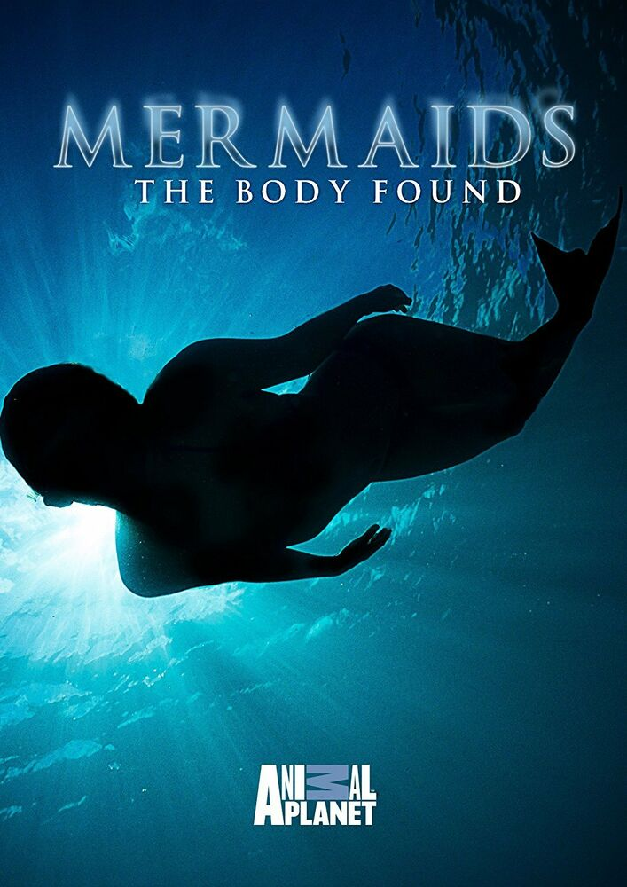
With the invention of the internet conspiracies have been more widespread and easier to debunk or to prove; the opposite can also be said, as fakes began popping up with no evidence to support them. “The Internet is far from the only medium in which conspiracy theories are aired. Mainstream news media expose people to conspiracy theories on a regular basis” (p.15, Ventsel, A.). Films and books are also responsible for this rise in popularity; documentaries such as ‘Super-size me’ (Spurlock, M. 2004), ‘Making a Murderer’ (Ricciardi, L. and Demos, M. 2015) and ‘Fahrenheit 911’ (Moore, M. 2004) are also responsible, each film mentioned is presented to the viewers as completely factual, however all three have lied numerus times about either statistics and results or by manipulating the editing and evidence wording to make the audiences believe everyone involved is being honest and trustworthy. ‘Mermaid: the body found’ (Bennett, S. 2012) was a mockumentary on Animal planet and the Discovery channel in America, however at no point did the show present the idea that this was a mockumentary. Many watched believing that this was a real documentary, after the ‘evidence’ was presented as fact to viewers. It wasn’t until after people sharing the film believing it that the creators and Animal Planet came forward apologizing for the film.
Fig 1. Mermaids: The Body Found Poster. Sid Bennet, 2012
This dissertation aims to analyse the complicated relationship between conspiracy and conspiracy theories in the first chapter, I aim to also mention some of the most popular conspiracy theories; some are more believable than others in the list. The second chapter is where I explore the reasoning behind people’s beliefs in conspiracies, also a brief discussion concerning the change in how and why conspiracies are created. Theories of this sort tend to change with the times and recently the conspiracies have had less evidence to support them, but more followers to support them. Finally, in the third chapter I move from the why to the what; what are the effects of conspiracy theories on the general populace? Here I will investigate how and if conspiracy theories affect us and in what ways, whether Directly and indirectly. Surprisingly, conspiracy theories aren’t all bad and can do some good for society, I will expand on this at a later date.

Chapter 1 (1000) = What are conspiracies?
Conspiracies and Conspiracy theories are often seen as interchangeable; however, the two words are wildly different entities with different meanings. For a start Conspiracies are defined as ‘A secret plan by a group to do something unlawful or harmful’ by the online Oxford dictionary. Conspiracies alone, on the other hand, are real life events through history from Governments, large corporations and large influential groups that effect the general public or hide information from the public for one reason or another. ‘Across history they have been closely linked to prejudice, witch hunts, revolutions, and genocide’ (Political Psychology, Understanding Conspiracy theories. Karen M. Douglas, 2019). The Tuskegee Syphilis experiment is a prime case example that was once orchestrated by the US Government from the 1930’s up to the 1970’s when the experiment was leaked to the press. The forty year experiment was created to observe the effects of untreated Syphilis in six hundred black men by offering treatment for ‘Bad Blood’ (a term that referred to a multitude of illnesses of the 1930’s). These people were compensated with free meals, health checks and free burial insurance; even after penicillin became the recommended treatment for syphilis. The experiment was unethical and unjust, however not the first and is far from being the last experiment of this kind (U.S. Public Health Service Syphilis Study at Tuskegee, Centres of Disease Control and Prevention).
A conspiracy theory is just that, a theory, defined as ‘A belief that some covert but influential organization is responsible for an unexplained event’ (Oxford dictionary) and that is what many forget, a conspiracy theory is just that, a theory. However, many take conspiracy theories as gospel, even without sufficient evidence. Theories were originally created to explain events that would other wise having missing information or information that is insubstantial, now the theory in conspiracy theory is gone, no longer being treated as that with many being created from the smallest coincidental evidence, making little to no sense. It has been “Recognized that there have indeed been actual conspiracies here and there in US history, but that a conspiracy theorist believes that there is ‘a vast or gigantic conspiracy as the motive force in historical events” (Knight, P. (2003)).
Another case following this trend is of Avril Lavigne. In the mid-2011’s a Brazilian blog post appeared and spread like wild-fire claiming that the singer had ‘reportedly committed suicide by hanging’ (Avril Lavigne died and was replaced by a double? (2011) in 2003 was quickly replaced by a clone named Malissa. News blogs soon dived on to the news and has even reached the singer who has since denied these claims. Evidence for these claims are circumstantial at best and straight up lies at worst. The ‘evidence’ for this claim is that around this time the singer’s style, appearance and attitude had changed; something that comes naturally with age (late teens). Since then the websites owned has come forward to correct people, the post was an experiment to prove a point; the point being nonsensical conspiracy theories spread too fast on the internet without any sort of fact checking.
When discussing conspiracies and conspiracy theories, you can’t neglect looking at some of the biggest throughout the world, this includes that JFK was assassinated by the US Government because they were afraid of the newest laws he planned to be put forward, or every conspiracy surrounding the Illuminati controlling the world including celebrities and the big companies.
In 2019 one conspiracy became a meme when an event was created to break into Area 51 to ‘free the aliens’, this was done as a joke however so many had agreed to go that the American government became worried that a serious attempt would occur on the day. For decades people have been believing that the worlds governments have been purposefully keeping the existence of alien. Incidents such as the ‘Alien autopsy tapes’ (Is this a REAL alien? Claims this is a ‘genuine 1947 Roswell alien autopsy image’, Jon Austin, Sep 28, 2017) to the ‘Roswell incident’ (Roswell, Nov 9th, 2009) and even to the amount of allegedly true footage online. People who have worked for NASA and CSI have admitted that aliens exist and many of them have died under weird circumstances after revealing information (Claims UFO investigators are being killed by ‘men in black’ after latest ‘mystery death’, Jon Austin, Jul 20th, 2016). It is claimed that live broadcasts go down often due to something coming on screen that the public isn’t meant to see.
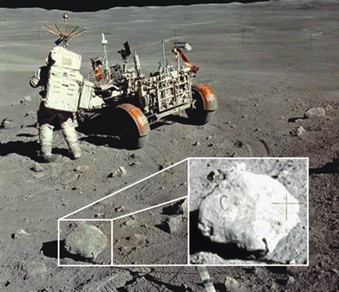
Linking to the last conspiracy’s topic we move on to the next; the moon landings in 1969 were faked in order to win the space race against Russia. In 1969 America had finally reached the moon and won the space race, however, many point out the fact that the race was on and as a result America is likely to lie about their accomplishes after promising to reach before the end of the 60’s, this would give them a reason to fake the landing. The theory goes that Stanley Kubrick had used the same set as ‘2001: A space Odyssey’ to fake the landing. There are many reasons as to why people believe that the landing is fake; starting with the original footage of the landing was lost by NASA at some point or recorded over by something else. This had seemed suspicious as something so large and important you’d think that they’d keep it safe. People also claim that when astronauts are bouncing around you can see a wire holding one of them up, allowing them to ‘bounce higher’, this expands to when someone falls it looks as if they are pulled back up rather than pushing themselves up. There is also a rock that allegedly has the letter C written on it, similar to a rock that would be used on a film set. Some have also claim that if it were real stars would be visible in the background of the footage. The last can be easily debunked as the cameras of the time weren’t detailed enough for capturing something so small and far away, the shutter speed wasn’t able to capture them. People who have looked have also said that you can’t see the flag that was left from earth after people have looked. This conspiracy, although interesting would be painful to create. So many people would need to be involved that it would be too difficult to keep all involved quiet, even if the technology was available to create such a complicated set.
Fig1. Does a Possibly Make a Probably? By Nbluedorn

Finally, I will be discussing, in brief, a few of the 9/11 conspiracies, as there are too many variants to each theory to fully delve into this topic, but it still deserved a mention somewhere. This is one of the biggest conspiracies of the 21st century with the possibly the most documentation on the conspiracies. this is due to how many were affected, both directly and indirectly; two-thousand, nine-hundred and ninety six died on this day and shock waves were sent through the whole of America, even the world (When was 9/11 and how many people died following the Twin Towers attack? Aidan Milan, 11th Sep 2019). On the 11th of September 2001 two planes struck the Twin towers, and a third was planned to hit the towers however, the passengers discovered the plan and rushed the cockpit of the plane causing it to go down over Pennsylvania. A finale plane had struck the Pentagon around the same time. Conspiracies for this one event range from a false flag attack from the American government to an insurance fraud from the owner of the building due to being cheaper than replacing the asbestos in the buildings, one even accuses the planes of being CGI and bombs being set off. But no matter how you look at it most of these conspiracy theories find a way to blame anyone besides Bin Laden. This is due to something called Proportionality bias, basically meaning that when a large scale event accrues people expect a force just as large to be responsible rather than a small group, I will be going more into detail during chapter 2.
The following conspiracies that are about to be mention are some of the most popular in a different way than the last few, but not for any good reasons. The following three are considered so crazy, weird and just stupid to the point that most people have made fun of them.
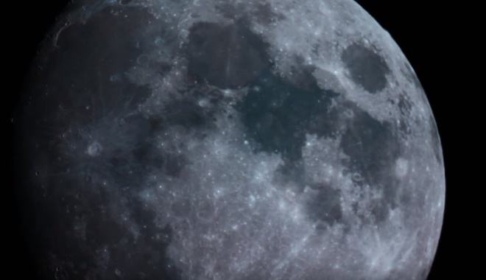
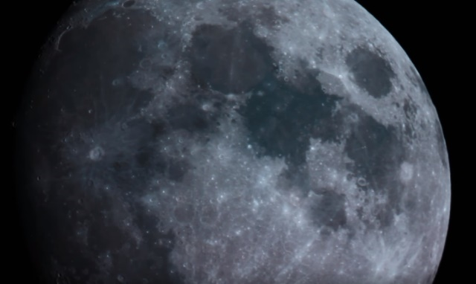
Going back to the moon landing being faked, some have taken the theory to the next level and now begun to claim that the moon is a hologram and the real one either never existed or was destroyed at some point and that no one had noticed. The evidence for this is flimsy at best. A user by the name of Crow777 had a video camera filming the moon continuously for over year, eventually he began to notice that ripples were appearing on the moon’s surface. He deduced that the moon must be the problem and that it was fake, he also claims to have been in contact with others who are confirming his story. Rather than being logical and checking if there were any external factors, he had jumped straight to the conclusion that the moon was a fake. There could have been issues with the camera, issues in the sky that caused ripples (heat) or, as scientists explained, an affect of the earth and moons gravities.
The moon – UPDATED The Moon is Not what you think by Crow777

Following of this we have the finale in this section, The Flat earth theory. This theory is pretty self-explanatory, but an alarming amount of people between the ages of eighteen and twenty-four believe that the earth is flat rather than round, something that was proven in 600BC. Many of the reasons behind the belief is due to people being unable to see the earths curvature, and because people have been ignoring the laws of gravity when talking about liquids. Therefore, they claim ‘that we live a big disk of water, the North Pole in the centre with the continents around it’ (Murphy. 1:35), they believe that the large disk is forever moving upwards, thus creating gravity and stopping us from drifting off.

Chapter 2 (1000) = Why do people believe in conspiracies?
A stereotype has surrounded conspiracy theorists as many are seen as paranoid and are ridiculed for it, however, that is not the always the case. Paranoia can be a major reason for some with the mental illnesses, but there are other factors to consider. There are now theories to explain why people believe in conspiracy theories. One of the larger factors is the fear of the unknown, humanity as a whole very much dislikes the idea of the unknown, this is why things like the bottom of the ocean, Space and death can trigger peoples fear response. Conspiracies and mysteries are similar, the mind some times can’t handle the idea that something may never have an official answer, like who was Jack the Ripper?; Even one-hundred and forty years later people are still trying to figure out his identity. This is when people will attempt to create the answers themselves by filling in the blanks with information; often in a negative view. Sometimes the information works, however some times not so much. You can see this in the evolution of Conspiracy theories, the past few years conspiracies are no longer a means to answer questions. “The Purpose of Conspiracy theories is no longer to explain reality or offer some account of the world; instead, the point is to erode trust in public figures or institutions.” (Rosenbloom, 2015). Originally, conspiracies answered questions about the untrustworthy and the people in control when something would go wrong but had holes in the story. Bow people are believing conspiracies that have no evidence. When asked about this many in the Flat Earth society had proudly claimed that it was done to keep people stupid and keep them under control, apparently they had suggested that governments were so confident that the earth was round that now it has been ‘debunked’ they refuse to tell the public as it would be a major screw up on their part.
Another reason people have accused conspiracy theorists of believing is Pattern recognition, the mind will often find patterners in anything it can even if the patterns are coincidental or very flaky. This is often why the mind will see faces in things that don’t have one, such as when people claimed that Mars once had an ancient civilization on its surface because when looking people were able to see a face in the sand. However, this was debunked multiple times as a mound of rocks and dust.
Projections is another reason some might believe; however, this has been less documented. But who fall into this accuse the larger companies and governments of the things they do because if small business owners and MP’s do this bad things (Steal, Lie, Ignore problems) ‘then of course this large businesses will do the same as I do’. This is people projecting their own lies and insecurities on to others in a similar stance who may or may not be doing these things that they are accused of.
Confirmation Bias is a large reason why when people believe a conspiracy they won’t change their minds; it doesn’t matter how much evidence to debunk a theory they receive they will still believe their own sources over something new. Example. After autism was found with no link to children’s vaccinations the believers threw blame on to ‘Big Pharma’ (Big Pharmaceutical companies) and accused them of hiding the paper and forcing believers in to silence so that they can make more money. Some Anti-Vaxxers (Anti vaccination groups) are adamant that the reason their children are autistic and becoming ill is due to the harmful chemicals in the shots. A healthy scepticism is good for the mind, however, these people will purposefully stop others from receiving the shots needed and in exchange have revived long dead viruses.
Lastly, Proportionality bias will be discussed. This last theory of belief is towards the likely hood that something as big as the president’s death couldn’t possibley be caused by one person and has to be the work of a large group of influential people who could successfully convince this person to kill JFK then be killed himself. Or the Titanc, people believe it was an early version of a false flag attack as there were potentially many people with illnesses or who had a lot of power. It is also stronger when events are especially large-scale or significant and when small-scale, mundane explanations therefore seem unsatisfactory (Leman & Cinnirella, 2013).
Conspiracies about conspiracies is a weird thing to believe however there sre a few documented cases of people believing that they have been either hypnotised (Similar to MK Ultra) or have had their minds wiped (Aliens). But there is no true way of ruling out why people believe what they do. It is the same for the paranormal or for religion. Although there are strong believers many aren’t sure why people believe without the evidence.

Chapter 3 (1000) = What are the effects of conspiracies on Society and its people?
Conspiracies and therefore conspiracy theories are always seen as a negative thing to believe in, whether it be that the US Government is hiding UFOs and aliens from the general public or that Iran killed Michael Jackson to distract people from the political issues that was starting riots, it’s seen as a weird thing to believe. Over time however, conspiracies have had an effect on people without many ever realising. Every bit of distrust shown towards any large bodies of people (i.e. Governments, Companies, Elite Clubs) is from decades and even centuries of conspiracies that have come to light after going wrong or information being leaked. ‘Conspiracy theories may allow individuals to question or challenge dominance hierarchies and query the actions of powerful groups.’ (P17. political conspiracies). Even now, we don’t know the full extent of conspiracy theories effects on societies social behaviours and our ability to make choices, there simply isn’t enough documented research on the topic as of yet. The biggest spike in distrust for the American Government would have been soon after both Chelsea Manning (2013) and Edward Snowden (2013) began leaking information about the secret operations of the USA to the rest of the world and to the American people. By doing this and being weary of big bodies allows those who are responsible for atrocities and wrong doings to be reprimanded for their actions. This is exactly what happened to Nixon when the Watergate broke to the general public, he was almost impeached but had resigned before there was a chance. Both Phaneesh Murthy (iGate) and Mark Hurd (HP) were CEO’s of large companies that covered up their sexually harassed people on their teams, until the news broke, both were soon fired and charged. Conspiracies have lessened since the blame is starting to be put on people and their actions, companies are becoming more transparent about their work and their pasts; this does not mean that they never happen anymore.
One serious effect that we touched on in the second chapter is Paranoia; a symptom that is normally overlooked in favour of making fun of their beliefs. The illness can affect the belief in a conspiracy, but the opposite can also be said. Untreated paranoia can be heightened or triggered by surrounding one’s self with conspiracies and theories, real or not it can have an unseen effect on the mind. These people rarely get the help that thy need due to their distrust of the pharmaceutical companies behind doctors’ offices. This paranoia can manifest to the point that people will refuse to be online in any sense of the word, from Facebook to email accounts, everything is done in person; some will even refuse to have credit and debit cards, preferring to do everything in person. This is the point people will often start cutting of family and friends who are believed to be working against them. ‘it is not usually meant as a strict clinical diagnosis of the conspiracy theorist as delusional, but instead uses the psychological category of paranoia as a way to identify the social phenomenon and the explaining some of its features.’ (P19, Making sense of Conspiracy theories). When we finale reach the furthest point, we have people who live in the middle of nowhere surrounded by wilderness or have begun building a dooms day shelter in their gardens or basements, some even go as far as buying plots of land where construction can be left in peace. During the world wars and the Cold war, they were in every other house but now very few keep theirs socked and ready.
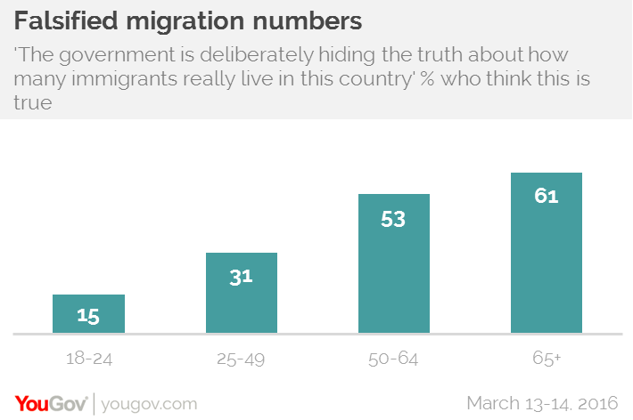
These aren’t the full extent of the effect’s conspiracy theories can cause; worse effects range from ruining someone’s life to slowly killing the earth and all its inhabitants. ‘Public dismissal of the risk of climate change poses serious bar-riser to individual and societal with the issue’ (p.171 Personality and individual differences). According to Sander Van der Linden’s paper, The Conspiracy-effect: Exposure to conspiracy theories (about Global Warming) decreases pro-social behaviour and science acceptance (2015), more than 37% of American’s believed that Global warming is a hoax. Even after everything people have accomplished in the past years people in power are now deciding for their countries that Global warming is fake and reversing any improvements in exchange for more money selling oil and plastics. Doing this is causing more problems for the environment and places like Rome (that’s Sinking) and The Antarctic (that’s Melting). A majority of scientist believe that global warming is real and causing problems, only a few are sceptical of the phenomenon, with some that believe claiming that it is natural for the earth to warm ever few millennia whereas others claim it is completely humanities fault for the earth heating up.
Being safe about what goes into your own body and the bodies of your children is healthy and a good practise to stop children becoming ill or unhealthy and even stop them eating toys. Doctors and the medical industry are one of the things that are getting strictly monitored by people as of late; being replaced by meditation, crystals and natural remedies. For sleep, headaches and colds these remedies can often be a big help without resorting to drugs, however, these home-made cures don’t work on serious illnesses like cancer, measles and air born viruses. Some are even doing worse as some are creating remedies with harmful side effects, one such is The Jilly Juice (Morris, M. 2018). The Jilly Juice has such a high quantity of salt that it is making its drinkers severely ill. The creator (Jillian Epperly) has claimed that drinking twice a day can cure anything from cancer to being gay and can even regrow limbs. These are what have begun replacing the vaccinations for kids. Many conspiracy theorists are being cuticle of vaccinations especially, claiming that the products and chemicals in them are giving children autism and making them ill. They claim that ‘Big Pharma’ (Pharmacy companies) do this for money rather than to help. No one has given a reason as to why they will want children to be autistic besides money.
Besides children getting ill and the earth warming up there is a much more direct side effect for some to conspiracy theories that people don’t like to talk about. The lives it can and has ruin when people are wrongly accused of crimes that have nothing to do with them or their families. In 2016 the Pizza shop called ‘Comet Ping Pong’ was celebrating its 10th anniversary with its owner James Alefantis, at the same time the Presidential elections were in full swing. Days after the celebration it became the centre of the conspiracy known as ‘Pizzagate’ by believers. Wiki Leaks released emails allegedly from the chairman of Hilary Clintons campaign that spoke about pizza and arranging a dinner with his brother. The followers of a Trump supporting forum on Reddit deduced that these emails were referring to a sex ring that was in the basement of the Comet Ping Pong (The shop does not have a basement). The theorists on the website believed that the shop was a front, ‘Hillary Clinton …was masterminding a global child-traffic ring that was holding kids as sex slaves in his basement’ (Haag, M. and Salam, M. 2017))The claims spread like wildfire through Reddit and eventually reached Twitter and the media where the reports blew up. People began to harass the owner and his family and leaving horrible reviews about his restaurant online.
Eventually everything came to a head when a man asked to investigate the property, the man’s name was Edgar Maddison Welch. After driving over tree-hundred and fifty miles he pulled out two guns and open fired in the restaurant, firing fifteen rounds. Luckily, for everyone involved he never hit anyone who was in the restaurant at the time but was still sentenced to only four years in prison. After being arrested he claimed that he had done it ‘believing he was saving children trapped in a sex-slave ring’ (Welch, E.). All this was due to a few people trying to discredit the Clinton campaign, the accusations are still present to this day to some die hard believers. So, the question stands, would Hilary be president now if not for this and how much worse could the shooting been?
‘Pizzagate’ was not the only theory that had destroyed someone’s life because of false conspiracies not based in reality. Many have done this in the past and there are plenty of lives being affect now. In 2012 a young man walked into an Elementary school with several weapons and at 9:41am fatally shot twenty students between the ages of five and ten, he also shot down six members of staff including the Principle of the school at Sandy Hook Elementary before turning the gun on himself and taking his own life. Before this incident he had shot his mother at point blank range in their home before he left for the school. The gunman was twenty-year-old Adam Lanza and this is not the person we are discussing, instead conspiracy falls on the children involved and their families.
You might be wondering what kind of conspiracy could surround a school shooting and you would be surprised. The shooting isn’t seen as a false flag attack that was orchestrated by some shade group of people, however, this is only half of the conspiracy. The rest involves crisis actors. A crisis actor is someone who is involved in some sort of crisis that has been staged, these events are done by emergency services for training new members in a professional environment. (Emergency response prepares for worst (2017)). However, according to Alex Jones everyone involved where simply actors playing a role rather than real victims who lost their lives or loved ones. There was no evidence behind this but that has seemingly not stopped people from believing every word that Jones has been babbling about. Ever since Jones brought this up on his show people have begun believing the theory and began harassing the families. Lenny Pozner was one of these victims. After loosing his son in the shooting, he thought that it couldn’t get worse, but sadly he was wrong. He has jumped from one place to another in an attempt to escape the harassment of Jones’ supporters; being harassed around every corner to ‘tell the truth’ about his deceased son. In 2016 the father of one of the children was found dead, proving that the constant reminders about the death of his six-year-old were too much. That day will be the worst day of everyone involved, however, the constant reminders is wearing on the health of the families involved.

Conclusion (389) =
After all this what can I really say about the topic of conspiracy theories? Should we believe every single one you find? No, of course not. Many are created to discredit others and their works. Should you ignore and mock everyone you find? No, because some are believable and may very well be true. In an ideal world we would be able to trust our Governments to be transparent with its people, even if no one else is. But sadly, we do not live in the ideal world, we live in this one. That means we need to be weary of everything we are told, especially when companies are trying to sell their products and services. So, who can you trust? Really no one, everyone can gain something from you, whether that is money or your information. I personally, try to be critical of what is told to me without resorting to conspiracy thinking, however, this can be hard if this is a natural default thinking for some.
While some of these are tragic it is perfectly natural and allowed to have an opinion of the official story, but if that opinion involves any sort of verbal or physical harassment then it is unfair and horrible to confront these people. Especially over cases such as 9/11 or Sandy Hook where many families are in morning over family and/or friends who have been lost. Or in the case of Flat Earthers it is one thing to make a joke about the conspiracy but harassing and mocking individual believers is the wrong way to go about the situation as some are relatively smart people who began being critical but couldn’t find evidence that they truly believed. Conspiracies can be seen similarly to religion, as long as no one is truly getting hurt then what is the harm in allowing people to think critically about subjects without being harassed?
However, believing that Jay Z is a vampire (Falconer, D. 2019) or that Avril Lavigne was replaced by a clone in 2003 are a bit different as many of the believers are children and teenagers who are incredibly venerable to these kinds of conspiracies. Personally, I had believed the Avril Lavigne conspiracy as a young teen. Children are gullible and sadly even as an adult many are still susceptible to these things.

Bibliography (References)
Linden, S. The conspiracy -effect: Exposure to Conspiracy theories (about global warming) decrease pro-social behaviour and science acceptance (2015)
Douglas, K. Sutton, R. and Cichocka, A. The psychology of conspiracy theories (2017)
Knight, P. Conspiracy theories in American history (2003)
Ventsel, A. Research on conspiracy theories in political science (no date)
Bolsen, T. and Druckman, J. Validating conspiracy beliefs and effectively communicate scientific consensus
Taylor, G. The believing Brain: From ghosts and gods to politics and conspiracies – How to construct beliefs and reinforce them as truths
Sharp, J. Remember, Remember, A cultural History of Guy Fawkes day (2005)
History.com, Julius Caesar’s forgotten assassin (2019)
Penn, B. History-UK.com Bethnal Green Tube Disaster (No date)
Bennett, S. ‘Mermaid: the body found’ (2012)
History.com, MK-Ultra (2018)
Emergency response prepare for worst(2017)
No author, Avril Lavigne died and was replaced by a double? (2011)
Morris, M. Jilly Juice recipe creator claims her concoction can regrow limbs, cure homosexuality (2018)
Haag, M. and Salam, M. (2017) Gunman in ‘Pizzagate’ is sentenced to 4 yearsin prison
Falconer, D. Is Jay Z a time-traveling vampire? (2019)

Douglas, K. and Prooijen, J. Conspiracy theories as part of history: The role of societal crisis situations (2017)
ABC News – Tragedy at Sandy Hook Elementary school: What happened during Newton, Conneticut shooting? https://www.theguardian.com/science/video/2019/feb/05/flat-earth-rising-meet-the-people-casting-aside-2500-years-of-science-video
American Heroes Channel. Was the Moon Landing Staged? (2016)
Uncovered. Was the Moon Landing Staged? (2016)
Uncovered. The Moon Landing Conspiracy – Unexplained objects (2016)

Further Reading
The Flat Earth Society website (.org)
Moore, M. Fahrenheit 9/11 documentary (2004)
Jazeer, A. The Many Conspiracy theories of 9/11 (2011)

