Module Number: LCBB4003

Module Name: Introducing the Modern Workplace

Assignment Title: Organisational Structure & Culture

Student name: Mariana Claudia Drajneanu

Student number: 2030896

Submission date: 05/01/2022

Introduction

Amazon as we know it’s one of the biggest online and physical company that has succeeded by the years past till today and expect a bright future as well. We cand say that Amazon it’s secretive but not like a black box.
Why Amazon and which are the changes, structures and behaviour for the last 2 years because of pandemic from Covid 19 I will explain in this report.
Also, the changing plan and situation looks different now since the Covid 19.
The pandemic brings to a lot of companies changes in good way or bad but depends on each one how they manage to stay up and no fail because of Covid 19. Amazon proved one more time that is true all what we know as a strong successful company and still do profit no matter what.
We believe that the challenge to overcome in order to address these problems is to understand how the strategy that sustains the economic success of a company is linked in a more profound way with the configuration of its organizational forms and techniques of work organization. Amazon stay on top of another’s company year by year and we can see that at the end of the report.

Specific objective, behaviour, and structure
To explore these problems, we will develop a compared case study of Amazon, in order to understand how with very different strategies and organizational practices, have succeeded to become world-class innovative company, creating entire business models that did not exist 20 years ago. The company was selected since to share many common features, Amazon is successful cases of innovative companies positioned in the technological frontier, and because to achieve so they had to develop new -still very different- business models.

Body of the report
The pandemic has upended businesses across the world, but it has been very good for Amazon. Every lockdown “click to purchase” nudged the company a little further toward utter domination of online shopping as total e-commerce sales nearly doubled in May. But if bigger was better for everyone, Amazon founder and CEO Jeff Bezos would not be appearing before Congress on Wednesday for an antitrust hearing.
In the first quarter of 2021, Amazon reported net sales of £106.516 billion, a 41.8% increase from £55.450 billion in the same quarter in 2020 but also around the world no just in the UK.
The Amazon marketing strategy we are familiar with today has evolved since it was founded in 1994.
Amazon growth surges over pandemic
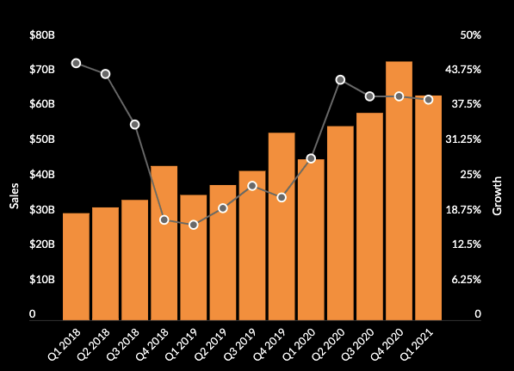
Amazon's success to 3 rules which it breaks, but we 'probably shouldn't.
- Strategy is about focus - despite Amazon has an incredible number of strands to the business today.
- Don’t throw good money after bad - with criticism mainly of Amazon's investment in groceries.
- Your core competencies determine what you can and can’t do -growing the Kindle with no hardware manufacturing experience.
In this way, we cans say that a 'risky' access to marketing strategy which, for Amazon, paid off in dividends. So, there is enough to learn from studying this company, even if we decide not to reflect all tactics and strategies.
Amazon says its platform let on anybody to make an income in an any other way impressive pandemic economy, and that it is working to help sellers while meeting increased order from consumers. “Our to our selling responsibility partners has never been more intense,” an Amazon spokesperson said in a statement. In the twelve months ending May 31, 2020, small and medium-sized businesses sold 3.4 billion products, up 25% from the same time the previous year, according to a report Amazon released July 21. Amazon says the average American small and medium-sized seller had more than $160,000 in sales during that time, though it did not provide averages for how much these sellers took home after expenses.
The coronavirus pandemic has not only killed more than 1 million people around the world. It’s also devastated the global economy, brought industries to a complete impasse, stimulate mass cutback and, in the case of retail, accelerated the slow-moving demise of already willing department store chains. Amazon is one of the few exceptions.
The flood of online orders propelled Amazon to record sales during the second quarter. It then spent billions on coronavirus-related investments like safety gear for workers and its internal testing initiative, called Project Ultraviolet.
Amazon’s pandemic-fuelled growth isn’t expected to slow down soon, especially as it prepares for the back-to-back shopping rush of Prime Day in October and the holidays after that. In fact, Amazon is expected to exceed $100 billion in quarterly revenue for the first time ever in the fourth quarter, according to analysts surveyed by FactSet.
So, Amazon specially UK one statistics show that a 50% or a little more the revenue has increase in the last year and for sure will be a good keeping on expanding the next years and will be a success with or without Covid19.

Here it’s a list with the top one’s in the UK:

- Almost 90% of shoppers in the UK are using Amazon.
- There are 21 Amazon FBA distribution centres in the UK.
- Amazon reported over 51% sales growth in the UK in 2020/2021.
- Amazon’s web traffic in the UK jumped 40% in 2020/2021 compared with 2019.
General Amazon UK Statistics

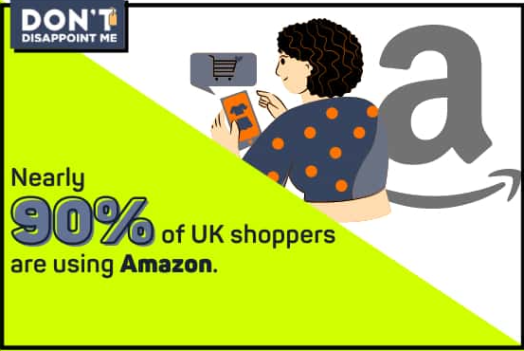

According to Statista’s late date, there are like 77 Amazon distribution centres in Europe, which 21 are in the UK.
So, after a calculation in the last 2 years Amazon reported a total net income of 4.5 billion pounds and another magnific happening is that the company saw a 37% increase in earnings in the same period fuelled by growing retail sales during the pandemic. (French, 2016).

Amazon UK Sales Statistics

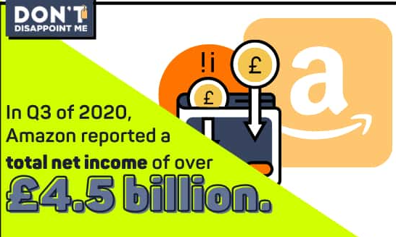

Another influential factor for one of the UK’s biggest user groups on Amazon is free delivery which so many interviewed in an online survey like to take advantage of this Amazon customer service because it comes for free with their Prime membership and costumers take advantage of that and they shop more and more day by day.
Between August 2020 and January 2021 indicate that users spend an approximative of 6 minutes on thy site with 7,58 pages a day, while the rate is 35.71%.
So, the pandemic made Amazon increase by almost 13 billion. This will be for January 2021, show a monthly number of visits coming from both desktop and mobile at 485 million.
CEO Jeff Bezos acknowledged early in the pandemic that the coronavirus upended Amazon’s operations. “The current crisis is demonstrating the adaptability and durability of Amazon’s business as never before, but it’s also the hardest time we’ve ever faced,” he said in April.

.

Amazon Web Traffic Statistics
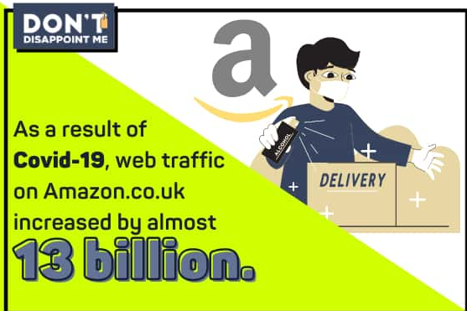

Amazon profits surge as pandemic shifts consumer behaviour

Amazon has confirmed its sales have exceeded £82.bn for the second quarter in succession as it continues to benefit from the pandemic which show as a non-expected to nobody.
With consumers across the world increasingly shopping online, streaming videos and working from home, as their behaviour has shifted during lockdowns, Amazon has reported net sales of £98.5 bn for the first quarter of the year, up by 44% from the same period a year before. Jeff Bezos, the founder of Amazon, has said that he will be stepping down and instead will take on the role of executive chair. (Buchanan, 2016)
Amazon is expecting its sales to continue to rise, even as lockdowns come to an end, as the company’s guidance suggests revenue somewhere between £95bn and £108bn for the current quarter. The company will spend £1.3bn on coronavirus related procedures within its logistics, and the company believes its net income will be between £4.3bn and £6bn this quarter.

Amazon Most Popular Online Retail Website Worldwide 2020/2021

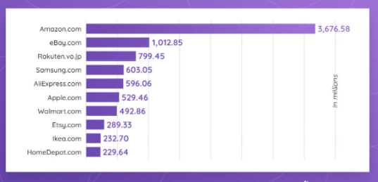

Amazon Organizational Culture:
- Hard
- Effectively
- Contribution

Amazon organizational culture has been described as “breakneck-paced, and notoriously cost-conscious, as befits a company that has run only a small profit, or a loss, under generally accepted accounting principles for most of its life as a public company.

Generally, Amazon organizational culture integrates the following three key elements:
- Constant reinvention and optimization of organizational culture.
- Customer-centricity.
- Diversity among workforces.
Key points that Amazon applied to stay positive and succeed during the pandemic (Mullane, 2020,)
- Amazon remains one of the few companies to benefit from the coronavirus pandemic, with surging online sales helping it to report record profits in July.
- It didn’t get there without boating an abundance of challenges, including a labour crisis that bring public analysis from lawmakers, regulators and workers’ rights groups.
- Amazon’s supply chain was hit hard, resulting in delivery delays and out-of-stock notices.
So here are some final facts that Amazon take as a measure during the pandemic:
Amazon is heavily invested in supporting employees, customers, and communities during the pandemic, from enhancing safety measures to increasing paid time-off. Here are a few examples:
- We provided more than $2.5 billion in bonuses and incentives for our teams globally in 2020.
- We established a $25 million relief fund for partners, such as delivery drivers, and seasonal associates facing financial hardship or quarantine.
- With an eye on customers, Amazon is vigorously combating price gouging to ensure fair pricing and fight entities seeking to profit off the COVID-19 crisis.
Amazon also not just is facing the pandemic well like always donate and support to a lot of companies and centres and all in needs and give a good and positive example for those companies there are not that kind. Here are a few of them where Amazon support:
- XPRIZE $5M Rapid COVID-19 Testing competition / joins XPRIZE Pandemic Alliance
- Amazon supports film, TV and cinema workers with donation to the COVID-19 Recovery Fund in the UK.

Conclusion
After the entire research, the great organizations come towards success with lots of sacrifices, soberness, and vision towards the long-term goals. This also adds up with the fundamental principles of the organization and its CEO and being adaptive to future needs and understanding to adapt to changes that can best full fill the organization's goal. The implementation of 14 principles, lead Amazon to be the greatest company of all times displaying its strategic.
Pandemic or not we can see that Amazon stay positive and goes on no matter what.
Nobody know how long this crisis will continue to remain, but the point is we need to accept it and live with it and focus on the business and succeed.
So, we can see that Amazon doesn’t just give us words and stops we have facts who are the most important and has priority always. Every day, week ,month and year its different and cand increase and sometimes decrease at any time but once again Amazon proved that even in a bad crisis like Covid 19 everything its possible and if you work hard and believe in your business and team you can do it no matter what.

Reference

- Mullaney, T. (2017) “3 key business lessons from Amazon’s Jeff Bezos” CNBC, Available at: http://www.cnbc.com/2016/05/13/5-key-business-lessons-from-amazons-jeff-bezos.html
- Buchanan, D. and Huczynski, A. (2016) Organizational Behaviour Pearson Education
- French, R. and Rayner, C. (2016) Organisational Behaviour Ed. 3 Topic: Business
- UK Investor (2021) Amazon profits surge as pandemic consumer behaviour. Available at: http://www.ukinvestormagazine.co.uk (Accessed: 02 January 2022).
- Betz, F. (2018), "Strategic Sales – The Case of Amazon", Strategic Business Models: Idealism and Realism in Strategy, Emerald Publishing Limited, Bingley, pp. 13-23. https://doi.org/10.1108/978-1-78756-709-220181002

- Amazon Pandemic Profit (2020) Available at: https://time.com/5870826/amazon-coronavirus-jeff-bezos-congress/ (Accessed: 03 January 2022).

