When designing buildings architects must be mindful of decreasing energy consumption (Makstutis, 2010), one way to do this is for the modern house to use renewable sources of energy (Dunster, 2018). An ‘Active House’, relies on renewable energy sources which can be an alternative to providing the building with all its energy (Kilbert, 2013; Kwok and Grondzik, 2018). For this assignment our group was given a brief to design an ‘Active House’ and the following report discusses the outcomes of four topics i.e. Design and Layout, Building and Energy Performance, Constructional Methods and finally Materials and Sustainability.
Design and Layout
According to Jankovic (2012) by 2050 the global population will be 9.2 billion, and this means a need for increase in housing, which ultimately takes up more land. Housing may need to decrease in size, whilst still providing a comfortable living space. For example, our ‘Active House’ is six metres smaller than the proposed site, which in turn allows for more houses to be built.
A modern house can be influenced and respond effectively to the surrounding climate, e.g. the orientation of a building can be effective in providing different rooms with natural light at different times of the day (Jankovic, 2012). Bergman (2012) suggests that orientating a house so that the dining-room and kitchen are towards the south will benefit from receiving most daylight. Our ‘Active House’ is orientated so that the dining-room and kitchen are south facing, and the living-room to the west, which maximises the use of sunlight. The ZEB Pilot House, Norway (figure 1) demonstrates an excellent use of orientation, by angling the roof towards the southeast to provide the Photovoltaic (PV) panels with the maximum amount of sun. Our ‘Active House’ (figure 2) has a south facing curved roof with PV film to maximise energy produced (Roaf et al. 2007; Kwok and Grondzik, 2018).
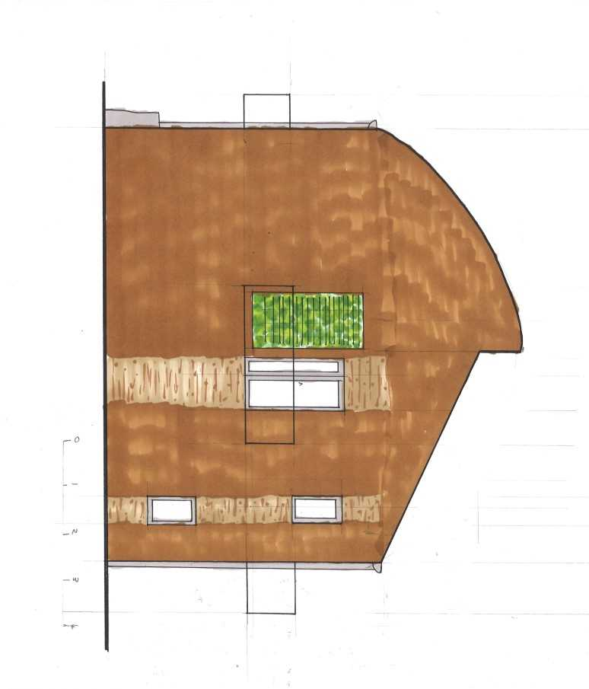
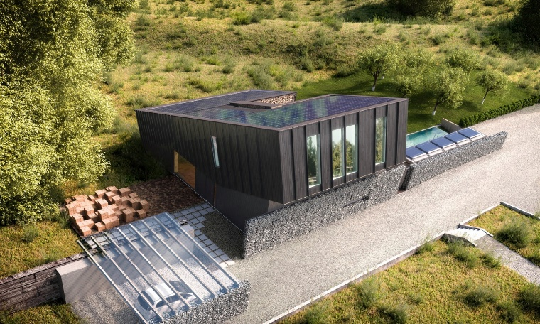

Figure 2
Figure 1:(Archdaily, 2015)

Building and Energy Performance
Water scarcity is a major on-going problem as climate change reduces access to water (Dunster, 2018) therefore our ‘Active House’ will harvest rainwater. Also, there is an east facing ‘living wall’, which provides insulation and can be irrigated using the recycled water (Bergman, 2012).
A modern house can use overhangs to reduce the need for cooling and prevent overheating in the summer (Bergman, 2012) so our ‘Active House’ will have a large, south facing balcony to shade the patio doors on the ground floor.
Prefabricated timber frames are cheaper to build and can speed up the construction process and may provide for a better performance (Reynolds and Enjily, 2005; Dunster, 2018). They also do not heat up in summer whereas steel structures do, therefore our ‘Active House’ will be constructed of a timber frame.
Although mainly active techniques were used in the design some passive techniques were also used. For example, in our design cross ventilation is used to cool the house. The windows were placed on the curved roof (above the pitched roof on the north), to utilise the site’s prevailing south west wind direction (Kwok and Grondzik, 2018).
Transpired Solar Collectors (TSC) will be fitted to the south wall of our ‘Active House’, which draws air from outside into the building decreasing the energy needed to heat and cool the house (Kwok and Grondzik, 2018).
Constructional Methods
Windows in a building have several important roles, they provide natural lighting and ventilation whilst reducing heat loss (Kibert, 2013). Our ‘Active House’ had a reduced number of windows on the north side, to reduce heat loss but still providing light and ventilation (Bergman, 2012; Dunster, 2018). More windows were on the south side to heat the space without the need for energy. However, south facing windows can cause a room to overheat from direct sunlight, so a balcony will provide shade. Furthermore, a south facing PV window on the ground floor is used to act as a blind to provide further shading.
Insulation is important in a modern house as this can greatly decrease energy consumption, as any gaps in insulation will create thermal bridges (Dunster, 2018). Our ‘Active House’ will use sheep’s wool as an insulator (Hetreed et al. 2017), because it has many benefits, e.g. it is sustainable, provides good sound insulation, doesn’t burn in a fire (only singes) and it purifies the air which provides a comfortable indoor climate (Green Age, 2017). Also, it does not contain any harmful chemicals as some previous insulators (Bergman, 2012).
To achieve the curved roof on our ‘Active House’ Glulam beams are used as they are versatile and 18% stronger than standard timber, therefore can be shaped easily (Hetreed et al. 2017).
Many timber frame houses use cost-saving strip foundations (Reynolds & Enjily, 2005), however our ‘Active House’ will have raft foundations, as the site is reclaimed land. Although raft foundations are more expensive, they can reduce time of construction (Hetreed et al. 2017).
Materials and Sustainability
Sustainability in the modern home is important as a building’s operational energy accounts for 47% of co₂ produced in the UK (Bordass, 2007). Ideally locally sourced materials should be used (The Green Register, 2016) and it is important to rely on renewables as the main source of energy. The quality of building and materials used is equally important as this can decrease energy consumption (Makstutis, 2010).
Our ‘Active House’ uses solar PV panels, which convert solar radiation to electricity (Bergman, 2012) and the energy produced can be stored in batteries (Kibert, 2013). The advantages of PV are that it is renewable, and they have a short payback period, which is important as many people live in fuel poverty (Roaf, 2007; Spragg and Evans, 2017) and Active House Schemes could save up to 60% of energy bills (BBC, 2017).
Most energy loss in the frame of a window is through conduction, and timber windows are most effective however may need a lot of maintenance; so our ‘Active House’ will use composite windows to reduce heat loss (Greenspec, 2019).
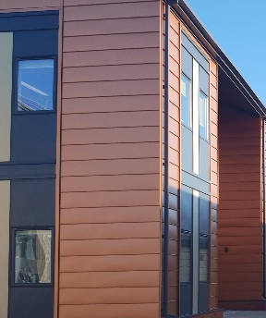
Prefabricated copper cladding (figure 3) was used on the exterior of our ‘Active House’; it is lightweight and waterproof, this ensures a better performance and allows protection for the timber frame.

Figure 3
To conclude our ‘Active House’ is a modern sustainable home which provides a comfortable and healthy living space (Kibert, 2013) whilst also being sustainable. The design and layout maximised the use of the sunlight to heat and light the home. The use of new renewable technologies, such as PV panels and materials, such as sheep’s wool can significantly increase the modern home’s efficiency (Bergman, 2012; Pearce et al. 2012).

Word count: 1093

References
Archdaily (2015) ZEB Pilot House. Available at: https://www.archdaily.com/773383/zeb-pilot-house-pilot-project-snohetta (Accessed: 9th March 2019).
BBC (2017) Energy-positive design ‘could cut home fuel bills by 60%’. Available at: https://www.bbc.co.uk/news/uk-wales-south-west-wales-40865141 (Accessed: 9th March 2019).
Bergman, D. (2012) Sustainable Design. New York: Princeton Architectural Press.
Bordass, B. (2007) ‘Energy Performance’. In Turrent, D. (ed.) Sustainable Architecture. London: RIBA Publishing.
Dunster, B. (2018) How to Build a Low-carbon Society Today. London: RIBA Publishing.
Greenspec (2019) Windows: Heat loss & Heat gain. Available at: http://www.greenspec.co.uk/building-design/windows/ (Accessed: 9th March 2019).
Hetreed, J. et al. (2017) Architect’s Pocket Book. 5th Ed. Oxon: Routledge.
Jankovic, L. (2012) Designing Zero Carbon Buildings. Oxon: Routledge.
Kibert, C.J. (2013) Sustainable Construction. New Jersey: John Wiley & Sons, Inc.
Kwok A.G. and Grondzik W. (2018) The Green Studio Handbook. Oxon: Routledge.
Makstutis, G. (2010) Architecture. London: Laurence King Publishing Ltd.
Pearce, A.R. et al. (2012) Sustainable Buildings and Infrastructure. Oxon: Routledge.
Reynolds, T. and Enjily, V. (2005) Timber Frame Buildings. A guide to the construction process. Available at: https://www.forestry.gov.uk/pdf/Timber-frame-buildings-a-guide-to-the-construction-process_D496.pdf/$FILE/Timber-frame-buildings-a-guide-to-the-construction-process_D496.pdf (Accessed: 9th March 2019).
Roaf, S. et al. (2007) Ecohouse. 3rd Ed. Oxford: Elsevier Ltd.
Spragg, J. and Evans, S. (2017) Low Carbon Energy in Wales. Available at: http://www.assembly.wales/Research%20Documents/17-010%20Low%20Carbon%20Energy%20in%20Wales/17-010-Web-English.pdf (Accessed: 9th March 2019).
The Green Age (2017) The Advantages of Sheep Wool Insulation. Available at: https://www.thegreenage.co.uk/advantages-sheep-wool-insulation/ (Accessed: 9th March 2019).
The Green Register (2016) Sustainable Building. Available at: https://www.greenregister.org.uk/sustainable-building (Accessed: 9th March 2019).

