Student Name: Wazadur Rob Chowdhury  Student ID: 2222624  Module Title: BA International Hotel Management - Foreign Languages and Cultural Awareness  Module Code: BMIH5003  Lecturer: Heidi Prosser  Date: 9th February 2024 | 
ASSIGNMENT 1: PORTFOLIO
(4 Components)

Component 1: Professional Reflection (500 words +/- 10%)

Weighting: 25%
Working as a food and beverage employee in a bustling beef eater restaurant during dinner service, I've encountered my fair share of challenges. However, one incident stands out to me is an encounter when I had a cultural misunderstanding with a hotel guest regarding their dietary preferences. The guest was unable to effectively communicate with me due to language barriers and was served non-vegetarian food despite being vegetarian. This experience shed light on the complexities of cultural differences and the need for enhanced communication and sensitivity in the hospitality industry.
The scenario unfolded during a busy evening shift when a hotel guest approached me with a request for a vegetarian meal. Unfortunately, the guest's limited ability in English made it challenging for them to communicate their dietary restrictions clearly. In my eagerness to accommodate their request, I failed to fully grasp the extent of their dietary preferences. Consequently, I served them a dish that contained meat, unaware of the cultural and religious significance of vegetarianism to the guest.
Cultural misunderstandings in such situations often stem from language barriers, misinterpretation of non-verbal cues, and assumptions based on one's own cultural norms. In this instance, the inability to communicate effectively compounded the issue, leading to a breach of trust and dissatisfaction on the part of the guest. Reflecting on this experience, I recognise the importance of improving my communication skills and cultivating cultural sensitivity to prevent similar misunderstandings in the future.
First and foremost, improving language proficiency is essential for effective communication in a multicultural environment. By investing time and effort in learning basic phrases and expressions in different languages commonly spoken by guests, I can bridge the communication gap and better understand their needs and preferences (Lustig, M. W., & Koester, J., 2013). Additionally, seeking opportunities for cross-cultural training and workshops can enhance my ability to navigate diverse cultural contexts such as faith, beliefs and traditions and anticipate potential misunderstandings.
Moreover, developing empathy and active listening skills is crucial for developing meaningful interactions with guests from diverse backgrounds (Chen, G. M., 2015). Instead of making assumptions based on stereotypes or preconceived notions, I must approach each interaction with an open mind and a willingness to understand the unique perspectives and preferences of the guest. This requires patience, humility, and a genuine interest in learning about different cultures and customs.
Furthermore, creating a culturally inclusive environment within the workplace is essential for promoting understanding and respect among employees (Martin, J. N., & Nakayama, T. K., 2013). By adopting a culture of diversity and inclusivity, where individuals feel valued and respected regardless of their background, we can cultivate a more welcoming atmosphere for guests from all walks of life. This involves promoting cross-cultural collaboration, celebrating cultural diversity, and addressing any instances of discrimination or bias proactively.
In conclusion, the experience of a cultural misunderstanding with a hotel guest served as a valuable learning opportunity, highlighting the importance of effective communication, cultural sensitivity, and empathy in the hospitality industry (Grobelna, A., 2015). Through self-reflection and continuous learning, I am committed to preventing similar misunderstandings in the future and am eager to creating memorable experiences for guests from diverse cultural backgrounds. I aim to contribute to an inclusive and culturally sensitive hospitality industry by continuously honing my communication skills, cultivating cultural awareness, and fostering a culture of inclusivity.
References:
- Lustig, M. W., & Koester, J. (2013). Intercultural Competence: Interpersonal Communication Across Cultures. Pearson.
- Chen, G. M. (2015). Intercultural Communication Competence. John Wiley & Sons.
- Martin, J. N., & Nakayama, T. K. (2013). Intercultural Communication in Contexts. McGraw-Hill Education.
- Grobelna, A., (2015). Intercultural challenges facing the hospitality industry. Implications for education and hospitality management. Journal of Intercultural Management, 7(3), pp.101-117.
Component 2: Training Plan (500 words +/- 10%)

Weighting: 25%

Identified cultural misunderstanding (in a few words) :
Miscommunication regarding dietary preferences resulting in serving non-vegetarian food to a vegetarian guest due to language barriers. Thus highlighted the need for cultural sensitivity training to prevent such incidents and ensure guest satisfaction.

Training plan (Why/What//Who/Where/When):
Objective: The training aims to equip all employees in the hotel sector with the necessary skills and knowledge to effectively communicate and handle cultural differences, specifically regarding dietary preferences, to prevent similar misunderstandings in the future.

Why: Cultural sensitivity and effective communication are essential for delivering exceptional guest experiences and avoiding misunderstandings that impact guest satisfaction.
- Enhance guest satisfaction: By improving communication and cultural sensitivity, employees can better meet the needs and preferences of guests from diverse cultural backgrounds, ensuring their satisfaction.
- Build trust and loyalty: Effective communication and understanding of cultural differences encourage a welcoming and inclusive environment, leading to increased guest loyalty and positive word-of-mouth (Kim, S., Lee, H. R., & Klenosky, D. B. , 2019).
- Avoid negative consequences: Preventing cultural misunderstandings helps avoid potential negative consequences, such as breach of trust, dissatisfaction, and potential reputational damage.
What: The training plan will focus on enhancing employees' understanding of cultural differences, improving their communication skills, and promoting empathy and inclusivity in interactions with guests from diverse backgrounds.
- Language Proficiency Training:
- Provide language training sessions, focusing on basic phrases and expressions commonly used by guests from different cultural backgrounds.
- Encourage employees to practice and use the learned language skills in their daily interactions with guests (Gudykunst, W. B., & Kim, Y. Y. , 2003).
- Provide language resources, such as phrasebooks or language learning apps, to support ongoing language development.
- Cross-Cultural Training and Workshops:
- Organise cross-cultural training sessions and workshops to increase employees' knowledge and understanding of different cultures, faiths, beliefs, and traditions (Samovar, L. A., Porter, R. E., & McDaniel, E. R. , 2017).
- Invite guest speakers from diverse cultural backgrounds to share their experiences and insights.
- Discuss cultural differences and potential misunderstandings related to dietary preferences, emphasising the significance of vegetarianism in different cultures.
- Empathy and Active Listening:
- Conduct training sessions on empathy and active listening skills to enhance employee’s ability to understand and empathise with guests’ perspectives.
- Teach techniques for active listening, such as paraphrasing, summarising, and asking clarifying questions, to ensure accurate understanding of guests’ dietary preferences (Martin, J. N., & Nakayama, T. K. , 2015).
- Role-play scenarios to practice active listening and responding appropriately to guests' requests and concerns.
Who: All employees, including front-of-house staff, kitchen staff, and management, will participate in the training to ensure a cohesive approach to cultural sensitivity throughout the hotel.
Where: The training sessions will take place in a designated meeting room or training facility within the hotel premises, thus beneficial to interactive learning and discussion.
When: The training will be conducted periodically, with initial sessions scheduled within the next month to address immediate needs, followed by ongoing reinforcement through regular refresher courses and workshops.
Training methods: include interactive workshops, guest speakers, and online resources. Workshops encourage active participation, while guest speakers provide diverse perspectives. Online resources offer self-paced learning on cultural sensitivity and intercultural communication.
Evaluation: Evaluation includes pre/post-assessments. Ongoing feedback via surveys and focus groups. Encourage open dialogue among employees to share experiences in cultural sensitivity.
Through a comprehensive cultural sensitivity training plan, the hotel aims to equip employees with skills to navigate cultural differences, prevent misunderstandings, and enhance guest satisfaction, fostering inclusivity for all guests.

References:
Kim, S., Lee, H. R., & Klenosky, D. B. (2019). The Role of Cultural Sensitivity and Communication Competence in Service Encounters: A Study of Perceived Service Quality in the Hospitality Industry. Journal of Travel Research, 58(4), 635-649.
Samovar, L. A., Porter, R. E., & McDaniel, E. R. (2017). Communication Between Cultures. Cengage Learning.
Martin, J. N., & Nakayama, T. K. (2015). Intercultural Communication in Contexts. McGraw-Hill Education.
Gudykunst, W. B., & Kim, Y. Y. (2003). Communicating with strangers: An approach to intercultural communication. McGraw-Hill.

Component 3: Student Self-Reflection (500 words +/- 10%)

Weighting: 25%
Cultural awareness is a fundamental aspect of the hospitality industry, influencing interactions with guests, staff dynamics, and overall service quality. Using the Gibbs Self-Reflection Model, I will critically examine my evolving understanding of the importance of cultural awareness within the hospitality sector. By reflecting on personal experiences, learning outcomes, and the broader significance of cultural sensitivity, I aim to deepen my understanding of this crucial aspect of hospitality management.
Description: Initially, my understanding of cultural awareness in the hospitality industry was somewhat limited, focusing primarily on basic etiquette and language proficiency to cater to diverse guests. However, over time, my perception evolved as I encountered various cultural nuances and challenges in real-world scenarios. For instance, during my placement at Premier Inn hotel, I encountered a situation where a guest from a different cultural background expressed dissatisfaction with the room layout, citing cultural preferences for sleeping arrangements. This incident highlighted the importance of cultural sensitivity in anticipating and addressing diverse guest needs beyond superficial expectations.
Feelings: At first, facing unfamiliar cultural norms and preferences from a group of middle eastern guests felt daunting, leading to moments of uncertainty and apprehension. However, through cultural awareness training and proactive engagement, I gained confidence in accommodating their needs. Understanding their preferences for privacy and dietary requirements which fostered mutual respect and enhanced their stay. Embracing cultural diversity not only enriched our interactions but also deepened my appreciation for the richness of human differences in hospitality (Zhang, J., & Wu, C. H. , 2019).
Evaluation: Reflecting on my journey at Premier Inn, I recognise the profound impact of cultural awareness in various aspects of the hospitality industry. One example is when a guest from Japan expressed dissatisfaction with the breakfast buffet, preferring a traditional Japanese breakfast instead. By understanding and respecting their cultural preferences, we were able to accommodate their request, resulting in a delighted guest and a positive interaction. This incident highlighted how cultural sensitivity plays a pivotal role in adopting meaningful connections and resolving conflicts. (Kim & Jogaratnam, 2019; Nunkoo & Ramkissoon, 2012).
Analysis: Analysing my experiences at Premier Inn Hotel broadened my cultural awareness. Serving guests from diverse backgrounds at the reception underscored how cultural differences shape preferences and behaviours (Kim, Y. S., & Yang, K. (2018). For instance, guests from high uncertainty avoidance cultures prefer clear instructions. This insight helped me tailor services, ensuring smoother interactions and guest satisfaction. Intercultural communication training emphasised empathy and attentive listening, enabling more meaningful interactions with diverse guests, enriching their experiences at the hotel.
Conclusion: In conclusion, the Gibbs Self-Reflection Model enabled a deeper exploration of my evolving understanding of cultural awareness within the hospitality industry. Through firsthand learning, training, and reflection, I gained insights into the multifaceted nature of cultural competence and its profound implications for overall success in the hospitality sector. Moving forward, I am committed to further enhancing my cultural awareness skills through ongoing education, cross-cultural exposure, and reflective practice to excel in hospitality management.
Action Plan:
- Engage in ongoing cultural awareness training programs to deepen understanding of diverse cultural norms and practices.
- Actively seek opportunities for cross-cultural exposure through travel, cultural events, and interactions with individuals from different backgrounds.
- Implement cultural sensitivity training initiatives within hospitality organisations to promote inclusive practices and enhance staff competence.
- Continuously reflect on personal experiences and interactions to identify areas for improvement and refine cultural awareness skills.

References:
Zhang, J., & Wu, C. H. (2019). Cultural intelligence and hospitality employees’ job performance: The mediating role of person–organization fit. International Journal of Hospitality Management, 81, 144-153.
Kim, S. S., & Jogaratnam, G. (2019). Cultural competence and customer orientation: The moderating role of organization size in the hospitality industry. Journal of Hospitality & Tourism Research, 43(1), 26-46.

Nunkoo, R., & Ramkissoon, H. (2012). Power, trust, social exchange and community support. Annals of Tourism Research, 39(2), 997-1023.

Kim, Y. S., & Yang, K. (2018). Cultural diversity management in hospitality industry: A review of empirical studies. International Journal of Contemporary Hospitality Management, 30(1), 353-382.

Component 4: Training Presentation (6 Slides)

Weighting: 25%
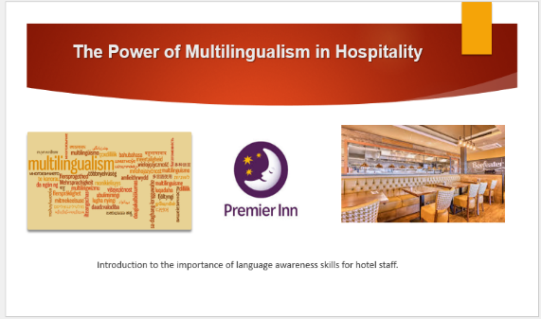
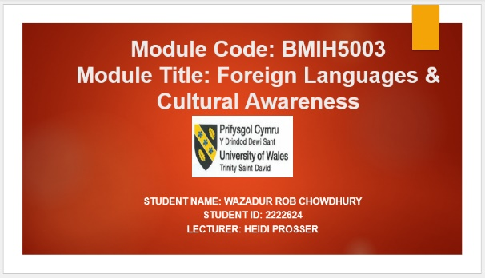

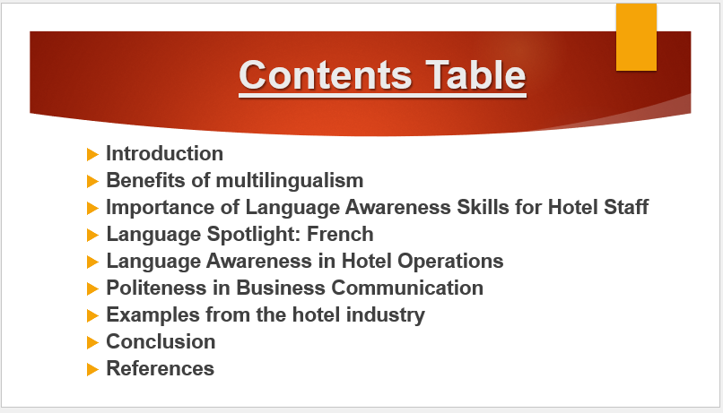

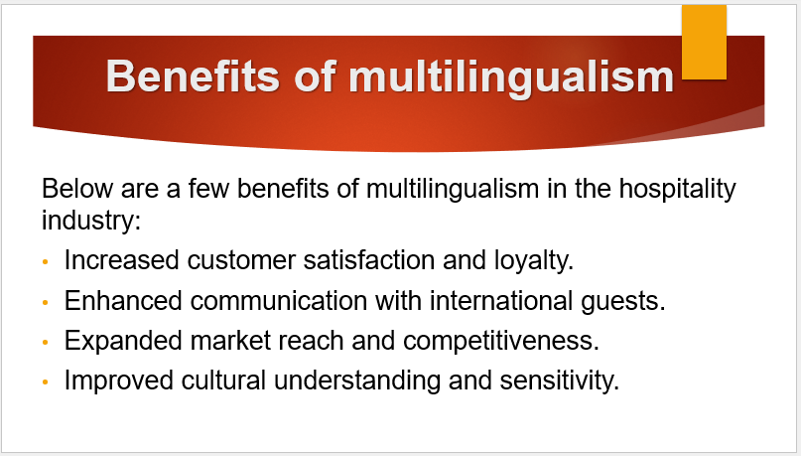
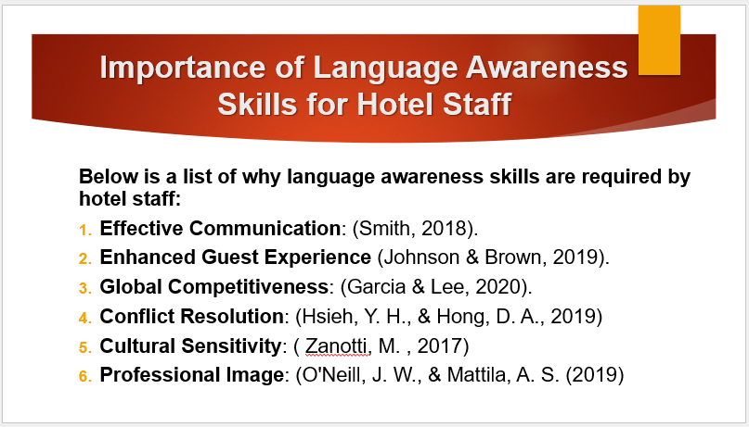
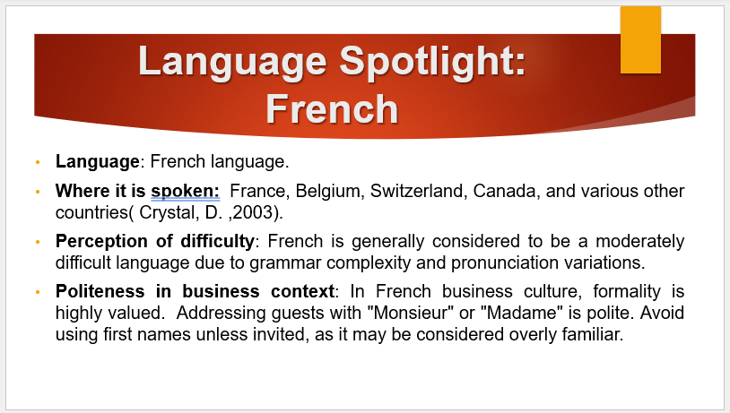
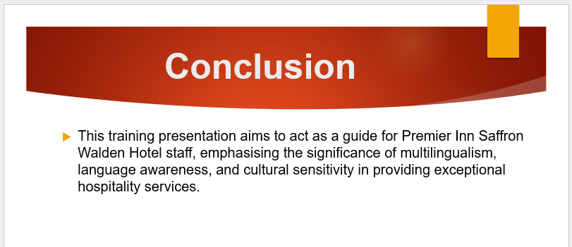
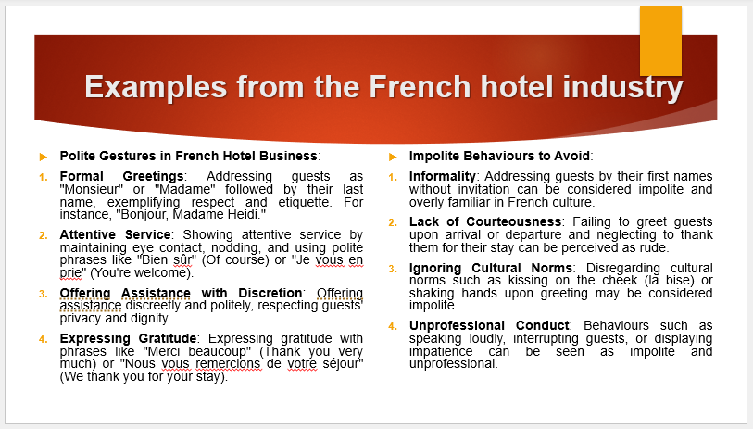
References (no screenshots):
- Smith, A. (2018). The Role of Language in Customer Service in the Hospitality Industry. Journal of Hospitality and Tourism Management, 25, 45-58.
- Johnson, B., & Brown, C. (2019). Multilingualism and Service Quality in Hotels: A Comparative Study. International Journal of Hospitality Management, 36(2), 178-187.
- Garcia, L., & Lee, S. (2020). The Impact of Multilingual Staff on Hotel Performance: Evidence from European Hotels. Tourism Management, 78, 104053.
- Hsieh, Y. H., & Hong, D. A. (2019). The Role of Communication in Conflict Resolution: A Mediation Model of Language Awareness and Conflict Management Styles. International Journal of Conflict Management, 30(1), 92-112.
- Zanotti, M. (2017). The Importance of Cultural Sensitivity in International Hospitality. Journal of Hospitality & Tourism Research, 41(6), 732-755.
- O'Neill, J. W., & Mattila, A. S. (2019). The Influence of Language Skills on Hotel Guest Perceptions of Service Quality. Journal of Hospitality Marketing & Management, 28(1), 69-86.

