UNIVERSITY OF WALES TRINITY SAINT DAVID BIRMINGHAM CAMPUS
Student Name: Sajida Bi
Student Number: 1810155
Module Title: Developing workplace critical thinking
Module Number: BMSK5001_BIRM (Part 2)
Lecturer Name: Ernest Ovia

Table of Contents:
Introduction:……………………………………………………………………..2
Theory of critical thinking:…………………………………………………...…3
Attitudes, values and believes:………………………………………………...4
Effect of individual beliefs and values on workplace behaviour:………..5
Equity theory of motivation:…………………………………………………….7
Reflection:………………………………………………………………………..8
Conclusion:…………………………………………..……………..……………9
Reference:……………………………………………………………….…….…9/10

Introduction:
My task of the assignment I will be making a report on the effect of an employee’s own values and beliefs on work place behaviour, in my assignment I am going to use myself as an employee. I work in a school and school nursery, the name of the school is Audley primary school, in this school the age of the children is 3 to 11years old, this school is on Audley road in Stechford Birmingham, the school and nursey are mixed raced, the capacity of this school is 840, the number of pupils attending is 889. The amount of children that are entitled to free meals are 37.2%, the rating of Ofsted is that the school needs improvement.
In a child’s life the transition from home to nursery and school is very difficult both for the parents/carers and also the child itself. School education gets children ready for the years ahead and makes them responsible individuals. By attending nursey and school the children have the chance to explore their hidden skills, socialise with others and get educated, all at the same time. Children in nursery and school are looked after by trained and professional members of staff.
The children in school and nursery have outdoor and indoor play and have the chance to use their fine and gross motor skills, the children get provided with nutritional and healthy snack and drinks to keep them full and hydrated while in the settings. The staff in this school is fully trained and well equipped in all aspects of learning and education which is a great asset to this school, the main reason of success of this school is school always train their staff for new skills and motivate their employees by giving them excellent rewards in return of their services, the core values of this school are respect, morality, sympathy, kindness, persistence, graciousness and flexibility.
Theory of critical thinking:
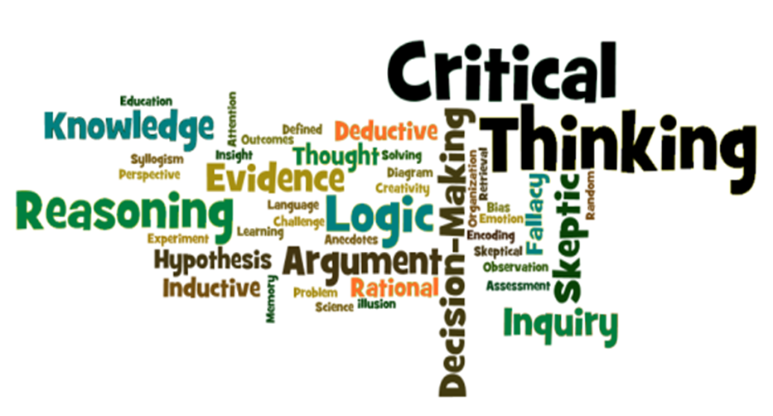
Critical thinking is a process of thinking where you use your skills and abilities for a reason, your ideas and questions should make positive sense, it is also ability to think clearly about what you want to do and what you really want to believe, this is one of the most important method managers use in any organisations to resolve any employee or individual problems may come across at the work place as you need to ask correct and relevant questions when observing employees and your writing should be able to show that you have quality and ability in yourself to take correct decisions when solving employee problems at workplace.
Critical thinking is also a ability to think widely and wisely and by doing this you can see clear links between different ideas to solve problems, it has been under discussion since the early age of Greek philosophers Plato and Socratesand even at present age it is still under discussion e.g. having good knowledge and ability to recognise the difference between invalid and valid news. (2017, Barriers to Effective Communication Plato and Socrates).
Critical thinking makes you very active and responsible learner rather than inactive and irresponsible learner and it also involve deep thinking while making decisions.
Critical thinking contains technical, logical, scientific, practical, fiscal, ethical and sensible thinking towards the establishment to resolve any misunderstanding among the workers and the managers or owners (Michael Scriven, Richard Paul, 1987).
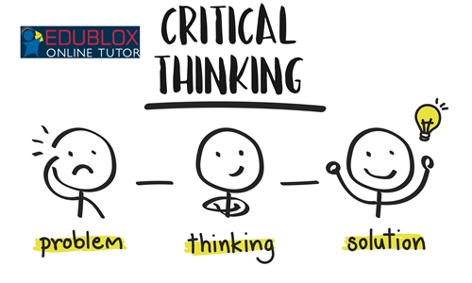
Critical thinkers always consider different thoughts and expectations rather than trying them without valid proof, they always make sure all ideas are available to others and all matters and all relevant, proofs and concerns are very clear to understand.
When making decisions on arguments critical thinkers needs to be very honest in their findings and all reasons behind their findings should be valid and genuine, critical thinkers always work hard and extra to achieve their targets as to make sure whatever decision they are going to make is correct as at no circumstances they use cross-cultural as a substitute truthful minded intentions (Linda Elder, 2007).
Attitudes, values and believes:
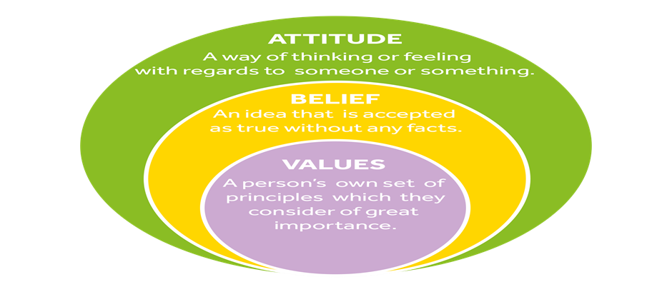
Attitude is your way of expression and it also your behaviour towards others and the way you speak to them when they speak to you or ask you for help, beliefs are expectations and principles we see and observe about others and sometimes it depends on the past experience we have about others and things we was told growing up and Values are helpful ideas primarily based totally on things we do and see around us, In general believes, attitude and values are same but in reality they have different meaning and use and they also define who we are and help others to understand us
Attitude:
Attitude is something like our behaviour towards others, how we react in front of others, how we deal with others, our likes and dislikes represent out attitude or behaviour, our attitude is shaped over many years and has both sensible and non-sensible features. For example when you deal with your co-workers and your project manager in the work place when they speak to you, you should have a good attitude towards them and the work you are instructed to do by them
Values:
Values are some kind of sense of finding difference between right and wrong, these are things that are important and they play a big part in our lives they help us to define who we are they help us to develop ourselves and help us achieve what we want to see in the future in our life. They are also very important in the work place as they help our co-workers understand who we are.
Beliefs:
Belief is something which can’t be obtained from education or training but it can only come from facts, past experiences and family. I believe that there is only one god that is one of my beliefs many people have different beliefs. And your beliefs can change or vary because of who you are, your religion and what you have been told before in the past. Beliefs can be due to superstition for example many people believe that the loch ness monster exists and some people don’t but those are all beliefs and as I said before they change due to who you are.
Effect of individual beliefs and values on workplace behaviour:
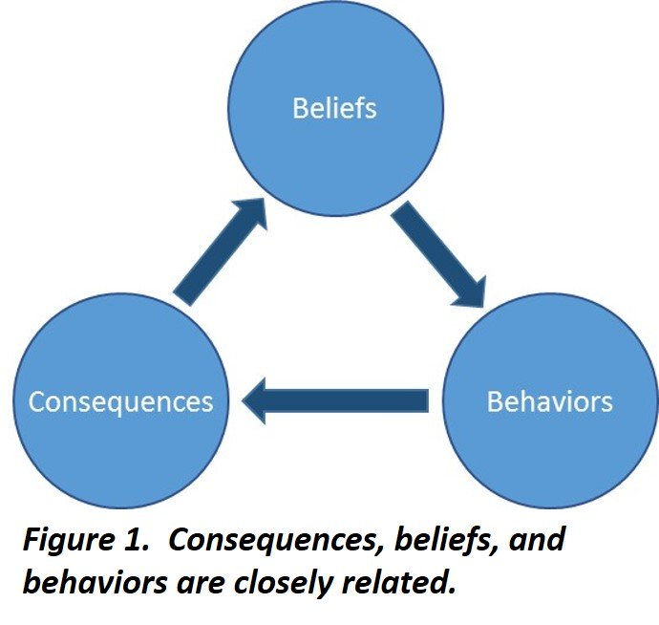
Values 1and 1believes 1describe 1what 1is 1important 1to 1you 1in 1the 1way 1you 1live 1your 1life, 1they give 1meaning 1to 1your 1life, 1they 1are 1the 1main 1foundation 1of 1all 1relationships 1at 1 1the workplace 1, 1they 1influence 1your 1decisions, 1actions 1and 1behaviour 1and 1impact 1on 1the 1life you 1choose 1to 1lead.
Our 1values 1and 1beliefs 1affect 1the 1quality 1of 1our 1work 1and 1all 1our 1relationships 1because what 1you 1believe 1is 1what 1you 1experience. 1We 1tend 1to 1think 1that 1our 1beliefs 1are 1based 1on reality, 1but 1it 1is 1our 1beliefs 1that 1rule 1our 1experiences, 1the 1beliefs 1that 1we 1hold 1are 1an important 1part 1of 1our 1identity.
All the knowledge and experience gained by employees while at work is not good until you can put and use this into practical life, if you do good job at work and meet all your targets on time you will be an excellent employee in the eyes of employers and manager and even if you leave the job they will still remember you due to your excellent work but if your work and behaviour is not good at workplace then nobody will really like you, so being at a responsible post in this school I can suggest new individuals or employees to be kind to children and truthful while doing their job at work place as it is very important for employees to take good interest in business progress as without their good interest success is not possible as no matter on what level of technology you have in your establishment until you don’t have sincere staff who actually take good interest in company progress success is not possible (Littlejohn, Milligan and Margaryan, 2012).
Beliefs and values play a very significant role in the work setting, by having good knowledge and understanding of these skills you will avoid conflicts and misunderstandings at the workplace, in case this issue had happened already in the past you will have the capability to resolve the matter without getting into any mishap. In this school I have come across different types of issues and concerns and while dealing with them I made sure I used all my past experiences and present skills to deal with the situations.
To be successful in any company organisation and business you need to know how to use these skills correctly and by using these skills you should set an example to other co-workers and staff (Morgan, P. 2016).
In any organisation you should consider your customers as your first priority as they are the ones that are bringing revenue to your organisation, even the beliefs and values of your customers are very important for you in order to become successful, you should take customer feedback very seriously as sometimes facial expressions will not tell you what your customers are thinking about your services and what image they have for your services. When resolving a customer query the decision might go against their favour so feedback option will give you an opportunity to read the customer reviews to understand the customer’s point of views more clearly and as you are representing your business or organisation, you’re honest and good decisions will put a good impact of your business to others (McQuerry, 2018)
In my establishment if I become aware that my fellow colleagues are having any issues in understanding the companies policies and procedures I will make sure to give them an helping hand in whatever they lack understanding in, it is vitally important for new employees to understand all the skills that are related to their jobs because employees are the backbone of any establishment, they can take your business to upper levels of success and can also take your business down the ladder with their lack of knowledge and understanding and unskilled behaviour at the workplace, skills are very important in any working environment as they represent your personality to others (Gibbs G 1988)
Equity theory of motivation:
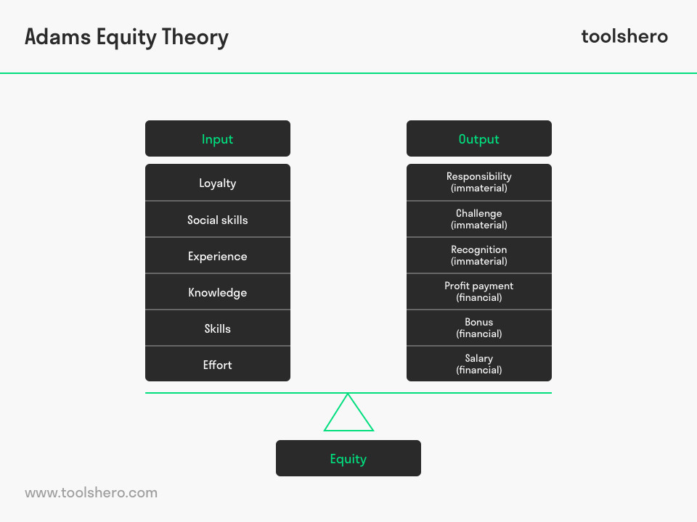
The 1Equity 1Theory 1of 1motivation 1was 1developed 1by 1the 1American 1psychologist 1John Stacey 1Adams 1in 11963. 1It’s 1about 1the 1balance 1between 1the 1effort 1an 1employee 1puts into1their 1work 1(input), 1and 1the 1result 1they 1get 1in 1return 1(output).
If 1an 1employee 1feels 1they’re 1receiving 1fair 1payment 1for 1their 1efforts, 1they 1are 1more 1likely 1to stay 1motivated 1and 1find 1satisfaction 1in 1their 1position. 1This 1concept 1is 1called 1the 1equity theory, 1which 1you 1can 1use 1to 1help 1your 1team 1stay 1motivated. 1In 1this 1article, 1we 1will discuss the 1equity 1theory 1of 1motivation 1and 1how 1you 1can 1apply 1it 1to 1your 1workplace.
The 1equity 1theory 1of 1motivation 1is 1the 1idea 1that 1what 1an 1individual 1receives 1for 1their 1work has 1a 1direct 1effect 1on 1their 1motivation. 1When 1applied 1to 1the 1workplace, 1it 1means an1individual 1will 1generally 1aim 1to 1create 1a 1balance 1between 1what 1they 1give 1to 1the organization 1compared 1to 1what 1they 1get 1in 1return.
Understanding 1the 1role 1of 1equity 1theory 1in 1professional 1environments 1can 1be 1helpful 1when you 1want 1to 1ensure 1that 1your 1team 1feels 1properly 1motivated 1and 1appreciated 1for 1their work. When 1you 1offer 1fair 1compensation 1for 1your 1team’s 1contributions, 1they 1may 1maintain 1higher levels 1of 1motivation. 1This 1can 1have 1a 1positive 1effect 1on 1factors 1such 1as 1teamwork, 1job commitment 1and 1communication.
The 1equity 1theory 1contains 1two 1primary 1components, 1inputs 1and 1outcomes, 1It 1is 1a 1team member’s 1perception 1of 1these 1two 1factors 1that 1can 1influence 1their 1motivation 1levels.

Criticism 1has 1been 1directed 1toward 1both 1the 1assumptions 1and 1practical 1application 1of equity 1theory. 1Scholars 1have 1questioned 1the 1simplicity 1of 1the 1model, 1arguing 1that 1a number of 1demographic 1and 1psychological 1variables 1affect 1people's 1perceptions 1of 1fairness 1and interactions 1with 1others, 1(Huseman, 1Hatfield 1& 1Miles, 11987).
Everyone 1in 1the 1workplace 1is 1motivated 1by 1something, 1as 1an 1example 1of 1equity 1theory, 1if an 1employee 1learns 1that 1a 1colleague 1doing 1exactly 1the 1same 1job 1as 1them 1is 1earning 1more money, 1and 1then 1they 1may 1choose 1to 1do 1less 1work, 1thus 1creating 1fairness 1in 1their 1eyes.
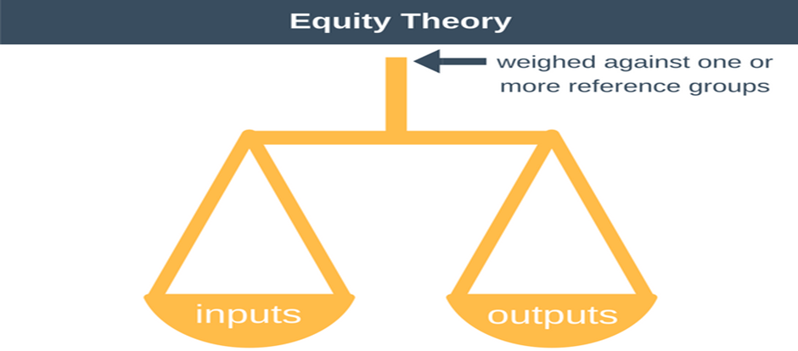
Equity 1theory 1can 1help 1you 1gain 1a 1better 1understanding 1of 1the 1different 1factors 1that influence 1your 1team’s 1motivation 1levels. 1If 1you 1want 1to 1apply 1the 1equity 1theory 1in 1your workplace, 1consider 1the 1following 1tips:
Fair balance:
Since 1many 1employees 1make 1work 1contributions 1based 1on 1what 1they 1think 1they 1will receive, 1you 1can 1benefit 1your 1entire 1team 1by 1setting 1standards 1for 1fairness 1and 1equality. Make 1sure 1all 1team 1members 1receive 1the 1same 1compensation 1for 1equal 1amounts 1of 1work. You 1can 1also 1hold 1regular 1team 1meetings 1to 1guarantee 1everyone 1feels 1valued 1for 1their efforts.
Offering comparable compensation:
Your 1team 1members 1may 1make 1different 1comparisons 1for 1inside 1and 1outside 1of 1the workplace. 1If 1an 1employee 1sees 1that 1they 1are 1receiving 1similar 1outcomes 1to 1others 1in 1their field 1with 1the 1same 1amount 1of 1experience, 1they 1will 1be 1more 1likely 1to 1stay 1satisfied 1in 1their position. 1When 1setting 1compensation 1standards, 1consider 1researching 1external 1positions for information 1about 1salary, 1benefits 1and 1incentives. 1Try 1to 1use 1like 1items 1so 1employees 1feel more 1comfortable 1with 1their 1roles.
In my opinion only good pay and rewards alone do not determine motivation, people value fair treatment which causes them to be motivated to keep the fairness maintained within the relationships of their co-workers and the organization.
Reflection:

From this assignment have learnt that beliefs values and attitudes play a very important part in any organisation or workplace without the correct knowledge and understanding of these skills it is almost impossible to succeed in your task that you are or have been set. As a responsible school employee I feel that it is vital to support new employees and help them reach their goals. I also strongly believe it is compulsory to treat everybody the same way in the workplace it should defiantly not vary due to their religion colour or gender everybody is the same and should be treated equally after all where all human, as according to equity theory of motivation, if you don’t treat all employees the same then the employees that are not being treated equally will not do their job up to their highest standard and due to this the company will be making great, continuous loss, all these management theories are very important for business success and they give you knowledge and skills any but using these skills you can understand your mistake better and never repeat them by learning from your past experience, (Thomson and Hoffman 12003).
I strongly believe that business success is not possible without the clear understanding and correct knowledge of these skills and once you know all of your weakness at work place it is easy for you to understand them and work on them, (Cottrell, S. 2011).
Conclusion:

As by studding all he above skills, believes, attitudes, values, and management theories I think all these theories are very important and can’t be neglected, it is also important for employees and hire management to give full training to new employees as they are new and don’t understand company policies and procedures and it is very easy for them to make mistakes, so it is organisation duty to use all available skills and methods and work together as a team to avoid any possible mistakes employees are making in the organisation. (Collins, J.C, 2001).
I the this day and age all businesses have the latest models of technology to sponsor their business nationally and also internationally (Perry, L, 2018) and I strongly believe that it is almost compulsory that business have the best and newest technology for their organisations so that they can peruse the tasks that they need to do and ge.t the job done in time but it is not only up to the technology the employees need to have the skills to conduct the task they are instructed to do.
References:
Adams, J. S., & Freedman, S, (1976). Equity theory revisited: Comments and annotated bibliography. In Advances in experimental social psychology (Vol. 9, pp. 43-90). Academic Press
Perry, G.L, (2018) 1Human 1Relations 1Management 1Theory 1Basics.
Thomson, G. & Hoffman, J, (12003). 1Measuring 1the 1success 1of 1EE 1programs. Canadian Parks 1and Wilderness 1Society.
Boudon, Raymond, (2018). Origin 1of 1values. 12nd 1Ed. 1Transaction 1Publishers. New Jersey.
Collins, J.C. 1and 1Jim, 1C, (2001) 1Good 1to 1great 1[why 1some 1companies 1make the leap 1and others don’t]. 14th 1edition. 1New 1York, 1NY: 1HarperCollins 1Children’s Book Group
Cottrell,S, (2011) 1Critical 1thinking 1skills, 1Developing 1effective 1analysis 1and argument palgrave study skills, 12nd 1ed, 1Basingstoke, 1Palgrave 1macmillan.
Huseman, R.C., Hatfield, J.D. & Miles, E.W, (1987). A New Perspective on Equity Theory: The Equity Sensitivity Construct. The Academy of Management Review. 12;2: 222-234.
Gibbs, G, (1988) 1Learning 1by 1doing: 1A 1guide 1to 1teaching 1and 1learning methods. London: FEU.
Morgan, P, (2016) 1The 1Business 1Student’s 1Guide 1to 1Study 1and 1Employability. Sage Publications.
McQuerry, L,1(20180 1How 1Do 1Negative 1& 1Positive 1Attitudes 1Affect 1the Workplace
Littlejohn, 1Milligan 1and 1Margaryan, (2012) 1Technology-Enhanced 1Professional Learning: Processes, Practices, 1and 1Tools.
Linda Elder, (2007), 1A 1Critical 1Thinker's 1Guide 1to 1Educational 1Fads: 1How 1to Get Beyond 1.
Barriers,(2017) 1Effective 1Communication 1Plato 1and 1Socrates, 1 1Critical 1Thinking: Tools 1for Taking Charge 1of 1Your 1Professional 1and 1Personal 1.
Michael 1Scriven, Richard 1Paul, (1987), 1Critical 1Dialogues: 1Thinking 1Together 1in Turbulent Times.

