Considerations of explosive trains in artillery rounds during service life and use.

Jon Walton (2028159)
2023

Abstract
This report explores the components contained in a typical large calibre artillery round and considers the explosive trains and how they function. The requirements related to storage and transport of explosive articles is explored, before a more specific examination of TNT is carried out. When looking into potential replacements for TNT, IMX-101 is proposed as a much better alternative to melt cast TNT as an HE fill. This is thanks to levels of insensitiveness that outstrip those of TNT whilst remaining equally as potent on the battlefield.
Table of Contents
1. Introduction 2
2. Exploring the components in a large caliber artillery shell 2
2.1. The projectile and its components 3
2.2. Propellent and bagged charges 3
2.3. Primers 4
3. The explosive train 5
3.1. Detonative explosive trains 6
3.2. Igniferous explosive trains 6
4. The classification of explosives substances and articles for storage and transportation 7
5. TNT and its properties. 9
6. A substitute for TNT 10
7. Conclusion 10
References 10

Figure 1 - A diagram showing the main components of a large calibre artillery shell [3]. 2
Figure 2 - An example of an artillery shell with the main components labelled [6]. 3
Figure 3– An example of a conventional bagged charge system. The bag marked ‘3’ contains the ignitor pad [7]. 4
Figure 4- Modular bagged charges for 155mm cannon howitzer. The red core is the central ignitor [8]. 4
Figure 5– A diagram showing the internals of a M82 Z primer used in 155mm howitzers [10]. 5
Figure 6 - Diagrams showing an example of both an Igniferous explosive train and a detonative explosive train [11]. 6
Figure 7 - Hazard division definitions table [16]. 7
Figure 8 - A table showing the 13 compatibility groups and all the possible Hazard Classification Codes [16]. 8
Figure 9 - A table and notes dictating the requirements for storing explosive articles [17]. 8
Figure 10 - 2-4-6 Trinitrotoluene, a symmetrical isomer of TNT [14]. 9

Introduction
This report will analyse design features of a large calibre artillery munition, how they function in an explosive train and the storage and transportation requirements during service life and operational use. Although the entirety of the munition will be considered, the focus of this report will be on the melt cast TNT fill being used in the shell. The properties and issues with TNT will be discussed and a potential replacement considered.

Exploring the components in a large caliber artillery shell
Typical large calibre artillery munitions often use a type of ammunition referred to as separate loading bagged charge ammunition [1]. This type of ammunition is composed of three components, the projectile, which is itself made up of several components, separate bagged charges, and a primer. The main advantages of this type of ammunition are numerous. Breaking the projectile into its component parts makes it easier to handle, as most large calibre artillery rounds are heavy and unwieldy [1]. More efficient storage in transport is possible due to components being smaller, and proper segregation decreases the risk of cook off; explosions caused when damage to ammunition, specifically when under fire, causes a chain reaction and catastrophic consequences [2]. It is also possible to add or remove bagged charges to affect the range of a projectile which is especially useful for artillery pieces. One more advantage of note, is the amount of metal saved in the production process that is usually associated with cased ammunition, this in turn reduces the number of spent cartridges that a crew would either leave at the site after firing, or they would have to carry around unnecessary weight whilst on the battlefield, neither of which are good options. One of the main disadvantages of bagged propellant over fixed case rounds is that protecting the propellant from moisture is more difficult, so greater care must be taken when handling and storing bagged charges [1].
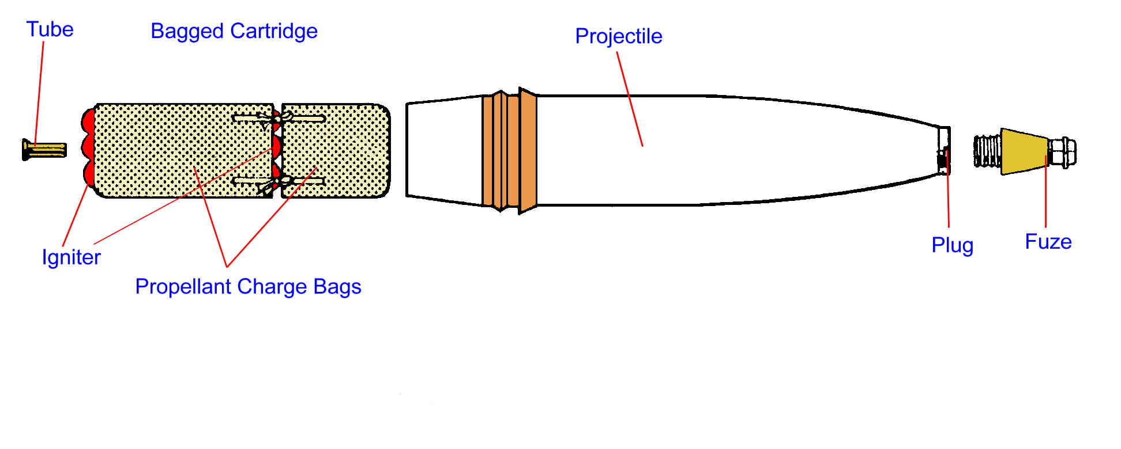
Figure 1 - A diagram showing the main components of a large calibre artillery shell [3].

The projectile and its components
A projectile is made up of several main components. The fuzee has the sole purpose of starting the detonation of the projectile at a specific and predictable time. The fuzee can be made to function in a variety of different ways, some being as simple as to function on impact with a sufficiently dense target and others will function at a specific altitude when travelling back towards the ground to ensure the desired effect is achieved.
The main component of an HE shell is the high explosive fill. This can be made from a variety of different high explosives, but as stated earlier, the focus of this report will be on a shell that is filled with melt cast TNT.
The casing, or munition body, is made from a strong material such as high tensile steel that provides sufficient strength to withstand the pressures associated with being fired from a barrel whilst allowing for the maximum amount of internal space for the high explosive fill [4]. The shell body will often be thin around the middle of the shell to ensure high fragmentation can occur whilst allowing high pressure levels from the blast effect are still applied to the target and energy is not lost breaking the case open. There is often a protective liner between the shell and the body that reduces friction and helps to protect the HE fill from the stresses of firing.
The last major component is the obturation ring. Often referred to as a driving band, the obturation ring is made of a soft material, usually copper, that forms a seal in the barrel of an artillery piece. Sometimes a bourrelet is used in conjunction with an obturation band to ensure the shell remains stable and aligned to the barrel during firing [5].

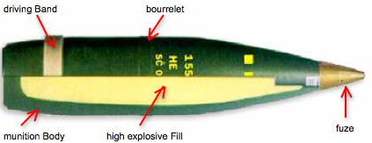
Figure 2 - An example of an artillery shell with the main components labelled [6].

Propellent and bagged charges
The bagged charges themselves come in two main forms; the conventional artillery charge system, which uses subtractive increments, and the modular charge system, which uses additive increments.
The conventional charge system uses several rods of bagged propellant of differing sizes within a larger outer bag. The large outer bag has an igniter pad at the base which will transfer the flame front from the primer through to the propellent charges within. These charges can be selectively removed to adjust the range of the projectile.
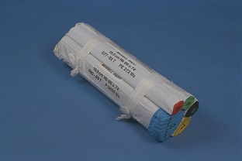
Figure 3– An example of a conventional bagged charge system. The bag marked ‘3’ contains the ignitor pad [7].
In a modular charge system, separate bags are stacked on top of each other to achieve the desired levels of propelling force. Instead of an igniter pad at the base, all the bagged charges have a central igniter that runs through the middle of the charges to ensure that the flame front is maintained when the projectile is fired from the artillery piece.
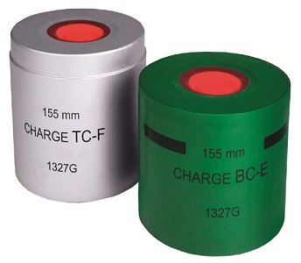
Figure 4- Modular bagged charges for 155mm cannon howitzer. The red core is the central ignitor [8].

Primers
Primers, as the most sensitive component of the ammunition, are introduced to the system last. Depending on the system the primer has been designed for, it will either be triggered mechanically or electronically, and its primary function is to ignite and initiate the explosive train to begin the process of deflagration required to send the projectile down range [9].
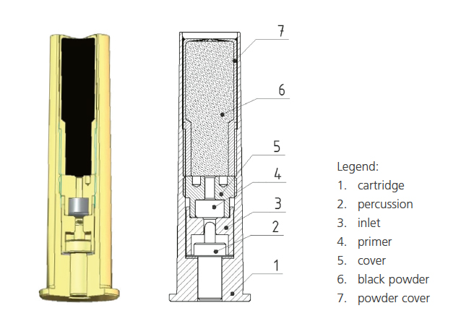
Figure 5– A diagram showing the internals of a M82 Z primer used in 155mm howitzers [10].

The explosive train
An explosive train is a term used to describe the components and the arrangement required to start and sustain an explosion to achieve a desired effect. An explosive train is primarily used to ensure both the reliability and the safety of the munition, the requirement being as close to 100% reliability as possible [11]. There are two types of explosive trains, a detonative explosive train and an igniferous explosive train. Understanding activation energy is crucial to the correct functioning of an explosive train. For a chemical reaction to occur, the is a required minimum energy input to start the reaction. This is called the activation energy, and this differs greatly for different chemical compounds [12]. An explosive train starts with a comparatively low activation energy explosive in the form of primary explosives to initiate increasingly more potent explosives with increasingly higher activation energies known as secondary explosives [13].

Detonative explosive trains
A detonative explosive train starts by imparting energy to a system which is intensified and transmitted to the next part of the explosive train which in turn will impart increased energy to a final high explosive charge or fill [14]. This energy is transferred between compositions when a flame front or blast wave passes from one material to another that is harder to initiate but will result in a greater energy release. The need for a detonator and a booster as well as the main charge is due to the relative insensitiveness of the main charge. Detonators, usually filled with primary explosive such as TATP or Lead Azide, are very easy to initiate but typically have lower energy outputs than secondary or tertiary explosives [11]. This means that they cannot always initiate the main fill of a weapon system; because of this, it is often the case that an intermediary called a booster is required. A booster is somewhere in between the detonator and charge in terms of activation energy. A booster will typically be made from a secondary explosive such as PETN, a compound with a high velocity of detonation, that produces enough energy to ensure the blast wave is transmitted into the main fill [13]. The main charge of fill is the last component in the explosive train and is how a desired effect will be applied to a target.

Igniferous explosive trains
An igniferous explosive train works in a similar fashion a detonative explosive train in that a primer is used to start a chemical reaction that forms a flame front that is sustained, but the goal is to push or propel an object over great distances. To achieve this, low explosives are used, specifically propellants such as Nitrocellulose and Nitro-glycerine, which when ignited, deflagrate, and impart energy to a projectile [15].
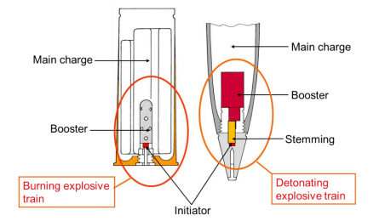
Figure 6 - Diagrams showing an example of both an Igniferous explosive train and a detonative explosive train [11].

The classification of explosives substances and articles for storage and transportation
Classification of hazardous materials is a legal requirement for the storage and transport of explosives, and this is done so using Hazard divisions, storage subdivisions and compatibility groups [16]. These methods of classification assess a variety of factors such as the sensitivity of the explosives, the packaging they are contained in, and the risks associated with fighting a fire containing said explosives.
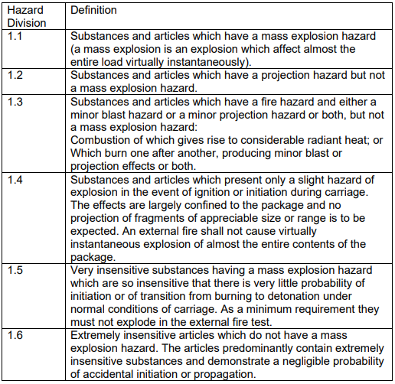
Figure 7 - Hazard division definitions table [16].
The UN classifies explosives substances and articles as dangerous goods, specifically Class 1 dangerous goods. Under this classification, there are many subgroups and categories that used to further classify explosive articles. Hazard divisions breaks up Class 1 into 6 subgroups. These 6 groups define the hazards that are likely to occur in the event of initiation. Compatibility groups define what articles can be stored with each other [16].
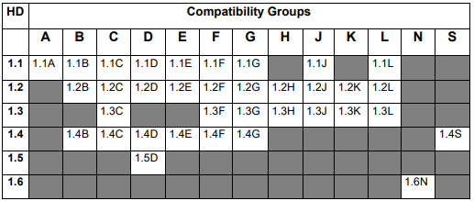
Figure 8 - A table showing the 13 compatibility groups and all the possible Hazard Classification Codes [16].
For a large calibre artillery round and all its constituent parts, each explosive element will have a separate classification. These will vary depending on the intended function, sensitiveness, and how the explosive explodes, i.e., by deflagration or detonation. The mixing of the compatibility groups is controlled using the table and guidance in figure 9.
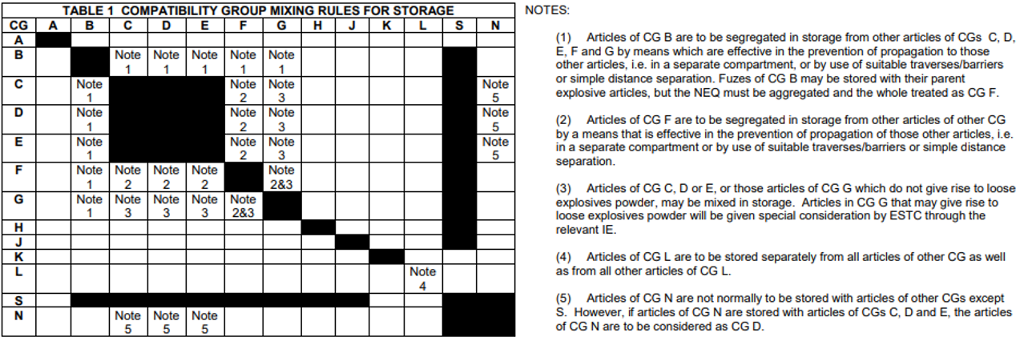
Figure 9 - A table and notes dictating the requirements for storing explosive articles [17].
Where possible, the safest method of transportation involves transporting all items of different compatibility groups separately to make sure the explosive train is never complete drastically reducing the chances of catastrophic initiation. This makes the management of hazards simpler and reduces the risks substantially. However, there is a degree of practicality that must be considered. Providing that the explosive components being transported together don’t significantly increase either the likelihood or magnitude of an accident, that mixing can occur [16]. This is very likely when considering that logistics is arguably one of the most important elements in military operation, and that, eventually, all of the explosive components in a munition are deliberately brought together to provide an effect on a target.

Where possible, the storing of explosive articles must be done to adhere to the compatibility groups, but there are also requirements of the storage locations that must be considered. It is recognised that when explosives are being used in a war zone, it is not always possible to adhere to the stringent regulations that are applied to dedicated storage sites, but there are strict guidelines that must be observed to ensure the explosives are stored correctly, even in the field [18]. The spacing of storage locations is important to reduce the likelihood of chain reactions between sites in the case of accidental initiation. These safety distances must also consider both military and civilian sites to ensure that the safety of personnel is kept as high as possible [18]. A huge factor regarding the safety of explosives, regardless of where or how they are stored, is lightning protection. Storage sites should be kept at least 15 meters away from tress and must be installed with a lighting protection system to ensure a lightning strike is caught and carried away to earth whilst protecting explosive articles. ISO containers form faraday cages which do provide a reasonable level of protection, but they must still be suitably earthed.

TNT and its properties.
TNT exists as 6 different isomers; the isomer primarily used in weapon systems is 2-4-6 Trinitrotoluene [14]. This pale, yellow, solid, explosive compound has a molecular formula of $C_{7}H_{5}N_{3}O_{6}$ and a melting point of approximately 80.1°C [19]. This is an important figure as this makes TNT an ideal explosive to be melted and then cast directly into a shell or casing [20]. However, this convenient melting point from the perspective of manufacture, can become problematic when TNT is used in hot climates. If improperly stored, TNT can be exposed to such temperatures. This is even more problematic if there are traces of impurities within the mix such as Dinitrotoluene, a product of the manufacturing process, which has a melting point of approximately 71°C [21]. This difference in melting temperatures can lead to a leaking or oozing of impurities which can result in several issues. Cracks and voids can form within the main fill, increasing the shock sensitivity of the munition due to the rise in hotspots. The exuding materials can also find their way out of the shell through the hole left for the fuzee and settle on the screw thread [14]. When the exudate cools and solidifies the chances of accidental initiation from friction caused by screwing in the fuzee is far higher than is acceptable [14].
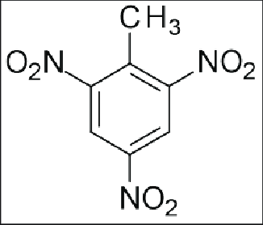
Figure 10 - 2-4-6 Trinitrotoluene, a symmetrical isomer of TNT [14].

A substitute for TNT
The drive to find safer munitions over the years hav resulted in the development of insensitive munitions (IM), munitions that are specifically designed to not detonate other than when used for their intended purpose such as delivering an effect to a target [14]. IMX – 101 (Insensitive Munitions eXplosive) is a relatively new, innovative explosive developed by BAE systems specifically to replace TNT [22]. It has already been cleared for use in the United States Army to replace the TNT based munitions used in large calibre artillery rounds as a considerably more stable, safer, and equally as effective alternative to TNT filled munitions [23].

Conclusion
TNT has been used in munitions since as early as 1902 by the German military, and this is a testament to its effectiveness [14]. As the years have passed however, the requirement for safer insensitive munitions has grown, and the development of compounds such as IMX-101 is the culmination of such efforts. An explosive that improves the levels of safety of the user by making munitions difficult to near impossible to initiate from everyday knocks and environmental conditions to direct hits from enemy fire or sympathetic detonation. These qualities will provide a safer munition both for its intended use and throughout its service life.

References

[1] | I. V. Hogg and J. H. Batchelor, Artillery, Balantine Books, 1972.
[2] | G. Cohn, "Cook-off in aircraft guns," Journal of the Franklin Institute, vol. 271, no. 4, pp. 342-344, 1961.
[3] | N. F. Evans, "British Artillery in World War 2 - Ammunition," 6 June 2014. [Online]. Available: https://nigelef.tripod.com/ammo.htm. [Accessed 28 June 2023].
[4] | BAE Systems, "155mm artillery ammunition," BAE Systems, [Online]. Available: https://www.baesystems.com/en/product/shell-155mm-how-he-l15#:~:text=It%20comprises%20of%20a%20high,high%20fragmentation%20and%20blast%20effect.. [Accessed 26 June 2023].
[5] | G. Slover, "Gene Slover's US Navy Pages - Navel Ordnance 1937 Chapter XIII - Projectiles," 1937. [Online]. Available: https://eugeneleeslover.com/USNAVY/CHAPTER-XIII-PAGE-1.html. [Accessed 26 June 2023].
[6] | GICHD, "152mm & 1555mm Artillery Guns," GICHD, 2017. [Online]. Available: http://characterisationexplosiveweapons.org/studies/annex-b-152-155-artillery-version/. [Accessed 26 June 2023].
[7] | Rheinmetall Nitrochemie, "Artillery," Nitrochemie Group, [Online]. Available: https://nitrochemie.com/en/nitrochemie_group/produkte/antriebe/rohstoffe_2/artillerie/index_3.php. [Accessed 28 June 2023].
[8] | CSG Defence, "Propelling charge," GSC Defence, [Online]. Available: https://csgdefence.cz/propelling-charge. [Accessed 28 June 2023].
[9] | D. C. Vest, E. V. Clarke, Jr, W. W. Shoemaker and W. F. Baker, "On the Performance of Primers for Artillery Weapons," Ballistic Research Laboratories, Maryland, 1953.
[10] | "Primer M82 Z," MSM Group, [Online]. Available: https://www.msm.sk/en/products/defence/ammunition/ammo-components/primer-m82-z/. [Accessed 28 June 2023].
[11] | Ministry of Defence, JSP 333 Service Textbook of Explosives, MoD, 2020.
[12] | C. Rye, R. Wise, V. Jurukovshi, J. DeSaix, J. Choi and Y. Avissar, Biology, Houston, Texas: OpenStax, 2016.
[13] | G. Collett, Basic Chemistry of Explosives and Hazards of Home-Made Explosives and Chemical Precursors, GICHD.
[14] | J. Akhavan, The Chemistry of Explosives, Cambridge: The Royal Society of Chemistry, 2011.
[15] | A. Bailey and S. G. Murray, Explosives, Propellants and Pyrotechnics, London: Brassey's, 1989.
[16] | Defence OME Safety Regulator, "Classification for Transport and Storage," in DSA 03.OME Part 1 Acquisition - Defence Code of Practice (DCOP) 106 Series, Defence Safety Authority, 2022, pp. 1-32.
[17] | Defence OME Safety Regulator, "Storage and Handling of Explosives," in DSA 03.OME Part 2 (Formerly JSP 482) - Defence Code of Practice (DCOP) for In-Service and Operational Safety Management of OME, Defence Safety Authority, 2021, pp. 1-64.
[18] | Defence OME Safety Regulator, "Defence Code of Practice (DCOP) for In-Service and Operational Safety Management of OME," in DSA 03.OME Part 2 (Formerly JSP 482), Defence Safety Authority, 2020, pp. 1-116.
[19] | PubChem, "2,4,6 - Trinitrotoluene," National Center for Biotechnology Information, 16 September 2004. [Online]. Available: https://pubchem.ncbi.nlm.nih.gov/compound/2_4_6-Trinitrotoluene. [Accessed 06 June 2023].
[20] | T. M. Klapötke, A. Penger, C. Pflüger and J. Stierstorfer, "Melt-cast materials: combining the advantages of highly nitrated azoles and open-chain nitramines," New Journal of Chemistry, vol. 40, no. 7, pp. 6059-6069, 2016.
[21] | PubChem, "2,4-Dinitrotoluene," National Center for Biotechnology Information, 16 September 2004. [Online]. Available: https://pubchem.ncbi.nlm.nih.gov/compound/2_4-Dinitrotoluene. [Accessed 29 June 2023].
[22] | BAE Systems, "Making Explosives Safer," BAE Systems, [Online]. Available: https://www.baesystems.com/en-uk/feature/making-explosives-safer. [Accessed 05 July 2023].
[23] | Rockville MD (SPX), "BAE IMX-101 Explosive Approved To Replace TNT In US Army Artillery," Space War - Your World at War, 03 August 2010.

