BMIH5006
Sustainable Hospitality and Tourism Management
Assignment 2
The Future of Hospitality and Is It Profitable to Be Green?

Lecturer: Kathryn Roberts.
Student Name: Naeem Qureshi.
Student ID: 2027460

Table of Contents
1. Introduction 3
2. Milton Friedman's Statement: Navigating Profit, Responsibility and Sustainability 4
2.1 The Relevance of Friedman's Statement 4
2.2 Does Finance Come First? 4
2.3 Business and Consumer Roles in Environmental Sustainability 5
2.4 Future Recommendations 6
2.5 The potential of the hospitality industry to be green 6
2.6 The importance of financial resiliency for sustainability 7
3. Elkington's Triple Bottom Line 8
4. Doxey's Irridex Model 10
5. Butler's Life Cycle Model 11
6. Conclusion 13
7. References 14

Introduction
Green practices in the hospitality industry are vital for environmental sustainability, cost reduction, and meeting the growing demand for eco-friendly options, which can improve a hotel's reputation, attract eco-conscious guests, and ensure long-term profitability (Shine, 2023). The purpose of this report is to explore comprehensively the multifaceted relationship between corporate profits, social responsibility, and environmental sustainability using various models. The first section of this report delves into the relevance of Milton Friedman's perspective in an era where the concerns of stakeholders, environmental impacts, and ethical dimensions have gained prominence. The following section of this report will delve into the interplay of finance, social responsibility, and environmental consciousness drawing from a range of models and frameworks, including Elkington's Triple Bottom Line, Doxey's Irridex Model, and Butler's Life Cycle Model.

Milton Friedman's Statement: Navigating Profit, Responsibility and Sustainability

The Relevance of Friedman's Statement
Milton Friedman's assertion that the primary responsibility of businesses is to maximize profits has faced substantial criticism. Critics argue that businesses should embrace a more comprehensive role in society, considering the welfare of various stakeholders like employees, customers, communities, and the environment (Ramanna, 2020). Proponents of Corporate Social Responsibility (CSR) contend that engaging in voluntary activities to enhance social and environmental sustainability can be advantageous, which includes improving reputation, attracting and retaining talent, reducing costs and risks, and fostering innovation and growth opportunities (Tepper, 2020). The contemporary relevance of Friedman's statement is a subject of debate. It can be viewed as a clear guideline for businesses in a profit-centric free market, where financial success signifies efficiency (Elrick and Thies, 2018). Alternatively, it can be seen as a narrow and outdated perspective that disregards the intricate societal challenges of the 21st century, including poverty, inequality, climate change, and human rights violations (Elrick and Thies, 2018).

Does Finance Come First?
The notion that finance should take precedence in business decisions is deeply ingrained in Friedman's perspective. However, modern business practices reflect a more nuanced understanding. While financial success is crucial, the business world now recognizes the importance of long-term sustainability. Financial success is not sustainable without ethical and responsible practices. Firms that prioritize finance over all else may find themselves facing reputational damage and regulatory scrutiny, which can undermine profitability.

Business and Consumer Roles in Environmental Sustainability
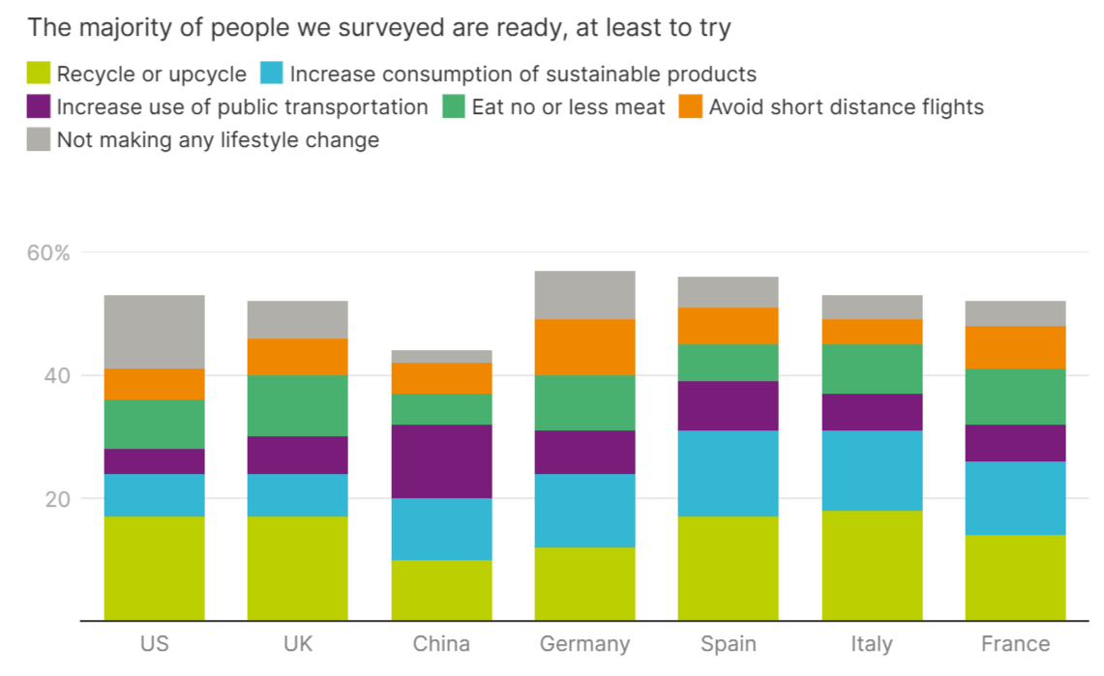
Figure 1: What are consumers doing to reduce their carbon emissions? (Cooper, 2021).
The responsibility for environmental sustainability in business is a complex interplay between corporate initiatives and consumer demand. While businesses have a fundamental role in adopting environmentally sound practices, consumer-driven factors play a pivotal role in shaping their strategies (Dangelico and Pujari, 2019). A survey conducted in 2021 shows that 98% of Chinese respondents expressed their readiness to adopt lifestyle changes to reduce emissions, closely followed by Italians and the French at 96%, with 95% in Spain, 94% in the UK, and 92% in Germany, while even in the US, 88% of the population expressed their intent to embrace greener living (Cooper, 2021). This growing demand for sustainable options forces businesses to consider eco-friendly practices to remain competitive. However, simply responding to consumer demand may not suffice in addressing long-term environmental challenges. Therefore, it is vital for businesses to take proactive steps in adopting eco-friendly practices (Dangelico and Pujari, 2019).

Future Recommendations
The following section provides some future recommendations:
- Embrace Ethical and Social Responsibility: The hospitality industry must embrace ethical and social responsibility, prioritizing Corporate Social Responsibility (CSR) beyond mere profits by focusing on the well-being of employees, customers, and local communities, as well as active participation in sustainability initiatives (Tepper, 2020).
- Sustainability as a Competitive Advantage: Sustainability should be recognized as a competitive advantage rather than an option. Implementing eco-friendly practices to reduce carbon footprints, conserve resources, and lower operational costs is essential (Cooper, 2021).
- Engage with Consumers on Sustainability: The hospitality industry should proactively engage with consumers regarding sustainability (Dangelico and Pujari, 2019). Capitalize on the growing interest in sustainable travel by effectively communicating eco-friendly initiatives and offering guests opportunities to participate in responsible practices during their stay.

The potential of the hospitality industry to be green
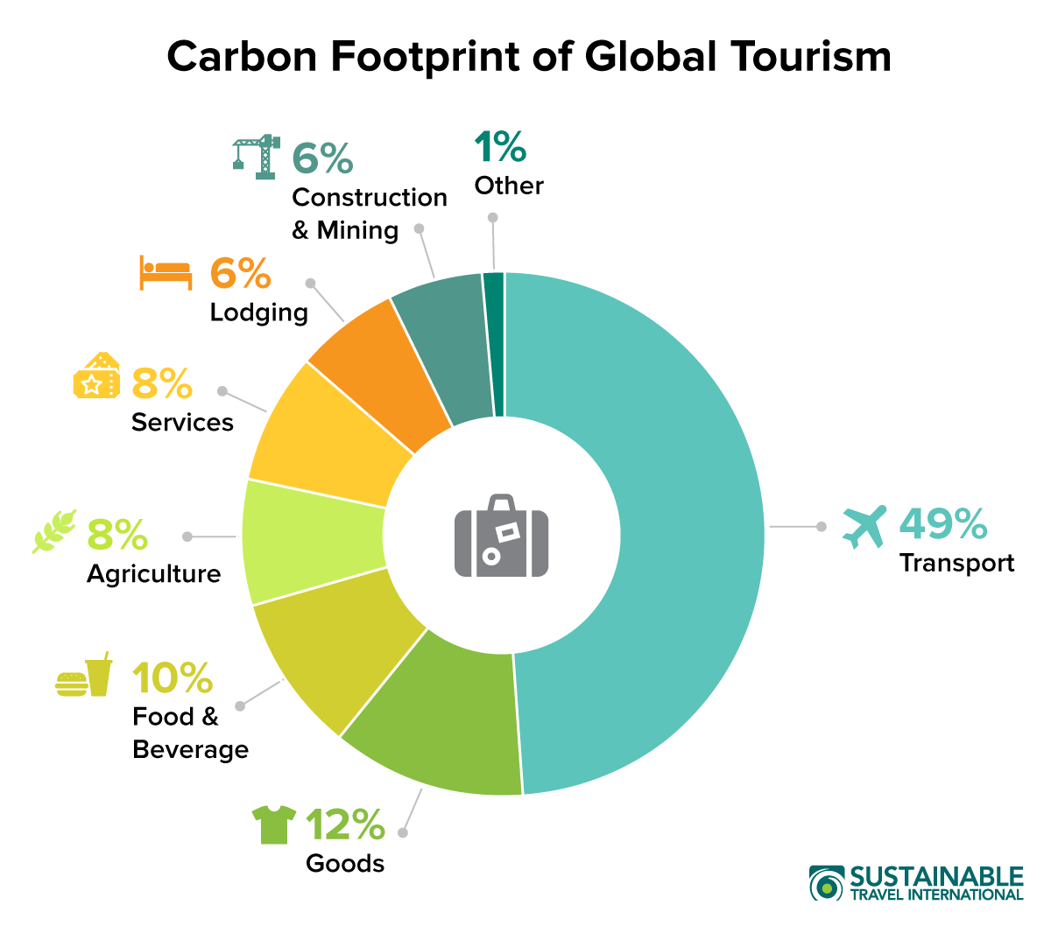
Figure 2: Carbon Footprint of Global Tourism (Shine, 2023).
The hospitality industry presents unique challenges in its quest to become "green." The industry's operations inherently require significant energy consumption, water usage, and waste generation (Liu et al., 2023). The tourism and hospitality industry contributes to approximately 8% of global carbon emissions, encompassing factors such as air and sea travel, souvenir production, and accommodations (Shine, 2023). Nonetheless, there are numerous strategies that the hospitality sector can employ to enhance its environmental sustainability. These strategies include adopting energy-efficient technologies, reducing water consumption, minimizing waste through recycling and composting, and sourcing local, sustainable products (Liu et al., 2023). Though difficult, the road to a "green" hospitality sector is not insurmountable. The hospitality sector can drastically lessen its environmental effects by combining coordinated efforts, sustainable practices, and cutting-edge technologies (Liu et al., 2023).

The importance of financial resiliency for sustainability
Sustainability and financial resiliency are inextricably intertwined. A company that is unable to stay solvent may find it difficult to make investments in environmentally friendly operations (Carmeli et al., 2020). Additionally, firms that are financially resilient are able to support Rand projects that focus on social responsibility and environmental sustainability. However, financial resilience is not the only requirement for sustainability. Even with substantial financial resources, a company may not be dedicated to ethical and sustainable business practices (Carmeli et al., 2020). Therefore, while having a strong financial foundation is important for sustainability, it also needs to be accompanied by a sincere commitment to upholding social, environmental, and ethical standards.

Elkington's Triple Bottom Line
The framework known as Elkington's Triple Bottom Line (TBL) assists organisations in assessing and disclosing their effects on three areas such as people, planet and profit (Miller, 2020). The hotel sector can assess its performance and pinpoint areas for development by using the TBL.
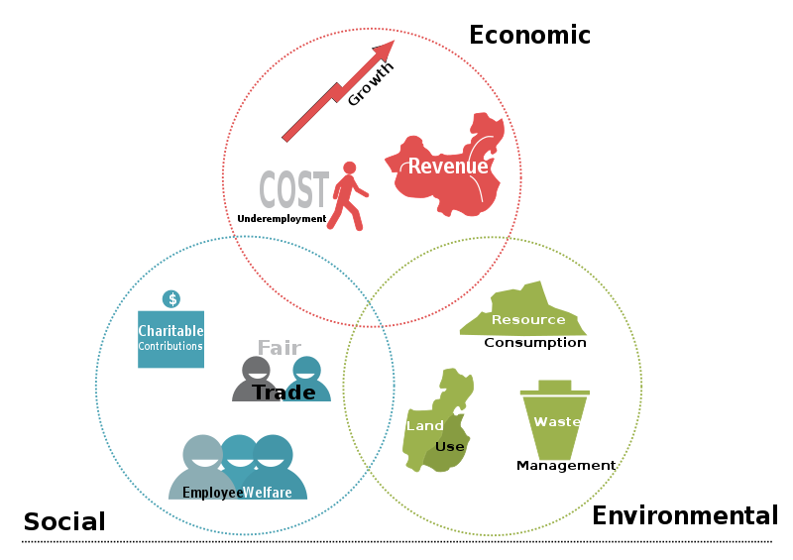
Figure 3: TBL (Slaper and Hall, 2021).
Planet: Natural resources and ecosystems that are impacted by commercial operations are referred to as the environmental dimension (Slaper and Hall, 2021). The hospitality sector has a big influence on the environment as it uses a lot of energy, water, food, and materials and produces waste, emissions, and pollution. A business's contribution to environmental sustainability can be further enhanced by sustainable practices such as water conservation, the use of eco-friendly materials, and the development of eco-tourism (Kraaijenbrink, 2019). For instance, the InterContinental Hotels Group (IHG) announced its "Journey to Tomorrow" sustainability strategy in 2021 and pledged to source all of its energy from renewable sources by 2035 and cut its greenhouse gas emissions by 46% by 2030 (IHG, 2023).

Figure 4: Journey to Tomorrow (IHG, 2023).
People: The social dimension refers to the human capital and well-being that are influenced by business activities (Slaper and Hall, 2021). The hospitality industry has a significant social impact, as it employs millions of people around the world, provides opportunities for learning and development, and contributes to the cultural diversity and social cohesion of destinations (Miller, 2020). The hospitality industry in the UK must prioritize employee well-being, offering fair wages, safe working conditions, opportunities for career development and inclusivity. For example, IHG aims to increase ethnic minority leadership representation from 20% to 26% in the US by 2025 and from 6% to 20% in the UK by 2027 (IHG, 2023).
Profit: The economic dimension refers to the financial viability and profitability that are generated by the business activities (Miller, 2020). The hospitality industry has a significant economic impact, as it creates value for shareholders, customers, suppliers and partners, stimulates economic growth and development in destinations, and pays taxes and fees to governments. Remaining competitive through innovation and adaptation to evolving market conditions and technological advancements is also part of ensuring economic sustainability (Kraaijenbrink, 2019). Moreover, the economic impact of the hospitality industry on local economies, including job creation and tax contributions, cannot be underestimated.

Doxey's Irridex Model
Doxey's Irridex Model is a framework that describes the stages of interaction between tourists and local residents in a destination (Pavlić and Portolan, 2015). The following section will apply the model to the UK hospitality industry and discuss its implications for sustainable tourism development.
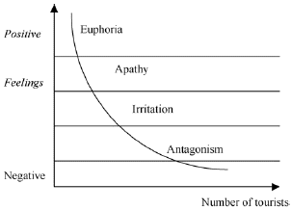
Figure 5: Doxey's Irridex Model (Pavlić and Portolan, 2015).
- Euphoria: At this point, the locals extend a warm welcome to the visitors (Gajdosik et al., 2018). They view tourism as a means of employment, revenue, and cross-cultural interaction. The destination's uniqueness, genuineness, and diversity draw in travellers. The UK hospitality business went through this phase during the post-World War II era when mass travel became a novel phenomenon (Gajdosik et al., 2018). The UK's government endeavoured to enhance its international reputation and augment its income by promoting tourism.
- Apathy: During this stage, the locals grow aloof and uninterested in the visitors. Even while the financial advantages are still recognized, they might not be valued as highly as they were in the euphoric phase (Pavlić and Portolan, 2015). The 1970s and 1980s saw the UK hospitality sector enter this phase as travel grew more commodified and competitive.
- Annoyance: The locals are resentful and antagonistic toward the visitors during this phase (Pavlić and Portolan, 2015). The 1990s and 2000s saw the UK hospitality sector enter this era, as travel became increasingly diversified and specialized. The management of tourism's effects, including social unrest, cultural clashes, and moral quandaries, presented difficulties for the UK government.
- Antagonism: During this stage, the locals get angry and hostile toward the visitors. Although the UK hotel sector has not yet reached this stage, there are indications that things could get worse, including terrorist attacks, vandalism, and anti-tourism demonstrations (Gajdosik et al., 2018). To stop this stage, the UK government has taken various preventative actions.

Butler's Life Cycle Model
Butler's Life Cycle Model refers to a theoretical framework that outlines the phases of a tourist destination's development and evolution (Dodds and Butler, 2019). The six phases of Butler's Life Cycle Model are examined in the section that follows.
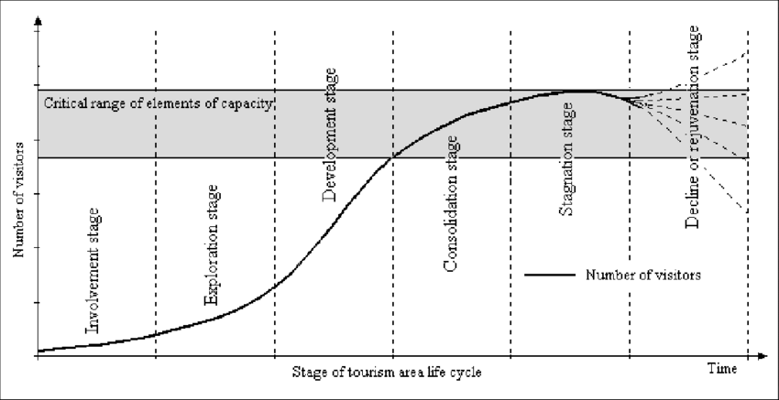
Figure 6: Butler's Life Cycle Model (Dodds and Butler, 2019).
- Exploration: A destination can draw adventurous travellers in its early stages when it is still undiscovered to tourists (Cudny, 2019). The UK boasts a wealth of historical and cultural sites, and many isolated areas were once under exploration. Although there was not much infrastructure in place for hospitality at this point, the industry was beginning to recognize its potential.
- Involvement: As more tourists discovered the diverse attractions, the involvement stage began. Historic cities like London, Edinburgh, and Oxford became prominent tourist destinations. The hospitality industry started to grow, with an increasing number of hotels, restaurants, and tour operators catering to the rising demand (Dodds and Butler, 2019).
- Development: In the development stage, the hospitality industry experienced significant growth (Dodds and Butler, 2019). The country saw the rise of international hotel chains, luxury accommodations, and a wide range of culinary experiences when the industry became a vital contributor to the UK's economy.
- Consolidation: The UK's major tourist destinations, such as London, matured into consolidated destinations. Tourist numbers stabilized, and the hospitality sector thrived. Renowned hotels, Michelin-starred restaurants, and vibrant tourism-related businesses defined this phase (Cudny, 2019). Major events like the Olympics and royal weddings further boosted the sector.
- Stagnation: Some areas in the UK, particularly those heavily reliant on mass tourism, may experience stagnation. The hospitality industry may need to adapt to changing consumer preferences, such as increased interest in sustainable and authentic travel experiences (Cudny, 2019).
- Rejuvenation or Decline: To combat stagnation, some destinations may undergo a rejuvenation phase. In 2021, the UK government launched the Tourism Recovery Plan by allocating at least £19 million to domestic and international marketing activity to help with the recovery and over £37 billion in support through grants, tax relief and loans to the hospitality industry (GOV.UK, 2021). If unable to adapt, may decline, leading to a reduction in the number of visitors and economic challenges for the hospitality sector (Dodds and Butler, 2019).

Conclusion
In conclusion, this report delves into the enduring relevance of Milton Friedman's profit-maximization perspective, highlighting both its applicability in a profit-centric free market and its limitations in addressing 21st-century societal challenges. The interplay of business initiatives and consumer demand in environmental sustainability is discussed, with recommendations focusing on embracing ethical and social responsibility and recognizing sustainability as a competitive advantage. The Triple Bottom Line framework underscores the need to consider people, planet, and profit, while the Irri Dex and Butler models provide insights into the evolving relationship between tourists and local residents in the hospitality industry. However, adaptation and rejuvenation are essential to combat stagnation and decline, ensuring a more responsible and environmentally conscious future.

References
Carmeli, A., Dothan, A. and Boojihawon, D.K., (2020). Resilience of sustainability‐oriented and financially‐driven organizations. Business Strategy and the Environment, 29(1), pp.154-169.
Cooper, S. (2021) Which global consumers are helping to save the planet, World Economic Forum. Available at: https://www.weforum.org/agenda/2021/07/global-consumers-save-the-planet/ (Accessed: 25 October 2023).
Cudny, W. ed., 2019. Urban events, place branding and promotion: Place event marketing. Routledge.
Dangelico, R.M. and Pujari, D., (2019). Mainstreaming green product innovation: Why and how companies integrate environmental sustainability. Journal of business ethics, 95, pp.471-486.
Dodds, R. and Butler, R. eds., (2019). Overtourism: Issues, realities and solutions (Vol. 1). Walter de Gruyter GmbH and Co KG.
Elrick, J. and Thies, C.F., (2018). The social responsibility of business: Milton Friedman reconsidered. Journal of Markets and Morality, 21(2).
Gajdosik, T., Gajdosikova, Z. and Strazanova, R., (2018). Residents’ perception of sustainable tourism destination development: A destination governance issue. Global Business and Finance Review (GBFR), 23(1), pp.24-35.
GOV.UK (2021) New plan to drive rapid recovery of tourism sector, GOV.UK. Available at: https://www.gov.uk/government/news/new-plan-to-drive-rapid-recovery-of-tourism-sector (Accessed: 26 October 2023).
IHG (2023) About Us, Intercontinental Hotels Group Plc. Available at: https://www.ihgplc.com/en/about-us (Accessed: 26 October 2023).
Kraaijenbrink, J., (2019). What the 3Ps of the triple bottom line really mean. Forbes Media LLC, pp.1-7.
Liu, D., Ji, J. and Wu, M., (2023). Tourism Carbon Emissions: A Systematic Review of Research Based on Bibliometric Methods. Journal of Quality Assurance in Hospitality and Tourism, pp.1-21.
Miller, K., (2020). The triple bottom line: What it is and why it’s important. Harvard Business School Online.
Pavlić, I. and Portolan, A., (2015). Irritation index, tourism. Encyclopedia of tourism, pp.1-2.
Ramanna, K., (2020). Friedman at 50: Is it still the social responsibility of business to increase profits? California Management Review, 62(3), pp.28-41.
Shine, I. (2023) Rising global temperatures are already affecting the tourism industry - here’s how, World Economic Forum. Available at: https://www.weforum.org/agenda/2023/08/temperatures-tourism-climate-impact/ (Accessed: 23 October 2023).
Slaper, T.F. and Hall, T.J., (2021). The triple bottom line: What is it and how does it work. Indiana business review, 86(1), pp.4-8.
Tepper, T., (2020). Milton Friedman on the social responsibility of business, 50 years later. Forbes Advisor.

