How did Arab-Israeli tensions during the 1960s and 1970s influence US and Soviet policy in the Middle-East?
The prolonged and complicated nature of Arab-Israeli tensions has spawned a wide range of narratives. This essay will attempt to offer relevant devolopments in the 1960s and 1970s that had an effect on perspetive and policies of the USA and Soviet Union. Events in Gaza, October 2023, makes this task particularly difficult, with the bombardment of media, protest and emotions that can often dwarf the scholarly and reasoned approaches neccesary to analyse the complex history of the region. To find information, particularly primary sources, on the influence of Soviet and American policy is far easier from the latter. In order to answer the question, this essay will primarily use United Nations archives, documents form the Congressional Research Service along with secondary commentary to present a case. Developments in the region throughout the 20th century continues to play a role in geopolitics of today. The Arab-Israeli tensions during the 60s and 70s, including the involvement of the USA and Soviet Union, reflect many of the themes in the cold war at large, especially those of expansion and containment.
The post-WWII scene promised to be a time of change, rebuilding and development throughout most of the world. In the victorious parties of USSR, USA and UK was forged a practically uncontested mandate in shaping that new order. This did not neccesarily mean peace, nor did this neccesarily mean a functioning and diplomatic future. The United Nations up to this day has attempted to bridge many of those gaps. Reading the Atlantic Charter its sentiment offered hope from the Anglo-American governments, during the end of the first half of the 20th century, where plenty of tragedy had already struck. The horrors of the holocaust to be revealed in the coming years. That context paved the way for the establishment of an independent Jewish state. David Ben-Gurion was representing the Jewish People’s Council on 14th of May 1948 when reading The Declaration Of The Establishment Of The State Of Israel. In that declaration, read outside Tel Aviv Museum Ben-Gurion describes the mandate of that declaration:
“This right was recognized in the Balfour Declaration of the 2nd November, 1917, and re-affirmed in the Mandate of the League of Nations which, in particular, gave international sanction to the historic connection between the Jewish people and Eretz-Israel and to the right of the Jewish people to rebuild its National Home”.
This followed the end of a British mandate in Palestine after they had administered the region following their conquering of the Ottoman Empire during the Great War. Any discussion of Arab-Israeli tensions must take into account this origin as it is a key piece of context in answering our question. We will now take this point as our introduction for Soviet involvement in the region.
In the 1950s, the Soviet Union aggressively pursued dominance in the Middle East by aligning itself with Nasser's pan-Arabism, prioritizing Arab relations over Israel. Initially, they had supported Israel's UN vote, but a shift occurred as Stalin aimed to expand Soviet influence, especially in anti-Western post-colonial territories. The rise of the Jewish Independence movement in Palestine weakened Britain's stance in the region, creating tensions between sympathies for European Jewry and Soviet objectives. Despite having prominent Bolshevik Jews, most Soviet Jews faced persecution, notably during Stalin's purges in the '30s and later years. Tensions escalated when Israel's ambassador arrived in Moscow, triggering an anti-Zionist campaign that strained diplomatic ties, severed before Stalin's death, and showed no substantial improvement afterward. As Israel lost its revolutionary impact, Soviet attention shifted towards supporting anti-Western movements in Arab countries. At the United Nations, the USSR supported Arab complaints against Israel but refrained from endorsing extreme Arab demands. The Soviets depicted Israel as a tool of American capitalism plotting against progressive Arab regimes. However, the Soviet Union encountered challenges in its nationalities policy, with the inability to release many Jews, this signifying a failure in their approach. This period marked a complex interplay of geopolitical strategies, shifting alliances, and ideological conflicts as the Soviet Union sought to expand its influence in the Middle East while navigating the complexities of its relationships with Israel and the Arab world. The next sections will focus mainly on US-Israeli relationships.
As mentioned in the introduction the USA, since the end of WWII have gradually and deliberately increased their hard and soft power in essentially every corner of the world. Few would deny their success in these aims, particularly in military dominance, along with expansive economic and cultural influence. Israel has been one such vessel for that growth, which as demonstrated in this essay can be seen in the colossal military aid provided by the USA. The Congressional Research Service, a public research service of the United States Congress has published multiple highly detailed reports on US-Israeli relations. In one such report published on March 1st 2023 they provide a background to that history:
“The United States and Israel have maintained strong bilateral relations based on a number of factors, including robust domestic U.S. support for Israel and its security; shared strategic goals in the Middle East; an avowed mutual commitment to democratic values; and historical ties dating from U.S. support for the creation of Israel in 1948. U.S. foreign aid has been a major component in cementing and reinforcing these ties. U.S. officials and many lawmakers have long considered Israel to be a vital partner in the region, and U.S. aid packages for Israel have reflected this calculation. Some U.S. citizens have worked to cultivate U.S. support for Israel since its creation in 1948, and since the 1973 Yom Kippur War, advocates for Israel have engaged in organized, broad-based domestic efforts to foster bipartisan support in Congress for the bilateral relationship, including for U.S. aid to Israel”.
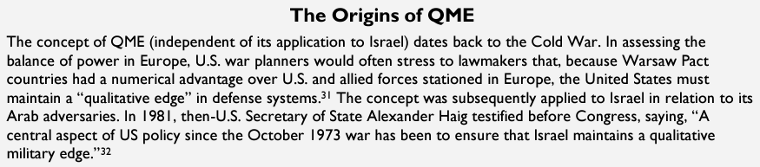
In the same report is mentioned the need for ‘Qualitative Military Edge’ as seen in the image below.

These facts explicitly demonstrate that tensions during the 60s and 70s influenced US policy immensely. The reasoning behind such policy has not neccesarily changed much, but the volume and intensity of spending and relations has no doubt been increased. It is important to note that throughout the 60’s and early 70s the USA was enganged in brutal conflicts in Vietnam. This requires us to be aware of the fact that any tensions in the Middle East, where the USA and USSR were involved, was happening against a background of proxy wars elsewhere. Geopolitical conflict globally was in the shadow of the determination of the two superpowers to exert their influence and ideology. Sensitivity to this puts the Arab-Israeli tensions into a wider context of the Cold War, which is not an abberation from US and Soviet practices. The picture above further demonstrates the reaffirment from the United States to continuously strengthen their Qualitative Military Edge in various territories. Cases can be made that this fans the flames, so to speak, or alternatively a continuous detterent in the region. Consequences of such decisions are yet to be seen fully.
Arab nationalism was strong under Nasser. ‘He was most popular with the Palestinians, many of whom genuinely believed that he was their saviour and that he, and no other, would soon deliver Palestine’. This idea, backed by the Soviet Union, was a challenge to USA authority and stability in the region. Tensions in the region from 1948 culminated into a definite conflict known as the Six-Day War:
“The war of June 1967 was a watershed for the Middle East. In just six days, Israel inflicted upon the Arabs their most humiliating defeat in modern times, perhaps of all time. The great promise of revolutionary Arab nationalism, as espoused by Egypt’s charismatic president, Gamal Abdel Nasser, proved to be no more than an illusion”.
There can be no doubt that this was an embarrasing reality check that led to the resignation of Nasser, albeit protests eventually led to his return. Egyptian airforces had been completely decimated almost immeadiately. The Soviet Unions efforts, through Arab alliances, in challenging US dominance in the region, had failed miserably. That is not to say that it benefitted the USA entirely. Secretary of State at the time Henry Kissinger, along with other officials at the time were weary:
“They estimated that such an outcomewould lead, on the one hand, to greater Israeli intransigence on withdrawing from the territories it occupied in the 1967 war, and on the other hand, to increased Arab mistrustand hostility toward the US”.
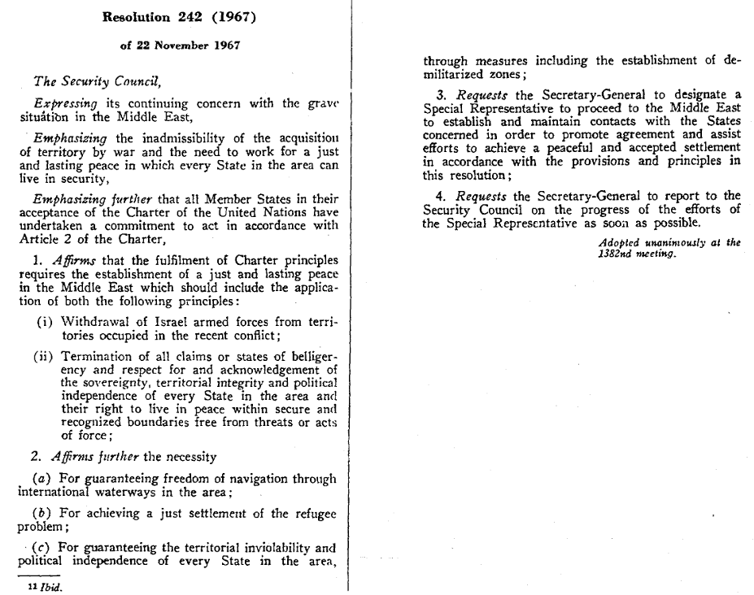
In terms of influencing policy, we saw earlier in the Congressional Research Service reports that US aid and diplomacy in Israel since the 60s and 70s has increased. It no doubt taught American officials to exercise caution, particularly in the need to upkeep a positive image in the international community. The Soviet Union no doubt had the same ideas in mind. Caution was exactly the theme that underpinned an important diplomatic moment in geopolitics of the 60s, with the UN Security Council’s Resolution 242. In the resolution is laid out an agreement of all member states, in reaction to the events of the Six-Day War, also refelcting the general unease of the time. As it is only a short memorandum, an image of the resolution is shown below.
Of particular relevance is 2.(a) refercning the need to stablilise international waterways. The United States, Soviet Union and all other trading nations reacted to tensions in the Middle East by reaffirming the joint need for secure trade, that was to the advantage of most parties. 2(b) discusses refugee problems, particularly Palestinian refugees, which remains an issue today, underlining the continuous difficulties and uncertainties in the region. The tone of Resolution 242 also has echoes of the Atlantic Charter, especially articles 1 and 2 of the Charter. These articles establish that both countries seek no territorial aggression or changes. This Charter predates Arab-Israeli tension by 7 years. It could be argued that Israel’s retainment of post-1967 borders is in conflicts with the Charter however it is not binded by international law, only domestic memoranda from an Anglo-American partnership.
To conclude this essay, we have touched upon the context and background of Arab-Israeli tensions, focusing on the establishment of the state of Israel, the rise of Arab nationalism from the 1950s with Nasser driving that surge under the backing of Soviet support, the Six Days-War and discussion of Resolution 242 of the United Nations Security Council. The USA’s strong backing of Israel in diplomatic, economic and military efforts has intensified since 1948, especially in modern weapons systems similar to their support of Ukraine against Russia. Tensions during the 1960s and 70s between Arab-Israeli forces and peoples is, as mentioned in the introduction, as relevant in 2023 compared to any point during the Cold War. Events in Gaza and the Middle East at large might even suggest that the Cold War has not ended, or that its consequences have not fully played out. This essay holds that those tensions in the 60s and 70s influenced US and Soviet policy in 2 tangible ways. Military spending and tactics, along with diplomatic approaches and refinement. Unfortunately, there has not been in this essay as clear of a demonstration of US policy compared to that of its counterpart. Hopefully, the reader can appreciate the delicate and challenging nature of this analysis and take advantage of thorough and vast literature that is available and being added.

References
Chomsky, N. (1999). Fateful Triangle. London: Pluto Press.
Congressional Research Service. (2023). U.S Foreign Aid to Israel. Washington D.C: Congressional Research Service. Retrieved November 18, 2023, from https://crsreports.congress.gov/product/details?prodcode=RL33222
Congressional Research Service. (2023). U.S. Security Assistance to Ukraine. Washington D.C. Retrieved November 19, 2023, from https://crsreports.congress.gov/product/pdf/IF/IF12040
Ginat, R. (1996, October). Soviet Policy towards the Arab World, 1945-48. Middle Eastern Studies, 32(4), 321-335.
Government Communications Headquarters (GCHQ). (2023, May 18). The Palestine Mandate. Retrieved from https://www.gchq.gov.uk/information/palestine-mandate
Gutfeld, A., & Vanetik, B. (2016). ‘A Situation That Had to Be Manipulated’: The American Airliftto Israel During the Yom Kippur War. Middle Eastern Studies, 52(3), 419-447.
Jewish People's Counciil. (1948, May 14). The Declaration of the Establishment of the State of Israel. Retrieved November 18, 2023, from Ministry of Foreign Affairs: https://www.gov.il/en/Departments/General/declaration-of-establishment-state-of-israel
Laquer, W. (1969). The Struggle For the MIddle East: The Soviet Union and the Middle East 1958-68. London: Routledge & Kegan Paul Ltd.
NATO. (1941, August 14). 'The Atlantic Charter'. Retrieved November 18, 2023, from https://www.nato.int/cps/en/natohq/official_texts_16912.htm
Susser, A. (2017, August 08). Fifty Years Since the Six-Day War. RUSI Journal, 162(3), 40-48.
United Nations General Assembly. (1947). Question of Palestine. (p. 13). United Nations.
United Nations General Assembly SecurityCouncil. (1993). Declaration of Principles on Interim Self-Government Arrangements. (p. 18). Washington D.C: United Nations.
United Nations Security Council. (1967). Resolution 242. Retrieved November 19, 2023, from https://peacemaker.un.org/sites/peacemaker.un.org/files/SCRes242%281967%29.pdf

NATO. (1941, August 14). 'The Atlantic Charter'. Retrieved November 18, 2023, from https://www.nato.int/cps/en/natohq/official_texts_16912.htm
Jewish People's Counciil. (1948, May 14). The Declaration of the Establishment of the State of Israel. Retrieved November 18, 2023, from Ministry of Foreign Affairs: https://www.gov.il/en/Departments/General/declaration-of-establishment-state-of-israel
Jewish People's Counciil. (1948, May 14). The Declaration of the Establishment of the State of Israel. Retrieved November 18, 2023, from Ministry of Foreign Affairs: https://www.gov.il/en/Departments/General/declaration-of-establishment-state-of-israel
United Nations General Assembly. (1947). Question of Palestine. (p. 13). United Nations.
Government Communications Headquarters (GCHQ). (2023, May 18). The Palestine Mandate. Retrieved from https://www.gchq.gov.uk/information/palestine-mandate
Laquer, W. (1969). The Struggle For the MIddle East: The Soviet Union and the Middle East 1958-68. London: Routledge & Kegan Paul Ltd.
Laquer, W. (1969). The Struggle For the MIddle East: The Soviet Union and the Middle East 1958-68. London: Routledge & Kegan Paul Ltd.
Laquer, W. (1969). The Struggle For the MIddle East: The Soviet Union and the Middle East 1958-68. London: Routledge & Kegan Paul Ltd.
Ginat, R. (1996, October). Soviet Policy towards the Arab World, 1945-48. Middle Eastern Studies, 32(4), 321-335. p. 323
Laquer, W. (1969). The Struggle For the MIddle East: The Soviet Union and the Middle East 1958-68. London: Routledge & Kegan Paul Ltd.
Congressional Research Service. (2023). U.S Foreign Aid to Israel. Washington D.C: Congressional Research Service. Retrieved November 18, 2023, from https://crsreports.congress.gov/product/details?prodcode=RL33222
Congressional Research Service. (2023). U.S Foreign Aid to Israel. Washington D.C: Congressional Research Service. Retrieved November 18, 2023, from https://crsreports.congress.gov/product/details?prodcode=RL33222
Susser, A. (2017, August 08). Fifty Years Since the Six-Day War. RUSI Journal, 162(3), 40-48.
Susser, A. (2017, August 08). Fifty Years Since the Six-Day War. RUSI Journal, 162(3), 40-48.
Gutfeld, A., & Vanetik, B. (2016). ‘A Situation That Had to Be Manipulated’: The American Airliftto Israel During the Yom Kippur War. Middle Eastern Studies, 52(3), 419-447.
United Nations Security Council. (1967). Resolution 242. Retrieved November 19, 2023, from https://peacemaker.un.org/sites/peacemaker.un.org/files/SCRes242%281967%29.pdf
NATO. (1941, August 14). 'The Atlantic Charter'. Retrieved November 18, 2023, from https://www.nato.int/cps/en/natohq/official_texts_16912.htm
Congressional Research Service. (2023). U.S Foreign Aid to Israel. Washington D.C: Congressional Research Service. Retrieved November 18, 2023, from https://crsreports.congress.gov/product/details?prodcode=RL33222
Congressional Research Service. (2023). U.S. Security Assistance to Ukraine. Washington D.C. Retrieved November 19, 2023, from https://crsreports.congress.gov/product/pdf/IF/IF12040

