ECONOMIC COMPARISONS
A related project built in Wales would be the Cardiff Central Library and community hub which is located the Hayes Street in Cardiff city centre. the Wales government funded £18M to Library and community which is appointed to Laing O’ Rourk (LO’R) construction 2006 and completed 2009, by which St David’s Partnership and the design team were committed to delivering a sustainable building which met the requirements of BREEAM.
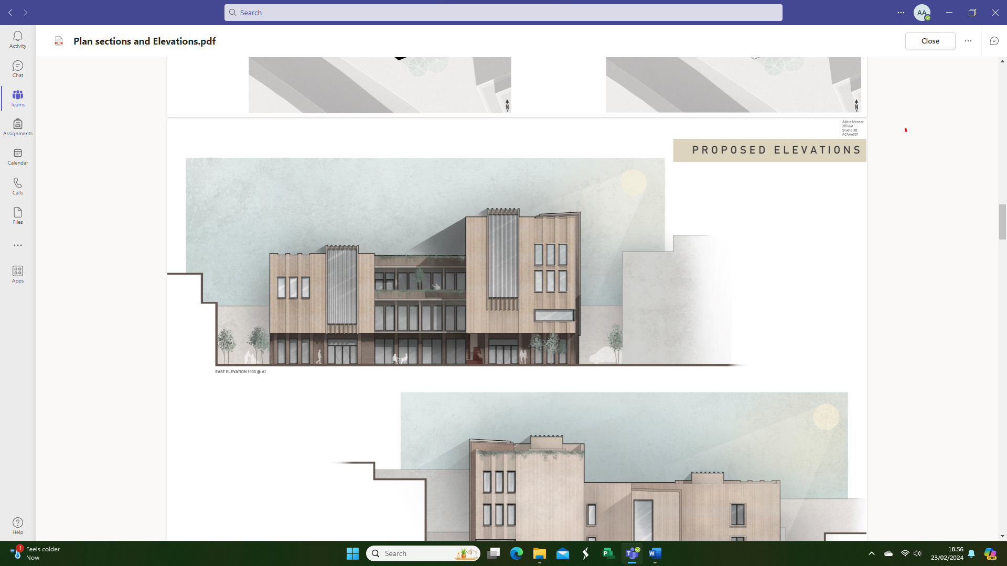
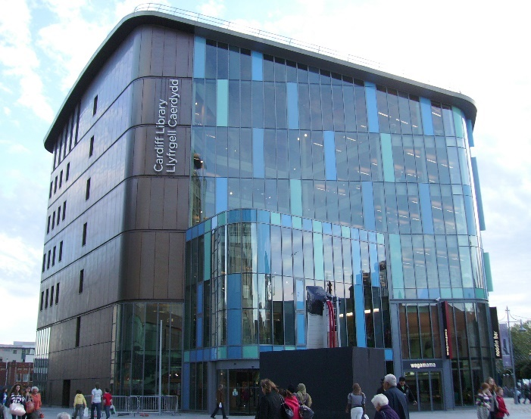
Cardiff central library and hub Sources (Cardiff Central Library - BDP.com)

Port Talbot new design of library and community hub

the six-storey building consists of 55,000m² of library space with 16,000m² of main reception, gift shop and coffee shop at ground level matching the adjacent restaurant section. BDP Architects, to develop the concept design, including structural and building services systems, outline specifications and cost plan.
However, the Cardiff central Library and community hub is intended to create an environment in all members of the community can enjoy studying, learning, contemplation, or relaxation. The building is composed of two interlocking elements; a transparent area defining the open plan library as a lantern, while the other has a solid appearance and houses cellular accommodation.

This area has an exterior surface of brass cladding that is inspired by the appearance of leather-bound books on shelves. The two elements are unified by a four-storey atrium that provides passive ventilation and daylight, while the upper floors of the building create a new window on the skyline with dramatic views over the cityThe exterior layout of the Cardiff central Library and port Talbot library and community hub is similar to that of the hybrid system, which is combined steel, concrete, timber, and Glass facade. It features a lot of The Structural frame which be made up of steel columns and beams, this will allow maximum strength with minimum interference from the frame obscuring the views from the glass façade.
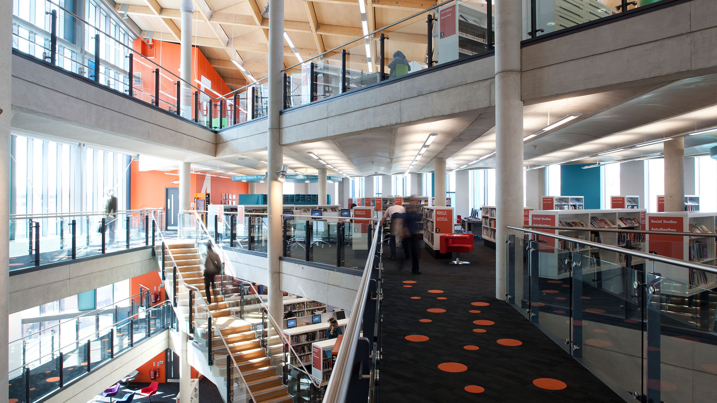
Cardiff central Library internal view Sources (Cardiff Central Library - BDP.com)

The inner layout of both structures exhibits striking similarities, showcasing shared public areas and rooms with distinct narratives. Both buildings boast open ceilings adorned with suspended acoustic panels, enhancing both sound quality and aesthetic appeal. Additionally, the proposed design recommends the installation of timber acoustic panels as a focal point in each classroom, promising enhanced sound quality and contributes relaxation a more inviting atmosphere.
Talbot library and community hub will provide access to a diverse selection of books and computer resources and activities suitable for individuals of all age groups. also, a range of community-based services similar to Cardiff central hub and library including:
- Library service including a quiet area & space for children’s events.
- Housing, benefit & advice services
- Free internet and Wi-Fi access
- Into Work advice & training courses
- IT Training Suite/ Private interview rooms
- Rooms for community meetings & events
- Modern Community café
- Community hall
- Wellbeing
- Meeting rooms
- Stock rooms.
- Study rooms.
- Children library
- Toilets

References
Available at: Cardiff Central Library - BDP.com (accessed 3rd Mar 2024)
Available at: Cardiff Central Library | AJ Buildings Library (accessed 2nd Mar 2024)

