‘Effective Team Working and Communication’
Student: Katarzyna Szymczak (1907183)

Module: BMSW_402LON
Molly Jack
London 03.01.2020
Group 3
University of Wales Trinity Saint David

Table of content:
- Introduction
- Types of communications
2.1 Verbal communication
2.2 Nonverbal communication
3.Theories of communication
3.1 Shannon and Waver model of communication
3.2 Berlo’s model of communication
3.3 Schramm’s model of communication
4. Conclusion
5. References

- Introduction
For any organization to become successful the main factor is the bond between people and understanding the ideas among them. This is known as effective communication. Effective communication is an essential part of life. All humans have to express their feelings, pass on an information and share ideas (Morgan 2017). Everything we do involves communication but to communicate successfully we have to know what tool to use and how to pass on the message.
Teamwork can simply be defined as the method a group of people adopt to work together to ensure the objectives of the group achieved. Simply put each member of the group is prepared to put their individual interests aside and channel their energies towards the common good of the group.
The way we communicate is most likely to dictate the response we get from others. In an organisation no matter how big or small the teams are communication is key. It is an effective tool for successful teamwork.
I work as a customer service checkout supervisor at ASDA. Asda is a supermarket that deals in a lot of items right from clothing, groceries to electrical goods. This means we have a very wide customer base. Due to this communication is very important for both between me and my teams and also customers. Effective communication at my workplace ensures that all colleagues are fully aware of their roles and responsibilities. It also ensures that we provide great customer service which is the main aim of the organisation.
In this write-up communication at my workplace will be analysed using different models. The aim of this report is to acknowledge importance of communication.
2.Types of Communication
Types of communication can be defined as ‘the various methods of sending information between people and places, especially phones, computers, radio.’ (Cambridge Dictionary). Communication can be defined by the way messages are conveyed from one person to another. Communication is a main factor to interact with others in every stage of our life.
Communication can take many forms: writing, speaking, signage and signalling. Tool we use to communicate is called channel, for example: phone, email, radio, letter. The challenge in communication is to understand the message correctly with idea and emotions otherwise there might be issues among team members (Morgan 2017). Channels of the communication:
-written communication (email, text massage)
-oral communication by the phone includes: how fast we speak, volume of speech emotions and feelings
-face to face communications it is more likely understand correctly as we can see body language, gesture, posture and we can demand of feedback.
(Morgan 2017)
The two main types of communication are verbal and non-verbal. Verbal being the oral form and non- verbal being physical such as body language. To communicate well it is necessary to have other skills like active listening and understanding. By communication we are able to exchange thoughts and ideas. Presentation is the part of communication which is very powerful and help us to pass the message more effectively (Maund et al 2017)
2.1 Verbal Communication
The most common way to communicate is verbal communication, which means exchanging statements. The main factors of this type of communication is listening, understanding, assertiveness and ability to interpret the message. Language is very important in verbal communication otherwise others will not be able to understand the meaning. Maund et al (2017)
The verbal form involves all communication where an individual is doing the speaking and the other is listening. Effective communication is a two-way street so it is very vital that people can be very good listeners as much as speakers. During the conversation we must:
- choose correct language, tone of the conversation,
- control stress level especially when we have something important to say,
- listen and do not interrupt,
- avoid our emotions, the moment person is angry we have to control our gesture, expressing our frustration is very hard to handle,
- make sure conversation ends positive.

2.2 Non -Verbal Communication
Non-verbal communication is equally important and it can take the form of body language, smiling and gesture. It is the ability to understand the meaning behind the words. Non-verbal communication helps to see or understand intention of speaker therefore body language of the receiver will be reflected as a feedback or response. Since this is how we communicate without necessarily speaking, body language can sometimes create confusion as there is a tendency for one party to misinterpret. At the same time, it can be used to convey emotions and feelings. According to Lavan (2002) ‘55% of interpersonal messages are conveyed non-verbally.’ None-verbal communication is our voice tone, behaviour and emotions.
Nonverbal communications codes are:
-body movement, posture (the way we stand and our gesture, for example ‘pointing finger’, head movements, crossed arms)
-facial/eye behaviour (our face expression and attitude, eye contact with the receiver)
-personal space (distance we keep,)
-touch (the way we approach, very powerful form of communication, it might have negative consequences, ways we welcome another person ‘kiss on the cheeks’)
-environment (sounds, colours, place, light surrounding us)
-physical appearance (the way we represent ourselves)
Maund et al(2017)

3.Theories of communication
3.1 Shannon-Weaver Model of Communication
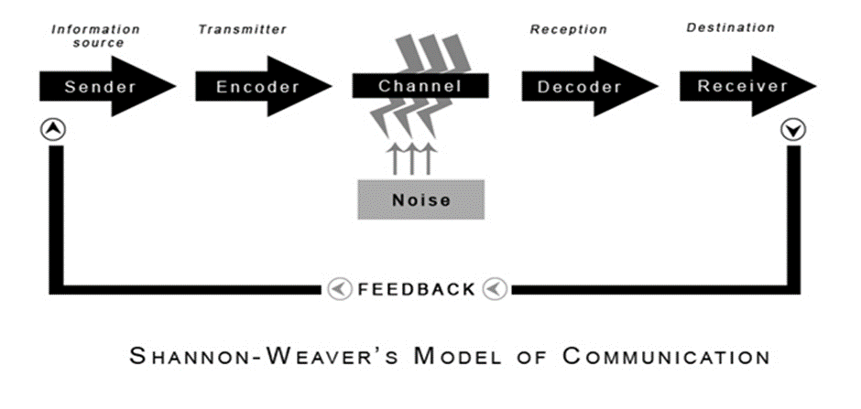This model is one of the common one used at the technical level. It is known as the mother of all communication models. In 1948 Shannon and Weaver wrote the article about effective ways of communication between sender and receiver including factors like information source, noise, channel, encoder and decoder. The aim of this model was to explain the process of communication and how it could be distracted or changed before it is received (AL-Fedahi 2012).
At the workplace there are several instances of communications issues that can be highlighted and rectified by the Shannon-Weaver model. For instance, when I experience an issue at work, I call one of the department managers. If the phone signal is poor or there is a lot of noise in the background, there is a great tendency of us misunderstanding each other and this can lead to a negative consequence of not knowing what to do next or ultimately the issue not being resolved. The Shannon-weaver model helps identify weak points of technical communication like phone calls. Below is an analysis of this particular situation.
Sender- ME
Encoder/Transmitter- PHONE
Channel- TELEPHONE LINES
Noise- POOR SIGNAL
Decoder- MANAGER PHONE
Receiver- MANAGER
Feedback is the last stage in the communication process. After hearing the feedback, I know if my manager heard my message or if I need to repeat it. At work I have to use many different sources of communication mainly phone and computer. To gain the required information and feedback my message must be very clear.
In the Shannon and Waver model of communication, feedback does not occur in every situation. For example, when we watch television, we do not respond to news we hear. Phone calls are very important way to communicate in any workplace.
3.2 Berlo’s Model of Communication

David Berlo elaborated further on the Shannon and Weaver model of communication. According to Berlo, in order for communication to be effective, the sender and receiver must have something in common, for example they should have the same listening skills.
Berlo's SMCR Model of Communication presents the communication process in its simplest form. The model is made up of four constituents that are each influenced by different factors. The four constituents which are included in the name are source, message, channel and receiver.
Berlo's model of communication can be broken down into six stages. These are the source of communication, the encoding of the message, the message, the delivery method of the message, the decoding of the message, and the message receiver. Berlo’s model does not consider any ‘noise’ which can change interpretation of the message. Berlo’s model of communication uses the senses as the medium or channel for example smelling, tasting, feeling, hearing and seeing. The more channels we are able to use in communication the more effective the message will be interpreted. (Lee n.d.)
Maslow according to Stead (2017) reiterates that once lower-level needs have been satisfied, they become less effective as a motivator so top level needs then take over take over. In that regard Berlo’s model focuses on the ultimate goal of the message. Berlo’s model of communication is a very verbal form meaning the theory is expressed in words. Berlo according to Stead (2017) suggests that communication is a process by which the source intentionally changes the behaviour of the receiver. To that effect, in the work place this model of communication will be reflected in instances such as senior management reporting on the financial performance of the company for the year. Once employees read or hear about the company’s financial performance they are more inclined to change their behaviours for the better or carry on as normal.

3.3 Schramm’s Model of Communication
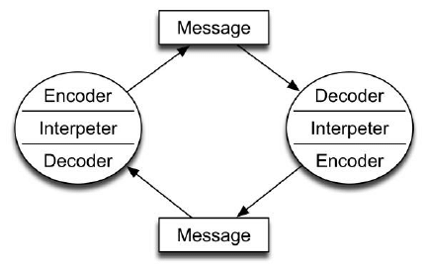
Wilbur Schramm communication theorist created new model of communication and published as ‘The Process and Effects of Mass communication’. Schramm’s model is slightly different from the other models of communication. It contains the same major constituents and factors of communication however it adds the idea of common ground of experience between the sender and the receiver of the message (Lee n.d.). Schramm(1954) noted communication can only occur when the encoded message ends up in an area somewhere in the common ground of experience. He noted that communication is a never ending activity or process. This means a sender encodes and sends message which will let the receiver decode and subsequently create a response. This facilitates mass communication. In the workplace Schramm’s model of communication can be used during employee opinion surveys or discussions involving employee performance review between employee and manager.
This means Schramm’s model works well and it is very suitable for wide audiences.

4.Conclusion
Communication is a very important aspect of every day life be it at the workplace, school or home. It is therefore vital that we get it right regardless of the form, mode or medium we use. Simply put, good communication fields positive results and poor communication results in negative consequences. Technology today has made communication faster and easier in most cases but errors and issues in communication have not been completely eradicated. This could be due to the fact that there is always a human element involved. No matter how hard we try to choose correct channel and language to send a message, if the receiver does not get the message then there is no communication or we can say the communication has been unsuccessful. Breakdown in communication can cause great problems in every part of life. At school, it can cause problems because the students might struggle to understand lessons and lead to poor performance in exams and general academic life. At home poor communication can cause marriage problems and result in unhappy family life. At the workplace it can create confusion between management and employees and in some cases customers will suffer the effect of it. This can lead to losses and bad reputation for the company. The great philosopher Aristotle 300 years before Christ wrote about oral communication and made the following statement ‘of the three elements in speech-making that is speaker, subject, and person addressed, it is the last one, the hearer, that determines the speech's end and object.’ (Lee n.d.)

5. References:
Al-Fedaghi, S., 2012. A conceptual Faundation for the Shannon-Weaver Model of Communications. Internationa Journal of Soft Computing, pp. 12-19. [Online]
Available at:
http://docsdrive.com/pdfs/medwelljournals/ijscomp/2012/12-19.pdf. Accessed 18 December 2019
Lee,D. (n.d) Communication. Developing Effective Communication, pp.1-98. [online] Avilable at: https://core.ac.uk/download/pdf/62786201.pdf. Accessed 2 January 2020
Maund, A, Schriek, M, Tinkler, P.K (2017). Certificate in Higher Education: Skills for the Workplace Student Yearbook. London: Sage
Morgan, P. (2017). The Business Student’s Guide to Study and Employability. London: Sage
Schramm, W. (1954).How Communication works. The effects and process of mass communication. Urbana, Illinois Press
Stead Betty, A. 2017 Berlo's Communication Process Model as Applied to the Behavioral Theories of Maslow, Herzberg, and McGregor, Academy Of Management Journal. vol15 no.3 [online] Available at: https://doi.org/10.5465/254868 Accessed 2 January 2020



