DIGITAL SKILLS AND RESEARCH METHODS

Student Name | Essie Adejare
Student Number | 1813503
Module No | BMSK 4003
Module Title | Digital Skills and Research Method
Lecturer | Balendran Kandasamy

Table of Contents
Introduction 3
Evaluation of modern Technology 4
Computer Tablets 4
Tablet provider comparison 5
Exploring Instagram as a social media tool 6
Marketing 6
Information gathering 10
Social media links 11
Facebook…………………………………………………………………………………………………………………….11
Twitter…………………………………………………………………………………………………………………….11
Linkedin………………………………………………………………………………………………………………………………….11
Conclusion………………………………………………………………………………………………………………………11
References……………………………………………………………………………………………………………………12

INTRODUCTION
This report is to address the relevance of modern digital technology and its impact on the personal life the workplace and the world in general. I will be exploring the computer tablet as a type of modern technology and secondly, the efficiency and effectiveness of the Instagram platform as a marketing and information gathering tool.

1.Evaluating the effectiveness of modern Technology- The transformation of technology has totally eradicated the paper recording system and, the continuous release of technology and mobile devices improves the quality of working, though cost is involved in purchasing. This is noticeable in the effective interaction with carer and patients considering social and healthcare workplaces in the community. The results are a satisfied carer and a happy patient. Samsung is a provider of one of such technologies. (Samsung, 2019)

1.1 Computer Tablets
A computer tablet is a thin, flat mobile personal computer that is weightless and easy to carry. Most tablets use a virtual on screen keyboard. It is between the size of a smart phone and most laptops. Lenovo describes it as “tablets simply combine the best aspects of smart phones and laptop PCs, creating what tablet lovers consider the ultimate mobile experience” It can be seen as a bridge between the smart phone and the PC or laptop.
-The size varies between 7 and 12 inches . The internet connection is wireless with the use of home/office WiFi or cellular data service -
-The device is attractively built with an interface touch screen giving the user collaboration options to slide, pinch and touch. A stylus pen can also be used to navigate around the tablet.
Tablets have evolved from models on mobile to PC operating systems. There are a few types that can either transform or deviate from the original light weight tablet:
- The tablet with a detachable keyboard
- The convertible tablet which has an option to turn the keyboard or flip backwards.
- The tablet can be enabled in different modes: supported on a desk, hung up on a wall for presentation or as a check in facility. (Lenovo, 2019)
Advantages of Tablets
- Instead of carrying a bulky device, a tablet can be used to view and update a patient’s medical record at their bedside or during a home care visit. Every medical professional has access to the patients records at the same time in different places. This is updated real time, which enhances solutions and avoids repetition of a patient’s medical history. Elimination of the paper process of recording negates the risk of any infection and quickens the care needed. (Samsung 2019)
- Each patient has a record of its daily activities, food, medication and the entire care plan in one place and this can be updated by any staff from any location. (The Guardian, )
- Improving Productivity -A tablet device can be and is currently being used as a self check in facility by patients in hospitals, General Practice Surgeries, and other medical centres. (Samsung, 2019) They are increasingly being used in restaurants to take orders.
Disadvantages of Tablets
- Cost maybe too high
- The transition and adapting to the change from paper to computers then tablets may be too complex especially for older staff. (NCBI, 2017)
- Viewing the small screen for a long period while working could increase
the chances of eye and headache. (Global scholars, 2018)

Tablet Provider Comparison (PC world, ND)

TABLETS | Samsung Galaxy Tab S4 10.5” | Apple Ipad pro 10.5”
Price- based on PC world offers | £509 (save £90) | £499 (save £120)
Operating system | Android 8.0 (Oreo) | iOS 11
Release year | Aug 2018 | June 2017
Processor | Snapdaragon 835 | A10X Processor
Capacity | 64GB | 64GB
Size | 249.3 x 164.3 x 7.1 mm (H x W x D) | 250.6 x 174.1 x 6.1 mm (H x W x D)
Display | 10.5”/Samoled display | 10.5”/Retina display, 120HZ refresh rate
Screen Resolution | 2560 x 1600/287 pixels | 2224 x 1668/264 pixels
Battery life | 16 hours | 10 hours
Pen | Yes – plus stylus Pen with air command menu | No- Apple pen, to be purchased separately
Memory | Micro SD expansion slot | No slot, but can buy more GB
Camera and | 13MP rear camera- 8MP front camera | 12MP rear camera – 7MP face time front camera compatible to Apples smart HDR
Security features | Iris scanner/Face recognition | Touch ID
Colours | Black or white two colour glass options | Space grey, Rose gold, gold, silver
Other features | -Samsung Dex  -Customisation of the android tablet | -Offers more elaborate Apps and games, which are custom built for the tablet  -Camera and video – superior quality

Recommendation
The two tablets compared are similar in more ways, but very different in a few areas. The Ipad pro is equipped with more refined apps and games. Apple is recognised for better Apps, which is in contrast to the Android with a lower grade. Although, android allows the user to customise their tablet to fit ones’ own service, the Ipad pro does not have this feature. The widgets are not customisable.
Value for Money- The pricing offered in the table is the same, but galaxy tab 4 has the stylus pen included with its air command menu feature. An apple pen will have to be purchased separately (additional high cost), although it has excellent features for artistic drawing and creation. Manufacturers guarantee for the Samsung is 2 years over a 1 year span for the Ipad pro. (PC world, ND)
Memory – The Galaxy tab 4 has a memory expansion slot up to 400GB while a purchase for more GB will be required for the Ipad pro. ( Macworld, 2019)
TheA10x processor for the Ipad pro is more powerful than the snapdragon 835
Extra features- The Samsung Dex interface is the most distinctive feature for the workplace. When a keyboard is attached it transforms to a PC mode supporting almost 20 windows. (Macworld, 2019)
For personal use, the Ipad pro 10.5 would be an excellent buy. However, considering that the device will be used in a workplace, and particularly a large care home, i would recommend the Galaxy tab 4 with regards to the Samsung dex , ability to customise the tablet, the fact that it gives a two year guarantee and offers better value for money with the added s-pen.

2. Exploring Instagram as a Tool in the workplace
Although the origins of social media can be traced back to Blogger, Friendster and my space, in my opinion the creation of Facebook in 2004 revolutionised the social media presence. Since they bought Instagram in 2012, its’ users have increased tremendously. By September 2017, the monthly visitors world-wide was 800 million.(statistica.com, 2018). Today it has 1 billion plus monthly active user accounts worldwide. (Business Instagram, 2019) This platform socially engages visually through images and videos. I have chosen to explore this social media platform as it is progressively popular and expanding.

Marketing
Advancement in technology, has paved the way for businesses to market on social media platforms. Results are ability to reach unlimited amount of people either, organically or through paid advertising.
To commence marketing, the first thing is to create an Instagram account. This can be done by downloading the App through the Google, windows or IOS store, or alternatively on the desktop. The site gives a straightforward step by step guide on how to create an account. (Business Instagram, 2019) It is important to ensure that the profile page content is attractive and easily engages with the public. The, brand name, contact details and main link to the company’s website need to be provided, so that when users arrive on the page there is a clickable link to direct them to the site. Instagram offers free online training for users (Business Instagram, 2019)

An example of my profile page

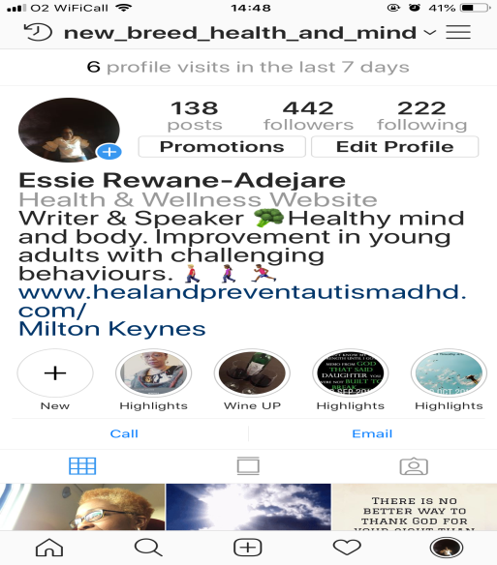

Instagram comes under the creative outlet social media category, which is sharing innovative and significant content with regards to the company’s brand and services (journal of advertising 2018- tandfonline), This category allows the user to post images and videos with descriptive words using related hashtags and tags to elaborate on the content. The purpose of using a hashtag # symbol with a word or phrase is to help classify together, content on trending topics. It creates more exposure and increases engagement with current and potential followers. The @ tag symbol is used to notify or name another business or person in a post. Another excellent engaging method as it exposes the company’s brand if an Instagram or business influencer or user with unlimited followers has been tagged. (thejsms, 2018) A social and healthcare workplace is able to promote the business with creative images. It is vital that photos to reflect the brand, services and company are taken with a good mobile device camera, use Apps that can do this or use photos from other sites that are not copyright. Images can be quotes, text on actual pictures or merely pictures. Videos on the other hand are moving photos with sound. Graphically designed animated images are a powerful way to tell a story. The content should depict the workplace, brand, logo and business in a clear engaging way. Posts can be created in different ways: stories, photo, video, collection of photos or a mixture of both. A variety of content can be used showing different activities in the workplace. Users engage with adverts by liking, commenting or following the Instagram channel. (Business Instagram, 2019) It is advisable to like others posts to create more exposure for your business channel.
The homecare channel evidenced below has one video with a total of 491posts. Videos attract more engagement and visibility, that is why the IGTV – Instagram Channel is slowly blossoming as users are beginning to tap the icon when posting stories
 Baxters homecare

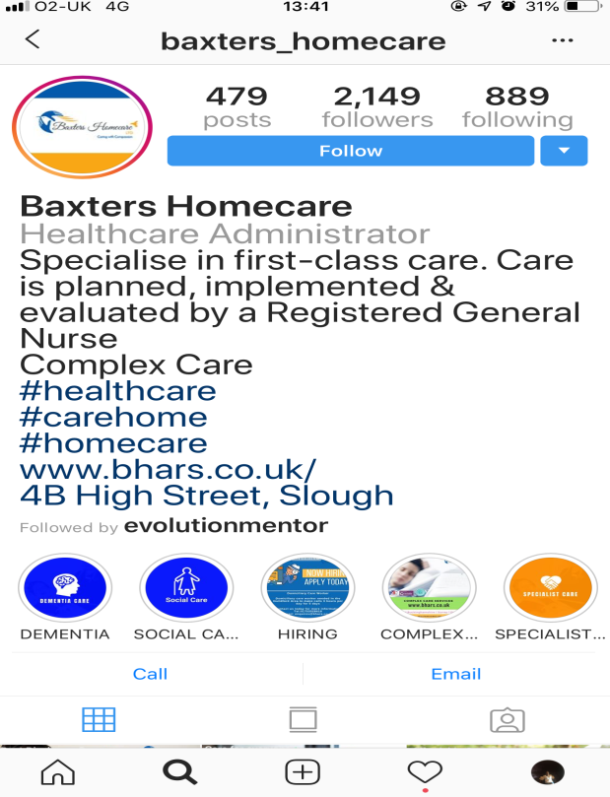

The other option to market services and products is by Paid advertising. -Promoting a new post or a previously shared post within the App. Instagram gives the business the option to either create a target audience or automatically creates it for them.

Example of video post being promoted below

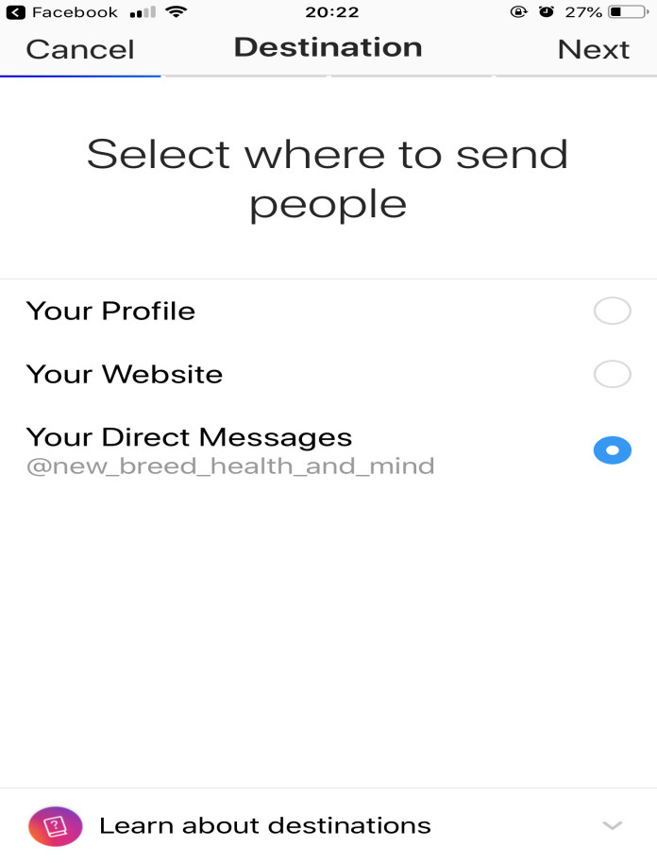
When creating a target audience, the location, interests, demographics, behaviours and types of audience are considered.
The budget and duration requirements are completed then submitted. The ad is reviewed, approved and published. For Facebook account users All advertising is processed on that portal as shown on the second image above. (business Instagram, 2019)

Facebook Ads manager or Instagram Partners are the two other ways to promote ads. Since Instagram was bought over in 2012, it has shared data with Facebook (Business Instagram, 2019)

Example of a sponsored advert -an autism home


Information Gathering
Consistent posting and engagement on Instagram enables the gathering of information which, will lead to new ways of further interaction with followers and in turn increase business growth.
Contribution -having created engaging posts, the business is able to gather information from their followers through comments. Requests can be made on ideas or topics that are trending through videos or images in relation to the brand and service of the business or any other topic.
Competitors-Following other businesses in the same industry that are on the platform is an opportunity to learn from the influencers in the field, irrespective of location. For example, starting up a restaurant or new care home, will push one to view accounts and sites of the high achievers with a 70% plus engagement rate
Insights is a tab on instagram which gives the business a preview to interactions by followers for each post. They are able to see the number of likes comments and actions taken towards the specific post. Actions include: visits to the profile, clicks and any new followers. (Business Instagram, 2019)

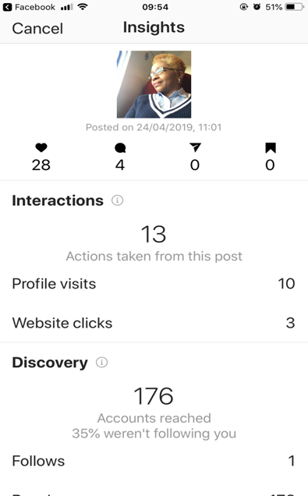

Instagram channel showing information

3. Social Media Links

My Facebook
https://www.facebook.com/essieodeliar

My Linkedin
https://www.linkedin.com/m/login/

My Twitter
https://twitter.com/EssieRewane

CONCLUSION
Digital transformation is inevitable in all areas of life, and the business or company in today’s world will have an option to follow the trend and increase or standstill and decrease. We are faced with an overload and a fast moving world: Increasing creations of different types of digital technology such as mobile devices to improve work quality and personal lifestyle, traditional marketing going extinct and giving way to online marketing. Overall the pros outweigh the cons.

REFERENCES

https://www.samsung.com/uk/business/healthcare-solutions/community-care/
https://www.lenovo.com/gb/en/faqs/laptop-faqs/what-is-a-tablet-pc/
https://www.samsung.com/uk/business/healthcare-solutions/hospitals/

https://www.theguardian.com/social-care-network/2014/nov/03/digital-technology-transforming-social-care

https://www.ncbi.nlm.nih.gov/pmc/articles/PMC5649151/

https://theglobalscholars.com/2018/11/05/pros-and-cons-tablets/

https://www.pcworld.co.uk/gbuk/computing/tablets-and-ereaders/tablets/apple-10-5-2017-ipad-pro-64-gb-space-grey-10165840-pdt.html (accessed 26/04/19)

https://www.pcworld.co.uk/gbuk/computing/tablets-and-ereaders/tablets/samsung-galaxy-tab-s4-10-5-tablet-64-gb-ebony-black-10183901-pdt.html

https://www.macworld.co.uk/review/ipad/ipad-pro-105-vs-samsung-galaxy-tab-s4-3681824/

https://www.statista.com/statistics/253577/number-of-monthly-active-instagram-users/

https://business.instagram.com/

https://business.instagram.com/getting-started/#start-an-account

https://business.instagram.com/advertising/
https://business.instagram.com/getting-started/#create-content

Journal of Advertising 2018 vol 47 issue 1 – Engagement with social media and social media advertising: The Differentiating role of platform type. Available at
https://www.tandfonline.com/doi/full/10.1080/00913367.2017.1405754 (access at 29/04/19)

The Journal of social media in society 2018 vol 7 N0 2 P 232-251 – Using Instagram to engage with (potential) consumers: A study of Forbes most valuable Brands’ Use of Instagram. Available at thejsms.org (accessed 30/04/19)

Evidence of Instagram account (accessed 29/04/19)

`

