
Innovation & Customer Journey
Design Thinking and Innovation
Table of Content
Najia Chaddoudi (2320940)
Lecturer: Dr Semih Yumusak
Word Count: 4317
1. Introduction and Company Background………………………………………………………………Page 2
2. Part 1 – Organisation Analysis……………………………..……………………….……………………Page 2-3
2.1 Overview of the Innovation Ambition Matrix….………………………..………………Page 3
2.1.1 Core Innovation: Enhancing Existing Services ……………………………………....Page 3
2.1.2 Adjacent Innovation: Expanding Capabilities ………………………………….. Page 3-4
2.1.3 Transformational Innovation: The Missing Strategic Shift……………..……… Page 4
2.1.4 Theory Integration and Critical Perspective …………………………………...….Page 4-5
2.2 Introduction to Customer Journey Mapping…………………………………..……….. Page 6
2.2.1 Current Customer Journey at British Airways ……………………………………Page 7-8
2.2.2 Critical Evaluation and Strategic Implications……………………….……………Page 8-9
3. Part 2 – Digital Transformation Initiative……………………………………………………… Page 10-16
3.1 Introduction to the Digital Transformation Initiative …………………………….Page 10
3.2 The Digital Twin Concept and Application to British Airways……………Page 11-12
3.3 How the Digital Twin Addresses Identified Customer Journey Gaps….Page 12-13
3.4 Enhanced Customer Journey: Before vs After Digital Twin Implementation ………….Page 13-15
3.5 Value to the Organisation and Measurement of Success …………………... Page 15-16
4. Conclusion ……………………………….……………………….……………………….……………………...Page 16
5. References ……………………………………………….……………………….………………….…….Page 17-18

1. Introduction and Company Background
The global aviation industry has shifted from prioritising operational efficiency to delivering seamless, digitally enhanced customer experiences. In a highly competitive and technology-driven environment, airlines face increasing pressure to meet the expectations of the “digital traveller”, who demands real-time information, personalisation, and frictionless interactions across all journey stages (International Air Transport Association, 2024). As a result, digital innovation has become a critical strategic priority.
British Airways (BA), established in 1974, is the United Kingdom’s flagship carrier and a subsidiary of International Airlines Group. Operating a global network and employing over 40,000 staff, the airline aims to deliver high-quality service and maintain a premium market position. However, it faces strong competition from airlines such as Virgin Atlantic, Lufthansa, and Emirates, all of which are investing heavily in digital innovation.
Despite its position, British Airways faces growing challenges linked to evolving customer expectations. Passengers increasingly expect seamless and personalised experiences, yet issues such as fragmented journeys and limited real-time responsiveness persist. Research suggests that many airlines still struggle to deliver fully integrated and predictive customer experiences across touchpoints (Shiwakoti et al., 2022).
Digital transformation therefore requires more than isolated technologies; it demands integrated, data-driven systems that enhance both efficiency and customer experience. In response, this report evaluates British Airways’ innovation approach using the Innovation Ambition Matrix (Nagji and Tuff, 2012) and Customer Journey Mapping. It then proposes a transformational digital twin strategy to create a more proactive, personalised, and connected passenger journey.
Ultimately, the report argues that sustained competitiveness depends on moving beyond incremental innovation towards fully integrated, intelligent systems that redefine the customer experience.

2. Part 1 – Organization Analysis
2.1 Overview of the Innovation Ambition Matrix
The Innovation Ambition Matrix, developed by Nagji and Tuff (2012), provides a strategic framework for categorising innovation activities into three levels: core, adjacent, and transformational innovation. Core innovation focuses on incremental improvements to existing products and services, adjacent innovation extends existing capabilities into new markets or offerings, while transformational innovation involves the development of entirely new solutions that can redefine business models and industry practices (Nagji and Tuff, 2012). This framework is particularly useful in evaluating whether organisations maintain a balanced innovation portfolio that supports both short-term performance and long-term growth.
2.1.1 Core Innovation: Enhancing Existing Services
British Airways demonstrates a strong emphasis on core innovation, primarily through incremental improvements to its existing services and operational processes. For instance, the airline has invested in enhancing its mobile application, enabling features such as digital boarding passes, real-time flight updates, and self-service check-in (British Airways, 2023). Additionally, improvements in cabin offerings, including upgraded seating, in-flight entertainment systems, and premium service experiences, reflect ongoing efforts to optimise existing products for current customers.
From an operational perspective, British Airways has also introduced digital tools to improve efficiency, such as automated check-in systems and improved baggage tracking capabilities (IAG, 2023). These initiatives align with core innovation as they enhance existing processes rather than fundamentally altering the service model (Nagji and Tuff, 2012).
However, while these improvements contribute to operational efficiency and customer convenience, their impact remains largely incremental. Core innovations offer limited competitive differentiation, as they are relatively easy for competitors such as Lufthansa and Emirates to replicate (Porter, 2008). Therefore, although British Airways demonstrates competence in optimising its current offerings, an over-reliance on core innovation may restrict its ability to achieve long-term strategic advantage.
2.1.2 Adjacent Innovation: Expanding Capabilities
Beyond incremental improvements, British Airways has engaged in adjacent innovation by extending its existing capabilities into new areas. A key example is the development of its loyalty ecosystem through the Executive Club and Avios programme, which expands the airline’s value proposition beyond flights into a broader travel and lifestyle network (IAG, 2023). Through partnerships with hotels, car rental services, and financial providers, British Airways leverages its existing customer base to create new revenue streams and enhance customer engagement.
Additionally, the airline has explored digital enhancements such as personalised offers and targeted marketing based on customer data, representing an extension of its existing digital infrastructure into more customer-centric applications (Chaffey and Ellis-Chadwick, 2019). These initiatives demonstrate how British Airways attempts to move beyond operational efficiency towards value-added services.
However, adjacent innovation within British Airways appears relatively conservative. While these initiatives expand the company’s service offering, they do not fundamentally transform the customer experience. Furthermore, such strategies carry moderate risk, particularly in terms of maintaining consistent service quality across partner networks and ensuring data-driven personalisation does not compromise customer trust (Verhoef et al., 2021). Although successful in strengthening customer retention, these innovations remain evolutionary rather than disruptive.

2.1.3 Transformational Innovation: The Missing Strategic Shift
In contrast to its strengths in core and adjacent innovation, British Airways appears comparatively limited in its engagement with transformational innovation. While the airline has adopted certain digital technologies, such as AI-driven customer support and operational analytics, these initiatives are often fragmented and lack full integration across the customer journey (Shiwakoti et al., 2022).
Transformational innovation requires organisations to reimagine how value is created, often through the adoption of advanced technologies that fundamentally reshape business models (Nagji and Tuff, 2012). In the context of the airline industry, this includes the integration of real-time data, predictive analytics, and intelligent systems to create a seamless and adaptive passenger experience (Davenport et al., 2020).
Currently, British Airways does not fully leverage such capabilities at a system-wide level. For example, while digital tools exist for booking and customer service, there is limited evidence of an integrated system that proactively manages the entire passenger journey from end to end. This indicates a significant gap in the airline’s innovation strategy, particularly in relation to emerging technological opportunities.
2.1.4 Theory Integration and Critical Perspective
The Innovation Ambition Matrix emphasises the importance of balancing innovation efforts across all three categories, with Nagji and Tuff (2012) suggesting an optimal distribution of approximately 70% core, 20% adjacent, and 10% transformational innovation. In the case of British Airways, the current distribution appears heavily skewed towards core innovation, with limited emphasis on transformational initiatives.
This imbalance can be further understood through Christensen’s (1997) theory of disruptive innovation, which highlights how organisations that focus predominantly on incremental improvements risk being overtaken by competitors introducing fundamentally new business models. British Airways’ focus on refining existing services, while valuable in the short term, may constrain its ability to adapt to disruptive technological shifts within the aviation industry.
Overall, British Airways demonstrates a competent but unbalanced innovation strategy. Its strong focus on core innovation ensures operational reliability and service quality; however, this comes at the expense of more ambitious, transformational initiatives. While adjacent innovations contribute to incremental growth, they do not significantly differentiate the airline within an increasingly competitive market.
Crucially, the lack of fully integrated, data-driven systems highlights a missed opportunity to enhance both operational efficiency and customer experience. This gap suggests that British Airways’ innovation strategy is reactive rather than proactive, addressing current challenges without fully anticipating future demands (Davenport et al., 2020).
Therefore, a strategic shift towards transformational innovation is necessary. Specifically, there is a clear opportunity for British Airways to adopt more advanced, system-wide digital solutions that integrate data, predict customer needs, and optimise the entire travel experience. This provides the foundation for the proposed digital twin strategy, which will be explored in Part 2 of this report.
The table below summarises British Airways’ innovation activities across the three levels of the Innovation Ambition Matrix.
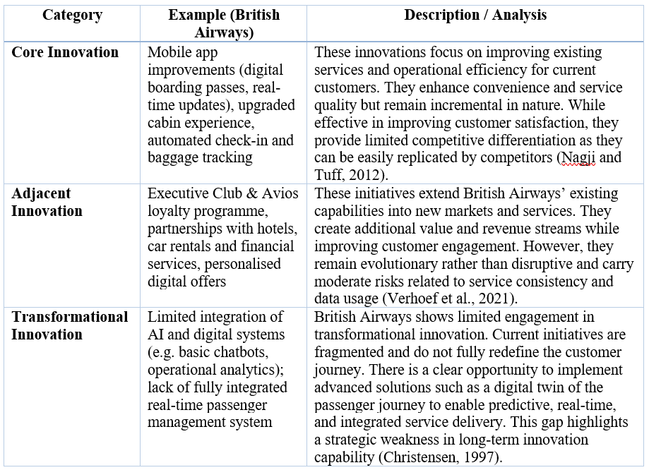
As illustrated in the table, British Airways’ innovation strategy is heavily concentrated in core innovation, with comparatively limited investment in transformational initiatives. This imbalance suggests a short-term focus on operational improvements rather than long-term strategic transformation, reinforcing the need for more advanced and integrated innovation approaches.
2.2 Introduction to Customer Journey Mapping
Customer journey mapping is a strategic tool used to visualise and analyse the end-to-end experience a customer has with an organisation across multiple touchpoints (Lemon and Verhoef, 2016). It enables organisations to identify key interactions, emotional responses, pain points, and opportunities for improvement throughout the customer lifecycle.
Lemon and Verhoef (2016) conceptualise the customer journey across three main stages: pre-purchase, purchase, and post-purchase, emphasising that customer experience is shaped by a combination of firm-controlled and external touchpoints. Similarly, McKinsey’s Consumer Decision Journey highlights the non-linear nature of modern customer interactions, particularly in digital environments where customers move between channels seamlessly (Court et al., 2009). Furthermore, service-dominant logic (Vargo and Lusch, 2004) reinforces that value is co-created through interactions, making the quality of each touchpoint critical to overall customer satisfaction.
Applying these models to British Airways allows for a comprehensive evaluation of how effectively the airline delivers its customer experience and where digital innovation opportunities exist.

2.2.1 Current Customer Journey at British Airways
The customer journey at British Airways can be divided into three key stages:
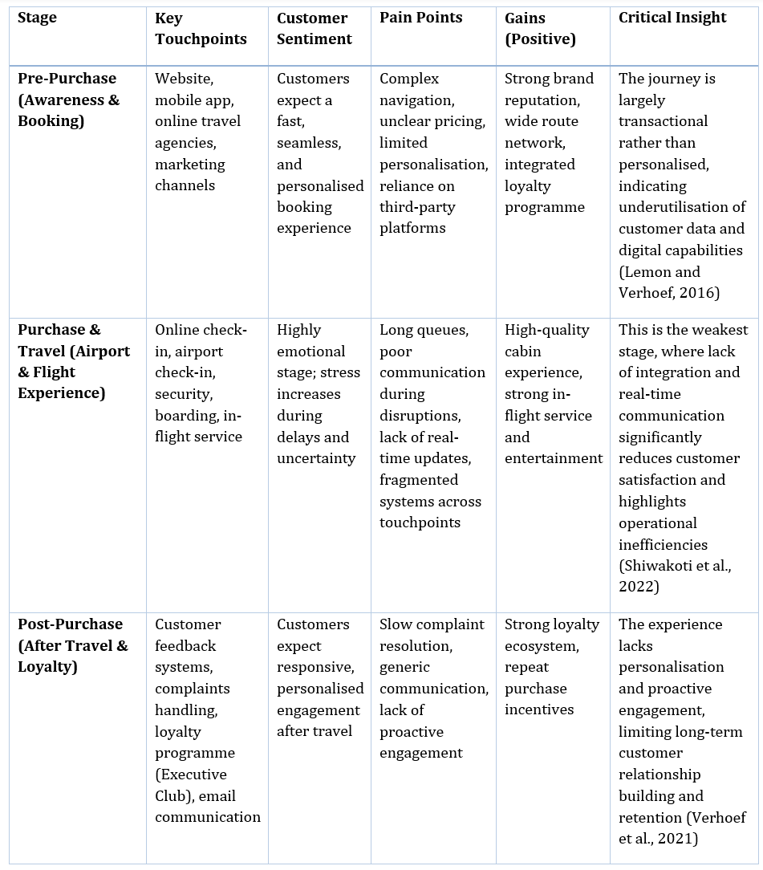
As illustrated in the table, British Airways delivers a customer journey that is operationally functional but strategically fragmented. While the pre-purchase stage performs relatively well due to strong brand presence and accessible digital platforms, the experience remains largely transactional and lacks meaningful personalisation. More critically, the travel stage exposes significant weaknesses, particularly in terms of real-time communication and coordination during disruptions, which negatively impacts customer satisfaction. This finding aligns with Lemon and Verhoef (2016), who emphasise that customer experience is shaped by the integration of touchpoints rather than their individual performance.
Furthermore, the post-purchase stage highlights a reactive approach to customer engagement, with limited proactive communication and personalisation. According to Verhoef et al. (2021), such fragmentation across the customer journey reduces both customer loyalty and long-term value creation. Overall, the analysis suggests that British Airways’ current approach lacks a fully integrated, data-driven system capable of connecting all stages of the journey. This gap presents a significant opportunity for digital transformation, particularly through the implementation of advanced technologies that enable real-time, predictive, and personalised customer experiences.
2.2.2 Critical Evaluation and Strategic Implications
The analysis of British Airways’ customer journey reveals a system that is operationally competent yet strategically fragmented. While individual touchpoints such as booking platforms, airport processes, and in-flight services function adequately in isolation, they fail to operate as part of a cohesive, end-to-end experience. This fragmentation is particularly evident during the travel stage, where disruptions expose a lack of real-time coordination and integrated communication. As a result, customer experience becomes inconsistent and reactive rather than seamless and anticipatory.
From a theoretical perspective, this misalignment directly contradicts the principles of customer experience management proposed by Lemon and Verhoef (2016), who argue that value is created through the integration of touchpoints across the entire journey. British Airways’ current model appears to prioritise operational efficiency at individual stages rather than delivering a unified, customer-centric experience. Moreover, the absence of predictive and data-driven capabilities highlights a limited adoption of digital transformation practices, particularly when compared to organisations that leverage real-time analytics to enhance customer journeys (Davenport et al., 2020).
Critically, this suggests that British Airways’ approach to customer experience is not only fragmented but also strategically short-sighted. By focusing on incremental improvements within isolated touchpoints, the airline risks reinforcing inefficiencies rather than addressing the underlying structural issues of its service delivery model. This aligns with Verhoef et al. (2021), who emphasise that true digital transformation requires organisations to rethink how value is delivered across the entire customer journey, rather than optimising individual components.
Consequently, the identified gaps highlight a clear need for a more integrated and intelligent system capable of connecting all stages of the customer journey in real time. The lack of coordination, personalisation, and predictive capability presents a significant opportunity for strategic innovation. In this context, a digital twin approach offers a compelling solution. By creating a real-time, data-driven representation of the passenger journey, British Airways could integrate operational data, customer insights, and predictive analytics into a single, unified framework.
Such a transformation would shift the organisation from a reactive service model where issues are addressed after they occur to a proactive and anticipatory system that predicts disruptions, personalises interactions, and optimises decision-making across the journey. This not only enhances customer satisfaction but also improves operational efficiency and strategic agility. Therefore, the adoption of a digital twin strategy is not merely an enhancement, but a necessary evolution in British Airways’ innovation approach, addressing the fundamental limitations identified in its current customer journey.

3. Part 2 – Digital Transformation Initiative
3.1 Introduction to the Digital Transformation Initiative
The preceding analysis has demonstrated that British Airways’ customer journey, while operationally effective at individual touchpoints, remains fundamentally fragmented and reactive in its overall structure. In particular, the absence of real-time integration, predictive capabilities, and seamless coordination across the travel experience limits the organisation’s ability to deliver a truly customer-centric service. This fragmentation reflects a broader issue identified within service industries, where disconnected touchpoints reduce perceived service quality and weaken overall customer experience (Homburg, Jozić and Kuehnl, 2017). Moreover, the inability to anticipate customer needs highlights a lack of dynamic capability, which is increasingly recognised as essential for organisations operating in data-rich environments (Teece, 2018).
Digital transformation is therefore not simply a matter of adopting new technologies, but a strategic process of integrating data, systems, and processes to enhance organisational responsiveness and value creation. Kane et al. (2015) argue that organisations that fail to embed digital technologies into their core operations often remain trapped in incremental improvements rather than achieving true transformation. In the context of customer experience, this results in reactive service delivery models that are unable to respond effectively to real-time changes in customer needs or operational conditions (Bolton et al., 2018).
Furthermore, the growing complexity of customer journeys, particularly within the airline industry requires organisations to adopt more advanced, data-driven approaches that enable continuous monitoring and optimisation. Research suggests that real-time analytics and intelligent systems play a critical role in enhancing both operational efficiency and customer satisfaction by enabling organisations to predict disruptions and respond proactively (Wamba et al., 2020). However, as identified in Part 1, British Airways has yet to fully integrate these capabilities into a unified system, resulting in inefficiencies and inconsistent customer experiences.
In response to these challenges, this section proposes a transformational digital initiative centred on the implementation of a digital twin of the passenger journey. A digital twin is defined as a dynamic, real-time virtual representation of a physical system that enables simulation, prediction, and optimisation (Fuller et al., 2020). While extensively applied in sectors such as manufacturing and smart infrastructure, its application to customer experience management remains relatively underdeveloped, presenting a significant opportunity for innovation within the airline industry.
By implementing a digital twin of the passenger journey, British Airways would be able to integrate operational data, customer data, and predictive analytics into a single intelligent system. This would enable the organisation to move beyond reactive service delivery towards a proactive and adaptive model, where disruptions can be anticipated, decisions optimised in real time, and customer interactions personalised at scale. Consequently, the proposed initiative represents not only a technological advancement, but a strategic reconfiguration of how value is created and delivered across the entire customer journey.
3.2 The Digital Twin Concept and Application to British Airways
A digital twin represents a dynamic, real-time virtual model of a physical system that integrates data from multiple sources to enable monitoring, simulation, and optimisation of complex processes (Fuller et al., 2020). Within the context of the aviation industry, digital twin technology has emerged as a transformative tool capable of addressing the increasing complexity of airport operations and passenger management. By combining real-time data streams with predictive analytics, digital twins enable organisations to move beyond static decision-making towards adaptive, data-driven systems (Durmaz and Göçmen, 2025).
In practice, digital twin systems have already demonstrated significant value in airport environments. For example, at Istanbul Airport and Singapore Changi Airport, digital twin technologies are used to monitor passenger flows, optimise resource allocation, and simulate operational scenarios in real time, enabling more efficient management of congestion, baggage systems, and ground operations (Durmaz and Göçmen, 2025). Similarly, Vancouver International Airport has implemented a digital twin that integrates historical and real-time data to improve situational awareness, streamline decision-making, and enhance coordination across operational teams (Unity Technologies, 2023). These implementations highlight the capability of digital twin systems to transform airports from reactive environments into proactive, intelligently managed ecosystems.
More advanced applications, such as Motional Digital Twins, extend this capability by continuously tracking the movement of passengers, baggage, and aircraft across the airport environment, using real-time spatial data and predictive modelling to forecast disruptions and optimise operational flow (International Airport Review, 2024). This enables airports to anticipate congestion, dynamically reallocate resources, and test “what-if” scenarios before issues materialise, significantly improving both efficiency and customer experience. Such capabilities are particularly relevant in addressing the fragmented and reactive nature of British Airways’ current customer journey, as identified in Part 1.
Applying this concept to British Airways, a digital twin of the passenger journey would involve the integration of multiple data streams, including booking data, passenger movement within the airport, operational flight data, and real-time environmental conditions. These data inputs would be continuously synchronised within a central digital platform, creating a live, end-to-end representation of each passenger’s journey. Through this system, British Airways would be able to monitor customer progress across touchpoints, identify potential disruptions, and implement corrective actions in real time.
For instance, if a passenger is predicted to experience delays at security or risk missing a connecting flight, the digital twin system could trigger automated interventions, such as re-routing the passenger, prioritising boarding, or reallocating resources to reduce congestion. This aligns with research suggesting that real-time data integration and predictive analytics are critical enablers of proactive service delivery and operational optimisation in complex service environments (Wamba et al., 2020).
Furthermore, the integration of digital twin technology would enable British Airways to transition from a fragmented service model to a fully interconnected system, where decisions are informed by a holistic understanding of the entire customer journey. As highlighted by McKinsey (2025), digital twins allow organisations to coordinate operations more effectively by providing a unified view of system interactions, reducing inefficiencies and improving responsiveness (McKinsey, 2025). In this context, the digital twin would act as the central intelligence layer of British Airways’ operations, connecting previously siloed systems and enabling real-time, data-driven decision-making.
Critically, this transformation extends beyond operational efficiency to fundamentally enhance customer experience. By enabling predictive, personalised, and adaptive interactions, the digital twin approach supports a shift towards anticipatory service delivery, where customer needs are addressed before they become problems. This represents a significant departure from British Airways’ current reactive approach and positions the organisation to deliver a more seamless, integrated, and customer-centric travel experience.
3.3 How the Digital Twin Addresses Identified Customer Journey Gaps
The implementation of a digital twin of the passenger journey directly addresses key limitations in British Airways’ current customer experience, including fragmented touchpoints, lack of real-time coordination, and reactive service delivery. As identified in Part 1, these issues lead to inconsistent experiences and reduced satisfaction, particularly during high-pressure stages such as airport processing and disruptions.
From a theoretical perspective, these challenges can be explained through service-dominant logic, which argues that value is co-created across multiple interactions rather than delivered through isolated transactions (Vargo and Lusch, 2004). British Airways’ fragmented systems restrict this value co-creation, as the lack of integration prevents seamless information flow. The digital twin addresses this by enabling continuous data integration, creating a more coordinated and responsive service ecosystem.
The system enhances real-time visibility by integrating operational data, such as flight status, with customer data, including passenger location and itinerary. This allows potential disruptions to be identified in advance, supporting a shift from reactive to proactive service delivery. This aligns with research showing that real-time analytics improves decision-making and responsiveness in complex environments (Wamba et al., 2020).
Additionally, the digital twin enables predictive personalisation, addressing the lack of tailored interactions. Homburg et al. (2017) emphasise that modern service delivery requires personalised, context-specific interactions. By anticipating passenger needs, such as delays or missed connections, the system can deliver targeted interventions, including re-routing and real-time notifications, thereby enhancing satisfaction and perceived service quality.
Furthermore, the digital twin improves communication by creating a unified information flow across all touchpoints. Verhoef et al. (2021) highlight that integrated digital systems are essential for delivering consistent omnichannel experiences. Acting as a central intelligence layer, the digital twin aligns operational systems, staff, and digital platforms in real time, improving coordination and reducing service inconsistencies.
Critically, this approach goes beyond improving individual touchpoints and instead reconfigures the entire customer journey into an integrated, adaptive system. As such, the digital twin represents a comprehensive solution that directly addresses the operational and experiential gaps identified in British Airways’ current approach.

3.4 Enhanced Customer Journey: Before vs After Digital Twin Implementation
To fully evaluate the impact of the proposed digital twin initiative, it is essential to compare the current customer journey with the enhanced, digitally integrated journey. As identified in Part 1, British Airways’ existing customer journey is characterised by fragmentation, reactive service delivery, and limited real-time coordination. The implementation of a digital twin fundamentally transforms this experience by enabling real-time data integration, predictive decision-making, and seamless coordination across all touchpoints.
This transformation aligns with the principles of customer experience management, which emphasise the importance of consistency, personalisation, and integration across the entire journey (Lemon and Verhoef, 2016). The table below illustrates the key differences between the current and enhanced customer journey.
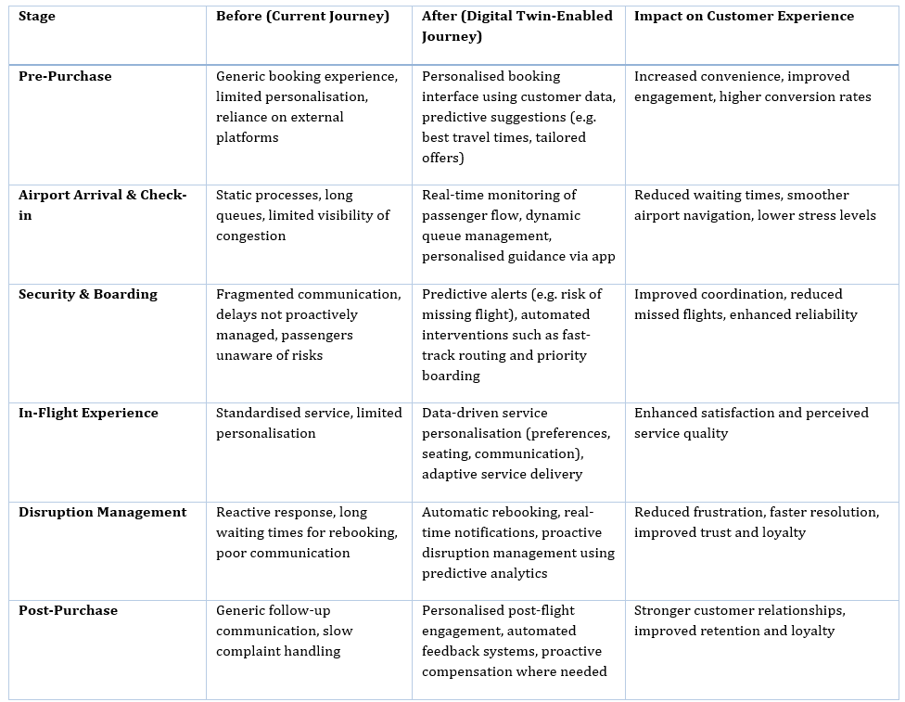
Table 1: Before vs After – Customer Journey Transformation

The comparison clearly demonstrates that the implementation of a digital twin transforms the customer journey from a reactive and fragmented process into a proactive and integrated system. In the current model, value is delivered at isolated touchpoints, often leading to inconsistencies and inefficiencies. In contrast, the digital twin enables continuous coordination across all stages, ensuring that customer interactions are both timely and contextually relevant.
This shift reflects the transition from a traditional service delivery model to a more advanced, data-driven approach to customer experience management. According to Lemon and Verhoef (2016), the integration of touchpoints is essential for delivering a seamless customer experience, while Verhoef et al. (2021) emphasise that digital transformation enables organisations to personalise and optimise interactions at scale. The digital twin approach directly supports these principles by creating a unified system that connects operational processes with customer needs in real time.
Furthermore, the enhanced journey highlights the role of predictive analytics in improving service delivery. By anticipating disruptions and customer requirements, British Airways can shift from reactive problem-solving to proactive experience management, which has been shown to significantly improve both customer satisfaction and operational efficiency (Wamba et al., 2020).
Critically, this transformation is not limited to incremental improvements but represents a fundamental reconfiguration of how the customer journey is managed. It addresses the core limitations identified in Part 1 namely fragmentation, lack of integration, and reactive service delivery while positioning British Airways to deliver a more intelligent, adaptive, and customer-centric experience.
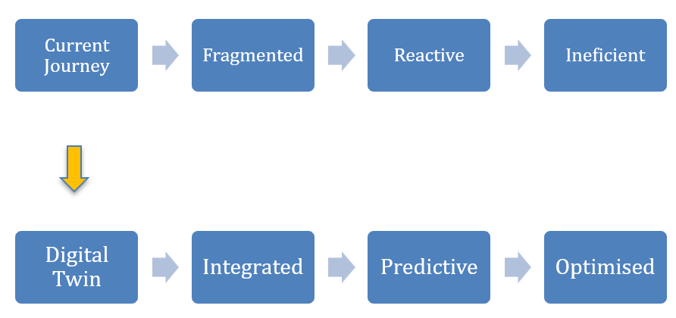

3.5 Value to the Organisation and Measurement of Success
The proposed digital twin of the passenger journey presents a strategically significant opportunity for British Airways to enhance customer experience, improve operational efficiency, and strengthen long-term competitiveness. By integrating real-time data with predictive analytics, the initiative enables a shift from reactive service delivery to proactive journey management, directly addressing the fragmentation identified in Part 1.
From a customer perspective, the ability to anticipate disruptions and personalise interactions is critical to improving satisfaction and loyalty. Empirical research shows that organisations leveraging data-driven customer experience strategies can achieve satisfaction improvements of up to 30% (Wamba et al., 2020). A relevant example is Singapore Changi Airport, which utilises advanced data systems to optimise passenger flow and deliver real-time journey updates, resulting in consistently high customer satisfaction rankings (Durmaz and Göçmen, 2025). For British Airways, similar capabilities would enhance reliability and reduce passenger stress during key touchpoints.
Operationally, digital twin technologies enable measurable efficiency gains. Studies indicate that such systems can reduce delays and inefficiencies by up to 50% through real-time monitoring and predictive optimisation (Fuller et al., 2020). This is evidenced by Vancouver International Airport, where digital twin implementation improved coordination and reduced congestion, leading to smoother operations (Unity Technologies, 2023). For British Airways, this translates into faster processing times, improved disruption management, and lower operational costs.
To measure success, clear performance indicators must be established. Customer satisfaction and Net Promoter Score will assess improvements in experience and loyalty. Operational efficiency can be evaluated through reductions in processing times and improved disruption resolution rates. Financial performance should be measured through customer retention and revenue per passenger, reflecting enhanced lifetime value.
Ultimately, the initiative aligns closely with British Airways’ strategic objective of delivering a premium, reliable service. By improving both efficiency and customer experience, the digital twin strengthens competitive positioning and enables sustainable value creation in an increasingly digital aviation environment.

4. Conclusion
This report has critically evaluated British Airways’ current approach to innovation and customer experience through the application of the Innovation Ambition Matrix and Customer Journey Mapping. The analysis revealed that while British Airways demonstrates strength in core and adjacent innovation, its approach remains largely incremental and operationally focused, with limited emphasis on transformational, data-driven innovation. This imbalance has resulted in a fragmented and reactive customer journey, particularly during high-pressure touchpoints such as airport processing and disruption management.
In response, the proposed digital twin of the passenger journey represents a strategically significant transformation. By integrating real-time data, predictive analytics, and operational systems, the initiative enables British Airways to shift from reactive service delivery to a proactive, personalised, and fully connected customer experience. This not only addresses current inefficiencies but also aligns with broader industry trends towards intelligent and data-driven service ecosystems.
Ultimately, the success of British Airways in an increasingly competitive aviation landscape will depend on its ability to move beyond incremental improvements and embrace transformational innovation. The digital twin strategy provides a clear pathway to achieving this, positioning the organisation to deliver superior customer value, enhance operational performance, and secure sustainable competitive advantage.
5. References
Bolton, R.N. et al. (2018) ‘Understanding generation Y and their use of social media: A review and research agenda’, Journal of Service Management, 29(3), pp. 281–308.
British Airways (2023) Annual Report and Accounts 2023. Available at: https://www.britishairways.com (Accessed: 15 March 2026).
Chaffey, D. and Ellis-Chadwick, F. (2019) Digital Marketing. 7th edn. Harlow: Pearson.
Christensen, C.M. (1997) The Innovator’s Dilemma. Boston: Harvard Business School Press.
Court, D., Elzinga, D., Mulder, S. and Vetvik, O.J. (2009) ‘The consumer decision journey’, McKinsey Quarterly. Available at: https://www.mckinsey.com (Accessed: 15 March 2026).
Davenport, T.H., Guha, A., Grewal, D. and Bressgott, T. (2020) ‘How artificial intelligence will change the future of marketing’, Journal of the Academy of Marketing Science, 48(1), pp. 24–42.
Durmaz, R. and Göçmen, F.D. (2025) ‘Usage of digital twin technologies in airports’, EAI Transactions on Industrial Networks and Intelligent Systems.
Fuller, A., Fan, Z., Day, C. and Barlow, C. (2020) ‘Digital twin: Enabling technologies, challenges and open research’, IEEE Access, 8, pp. 108952–108971.
Homburg, C., Jozić, D. and Kuehnl, C. (2017) ‘Customer experience management: Toward implementing an evolving marketing concept’, Journal of the Academy of Marketing Science, 45(3), pp. 377–401.
International Air Transport Association (2024) The rise of the digital traveller. Available at: https://www.iata.org (Accessed: 15 March 2026).
International Airlines Group (IAG) (2023) Annual Report and Accounts 2023. Available at: https://www.iairgroup.com (Accessed: 15 March 2026).
International Airport Review (2024) ‘How motional digital twins improve flow efficiency and airport performance’. Available at: https://www.internationalairportreview.com (Accessed: 15 March 2026).
Kane, G.C. et al. (2015) ‘Strategy, not technology, drives digital transformation’, MIT Sloan Management Review.
Lemon, K.N. and Verhoef, P.C. (2016) ‘Understanding customer experience throughout the customer journey’, Journal of Marketing, 80(6), pp. 69–96.
Nagji, B. and Tuff, G. (2012) ‘Managing your innovation portfolio’, Harvard Business Review, 90(5), pp. 66–74.
Porter, M.E. (2008) Competitive Strategy. New York: Free Press.
Shiwakoti, N., Fan, Y., Mohammadi, A. and Ahasan, R. (2022) ‘Passenger satisfaction with digital technology adoption in airlines’, Sustainability, 14(4), pp. 1–18.
Tao, F., Qi, Q., Liu, A. and Kusiak, A. (2019) ‘Data-driven smart manufacturing and digital twin’, Journal of Manufacturing Systems, 48, pp. 157–169.
Teece, D.J. (2018) ‘Business models and dynamic capabilities’, Long Range Planning, 51(1), pp. 40–49.
Unity Technologies (2023) Vancouver Airport Authority digital twin case study. Available at: https://unity.com/case-study/vancouver-airport-authority (Accessed: 15 March 2026).
Vargo, S.L. and Lusch, R.F. (2004) ‘Evolving to a new dominant logic for marketing’, Journal of Marketing, 68(1), pp. 1–17.
Verhoef, P.C. et al. (2021) ‘Digital transformation: A multidisciplinary reflection and research agenda’, Journal of Business Research, 122, pp. 889–901.
Wamba, S.F., Gunasekaran, A., Akter, S., Ren, S.J.F., Dubey, R. and Childe, S.J. (2020) ‘Big data analytics and firm performance’, International Journal of Information Management, 50, pp. 146–155.

