University of Wales Trinity Saint David School of Applied Computing

Assignment
Academic writing M4X01498

Ryan Williams
1708310
14/3/2018

Introduction
The increasing complexity and demand of software has meant that there is a need for more software project managers to oversee software development lifecycles. A software project manager can be involved in all stages of a software development lifecycle from the initial requirements specification given by the customer, the viability, cost effectiveness and development stages to the final end product and to the evolution of the software. These different stages can vary and are dependent on the project required, the size of the project, the time scales, company policies and the methodology used. [1]

Software project management is unique compared to other project management roles and methods as it can be difficult to see the progress of a software project. Software projects are built to human requirements that differ to other engineering projects that can use physical systems such as materials that can impose limitations to requirements. As software can be easily changed compared to other engineering tasks this can mean further complexity and higher costs as the plans for the project can change a lot more rapidly compared to other industries.

Aims
In a typical software project there are a various number of different teams and processes that are working at different speeds and to different deadlines. Without effective management a project could collapse early on during the analysis or development stages for example, where considerable time and money has already been invested in the project.

An example of this is in 2003 “The Standish group in the United States analysed 13,522 projects and concluded that only a third of projects were successful; 82% of projects were late and 43% exceeded their budget” [2](page 2)

With effective management it may be possible to meet or even exceed the project and customer expectations and can insure that the project can be completed within the expected time frame. This can be achieved as effective software project management can provide better communication between teams as the software methods can provide real time updates. This allows teams to keep better schedules and project managers can track projects more efficiently.

Depending on the size and scale of the project the costs involved could greatly impact the project from ever being completed. This could have a detrimental effect to the software developer’s business and also to the customers as the costs could be substantial. These costs can quickly spiral out of control without effective management and strategies in place.
Other costs such as improvements or maintenance to the software may not be budgeted for correctly without a plan in place to future proof the software systems.

2 Methodology Discussion
Software development can be managed using a number of different methods including the waterfall method and Agile methods. The correct approach to use could depend on a number of different circumstances. Some of these could include, the size of the software that could be developed and the number of employees working on the project. The timescales involved, and the type of projects are the risks involved in developing the software.

2.1 Agile Methods
Agile methods are based on incremental methods of managing software development lifecycles. Agile methods use short releases and bursts to develop and release the software to minimise risk. Agile methods are more suited for projects where a lot of user/customer feedback may be possible and allows for the software development to be cancelled without great costs to the customers. Agile and incremental methods are often suited to smaller teams that can work on a smaller scale to complete the projects in stages and increments.
[3] (Figure 1 below shows an agile method using the spiral model).
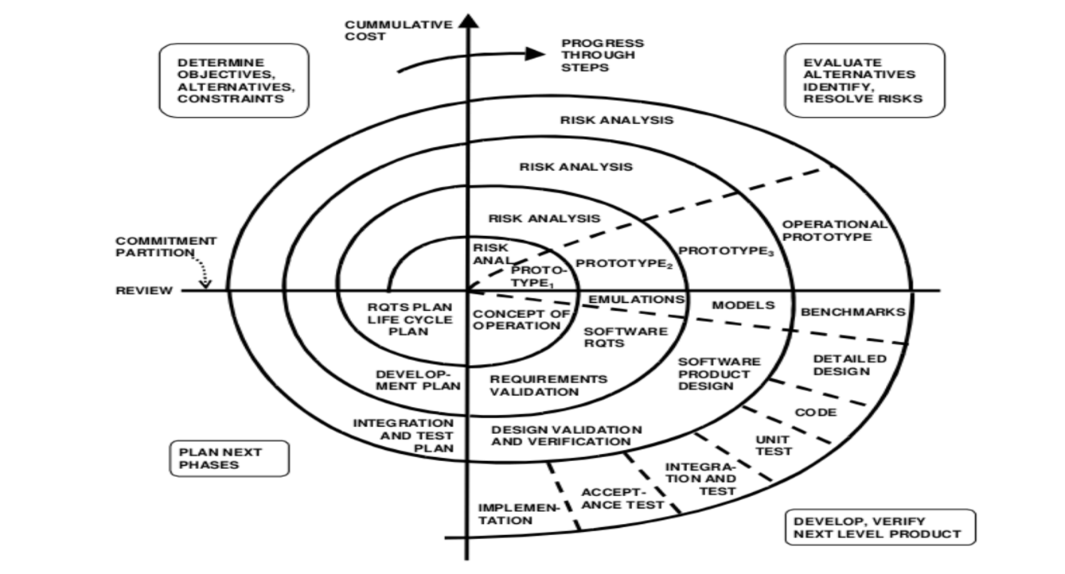
Figure 1

2.2 The waterfall method
The waterfall method takes a more conventional approach to software project management and can be used for low risk tasks such as for user interfaces and for performance. This method also represents a high risk with regards to the schedule and control of the software development lifecycles, as more tasks could be undertaken at the same time. Real time critical systems for example, could need more work done on the analysis, development and testing stages as it may be crucial to ensure the software is safe to use. The waterfall method is often used by larger organisations, such as the government and electricity companies where the infrastructures are vast, and systems are already in place that may need to interact and work with the current software that is in place. (Figure 2 below shows a graphical example of the waterfall method). [4]
[4]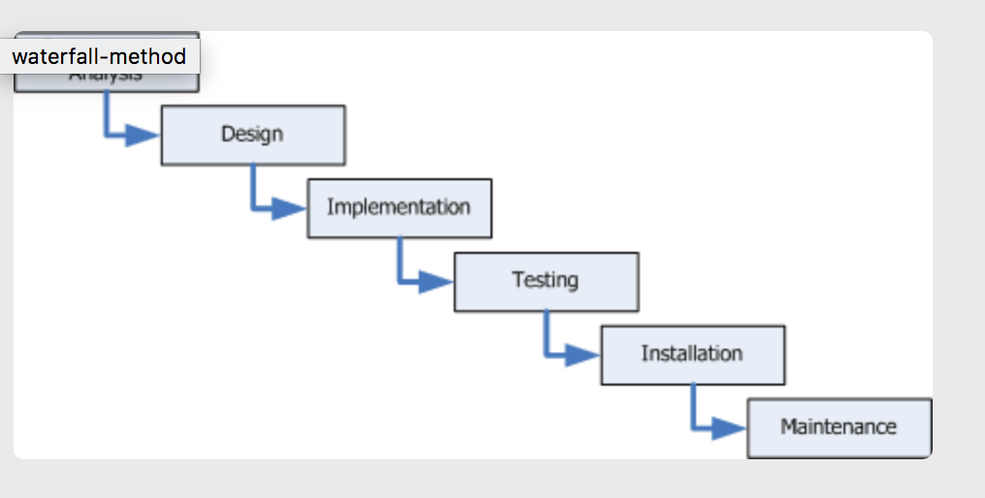 Figure 2

2.3 Hybrid Methods
It is possible that businesses use a combination of both software project management methods as this could be the most effective way to complete different sections of the software development lifecycle or to successfully complete the project. For example, a hybrid project could include a significant amount of planning and analysis at an early stage and could use agile processes for the release stages and user feedback. The hybrid approach would need to either give up some flexibility with regards to the agile methods or give up a level of certainty with regards to the waterfall methods.
[5]

Conclusions
Since researching software project management, it has become clearer on why software projects need both a management structure and methods put in place in order for the project to be completed successfully. A successful software project must meet the requirements and objectives set by the customers and company as failing to meet these requirements can result in significant costs and penalties that can damage both the customers and businesses reputations.

The number of different methods that are used for software projects outline how complex and unique software project management can be and choosing the right method can be critical to the successful completion of the project.

Completing this assignment has given an insight into software project management and I will continue reading and gathering information to be better equipped for future software projects that I may become a part of.

Bibliography

[1] | A. Mishra, “Software Project Management Tools: A Brief Comparative View,” Newsletter ACM SIGSOFT Software Engineering Notes archive , vol. Volume 38, no. 3, pp. 1-4, May 2013.
[2] | B. Hughes and M. Cotterell, Software Project management, Maidenhead: McGraw-Hill, 2002.
[3] | V. Vliet, Software Engineering Principles and Practice, Chichester,West Sussex: John Wiley and Sons Ltd, 2008.
[4] | W. Dawson, Projects In Computing and Information Systems, Edingburgh Gate, Harlow: Pearson, 2015.
[5] | www.cprime.com, “hybrid-projects-how-can-waterfall-and-agile-work- together,” [Online]. Available: https://www.cprime.com/2014/05/hybrid-projects-how-can-waterfall-and-agile-work- together/.

