Portfolio of evidence outlining how to use an outdoor environment to promote and support children’s scientific/mathematical thinking.

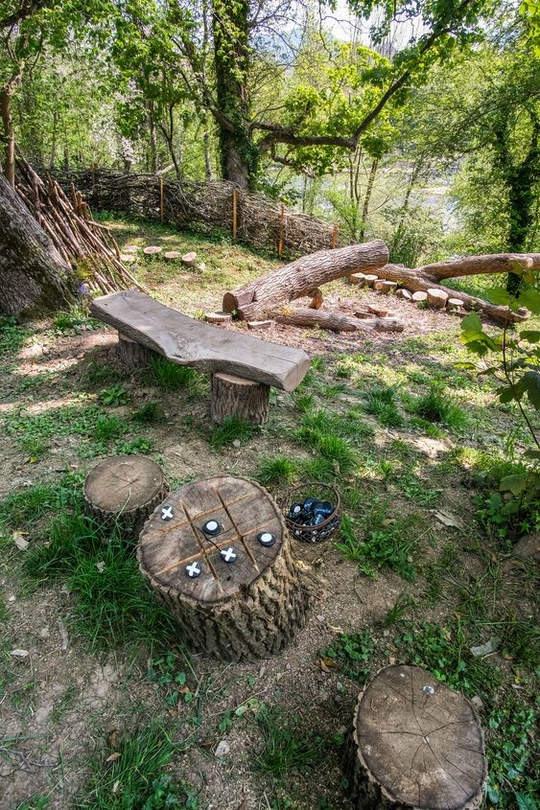
Section 1
Image 1: Pinterest (no date)

Hello and thank you for reading my portfolio on Awe and Wonder: Science, Mathematics and the Outdoors. Above I have a photograph and I have picked out 3 features. Feature 1 is using the big stump to build a seesaw, feature 2 is making a den with the sticks, and feature 3 is using the branches of the trees to hang a prism and develop an activity around this. In the first part of this portfolio I will explain how these three features can help children learn and progress, specifically linking to two of the six areas of learning within the Early Years' Foundation Phase:
- ‘Mathematics and Numeracy
- Science and Technology’

Feature 1 – Making a seesaw
For feature 1, the activity is based on making a seesaw using a large log positioned across a big stump, so that the stump acts as the pivot point. Loose parts such as ‘coat hangers’ and small buckets or tins could also be added for the children to fill with the leaves and stones (Robertson, 2017, p.106). The children can use this activity as a way to test weights and balance for a mathematical approach, or they can test forces using a scientific approach, such as gravity. This activity is a good opportunity for the children to learn the concept of how ‘Forces are pushes or pulls, they can be balanced or unbalanced,…’ (BBC Bitesize) For example, they could use the leaves and stones to help them to see which will weigh the heaviest, and how many leaves and stones of different sizes or quantities it would take on each side of the seesaw to balance the scales. This links to the Curriculum for Wales, Science and Technology on HWB (2020) Progression 2 which states that ‘I can communicate the effect forces have on myself and on objects’. The children could discuss their ideas with each other to try and solve the problems that may occur, and eventually reach some conclusions. In doing this they are problem-solving using metacognitive talk and sustained shared thinking. The Early Years Foundation Phase states that ‘Within numeracy we expect children to become competent in developing numerical reasoning, using number skills, using measuring skills, and using data skills’ (Welsh Government, 2013, p. 8) and many of these skills are embedded within this seesaw activity as the children will need to measure, or estimate, the distance the log needs to rest on the stump for the seesaw to balance. As highlighted by (Siobhannixon, 2016) depending on how far over the log is, the weight would need to sit closer to the pivot point for it to be balanced. This can be demonstrated by sitting the adult at one end and seeing how many children it takes to lift up the teacher from the other end, and seeing if the log position is moved across the pivot point, less weight may be needed the other side to maintain balance.

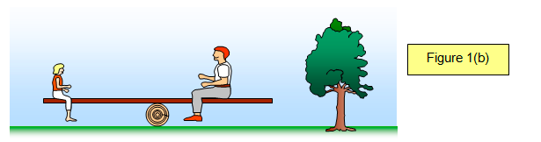
Image 2: Distribution of weight to balance the seesaw (Siobhannixon, 2016)

Feature 2- Building a den
The children could build a den with the sticks and other resources that they can find within the natural environment, such as leaves and moss. They could even add tarpaulin or netting to use as a cover for their den. This activity can help in many ways that link to science and mathematics, such as helping the children with judging height and distance, how big and tall to make the den so that everyone can fit inside. Also, considering how much of each resource they need to complete the den can help them with skills such as counting and estimating. This links directly to the Foundation Phase Framework (Welsh Government, 2015, p. 27) which states that children can develop their skills in mathematics when:

They explore estimate and solve real life problems in both the indoor and outdoor environment. They develop their understanding of measures investigate the properties of shape and develop early ideas of position and movement through practical experiences.
(Welsh Government, 2015, p. 27)

Whilst making a den the children are sorting the sticks, putting similar sizes together so the height on each side of the den is fairly equal so that it is a sturdy structure.
Another advantage of this type of activity is that children can do it with the minimum of intervention from adults, it also helps to encourage their holistic development, and ‘gives them the opportunity to think outside the box and problem-solve to create a structure’ (Early Years Careers, 2021).
Den building can also be an opportunity for young children to start learning about the natural environment, why dens are important, what animals make dens Twinke (No Date). They can also learn about the plants and animals that live in the forest, helping them to connect with nature and learn about the science of things like why leaves change colour and fall off the trees ESF (2020).

Feature 3 – Hanging a prism

- Firstly explain WHAT you are doing, describe the activity
- Then, WHY you are doing it, describe the purpose of the activity
- Finally, HOW it links to the framework/curriculum, find references

Children who participate in the activities outlined above will have the opportunity to challenge themselves outdoors, to learn new skills and to be creative. This links directly to the new curriculum for Wales which highlights four main purposes, accodring to Early Years Wales (2021), and their objective is for all children in Wales to progress and become:
- ‘ambitious, capable learners
- enterprising, creative contributors
- ethical, informed citizens
- healthy, confident individuals’

Section 2 – Risk-benefits assessment
Produce a risk-benefit assessment for the outdoor space provided in your photograph with a specific focus on the science and mathematics opportunities. A template for this section will be provided (approx. 1000 words).
RISK BENEFIT ASSESSMENT

Location / Activity: |  | Date:
Assessor: |  | Review date:

The boxes in the table below will expand as you type into them; pre-entered text is simply for illustration. You should delete irrelevant items and replace with text relevant to your circumstances.
Your overall risk rating – Low, medium or high – is based on your judgement about whether the BENEFITS of the activity or opportunity outweigh the RISKS.

ACTIVITY | How will young people BENEFIT from this activity? | Possible hazards | Who is at risk? | PRECAUTIONS in place to reduce the risk of injury | Overall risk RATING: L/M/H
Feature 1 – Making a seesaw
Feature 2- Building a den
Feature 3 – Hanging a prism

Section 3 – Theoretical links
With reference to theory and research consider how the adults working with children can support and encourage children to have an opportunity to engage with mathematical and scientific concepts in an outdoor space such as the one in your photograph (2000 words).

For example, this section could make links to ideas such as:
- adding loose parts
- affordance
- open ended and child-led play
- sustained shared thinking
- observation
- curiosity and discovery
- approaches such as Reggio Emilia
- theorists such as Bruner, Piaget, Vygotsky, Froebel or other ideas discussed in your lectures
- specific early years science / mathematical research documents

References
Early Years Careers, (2021). Why is den building important for children’s development? Available at: https://www.earlyyearscareers.com/eyc/learning-and-development/den-building-important-childrens-development/ (Accessed 30 September 2021).
Early Years Wales, (2021). Introduction to Curriculum for Wales 2022. Available at: https://www.earlyyears.wales/sites/www.earlyyears.wales/files/taflen_cyflwyniad_cwricwlwm_newydd_terfynol_27.4.21.pdf (Accessed: 22 September 2021).
ESF,(2020). Around your world, Available at: https://www.esf.edu/pubprog/brochure/leaves/leaves.htm#:~:text=Chlorophyll%20Breaks%20Down,part%20of%20their%20fall%20splendor (Accessed 30 September 2021).
HWB (2021) Area of Learning and Experience: Science and Technology. Available at: https://hwb.gov.wales/curriculum-for-wales/science-and-technology/descriptions-of-learning/ (Accessed: 22 September 2021).
Robertson, J. (2017) Messy Maths: A playful outdoor approach for early years. Carmarthen: Crown house publishing.
Siobhannixon (2016) The Physics Behind the Seasaw. Available at: https://siobhannixon.wordpress.com/2016/12/08/the-physics-behind-a-seesaw/(Accessed: 22 September 2021).

Twinkle, (No Date) What is Den Building EYFS? Available at: https://www.twinkl.co.uk/teaching-wiki/den-building-eyfs (Accessed 30 September 2021.

Welsh Government (2013) National Literacy and Numeracy Framework: To support schools in introducing the National Literacy and Numeracy Framework. Available at: https://hwb.gov.wales/api/storage/64812b0e-3d20-4d10-94e8-68221e47a38d/to-support-schools-in-introducing-the-national-literacy-and-numeracy-framework.pdf (Accessed: 22nd September 2021).
Welsh Government (2015) Foundation Phase Framework Available at: https://gov.wales/sites/default/files/publications/2018-02/foundation-phase-framework-revised-2015.pdf (Accessed 30 September 2021).

Images
Image 1
Pinterest (no date) Natural Playground Design. Available at: https://www.pinterest.co.uk/pin/732046114419549425/ (Accessed: 13 September 2021).
Image 2
Siobhannixon (2016) The Physics Behind the Seasaw: Distribution of weight to balance the seesaw. Available at: https://siobhannixon.wordpress.com/2016/12/08/the-physics-behind-a-seesaw/ (Accessed: 22 September 2021).

