FOREIGN LANGUAGES & CULTURAL AWARENESS

Portfolio 4 Components

STUDENT : DANIELA LIVIA ISAR
STUDENT ID : 2242723
MODULE : FOREIGN LANGUAGES & CULTURAL AWARENESS
MODULE CODE : BMIH5003
LECTURER : GIULIA CHIFARI

Table of Contents
COMPONENT 1: PROFESSIONAL REFLECTION (500 WORDS) 2
COMPONENT 2: TRAINING PLAN (500 WORDS) 3
Introduction 3
Training Objectives 3
Training Components 3
Training Implementation 4
Training Evaluation 4
Conclusion 5
COMPONENT 3: STUDENT SELF REFLECTION (500 WORDS) 5
COMPONENT 4 : TRAINING PRESENTATION ……………………………………………….

COMPONENT 1: PROFESSIONAL REFLECTION (500 WORDS)
During the level 4 Placement in a hotel restaurant; I and my colleague were providing dinner services I experienced an incident of cultural misunderstanding with a guest named Charlie; who was a Chinese native. As I move forward to ask him for the order, I noticed that he was quite reserved, and hesitant to engage any conversation with me. I made several attempts to make him comfortable. Despite my multiple efforts to communicate the menu offerings to him clearly; the guest seemed to be puzzled and endeavoring to come to a decision to order from the menu. Eventually, he just named a random item from the menu which I assumed was his choice. However, when the dish was served; Charlie seemed really disappointed and dissatisfied with the selection they made.
Reflecting on this incident, I realized that how language barrier, or cultural misunderstanding is rooted from the different communication styles. One of the prevailing factors, which is contributing to the cultural misunderstanding was the language barrier. I am proficient in English; while the guest had limited proficiency in English language, which made it very challenging for him to understand the menu options properly. According to Do et al., (2021), language barriers may prevent effective communication and lead to misconceptions especially in cross-cultural contexts. In this case, the guest's lack of English proficiency may have limited their ability to convey, their preferences accurately.
This misconception was further complicated by the fact, that different cultures, have different standards of eating etiquette. The Chinese culture places a great significance on the concept of communal dining, as well as the practice of sharing meals among the individuals, who are present at a gathering (Hussain et al., 2018). As a consequence of this, the guest would have anticipated experiencing a greater number of items for community use yet, the individual serving size that is typical in Western restaurants might have come as a surprise to them.
To avoid future cultural misunderstandings; I recognise the need of developing several key abilities. Improving my proficiency in commonly spoken languages among hotel guests such as Mandarin Chinese, would increase my communication skills, and allow me to completely understand client’s preferences (Wu & Cheung, 2002). Cultural sensitivity training in staff development courses, can improve understanding of cultural differences in communication strategies and dining patterns (Christiansen et al., 2020). By learning about different cultural norms and practices, I can tailor my communication methods and service approach to better meet the needs, and expectations of a diverse spectrum of guests. Finally, engaged in attentive listening, and requesting clarification through questions may successfully improve shared comprehension while reducing the possibility of misconceptions caused by assumptions, or misinterpretation (Chen et al., 2019). Cultural misunderstanding between F&B employee and hotel guest may occur due to language barriers; different communication styles and diverse dining traditions.

COMPONENT 2: TRAINING PLAN (500 WORDS)

Introduction
Effective intercultural communication, is critical in today's globalised hotel industry, to provide exceptional service and ensure visitor satisfaction. To support our ongoing efforts to improve; we are launching a comprehensive training initiative aimed at providing all Food and Beverage department employees, with the necessary expertise, and awareness to effectively handle cultural differences, and avoid miscommunications during interactions with guests (Arasaratnam, 2015). This training plan aims to increase language abilities, cultural awareness and communication approaches with the ultimate goal of providing a more inclusive and welcoming atmosphere for visitors, from all cultural backgrounds.

Training Objectives
- To develop proficiency in commonly spoken languages among hotel guests; e.g., English, Chinese, French etc.
- To improve the awareness of cultural differences in communication styles, and dining customs.
- To enhance active listening, and clarification skills to ensure mutual understanding with guests.
- To improve the customer satisfaction by delivering culturally sensitive and personalized services.

Training Components
- Language proficiency training is required for efficient communication with guests from diverse cultural backgrounds. Our training plan will provide professionals with access to language courses or materials prepared expressly for the most often spoken languages among hotel guests. These languages may include Chinese, Spanish, French, or other languages, depending on the hotel's guest demographics. Language learning activities will be included into staff's everyday routines, allowing them to rehearse basic pleasantries, menu items, and common phrases used during visitor encounters (Maheshkar & Sharma, 1 C.E.).
- Cultural sensitivity training is essential for understanding and respecting the customs, beliefs, and behaviours of people from other cultural backgrounds. This plan will look at real-life scenarios and case studies to show how cultural misinterpretations can occur, as well as how to communicate effectively across cultures (Moran & Abramson, 2017).
- Developing communication skills is critical for building good relationships with visitors and fostering clear comprehension. Employees will receive feedback and coaching based on observed interactions. This will help them enhance their communication skills and boost their ability to interact with guests from diverse backgrounds (Holliday, 2021).
- Personalised service training focuses on meeting each visitor's specific needs and preferences, regardless of cultural background. During the training sessions, individuals will learn the importance of tailoring interactions to cultural preferences in terms of food selection, seating arrangements, and service delivery (Deresky, 2016).

Training Implementation
- Consistently schedule training sessions throughout the year to facilitate continuous skill enhancement, and solidify fundamental concepts.
- Integrate training modules into the induction processes for new employees, and provide refresher courses for current personnel.
- Employee performance and development should be monitored through feedback mechanisms, performance evaluations and visitor satisfaction surveys.

Training Evaluation
- Test your employees' knowledge, skills, and views about intercultural conversation before and after training to see how they've changed.
- Solicit feedback from employees on the training program's efficacy and areas for improvement.
- Evaluate the feedback and happiness numbers from guests to see how training has changed how they feel about service quality and cultural sensitivity.

Conclusion
Our goal is to provide an inclusive and inviting atmosphere that increases visitor pleasure and loyalty through the development of language competency, cultural sensitivity training, communication skill upgrading, and personalised service training. Together, we can make sure that every visitor connection is marked by mutual understanding, tolerance, and admiration for cultural variety.

COMPONENT 3: STUDENT SELF REFLECTION (500 WORDS)
Gibbs Reflective Cycle, is chosen as a self-reflective model. Using Gibbs Reflective Cycle, I may critically evaluate my understanding of the value, of cultural sensitivity in the hospitality sector.
At first, my understanding of ethnic diversity in the hotel industry, was relatively restricted. I acknowledged the significance of fundamental communication abilities, and exhibiting politeness towards visitors from other origins; although I did not completely comprehend the intricacies of cultural subtleties, and their influence on interactions with guests. Nevertheless, as I acquired additional expertise through my involvement in diverse positions, within the hotel industry while my comprehension underwent a substantial transformation (Deresky, 2016).
During the early stages of my career, I faced instances where cultural disparities resulted in misinterpretations, or unease among guests. During my tenure as a front desk worker, I saw a client from a collectivist culture who was bewildered by the notion of having separate room keys, for each individual (Potter, 2015). Within their cultural norms; it was customary for family members to exchange keys and have unrestricted entry to one other's rooms. This encounter led me to realise that cultural awareness extends beyond language obstacles, and embraces wider cultural norms and values (Hasan & Rose, 2016).
Over time, I proactively pursued opportunities to enhance my cultural understanding by participation in training programmes; workshops and engaging with colleagues and guests from diverse backgrounds. I have gained an understanding, and admiration for the vast array of cultural differences, present in the hospitality sector and how these differences can greatly improve the overall experience for guests. While working in a hotel restaurant during my employment, I realized the importance of personalizing the service in a way that accounts for the cultural preferences in dining practices. For example, the choice of family-style meals or individual portions (Trompenaars & Hampden-Turner, 2020). Hence, I learned that cultural awareness is certainly a fundamental component of the hospitality sector, and intercultural understanding is the basis of the successful services and the memorable visitor experiences (Jackson, 2019).
Through understanding and appreciating our guests' cultural backgrounds; we are able to better comprehend their needs and preferences; thus, they will feel more included and belong to our community. In addition, I became more knowledgeable of cultural sensitivity as I confronted obstacles and successfully manage cultural conflict by direct experience (Klyukanov, 2020). For example, once, a visitor who comes from a culture that relies on implicit communication, complained about the hotel's communication manner as it was considered to be only full of directness and lacks personal touch. My internship has opened up my mind to the fact that communication strategy is dependent on the cultural tastes of the consumers. The strategy is to use more circumlocution and be more intentional about rapport building (Hofstede et al., 2010).
Through informing myself and want to have the deep understanding about cultural sensitivity in hospitality industry, I have been learning and thinking repeatedly. The process of interacting with people, practicing, and working with different stakeholders has helped me recognize that cultural understanding is a critical element of giving the best service possible and thus, making clients happy (Singal, 2015). For the future, I will continue to learn and apply cultural competence to my profession and the cultural sensitivity to all my work areas.

COMPONENT 4 : TRAINING PRESENTATION


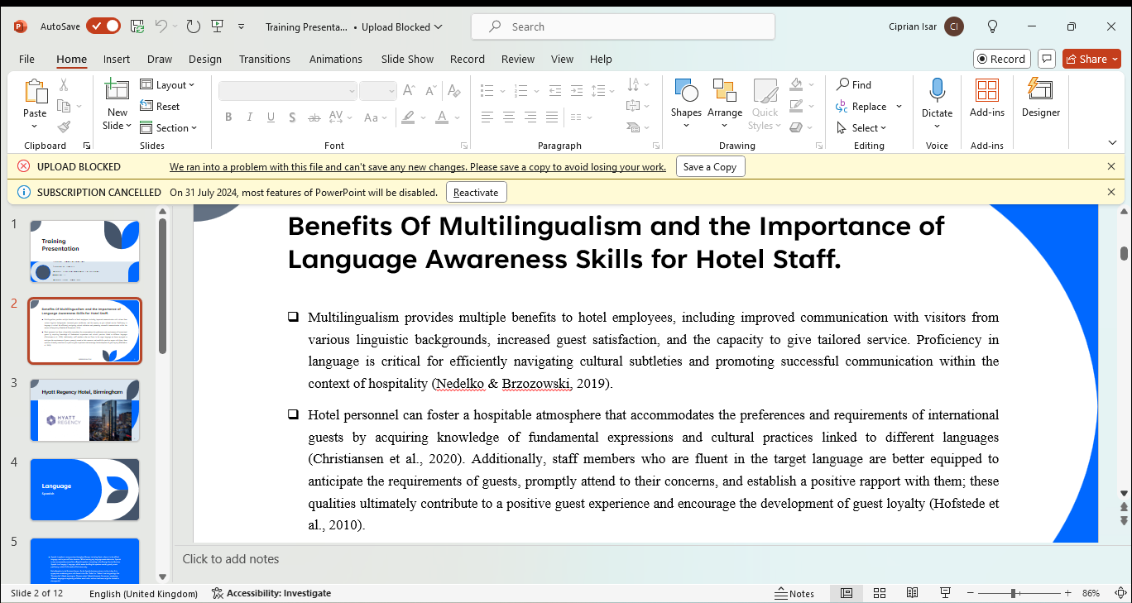















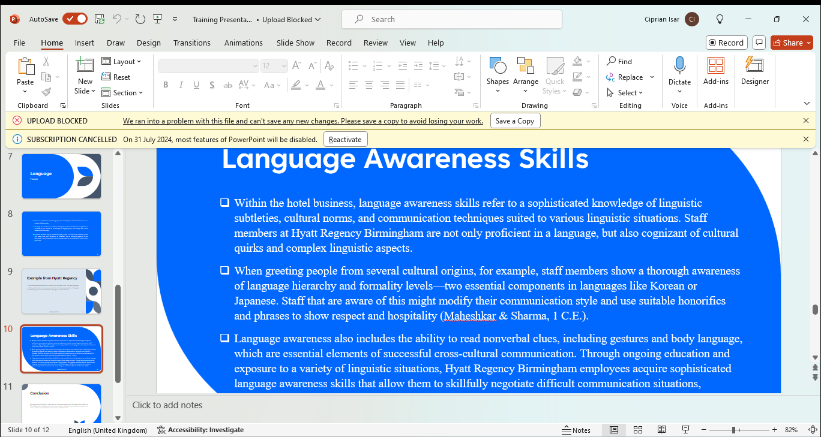





References
Arasaratnam, L. A. (2015). Research in Intercultural Communication: Reviewing the Past Decade. Journal of International and Intercultural Communication, 8(4), 290–310. https://doi.org/10.1080/17513057.2015.1087096
Chen, M., Zee, M., Koomen, H. M. Y., & Roorda, D. L. (2019). Understanding cross-cultural differences in affective teacher-student relationships: A comparison between Dutch and Chinese primary school teachers and students. Journal of School Psychology, 76, 89–106. https://doi.org/10.1016/j.jsp.2019.07.011
Christiansen, B., Branch, J. D., & Karmowska, J. (2020). Cultural Factors and Performance in 21st Century Businesses. IGI Global.
Deresky, H. (2016). International Management: Managing Across Borders and Cultures, Text and Cases (9th edition). Pearson.
Do, J., Fitz-Patrick, E., & Potroz, M. (2021). The Influence of Culture on Customer Satisfaction and Service Quality in the Hotel Industry. https://doi.org/10.13140/RG.2.2.31872.30723
Hasan, R., & Rose, F. (2016). Blasphemy, Multiculturalism and Free Speech in Modern Britain. In P. Cliteur & T. Herrenberg (Eds.), The Fall and Rise of Blasphemy Law (pp. 209–234). Leiden University Press. https://www.jstor.org/stable/jj.1011750.13
Holliday, A. (2021). Intercultural Communication: An advanced resource book for students (4th ed.). Routledge. https://doi.org/10.4324/9780367482480
Hussain, K., Jing, F., & Parveen, K. (2018). How do foreigners perceive? Exploring foreign diners’ satisfaction with service quality of Chinese restaurants. Asia Pacific Journal of Tourism Research, 23(6), 613–625. https://doi.org/10.1080/10941665.2018.1476391
Jackson, J. (2019). Introducing Language and Intercultural Communication (2nd ed.). Routledge. https://doi.org/10.4324/9781351059275
Klyukanov, I. E. (2020). Principles of Intercultural Communication (2nd ed.). Routledge. https://doi.org/10.4324/9780429353475
Maheshkar, C., & Sharma, V. (1 C.E.). Handbook of Research on Cross-Cultural Business Education. In Https://services.igi-global.com/resolvedoi/resolve.aspx?doi=10.4018/978-1-5225-3776-2. IGI Global. https://www.igi-global.com/book/handbook-research-cross-cultural-business/www.igi-global.com/book/handbook-research-cross-cultural-business/181512
Moran, R. T., & Abramson, N. R. (2017). Managing Cultural Differences: Global Leadership for the 21st Century (10th ed.). Routledge. https://doi.org/10.4324/9781315403984
Potter, C. (2015). Leadership development: An applied comparison of Gibbs’ Reflective Cycle and Scharmer’s Theory U. Industrial and Commercial Training, 47(6), 336–342. https://doi.org/10.1108/ICT-03-2015-0024
Singal, M. (2015). How is the hospitality and tourism industry different? An empirical test of some structural characteristics. International Journal of Hospitality Management, 47, 116–119. https://doi.org/10.1016/j.ijhm.2015.03.006
Wu, D. Y. H., & Cheung, S. C. H. (2002). Introduction: The Globalization of Chinese Food and Cuisine: Markers and Breakers of Cultural Barriers. In The Globalisation of Chinese Food. Routledge.

