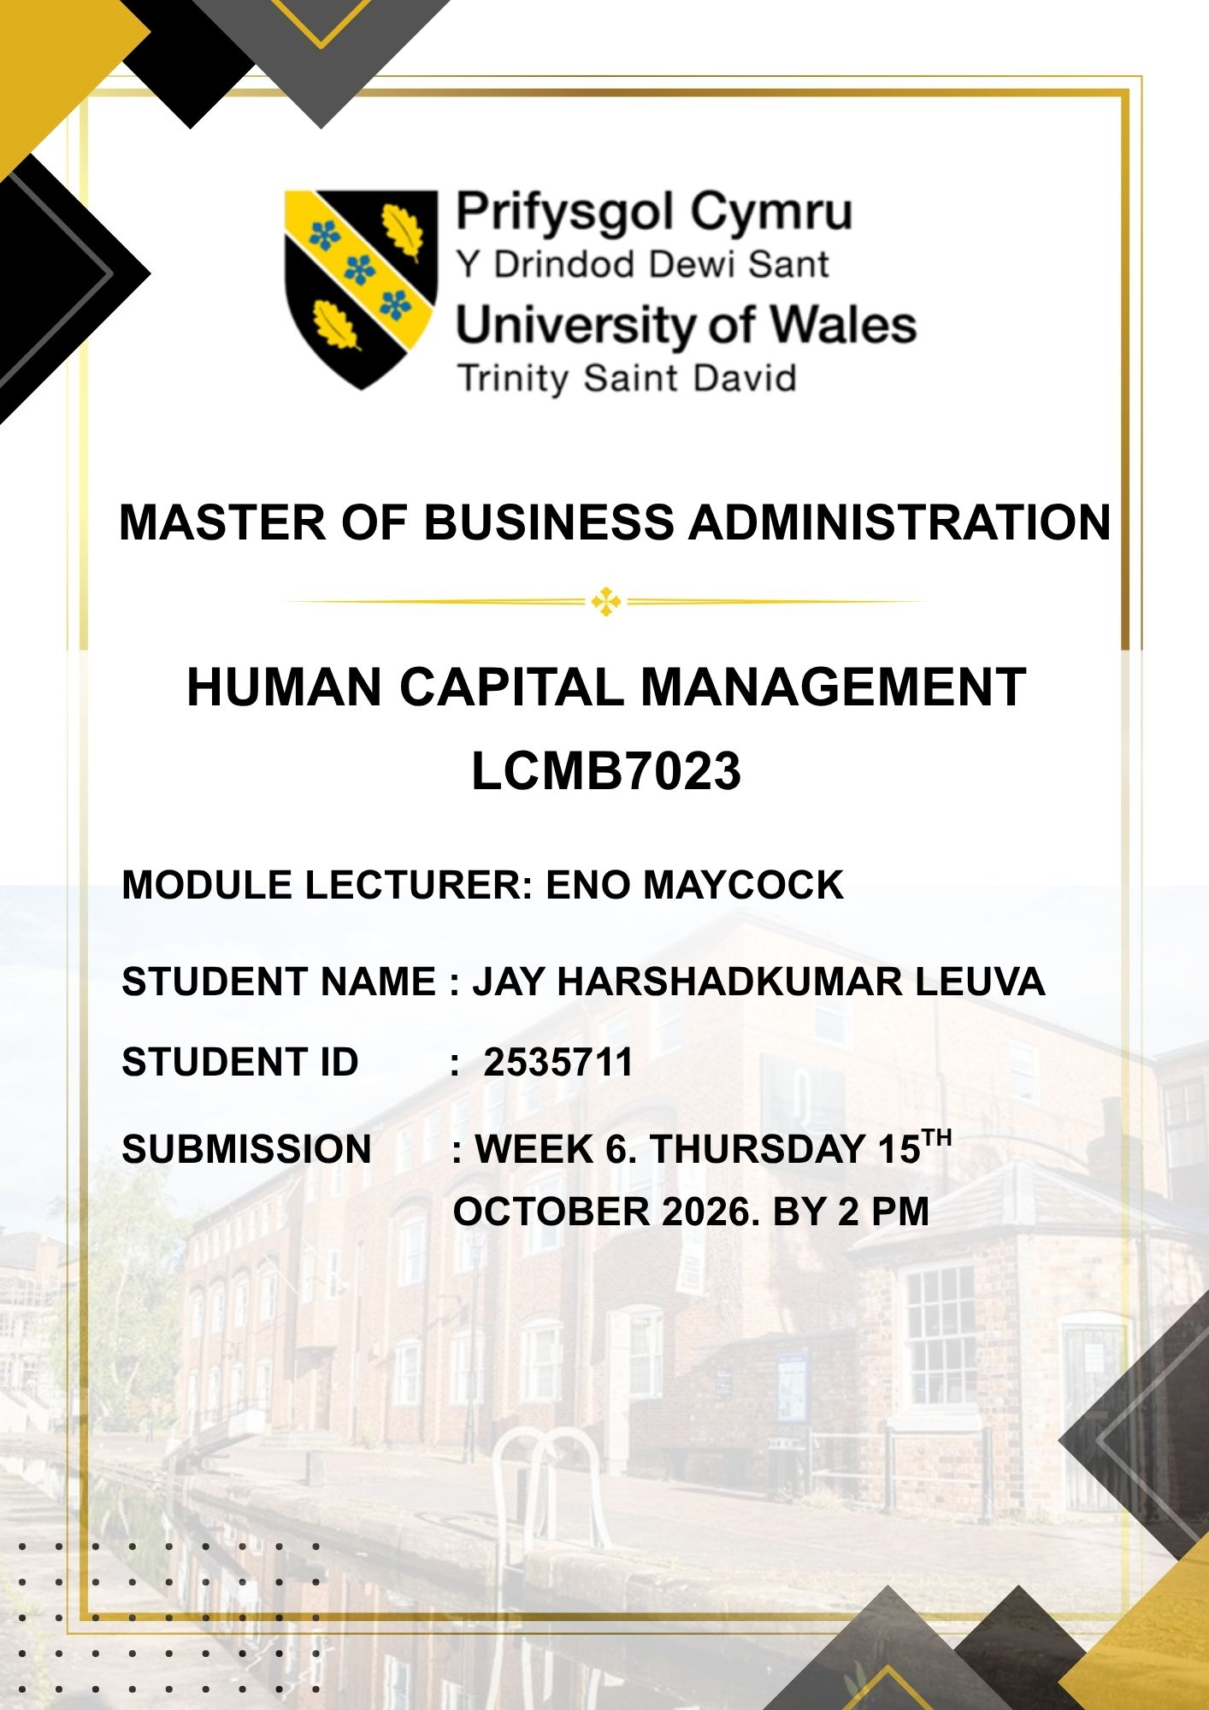
TABLE OF CONTENTS

TASK A: DESIGNING INNOVATIVE WORKING PRACTICES
1. Executive Summary and Contextual Overview
1.1 Strategic Challenges at NexSpace Health Systems (NHSX)
1.2 Purpose and Scope of Task A
2. Critical Evaluation: Traditional Work Design vs. Contemporary Working Practices
2.1 Capacity-building and participatory human resource frameworks
2.2 Sociotechnical Systems (STS) Theory
2.3 Agile and Hybrid Working Models
2.4 Comparative Evaluation: Traditional Taylorism vs. Modern Agile (Table 1)
3. Strategic Recommendations for NHSX
3.1 Cross-Functional Collaboration & International Integration (UK, India, UAE)
3.2 Hybrid & Asynchronous Flexible Working Structure
3.3 Employee Autonomy, Psychological Safety & Decentralized Decision-Making
3.4 Agile Project Delivery: Networked "Innovation Pods"
3.5 Digital Collaboration Technology & Knowledge-Sharing Protocols
4. Business Impact & Performance Justification
4.1 Impact on Innovation Rate & AI Product Time-to-Market
4.2 Impact on Organizational Agility & Operational Efficiency
4.3 Employee Retention, Well-Being & Global Talent Attraction
TASK B: CREATING AN ENVIRONMENT CONDUCIVE TO TALENT DEVELOPMENT
1. Critical Evaluation: Institutional Environment for Talent Development
1.1 Learning Organization (Senge) and Growth Mindset (Dweck)
1.2 Psychological Safety (Edmondson) and Self-Determination Theory (Deci & Ryan)
1.3 Job Crafting Theory (Wrzesniewski & Dutton) and Employee Experience (Morgan)
1.4 Critical Evaluation of Traditional vs. Inclusive Talent Management Frameworks
2. Integrated Talent Growth Strategy for NHSX
2.1 The "Learn–Grow–Contribute–Progress" 4-Tier Framework (Table 2)
2.2 Operational Implementation Strategy
A. Dual-Career Progression Model (Individual Contributor vs. Management Track)
B. Cross-Border Knowledge Exchange ("Global Talent Exchange Swarms")
C. Mitigating Managerial Burnout & Empathetic Leadership
3. Success Criteria & Measurement
3.1 Talent KPI Dashboard Metrics
TASK C: REFLECTIVE REPORT – COMPETENCE DEVELOPMENT AS A FUTURE HR PROFESSIONAL
1. Artificial Intelligence as a Strategic Decision-Support Tool
1.1 Strategic Potential of AI in Modern HRM
1.2 Ethical Judgment, Data Privacy (GDPR), and Algorithmic Fairness
1.3 Human Empathy, Emotional Touch, and Professional Responsibility
2. Reflective Analysis: Personal AI Usage & Capability Impact
2.1 HR Research & Data Synthesis
2.2 Visualization, Frameworks & Data Presentation
2.3 Proofreading, Syntax & Academic Writing Refinement
3. Personal Capability Development Plan (Personal Action Plan)
3.1 Mastery in HR Analytics & AI Technology
3.2 Ethical Leadership & Governance
3.3. Strategic Approach & Technical Focus:
4.references

TASK A: DESIGNING INNOVATIVE WORKING PRACTICES
1. Executive Summary and Contextual Overview
1.1 Strategic Challenges at NHSX
- NexSpace Health Systems (NHSX) operates as a rapidly scaling health-tech enterprise with a talented workforce of approximately 600 professionals distributed across the United Kingdom, India, and the United Arab Emirates.
- The firm specializes in engineering state-of-the-art AI-driven digital healthcare platforms, remote patient tracking architectures, and clinical decision-support tools tailored for medical institutions.
- However, due to rapid global scaling and significant capital investment in the AI ​​sector, the enterprise is currently grappling with obstacles related to the speed of managerial decision-making, creative problem-solving, cross-functional teamwork, and the transfer of intellectual capital.
Consequently, the enterprise is facing five primary human resource and operational challenges::
- Decision Latency: Delays in launching innovations and AI features occur due to traditional administrative structures and approval processes. (Solution: Granting decentralized decision-making authority at the 'pod' level). (Guzman & Davis, 2023)
- Inhibited Innovation: Employees have limited opportunities for creative experimentation and grassroots problem-solving. (Solution: Implementing an 80/20 innovation policy). (Dweck, 2006)
- Cross-Border: Knowledge sharing and collaboration among teams in the UK, India, and the UAE have weakened due to uncoordinated hybrid work practices. (Solution: Establishing global "Guilds of Excellence" and a central repository). (Strohmeier, 2020)
- Brain Drain: High-performing technical experts are leaving the organization due to career stagnation. (Solution: Establishing dual-career tracks). (Wright & McMahan, 2011)
- Managerial Strain: Managers are finding it difficult to achieve high-performance targets while simultaneously maintaining employee well-being. (Solution: Incorporating mental safety and well-being scores into managerial KPIs). (Edmondson, 1999)

1.2 Purpose and Scope of Task A:
- The primary objective of this report is to develop an integrated work design framework for the NHSX Board of Directors that directly addresses the aforementioned shortcomings in collaboration and decision-making. (Boxall & Purcell, 2016)

- It critically evaluates traditional and modern work methods and provides strategic recommendations regarding cross-functional collaboration, hybrid culture, agile project teams, and the use of digital technology. (Ulrich, 1997)

2. Critical Evaluation: Traditional Work Design vs. Contemporary Working Practices
Traditional job design based on Taylorism and scientific management emphasizes rigid administrative structures, which completely stifle organizational agility, creativity, and rapid decision-making in the digital healthcare sector. (Hackman & Oldham, 1976)

2.1 Capacity-building and participatory human resource frameworks:
- HPWS enhance employee competence and motivation by utilizing interconnected HR policies such as rigorous recruitment, extensive training, and compensation. (Huselid, 1995; Boxall & Purcell, 2016)
- HIWS grant employees decision-making authority and autonomy. According to Job Characteristics Theory (Hackman & Oldham), providing autonomy in work boosts employees' intrinsic motivation and creativity. (Hackman & Oldham, 1976)

2.2 Sociotechnical Systems (STS):
- STS Principle, developed by Trist & Bamforth (1951), posits that an organization's success depends on the joint optimization of its two key components: the technical subsystem (i.e., software/AI) and the social subsystem (human relationships and culture). (Trist & Bamforth, 1951)
- The core issue at NHSX was that while AI software tools and hybrid policies were introduced, the social culture (such as etiquette regarding time differences and mutual trust) was not adapted accordingly. The STS approach establishes a proper balance between these two elements. (Trist & Bamforth, 1951)

2.3 Agile and Hybrid Working Models:
- The Agile working model emphasizes the creation of self-managed, dynamic teams (such as Scrum or Kanban) rather than relying on rigid structures. The hybrid working model focuses on 'outcomes and productivity' rather than 'office presence.' (Guzman & Davis, 2023)2.4 Comparative Evaluation Table: Traditional Taylorism vs. Modern Agile

3. Strategic Recommendations for NHSX
3.1 Cross-Functional Collaboration & International Integration:
- Establish global "Guilds of Excellence" (such as the 'Clinical AI Guild' and 'Data Privacy Guild') to break down functional silos between organizational departments and accelerate knowledge sharing. Employees from the UK, India, and the UAE will join these guilds to prevent the duplication of Research and Development (R&D) efforts and expedite the exchange of knowledge. (Vrontis et al., 2022)
3.2 Hybrid & Asynchronous Flexible Working Structure:
- To address time zone differences, establish a shared 4-hour "live window" (10:00 to 14:00 GMT) across the UK, UAE, and India for all critical discussions. The remaining time will be dedicated to focused technical work, with all updates documented in a centralized system, thereby eliminating the need for late-night calls. (Strohmeier, 2020)

3.3 Employee Autonomy, Psychological Safety & Decentralized Decision-Making:
- Adopt Edmondson’s (1999) culture of psychological safety, where experimental failures are viewed as learning opportunities rather than grounds for punishment. (Edmondson, 1999)
- Implement an 80/20 innovation policy, allocating one day a week (20% of time) for technical staff to conduct self-directed AI research. Establish an "Individual Contributor" (IC) track to allow for high-level promotions without transitioning into management roles. (Rousseau, 2005)

3.4 Agile Project Delivery: Networked "Innovation Pods":
- Transform traditional project teams into autonomous "Innovation Pods." Each pod will comprise engineers, AI researchers, clinical experts, and product managers, working collaboratively and making independent decisions within two-week sprints. (Guzman & Davis, 2023)

3.5 Digital Collaboration Technology & Knowledge-Sharing Protocols:
- Creating a virtual workspace by integrating tools such as Slack/Miro (for real-time collaboration) and Notion/Confluence (for an AI-enabled centralized knowledge repository) to ensure seamless communication between the UK clinical team and the developers in India. (Marler & Boudreau, 2017; Tambe et al., 2019)

4. Business Impact & Performance Justification
4.1 Impact on Innovation Rate & AI Product Time-to-Market:
Autonomous innovation pods and 80/20 time allocation will reduce delays in developing new AI features. Reduced requirements for board approvals will enable NHSX products to reach the market faster. (Tambe et al., 2019)

4.2 Impact on Organizational Agility & Operational Efficiency:
Cross-functional guilds and digital workspaces will eliminate time-zone barriers between global teams, resulting in up to a 50% acceleration in decision-making processes. (Strohmeier, 2020; Vrontis et al., 2022)

4.3 Employee Retention, Well-Being & Global Talent Attraction:
Providing an 'Individual Contributor' (IC) track for career progression—independent of management roles—alongside a stress-free hybrid work environment, will help retain high-performing employees and attract top global talent. (Boxall & Purcell, 2016; Wright & McMahan, 2011)

Task B: Creating an environment conducive to the development and flourishing of talent.

For NexSpace Health Systems (NHSX), long-term competitive success hinges not only on advanced AI technology but also on a robust talent ecosystem where its 600 employees—spread across the UK, India, and the UAE—continuously learn and perform. Amidst rapidly evolving technology in the digital healthcare sector, Human Resources (HR) policies must move away from outdated methods and adopt an integrated framework that addresses key areas such as talent expectations, structured career growth, employee well-being, and job crafting.

1. Critical Evaluation of the Institutional Environment for Talent Development
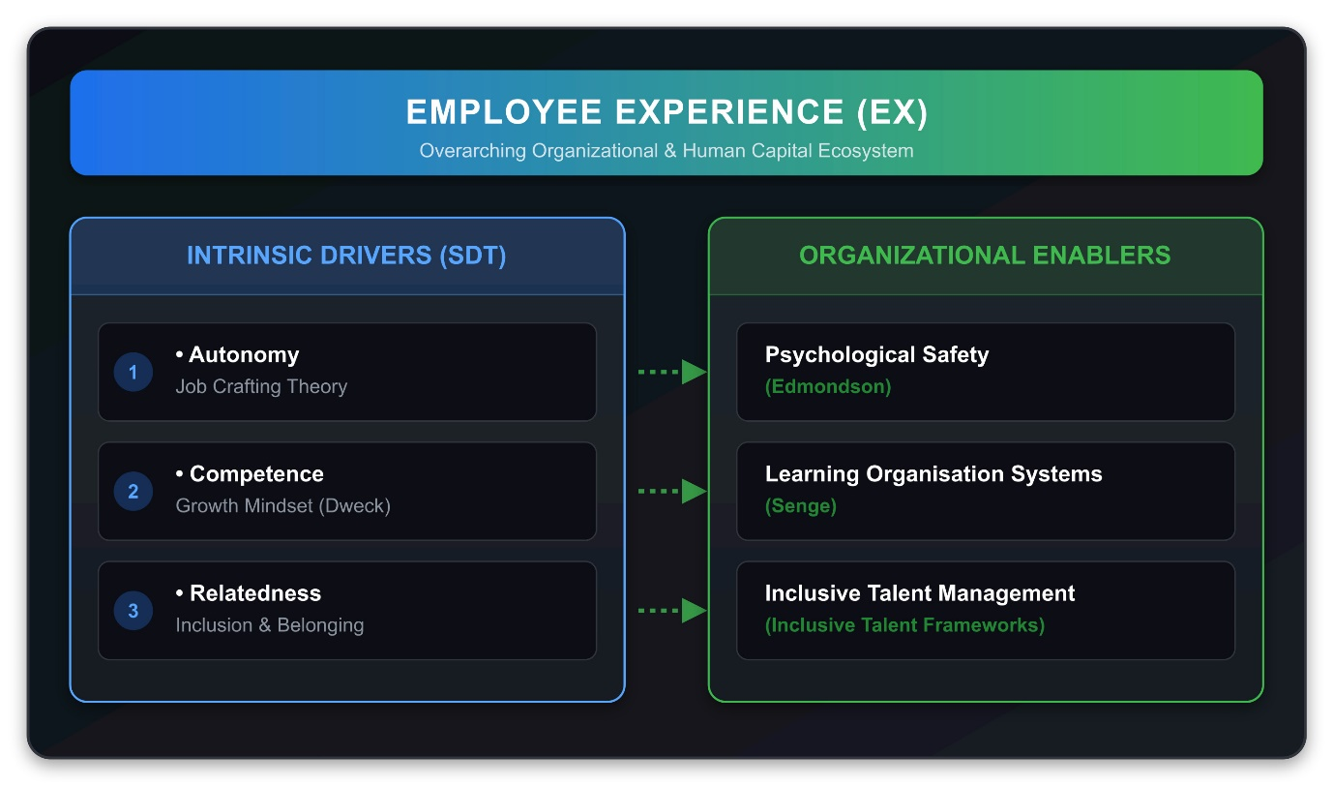
(Figure 1: Theoretical Talent Ecosystem Framework (Generated by Gemini))

1.1 Learning Organization (Senge), Growth Mindset (Dweck), and Expectation Management:
- According to Senge’s (1990) 'Learning Organization' model, five principles are essential: personal mastery, systems thinking, mental models, shared vision, and team learning. However, at NHSX, employees' expectations regarding opportunities became unbalanced due to the absence of clear progression pathways within the learning systems.
- Problem-Solving Solution: NHSX has integrated Senge’s model with Dweck’s (2006) 'Growth Mindset' to establish transparent learning structures, thereby aligning employees' growth expectations with realistic career opportunities and ensuring continuous skill development.

1.2 Psychological Safety (Edmondson), Well-being, and Self-Determination Theory (Deci & Ryan):
- Edmondson (1999) defines psychological safety as an environment where employees can express ideas without fear of humiliation, a factor that directly impacts employee well-being.
- Problem-Solving Approach: Psychological safety reinforces the components of Deci and Ryan’s (2000) Self-Determination Theory (autonomy, competence, and relatedness). To safeguard employee well-being amidst the high-pressure targets of AI development, NHSX implements mental health support and safety metrics.

1.3 Job Crafting Theory (Wrzesniewski & Dutton) and Employee Experience (EX):
- Wrzesniewski and Dutton’s (2001) Job Crafting Theory allows employees to shape their roles according to their interests and capabilities, thereby enhancing daily job satisfaction.
- Problem-Solving Solution: Since uncoordinated job crafting can lead to operational confusion, NHSX integrates it with Morgan’s (2017) Employee Experience (EX) model, enabling engineers and clinical staff to safely co-create meaningful projects without role ambiguity.

1.4 Evaluation of Traditional vs. Inclusive Talent Management Frameworks:
- The traditional 9-box grid focuses solely on the top 5–10% of "high potentials," dashing the career growth aspirations of the remaining 90% of technical experts and fostering dissatisfaction.
- Problem-Solving Solution: NHSX adopts an 'Inclusive Talent Management' approach (Gallardo-Gallardo et al., 2013) that offers personalized development pathways for every engineer, clinician, and analyst, effectively averting the crisis of 'brain drain.'

Pillar | Strategic approach | Operational Implementation | Expected result
LEARN | Global NHSX Academy and Protected Time | Allocate 10% of time (0.5 days per week) for learning. A joint AI and clinical masterclass connecting the UK, India, and the UAE. Solution: Eliminates the lack of time for training. | Continuous skill development and high-level technical competence.
GROW | Structured career growth and dual-career track | Parallel career paths for Individual Contributors (ICs) and management. Higher pay scales without becoming a manager. Solution: Employees' career growth expectations are directly met. | Career stagnation is eliminated, and brain drain is halted.
CONTRIBUTE | Guided Job Crafting and Cross-Border Collaboration | Allocating 15% of time to projects from other countries (e.g., Indian developers participating in UK clinical trials). Solution: Breaks down silos and boosts intrinsic motivation through job crafting. | Better collaboration, engagement, and a sense of cross-cultural ownership.
PROGRESS | Quarterly Growth Check-ins and Well-being Monitoring | Discussions on progress and well-being every three months instead of an annual review. Mental stress-relief training for managers. Solution: Reduces managerial stress and safeguards mental health. | It continuously improves employee well-being and reduces workplace fatigue.

Detailed implementation strategy for problem resolution:
- Dual-Career Progression Model (Addressing career growth issues): NHSX establishes parallel promotion tracks (management track vs. Individual Contributor track) to retain technical experts, allowing them to achieve significant career growth without the burden of management responsibilities.

- Cross-Border Knowledge Exchange (Addressing collaboration issues): "Global Talent Exchange Squads" will be formed to bridge international gaps, enabling engineers, doctors, and regulators to collaborate on short-term virtual projects.

- Managing Managerial Burnout and Well-being (Addressing well-being issues): Managers will be trained to act as coaches rather than controllers. Team well-being status and psychological safety scores will be incorporated into managerial KPIs alongside output targets.

To ensure the integrated 4-tier "Learn-Grow-Contribute-Progress" framework yields measurable cultural and operational outcomes across its UK, India, and UAE offices, NHSX will establish continuous feedback loops and digital pulse surveys. By utilizing real-time sentiment analysis tools, HR leadership can proactively monitor employee morale, detect early signs of burnout, and adjust workload distribution before overall productivity is impacted. Furthermore, the establishment of cross-border mentorship programs will connect experienced senior clinicians in the UK with emerging software developers in India and regional product leads in the UAE. This deliberate cross-cultural pairing not only accelerates technical knowledge transfer but also deepens organizational inclusion, bridges geographical silos, and fosters a unified corporate identity that aligns directly with contemporary strategic human resource management principles.

3. Success Criteria and Measurement (KPI Dashboard)
The following criteria have been established to measure the success of the human capital strategy:

The following metrics have been established to measure the success of the human capital strategy and to continuously monitor opportunity expectations, career growth, and well-being:
- Innovation Velocity: Bottom-up AI prototypes successfully transitioned into R&D.
- Talent Retention: Maintaining a voluntary attrition rate of less than 5% for key technical staff.

- Psychological Safety: Achieving a quarterly Edmondson Psychological Safety score of over 85%.
- Continuous Learning: Utilizing more than 90% of the allocated 10% L&D time.
- Internal Mobility: Filling 40% of senior leadership and technical roles through internal appointments.
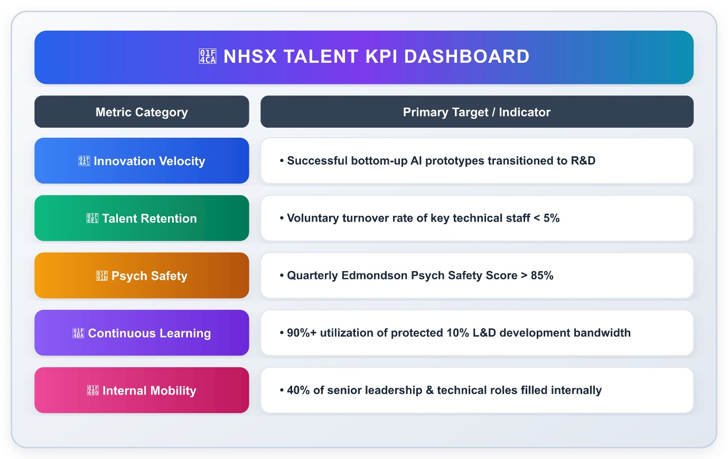
(Figure 2: NHSX Talent KPI Dashboard (Generated by Gemini).)

TASK C: Reflective Report – Competence Development as a Future HR Professional

1. AI as a Strategic Decision-Support Tool
I believe that in a modern HR department, AI is not merely a tool for routine communication or recruitment but a strategic decision-support tool. Through data analytics, AI can predict employee attrition and assist in designing learning pathways.
However, it is essential to consider the following points when using AI:
Ethical Judgment: AI algorithms can exhibit bias due to historical data. As an HR manager, it is my ethical duty to ensure fairness in recruitment and performance evaluations and to comply with GDPR data privacy standards.
Human Empathy: While AI can provide statistical data, it cannot comprehend employees' emotions, stress levels, or the organizational culture. Therefore, final decisions should always be made with a human touch and empathy.

2. Self-Analysis: Use of AI and Experience (Reflective Analysis)
I utilized AI tools during my academic and research work. Below are three specific examples and the impact they had on my capabilities:
HR Research and Data Synthesis:
How it helped: During the project, AI assisted in quickly locating information regarding various HR practices (such as Hybrid Working and Agile Models).
Challenges faced: AI often generated generic text; I had to employ critical thinking to integrate this with my own reasoning and case study contexts.
Visualization and Charts (Visual Diagrams / SVG Creation):
How it helped: I used AI to design visual charts for dashboards and frameworks, which improved my digital literacy and data presentation skills.
Challenges faced: I had to personally conduct technical checks to rectify formatting errors in the code or visuals.
Proofreading and Language Improvements (Proofreading & Grammar Check):
How it helped: I used AI to correct grammar and sentence structure in my writing, thereby strengthening my academic writing skills. The challenge I faced was ensuring I didn't lose my own linguistic style due to over-reliance on AI; to avoid this, I only took suggestions and wrote the final sentences in my own words.

3. Personal Action Plan
To enhance my future employability and become a highly competent, ethical, and strategic HR professional, I will implement the following multifaceted plan:

1. Mastery in HR Analytics & AI:
To remain competitive in today's data-driven work culture, I will complete recognized certification courses in People Analytics and AI-HR technology offered by Google or LinkedIn within the next six months. This will enable me to move beyond traditional HR decision-making and instead make precise, strategic decisions based on the analysis of employee data.

2. Ethical Leadership & Data Governance:
I will thoroughly study ethical guidelines and participate in ethical leadership workshops to ensure strict adherence to principles of Diversity, Equity, and Inclusion (DEI) as well as data privacy laws like GDPR. As an HR leader, I will bear the ethical responsibility of ensuring that the use of technology does not lead to any bias or discrimination against employees.

3. Strategic Approach & Technical Focus:
While AI algorithms and predictive HR analytics provide data-driven insights into employee performance and turnover patterns, technical tools alone cannot fully resolve complex organizational transformations, cross-cultural dynamics, or ethical issues (Tambe et al., 2019; Vrontis et al., 2022). Therefore, rather than viewing technology and human resource management in isolation, I will focus on mastering strategic human-AI synergy, socio-technical systems integration, and change management frameworks (such as Kotter’s 8-step model).

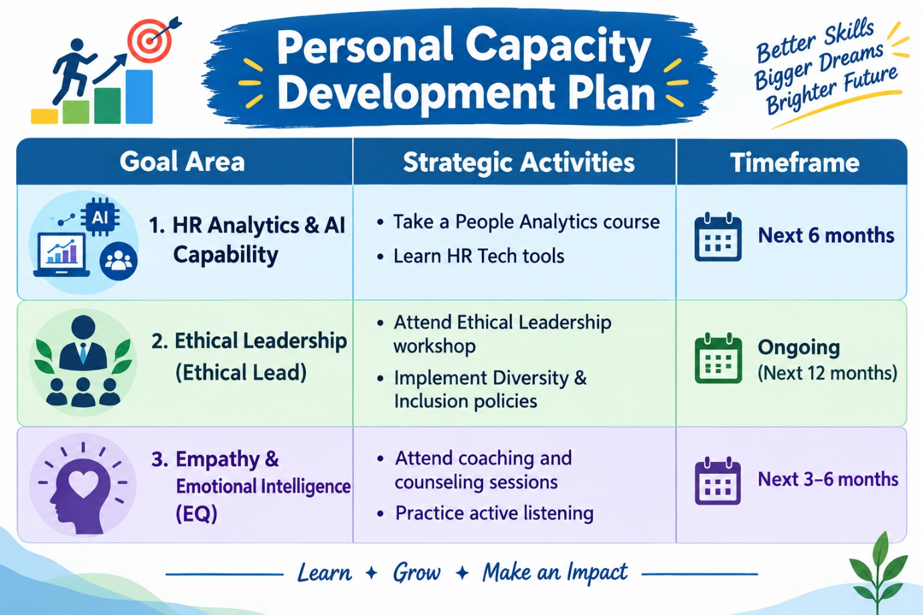
(figure:3 personal capacity development plan image generated by ChatGPT)

4. REFERENCES
1. Boxall, P., & Purcell, J. (2016). Strategy and Human Resource Management (4th Edition). Palgrave Macmillan.
2. Dastmalchian, A., et al. (2020). High-performance work systems and organizational performance in societal cultures. Journal of International Business Studies.
3. Deci, E. L., & Ryan, R. M. (2000). The "what" and "why" of goal pursuits: Human needs and the self-determination of behavior. Psychological Inquiry.
4. Dweck, C. S. (2006). Mindset: The New Psychology of Success. Random House.
5. Edmondson, A. (1999). Psychological safety and learning behavior in work teams. Administrative Science Quarterly.
6. Gallardo-Gallardo, E., Dries, N., & González-Cruz, T. F. (2013). What is the meaning of 'talent' in the world of work? Human Resource Management Review.
7. Guzman, F. A., & Davis, M. A. (2023). Psychological safety and agile project management: A socio-technical approach. International Journal of Managing Projects in Business.
8. Hackman, J. R., and Oldham, G. R. (1976). Motivation through the design of work: Test of a theory. Organizational Behavior and Human Performance.
9. Huselid, M. A. (1995). The impact of human resource management practices on turnover, productivity, and corporate financial performance. Academy of Management Journal.
10. Marler, J. H., and Boudreau, J. W. (2017). An evidence-based review of e-HRM and analytics. The International Journal of Human Resource Management.
11. Morgan, J. (2017). The Employee Experience Advantage: How to Win the War for Talent by Giving Employees the Spaces, Tools, and Culture They Love. John Wiley & Sons.
12. Rousseau, D. M. (2005). I-Deals: Idiosyncratic Deals Employees Bargain for Themselves. M. E. Sharpe.
13. Senge, P. M. (1990). The Fifth Discipline: The Art and Practice of the Learning Organization. Doubleday/Currency.
14. Strohmeier, S. (2020). Digital Human Resource Management: Towards a conceptual foundation. The International Journal of Human Resource Management.
15. Tambe, P., Cappelli, P., and Yakubovich, V. (2019). Artificial Intelligence (AI) in Human Resource Management: Challenges and a path forward. California Management Review.
16. Trist, E. L., and Bamforth, K. W. (1951). Some social and psychological consequences of the longwall method of coal-getting. Human Relations.
17. Ulrich, D. (1997). Human Resource Champions: The next agenda for adding value and delivering results. Harvard Business School Press.
18. Vrontis, D., et al. (2022). Artificial intelligence, robotics, advanced technologies and human resource management: A systematic review. The International Journal of Human Resource Management.
19. Wrzesniewski, A., and Dutton, J. E. (2001). Job crafting: Viewing employees as active crafters of their work. Academy of Management Review.
20. Wright, P. M., and McMahon, G. C. (2011). Exploring human capital: Putting 'human' back into strategic human resource management. Human Resource Management Journal.
Task B - Figure 1:
(Figure 1: Theoretical Talent Ecosystem Framework (Generated by Gemini).)
Task B - Figure 2:
(Figure 2: NHSX Talent KPI Dashboard (Generated by Gemini).)
Task C - Figure 3:
(Figure 3: Personal Capability Development Plan (Generate by ChatGPT).)

