数字和日期
rhifau a dyddiadau
numbers and dates

Vocabulary
中文 | Pinyin | Welsh | English
一月 | yīyuè | Mis Ionawr | January
二月 | èryuè | Mis Chwefror | February
三月 | sānyuè | Mis Mawrth | March
四月 | sìyuè | Mis Ebrill | April
五月 | wǔyuè | Mis Mai | May
六月 | liùyuè | Mis Mehefin | June
七月 | qīyuè | Mis Gorffennaf | July
八月 | bāyuè | Mis Aust | August
九月 | jiǔyuè | Mis Medi | September
十月 | shíyuè | Mis Hydref | October
十一月 | shíyīyuè | Mis Tachwedd | November
十二月 | shíèryuè | Mis Rhagfyr | December

* colour code for tones: first tone (blue), second tone (yellow), third tone (green), fourth tone (red)

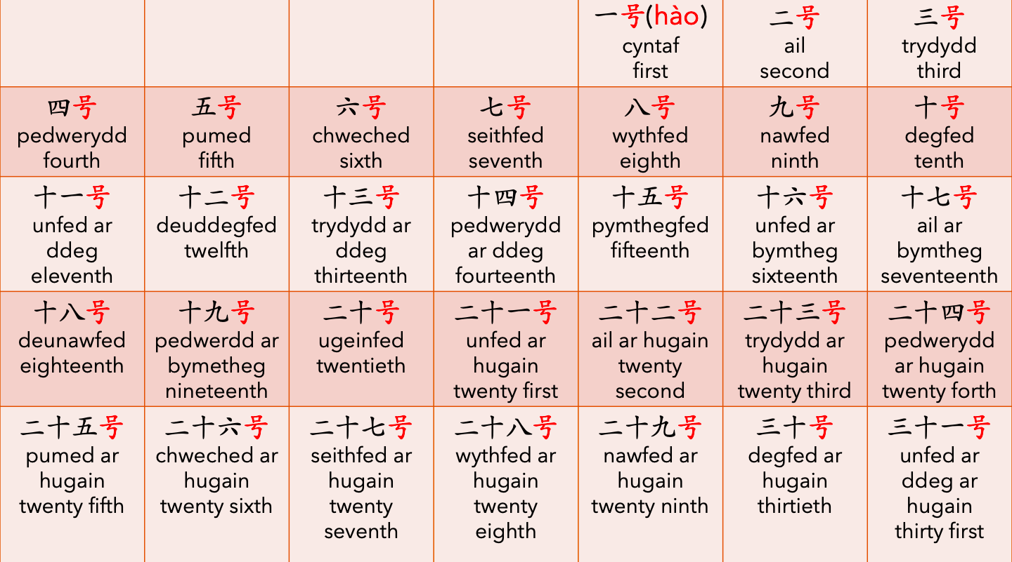
sentence builder 1

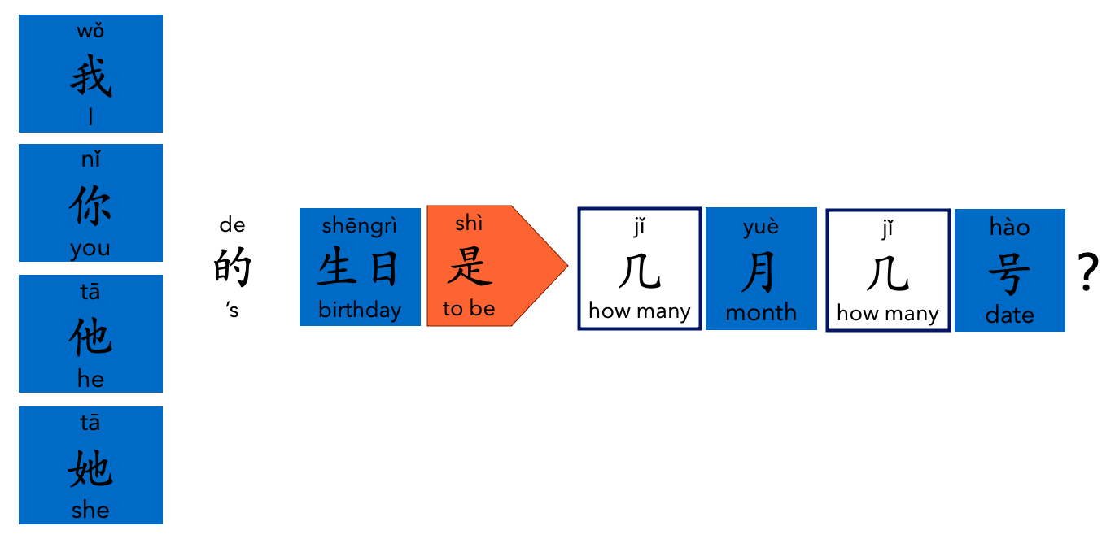

sentence builder 2


