

University of Wales Trinity Saint David
School of Engineering

Project First Report
Catriona Burn 2203239
James Saccone 2200780
Matthew Starke 2200996
Jake Davies 2205290
Dan Reynolds 2205457

Motorsport/Motorcycle Engineering
January 2023
Integrating Project
ACHA4008

Contents
- Introduction
- Gantt chart (Figure 1)
- Aims
- Methods (Figures 2, 3, 4 and 5)
- Research
  - Bodywork
  - Chassis (Figure 6)
  - Steering
  - Brakes
- Conclusion
- References

- Introduction

Once handed our assignment brief, we arranged a group meeting. In this meeting we did some basic research (Soapbox Car: A Motorless Race Car For Children, 2020), assigned each section and talked about our ideas, while also studying the regulations to find our limits. After this, we went away to do research on our own sections and during this time kept each other updated using our Microsoft team's chat. We then came together a few weeks later to put our ideas together and make further progress.

- Gantt chart
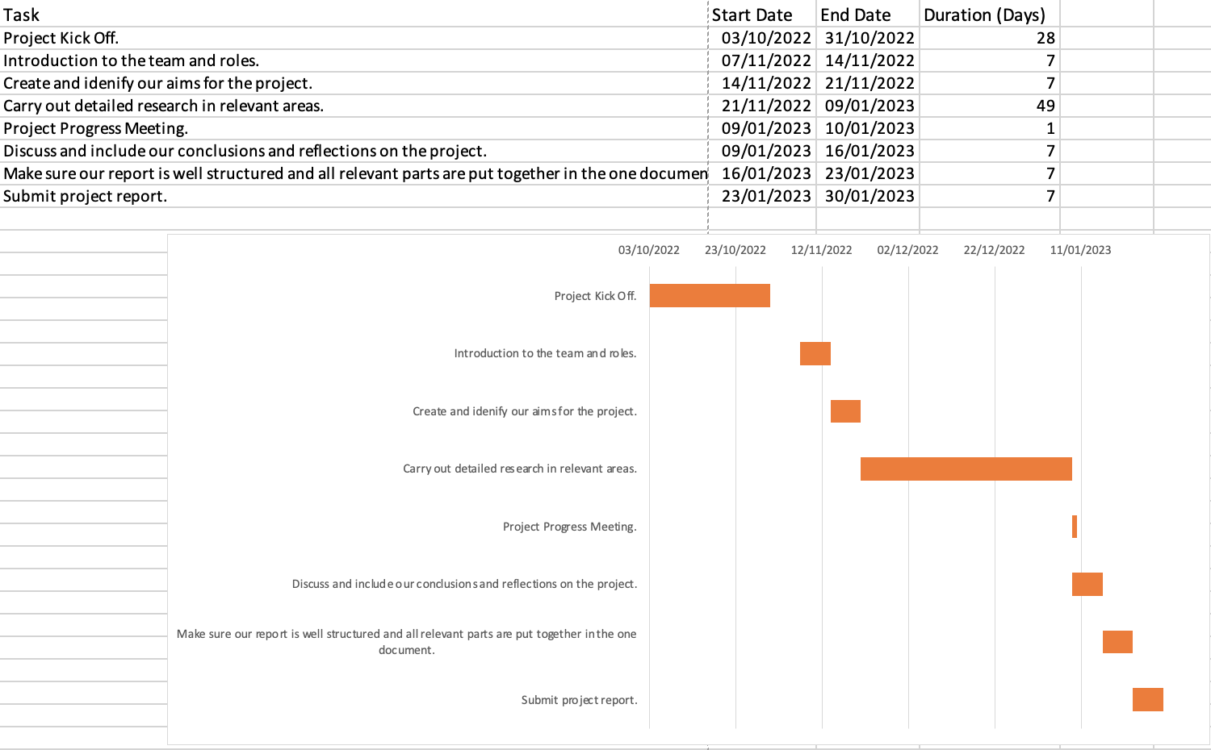
[Figure 1] Chart to show how we organised our progress with the project.

- Aims
As a group our aim when it comes to visual design is to have our car resemble a Formula 1 car from the 1970s to early 1990s era. We have agreed on this idea as we all enjoy the sport and love the style of the race cars.
To help us be successful with this project we will concentrate mostly on the aerodynamics, weight reduction, and use of cost-effective materials. This will assist us in designing a soapbox car that is fast and affordable. Lightweight materials such as fibreglass and square aluminium tubing, in addition to the slightly heavier wood and plastic, will help with enhancing the car's performance.
Our soapbox car's speed will be greatly influenced by aerodynamics. It will pass through the air much more effectively with a streamlined shape because this lowers drag, which in turn boosts speed. The car's frame will be made out of square aluminium tubing because it is strong, lightweight, and easily malleable into our desired shape.
Keeping the weight down is essential for gaining higher speeds because the amount of energy needed to move the car will decrease with its weight. The body of the car will be built out of fibreglass, a material commonly used in the automotive industry because it is strong, lightweight and not hugely brittle (Phelps, 2019). It is also a cost-effective choice because it is widely accessible and reasonably priced.
Using cost-effective materials is key to keeping the cost of the car down. Fibreglass and square aluminium tubing are both low-cost materials with high performance. Fibreglass is a more affordable substitute for more expensive materials like carbon fibre, but still produces a similar performance. Square aluminium tubing will protect our driver if anything is to go wrong while also being quite easy to mould to the correct shape.

- Methods
The methods we plan to use for the design vary, we will use perspective drawings to gain a better visualisation of the car from a 3D perspective. These drawings will be done in a paper format as well as using Digital drawings to cut down on paper usage, these would be scanned into the designers PC/laptop and added later on. Technical drawings will also be used in the next part of the project to show the dimensions of the car and to gain an understanding of the dimensions & scale of the car.

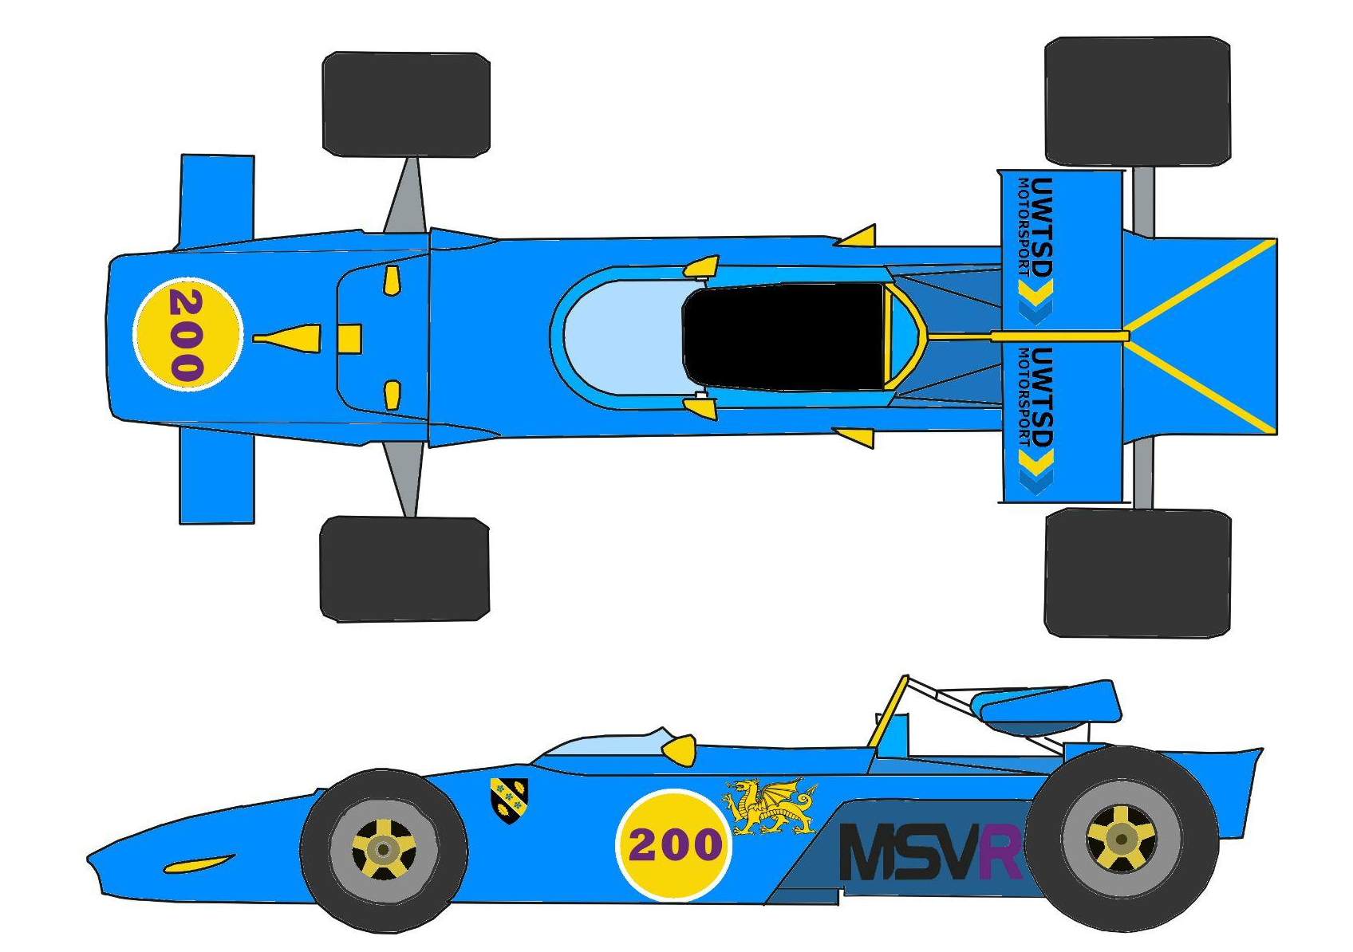
To decide on the size & scale of our car we came up with multiple different design styles ranging from the 1970/71 Ferrari 312b (figure 2), 1991/92 Jordan 191(figure 3) & 1981/82 McLaren MP4/1 (figure 4&5). We placed these as our three options because we agreed they would suit the type of design we would need as downforce wouldn’t play a big part in the race.

[Figure 2] Our design of the 1970/71 Ferrari 312b
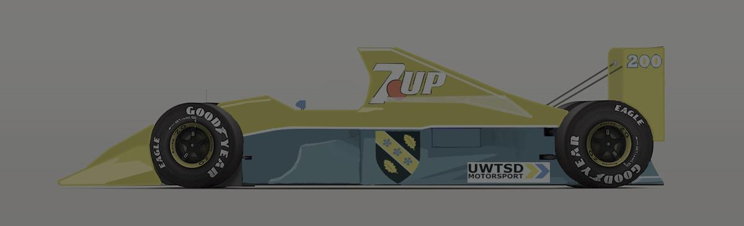

[Figure 3] Our design of the 1991/92 Jordan 191
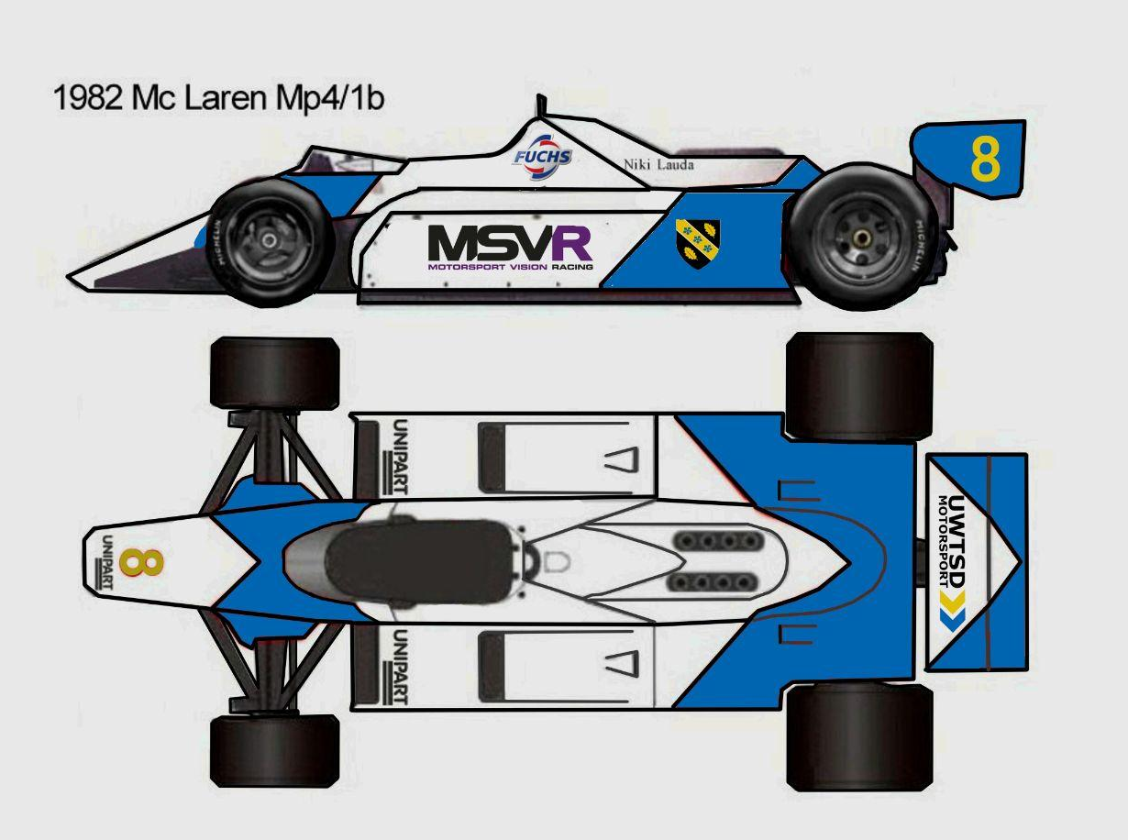

[Figure 4] Our design of the McLaren MP4/1
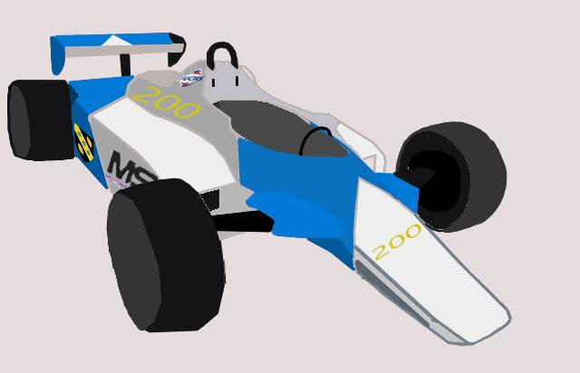

[Figure 5] Different view of the MP4
After much consideration we decided to go with the McLaren MP4/1 as it was our favourite aesthetically. Another reason we chose this car over the other options was due to the nose cone design that the car featured. The original nose supported a winged design which would have produced a significant amount of downforce. We did not need the downforce therefore we had decided unanimously that it would be best to remove the wing to produce a more streamlined car with less drag. This in turn would mean our car would be able to achieve a greater speed. We chose to keep the rear wing as it would make the car more stable at higher speeds and produce some downforce which would help with turning corners. It also makes our design more unique and eye-catching, as we don’t want a boring design.

- Research
Our research methods will consist of Secondary research via Websites, books & journals, due to the lack of Data available from McLaren Racing. Although the team hasn’t released data there are external sources which have released their own primary research conducted after the season had been completed.
We plan to use the data/statistics from these sources to scale down the car so that it fits into the regulations that were set by the governing body for the Soapbox car race. By doing this we will be able to design a well suited car for the intended purpose we have.
During the research we found the general dimensions for the MP4/1 (Melissen, 2009), which led to us scaling them down by 29% to fit into the regulations. This reduction in size also gives us weight reduction which, as said previously, will assist with the speed of the car.

5.1. Bodywork:
For the bodywork we will use either a cardboard or fibreglass body. This is because these materials will be noticeably light in order to keep the weight of the soapbox down, along with also being cheaper to get hold off, especially if we choose to go with cardboard bodywork.

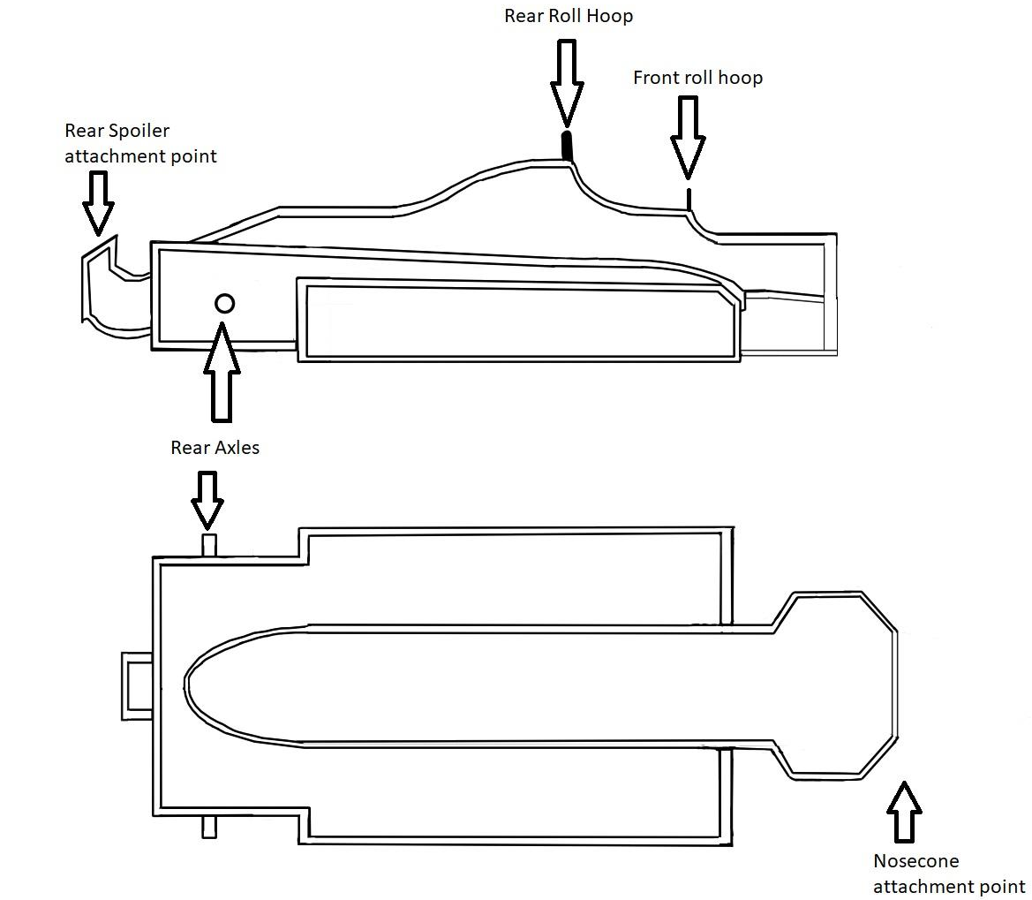
5.2. Chassis:

[Figure 6] Chassis design of our McLaren MP4 style car.

For the chassis and the main overall structure of the soapbox, we will most likely use a steel frame. This will provide the soapbox with enough sturdiness to last the run. The steel frame will also allow us to meet the rules and regulations for the safety of the soapbox, allowing us to create a substantial roll bar that is at least 35mm above the drivers helmet and another bar that is raised to at least 25 mm above the driver’s hands/gloves. A steel rollbar is the main way forward in order to meet these requirements and to know that the roll bar will serve its purpose if it is needed. The cost of the steel to create the chassis could prove quite a bit, however it should work out cheaper than the lighter alternative we could use such as aluminium. Although this material is lighter than steel, it would cost more to purchase, and it wouldn’t have the same tough durability that steel has to offer.

5.3. Steering:
For the steering mechanism we can use a simple but effective go-kart like steering setup, consisting of Go kart steering wheels that are made of aluminium and attached to a steering shaft and two tie rods (left and right). These connect to the spindles on each side that turn when you turn your steering wheel. This setup would be relatively cheap and easy to get hold of with most ‘ready built’ systems costing less than £100 to buy and they would be relatively easy to put as well.

5.4. Brakes:
For the braking system (Joe Ellison, 2021), we are looking to incorporate traditional push bike disc brakes to each of the front wheels. This will allow adequate stopping power for the run down the hill, whilst also incorporating well if we decide to go down the route of using bicycle wheels for the soapbox as well. This will allow the braking system to fit well with the wheels as both components would have been designed to work effectively together. In Addition, we have also chosen disc brakes because of their cheap cost and availability to modify to our needs as we can choose a larger rotor for more braking power. They are also lighter than other methods such as rim brakes which can help us achieve a higher top speed along the run. It allows for the racer to navigate around a circuit with easy control and able to keep traction, and is a simple installation to the wheels. For the braking system, it will simply be operated with brake levers below the steering wheel so that the brake lines can easily be routed conveniently and can be used easily even if the driver is feeling fatigued making his way down the circuit.

- Conclusion
In conclusion, by keeping the overall weight of our car down and doing lots of research on the lightest and most economical materials, we will be able to ensure that the car can set a good time down the hill while still keeping the price to a minimum. Our choice in materials will make the car very durable without greatly hindering the performance of the car as we believe it is vital to make sure the car does not deform or break during our run. The effective but simplistic choice of steering method will make it easier to build and fix if we encounter any difficulties. With our design choices a lot of time was spent choosing and finalising it so as a team we have a developed understanding of the final goal we want to achieve. Our braking system is effectively proven by high performance push bike racers. It keeps our simplistic methods, as it is more cost effective and lightweight, whilst keeping high durability and performance. The fairing of our soapbox car is cost effective and easy to get hold of in large quantities meaning we have more room for making the perfect design so it stays as authentic to the design that we want to achieve.

References
[1] (2020) Soapbox Car: A Motorless Race Car For Children. Available at: https://tech.hyundaimotorgroup.com/article/soapbox-car-a-motorless-race-car-for-children/

[2] Phelps, (2019). Fibreglass – Types, Properties, and Applications Across Industries.

[3] Melissen, W (2009) McLaren MP4/1B Cosworth. Available at: https://www.ultimatecarpage.com/spec/337/McLaren-MP4-1B-Cosworth.html

[4] Ellison, J (2021) How To Build A Soapbox Car. Available at: https://www.redbull.com/gb-en/how-to-build-a-soapbox-car

