VIRTUALISED ENTERPRISE NETWORK IMPLEMENTATION

BSC APPLIED COMPUTING
ACCA5023

NATHAN AMOBI
2325455

Table of Contents
1.Introduction 2
2. Network Overview and Environment. 2
3.Routing Configuration 3
3.1 Swansea and London Routing Using Windows Server 3
3.2 London and Swansea Routing Using Debian Server 4
4. Active Directory Domain Services and DNS 6
4.1 Domain Creation and Security 6
4.2 DNS Configuration 7
5. Secure Inter-Site Connectivity Using Site-to-Site VPN 8
6. User Account Management 10
7. Domain Membership 11
8. DHCP Services 12
8.1 DHCP Server Configuration 12
8.2 DHCP Relay on Debian 13
9.Testing and Debugging. 14
11. IIS Web Services 17
12. Remote Desktop Services 17
13. Conclusion 19

TASK 1 REPORT: CONFIGURE AND MANAGE A VIRTUALISED ENTERPRISE NETWORK

Introduction
This report presents the design, configuration, implementation, testing and validation of a virtualised enterprise network which is configured with both windows server and Debian operating systems. This assignment is part of Coursework 2 and a continuation of the network topology that was created in Coursework 1. The task aims to show applied ability of configuring and operating the network operating systems and services in a multi-site enterprise-level environment, in accordance with the learning outcomes of the Network Operating Systems and Services module.
The enterprise network is made up of two geographically different locations, Swansea and London connected with each other via a secure routed communication. Windows server is deployed in providing some core enterprise services, which include, Active Directory Domain services, DNS, DHCP, file services, web services, and remote desk-top services. At the London site, routing, IP forwarding, DHCP relay, and site-to-site VPN are offered on Debian Server deployed via command-line interface. The practice of heterogeneous operating systems will also mimic the empirical enterprise systems and guarantee cross-platform interoperability.
The overall goal of this task is to provide a secure, resilient, and fully functional network infrastructure, which facilitates centralised authentication, automated addressing, reliable name resolution, encrypted inter-site connectivity, and limited access to shared resources. Each of the configurations was tested in terms of persistence and functionality and validated both graphically and using command-line tools. Configuration outputs and system behaviour recorded during testing and live demonstration are evidence of successful implementation.

Network Overview and Environment.
The enterprise network is separated into two logical sites Swansea, being the main site of operations, and the remote branch site being London. This form of multi-site design is a characteristic organisation network in which the main services are centralised in one head office and accessed by the branch locations. The Swansea location contains a Windows Server (Standard Desktop Experience) which is the Domain Controller (S-DC). This server has been configured to offer generic services to the enterprise such as Active Directory Domain Services, DNS, DHCP, File Services, IIS Web hosting, and Remote desktop services.
The windows client machines are deployed at both the sites and configured to be part of the domain and auto-configure through DHCP. This guarantees uniformity in policy implementation, easy administration and safety in network resources.
The London location has a Debian Server which has been setup with a command-line interface. This server will perform IP routing, packet forwarding, DHCP relay service and also the termination of the site-to-site VPN tunnel between the two sites. Applications Routing functions can be assigned to Debian and leave enterprise services to Windows Server to show cross-platform interoperability. The language settings and time format are both English (US) and are of the UK time format. All the sites are in different IP subnet and routing and VPN services promise to make the communication between the sites reliable and secure.

Routing Configuration

3.1 Swansea and London Routing Using Windows Server
The routing and Remote Access Service (RRAS) was installed and configured on the Swansea Windows Server and it gave the internal LAN routing capability at the main site of the primary site. A tailor-made setup was utilized to make the RRAS job feasible whereby LAN routing was picked clearly to provide a regulated packet exchange between network interfaces. The arrangement enables the traffic that is internal to the Swansea subnet and traffic that is bound to the London location to be directed efficiently over the server. Windows Defender Firewall rules were analyzed and altered to allow the ICMP traffic, so that the connectivity testing and troubleshooting can be done effectively during the implementation. The routing persistence was confirmed through a restart of the RRAS service and also a restart of the server and then the routine packet forwarding went on as anticipated.
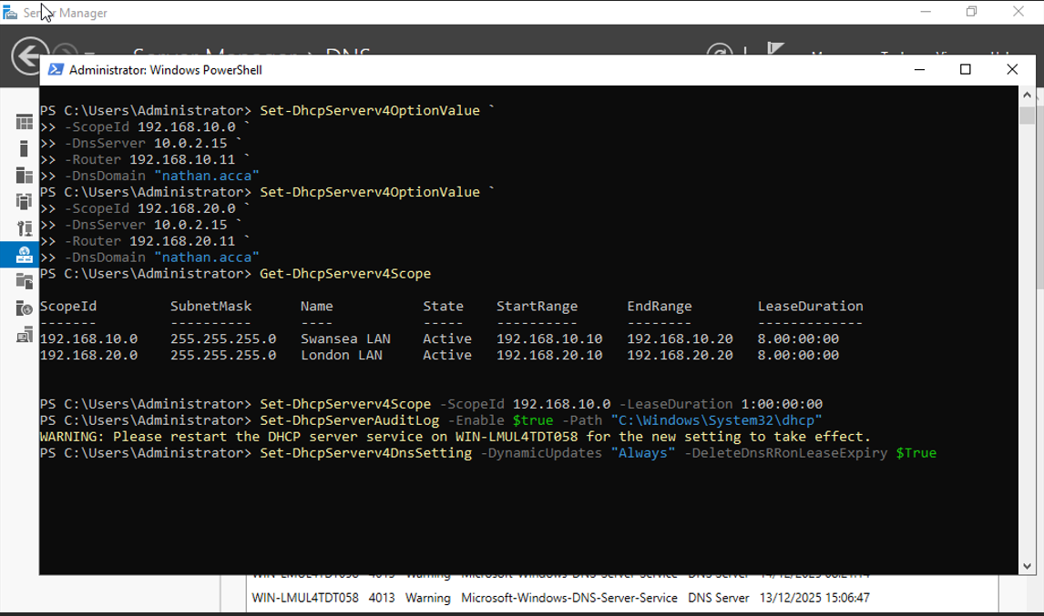
installed and enabled on Swansea server

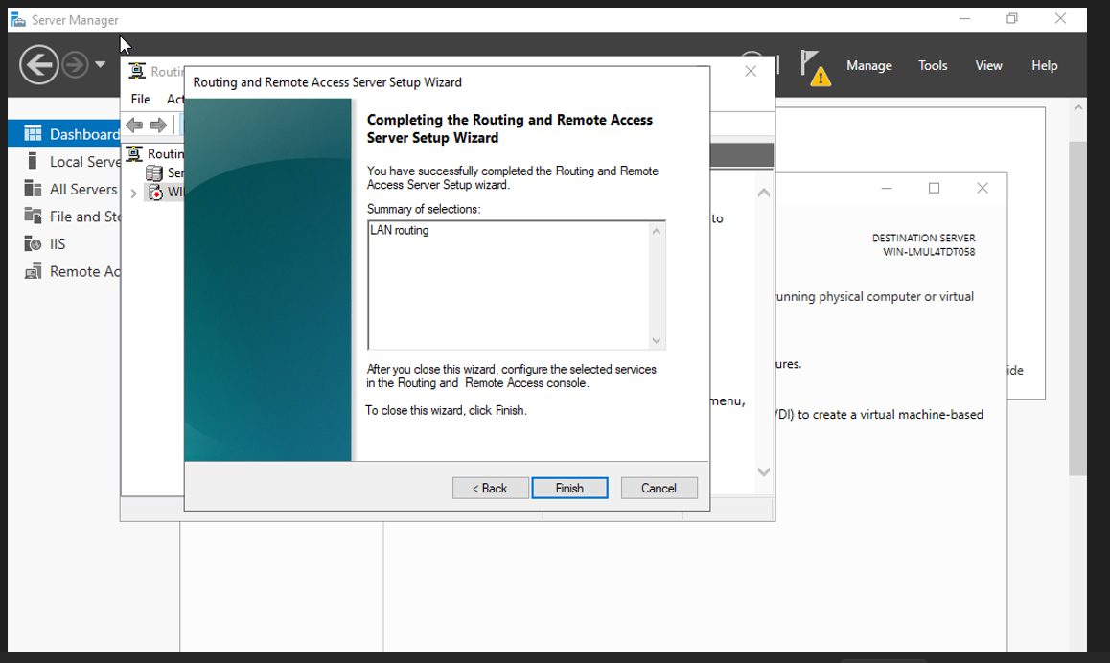
Firewall rule that permits ICMP traffic.
The effectiveness of routing was checked by various ping tests between different hosts on various subnets and it ensured the ability to choose an appropriate path as well as reachability.

3.2 London and Swansea Routing Using Debian Server
At the London location, the Debian Server was made to work as a router with the command-line networking tools. IP forwarding was facilitated via constant changing of system configuration files so that forwarding does not go off at the time of system re-boot. The routes were then made to be static pointing traffic to Swansea subnet using the appropriate address of the gateway. Firewall policies had been audited in order to permit forwarded traffic to be allowed and retain a safe baseline configuration. The routing tables were checked with normal Linux commands to ensure that the routes have been installed.
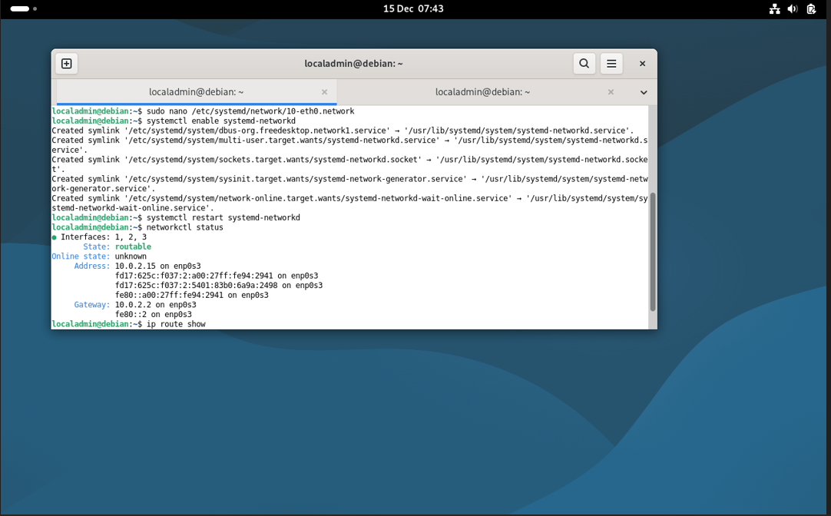
IP forwarding is being enabled in Debian.
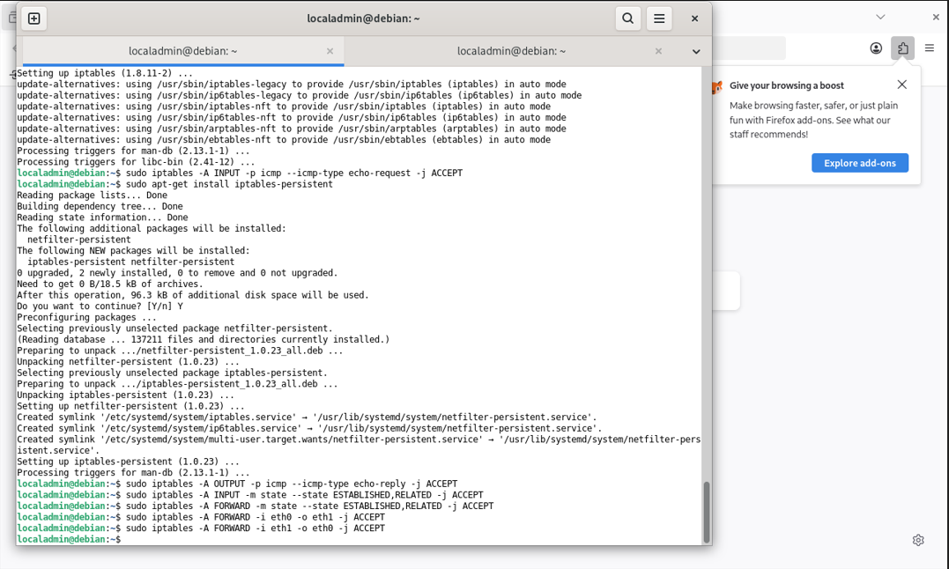
Debian routing table of statical route.
Testing of the bidirectional connectivity between Swansea and London hosts established that routing was properly done across both operating systems. This setup exhibits a leveraged routing strategy, integrating windows server graphical administration and Debian command-line management. Introduction of routing into heterogeneous platforms strengthens knowledge on the behaviour of protocols, interoperability and enterprise network design concepts. It also facilitates the reliability of higher level services, like VPN, DHCP relay and directory services, to work across the boundaries of the sites without relying on just one operating system. This enhances resiliency, scalability and fault-tolerance.

Active Directory Domain Services and DNS

4.1 Domain Creation and Security

In order to create a centralised identity and access management framework of the enterprise network, the Swansea Windows Server was installed with Active Directory Domain Services. When installing, a new forest and domain were created which is nathan.acca and which formed the base of authentication, authorisation and policy enforcement in both Swansea and London sites. The domain controller was set to act as the authoritative source of authentication of all the systems that were in the domain so that all security can be easily managed and so that the management can be easily done.
A secure domain password policy was used to implement hard credentials and minimise the chance of unauthorised access. This policy also contained the minimum password length, complexity and expiry requirements that are consistent with best practices in enterprise security. Implementation of the controls on a domain level will make sure that the accounts of all users are subject to uniform security standards without the need to enforce this on a case-by-case basis to specific systems.
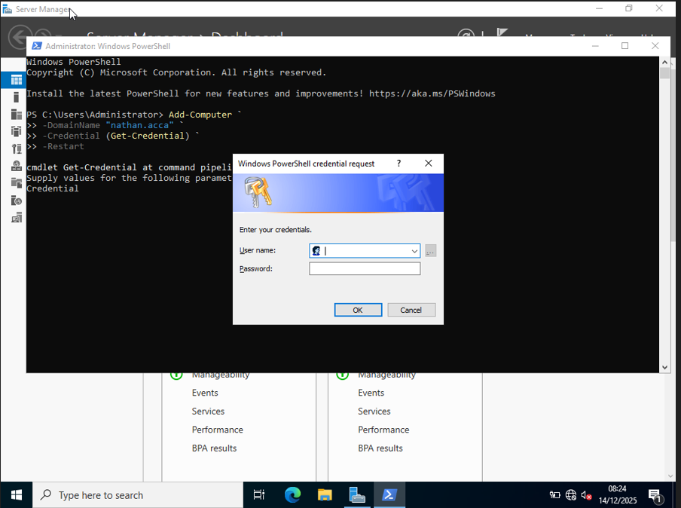
Domain nathan.acca was created successfully.
The domain success has been proven by the domain login tests and checking in the active directory management tools.

4.2 DNS Configuration
DNS was installed as a part of the Active Directory to facilitate the successful name resolution across the enterprise network. All servers and important services on both Swansea and London sites were added to forward lookup zones to allow systems to determine IP addresses of hostnames effectively. Each subnet was set up with reverse lookup zones and PTR records with a reverse configuration to permit reverse resolution of hostnames using IP addresses.
It has a DNS setup to facilitate authentication, service discovery, and logging besides making the task of troubleshooting and managing the network a lot easier.
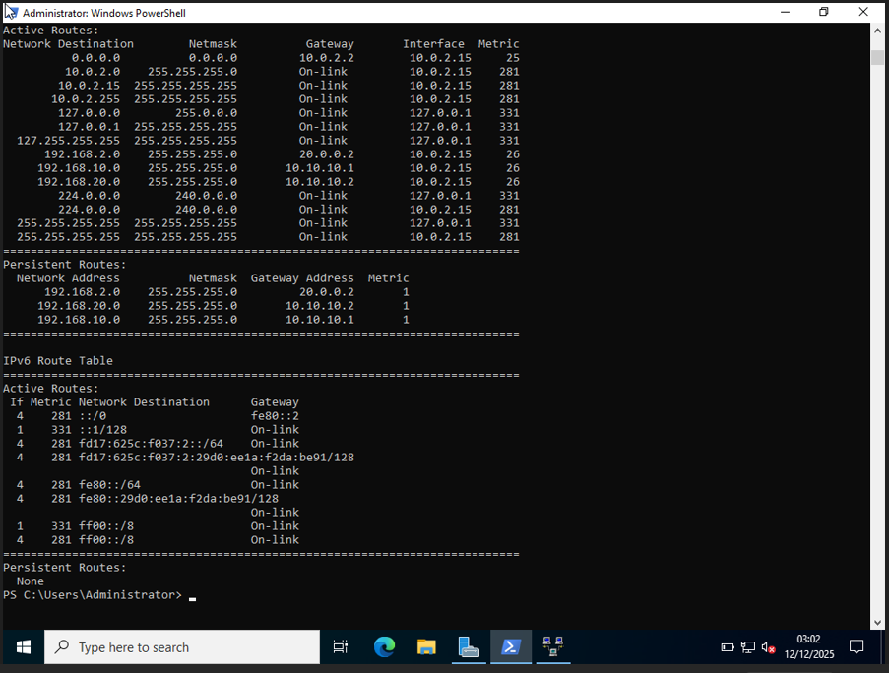
DNS forward look up zone.
Active Directory, along with DNS are a closely integrated infrastructure that allows secure communication, central management and reliable operation of the enterprise network infrastructure across sites.

5. Secure Inter-Site Connectivity Using Site-to-Site VPN
To ensure the safety of inter-site connectivity a site-to-site VPN tunnel was created between the Swansea Windows Server and the Debian Server at the London site. The VPN facilitates coded transfer amid the two networks, which guarantees secrecy, wholeness and safety of information that is sent over the unfaithful network connection. It was implemented in accordance with the best practices of the enterprise standards of strong encryption and authentication to minimize the chances of interception, tampering or unauthorised access of data in the process of transmission.
The VPN was set up on Swansea Windows Server through Routing and Remote Access Service and the correct tunnel type and security parameters were selected so that the endpoint of the tunnel interoperates with the Debian endpoint. The VPN setup on the Debian Server was enacted by command-line tools that had the VPN setup controlled with utmost accurate control of cryptographic parameters and tunnel behaviour. Authentication credentials and encryption settings were matched on both endpoints to have a successful establishment of the tunnel.
VPN was set up as a persistent connection, which means that the tunnel would automatically reconnect in case of temporary network failure or service re-initiation. The continuity aspect of this helps in sustaining business since it ensures that there is a secure communication between sites without necessarily having to use hands. It also guarantees that the dependent services including the Active Directory authentication, DNS resolving and the DHCP relay are accessible throughout the enterprise network.
VPN windows server settings.
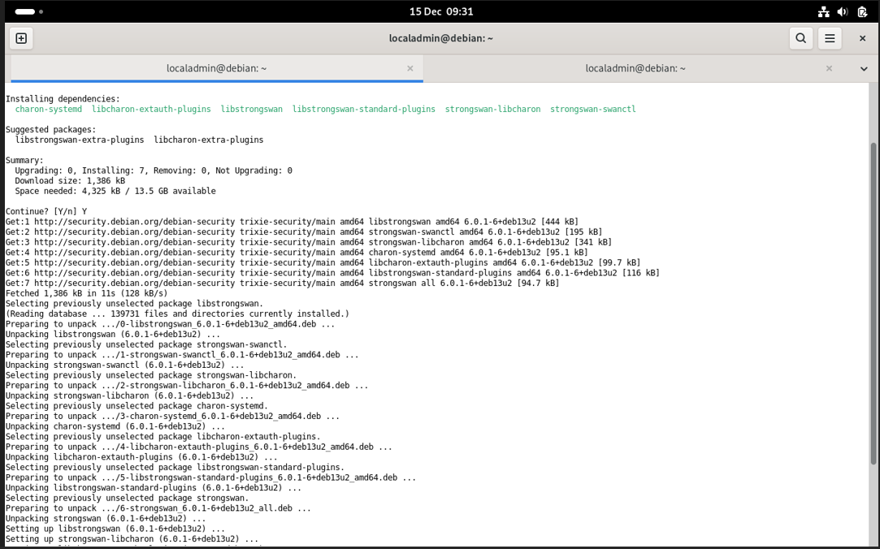
VPN settings in Debian.
The cross-site communication across the VPN was tested to be successful with connectivity checks such as ping tests between the hosts across the two locations. These tests proved that when the traffic was operated in the normal mode, it was safely passed through the encrypted tunnel.

6. User Account Management
Information given in the spreadsheet issued by the lecturer was used to create user accounts within nathan.acca domain. In order to remove inaccuracies and discrepancies, the bulk user creation was done using windows power shell as opposed to the manual graphical creation. This solution minimised typographical errors, provided constant attribute configuration and proved useful command-line administration in a Windows Server operating system. The usernames were created in reference to the necessary naming policy, which was the combination of the first initial and the surname of the user.
PowerShell bulk user creation command.
When creating an account, default passwords have been used as per the domain security policy and an account has been set to use it so that it can be immediately authenticated. The user objects were authenticated in the Active Directory Users and Computers to ensure that they have the correct placement and membership. The accounts were able to authenticate successfully across the enterprise network according to successful logon tests by domain-joined client machines. This procedure endorses centralised identity administration and user management that is scalable. This fulfills enterprise access control needs.

7. Domain Membership
The enterprise integration process has been successful by having windows client machines in both Swansea and London sites joined to the nathan.acca domain successfully. Addition of every client to the domain enables authentication to be centrally performed by Active Directory and no longer by local accounts. This would facilitate uniform implementation of security policies, easier management of users as well as regulated access of shared network resources between the two sites.
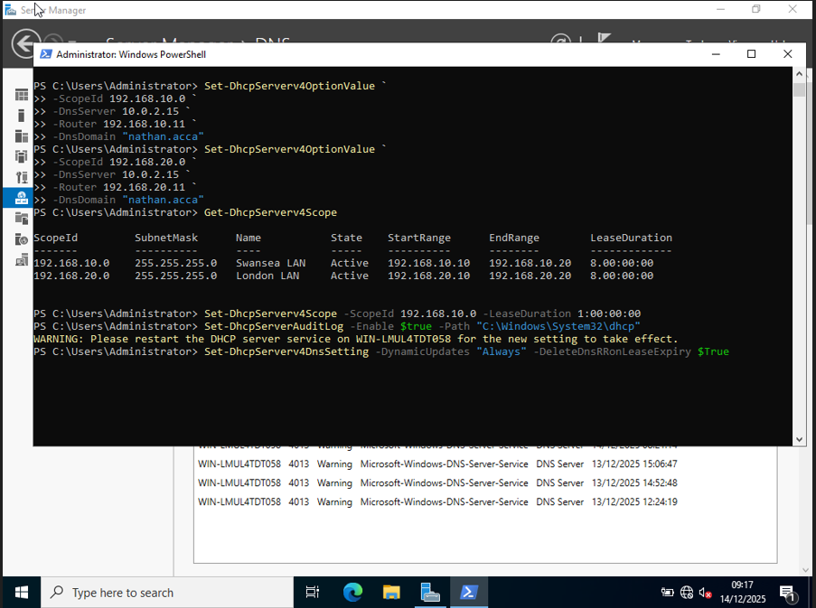
ClientS1 was added to domain.
All clients were checked in the table Active Directory Users and Computers to check that computer objects are created and placed correctly. The establishment of trust between the clients and the domain controller was established by successful authentication and access to the network services. This proved the secure domain integration and the identical authentication behaviour on all the endpoints throughout the enterprise on both sites throughout testing.

8. DHCP Services

8.1 DHCP Server Configuration
Swansea Domain Controller is set up as the head end DHCP server in the enterprise network. The scopes of the DHCP were developed on individual site subnets with a range of addresses starting with X.X.X.10 up to X.X.X.20 that ensures IP addresses are allocated in a controlled and efficient manner. The default gateway, DNS server address and domain name were automated to be apportioned to the client machines automatically, and this minimized the amount of effort spent on manual configuration and the possibility of addressing errors. The DHCP server was authenticated in the Active Directory to avoid the possibility of unauthorised or rogue DHCP services running on the network.
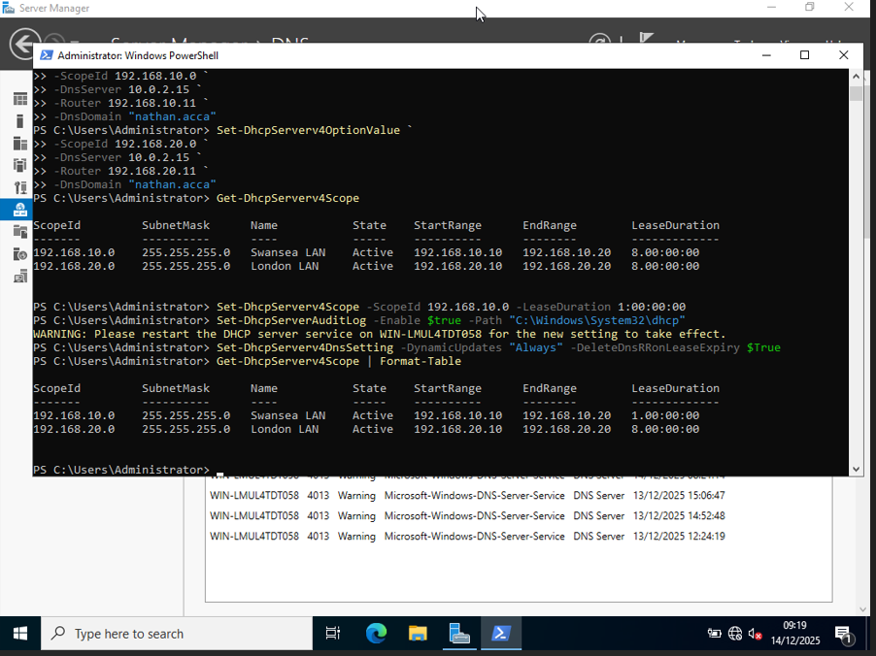
DHCP scope settings.

8.2 DHCP Relay on Debian
The Debian Server in the London site was set up as a DHCP relay agent. The relay routes address broadcast requests in DHCP of the London subnet to the central DHCP server in Swansea, allowing address allocation to be centrally managed yet allowing remote sites to be connected.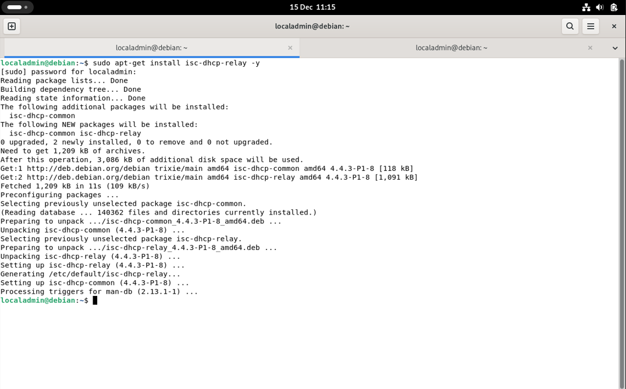
debian DHCP relay setup
This architecture is scalable, consistent, and easy to administer throughout the enterprise environment.

9.Testing and Debugging.
Extensive testing was done to ensure that all the configured services were valid. Tests were routing verification, DNS resolution, DHCP lease allocation, VPN status check and domain authentication. Any problems that were met were solved by being systematically troubleshooted.
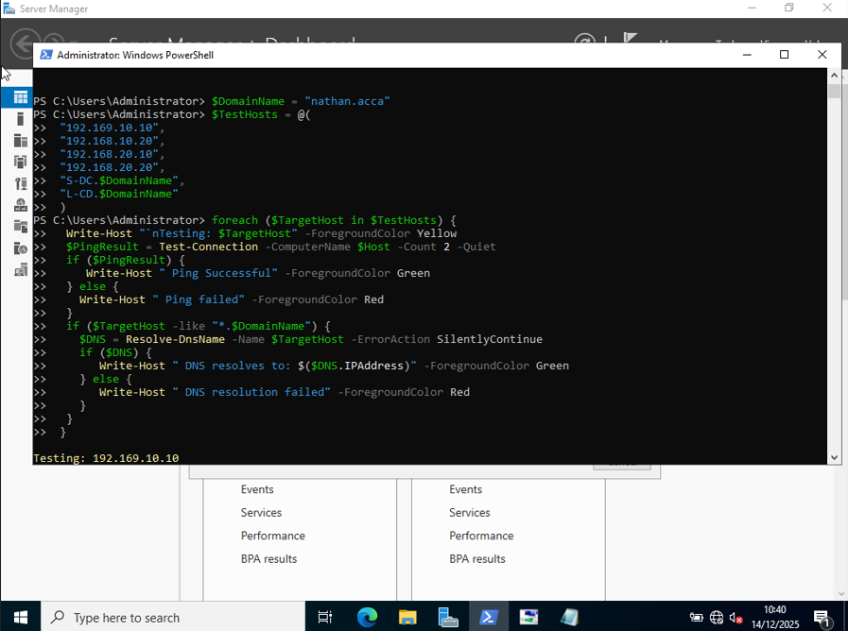
Connectivity tests
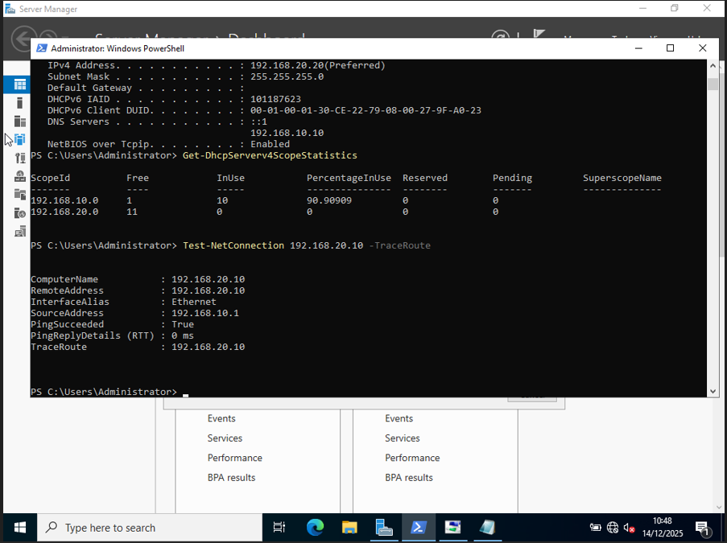
Test of DNS resolution.

A secondary disk was attached to the Swansea server and was given the name E:\SwanseiFiles. The folder was made available throughout the network with restrictions set to allow the domain users adequate access. Share permissions and NTFS were aligned so as to implement security.

11. IIS Web Services

The Swansea server was installed with Internet Information Services that used to host an internal enterprise site. A web site called htpps.nathan.acca was developed using Windows Authentication which is on. Users who have been authenticated and are using the site through the HTTPS are given the message “Welcome to Swansea Website.”
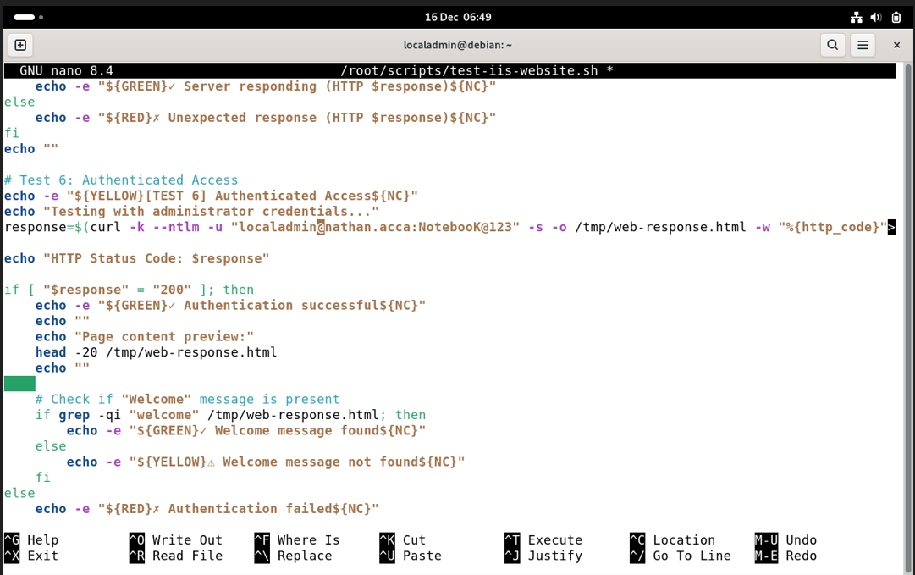
IIS site configuration.

12. Remote Desktop Services
Swansea server had Remote Desktop services which were enabled to enable secure remote administration. The RDS Web Access was to be configured to permit access via browser through https://rds.nathan.acca, through certificates.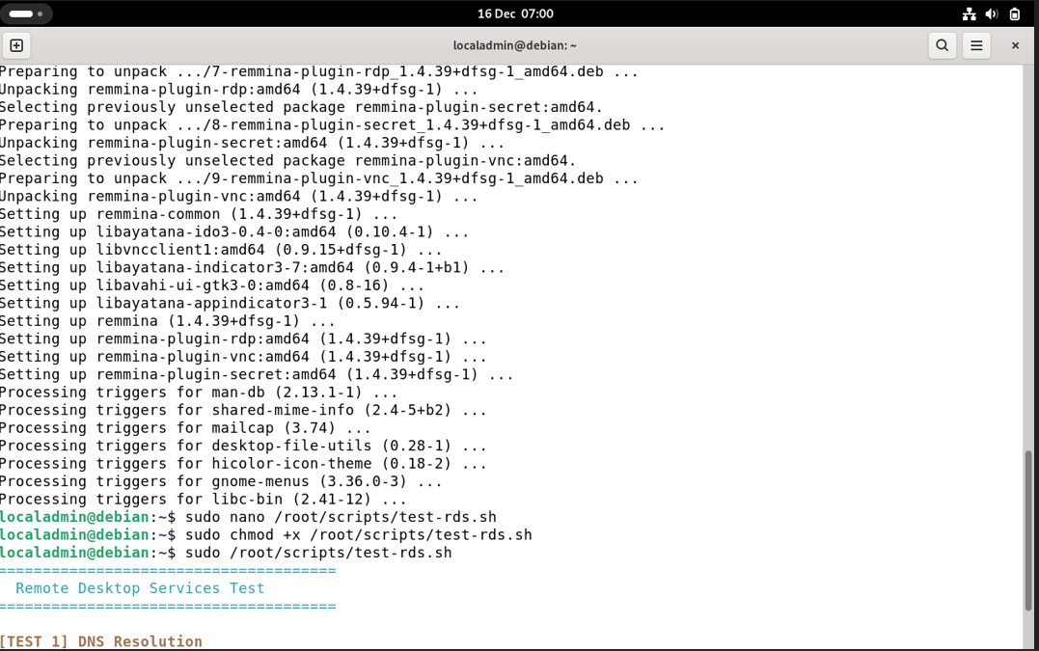
Remote Desktop ON.
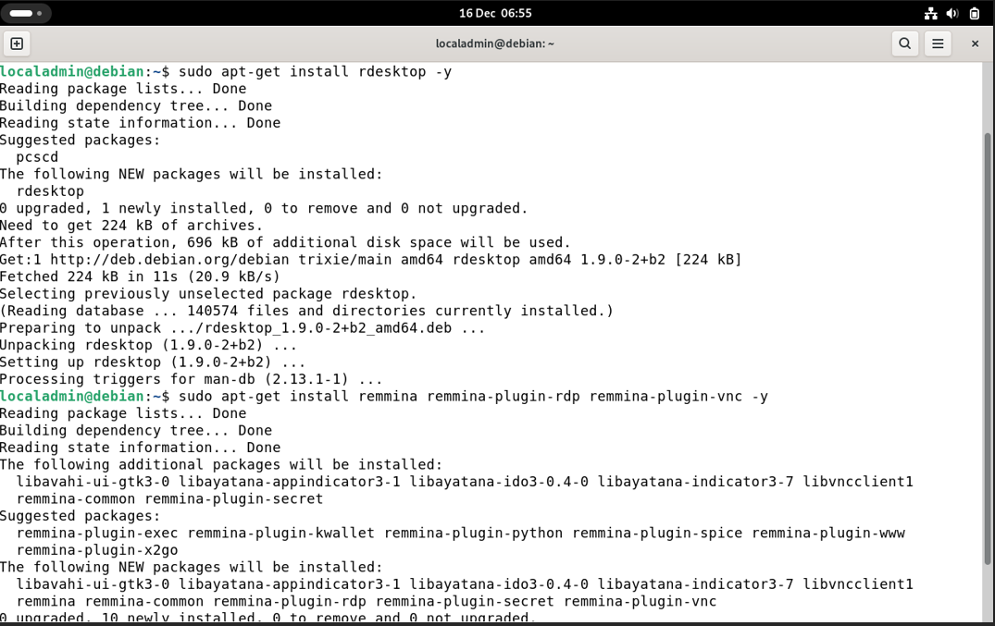Web Access page.

13. Conclusion
This project was able to successfully provide a fully operational virtualised enterprise network which was based on both windows server and Debian. Basic services mentioned such as routing, Active Directory, DNS, DHCP, VPN and file services, IIS, and Remote Desktop Services were installed, tested and validated. The implementation has good practical competence in the management of heterogeneous network operating systems and satisfies the requirements and module learning outcomes of assessment.

