Digital Skills and Research Methods
BMSW4003_LON

The impact of Virtual Learning Environment on students’ learning experience

Lecturer: Balan Kandasamy
Student: Andreea Filip -1817999

Table of Contents
Executive Summary 2
Introduction 3
Literature Review 3
Primary Research 4
Methodology 5
Ethical considerations 5
Results 5
Limitations of the Study 12
Conclusion 13
References 13
Appendix 14
Appendix I - Questionnaire design 14
Appendix II - Average age or respondents 16
Appendix III - Responses – data base 16

Executive Summary
Virtual learning environments are one of the most important tools in a modern teaching environment. The new number of new VLE is rapidly increasing, as the demand is growing on a global scale. VLE is used in almost any field, from toddlers that learn the numbers to simulators that train operators in nuclear plants.
The purpose of this study is to determine the impact of Virtual Learning Environment on students’ learning experience at the University of Wales Trinity Saint David London campus.
In order to achieve this goal, the study had a quantitative methodological approach. It has been used a survey formed by 8 closed-ended questions. 15 students were selected through convenience sampling.
The study showed that most of the students are using VLI weekly, for online learning or to check the email, presenting a high level of satisfaction. All the responded confirmed that VLE (Moodle) is useful for assignments.

Introduction
The aim of the study is to showcase the impact that Virtual Learning Environment present on students’ level of satisfaction and learning outcome.

Literature Review
Virtual learning environments are advertised as being the solution for remote education. Therefore, in a world where the meaning of borders is changing and globalisation made any transaction possible in any part of the world, the number of new virtual learning environments is rapidly increasing. A vast variety of exercises can be achieved by students in a computer-based learning environment. Virtual Reality has been used to train young doctors, simulators to train operators in nuclear plants, or pilots, and these are just some of the vast range of virtual learning environments. (Walker and Harrington, 2004)
The high importance of virtual learning environments has conducted to a great number of studies on the subject. However, the majority of published studies have been done more than 10 years ago and this leads to a limitation in modern learning environments like the ones generated from the usage of artificial intelligence or machine learning.
One of the studies compared the learning experience and the learning outcomes of some college students. This study has been conducted by Kekkonen-Moneta and Moneta in 2001. They used two groups of students, the first group (105 students) had to study through lectures and the second group (180 students) through an online course. The results were concluded by a mid-term examination formed by multiple-choice questions. The study presented no difference in the learning level of the two groups. However, the students that study through online courses perceived the learning experience more pleasant and less difficult.
The second study realised by Marandi and Luik in 2003, showed that the subjects that used VLE were more satisfied and self-confident with their gained skills, compared with the subjects that used a traditional teaching method. The study was conducted with a group of 39 teachers, that was divided in two groups of 27 and 12 teachers. The study’s data was collected via questionnaire. The first groups studied using the WebCT and the second groups studied in the traditional face to face teaching. The aim of the study was to measure the effectiveness, level of improvement in learning IT skills and attitude provided by VLE.

Primary Research

Methodology

The methodological approach was based on a quantitative method, which helped in identifying patterns, ranking, measuring and categorisation. In order to collect all the data needed for the research purpose, the survey has been used as the main tool.
The survey has included 8 questions and had an average time of completing one and a half minutes. All of the questions were closed-ended questions. The questions had binary answers, multiple answers, single answers possible and multiple answer possible, scaling and ranking questions were also used.
The used sampling method was convenience sampling. The sampling frame has been formed by one of the six groups of students that are studying for Certificate of Higher Education Skills for the Workplace. The sample included 13 students from that group and two students from a different year.

Ethical considerations

The entire ethical principles of data collection have been followed. The information collected from the respondents was used only for the purpose of this assessment and will have been destroyed ones the purpose is fulfilled. Research participants have not been harmed in any way, their privacy and anonymity have been ensured. Furthermore, the data was collected only after their consent, in accordance with GDPR rules and The Data Protection Act.

Results

- Your age

- 18-24
- 25-29
- 30 - 34
- 35- 40
- more then 40

Frequency Table:
Age
18-24 | 4
25-29 | 8
30 - 34 | 2
35- 40 | 1
more then 40 | 0
Total | 15

All the respondents ages are between 18 and 40 years old, the majority of them, 53%, between 25 and 29 years old, the average age being 26 years old. There was no respondent beyond the age of 40.

2. Your gender
- Female
- Male

Frequency Table:
Gender
Female | 4
Male | 11
Total | 15

Following the above information, it can be determined that the respondents are preponderant males having 73% of the responses and only 27% females.

3. For how long have you been a student at UWSTD?
- less than one year
- 1 year
- 2 years
- 3 years
- 4 years or more

Frequency Table:
Student for:
less than one year | 13
1 year | 2
2 years | 0
3 years | 0
4 years or more | 0
Total | 15

As expected, the majority of respondents are in the first year of study at the University of Wales Trinity Saint Davis, only 2 students are in their second year.

4. How often do you use VLE?
- daily
- weekly
- monthly
- only when I must submit my assessments

Frequency Table:
VLE frequency of use
daily | 0
weekly | 10
monthly | 5
only when I must submit my assessments | 0
Total | 15

As it can be concluded from the above chart, 67% of the student are using VLE weekly, 33% of them monthly and none of them only for submitting the assessment. On the other hand, none of the students are using VLE daily.

5. What are you most using VLE for? (please order the answers)
- Submit assessments
- Online learning
- Email
- Check attendance
- OneDrive
- Online Library

Rank | Options
1 | Email
2 | Online learning
3 | Check attendance
4 | Submit assessments
5 | OneDrive
6 | Online Library

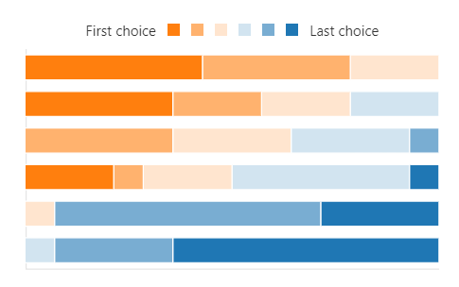

On the above question, responded had to order the answers from one to six, one being the most common reason of using virtual learning environments. The most common reason of using virtual learning environment, in this case Moodle Hub, is to check the student email, 42% of the students ranked email as the most common reason, followed by online learning with 35% ranking of the first place and to check attendance. Least use of VLE is for the online library with 64% of the student having this reason their 6th choice, and OneDrive being chose by 28% of the students as last choice. Checking attendance was the fourth most common reason.

6. Where do you use Moodle most?
- At home
- At University
- At Work
- Other

Frequency Table:
Places frequencies of Moodle usage
At home | 10
At University | 5
At Work | 0
Other | 0
Total | 15

Most of the students are accessing Moodle at home with a percentage of 67%. The second place, having 33%, from where the students are accessing Moodle is the University, and none of the respondent are accessing Moodle from work or other places.

7. How satisfied are you using Moodle?
☆☆☆☆☆

Moodle satisfaction level
Xi | Wi
1 | 0
2 | 0
3 | 3
4 | 5
5 | 7
Total | 15

Weighted Mean = $\frac{∑(XiWi)}{∑Wi }$ =$\frac{1*0 + 2*0 + 3*3 + 4*5 +5*7 }{3+5+7}$ = $\frac{64}{15 }$ = 4,26


4,26

From the above information it can be concluded that Moodle present a high level of satisfaction for student, as none of them marked it with one or two stars and only three respondents marked it three start. Moreover, most of the student marked Moodle with four and five stars. Five gave Moodle four starts and seven of them five stars, recording a weighted mean above average of 4,26.

8. Does Moodle help you with your assignments?
- Yes
- No

Does Moodle help with assignments:
Yes | 15
No | 0
Total | 15

For question 8, the responses were 100% positive, all the respondents affirmed that Moodle is a useful tool for assignments.

Limitations of the Study

Errors occur in the study, due to poor sampling. Having a study conducted on 15 subjects from thousands is far from being a decent representative sample. Consequently, the presented results are not representative for the entire statistical population of students, as was the main objective of the study. However, it is a good study that is representing one group from level 4 Certificate of Higher Education Skills for the Workplace. In order to reduce the errors, the study should have been done for a higher percentage of students, using systematic sampling from all the disciplines.

Conclusion
The research showcased the impact of VLE on students’ learning experience. It concluded that all the students believed that Moodle is a useful tool for assignments, most of them reporting a high level of satisfaction. It is used on a weekly basis, mostly for online learning, email and attendance checking.

References

- Bulmer, M (1979) Principles of Statistics. New York: Dover Publication Ink.
- Kekkonen-Moneta, S. Moneta, G. (2001) Online Learning in Hong Kong: A Preliminary Comparison of the Lecture and Online Versions of a Computing Fundamentals Course, in Proceedings International WWW Conference (10), Hong Kong.
- Koskela, M. Kiltti, P. Vilpola, I and Tervonen, J. Suitability of a Virtual Learning Environment for Higher Education. Finland: Tampere University of Technology.
- Marandi, T. Luik, P. (2003) Teacher Training – With or Without Computers? in Proceedings of the 2nd European Conference on e-Learning, Academic Conferences International Reading, UK.
- Maund, R. Schriek, M. and P.K. Tinkler (2017) Certificate in higher education: skills for the workplace student yearbook. London: SAGE.
- Walker, B. Harrington. S. (2004) ‘Can nursing facility staff with minimal education be successfully trained with computer-based training?’ Nurse Education Today, 24, pp. 301-309.

Appendix

Appendix I - Questionnaire design
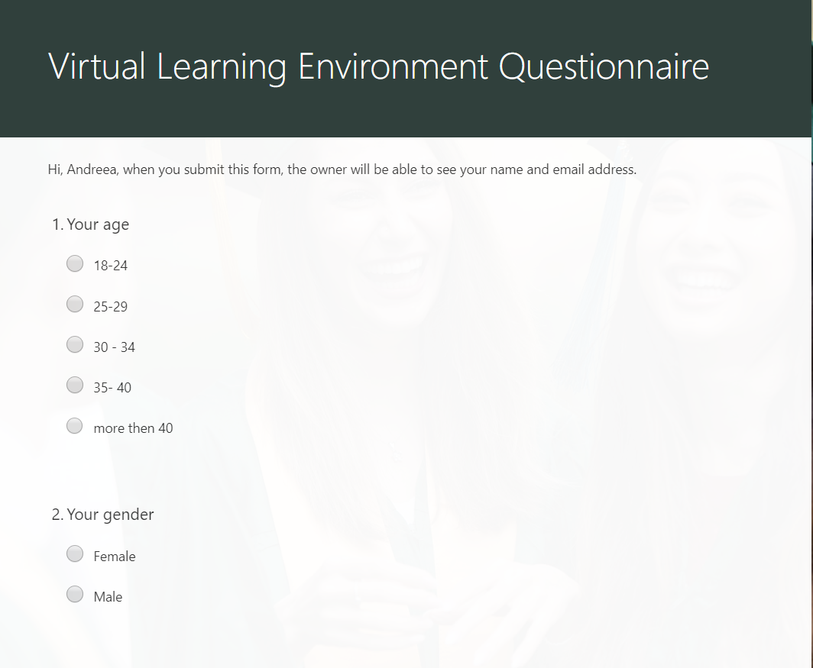

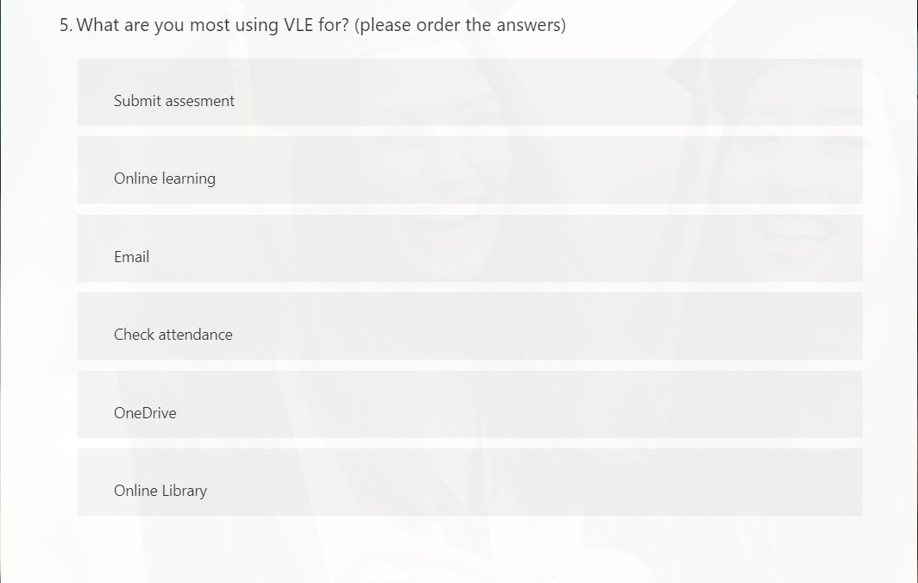
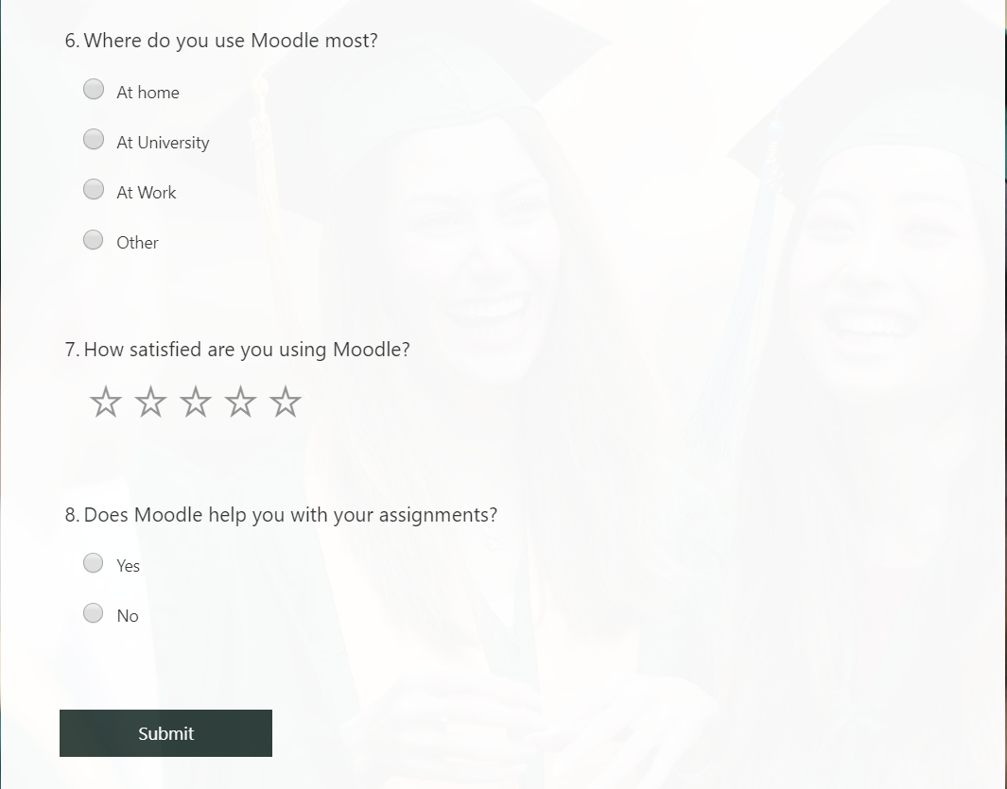

Appendix II - Average age or respondents
Age | f |  | x | fx
18-24 | 4 |  | 21 | 84
25-29 | 8 |  | 27 | 216
30 - 34 | 2 |  | 32 | 64
35- 40 | 1 |  | 37.5 | 37.5
more then 40 | 0 |  | 40 | 0
Total | 15

Mean = (∑(fx))/N = 26.76667

Appendix III - Responses – data base

Q1 | Q2 | Q3 | Q4 | Q5 | Q6 | Q7 | Q8
25-29 | Male | less than one year | weekly | Email;Check attendance ;OneDrive;Online learning;Online Library;Submit assesment ; | At home | 3 | Yes
25-29 | Female | less than one year | weekly | Email;Check attendance ;Online learning;Submit assesment ;OneDrive;Online Library; | At University | 4 | Yes
18-24 | Female | 1 year | weekly | Email;Check attendance ;Online learning;Submit assesment ;OneDrive;Online Library; | At home | 4 | Yes
30 - 34 | Male | less than one year | montly | Submit assesment; Check attendance; Email;Online learning;OneDrive;Online Library; | At home | 3 | Yes
25-29 | Male | less than one year | montly | Online learning;Submit assesment ;Email;Check attendance ;OneDrive;Online Library; | At home | 5 | Yes
18-24 | Female | less than one year | montly | Submit assesment; Online learning;Email;Online Library;Check attendance ;OneDrive; | At home | 4 | Yes
35- 40 | Male | less than one year | weekly | Online learning;Email;Check attendance ;Submit assesment ;Online Library;OneDrive; | At home | 5 | Yes
18-24 | Male | less than one year | montly | Submit assesment ;Email;Online learning;Check attendance ;OneDrive;Online Library; | At home | 4 | Yes
25-29 | Male | less than one year | weekly | Email;Online learning;Submit assesment ;Check attendance ;OneDrive;Online Library; | At home | 5 | Yes
30 - 34 | Male | less than one year | weekly | Online learning;Email;Check attendance ;Submit assesment ;OneDrive;Online Library; | At University | 3 | Yes
25-29 | Male | less than one year | weekly | Email;Check attendance ;Online learning;Submit assesment ;OneDrive;Online Library; | At University | 5 | Yes
25-29 | Male | 1 year | weekly | Online learning;Email;Check attendance ;Submit assesment ;OneDrive;Online Library; | At home | 4 | Yes
25-29 | Female | less than one year | montly | Email;Check attendance ;Submit assesment ;Online learning;OneDrive;Online Library; | At University | 5 | Yes
18-24 | Male | less than one year | weekly | Email;Online learning;Check attendance ;Submit assesment ;Online Library;OneDrive; | At home | 5 | Yes
25-29 | Male | less than one year | weekly | Online learning;Email;Submit assesment ;Check attendance ;Online Library;OneDrive; | At University | 5 | Yes

