WENDY HUGHES 1803214.
In this essay the author will be writing about a small scale participatory research project they were involved in, with young people in Carmarthen wales in 2019. The question for the research project is based upon an issue raised by the young people,which is how would having services like women’s aid, and a women’s refuge benefit young people. Research is a detailed study of something specific whether it be an issue a problem or a concern raised by individuals or a group of people. There are different ways of doing research, there is quantitative and qualitative methods. The author has decided to do their research project with qualitative methods as they feel this can be more creative, therefore will get the young people to actively engage more in the study. The author feels quantitative research is not exhilarating for young people whereas qualitative research is exciting and more practical, where the author can find out about the issues young people face in a more enjoyable way, it is the young people who are the experts and the author wants to know what they know and understand about the research question, in addition why they wanted to know more about domestic violence.
We involve young people in research so we can get a true reflection on any issues faced, and more importantly so they get their voices heard, it gives young people the feeling of empowerment and of responsibility. It helps them gain confidence, self-esteem and to learn new skills.
The author has decided on this particular question as there is a great need of domestic violence services in the area, which can benefit young people greatly if they are experiencing any form of domestic abuse. The research is taking place in a local youth club which the young people are familiar with, it has adequate facilities and is warm and welcoming for young people. The project is being done with ten young people between the ages of fifteen and twenty five. All ages from eleven to twenty five were asked if they wanted to participate but the specified ages as mentioned above were the ones wanting to be involved in the research. The project runs alongside the participatory approach of youth work, which is involving the young people letting them have their voices heard and being able to express their own views. Roger Harts 1992 participation ladder states that when working with young people, adults should not be the ones in charge therefore listening to the thoughts and opinions of the young people and letting them decide what they want to do is the best way to work with young people, and for the young people and the adults to make the final decisions together. (Anon, 1992) The principles and practice of youth work also links to the national occupation standards. For example building relationships and engaging with young people yw01, along with building young people’s self-awareness confidence and participation yw15. It is extremely important in youth work that the young people have a choice on whether they want to be involved and to engage in any research project or activity, which promotes the participatory approach alongside active involvement, to ensure their needs are met.
A definition mentioned by the council of Europe suggests that participation is a civic right for young people in today’s society to be included in decisions that have an impact on their lives. One of the most vital policies in youth work is to ensure a young person develops holistically to give them independence and to take responsibility for their own actions which has a positive impact on their lives. (Eberson, 2002)
The authors main focus of this research project is to find out and explore what the young people feel the benefits are of such services for domestic violence, and what positive impact it has on them knowing what support is available and where they can go. The questions that will be asked by the author are as follows. What are the benefits of the services. What support would they like. What programmes would they like to be involved in and the positive impact these all have.
The author will know discuss how they are going to achieve these goals with the young people and explore the methods which will be used. Firstly the author split the young people into two focus groups, each with five people in, the activity involved a picture collage where the young people cut out pictures and words from magazines showing how they believe these services benefit them. The group worked well with this activity and were fully engaged discussing it with their peers. One idea which came from the group was they would like to see more discussions and activities in schools and colleges about the impact domestic violence has on young people today. Secondly a visit to the domestic abuse services in Carmarthen was arranged where the young people were met by four ladies who use the services. They spoke to the young people about all the help and support services they use and how they benefit from these. Nothing negative was spoken about not to cause any trauma, therefore the young people really engaged and participated in asking the four ladies a number of questions. Some of the questions asked were, do you think there is enough being done to highlight the dangers of domestic abuse, and the majority answered that they believed it should be spoken about more so that young people have the confidence to come forward if they needed support. Thirdly the author run an activity called the freedom programme as some of the young people expressed they did not know there was other forms of domestic violence other than physical. The freedom programme helps recognise different forms of domestic violence from physical, mental, control and emotional. The author feels the freedom programme is a vital part of these services as it can be extremely beneficial in recognising the signs.
The freedom programme was very affective , therefore the young people learnt about all the different forms of domestic abuse, the young people made some more collages with a spider diagram, one for each type of abuse and how to recognise it, which ensured the author had data at the end of the research. The data would be shared with the local council to highlight the need for these services, as a lot of cuts in funding affect these services, therefore it is fundamental these services are not cut anymore as domestic abuse is on a high scale in today’s society. In figures released by the crime survey in England and Wales it states that an estimated two million people between the ages of sixteen to fifty nine experienced domestic violence in the last twelve months. (Ons.gov.uk, 2018) The data will also be shown in schools and colleges.
Before all this was arranged I assured the young people that this was voluntary , they did not have to participate if they did not want to, I ensured all questions that were asked did not cause the young people any trauma and ensured them that after the research project was over that there were services available if they felt the need to talk to anyone or seek further support that there were things in place for them.
The author made sure that all the young people participating in the research fully understood the research question and what would be discussed so they could give their consent if they wanted to engage which is known as informed consent, this gives the young people a chance to make sure their own decisions on whether they want to participate or not. The author made it clear to the young people that at any time they did not feel comfortable doing the research that they could stop at any time. The author told the young people that anything their say during the research project would remain confidential, except if the author thought there was a safe guarding issue and that details would have to be passed on to other agencies. (NSPCC Learning, 2000)
As some of the young people were under the age of sixteen they cannot legally give their consent to participate so the author had to get written consent from their parents and guardians, however even though parental consent was given, the author ensured that the young people wanted to engage and participate, in addition have the right to withdraw from the research at any time. It is important that young people are given the correct support and that the research is done in a way that they are not caused any trauma or upset during the process. The wellbeing of the young people is extremely important at all times during the research. The author ensured they acted appropriately during the research and the rights of the young people were met with respect and integrity.
The author ensured they knew who the safeguarding officer was in case any issue occurred during the project, as well as for data protection told the young people that all data collected from the research would be disposed of after six months. The author ensured that everyone involved with working with these young people all had full dbs. checks to ensure the safety of the young people and everyone involved in the research.
Research must always follow clear ethical guidelines at all times, to protect and keep the young people safe at all times. The author ensured the young people were coded for example person one and person two to ensure confidentiality, therefore they engaged more and were truthful, knowing their real identity would not be revealed for the purpose of the research project as this would not be ethical. One particular need the young people identified at the end of the research project was to have the hours of domestic abuse services increased and for people to be made more aware of the services available.
The author picked this particular research question, as this is something they had experienced from a young age for many years. Domestic violence is something that happens to a lot of people and its vital these services exist, the author wanted to ensure that young people knew about all the services and support they can access if needed. The author feels the research with the young people went extremely well and the end result concluded that all the young people that were involved now all knew exactly what all the different types of domestic abuse are and where to access the services. The author feels it had a positive impact on the young people, and the research will be shown in secondary schools across Carmarthenshire to help all young people, as well as rolling out the freedom programme in all secondary schools. The author states one thing that could possibly have been done different, which is, if the research was to be done again, to wider the area of participants especially in areas that have high crime rates of domestic violence, this would ensure every young person knows the dangers, and more importantly what to do if this issue was to occur with them. The author found it hard when they experienced domestic abuse as it was not spoken about in schools and colleges, so they did not really know a lot about the services at first, however as domestic violence is on a high scale in today’s society it is vital that research like the authors is done to ensure the safety of young people today.
At the end of the research the author identified two themes with the young people which were, being together and learning new skills. They expressed how this was helpful for them. The author and the young people spoke in depth about the research and the young people expressed their enjoyment of being together and working as a group to help one another. They said they felt more confident, therefore it was obvious during the focus groups that hearing one another speak helped them greatly. The young people stated that they learnt new skills and that their self-esteem and confidence had grown. Two of the members who had extremely low confidence and were very shy to begin with are now organizing school domestic violence projects where they will go in and talk to students about domestic abuse services available to them if needed. Two other group members are now trying to get the freedom programme handbook published for free to be handed out to all schools and colleges. In addition to this all members of the focus groups have started a petition to get domestic violence awareness taught in every school across the country, they are designing and printing off leaflets with all the support services listed and will be handing them out across schools and colleges. The author feels accomplished after this project as many of the young people thanked the author for undertaking this research as well as thanking the author for listening to them and letting them have their voices heard. They expressed that before the research project was carried out they thought domestic violence was just physical, however it soon became clear to them that that was not the case, some stated that that after doing the research it became clear to them that some of them had already been victims of domestic abuse and were now fully aware of all the different types, and were able to see the signs that themselves, friends or family members were being abused whether it be mentally or physically by partners.
The authors reflection on this research project is as follows, it was an extremely difficult research question as the author had experienced all the different types of domestic violence in the past, however it was a positive question if it meant other young people learnt what domestic violence was. The author choose the question as they wanted to ensure every young person knows the dangers, but more importantly to know what services and support are available to them. The author feels the young people learnt a lot and this research was beneficial to them and could potentially one day save their lives. The author believes the research project went very well and everything was done what was needed, further reading was undertaken on all aspects of domestic violence to ensure the correct support and information was giving to the young people. The research project was a huge success, in addition to this the author is extremely happy with the results and findings, which clearly showed how much the young people needed to learn something like this. The author believes if they were to do research like this again they would use the same approach with focus groups as it was clear the young people enjoyed it. The research will have a big impact on the young people as they became aware of the signs of domestic violence. They engaged thoroughly with the research question and found it exceedingly helpful. The Naomie model of planning was used within this research project and all of them were met. The needs of the young people being the most important, the aim why the author was doing it and why, the objectives where how affective it would be and what the final result show, the methods which was the activity the author used and how this was done, how the author implanted the research , and the evaluation on what went well and what can be different next time.
Appendices.
Below are template consent forms for the research project and two pictures of evidence of the focus groups. In the pictures it is clear to see all members were fully engaged in the research , in addition to this they had fun interacting with each other, learning new skills and building confidence.
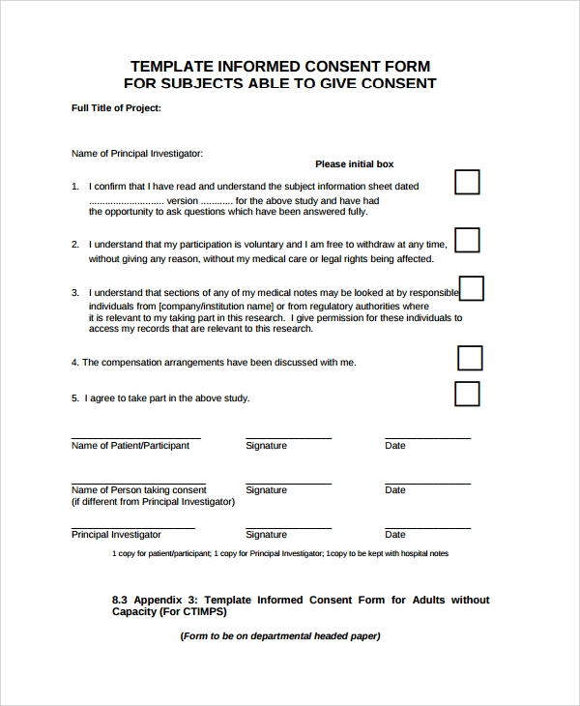
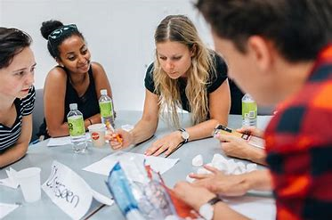
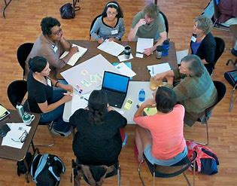

REFERENCES. Eberson, A. (2002). 360participation - » The Importance of Young people participation in the process of creating youth policy. [online] 360participation.com. Available at: https://360participation.com/the-importance-of-young-people-participation-in-the-process-of-creating-youth-policy/?fbclid=IwAR19YUDyxktnvJYvrxkiCi0LH2j1imuel-0MKw3yud0_6k34cpWLOmX3ChI [Accessed 8 Dec. 2019].
NSPCC Learning. (2000). Research with children: ethics, safety and avoiding harm | NSPCC Learning. [online] Available at: https://learning.nspcc.org.uk/research-resources/briefings/research-with-children-ethics-safety-avoiding-harm/?fbclid=IwAR1h5kxPpfdYQqa0SeozGNeY47m0Aw4VHi-Qtp88nshw6qC4fuhF80kMdW0 [Accessed 8 Dec. 2019].
Anon, (1992). [online] Available at: https://www.researchgate.net/figure/Harts-1992-Ladder-of-Participation_fig1_321783095 [Accessed 15 Dec. 2019].
Ons.gov.uk. (2018). Domestic abuse in England and Wales - Office for National Statistics. [online] Available at: https://www.ons.gov.uk/peoplepopulationandcommunity/crimeandjustice/bulletins/domesticabuseinenglandandwales/yearendingmarch2018?fbclid=IwAR2ylvFSjK4q3-Y8YJbv7d_nlpZpKkZTcuyCNcUdYncuhM4Fy2uHilLExr0 [Accessed 29 Dec. 2019].

