
Motivation - Motivation for learning is therefore essential, for all learners to create their own meaning and understanding from similar stimuli, this can be difficult due to the difference in motivations for different children. Marcus, 2016; Rutter, 1987; Cefai, 2008) suggest that motivation has a large effect on the learning that takes place in the classroom, where schools who promote resilience and motivation allow children to create their own conditions for learning. This is agreed by (Siraj-Blatchford, 1999; Davis et al, 2016). It is therefore important that teachers understand what children’s individual needs are in order to help them learn as asserted by (Florian, 2008; Lindsay, 2007; Marcus, 2016). Engagement is crucial for children’s ability to learn and therefore create meanings. Behaviourist theorist’s such as Skinner (2014) and Watson (2017) maintains that rewards and conditioning are critical in creating children’s motivation.

What is Cross curricular learning –Barnes and Shirley 2007) delivering cross curricular themes teachers should : Identify and focus on clear appropriate subject learning objectives, Continually monitor the depth of understanding, informal assessment, Avoid compromising subjects in effort to fit them in, give children early opportunities to apply newly learned skills and knowledge, Generate genuine question stance, Be prepared to intervene in any group activity in order to help raise standards. Interdisciplinary/cross curricular teaching provides a meaningful way in which students can use knowledge they have learned in one context as a knowledge base in other contexts in and out of school (Collins, brown and Newman, 1989).

Whole school Approach
It is important that a school creates a whole school approach when implementing Cross curricular learning, this should start early on, allowing children the ability to get better and used to this approach of learning. Gardner (2000) and Barnes (2013) suggest there are fundamental beliefs that are taught early in school, where these beliefs become difficult to shift as a teenager. This approach must be used as a whole school approach building on children’s understanding throughout this period. Barnes (2015) shows in his case studies 2,3 and 7 that schools help provide the construction of hopeful futures, becoming cohesive cultures, modelling a sustainable and supportive community (Barnes, 2015). Learning must replicate the world beyond school, by mimicking the conditions faced with jobs being inherently cross curricular, this experience allows children a leg up, helping their experience before they start work. Wenger (1998) suggests experiences allow children to create meaning and understanding. The effectiveness of the community in helping children learn is increased or decreased by the amount of social capital that is available.

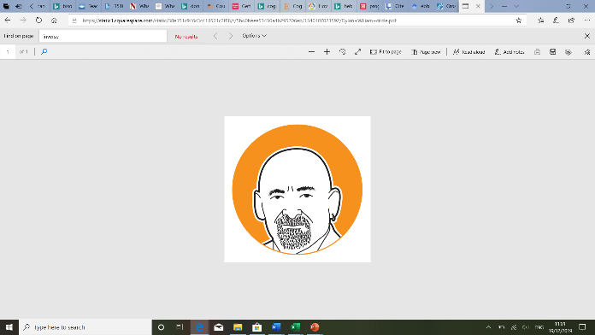

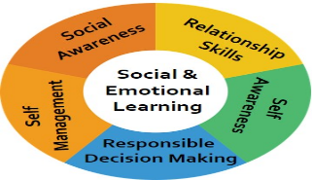
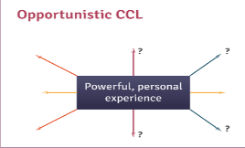
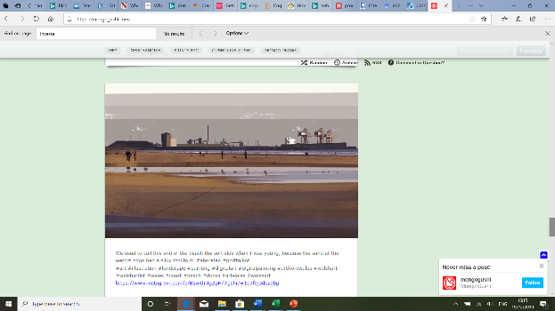
(rubicon, 2019)
Social emotional learning
Immordino-Yang and Damasio (2007) believe personal emotions direct their behaviour. However they suggest there is not much time during the curriculum to use this approach effectively. Goodman and Gregg (2010) however suggest there has been a shift In policy making, where policy makers have provided a focus on children’s emotional and social learning. Immodino-Yang and Faeth 2010; Bechara & Damasio, 1997 stress the importance emotional wellbeing has on learning, Immordino-Yang and Damasio (2007) state that emotion is alike a rudder, which guides the learning. Emotional wellbeing has a big effect on how children learn, it allows them the ability to process more information, preparing them for learning. Fredrickson 2009 and Dweck talk about the importance of positivity and the growth mindset, This is agreed by Cope and Whittaker (2012) who believes positivity and wellbeing allow children to find success. Barnes (2015) shows most cognitive psychologists point to a number of influences on children’s thinking and learning. Barnes (2015) points out self-confidence, metacognition, heredity, peers examples and perceived relevance for learning, which affect the ability for children to achieve. This means that there are many factors influencing the ability children have to take learning on. Barnes, 2015; Entwistle, 2000; Fisher, 2008 show the enormous advantages of children having the ability to examine their own thought processes. Sternburg’s (1997b, 2003) views on learning suggest that children require good memory, intelligence and analytical, creativity and practical ways of thinking. Suggesting the need for children to engage in differing contexts of learning, helping develop their thinking development. Cognitive psychologists believe there is a great importance of creating meaning. Bruner, 1996; Csikszentmihalyi, 1997; Marton and Booth, 1997) believe creating meaning from personalised language of learning is essential to allow this understanding to become engrained into children’s memory and therefore be useful. This point is agreed by Perkins (2009) who believe relevant context learning sticks and is transferrable, where Barnes states “cross curricular approaches provide fuller understanding of real world experiences” (Barnes, 2015, pp167).

(Oli Cav, 2019)
Barnes (2007) suggests the school is required to have a whole school policy which allow long term tracking and assessment for learning. This can be created by individual appraisal and promotes the teacher's professional judgement Barnes (2015). During this lesson I would be tracking information using Kinteract, it is an interactive tool in which parents and children can be involved in the process. Being able to track progress and understand where the child needs to go next in their learning is crucial. Christodoulou (2017, pp, 162) states “testing doesn’t just help measure understanding; it helps develop understanding”. An AfL approach looks at the learner's holistic engagement within the learning and assessment process, providing feedback which allows the learning to move forward.. ‘Assessment for learning should recognise the full range of achievements of all learners’ (Assessment Reform Group, 2002). The (QCA, 2008) supports the idea of practitioners looking at the whole child when evaluating the effectiveness of learning. This is enabled when using a variety of subjects, this allows the teacher the ability to see if learners can transfer their knowledge to different contexts.

(Osiriseducational, 2019)
(Osiriseducational, 2019)
(Mongo Gushi, 2019)
Hierarchical Cross curricular learning – Lesson 2
The second approach and lesson I have created is using a hierarchical cross curricular (BENEFITS AND LIMITATIONS approach to learning. This approach is where learning from one subject, in this instance Art helps the development of other subjects (Barnes, 2015). In this lesson the class will be looking at the work of local artist Mongo Gushi. This style generally uses landscape pictures of the local area. This will allow the class the ability to connect with the art and create a relevance. This links to Curriculum Cymreig where children should be given opportunities to learn about their local area and use their local are to develop learning (Welsh Government, 2008). Using pictures from a Facebook page called Port Talbot Old and new, children will be able to see the history of the town and what it had once looked like. They will use these images create an art piece using their own interpretation of the picture, looking at the mood and the colours of the picture to develop their understanding of the town. They will be creating a piece of writing to show their understanding of the town and the history using the pictures. Within the English part of the lesson the class should “Craft their writing by using the standard forms of English (Welsh Government, 2008, p. 12). The class will write an introduction that establishes context, a series of appropriately ordered points and a suitable conclusion (Welsh Government, 2008, pp11) In art and design, learners develop at first hand a meaningful understanding of their immediate environment, culture and language. They are given access to historical and contemporary Welsh art and design, enriching their creative activities (Welsh Assembly Government, 2008,P. 8). In a mathematics context, the class will identify the appropriate steps and information needed to complete the task or reach a solution (Welsh Assembly Government, 2008, p. 2). When comparing dates and looking at number problems using dates. The class will also check their answers using inverse operations, showing their workings to check their answers (Weksh Assembly Government, 2008, p.5). The class will create this piece of artwork using software where they can edit the picture and add colours and develop what specific arts of the picture they want to add attention to. Investigating - Pupils should be given opportunities to: 1. select and record from: • observation • experience • memory • imagination 2. investigate: • the natural environment • the made environment • the world of imagination using a variety of materials (Welsh Government, 2008, pp12).DCF Outcome 3 - select and combine a range of text, image, sound, animation and video to produce an outcome for a selected purpose; use software tools to enhance the outcomes for specific audiences.(DCF) use a range of software to produce and refine multimedia components. Using the art from mongo gushi, the class will produce an art piece, using different components they have learned from the town, and the artist. This will be heavily influenced by the high pollution levels seen in port Talbot and culture of Port Talbot. Hierarchical cross curricular learning aims to achieve progress in one discipline by teaching aspects of another subject. The idea of using cross curricular allows the learning to be flexible, teachers can adapt their practice according to children’s likes and dislikes, allowing more time for certain types of activities to learn. Barnes (2012) agrees suggesting that this allows children to generate creative thinking. However I know this approach needs to be carefully introduced by the teacher and carefully planned as the DfE (1999) shows there is no national guidance on this approach to teaching, suggesting more content is added without the expertise to match this. Barnes and Shirley agree saying that many teachers do not experience cross curricular approaches in training and often had limited experience when they were students. Barnes (2012) believes that assessing learning can be difficult due to the differing nature of subjects being introduced at the same time, suggesting that some children become confused. However Rowley and Cooper (2009) suggest that cross curricular learning assess the whole child, often showing learning in differing contexts.

Opportunistic Cross curricular learning – Lesson 1
A group of lessons will provide children with a wide depth of knowledge and understanding of their local area and knowledge of what happens in their town. These lessons will be aimed at Year 5 . The first cross curricular theoretical model I will be using is what Branes (2015) calls an Opportunistic cross curricular approach, Barnes (2015) suggests this method is where “children and teacher share a powerful personal experience, such as a visit, visitor, or other powerfully presented stimulus. The teacher, or teaching assistant, listens carefully to children’s reactions, observing changes in behaviour” Barnes (2015, pp, 273). Before the cross curricular session, the class has been on a trip to the local steel works where they had learned about the process of creating steel, what materials is required, how much energy is needed to produce steel. On this trip the class had to come up with questions following a lesson on the production of steel and the history of our area. Curriculum Cymreig - Learners aged 7–14 should be given opportunities to develop and apply their knowledge and understanding of the cultural, economic, environmental, historical and linguistic characteristics of Wales. (2008, pp, 8). This lesson will link to the Chronological awareness, looking at dates when the steel works were created and other prominent days such as when the new blast furnaces were put in place. Pupils should be given opportunities to: 1. use timelines to sequence events, 2. use appropriate key words to estimate, measure and describe the passage of time (Welsh Government, 2008, pp12). The Range - Pupils should develop their historical skills, knowledge and understanding through learning about a range of historical contexts. These should be based primarily on the local area (Welsh Assembly Government, 2008, pp12). Some children’s parents work in the steelworks and so their personal experience and knowledge helped the children understand some of the more complex nature of the steel making process. Following the visits of steel workers, telling stories and helping children’s understanding and a visit to the site in Port Talbot. Ofsted (2010a) show that some schools use “wow” experiences in order to engage children emotionally, driving the child to want to understand more. In these series of lessons I will be using the experiences from the trip to understand the history of our local area, we will be looking to create an online interactive experience where children will recount experiences online using children’s ideas on what method they want to use to present their findings, such as a podcast as a group, QR codes, using pictures and videos taken at the Steel works in order to create a Virtual reality experience or a YouTube vlog style experience as groups. These projects will be uploaded on to SeeSaw, where restricted access for parents teachers and children is available. Maths – In maths the class will be using statistics of the costs of producing and selling steel, these numbers will be simplified for the year 5 class, using numbers up to 100,000 for the children at the levels 4 and 5, this can be differentiated for certain learners. . They will figure out problems with the data relating to how much steel needs to be produced. At Level 3 Learners organise their work, check results, and try different approaches. They talk about and explain their work (Welsh Assembly Government, 2008, pp, 13). Level 4 Learners develop their own strategies for solving problems, and present information and results systematically. They search for a solution by trying out ideas of their own (Welsh Government, 2008, pp13). Using data skills, the class will represent data using : lists, tally charts, tables, diagrams and frequency tables – bar charts, grouped data charts, line graphs and conversion graphs • extract and interpret information from an increasing range of diagrams, timetables and graphs (including pie charts) • use mean, median, mode and range to describe a data set (Welsh Government, 2008, pp, 11). LNF interpret answers within the context of the problem and consider whether answers, including calculator, analogue and digital displays, are sensible, using exemplification materials drawing conclusions from data and recognise that some conclusions may be misleading or uncertain. English – During the English lesson the class will speak about the ecological problems the steel works has caused, where they will present their ideas as groups and have a class discussion on the matters of pollution and the affect on our local area. The class will explain information and ideas, exploring and using ways to be convincing, e.g. use of vocabulary, gesture, visual aids. develop their ability to use a wide range of syntax structures, vocabulary and terminology in their talk. explore issues and themes through role play pp 3. listen to others, asking questions and responding to both the content and the speakers’ viewpoints. express opinions about topics and written texts and include some supporting reasons pp4. Level 4 Learners talk and listen with confidence in an increasing range of contexts. Their talk is adapted to the purpose. Level 3 Learners talk and listen confidently in different contexts, exploring and communicating ideas. In discussion, they show understanding of the main points. LNF gather and organise information and ideas from different sources. Welsh Assembly Government (2008) DCF framework, the class will be using VR cameras iPad’s uploading things saving files using it to present their findings. – Outcome 3 modify and present a range of text, image, sound, animation and video for selected purposes. combine a range of multimedia components to produce an appropriate outcome. DCF Outcone 3 create, collect and combine a range of text, image, sound, animation and video for selected purposes. Voogt and Roblin (2010) state that digital competence are an essential set of 21st century skills. This can be seen in a European context as the European Parliament has set out digital literacy as one of the 8 key competencies for lifelong learning. Alternatively Yelland (2006) suggests that often technology is used through a curriculum that has been created before these new technologies had been created, therefore not allowing technology to be used to it’s potential and can become problematic. The (DCFS, 2005; QCA, 1999) found that technology created enjoyment for children…

Estyn (2015) show good practice in Ty y Wern Primary Schooll ensure they provide a broad curriculum, allowibg children the ability to experience stimulating learninv experiences. Fletcher-Wood (date) suggests deep learning isn’t purely based on a plethora of knowledge but an organised mental model of learning. Donaldson (2015) has suggested the use of areas of learning allow teacher to provide close ties between learning, building a web of learning

