A study to explore the word length effect
Introduction
Memory is the ability to preserve information/past events, based on the mental processes of learning or encoding, retention across periods of time and retrieval of the memory (APA, 2022). Memory is essential to the society, within everyday life, in storing information and experiences and recalling them at a later time. Without memory individuals would be unable to perform everyday tasks, an example is the properties of objects – a microwave, without having to relearn every step (Tulving and Craik, 2005). There are many theories in connection to memory, one of these being the Working Memory Model, created by Baddeley and Hitch (1974) and Baddeley (1992). The working memory model contains attention controlling executive; accountable for binding information and comprises of three storage components: the phonological loop; stores and processes sound, the visuospatial sketchpad; similar to phonological loop in regard to proceeding section, except this is a visually presented stimuli and the episodic buffer; limited capacity store capable of multidimensional coding (Hills and Pake, 2016). The phonological loop; the minds ear, is where each individual stores and processes sound. Within the phonological loop there is two components, first the phonological store has auditory memory traces that are subject to rapid decay and second, the articulatory rehearsal mechanism that can revive the memory traces (Harrison, 2010). Longer words within the articulatory process, within the phonological loop, take longer to run than that of short words (Longoni et al, 1993).
The word length effect: a cognitive experiment investigating memory span indicated that individuals could remember a greater number of shorter words than longer words (APA, 2022). The word length effect is traditionally explained by the increased complexity of longer items (Neath and Nairne, 1995) or as Baddeley (1986 and 2003) explains as an increasement of rehearsal time of longer items. The shorter the rehearsal time for a word, the easier it is for more words to be recalled. Whereas the longer the rehearsal time of a word less words are able to be recalled.
According to Baddeley et al (1975), individuals are more capable at recalling shorter words than longer words. Baddeley et al (1975) investigated the word length effect by running an experiment. Participants were told a number of words out loud and then, once they hear the word ready, recall the words that the researcher had called. This indicated that the participants could recall more short words than longer words. Furthermore, Cowen et al (1992), investigated the word length effect on immediate memory. Similar to Baddeley et al (1975), Cowen et al (1992), selected stimuli through the use of long and short words. They concluded that the spoken duration was the main factor rather than the number of syllables within the word; spoken duration can be varied yet, the amount of syllables can be held continuously; Wicket and Labile (Neath et al., 2003). Moreover, Ellis and Hennelly (1980), did a similar study to that of Baddeley et al (1975) and Cowen et al (1992), however, this was a bilingual word-length effect, Welsh, and English. Their research was done over five experiments, with 20 individuals, aged between 20-30 years old. They concluded that within bilingual subjects that the Welsh digits took far longer to articulate than the English equivalents. Ellis and Hennelly discovered that Welsh speakers actually scored lower on IQ tests than that of English speakers. The differences between both languages were attributable to the word length differences, rather than intellectual differences. Through these calculations, Ellis and Hennelly found through their research, predicted that the mental calculations within the Welsh language are more difficult than that of English language (Ellis and Hennelly, 1980).
The study to explore word length effect, that has been undertaken for this report, is a partial representation of the Baddeley et al (1975) study. The purpose of this experiment/study on word length effect is to underpin the stress that is caused within the education system, in regard to, overloading cognition ability.
The aim of this word-effect report is to explore whether the word length effect truly exists and also, whether word effect affects the participants’ memory through word recall.
Hypothesis
Participants will recall significantly more short words than long words.

Method
Design
A within-subjects design was used. There was one independent variable with two conditions: the length of long and short words. There was one dependent variable: how many words were recalled. Participants took part in both conditions of the experiment.
Participants
A convenience sample of 26 participants completed both conditions of this study: 26 females and no males. Ages ranged from 18-49 years (M= 29.42; SD = 3.79 years). Participants were all undergraduate students from West Wales who took part in the study. All participants were naïve to the purpose of the experiment.
Materials
- Computer
- Large screen
- Pen and paper
Stimuli used were two lists of words: one with 15 short words and one with 15 long words, chosen by the chief researcher.
The short words included: paid and mood (see appendix 1).
The long words included: illuminate and forgiveness (see appendix 1).
The words presented were white in colour on a blue background in arial font size 72. The words were presented to the participants for 1 second and then the next word was displayed after another second.
Procedure
(See appendix 2).

Results
The following results present the findings for the study word length effect.
Chart 1
Median scores for the recall of long and short words.
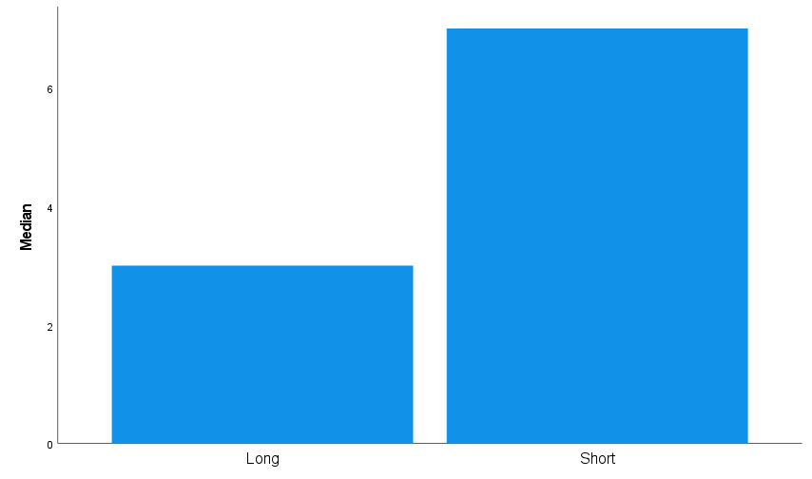
The chart above shows the median scores for long and short words. The median for short words were higher than those of long words.
To examine if the median scores for both conditions are significantly different to the probability of .05, the non-parametric Wilcoxon statistical test was carried out.
A Wilcoxon signed-rank test showed a significant difference between the long and short words condition (Z = - 4.136, p = .001). Median recall scores for short words were significantly better than for long words (7.00 and 3.00, respectively).
The results indicate that the hypothesis that participants will recall significantly more short words than long words was supported and provides support for the word length effect.

Reference List
American Psychological Society. (2022). APA Dictionary of Psychology: Memory. Dictionary.apa.org https://dictionary.apa.org/memory
American Psychological Society. (2022). APA Dictionary of Psychology: Word-Length effect. Dictionary.apa.org https://dictionary.apa.org/word-length-effect
Baddeley, A. (2012). Working Memory: Theories, Models, and Controversies. Annual Review of Psychology, 63(1), 1-29. https://doi.org/10.1146/annurev-psych-120710-100422
Baddeley, A. D. (1986). Working Memory. Oxford, England: Oxford University Press.
Baddeley, A. D. (2003). Working memory and language: an overview. J. Commun. Disord. 36, 189–208. https://doi.org/10.1016/S0021-9924(03)00019-4
Baddeley, A. D., & Hitch, G. (1974). Working memory. In G.H. Bower (Ed.), The psychology of learning and motivation: Advances in research and theory, 8, 47–89. New York: Academic Press.
Cowan, N., Day, L., Saults, S., Keller, T, A., Johnson, T., & Flores, L. (1992). The role of verbal output time in the effects of word length on immediate memory*1. Journal Of Memory and Language, 31(1), 1-17. https://doi.org/10.1016/0749-596x(92)90002-f
Ellis, N. C., & Hennelly, R. A. (1980). A bilingual word‐length effect: Implications for intelligence testing and the relative ease of mental calculation in Welsh and English. British Journal of Psychology, 71(1), 43-51.
Harrison, M. (2010). Memories of Unsoiled Decay. Kiwi Press, pp. 36-40. https://books.google.co.uk/books?id=e2zFAgAAQBAJ&pg=PA36&lpg=PA36&dq=The+phonological+loop+(or+%22articulatory+loop%22
Hills, P., & Pake, J. (2016). Cognitive psychology for dummies. John Wiley & Sons, pp. 10-28.
Longoni, A.M., Richardson, J.T.E. & Aiello, A. (1993). Articulatory rehearsal and phonological storage in working memory. Memory & Cognition, 21, 11–22. https://doi.org/10.3758/BF03211160
Neath, I., and Nairne, J. S. (1995). Word-length effects in immediate memory: overwriting trace decay theory. Psychon. Bull. Rev. 2, 429–441. https://doi.org/10.3758/BF03210981
Neath, I., Bireta, T., & Surprenant, A. (2003). The time-based word length effect and stimulus set specificity. Psychonomic Bulletin & Review, 10(2), 430-434. https://doi.org/10.3758/bf03196502
Tulving, E., & Craik, F. I. (Eds.). (2005). The Oxford handbook of memory. Oxford University Press.

Appendices
Appendix 1:

Appendix 2:

Appendix 3:

Appendix 4:

Appendix 5: Raw Data
Condition 1: Long words | Condition 2: Short words.
3 | 5
4 | 6
4 | 7
2 | 3
3 | 9
3 | 7
4 | 7
4 | 9
2 | 7
3 | 6
6 | 8
7 | 9
3 | 7
5 | 7
4 | 7
5 | 4
3 | 8
3 | 3
6 | 8
3 | 4
4 | 7
4 | 3
2 | 3
1 | 3
2 | 2
3 | 7

Appendix 6:
Medians and SD for long and short words.

Wilcoxon Signed ranks test.


