Question 3: Outline a pair of opposites discussed in the lecture series. For example ‘weight and light’: ‘silence and noise’: ‘ephemeral and permanent’, Showing examples of 2 artists and 1 writer who have explores these opposites in their work
Student Number: 1802758
Course Title: Fine Art Studio Sit and Context
Module title: Research in Context ADAD5003
Word count: 2412
Tutor's name: Alex Duncan

The Original and Simulacra
The original and the simulacra. Which is more important and what does this mean for the future of art?
“A simulacrum is the representation or imitation of a thing or person.” (Lexico Dictionaries | English, 2019)It's a fake version of something. While the original is the person or object the copy is based off. It's only in the late 16th century that the word had been ascribed to the behaviour of mimicking. What are the boundaries of simulacra? When is the copy, not the copy? When is the imitation too far? And what are the parameters you have to meet to be able to call something simulacra?

Simulacra is difficult to explain it is either fake, pretend or imitation. Yet, pretending is behaving as if something is the truth when the pretender has the knowledge it is not. This can be relevant to the creator of the object but the knowledge and the perspective of the audience are what empowers the title of simulacra. One example of this is to think of the perception of the simulacra. The audience can view work such as Ai Weiwei’s ‘Fountain of Light’ which was inspired by Tatlin’s tower, this was a design for a monumental building by the Russian artist and architect Vladimir Tatlin, that was never built. (Architectuul.com, 2019) But does the inspired mean copy? It does not have to, but often that is what happens. Some would agree that Ai Weiwei’s piece, is a representation of Tatlin’s tower and is simulacra - but the artist never stated this. As that is his perception and he is the creator does that mean it is not simulacra? This blurs the boundary between imitation and inspiration. It must be asked what are the characteristics of simulacra? Are simulacra solely based on perception? In Figure 1 and Figure 2 we can see a direct likeness in the structure of the pieces through the winding architectural layers, visually proving the original to be ‘Tatlins Tower’ and the simulacra to be the ‘Fountain Of Light’.
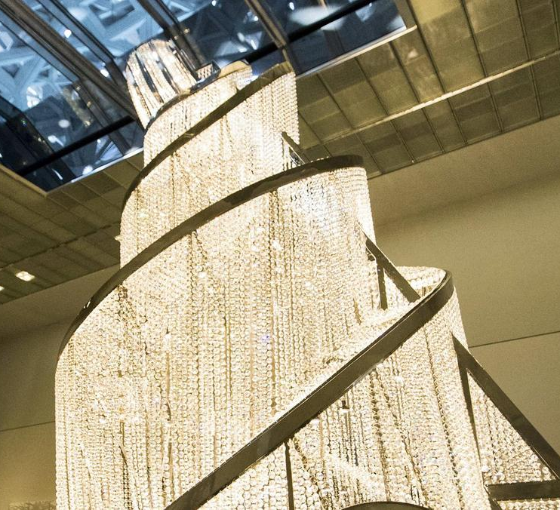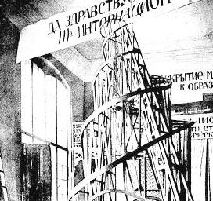
Figure 1 Ai Weiwei’s Fountain of light (The National, 2019) Figure 2 Tatlin’s Tower(Architectuul.com, 2019)

The notion of the simulacra is inevitable, the imitation of something else is an evolutionary trait it is necessary for survival. We witness the world through our interactions with others, learned behaviour from our parents, friends and even strangers shape our response to the world. The nature of simulacra is referenced in the biology of living things, an example of this is mirror neurons which are active both when we complete an acton and when we see someone else do the same action. “The mirror neuron system for actions in humans is directly involved in imitation, in the perception of communicative actions, and in the detection of action intentions”(Bayne, Cleeremans and Wilken, 2014) The mirror neurons detect the action that another animal is doing, sees that its safe and imitates it. This notion has evolved but not by much, it is now focused on the success of an idea and then imitating that to profit. The current state of the modern world means that we are surrounded by knock offs of copies of fakes. We imitate behaviour, clothes, styles, ‘likes’ and ‘dislikes’. Entire people. We discard ourselves to become someone else constantly growing into another. We are a representation of our younger selves “One is not born, but rather becomes, a woman.” (Beauvoir, Borde and Malovany-Chevallier, 1949) this means that you grow through experience the good and bad necessary to become a woman you are not born with the right to be a woman. There is also the repetition of history that can be used to reference simulacra whether it is through learned behaviours such as war or a more academic approach such as mimicking successful architecture, like the Great Wall of China, made to keep out the enemies of China it is seen as a symbol of protection but it also kept the Chinese citizens from leaving. That is the original and Trump’s idea, to build a wall to keep people crossing over illegally, the copy. The importance of the original influences the reasons for choosing the original to make a fake from. The original is what the simulacra is based off, in some context, it's what gives the copy its power. To represent a god; considered a higher power the copy is statues or to copy an original design and manufacture copies. the reputation of the thing and the artifice of the simulacra dictate the success.

Gavin Turk uses simulacra in his work constantly but in a different way, he uses his skill to manipulate the meaning of the original, creating life-size casts of objects and painting them to exact perfection. Which means that deciphering which is the original would be impossible when they are staged in the same location. The power of the simulacra is most obvious when staged in such a way as the artifice of the creation is unquestionable, causing intrigue of the thing and giving reputation to the artist for the successful simulation of the object. “So the very same objects are metamorphosed from worthless to valuable - even beautiful - just by a change of mental gear.”(Gayford, 2019) This method is awakening, people expect statues and clothes and even nature to be faked but to fake but Turk chose rubbish to imitate, it causes more of a reaction. In this case, the original is the object as it exists in its raw form and the simulacra are Gavin Turk’s imitation of the object.

But there are other types of repetition as well, the false representation in media is a huge example of simulacra. One aspect of this is Deep Fake, an altered video to present something that never occurred. What it means is that some of these are inconspicuous in their execution, leading to the public as a collective mistaking the content as truth forming a hyperreal. The damage of a fake, a flawed representation of a thing will lead to misinterpretation of that thing affecting the original person or object. A hyperreal: “The inability of consciousness to distinguish reality from fantasy, especially in technologically advanced postmodern cultures.”(Definitions.net, 2019) The original, an actress in a scene and the deepfake is Nicholas Cage’s face in place of hers. This example was chosen because the extent of this particular deepfake is the recreation of the entire scene with the ‘Nicholas Cage fake’ following the expressions, behaviour and mannerisms that the actress originally used. This represents the original being any movie scene used and the representation of the simulacra is Nicolas Cage’s face deep faked onto any movie scene.
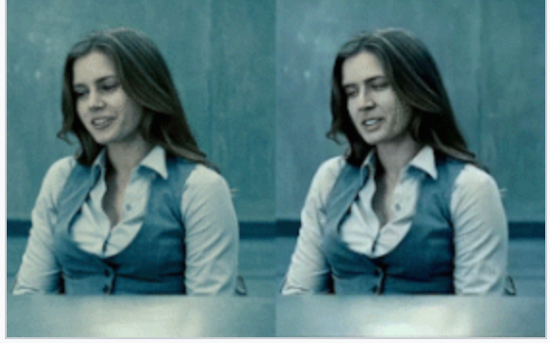
Figure 3 (Sharf, 2019)

Something that has the ability to contradict art simulacra is virtual reality. Computer-generated simulation of a three-dimensional image or environment that can be interacted with in a seemingly real or physical way. A big reason for contemporary art was the invention of photography, the artist could not compete with photorealism so they did not try. With VR stands the same logic. “I’ve always enjoyed the film, but I'm a little afraid of it because I think it is very powerful as a medium. You have the visuals, the sound, the colours, all of these things coming at you, and they transport you physically so it becomes this surround sound, virtual reality.”(Thomas.M, 2019) VR is able to copy the environment in a way the artist using traditional means never could. This presents the possibility of a threat to art as once again it is made obsolete. For part of the reason, simulacra have been so mainstream is the ease of it especially in manufacturing. VR provides perfect copy worlds. Though it is possible that since their techniques are so far from each other the impact will be lessened as both have the ability to stand out in different ways. In this case, the original is the real world and the simulacra are the fake online world. Art will always have more context for existing, the meaning behind the copy.

“The simulacrum is never what hides the truth— it is truth that hides the fact that there is none. The simulacrum is true.” (Baudrillard and Glaser, 2018) The simulacrum in this instance is the representation of the people the movies are about. Pocahontas, real name Amonute aged 11-12 and died in England of either pneumonia or tuberculosis,(Biography.com, 2019) and Mulan, whose real tale is unknown but one has been pieced together through fables and ‘the ballad of Mulan,’ were real people in history whose stories were twisted into idyllic westernised renderings. Westernised interpretations often glorify oppression and war downplaying its role in participating in the destructions of people and their cultures. The original is the untold correct stories. Simulacra can often reveal the truth, in this case, it is the lengths people are willing to go to make money. Some argue that this was simply to make the story family-friendly, however, if the story has to be distorted to such an extent, to be suitable to show to the target audience it should not be used. “Today cinema can place all its talent, all its technology in the service of reanimating what it itself contributed to liquidating. It only resurrects ghosts, and it itself is lost therein.”(Baudrillard and Glaser, 2018) In some instances, this habit of recreating, again and again, has created a hyperreal surrounding the stories as few searches for the history and so the movies are taken as based in truth when really they are more based and a re-telling of a re-telling. The original and the copy are once more obscured.

The simulacra, the copies are made into hyperreals by the power they hold the context for their creation, one opinion is that this can account for the existence of God. That the image of God is a thing of power and without the image, there would be no power of the simulacra. It has previously been stated that the simulacra’s success is parallel to the reputation of the original but this is the case of the simulacra causing the reputation, though the misconception of a higher being. “But what if God himself can be simulated, that is to say, can be reduced to signs that constitute faith? Then the whole system becomes weightless, it is no longer anything but a gigantic simulacrum - not unreal, but a simulacrum, that is to say never exchanged for the real, but exchanged for itself, in an uninterrupted circuit without reference or circumference.”(Baudrillard and Glaser, 2018) The hyperreal created would be the religion, something so powerful and terrifying could be fake, but without a way to break the cycle and prove it real or false, it will continue as we are unable to distinguish fantasy from reality. This theory stands for religions following idols but Islamic religion has no idols, statues to praise. This theory does not work for all religion.

A contrasting example of original is when the original is made not by the artist but by another party with the rights to the design to create the original. This is what happened for the making of ‘The Gates of Hell’ by Rodin “ thus ‘the Gates of hell’ cast in 1978 by perfect right of the state, is legitimate work.” Although an issue with this method is the debate of this being a true original, as we are the sure knowledge that if Rodin had cast this piece it would look different as the artist was known to move around the figures of his work as he felt, does this mean the piece is not original? Merely a copy, “we could say that all casts of ‘The Gates of Hell’ are examples of multiple copies that exist in the absence of the original.” (Phillips and Wallis, 1984) The original design was copied to create the work we see today in this they are not being called original as Rodin did not make them.
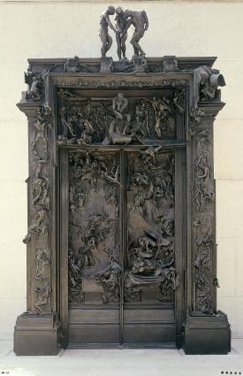
Figure 4(Musee-rodin.fr, 2019)

There are limits with a copy, the original will always hold more lasting power as it is the source. Simulacra can create the reputation but there would be no copy without the original. Some things are impossible to imitate to perfection without technology“There have been painted draperies whose folds who could probe, goblets we could place our lips, perspective interiors we might walk into, water we could bathe in, flowers and fruits whose perfumes we might inhale, but no face or form depicted upon a canvas has ever so far deceived the eye to be mistaken for reality.”(Schwartz, 2014) We as the artist has been successful in mimicking objects and things to the point of crossing the line between drawing and reality but still, the human figure alludes. This restriction can be thwarted with time but as of right now there are very few who have the skill to create photorealistic images and so the original maintains its status. Here we could say that the original is the artist inspiration and the simulacra are the artist’s creation.

Simulacra is the representation or imitation of a thing or person, that is the base of its meaning. However, the success of the simulation is dependant on the context of the copy. Simulacra can create a reputation both negative and positive if it is successful in its execution, it can make stories tangible making the original more accessible to the populace. A negative impact is the falsified story of the simulacra such as deepfakes which are harmful to the original. The original can also be responsible for the reputation of the simulacra though this is normally dependant of how much profit can be made from the original, or if the copy is a false depiction of the original. Also, there is of course when the copy has failed to imitate the original. These conflicting events are dependant on the audience and what they want to be real. Would you want to know when everything is a copy? Current society is fake. More now than ever that the world is reliant on fakes, there are more things, more people and more styles to imitate. There will always be copies when something works it safe and so is learnt by the rest. When it causes a positive reaction for yourself, people around will always try to emulate so that they can have the same reaction.

Figure list
Figure 1 Ai Weiwei’s Fountain of light (The National, 2019)
Figure 2 Tatlin’s Tower(Architectuul.com, 2019)
Figure 3 Deepfake of Nicholas Cage (Sharf, 2019)
Figure 4 Rodin’s ‘The Gates of Hell’ (Musee-rodin.fr, 2019)

Ai Weiwei, (2016), Fountain of Light [ONLINE]. Available at: https://www.thenational.ae/arts-culture/art/in-the-frame-the-story-behind-ai-weiwei-s-fountain-of-light-at-louvre-abu-dhabi-1.741574 [Accessed 8 December 2019].

Architectuul.com. (2019). Tatlin's Tower. [online] Available at: http://architectuul.com/architecture/tatlin-s-tower [Accessed 10 Dec. 2019].

Baudrillard, J. and Glaser, S. (2018). Simulacra and simulation. Ann Arbor: University of Michigan Press.

Bayne, T., Cleeremans, A. and Wilken, P. (2014). The Oxford companion to consciousness. Oxford: Oxford University Press.

Beauvoir, S., Borde, C. and Malovany-Chevallier, S. (n.d.). The second sex.

Biography.com. (2019). Pocahontas - Real Person, History & Death - Biography. [online] Available at: https://www.biography.com/historical-figure/pocahontas [Accessed 10 Dec. 2019].

Cohen, Andrew. AI WEIWEI. 2011. Web.

Definitions.net. (2019). What does HYPERREALITY mean?. [online] Available at: https://www.definitions.net/definition/HYPERREALITY [Accessed 9 Dec. 2019].

Gayford, M. (2019). I can't believe it's not rubbish. [online] Telegraph.co.uk. Available at: https://www.telegraph.co.uk/culture/art/3612044/I-cant-believe-its-not-rubbish.html [Accessed 10 Dec. 2019].

Iacoboni, M. (2009). Mirroring people. New York: Farrar, Straus and Giroux.
Kalhor, Marguerite Elizabeth. "Artifice & Superfice: An Analysis of Self-Media." (2017): 38. Web.

Lexico Dictionaries | English. (2019). Simulacrum | Definition of Simulacrum by Lexico. [online] Available at: https://www.lexico.com/en/definition/simulacrum [Accessed 9 Dec. 2019].

Musee-rodin.fr. (2019). The Gates of Hell | Rodin Museum. [online] Available at: http://www.musee-rodin.fr/en/collections/sculptures/gates-hell [Accessed 10 Dec. 2019].

Nietzsche, F. and Common, T. (2010). Thus spake Zarathustra.

The National. (2019). In the frame: The story behind Ai Weiwei's Fountain of Light at Louvre Abu Dhabi. [online] Available at: https://www.thenational.ae/arts-culture/art/in-the-frame-the-story-behind-ai-weiwei-s-fountain-of-light-at-louvre-abu-dhabi-1.741574 [Accessed 6 Dec. 2019].

Phillips, C. and Wallis, B. (1984). Art After Modernism: Rethinking Representation. 7th ed. USA: The new Museum of Contemporary Art.

Schwartz, H. (2014). The culture of the copy. New York: Zone Books.

Sharf, Z. (2019). Nicolas Cage Can Now Be Put Into Any Movie in History Thanks to A Machine-Learning Algorithm. [online] IndieWire. Available at: https://www.indiewire.com/2018/01/nicolas-cage-machine-learning-algorithm-deep-fakes-1201923224/ [Accessed 10 Dec. 2019].

Smith, Ali. Last. Vol. 138. 2009. Web.

The True Story of Pocahontas. [online] Smithsonian. Available at: https://www.smithsonianmag.com/history/true-story-pocahontas-180962649/ [Accessed 10 Dec. 2019].

Wildgoose, Jane. "Lasting Impressions: The Ambiguous Appeal of Life Casting." The Lancet 359.9314 (2002): 1353. Web.

