Analysis.
This chapter of the dissertation is the analysis part where the findings from the questionnaire are examined in more detail, so that we are able to understand or discover more about what we originally set out to do. Coding is known as a qualitative data analysis strategy, where some part or parts of the data will have a descriptive label so that the researcher is able to identify all its related content. The methodology should help you to decide whether your data needs coding. Your coding will come from the information gathered from your questionnaire (Kumar, 1999).
The stark truth of the criminal justice system for females within Wales can be incomprehensive unless you have been in this situation. From within the gathered results, not many of the respondents were aware of the happenings of female offenders. With there only being twenty – three respondents, the outcome for this is not as good as if there had been ten times more. Twenty – three participants is relatively small, so in this case, qualitative data would be the best to use rather than quantitative data (Denscombe 2017).
The Corston Report (2006) tends to focus upon the vulnerability of female offenders, plus it also takes into account that most of the offenders are mothers. The criminal justice system however do not take this into account, all they see are offenders regardless of if they are mothers or not (NICCO, 2018).
Research for this topic is needed because there seems to be a gap within some of the published literature that has regards to the treatment and any concerns which concern female prisoners. The majority of the data that does exist is broken and seems to be failing within its adequacies of trying to address all needs of female offenders. There needs to be an overall reform for women as to adapting to a shift so there can be more formal centred approaches towards their punishment (Ornella, 2020).
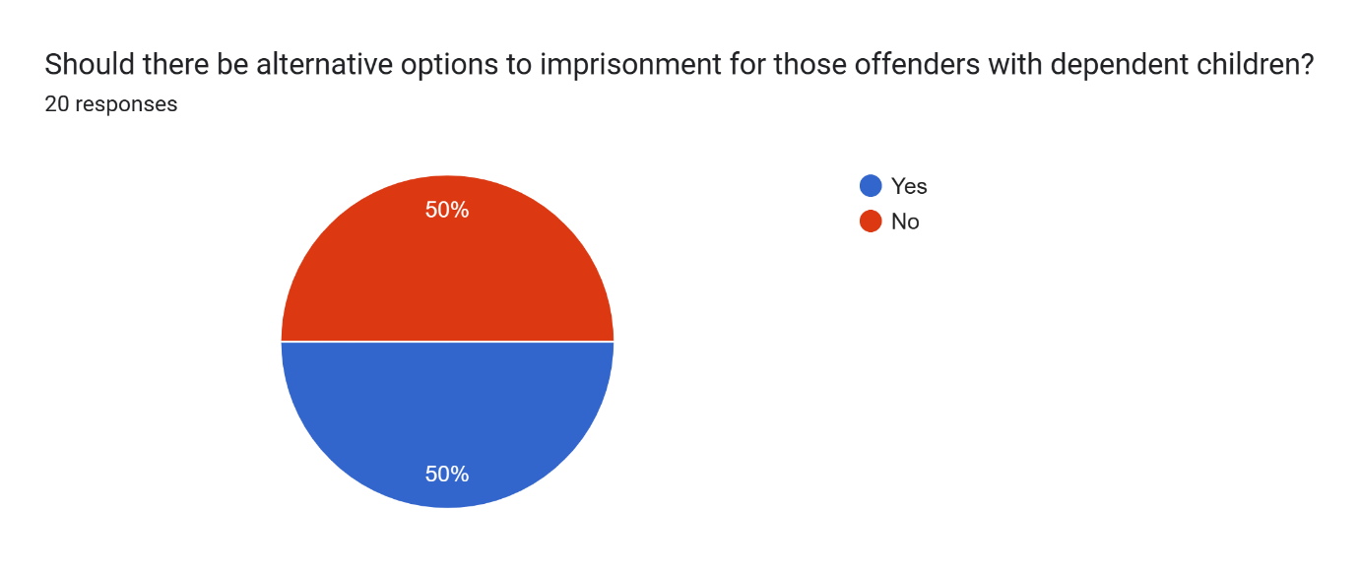

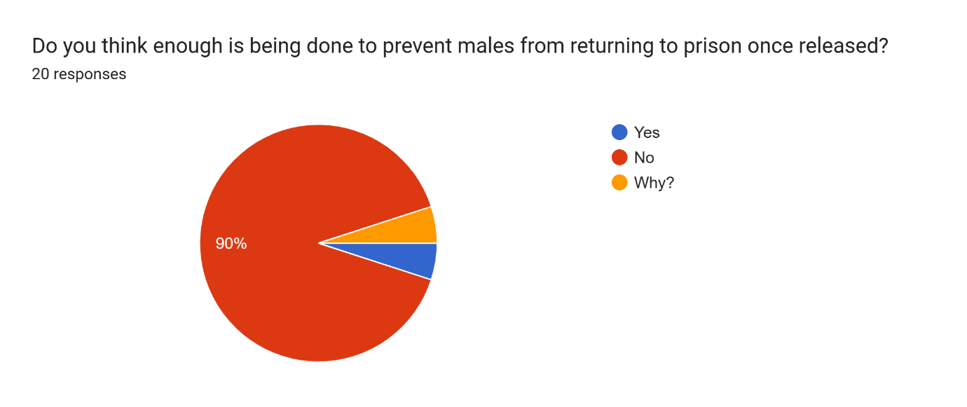

There were three objectives for the dissertation that mainly revolve around female offenders. The first was trying to identify the needs of these offenders within England and Wales. The outcome for this is much the same for both England and Wales. The second objective was to evaluate the treatment of female offenders in England and Wales. Not many of the respondents were aware that all Welsh female offenders have to travel over a hundred and fifty miles for a prison as there are no prisons for females in the whole of Wales. The treatment of all female offenders should be the same, no matter where they are placed to serve out their sentence. The third objective was to evaluate the publics perception of how prisons manage female offenders (Bell & Waters, 2014).
Women can often become neglected within the criminal justice system; they are known to become just another statistic. There should be more care and compassion for the female offenders. Custodial sentences should only be for the most violent and serious offenders. Since the Corston report, the harmful impact of being in prison upon the women and their children and the fact that most women only serve a short sentence still remains. These short sentences will have more of a detrimental effect upon these women, more needs to be done to try and prevent this. By getting to the root cause of why these women are in prison would be a great place to begin (Clinks, 2024).

