Module: Creative Practice 1
Module Code: M4X01557
Tiegan Hughes (1701231)
13/12/2018

For this project we were asked to create an animatic from a script we were given, which was written by our tutor which characterised his interpretation of the ‘Jabberwocky’ poem by Lewis Carroll as evidenced in the Explicator Volume 57(1999, pp. 86-88).
We all started off sketching our ideas of what we thought the characters looked like based off the actions they made in the script, we were not allowed to research into the Alice in Wonderland version and other peoples work as this may have influenced our approach to the design work. Alice in Wonderland is a very popular book with many versions which has also been interpreted by numerous illustrators.
We all chose the roles we wanted to experience, and we all agreed on those positions. Originally, I was supposed to be helping with the storyboards and designing the characters but Instead ended up colouring in Karol’s thumbnail scenes as several of the class members had already decided what they wanted to do individually. I also felt that decisions were made which were not representational of the whole group, as some team members were making decisions without the others’ opinions being considered.
For my design work I created the father and son (image below) I made the characters androgynous so that they had both male and female characteristics, I used colours such as pinks and purples to highlight their androgynous nature as these colours are viewed as feminine in society.
Originally the characters were decided to be giants but as a group we decided not to go down this route and chose to do Elven characters instead. There was disagreements on skin tone so we agreed on a unnatural skin tone such as blues, purples or greens.
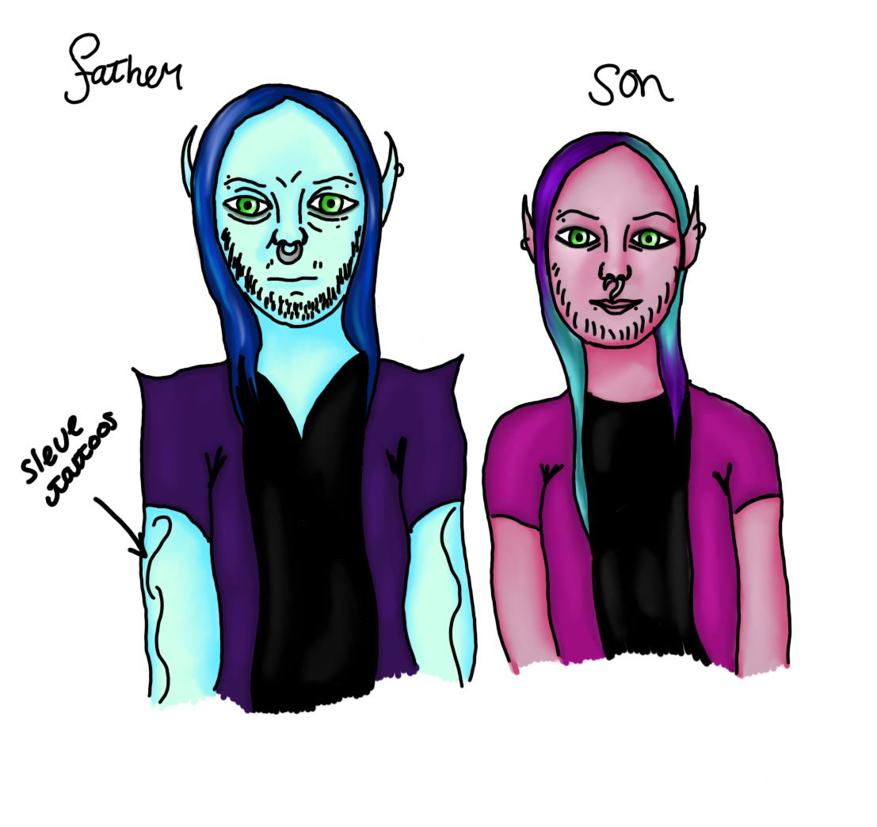
My characters weren’t taken into consideration I believe for not fitting in to preconceived ideas, as they wanted the stereotypical masculine protagonist character.

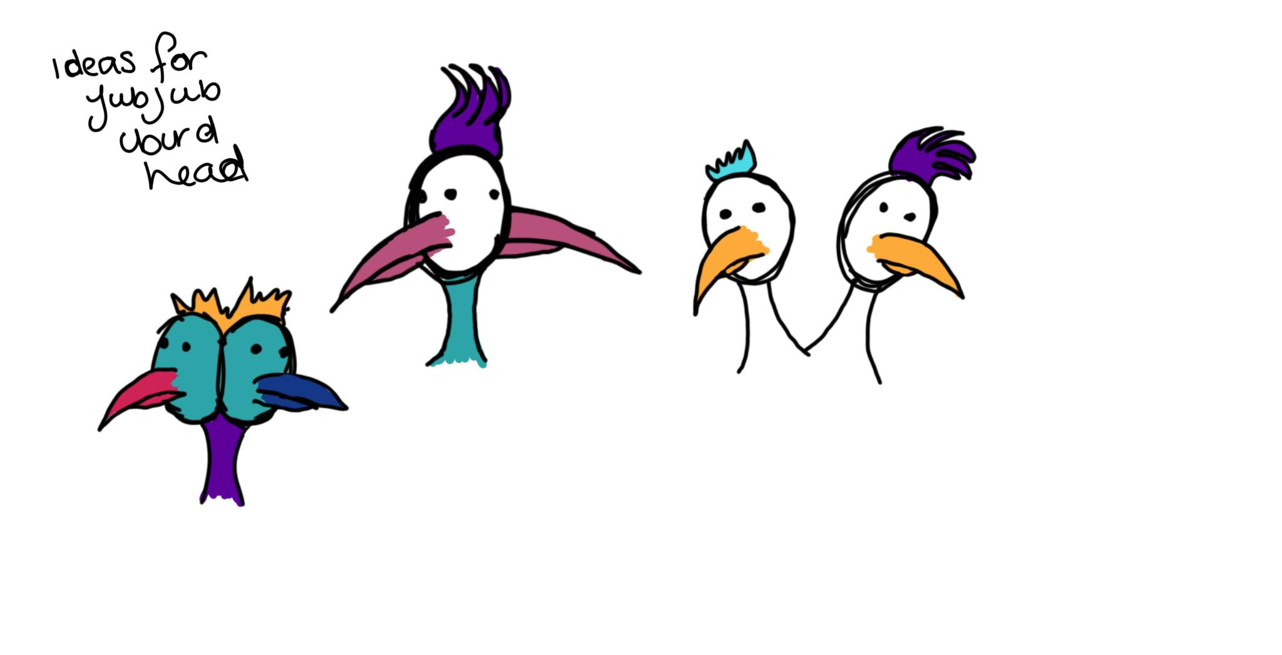
I experimented with three different types of double-headed birds.
The first one had two heads on one neck, the second one had two faces on one head and the last had two necks on one body
Through a process of elimination the most successful was the first green bird due to the last one I felt being too similar to a Pokemon character the Doduo and the second one having the faces too close together.

I created the JubJub bird, the bird has been designed based off having two heads as this reflected the name of the bird, this decision was agreed on as a group. The other elements of the character design came from my imagination.

The colour scheme selected included deep purples such as royal purple, blue toned reds such as fire engine and true red, greens may also be used such as Lawn and dark pastel greens as accessed from workwithcolor.com. These intense colours will be used because the JubJub bird needs to stand out as the character is the narrator of the script. If these colours were non-descript it would be feasible to lose him in the background through to blending in. The colours are also mostly cool toned due to the background being very orange creating high contrast imagery.

For the thumbnails I used a warm tonal range sunset using light yellows and oranges, as in the script it is supposed to be early evening with the sun setting throughout and then in the last few scenes it is evening and the sun has set making it more of a darker orange. The grass and trees where made a darker tone of green to show that it was getting dark. I have left out the characters for now as there’s been no decision on what colours are going to be used there.
The storyboard was completed in Photoshop by another class member. To develop these with added colour I used Sketchbook Pro because I feel it is more user friendly and as a person with specific learning difficulties Photoshop can be an obstacle due to the masses of menus and text instead of icons and being one colour scheme.
The images were 2D, using flat colour similar to cutouts for the backgrounds, I used flood fill to colour the selections that I made using the paintbrush.
I created depth by using foreground, midground and background imagery, the trees were in a wood which gave opportunity to create multiple layers on a singular layer through the use of different shading and lighting techniques. Two were pre-shaded in monochrome by the other classmate but the rest he gave me were quick sketches that I had to interpret myself making it harder as someone without depth perception. I started off making the foreground darker than the background to create an atmospheric perspective however the other classmate wasn’t happy so halfway through it switches to lighter in the foreground and darker in the background.
I used multiply to add my colour layers as I would usually add colour behind the line drawn layer itself.
The classmate did not sketch these on a transparent layer this had the outcome that I had to colour on top. I was not in control of his usage of layers although made the best of it however also feel that this resulted in less detailed colour work by me.
What I got from this group work was that I worked out who specialised in particular areas and which members of the team are able to take on other people’s ideas as well as their own so I know who to look out for the next project. However, I felt organisation could be planned better for the next project and also I feel like we should have worked more consistently, including regular meetups to make sure everyone can complete the roles they have been assigned.

Bibliography
Goldfarb, N. (1999). Carroll’s Jabberwocky. The Explicator, 57(2), 86-88.

Author not known ( 2013) Work with color: Color changes the World. Available at : http://www.workwithcolor.com/green-color-hue-range-01.htm (Accessed: 6th December 2018)

Author not known ( 2013) Work with color: Color changes the World. Available at: http://www.workwithcolor.com/red-color-hue-range-01.htm (Accessed: 6th December 2018 )

