Economics of Sustainability (BMSP6007)
Anthony Burns
Essay
Joaquim Anthony Fernandes (1805865)

Introduction

The purpose for this assignment is to investigate a solution to a failing market that has been found in relation to an externality of a pollutant produced through the production of a good. Which is going to be done by discussing the failure of making petrol cars as it produces a harmful pollutant called carbon dioxide, which is the main pollutant that everybody hears about due to it being a major contributing factor towards climate change. Therefore, the purpose of this assignment is to see how the EU is trying to reduce the emissions of carbon dioxide from petrol cars by either looking at the correct regulations and legislations and will even be looking at to see what kind of figures and solutions that are being put in place to reduce the emissions of carbon dioxide coming out of the petrol cars.

The figures will be done through explaining and describing the diagram of a negative externality by explaining about the marginal social cost, marginal private cost, and the marginal private benefits. Once that is done the solution will be done by describing and explaining about the subsidy that will be used as the solution.

The failure of making petrol cars previous to EU regulations

Petrol cars are a source of market failure due to the pollution that is being emitted into the atmosphere. The main harmful pollutants that are caused by conventional petrol cars that contribute to air pollution are carbon dioxide (CO2) CO2 is a greenhouse gas that is thought to be a large contributing factor towards climate change, carbon monoxide (CO) is an inviable gas which is the result of unfinished burning of fuel and this invisible gas is very toxic to humans, nitrogen oxides (NOx) are made in any combustion process. They are highly reactive and can contribute to smog when they come into contact with other airborne chemicals and sulphur dioxide (SO2) which is a colourless gas that smells like burnt matches and occurs naturally in crude oil to refine petrol and diesel, when burned it forms acids which leads to engine corrosion and smog (RAC, 2021).

However, for the purpose of this assignment the main pollutant that is going to be focused upon is carbon dioxide as it is the main pollutant that everyone hears about as it is a contributing factor towards the acidification of the earth’s oceans, and it is one of the most significant greenhouse gases. Government policies around the world are intended to reduce the emissions of carbon dioxide to tackle the issue of global warming (AA, 2021). For millions of years, carbon dioxide (CO2) emissions had been formed naturally on the earth by decomposition, ocean release and respiration. These natural levels are normally kept in a sense of balance by the ecosystem of the planet as the carbon dioxide is reabsorbed in a natural cycle. Although carbon dioxide can be formed through human intervention and the burning of fossil fuels for heating, industry, and transportation (motorway, 2021).

The increase of man made decisions has caused a rift in the natural balance to the point where it possibly causing irreversible damage to the earth and its atmosphere, by having concerns on the effects on green growth and sustainable development. This can also put pressure on the ecosystems and biodiversity, which will then affect water resources, human settlements and the frequency and scale of severe weather conditions, which would then come with significant consequences for food production, human wellbeing, socio-economic activities, and economic output, and this can be well known as climate change (OCEDiLibary, 2021).

At this present time transport is accountable for nearly 30% of the EU’s total carbon dioxide emissions, as of which 72% derives from road transportation. The carbon dioxide emissions within transport will not be as simple to reduce, as the rate of emission reductions has slowed down due to people becoming more mobile than they used so therefore the carbon dioxide emissions are rising rapidly (European Parliment, 2019).

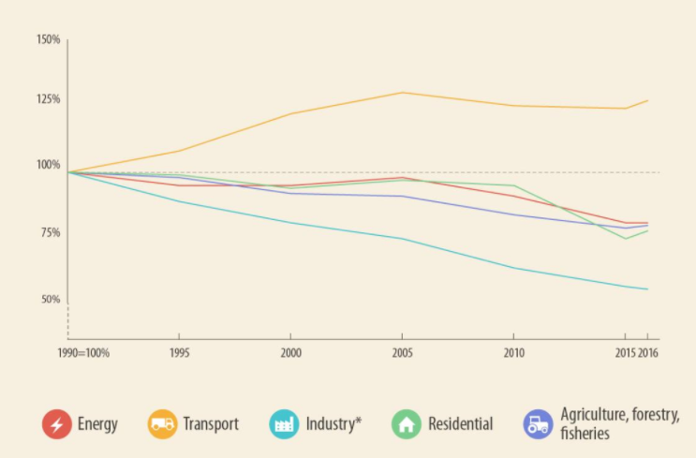
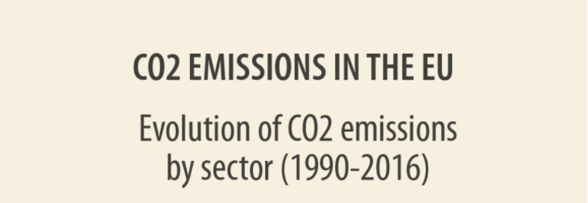
(European Parliment, 2019)

Carbon dioxide emissions from passenger transport differ expressively depending on the transport mode. Passenger cars is one of the key polluters, as it accounts for 60.7% of total carbon dioxide emissions from road transport in Europe. However, with around about 1.7 people per car in Europe, other modes of transport such as buses are a cleaner alternative. The reason for the rise of emission in cars is due to the rising share of the sport utility vehicle (SUV) segment. Also, the gap in the market for electric cars did remain slow in 2019 (European Environment Agency, 2021).
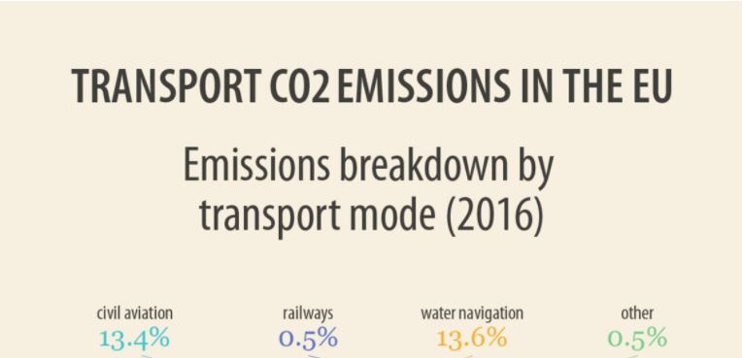
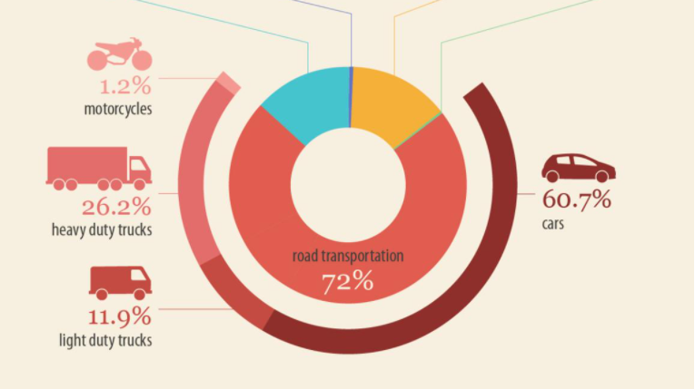
(European Parliment, 2019)

The pollution from petrol cars is a prime example of a negative externality. A negative externality takes pace when the consumption or production of a good causes a harmful effect to a third party without the third party affected being taken into consideration or being compensated (Pettinger, 2019). In a competitive economy people pay the market price for a good, which is where supply equals demand). However, this does not take into account the costs to others of that good being manufactured and consumed. Therefore, when one person drives a car it will make the road more congested and petrol cars cause pollution and then this will participate towards the rising of carbon dioxide emissions being emitted into the earth’s atmosphere which then again is affecting other people. Due to the private benefit being greater than the social benefit, the good is over consumed with the negative effects on others which are called externalities that are not taken into account. This can then be considered as a failed market as it has failed to allocate resources well (MyTutor, 2021).

To analyse the figures of a negative production externality which is where there is an externality caused by the manufacturers production process which then leads to reduction in the well-being of an unrelated third party. The figures of the negative production externality will consist of a marginal external cost, a marginal private cost, and a marginal social cost which is shown in the diagram below. A marginal external cost signifies the additional costs that are bracketed together with the production of an additional unit of a good that are experienced by a party or another producer or the buyer of that good. The marginal external cost can impact third parties either in a positive or negative manner (Economics Online, 2021) The marginal private cost refers to the costs that the company pays to obtain inputs of production (CFI Education, 2021). The marginal social cost is the total cost to society which consist of any private costs or any external costs. For example, driving to form place A to place B consists of paying for petrol which would be the personal cost, which would then lead increased congestion while traveling from place A to place B, which cause pollution and worse air quality such as carbon dioxide, carbon monoxide and sulphur dioxide etc… and they would be the external costs. Therefore, the social cost includes all of the above (Petrol + congestion + pollution) (Economics Help, 2021).
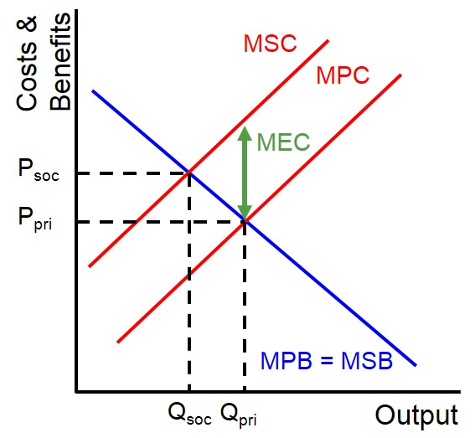

With applying this model, a company is able to measure the external cost that is present in a market with a negative production externality. By processing the size of the external cost that will be comprehended from third parties if the amount of goods produced falls to the socially optimal amount in this instance the marginal cost occurs because there is a divergence between the marginal private cost and the marginal social cost curves. Therefore, the marginal social cost is more than the marginal private cost. The reason this good is overproduced is because the individual producers who are the car manufacturers do not comprehend the external cost they are distributing onto society (EZY EDUCATION, 2021).

Market performance within petrol car industry after EU regulations

As soon as it has been noticed that the market is failing, the market can then begin to improve by using different methods to improve the market. However, this will depend on the type of market as it could be different for each market. The top three methods to improve market failure is with direct provision which is a well known method used by many governments in order to fix the public goods, which basically means that the government oversees the public goods and their products along with their public distribution. The second way to improve market failure is to input market regulation which is a method that regulates the consumption production and exchange decisions which are taken by the private sector, again the rules are set out by the government, but these rules are intended to correct the failures of the market. The last method is taxes which is where corrective action would be taken place for the market failure by collecting taxes from people. For example, if the petrol car industry is creating pollution, then the government may enforce a tax, the value of which may be equal or more than the external cost. On the other hand, the government reduces subsidies in order to encourage certain activities that correct the market failure (Bhasin, 2020).

To stop the trend of the decline of the efforts of trying to improve the fuel efficiency of new cars, the EU introduced new carbon dioxide emission targets which is to reduce the 2021 limit for emissions from new cars and vans by 15% and to double it up to 30 % from 2030, which intend to cut the harmful emission from new cars and vans. Also by 2030 they will be looking to stop the sale of petrol cars to make the air less cleaner to try and put less pollution into the earth’s atmosphere (European Environment Agency, 2021).

Since the EU regulations and carbon dioxide emission legislation in the EU were put in place three has been a significant amount of carbon dioxide that has dropped in comparison to what they were before the regulations and legislations were put in place. The first target was to cut the average car emissions to140g CO2/km, in 2015 the target reduced to 130g CO2/km for the year 2021 the goal is to achieve 95g CO2/km. Carbon dioxide emissions are measured by weight in grammes (g) and calculated by how much carbon dioxide is emitted from the exhaust pipe per the distance driven which is measured in kilometres (km) and the carbon dioxide emission rates are usually displayed as g/km, henceforth the target ratings looking like CO2/km (motorway, 2021).

The MSC of abatement is the cost to society as polluters reduce their emissions that they have emitted by reducing one more unit of pollution is more expensive, therefore the MSC is an upward curve. The MSB of abatement is the social gain of having a fresher and cleaner environment as it is the society demand for pollution abatement. Which basically means that the society are willing to pay for a fresher and cleaner environment however, this willingness decreases with the rising levels of abatement (Bockel, 2012).
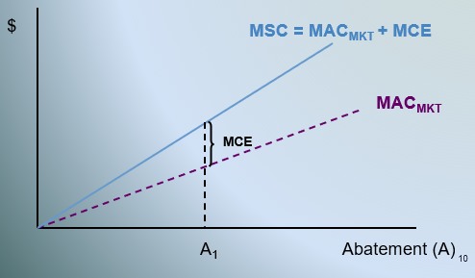

The solution for the carbon dioxide emissions to be reduced is to implement subsidies for pollution control which is called a pollution reduction subsidy. Subsidies are forms of financial government support for activities that are believed to be environmentally friendly. Instead of charging a polluter for emissions, the government rewards the polluter a subsidy for every unit of pollution abated. Which can consist of grants, low interest loans, tax credits or exemptions and rebates (Environmental Protection Agency, 2021).

The future of CO2 emissions in petrol cars in the EU

As petrol cars are expected to be phased out and banned by 2030, the ban is expected to reduce greenhouse has emissions and improve local air quality. Petrol cars that emit carbon dioxide now have a legal target to cut greenhouse gasses to net zero by 2050. The petrol cars are going to be replaced by electric cars as they are cleaner when they are manufactured and can be recharged using energy that has been produced by renewable sources such as wind and solar energy. Also, when the electric cars are in use it produces zero emissions (Dron, 2020).
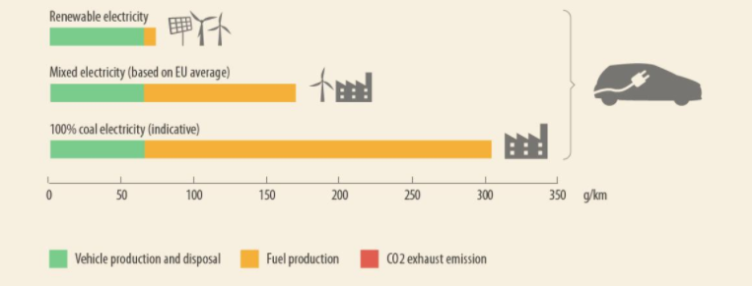
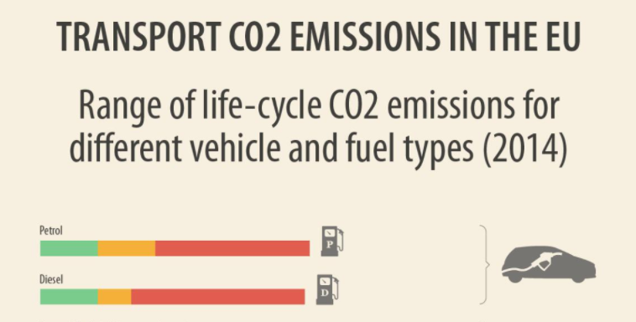

Conclusion

I have met the purpose of this assignment as I have identified a failing market in the automobile industry and that was petrol cars. The petrol cars was a failing market due to the pollutants being emitted as this was not being costed into the externality costs so therefore previous to the EU regulations and legislation the market was suffering greatly in its social costs as the car manufacturers did not comprehend the external cost they were distributing onto society. Another purpose that has been met was that the solution to the failing market was identified by implementing regulations and legislation that was allowing for the decrease in carbon dioxide emissions by seeing where the market was failing and then seeing how they could improve on that for the future.

Utilising these diagrams hypothetically has helped me understand the changes that need to be made to make the automobile industry better and identify its potential benefits such as the electric cars coming in to try and achieve net zero emissions to reduce the carbon dioxide emissions so that the air will be cleaner. It has also shown me that if you do not add in the externality costs into an industry such as the pollution effecting third parties that have not been accounted for then there is always going to be a failure within the market industry.

References
AA. (2021). Vehicle Exhaust Emissions. Retrieved from https://www.theaa.com/: https://www.theaa.com/driving-advice/fuels-environment/emissions
Bhasin, H. (2020, August 02). The 5 Types of Market Failure and 3 Best Ways to Fix It. Retrieved from https://www.marketing91.com/: https://www.marketing91.com/market-failure/
Bockel, L. (2012). Using Marginal Abatement Cost Curves to Realize the Economic Appraisal of Climate Smart Agriculture Policy Options. Rome: EASYPol Resources for policy making.
CFI Education. (2021). What is Marginal Social Cost (MSC)? Retrieved from https://corporatefinanceinstitute.com/: https://corporatefinanceinstitute.com/resources/knowledge/other/marginal-social-cost-msc/
Corporate Finance Institute. (2021). What is Market Failure? Retrieved from https://corporatefinanceinstitute.com/: https://corporatefinanceinstitute.com/resources/knowledge/economics/market-failure/
Dron, W. (2020). 2030 PETROL AND DIESEL CAR BAN: 12 THINGS YOU NEED TO KNOW. The Sunday Times, 1.
Economics Help. (2021). Social Cost. Retrieved from https://www.economicshelp.org/: https://www.economicshelp.org/blog/glossary/social-cost/
Economics Online. (2021). Definition of external cost. Retrieved from https://www.economicsonline.co.uk/: https://www.economicsonline.co.uk/Definitions/External_cost.html
Environmental Protection Agency. (2021). Economic Incentives. Retrieved from https://www.epa.gov/: https://www.epa.gov/environmental-economics/economic-incentives#subsidies
European Environement Agency . (2019). Are new passenger cars becoming more efficient? Eurpoean Environement Agency.
European Environment Agency. (2021, May 11). Average CO2 emissions from new cars and new vans increased again in 2019. Retrieved from https://www.eea.europa.eu/: https://www.eea.europa.eu/highlights/average-co2-emissions-from-new-cars-vans-2019#:~:text=Indicator%20Assessment%20Average%20CO2%20emissions,to%20122.4%20grams%20of%20CO2
European Parliment. (2019, April 18). CO2 emissions from cars: facts and figures (infographics). Retrieved from https://www.europarl.europa.eu/: https://www.europarl.europa.eu/news/en/headlines/society/20190313STO31218/co2-emissions-from-cars-facts-and-figures-infographics
EZY EDUCATION. (2021). Marginal external cost. Retrieved from https://www.ezyeducation.co.uk/: https://www.ezyeducation.co.uk/ezyeconomicsdetails/ezylexicon-economic-glossary/741-marginal-external-cost.html
motorway. (2021). Car CO2 emissions – ultimate guide. Retrieved from https://motorway.co.uk/: https://motorway.co.uk/guides/car-co2-emissions#:~:text=Currently%2C%20transport%20is%20the%20highest,%2C%20and%2030%25%20across%20Europe.&text=The%20first%20target%20in%202009,to%20140%20g%20CO2%2Fkm.
MyTutor. (2021). Explain why the use of petrol and diesel cars may be a source of market failure. Retrieved from https://www.mytutor.co.uk: https://www.mytutor.co.uk/answers/54436/A-Level/Economics/Explain-why-the-use-of-petrol-and-diesel-cars-may-be-a-source-of-market-failure/
OCEDiLibary. (2021). Climate Change. Retrieved from https://www.oecd-ilibrary.org/: https://www.oecd-ilibrary.org/sites/5584ad47-en/index.html?itemId=/content/component/80661e2d-en&_ga=2.4714294.426298598.1620997103-53938889.1619873784&_csp_=cafccd100b18232edeb5735daf54d8f4&itemIGO=oecd&itemContentType=chapter#section-d1e259
Pettinger, T. (2019, July 24). Negative Externalities. Retrieved from https://www.economicshelp.org/: https://www.economicshelp.org/micro-economic-essays/marketfailure/negative-externality/#:~:text=Negative%20externalities%20occur%20when%20the%20consumption%20or%20production,your%20neighbour%20may%20not%20be%20able%20to%20sleep.
RAC. (2021). Vehicle Exhaust Emissions. Retrieved from https://www.rac.co.uk/: https://www.rac.co.uk/drive/advice/emissions/vehicle-exhaust-emissions-what-comes-out-of-your-cars-exhaust/

