
OppORtunities for female leaders in the 21st century
Peter Scott 2307123– Implementation Plan – The policing Sector


University of Wales Trinity Saint David

Summary

​The purpose of this document is to critically analyse how contemporary leadership can contribute to driving change towards challenging attitudes towards women pursuing leadership roles, with focus on policing, it is however easy to corelate broad findings with most organisational sectors. A discussion focuses on societal attitudes and impact regarding women and young girls when considering effects of traditional gender stereotyping in educational learning, and the effects this may have on in developing confidence amongst girls and women. The attitudes of the public as well as organisation culture regarding the acceptance and support of women in policing are considered, using options such as procedural justice in determining findings between women and men in policing roles.

The benefits of transformational leadership in policing are compared against the concept of women naturally leading with a transformational style and the perceived associated benefits.
​The Implementation plan seeks to consider those almost invisible barriers for women that create the 'Labyrinth' towards leadership progression; self-confidence, ambition and societal expectations regarding childcare and support, seeking to challenge the 'ideal' worker concept working against women who engage with accommodations due to temporary breaks in career and work trajectory. This plan seeks to address imbalances in promotion opportunities to the first gateway ranks of sergeant and Inspector, whilst challenging poor cultures and processes that limit expected progression for women. Success in determining the right support through mentors and role models in both local organisational mechanisms as well as national and international models will ultimately strengthen and positively reinforce leadership progression within organisations.

Table of Contents
Summary 1
Table of Figures 2
1. Implementation Plan 3
2. Rationale 5
2.1 Aims and Objectives 6
2.2 Action Plan 7
2.2.1 Time Plan 9
2.2.2 Risk Management and Strategies 10
Recommendations 11
Conclusion 12
Bibliography 13
Appendix 14
Appendix 1 Ideas and Concept mind map by Peter Scott (self) 14
Appendix 2 SWOT analysis toinform Aims & Objectives 14
Appendix 3 Risk Matrix to guide Risk assessment gradings 14

Table of Figures
Figure 1 – ‘Labyinth’ devised from Northouse, (2016) 4

Implementation Plan

  - Introduction

Societal attitudes towards women in policing are changing slowly. Progression, particularly senior women in leadership within British policing is encouraging. However, equality parity remains distant with women in initial supervisory positions of Sgt & Inspector barely above 25% according to, Home office (2023). Women represent 34.7 % of officers in policing, achieving policing legitimacy within our communities in equality and ethnicity is critical. Leadership in policing is under increased scrutiny following several high public interest events, Davis & Silvestri (2016). The demands in complexities of leadership, increasing scrutiny and risk and the relationship of new governance expectations, indicates that approaches using traditional leadership styles are not fit for this time, Davis & Silvestri (2016). There are unique expectations on Police leaders operating in the scope of, a non-profit, public-sector organisation. Mullins (2019) invites several leadership theories for exploration.
​Situational Leadership Theory (SLT) is regarded as a popular and widely known model, it concentrates on the needs and capabilities of those under leadership – it regards the state and readiness of a follower as important, Northouse (2016) cites Blanchard et al (1993). The follower’s ability and willingness are key specifics, Hersey & Blanchard, (1997), cited by Northouse, (2016) The theory demonstrates four different styles from Leader to follower.
​As the maturity or readiness of the follower increases, the less responsiveness from the leader is required, Northouse (2016).
​Telling | ​Strong guidance for individuals, high supervision, limited support.
​Selling | ​Strong explanation & discussion around decisions, medium support.
​Participating | ​High communication, supportive, low guidance.
​Delegating | ​Little direction, low support, for high follower readiness.
​Source: Mullins (2019)
​Critics of this model have highlighted concerns regarding the identified relationships described in situational models according to Yukl (2013). Concerns raised in researching situational leadership, where questionnaires are suspected of producing a ‘halo’ effect of ‘desirable’ behaviours, but also cementing traditional stereotypes, Yuk (2011). Despite situational theory retreating in the last years, its context within police leadership is an important consideration. Davis & Silvestri (2020). SLT, according to Whitfield et al (2008) has an appeal within policing that is innate, due to high impact and critical situations in policing environments, being quickly adapted to robust situations.
​The comparative model is transformational leadership; consideration is made for the different factors of the model from Bass (1990)
​Idealised influence | ​Role model attributes, ethical leadership, inspiring mirroring behaviours, trustworthy.
​Inspirational motivation | ​Motivating followers of organisation vison, perform for the relative outcome, emotionally connected leadership.
​Intellectual stimulation | ​Encourages leadership challenges from others & organisation, innovative, creative flare, sound decision making.
​Individualised consideration | ​Facilitates coaching &mentoring, listens, develops followers to full potential, caring & supportive leadership.
​Source: Mullins (2020)
​
​Positive values that would be moving a vison forward and creating new avenues for organisations, there are numerous criticisms of transformational leadership, one such criticism, is that it can be seen as elitist and working against a democratic solution, due to the directive role in the vision and change being sought. Creating a perspective that the leader is acting solo and positioning themselves above the followers. Bass, (1990) Although elitism disputed by Bass & Avolio,(1993).
​The women's demonstrated style, overtakes men using transformational leadership, using a communal & egalitarian style. This is aligned with effectual leadership according to Northouse, (2016)
​The recent example of Dame Commission Cressida Dick can be attributed to a strong, transformational leader who has driven transformational change against a difficult culture in the metropolitan police. Casey, (2023)
​This plan considers challenges from a women’s perspective, addressing beliefs, aspirations for leadership within a culture of policing.

2. Rationale
​According to Home Office (2023) women in the rank of Sgt and Inspector are only 27% & 26.9% respectively. Women in senior leadership positions decreases the higher up the rank structure you travel. Despite these numbers not demonstrating the strongest position for women in modern times, steady, but slow progression is being achieved across all ranks. Home Office (2023)
​Underrepresentation of women in senior roles continues to exist within policing both nationally and internationally. The IAWP (2023) state their strategic plan 2022-2026 aims to galvanise support and direction in these areas.
​Understanding and bringing into focus the areas of challenges perceived for senior women in leadership roles and their underrepresentation, reflecting on ‘The Labyrinth’ as documented by Northouse (2016) Figure 1. Areas of focus are the different capital investment of men and women, the equality contrasts between men and women and discrimination of women including prejudice, Northouse (2016) According to McGraw (2022) confidence for women seeking leadership is” Liquid Gold” she suggests that Women should apply three concepts; Achieve stronger self-confidence, ask more, not wait to be asked, obtain credible mentors for development.

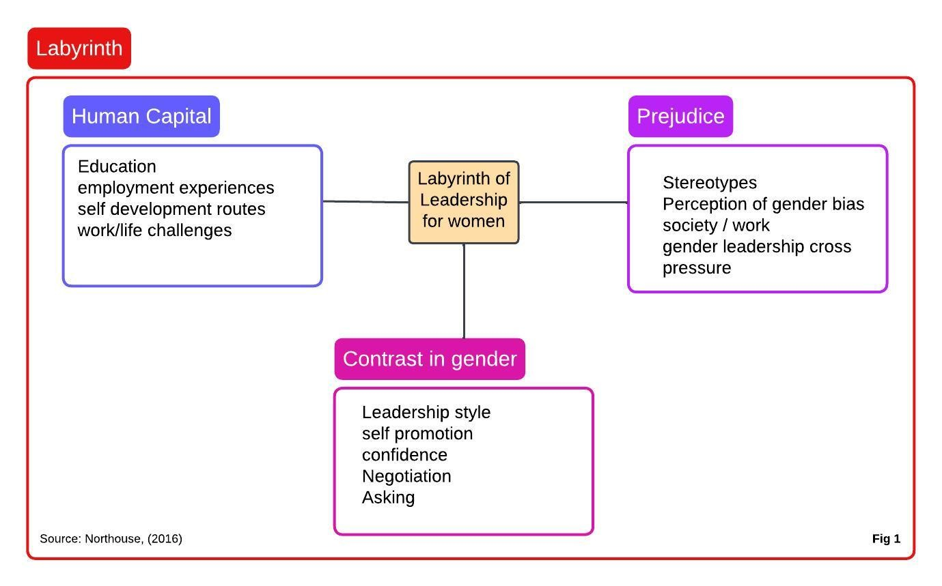

2.1 Aims and Objectives

​ SWOT analysis [Appendix 1] informs Aims and Objectives.
​
- ​Strengthen leadership development for girls and women in mainstream education, strive to dispel traditional gender stereotyping within education.
​
- ​ Tackle disparity at Sergeant and Inspector rank and raise women in these ranks above 40%.
- ​Achieve bespoke unconscious bias training to all recruits in policing alongside the Code of Ethics, together with fully revised independent promotional application assessment training.
​
- ​Establish mentorship programmes for women, with both national and international support mechanisms with robust and transparent role model platforms to increase confidence and reach of aspiring women leaders within policing.
​
- ​Re-model maternity, childcare and support policies. Ensuring that women and men who return are reintegrated fully upon return, regardless of working accommodations. Actively move from the ‘ideal worker, time served’ barriers. Increasing number of women with working accommodations into supervisory positions.

2.2 Action Plan

​Strengthen leadership skills development for young girls and women in mainstream education, utilizing both national programs and learning from international communities.
​According to Golden and Jacoby (2018) evidence from children reporting from an early age their gender stereo types, including their abilities & beliefs including career preferences. Children’s decisions and beliefs in later life can be linked to their early, gender Stereo typical beliefs Wigfield & Eccles (2000)
​
​Several international programs and models have been exercised to inspire young children to be open minded when viewing non-traditional occupational options, one example being the Norway Government (WISE campaign) The idea of both children, and hearing people in non-traditional roles promotes behaviors that are non-traditional. Ollsen & Martiny (2018) Utilize learning from the 10-step framework. (Wise campaign, 2023).
​
​Ely et al (2011) has advocated women's development leadership programs to enable progression into top management roles. stating that the internalizing of being a female leader through leadership training assists in achieving success.
​______________________________________________________________
​Work in close collaboration with the College of policing to actively tackle disparity within early ranks at Sergeant and Inspector.
​The College of Policing outlines the challenges for lower levels of leadership (Sgt and Inspector.) Recognition of first line managers roles, the new NLCP national leadership program will work to support the newest recruits through to Chief Officers ranks. (College of Policing, 2023)
​Gau et al (2013) suggests research provides a view that female American officers were less likely to consider progression into higher roles and viewed promotions as less important – supporting a view from Boag-Munroe (2018) that the women's outlook in progression at initial ranks presents barriers in achieving equality throughout the hierarchy structure.
​
​________________________________________________________________________
​Embed bespoke unconscious bias training & procedural justice training to all recruits in policing alongside the Code of Ethics together with promotion panels handled by accredited personnel in Equality & diversity unconscious bias.
​The college of policing suggests that learning through lessons learnt in procedural justice should be rolled out to staff to enhance skills and training for police and public interactions. (College of Policing, 2023)
​
​The interactions of women policing in communities can have significant impact due to Gender stereo typing. There is still a deep routed prejudice and perception around women and how this affects their interactions with communities. Working holistically to understand the effects of procedural justice could improve relationships between the community and the police, lowering damaging effects of prejudicial sexism for women policing in their communities and positioning for police leadership, Hellwege et al (2021)
​
​ According to Ridgeway & Correll, (2004) The Hegemonic gender standards that are expected by others in society are considered ingrained and expected. This being due to the adverse reactions of not conforming, there is a considered consequence for those not conforming to the expected gender traits, due to this stereotyping it is often reinforced, Rudman & Fairchild (2004)
​
​According to Ollsen & Martiny (2018) The expectations of society on how police officers should act in terms of authority and agentic traits, can go against societal expectations of women of being approachable, friendly, and inviting. This creates a gender bias that may create challenges for women police officers on communities.
​
​In determining procedural Justice training to enhance legitimacy, the urgency of training should be aimed at enhancing male officers' knowledge and attributes to reduce the gap of this gendered divide, Wolfe et al (2020)
​___________________________________________________________________________
​
​Establish mainstream and effective mentorship programs and role models for women from both a national and international support mechanism.
​The encouragement of women into top underrepresented role positions, should prioritize to connect women to role models that are also female. Stout et al (2011), Lockwood (2006)
​
​Too few role models for female leaders maybe a barrier and challenge to women progression in leadership to higher positions. Yu (2015)
​When considering the expectations and aspirations of women in career progression, these areas have influence on women's future optimism of career progression, Kirchmeyer (2002)
​
​Continued pressure not just for higher ranked promotion, but any supervisory position will remain a future challenge for policing according to Boag-Munroe (2019)
​__________________________________________________________________________
​
​Maintain a view on society challenges upon gendered policing and police leadership, to better understand and prevent poor communication that may affect public & organizational opinion and confidence.
​
​There are risks identified by Ward et al (2021) in Australia where increase in women officers have been met with challenge by both the public and officers within. Adverse views on campaigns, and suspicion of ‘reverse sexism’ indicating the lowering of standards for recruits. The perception of females being placed into unqualified positions has increased public debate, highlighting the views of discrimination of males, and the entry standards of females to engage with policing. (Crime & Corruption Commission, 2021)
​
​The view that if Australian conservative society views the rise of women officers in policing as a challenge and treat masculine traditions of as the normal, this could cause a threat to relations in the community and policing by women officers. Davenport-Klunder & Hine (2023)
​There is a view that lack of knowledge or inaccurate information may be influencing the views of the public and community. This seen as an opportunity for policing leaders to fully address misconceptions and myths around recruitment and fitness requirements for female officers, thereby dispelling myths and seen as inviting for increasing women into policing.

​Gender perspectives from a public viewpoint regarding female officers is important, opinions of discrimination against men, and capabilities of women in a physical context, are opportunities for police organizations in increasing policy review and address discriminatory practices, to increase the processes and education into communities regarding the positive attributes and effective policing delivery by women officers in the community according to Davenport-Klunder & Hine (2023)

2.2.1 Time Plan

￼Date | ￼Actions for progression
￼2024 | Promote knowledge of equality Act 2010 – (Legislation Gov.uk, 2023) ​Embed and promote Family Leave Pregnancy Act 2023. (Legislation Gov.uk, 2023)​
￼2026 | ​Embed and promote Flexible Working Act 2023. (Legislation Gov.uk, 2023)
￼2028 | Embed new structures for promotion for Sgt’s & Inspectors. (College of Policing, 2023)  ​Promote and enhance new fast track proposals from Inspector to Superintendent. (College of Policing, 2023)  ​Drive Initiatives to conclusion that support & encourage underrepresented officers at less senior ranks. (College of policing, 2023)  ​Embed educational support for tackling Gender stereotyping and bias for young girls and women. Challenging the current societal attitudes. Wigfield & Eccles (2000)
￼2030 | Implement Policing Force Vison Strategy 2030, Adopting Pillar 4 -” Develop and Inspire our work force and evolve culture” (NPCC, 2023)  ​  ​Land aims and objectives from the United Nations suitability [Goal 5] in line with Gender diversity. (United Nations,2023)  ​  ​Complete and evaluate a top-down review of organisational culture in line with Culture and organisations. Schein (2017)
￼2040 | Utilise the guidance and direction to implement Operational NPCC operating environment strategic aims in 2040. (College of policing, 2023)
￼2060 | The current projection of women in UK policing to reach parity should be achieved before 2060, the projection from 2010 to 2023 is 25.7% rising to 34.7% respectively - a 9% difference in 13 years. At this sustained rate it will take 36 years (2060) data collected from; (Home Office, 2023)
￼￼ | ￼￼

2.2.2 Risk Management and Strategies

​Description | ​Effect/Harm | ​Risk Rating  ​H, M, L | ​Existing Controls | ​Action to reduce risk | ​Revised risk
​Poor Accommodations returning to work, | ​Lacking confidence & aspirations captured in ‘ideal worker, ‘time served’ challenges. | ​M | ​Equality Act 2010.  ​Local policy & Processes.  ​Police regulations | ​Engage new pregnancy and family leave Act 2023.  ​Engage Flexible Working Act 2023. | ​L
​Unfair Promotional processes | ​Gender Bias – Restriction of candidate(s) | ​H | ​Current local processes, COP protocols. | ​Immediate COP intervention for process change | ​L
​No Diversity in SGT&INSP ranks. | ​No change – Organisational Cultural Impact. Minimal Representation. | ​M | ​Current police recruitment and marketing.  ​Standard interview and selection processes.  ​Managers endorsed applications | ​Gender bias training & boards  ​Non-management endorsement of application | ​L
​Reduced ambition of women into senior roles through lack of confidence, mentoring, role models | ​Poorer ambition and confidence to attain leadership at senior ranks, increasing equality disparity. | ​M | ​Basic and fundamental support processes, ad hoc and application only support. No clear mentor program. | ​COP leadership initiatives targeting constable and Sgt ranks, increased mentorship, and role model focus. | ​L
​Sexism, harassment & misogyny | ​Breach of MASLOWs theory and safe environment for women. | ​H | ​Code of Ethics – attention to culture recommendations (Casey Report 2023) | ​Significant challenge to in appropriate masculine culture, embed revised Code of Ethics. | ​M
​Failure to adopt leadership for women & girls in education. | ​Under prepared and equipment women and girls for Woking environment. | ​M | ​Mismatch approach, no central driven programmes. | ​Tackle stereotypical attitudes, working with business and organizations to prepare young women better. | ​L

Recommendations

Research from early years education describes the importance of tackling stereo typical gender concepts. A focused programme from the start of education though to starting work experience is critical. The highlights regarding the importance of early leadership development for girls and young women can build on early works in tackling gender stereo types, but particularly in confidence building and enabling girls and young women to have their voice at the table. Leadership development should also include boys and men in understanding the views and practices in society, particularly domestic attitudes and family rearing challenges and unseen expectations in a modern-day society. Marketing and recruitment of women officers should be reviewed to strengthen real policing activity's that don't just include the projected masculine and male dominated traditional activities. Retention of police recruits, especially women and ethic officers are critical to establishing a diverse and legitimate police service, focus on mentor and coaching for women at constable rank should aim to increase the number of both Sgts and Inspectors, whilst ensuring that promotion processes are reviewed to enhance transparency and trust in the process, utilising Gender bias training as one mode of improvement. Enhancement and support for women engaging with the new College of Policing leadership programme, including tangible support agencies such as IAWP and BAWP and women's network to encourage necessary cultural challenge in every policing department across the country. The enhancement of positive communication regarding progression of women in the police to be embraced by role models, encouraging our future women in policing towards senior leadership progression.

Conclusion

The ultimate progression of women in leadership is reviewed by re-visiting the start of the educational journey, to explore whether education has a bearing in facilitating women into leadership within the policing sector, by looking at initial factors of traditional stereotype behaviours that exist, suggesting the start of learnt society opinions of gender roles, and gender mindset within early education.
Exploration of public views in the community referencing female policing and attitudes that can affect women in this profession, views are considered alongside research in procedural justice.
The ideas of building confidence, role models and proper mentoring for women is a strong argument in supporting women through the ’labyrinth 'that exists in achieving senior police leadership.
Women progressing into senior leadership roles is evident in the Policing sector, According to Home Office (2023). Successful accomplishments now showing 40% of female in Chef Constable positions. However, when comparing the data at all ranks, there is clearly disparity of equality in all ranks particularly Sgt and Inspector. This implementation plan has sought to explore not only the challenges facing women in terms of organisational culture, harassment and gender bias but to holistically consider local, national and international support and research that can assist and capitalise on future successful female leaders, examples of clear transformational approaches used by those like commissioner Cressida Dick can steer our aims in achieving a diverse police service that is capable of actively supporting and encouraging young women. Addressing the concerns of weak leadership, this plan supports the active encouragement of clearer robust action by everyone in altering the ‘basic assumptions 'of organisational culture to achieve the equality and diversity in senior positions of leadership.

Bibliography

Acker, J. (1990) ‘Hierarchies, Jobs, Bodies: A Theory of Gendered Organizations’, Gender & Society, 4(2), pp. 139–158. Available at: https://doi.org/10.1177/089124390004002002. (Accessed: 11 Dec 2023).

Alexander, J. and Charman, S. (2023) ‘Parallel lines? The homogeneous and gendered career patterns of senior leaders in policing in England and Wales’, Police Practice & Research, pp. 1–22. Available at: https://doi.org/10.1080/15614263.2023.2231593. (Accessed: 13 Dec 2023).

Bass, B.M, & Riggio, R.E. (2006) Transformational leadership. Second edition. Mahwah, N.J: L. Erlbaum Associates. Available at: https://doi.org/10.4324/9781410617095. (Accessed: 11 Jan 2024).

Bass, B.M. (1990) ‘From transactional to transformational leadership: Learning to share the vision’, Organizational dynamics, 18(3), pp. 19–31. Available at: https://doi.org/10.1016/0090-2616(90)90061-S. (Accessed: 11 Jan 2024).

Bertrand, M. (2020) ‘Gender in the Twenty-First Century’, AEA papers and proceedings, 110, pp. 1–24. Available at: https://doi.org/10.1257/pandp.20201126. (Accessed: 23 Dec 2023).

Blanchard, K., Zigarmi, D., & Nelson, R. (1993). ‘Situational Leadership after 25 years: A retrospective’. Journal of Leadership studies, 1(1), 22-36.

Boag-Munroe, F. (2019) ‘Career Progression Expectations and Aspirations of Female Police Officers in England and Wales’, Policing: A Journal of Policy and Practice, 13(4), pp. 426–440. Available at: https://doi.org/10.1093/police/pax053. (Accessed: 9 Jan 2024).

Breci, M. (1997) ‘Female officers on patrol: public perceptions in the 1990s’, Journal of Crime & Justice, 20(2), pp. 153–165. Available at: https://doi.org/10.1080/0735648X.1997.9721587. (Accessed: 03 Jan 2023).

British Association for Women in Policing (2023) Grapevine. Available at https://www.bawp.org/Grapevine - Spring 2023/ (Accessed: 22 Nov 2023).

Casey, L. (2023) An independent review into the standards of behaviour and internal culture of the Metropolitan police service. Available at: https://www.met.police.uk/police-forces/metropolitan-police/areas/about-us/about-the-met/bcr/baroness-casey-review /. (Accessed: 16 Nov 2023).

College of Policing (2016) National Police Promotion Framework Guidance. Available at: http://www.college.police.uk/ What-we-do/Development/professional-developmentprogramme/Documents/NPPFGuidance.pdf (Accessed: 18 May 2017).

College of Policing (2020) Fast track and direct entry evaluation: July2020. Available at: https://data.parliament.uk/DepositedPapers/Files/DEP2020-0445/FTDE-Evaluation-Overview.pdf (Accessed: 23 Nov 2023).
College of Policing (2021) Policing violence against women and girl's National framework for delivery: Year 1. Available at: https://assets.college.police.uk/s3fs-public/2021-12/Policing-VAWG-national-framework-for-delivery.pdf (Accessed: 17 Nov 2023).

College of Policing (2023) Equality and diversity. Available at: https://www.college.police.uk/about/equality-and-diversity. (Accessed 04 Jan 2024).
College of Policing (2023) Inclusion moments (learning and conversations around diversity, equality, and inclusion topics). Available at: https://www.college.police.uk/support-forces/practices/inclusion-moments-learning-and-conversations-around-diversity-equality-and-inclusion-topics (Accessed: 18 NOV 2023).

College of Policing (2023) Leadership. Available at: https://www.college.police.uk/career-learning/leadership (Accessed: 28 Dec 2023).

College of Policing (2023) New Fast Track inspector to superintendent program. Available at: https://www.college.police.uk/article/new-fast-track-inspector-superintendent-programme. (Accessed 04 Jan 2024).
College of Policing (2023) Promotion and progression for sergeants and inspectors. Available at: https://www.college.police.uk/article/promotion-and-progression-sergeants-and-inspectors. (Accessed 04 Jan 2024).

Crime and Corruption Commission (2021). A report concerning an investigation into the Queensland Police Service’s 50/50 gender equity recruitment strategy. Brisbane: Crime and Corruption Commission. Available at: https://www.ccc.qld.gov.au/sites/default/files/Docs/Publications/CCC/Investigation-Arista-A-report-concerning-an-investigation-into-the-Queensland-Police-Services-50-50-gender-equity-recruitment-strategy.PDF. (Accessed: 02 Jan 2024).

Cunningham, E. (2022) Women in Policing: Feminist perspectives on Theory and practice. Oxfordshire: Routedge.

Davenport-Klunder, K. and Hine, K. (2023) ‘Setting benchmarks and breaking chains: public opinions of female police officers’, Policing & Society, 33(6), pp. 643–665. Available at: https://doi.org/10.1080/10439463.2023.2175823. (Accessed: 04Jan 2024).

Davenport-Klunder, K. and Hine, K. (2023) ‘Setting benchmarks and breaking chains: public opinions of female police officers’, Policing & Society, 33(6), pp. 643–665. Available at: https://doi.org/10.1080/10439463.2023.2175823. (Accessed: 05 Jan 2024).

Davis, C. and Silvestri, M. (2016) Critical Perspectives on Police leadership. Bristol: Policy Press, c. 41.

Dick, P. and Hyde, R. (2006) ‘Line manager involvement in work-life balance and career development: can’t manage, won’t manage?’, British Journal of Guidance & Counselling, 34(3), pp. 345–364. Available at: https://doi.org/10.1080/03069880600769480. (Accessed: 05 Jan 2024).

Eagly, A. H. (1994). II. On comparing women and men. Feminism & Psychology,4(4), 513–522.
Eagly, A.H. (1995) ‘The Science and Politics of Comparing Women and Men’, The American Psychologist, 50(3), pp. 145–158. Available at: https://doi.org/10.1037/0003-066X.50.3.145. (Accessed: 05 Jan 2024).

ELY, R.J., IBARRA, H. and KOLB, D.M. (2011) ‘Taking Gender into Account: Theory and Design for Women’s Leadership Development Programs’, Academy of Management Learning & Education, 10(3), pp. 474–493. Available at: https://doi.org/10.5465/amle.2010.0046. (Accessed: 11 Jan 2024).

Equality and Human Rights Commission, (2017) Applying behavioural insights to reduce pregnancy- and maternity-related discrimination and disadvantage. Available at: https://www.equalityhumanrights.com/our-work/our-research/applying-behavioural-insights-reduce-pregnancy-and-maternity-related?return-url=https%3A%2F%2Fwww.equalityhumanrights.com%2Fsearch%3Fkeys%3Dmaternity (Accessed: 14 Jan 2024).

Gaston, K, & Alexander, J. (1997). Women in the Police: Factors influencing managerial advancement. Women in Management Review, 12(2), 47-55. https://doi.org/10.1108/09649429710162802. (Accessed: 22 Nov 2023).

Gau, J.M., Terrill, W. and Paoline, E.A. (2013) ‘Looking Up: Explaining Police Promotional Aspirations’, Criminal Justice and Behaviour, 40(3), pp. 247–269. Available at: https://doi.org/10.1177/0093854812458426. (Accessed: 5 Jan 2024).

Gipson, A.N. et al. (2017) ‘Women and Leadership: Selection, Development, Leadership Style, and Performance’, The Journal of Applied Behavioural Science, 53(1), pp. 32–65. Available at: https://doi.org/10.1177/0021886316687247. (Accessed: 04 Jan 2024).

Golden, J.C. and Jacoby, J.W. (2018) ‘Playing Princess: Preschool Girls’ Interpretations of Gender Stereotypes in Disney Princess Media’, Sex Roles, 79(5–6), pp. 299–313. Available at: https://doi.org/10.1007/s11199-017-0773-8. Accessed: 22 Dec 2024).

Gov.uk (2017) Home Secretary appoints Cressida Dick as next Commissioner of the Metropolitan Police. Available at: Home Secretary appoints Cressida Dick as next Commissioner of the Metropolitan Police - GOV.UK (www.gov.uk) (Accessed: 21 Nov 2023).

Haake, U. (2018). ‘Conditions for gender equality in police leadership – making way for senior policewomen’. Police Practice & Research. 19(3), 241-252. Available at: https://doi.org/10.1080/15614263.2017.1300772. (Accessed: 4 Jan 2024).

Hargreaves, J., Cooper, J., Woods, E., and McKee, C. (2016) Police Workforce, England and Wales, 31 March 2016. Available at: https://www.gov.uk/government/statistics/police-workforce-england-and-wales-31-march-2016/. (Accessed: 04 Jan 2024).

Heilman, M.E. (2012) ‘Gender stereotypes and workplace bias’, Research in organizational behaviour, 32, pp. 113–135. Available at: https://doi.org/10.1016/j.riob.2012.11.003. (Accessed: 04 Jan 2024).

Hellwege, J.M., Mrozla, T. and Knutelski, K. (2022) ‘Gendered perceptions of procedural (in)justice in police encounters’, Police Practice & Research, 23(2), pp. 143–158. Available at: https://doi.org/10.1080/15614263.2021.1924170. (Accessed: 05 Jan 2024).
Hersey, P., &Blanchard, K. H. (1977). Management of organizational behaviour: Utilizing human resources (3ed.) Englewood Cliffs, NJ: Prentice Hall.

Hersey, P., Blanchard, K. (1977) ‘Management of Organizational Behaviour: Utilizing Human Resources’, Group & Organization Studies. 2(4), pp. 514–515.

Home Office, (2023) National statistics police workforce, England, and Wales 31 March 2023. Available at: https://www.gov.uk/government/statistics/police-workforce-england-and-wales-31-march-2023/police-workforce-england-and-wales-31-march-2023#diversity. (Accessed: 04 Jan 2024).

Howard, C. (2019) Picture a leader, is she a woman? Available at: https://www.ted.com/talks/carla_howard_picture_a_leader_is_she_a_woman. (Accessed: 12 Dec 2023).

International Association of Women Police (2023) Gender Responsive Policing. Available at: https://www.iawp.org/Gender-Responsive-Policing-GRP (Accessed: 03 Jan 2024).

International Association of Women Police Officers (2023) Strategic Plan 22-25. Available at: https://www.iawp.org/resources/Documents/Strategic%20Plan%202022-2025.pdf. (Accessed: 23 Dec 2023).

Keddie, A. (2023) ‘Gender equality reform and police organizations: A social justice approach’, Gender, Work, and Organization, 30(3), pp. 810–825. Available at: https://doi.org/10.1111/gwao.12918. (Accessed: 6 Jan 2024).

Kirchmeyer, C. (2002) ‘Gender Differences in Managerial Careers: Yesterday, Today, and Tomorrow’, Journal of Business Ethics, 37(1), pp. 5–24. Available at: https://doi.org/10.1023/A:1014721900246. (Accessed: 04 Jan 2024).

Leger, K. (1997) ‘Public perceptions of female police officers on patrol’, American Journal of Criminal Justice, 21(2), pp. 231–249. Available at: https://doi.org/10.1007/BF02887451. (Accessed: 03 Jan 2024).

Legislation Gov.uk (2023) Employment Relations (Flexible Working) Act 2023. Available at: Employment Relations (Flexible Working) Act 2023 (legislation.gov.uk). (Accessed: 11 Jan 2024).

Legislation Gov.uk (2023) Equality Act 2010. Available at: https://www.legislation.gov.uk/ukpga/2010/15/contents. (Accessed: 12 Jan 2023).

Legislation Gov.uk (2023) Protection from Redundancy (Pregnancy and Family Leave) Act 2023. Available at: Protection from Redundancy (Pregnancy and Family Leave) Act 2023 (legislation.gov.uk). (Accessed: 11 Jan 2024).

Lockwood, P. (2006) ‘Someone Like Me can be Successful: Do College Students Need Same-Gender Role Models?’, Psychology of Women Quarterly, 30(1), pp. 36–46. Available at: https://doi.org/10.1111/j.1471-6402.2006.00260.x. (Accessed: 04 Jan 2024).

Marks, M. and Fleming, J. (2004) ‘As Unremarkable as the Air they Breathe? Reforming Police Management in South Africa’, Current Sociology, 52(5), pp. 784–808. Available at: https://doi.org/10.1177/0011392104045370. (Accessed: 10 Jan 2024).

Mazerolle, L., Antrobus, E., Bennett, S., & Tyler, T. R. (2013) ‘Shaping citizen perceptions of police legitimacy: A randomized field trial of procedural justice’. Criminology, 51(1), 33 63. Available at: https://doi.org/10.1111/j.1745-9125.2012. (Accessed: 11 Jan 2024).

McGraw, L. (2022) We still have too few women in Leadership, What now? Available at:https://www.youtube.com/watch?v=uQluBUgDsek. (Accessed on 12 Dec 2023).

Mullins, l. (2019) Organizational Behaviour in the Workplace. 12th edn. London: Pearson.

Northouse, P. (2016) Leadership: Theory and practice, 7th edn, London: Sage Publications.

NPCC (2023) Policing in England and Wales: Future Operating Environment 2040. Available at: https://assets.college.police.uk/s3fs-public/2020-08/Future-Operating-Environment-2040-Part1-Trends.pdf. (Accessed: 05 Jan 2024).
NPCC, (2023) Policing Vison 2030, Available at: https://www.npcc.police.uk/SysSiteAssets/media/downloads/publications/policing-vision/policing-vision-2030.pdf (Accessed: 04 Jan 2024).

Olsson, M. & Martiny, S.E. (2018). ‘Does exposure to counter stereotypical role models influence girls and women's gender stereotypes and career choices?’ A Review of Social Psychological Research. Frontiers in Psychology. Available at: https://doi.org/10.3389/fpsyg.2018.02264 (Accessed: 04 Jan 2024).

Ridgeway, C., & Correll, S. (2004). ‘Unpacking the gender system: A theoretical perspective on gender beliefs and social relations.’ Gender & Society, 18(4), 510–531. Available at: https://doi.org/10.1177/0891243204265269 (Accessed: 06 Jan 2024).

Rudman, L., & Fairchild, K. (2004). ‘Reactions to counter-stereotypic behaviour: The role of backlash in cultural stereotype maintenance’. Journal of Personality and Social Psychology, 87(2), 157–176. Available at: https://doi.org/10.1037/ 0022-3514.87.2.157 (Accessed: 06 Jan 2024).

Savage, S. (2003) ‘Tackling tradition: Reform and modernization of the British police’, Contemporary Politics, 9(2), pp. 171–184. Available at: https://doi.org/10.1080/1356977032000107018 (Accessed: 23 Nov 2023).

Schein, E (2017) Organizational culture and leadership. 5th edn. Hoboken: Wiley.

Sheryl Sandberg (2010) Why we have too few women leaders? Available at: https://www.ted.com/talks/sheryl_sandberg_why_we_have_too_few_women_leaders?language=en. (Accessed: 12 Dec 2023).

Silvestri, M. (2006) ‘Doing Time’: Becoming a Police Leader’, International Journal of Police Science & Management, 8(4), pp. 266–281. Available at: https://doi.org/10.1350/ijps.2006.8.4.266. (Accessed: 21 Dec 2023).
Silvestri, M. and Tong, S. (2022) ‘Women police leaders in Europe: A tale of prejudice and patronage’, European Journal of Criminology, 19(5), pp. 871–890. Available at: https://doi.org/10.1177/1477370820931867.(Accessed: 25 Nov 2023).

Silvestri, M., Tong, S. and Brown, J. (2013) ‘Gender and police leadership: time for a paradigm shift’, International Journal of Police Science and Management, 15(1), pp. 61-73. Available at: https://doi: 10.1350/ijps.2013.15.1.303.05 (Accessed: 15 Nov 2023).

Stout, J.G. et al. (2011) ‘STEMing the Tide: Using Ingroup Experts to Inoculate Women’s Self-Concept in Science, Technology, Engineering, and Mathematics (STEM)’, Journal of Personality and Social Psychology, 100(2), pp. 255–270. Available at: https://doi.org/10.1037/a0021385. (Accessed: 04 Jan 2024).

Sunshine, J., & Tyler, T. R. (2003). ‘The role of procedural justice and legitimacy in shaping public support for policing’. Law & Society Review, 37(3), 513–548. Available at: https://doi.org/10.1111/1540-5893.3703002 (Accessed: 07 Jan 2024).

United Nations (2023) Achieve gender equality and empower all women and girls. Available at: https://sdgs.un.org/goals. (Accessed: 04 Jan 2024).

Ward, A., Prenzler, T. and Drew, J. (2020) ‘Innovation and transparency in the recruitment of women in Australian Policing’, Police Practice & Research, 21(5), pp. 525–540. Available at: https://doi.org/10.1080/15614263.2020.1720955. (Accessed 05 Jan 2023).

Wigfield, A. and Eccles, J.S. (2000) ‘Expectancy–Value Theory of Achievement Motivation’, Contemporary Educational Psychology, 25(1), pp. 68–81. Available at: https://doi.org/10.1006/ceps.1999.1015. (Accessed: 06 Jan 2024).

Wolfe, S. et al. (2020) ‘Social Interaction Training to Reduce Police Use of Force’, The Annuals of the American Academy of Political and Social Science, 687(1), pp. 124–145. Available at: https://doi.org/10.1177/0002716219887366. (Accessed: 06 Jan 2024).

Yu, H.H. (2015) ‘An Examination of Women in Federal Law Enforcement: An Exploratory Analysis of the Challenges They Face in the Work Environment’, Feminist Criminology, 10(3), pp. 259–278. Available at: https://doi.org/10.1177/1557085114545824. (Accessed: 06 Jan 2024).

Appendix

Appendix 1

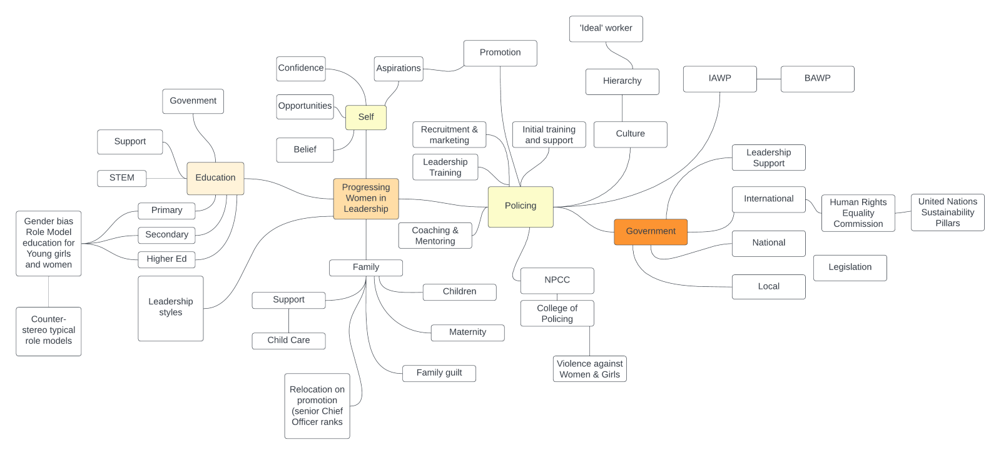
Ideas and concept map to tackle ideas for implementation plan by Peter Scott.

Appendix 2

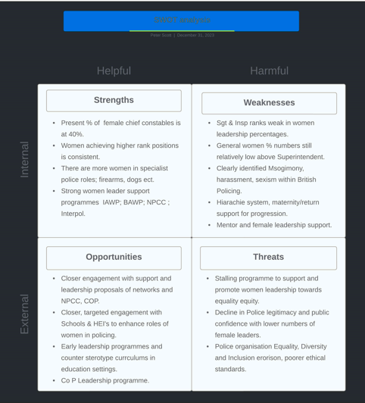
SWOT analysis used as a management tool to assist in informing the creation of the Aims & Objectives. SWOT tool process sourced from: Mullins, (2019)

Appendix 3

Risk Matrix
 | 1 Insignificant  Impact | 2 Minor  Impact | 3 Moderate  Impact | 4 Major  Impact | 5 Severe  Impact
5 Frequent  Likeliness | 5 moderate | 10 high | 15 extreme | 20 extreme | 25 extreme
4 Often  Likeliness | 4 moderate | 8 moderate | 12 High | 16 extreme | 20 extreme
3 Likely  Likeliness | 3 Low | 6 moderate | 9 High | 12 High | 15 extreme
2 Possible  Likeliness | 2 Low | 4 moderate | 6 moderate | 8 High | 10 High
1 Rare  Likeliness | 1 Low | 2 Low | 3 Low | 4 moderate | 5 moderate
<IMPACT >
Impact = 1insignificant – 5Severe (Impact or seriousness of the event)
Likeliness = 1 Rare – 5 Frequent (The likelihood/chance of event occurring)

Example: An event that has a High/frequent likelihood [5] of occurring against a Severe [5] impact in the event occurs would provide a risk rating of [25] - Leading to an Extreme Risk Grading.

