Student name  Programme | Peter Nguty Acha (2018019)  Certificate of higher Education, Skills for the Workplace Health, and social care
Module  Module Code | Problem solving and decision making  BMSW4004
Lecturer | Betsy Jose
Assignment Title | Problem solving and decision making

Abstract
Discussions and research most recently point out that UK job markets are tremendously affected by staff shortages.
According to BMJ (2015) England’s regulator of health and social care services is currently understaffed.
The purpose of this report is to Pinpoint out some of the main causes of staff shortages at Proper care UK and the world at large. I would also expand possibility of addressing this problem using some recognise methods like the fishbone, Pestel analyses, and the PMI.
In this report I will be discussing the
- scope of the problem of staff shortages.
- who is impacted?
- how they are impacted.
- I will also be discussing a plan to implement and monitor the decision I have made to solve the complex problem and plan to measure the success of the plan.

Contents
Abstract...........
Introduction........
Scope of the problem of staff shortages
Analysis of the problem
Solving the problem of staff shortages
Evaluation of the problem
Plan implementation solution, monitoring and review process
Conclusion
Reference list

Introduction
We are going to talk about how to solve this problem of staff shortages at Proper Care UK and the decision we will be making to address this problem.
Before proceeding, I would like to define the two main terms here: -
- Problem solving
- Decision making
According to Newell and Simon (1972) proposed that problem solving consist of a search in a problem space. A problem space has a starting state, a goal state, and a set of operators that can be applied that will solver from one state to another.
As maintained by R. Harris (1998) decision making is the process of sufficiently reducing uncertainty and doubt about alternatives to allow a reasonable choice to be made from among them. This simply means making the best choice from among another choices.
One of the chief challenges for health system globally is securing a skilled workforce and preventing the effect of staff shortages.
In this report I will be talking about staff shortages at PROPER CARE UK, and I will also be talking about how to address this problem not only at Proper Care UK but also globally because it is worldwide phenomenon, not only affecting PROPER CARE UK, but the world at large.
Before I proceed, I would like to define the meaning of staff shortage.
Staff shortage is when the demand for workers for a specific occupation is more than the available qualified workers for that occupation.
As maintained by BMJ (2015) England’s regulator of health and social care services is understaffed.
After the covid outbreak in 2019 and the United Kingdom exit from the European Union, staff shortages in the United Kingdom have been skyrocketing every day.

Scope of the problem of staff shortages
Shortage of staff is extended within the care domain and exist across all disciplines. The care domain is on the point of collapsing if quick and effective actions are not taken. The scope of this problem is enormous that it can even be term a global phenomenon because it affects countries across the globe. In the UK in particular this problem is not only affecting Proper Care UK, but it is also affecting the NHS (National Health Services) with too few nurses, midwives, GPs, hospital doctors and mental health staff. Workers are abandoning the service due to low work satisfaction. Recruitment continues to be an alarming issue.
As maintained by King’s fund (2020) 100 GP closed in the United Kingdom in 2019. This implies that the ratio of the population per available GP will be disproportionate making it beyond no doubt that the quality of services render to the population by the GPs will diminish.
Due to this phenomenon of staff shortages many people have opted to take private medical care policies making them to spend more than usual. Some people will be forced to travel more farer than normal to meet up with GP appointments. On the other side the GPs also face a lot of stress and burn out due to workload.
According to Allen et al (2008) work overload is the ultimate consequence of huge workloads and strict deadlines given to accomplish a task.
The most important part of this complex problem is that waiting times are too long.
- The diagram below shows some data of NHS huge rise in waiting time.
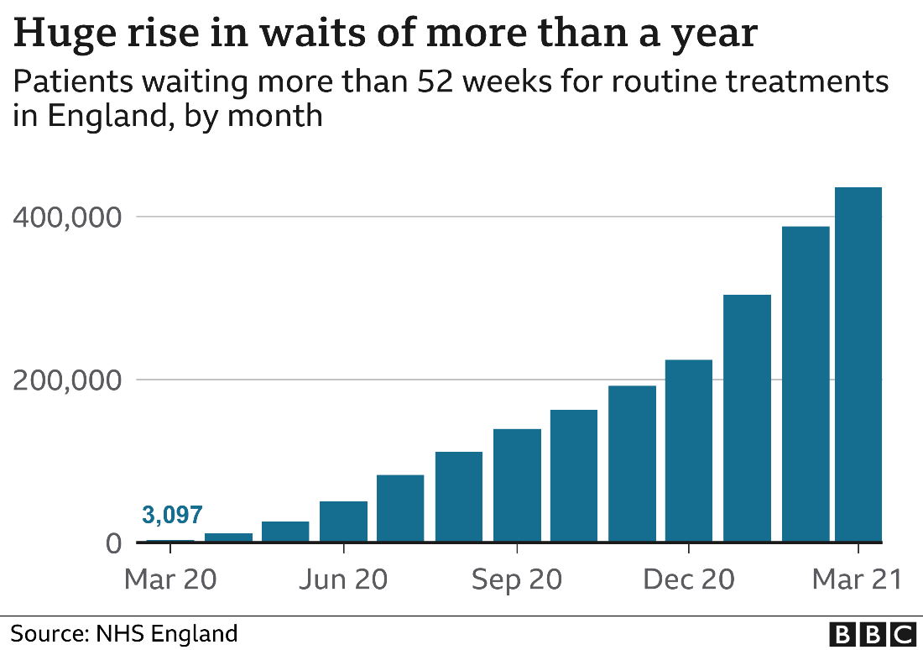
In this short conclusion i can conclude that both the service users and the service lenders are both affected by staff shortages.
The organisation will also be affected financially because if there are short of staff, they will have few people coming to them to ask for their services. They would preferably go to where they will be attended to.

Analysis of the organisation and problem
I will be using the PESTEL analysis and the fishbone diagrams to analyse the cause and effect of the complex problem of staff shortages at Proper Care UK.
When we talk of a cause-and-effect analysis we simply mean a technique for sporting out all likely causes (input) associated with a defined problem or effect (output) before moving down to the sub causes which need to be resolved.
A framework like the PESTEL is used for identifying factors that affect an organisation from the external. Without the help of this structure, it would be difficult to know where to commence because all organisations are affected by numerous outside factors.
The diagram below is a fishbone diagram showing some of the main causes and sub-causes of staff shortage at Proper Care UK. I would like to use this tool because it will help us to identify the causes and sub-causes of staff shortage at Proper Care UK so that when we are resolving the complex problem, we would not miss to address the real causes of the problem.
As maintained by Pearson (2005) root cause or fishbone analysis is increasingly being used in health and social care services to improve adverse events as it provides retrospective reviews of incidents or events.

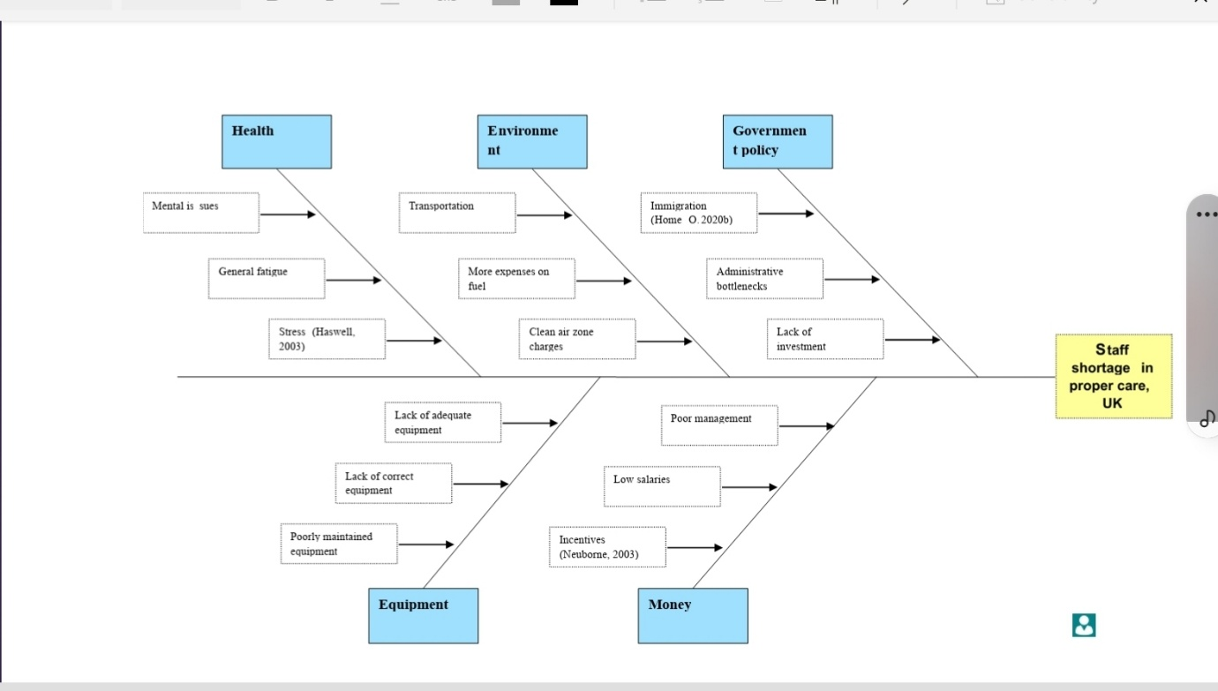

The next diagram is a PESTEL analysis. This structure will help us spot out some of the political, economic, socio-cultural / social, technological, environmental and legal problems causing the problem of staff shortage at Proper Care UK.
The word PESTEL is an acronym. As mentioned, above.
- P – political
- E – economical
- S – socio- cultural / social
- T – technological
- E – environmental
- L – legal.

P | E | S | T | E | L
Government policy | Unemployment rate | Population growth | Technological incentives | Climate | Discrimination laws
Political instability | Exchange rate | Age distribution | Technology change | Environmental policies | Employment laws
Tax policy | Economic growth | Disponible income | Technological awareness | Pleasure from NGOs | Antitrust laws
Labour law | Inflation rate | Cultural barriers |  | Weather | Health and safety laws

Decision making
According to Edwards, W. (1954) decision making is how people make choices among desirable alternatives.
As also maintained by Harris (1980) decision making is the study of identifying and choosing alternatives based on the values and preferences of the decision maker. Making a decision means that there are other choices to be considered, and in such a situation we do not want only to identify as many of these alternatives as possible but to choose the one that best fits with our purpose, objectives, desires, values etc.
In other to solve this problem of staff shortage at Proper Care UK, we must go through what is known as the rational decision process.
This process consists of -
- Problem identification
- Criteria definition
- Alternative generation and evaluation
- Implementation
- The problem has already been identified as staff shortage at Proper Care UK.
- Criteria definition. Most problems can be seen as multidimensional of which in this case making a decision all the factors influencing the problem must be taken into consideration.
- The next step should be alternative generation and evaluation. During this stage, the decision maker should be able to identify the different possible courses of action and evaluates each course based on previous stages. The disadvantages and advantages of each alternative should be weighed to establish the most appropriate solution.
- Implementation. Once the main option has been established, the implementation step is required to apply the solution. This also mean acting on the chosen choice. This is one of the most delicate stages because if the identification and structuring of the original problem was not carried out completely, the problem may resurface.

Evaluating a possible solution to address the problem of staff shortage at Proper Care UK
I will be using a PMI (plus, minus interesting) a critical thinking decision making tool to evaluate the best option solution among three propose solutions to address the problem of staff shortage at Proper Care UK.
Having previously identifying immigration, absenteeism, environment as one of the courses of staff shortage at Proper Care UK, I will use a PMI to evaluate which of them is more likely than the other two.
According to Oxford Review of Economic Policy (2022) one of the most important question facing immigration policy- makers is which jobs should be eligible for work visas. This question has dominated discussions about the post-Brexit immigration system, which has focused on the issue if staff shortages.
PMI aim at solving the problem of absenteeism

PLUS | MINUS | INTERESTING
INCENTIVES +5 | MORE EXPENDITURE FORE THE ESTSBLISHMRNT -4 | MORE STAFF +5
DECIPLINARY ACTIONS +4 | MORE WORK FOR THE MANAGEMENT TEAM -5 | LESS STRESS +5
MORE TRAINING +5 | LESS SHIFTS FOR THE STAFF  -5 | MORE SPACE NEEDED -3
MORE STAFF +3 | LOW SALARY –4  MORE COMFLICTS AMONG STAFF-5 | MORE EQUIPMENT +3
FLEXIBILITY + 5 | STAFF EXODUS DUE TO LOW SALARY-5
+22 -28 +10
TOTAL +4

PMI
Solving the problem of staff shortage at Proper Care UK
Environment

PLUS | MINUS | INTERESTING
Good air quality +5 | Clean air zone charges -5 | Less respiratory issues +5
Less congestion +5 | Transport fairs more expensive -3 | More spending - 6
Less noise +5 | More time is invested back and forth work if far from home - 5  More expensive for fuelling -3
+15 | - 16 | - 1
TOTAL = -2

PMI
Solving the problem of staff shortage at Proper Care UK on immigration

PLUS | MINUS | INTERESTING
Increase in workforce + 5 | Potential fall in wages - 4 | Greater cultural diversity + 5
A solution to ageing population + 5 | Increase pressure on public services -2 | Social dis harmony -3
Fills job vacancy +5 | Increase in housing cost - 3
More Flexible labour markets + 4 | It can impact the GDP -2
Increase economic growth + 5  +24 | - 11 | +2
TOTAL = 15

Plan for implementing the best solution to address the problem of staff shortage at Proper care UK
After using the PMI, a critical decision making and evaluation tool it has been proven that the immigration problem is the paramount course for staff shortages at Proper care Uk and should be addressed to resolve the complex problem.
To address this problem, it needs a planning.
According to Koontz and O’Donnell (1955) said planning is deciding in advance what to do, how to do it, when to do it and who is to do it.
There are some key factors that must be taken into consideration when planning because if any of this factor is missing, we might not achieve our aims.
- We must consider what outcome we expect after implementing the solution.
- What steps should be taken to implement the best possible respond to solve the problem.
- You must also consider changes and policies to address the problems if need be.
- What resources you will need from such as material, people and facilities.
- A development plan will be need that is when to start and when to finish
- Who will be responsible to make sure the plan is implemented.

The plan to address the problem of staff shortage at Proper Care UK
After using the decision-making tool (PMI) to compare, analyse and evaluate the different courses of staff shortage at Proper Care UK among which was immigration, environment and absenteeism, the results proved beyond no doubt that the immigration problem was the main problem coursing staff shortage at Proper Care UK.
To resolve this complex problem-
- Proper Care UK will need an immigration lawyer here in the UK to advise them about the latest immigration laws and rules. He will also be in charge to follow up all the applicant's documentation works at the home office that is getting in contact with the home office here in the UK and different UK embassy wherever he may need to contact. The same lawyer will need to handle their paperwork once the applicants are successful to travel to the Uk.
- Proper care will need to open their own recruitment agencies outside the UK in the countries they would want to recruit from. They would need money to rent offices, money to furnish the agency, they will need money for to buy computers, communication equipment. They will need money to pay the workers.
The next step is to give six months after the plan has gone into effect to evaluate the outcome of the plan implemented. The out outcome expected in this case is that Proper Care should have all the staff they need to be fully operational.

Conclusion and discussion
This problem of staff shortages is not only affecting Proper Care UK, but it is affecting many other establishments all over the world. There is need for the government and managers to reconsider management and immigration policies. The United Kingdom have been suffering from staff shortages for some years now but since the covid outbreak in 2019 and the United Kingdom exit from the European Union, staff shortages have been skyrocketing every day especially in the domain of care. This problem is so serious that both the service user and the service lenders are both tremendously affected. The complexity of staffing challenges both the employers and the government to focus on predictability of workload needs and other factors that affect staffing requirements, such as: immigration laws and policies, flexible working timetables to match the demand and reduce sickness, absenteeism and other factors influencing this phenomenon of staff shortages.

Reference list
- BMJ 2015; 351 doi: https://doi.org/10.1136/bmj.h4000 (Published 22 July 2015)
- Newell, A., & Simon, H.A. (1972) Human Problem solving. Englewood Cliffs, NJ:PrenticeHa
- Harris, R. (1998) Introduction to Decision Making, VirtualSalt.
- King’s Fund. Medical workforce: trends in the medical workforce. 2020. www.kingsfund.org.uk/projects/time-think-differently/trends-workforce-medica
- Allen, M., Armstrong, D., Reid, M., & Riemenschneider, C. (2008). Factors impacting the perceived organizational support of IT employees. Information & Management, 45(8), 556-63
- Edwards, W. (1954). The theory of decision making. Psychological Bulletin, 51(4), 380–417. https://doi.org/10.1037/h0053870
- Harris, R. (1998) Introduction to Decision Making, VirtualSalt. http://www.virtualsalt.com/crebook5.htm
- Oxford Review of Economic Policy, Volume 38, Issue 1, Spring 2022, Pages 97–111, https://doi.org/10.1093/oxrep/grab046
- Pearson A (2005) Minimising errors in health care: Focussing on the ‘root cause’ rather than on the individual. International Journal of Nursing Practice; 11: 141

