INTRODUCTION TO HEALTH AND SOCIAL CARE

MODULE CODE: LCHS4003
LECTURER: DR AISHAT BAKRE
ASSINGMENT TITLE: PORTFOLIO – TWO TASKS
STUDENT NAME: NARGOS HUSSAIN
STUDENT NUMBER: 2432693



TASK 1 POSTER
COMMUNITY ANTENATAL MIDWIFERY
SERVICES



This Photo by Unknown Author is licensed under CC
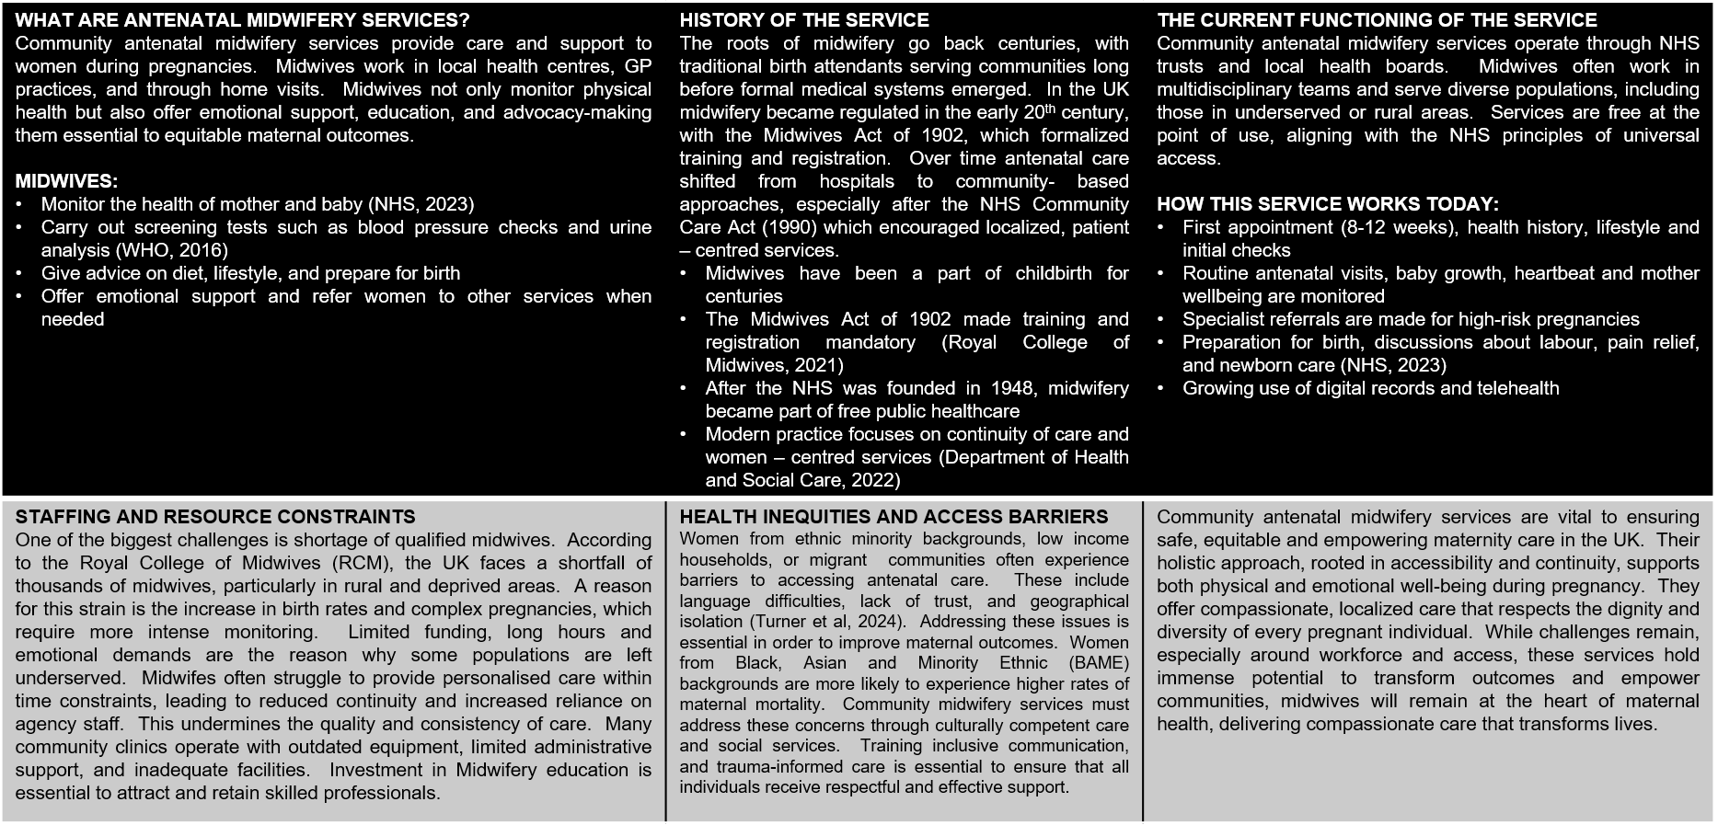


TASK 2 ESSAY

THE ORIGINS AND STRUCTURE OF THE NATIONAL HEALTH SERVICE (NHS)

The National Health Service (NHS) is widely regarded as one of the most significant achievements in British social policy. It’s founding in 1948 was the culmination of ideas, political will, and social change. It marked a transformative shift in the provision of healthcare, from an inequitable system to a publicly funded service. Before its creation, healthcare provision in the UK was fragmented. Access depended on income, charity, or insurance schemes, which meant that many working-class families could not afford treatment. The Second World War, with its demand for coordinated emergency medical services, showed that a more organised and universal approach was both possible and necessary. This essay explores the historical context and founding principles of the NHS, followed by a critical analysis of its contemporary structure and functioning.

Prior to the NHS, healthcare in Britain was largely dependent on private payments, charitable organisations, and limited insurance schemes. Access was uneven, and many working-class families could not afford medical care (Gorsky, 2008). During the First World War and the interwar period, calls for reform grew, with proposals for state provision of health services (Delamothe, 2008). The 1942 Beverage Report, commissioned during the Second World War, was pivotal: it proposed a postwar welfare state that would tackle the “five giants” of want, disease, squalor, ignorance, and idleness (Beveridge, 1942). When Labour came to power in 1945, it was committed to turn these ideas into reality. Aneurin Bevan, the health minister, took charge of the reforms. He faced strong opposition from doctors, local authorities and voluntary hospitals, but eventually succeeded in uniting them under a single system (Timmins, 2017). The service was funded through general taxation and was free at the point of delivery. Its founding principles were simple: it should be universal, comprehensive, and based on clinical need rather than the ability to pay (NHS England, 2023).

The founding of the NHS rested on several interlocking principles:
1. Universality / Comprehensiveness: services should be available for all, covering a full range of medical and preventive care (Delamothe, 2008; Shapiro, 2010).
2. Free at the point of use: individuals would not pay at the time of service; costs would be borne by general taxation (Lords Library, 2025).
3. Based on need, not ability to pay: equity was central – care would be allocated by clinical need, not financial status (Delamothe, 2008).

4. Public funding and central oversight: funding was to come from the state and services centrally organized to ensure uniform quality (Delamothe, 2008; Lords Library, 2025).
5. National solidarity and standardization: the NHS sought to reduce regional disparities, ensure consistent standards and unify service delivery (Gorsky, 2008).

The NHS has clear strengths. It provides a guaranteed safety net, so people don’t avoid care because of cost, and it runs many highly specialised and efficient services. Public support for a universal NHS is strong, and that political backing helps keep it central to UK society.

At the same time, real challenges are visible. Funding has not kept pace with rising demand and medical advances, producing long waiting lists for some elective treatments (King’s Fund, 2022). An ageing population and more people living with multiple long-term conditions increase pressure on both health and social care. Staff shortages in nursing, general practice and some specialties have made services harder to run and left many workers burned out (Buchan et al., 2019). Health outcomes also vary by region and social class, so equal access hasn’t erased inequalities in health (Marmot, 2020). Finally, the growing role of private providers and market-style reforms has sparked debate about accountability and whether those changes help or harm continuity of care (Pollock, 2005).

If the NHS is to work well in future, a few things matter most: sustainable funding that matches demand; serious investment in the workforce (training, pay, retention); better integration with social care so people don’t fall through the gaps; and stronger efforts on prevention and the social causes of ill health (Ham, 2014; Marmot, 2020). In short, the NHS’s founding principles still make sense, but they need modern policy choices and resources to be realistic in the twenty-first century.

REFERENCES

Appleby, J., Galea, A. and Murray, R. (2017) The NHS at 70: NHS funding and productivity.
Beveridge, W. (1942) Social Insurance and Allied Services (The Beveridge Report). London: HMSO.
Buchan, J., Charlesworth, A., Gershlick, B. and Seccombe, I. (2019) A Critical Moment: NHS staffing trends, retention and attrition. The Health Foundation.
Ham, C. (2014) Reforming the NHS from Within: Beyond hierarchy, inspection and markets. London: The King’s Fund.
King’s Fund (2022) NHS funding projections 2022–2030. The King’s Fund.
NHS England (2023) Principles of the NHS. Available at: https://www.england.nhs.uk (Accessed: 17 September 2025).
Timmins, N. (2017) The Five Giants: A Biography of the Welfare State. 2nd edn. London: William Collins.
Webster, C. (2002) The National Health Service: A Political History. 2nd edn. Oxford: Oxford University Press.
National Institute for Health and Care Excellence (NICE) (2021) Antenatal care guideline [NG201]. Available at: https://www.nice.org.uk/guidance/ng201 (Accessed: 28 September 2025).
Nursing and Midwifery Council (NMC) (2022) Standards of proficiency for midwives. Available at: https://www.nmc.org.uk (Accessed: 28 September 2025).
Public Health England (2020) Health inequalities: place-based approaches to reduce inequalities. Available at: https://www.gov.uk/government/publications (Accessed: 28 September 2025).
Royal College of Midwives (RCM) (2023) State of Maternity Services Report. Available at: https://www.rcm.org.uk.

