

By Aleksandar Peshankov

Computer Architecture
SCENARIO 1

Submission date:
Submission ID: 1905148
File name:
Word count:
Character count:

Aleksandar Peshankov
Bcs in Cloud Computing

Scenario 1:

Case | PCS 3312B BLACK CASE
Processor (CPU) | Intel® Celeron® Dual Core Processor G4930 (3.20GHz) 2MB Cache
Motherboard | ASUS® H310M-A R2.0: Micro-ATX, DDR4, LGA1151, USB 3.1, SATA 6GBs
Memory (RAM) | 4GB Corsair VENGEANCE DDR4 2400MHz (1 x 4GB)
Graphics Card | INTEGRATED GRAPHICS ACCELERATOR (GPU)
1st Storage Drive | 256GB PCS 2.5" SSD, SATA 6 Gb (500MB/R, 400MB/W)
DVD/BLU-RAY Drive | NOT REQUIRED
Power Supply | FSP 250W 80+ BRONZE POWER SUPPLY (For PCS 3312B BLACK Case Only)
Power Cable | 1 x 1 Metre UK Power Cable (Kettle Lead)
Processor Cooling | STANDARD CPU COOLER
Thermal Paste | STANDARD THERMAL PASTE FOR SUFFICIENT COOLING
Sound Card | ONBOARD 6 CHANNEL (5.1) HIGH DEF AUDIO (AS STANDARD)
Wireless/Wired Networking | WIRELESS 802.11N 300Mbps/2.4GHz PCI-E CARD
USB/Thunderbolt Options | MIN. 2 x USB 3.0 & 2 x USB 2.0 PORTS @ BACK PANEL + MIN. 2 FRONT PORTS
Operating System | Windows 10 Home 64 Bit - inc. Single Licence
Operating System Language | United Kingdom - English Language
Windows Recovery Media | Windows 10 Multi-Language Recovery Image - Unlimited Downloads from Online Account
Office Software | FREE 30 Day Trial of Microsoft® Office® 365 (Operating System Required)
Anti-Virus | BullGuard™ Internet Security - Free 90 Day License inc. Gamer Mode
Browser | Microsoft® Edge (Windows 10 Only)
Monitor | IIYAMA E2283HS-B3 21.5" Widescreen Monitor
Monitor Cables | 1 x 2 METRE HDMI (M) to DVI (M)
Keyboard | PCS S300 USB MEDIA KEYBOARD
Mouse | LOGITECH® OPTICAL USB MOUSE

£350.00 - ex VAT
£420.00 - inc VAT

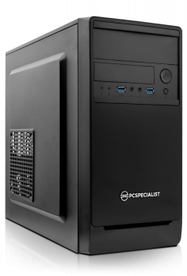  £12.00 | Dimensions | 372mm x 188mm x 390mm
 | Colours | Black
 | Materials | Plastic, Steel
 | Bays | 1 x 5.25" Drive Bay
 | Bays | 1 x 3.5" Bay
 | Top/Front USB & Audio | 2 x Front USB 3.0 Ports
 | Top/Front USB & Audio | 1 x Mic in
 | Top/Front USB & Audio | 1 x Headphones Out
 | Features | - Reinforced EMI Shield  - 2.5" SSD Supports  - USB 3.0 Ready
 | Fans | 1 x 80mm rear fan

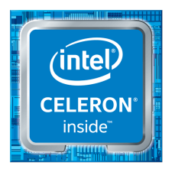  Intel® Celeron® Processor G4930  £86.16 | Performance | Cache | 2 MB Intel® Smart Cache
 | Performance | Processor Base Frequency | 3.20 GHz
 | Performance | Bus Speed | 8 GT/s
 | Performance | Thermal Design Power | 54 W
 | Memory Specifications | Max Memory Size | 64 GB
 | Memory Specifications | Memory Types | DDR4-2400
 | Memory Specifications | Max # of Memory Channels | 2
 | Memory Specifications | Processor Graphics | Intel® UHD Graphics 610
 | Memory Specifications | Max Resolution | 4096x2304@60Hz

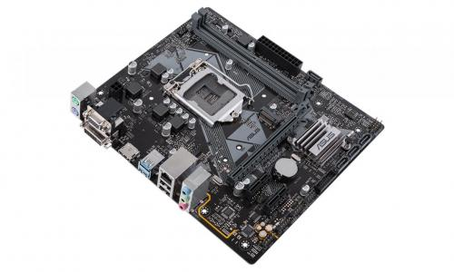  £61.19 | Chipset | Intel® H310
 | RAM Slots | 2 x DIMM, max. 32GB, DDR4 2666MHz, non-ECC, un-buffered memory
 | Expansion Slots | 1 x PCI Express 3.0/2.0 x16 slot, 2 x PCI Express x1 slots
 | SATA Ports | 4 x SATA 6Gb/s ports, 1 x M.2 Socket
 | USB Ports | 4 x USB 3.1 ports (2 mid-board, 2 back panel), 6 x USB 2.0 ports (4 mid-board, 2 back panel)
 | Networking | Realtek® 8111H Gigabit LAN support LANGuard
 | Audio | Realtek® ALC887 8-channel* High Definition Audio CODEC

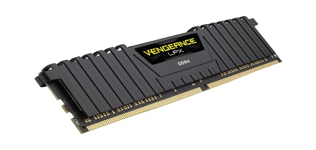  £20.99 | Size | 4GB
 | Number of Modules | 1
 | Speed | 2400 MHz

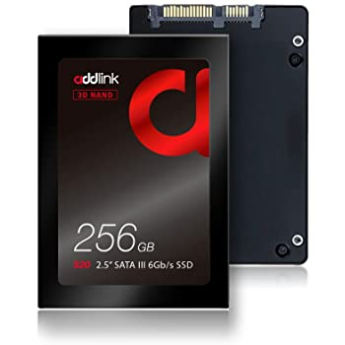  £39.44 | Data Transfer Rate | 510.00 megabytes_per_second
 | Installed Flash Memory Size | 256.0 GB
 | Hard Disk Size | 256.0 GB
 | Item Dimensions | 10.00 x 6.98 x 0.71 centimeters
 | Memory Storage Capacity | 256.00 GB

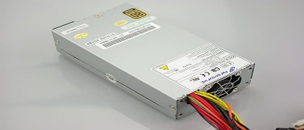  £8.99 | Max power | 250W Continous

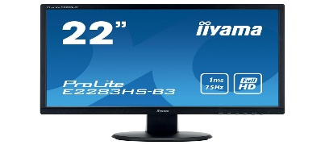  £93.00 | Size | 21.5"
 | Resolution | 1920 x 1080, Full HD
 | Dynamic Contrast Ratio | 80,000,000:1 ACR, 1000:1 typical
 | Response Time | 1ms
 | Connections | VGA, DP, HDM
 | Speakers | 2 x 1W (Stereo)
 | Display Cables | HDMI

Before mounting the first component in the box, namely the motherboard, we must place the I / O protection panel in the appropriate place in the box.
As for the main components, the central processing unit (CPU) is the heart of the computer and it is desirable to put it in the beginning. This is relatively easy by carefully checking that the socket and the processor itself are clean before installing it. When placing the processor, we must make sure that it is oriented correctly so that it fits into the socket. It is very important to be careful when installing the processor and not to rush.
Once we deal with this comes the place of the cooler. Here, however, keep in mind that if we do not use the cooler provided with the processor, but purchased separately, it is good to install the RAM modules first. This is necessary provided that the cooler is large and we may not have access to the RAM slots.
It is also important to know that high-end RAM modules often come with cooling heatsinks that are higher and there is a possibility that they rest on the CPU heatsink, which should be avoided. In this case we choose low profile RAM.
The most common mistake when installing RAM is to fail to read the bottom manual in this section. Does it support two-, four- or three-channel memory configuration? Placing the modules in the way indicated by the manufacturer is of particular importance. If we don't study the information well enough, we can use single-channel memory, which will reduce performance.
After installing the RAM, it's time for the CPU cooler.
Here we have a few possible stumbling blocks. The cooler radiator is placed on the processor itself so as to extract heat from it, and between them we must place a thermal paste, which facilitates and enhances this process. Some of the coolers, including those that come with the processors, have pre-applied thermal grease. In others, however, we have to buy and put the paste.
Using too much or too little paste can be a problem. We put a quantity the size of a pea in the center of the processor for best results. We must not forget to check (and remove) the presence of a plastic fuse glued to the base of the cooler.
Once we have completed the previous steps and the I / O panel is in place, we can proceed with the installation of the bottom in the box.
The box we have chosen has screw pads that aim to keep the bottom of the bottom separate from the box itself. If we forget to put them on and turn on the power, there is a high probability that we will burn our components. We place and screw the necessary pads without tightening them too much, because we can damage their thread. The placed pads must coincide with the screw holes located on the bottom.
It puts the power supply before the bottom, because then we may not have enough space to work.

Most motherboards have more than one PCI Express x16 but not all are the same. Two slots on the Intel board shown look similar, but one has a full 16-track electrical connection and the other has only 8 tracks.
Here one of the possible mistakes is the installation of the video card in the wrong PCI Express slot. As a rule, always insert the video card into the slot that is closest to the processor to achieve the highest possible performance. In any case, it is good to check the instructions at the bottom before installing the card, especially if you use more than one.
Another common mistake is to skip the wiring. A well-arranged box not only looks nice, but also contributes to better airflow - an important aspect of cooling the system.
And perhaps last among the mistakes we can make, namely forgetting a cable, happens to everyone. Even a small omission can make the computer unable to start. We need to pay special attention to the cables coming from the front panel of the box, to review the instructions to the bottom to deal with their proper placement.
Once we have installed all the components, we carefully examine the box to make sure everything is in place and connected properly. And we must not forget to connect the cables from the power supply to the bottom, the video card, the disks and the optical drive.

When assembling the computer, we work with Anti-Static Wrist Strap

https://www.pcspecialist.co.uk/computers/intel-home-office-pc-II/

By Aleksandar Peshankov

Computer Architecture
SCENARIO 2

Submission date:
Submission ID: 1905148
File name:
Word count:
Character count:

Aleksandar Peshankov
Bcs in Cloud Computing

Scenario 2:

Case | COUGAR DarkBlader – G
Processor (CPU) | AMD Ryzen 9 3900X
Motherboard | ASRock X570 Pro4
Memory (RAM) | 2x16GB DDR4 3600 Kingston HyperX Predator
Graphics Card | GIGABYTE GeForce RTX 2080 Super 8GB Windforce
1st Storage Drive | SSD – Samsung 970 EVO Plus 500gb
2nd Storage Drive | HDD WD Purple 3TB
Power Supply | 750W Thermaltake Smart BX1
Processor Cooling | DeepCool CASTLE 360RGB V2
Sound Card | ASUS Xonar SE 5.1
Monitor | LG 27UL550-W 4K IPS monitor

Total: £2482.48 - inc VAT

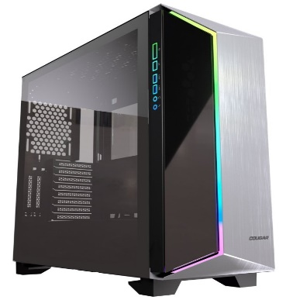  £109.89 | - Mini ITX / Micro ATX / ATX / CEB  - 232 x 523 x 518 (mm) (WxHxD)  - x1 Rear 120mm Pre-Installed Fan  - Tempered Glass Panels
https://www.ebuyer.com/950758-cougar-dark-blader-g-premium-mid-tower-gaming-case-brushed-aluminium-cgr-58m3b-g?gclid=Cj0KCQjw-_j1BRDkARIsAJcfmTGy7_NIiVkSbMCblhfz3hDzV3CYugbkWUYzfsKzfIvSMKAHDiP4KgkaArRHEALw_wcB
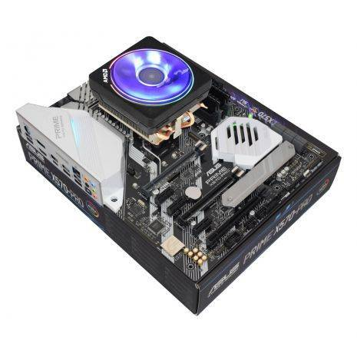  £439.99 | - # of CPU Cores: 12  - # of Threads: 24  - Base Clock: 3.8GHz  - Max Boost Clock: 4.6GHz  - Total L2 Cache: 6MB  - Total L3 Cache: 64MB  - Unlocked: Yes  - CMOS: TSMC 7nm FinFET  - Package: AM4  - PCI Express® Version: PCIe 4.0 x16  - Default TDP / TDP: 105W
https://www.overclockers.co.uk/amd-ryzen-9-3900x-twelve-core-4.6ghz-socket-am4-processor-retail-cp-3b5-am.html?gclid=Cj0KCQjw-_j1BRDkARIsAJcfmTGyzpodes3FV06l_TNf0R2eAKj_GOSMgsqdv3vHpiwUxmF1Ltb4NqYaAquyEALw_wcB
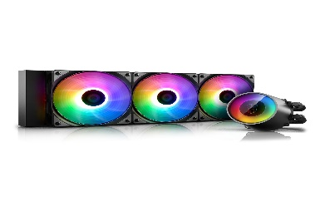  £129.98 | - Edition: CASTLE 360 RGB V2  - Cooler Form Factor: 360mm All-In-One Hydro Cooler  - Cooler Features: Addressable RGB Lighting  - Aluminium Fins  - Copper Base  - RGB LED CPU Block
https://www.scan.co.uk/products/deepcool-gamerstorm-castle-360rgbv2-all-in-one-liquid-cpu-cooler-pwm-360mm-radiator-intel-amd?gclid=Cj0KCQjw-_j1BRDkARIsAJcfmTE1H4vMIx5J9YHE9YbwhrXHkW71K_ZfSqx3ie8CK7JUAhSsvHfRmFwaAkDSEALw_wcB
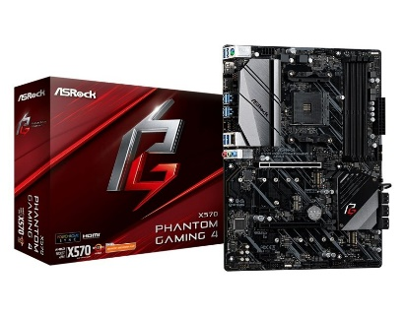  £164.78 | - Supports AMD AM4 Socket Ryzen™ 2000 and 3000 Series processors  - 10 Power Phase Design  - Supports DDR4 4066+ (OC)  - 2 PCIe 4.0 x16, 2 PCIe 4.0 x1, 1 M.2(Key E) For WiFi  - AMD Quad CrossFireX™ and CrossFireX™  - Graphics Output Options: HDMI, DisplayPort  - 7.1 CH HD Audio (Realtek ALC1200 Audio Codec), ELNA Audio Caps  - 8 SATA3, 1 Hyper M.2 (PCIe Gen4 x4 & SATA3), 1 Hyper M.2 (PCIe Gen4 x4)  - 2 USB 3.2 Gen2 (Rear Type-A), 10 USB 3.2 Gen1 (4 Front, 6 Rear)  Intel® Gigabit LAN
https://www.ebuyer.com/892323-asrock-x570-phantom-gaming-4-am4-ddr4-atx-motherboard-x570-phantom-gaming-4?gclid=Cj0KCQjw-_j1BRDkARIsAJcfmTHKYlwUEsO4z9c8Dvtc_CGsSNOmTa0cFl73IGRRQd56K8_5y0dXxp0aAu6-EALw_wcB
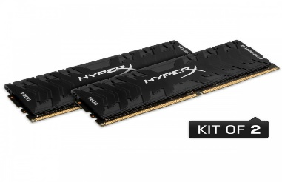  £269.99 | - Perfect for AMD & Intel  - Capacity: 32GB  - Frequency: 3600MHz  - Latency: 17-19-19-39  - Voltage: 1.35V  - Registered/Unbuffered: Unbuffered  - Error Checking: Non-ECC  - Type: 288-pin UDIMM  - Operating Temperatures: 0°C to 85°C  - Dimensions: 133.35mm x 42.2mm  - Features: Intel XMP 2.0
https://www.overclockers.co.uk/kingston-hyperx-predator-32gb-2x16gb-ddr4-pc4-28800c17-3600mhz-dual-channel-kit-hx436c17pb3k2-32-my-291-ks.html?gclid=Cj0KCQjw-_j1BRDkARIsAJcfmTE_gd8K0USXtWIoVxwJvFLdbI1fI_vQRIjbzed6IU8gkZB2_CECM0MaAkMiEALw_wcB
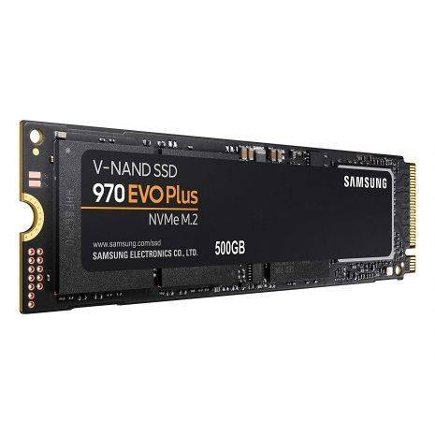  £119.99 | - SSD CAPACITY: 500GB  - SSD FORM FACTOR: M.2 (2280)  - SSD INTERFACE: PCIe Gen 3.0 x4, NVMe 1.3  - SSD READ SPEED: 3500 MB/s  - SSD WRITE SPEED: 3200 MB/s
https://www.awd-it.co.uk/samsung-970-evo-plus-nvme-m.2-500gb-internal-solid-state-drive-ssd-mz-v7s500bw.html?gclid=Cj0KCQjw-_j1BRDkARIsAJcfmTFrMg8iom9KvTywCc4nEcp365EgbGXcbK344QxOhST4URmD9fIRwOwaAuxxEALw_wcB
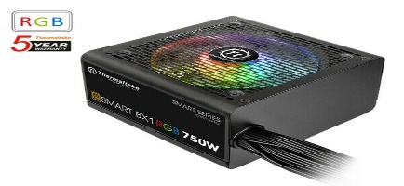  £84.00 | Max power: 750W
https://www.ebay.co.uk/i/264715442837?chn=ps&norover=1&mkevt=1&mkrid=710-134428-41853-0&mkcid=2&itemid=264715442837&targetid=878634471058&device=c&mktype=pla&googleloc=1006886&poi=&campaignid=9437742368&mkgroupid=95452926426&rlsatarget=pla-878634471058&abcId=1140496&merchantid=6995734&gclid=Cj0KCQjw-_j1BRDkARIsAJcfmTF3bwonBtQ1yMlAHtgmzJU3pC7CntgmCtd2jkfE5-zwxeOuI3b_8dcaAuC8EALw_wcB
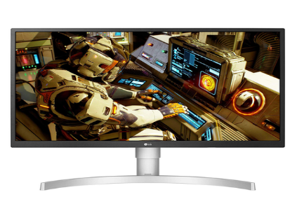  £349.97 | Size | 27 Inch
 | Resolution | 3840 x 2160, Ultra HD 4K
 | Dynamic Contrast Ratio | 16:9 Aspect
 | Response Time | 5ms
 | Refresh rats | 60Hz
 | Display Cables | HDMI DisplayPort
https://www.laptopsdirect.co.uk/-27ul550/version.asp?refsource=ldadwords&mkwid=sTvQvUfp9_dc&pcrid=352718151580&product=27UL550&pgrid=71068490596&ptaid=aud-720031161739:pla-734822102085&channel=search&gclid=Cj0KCQjw-_j1BRDkARIsAJcfmTF8XN6UEx5YbZU7jFgi7jEJDZf9SB3TBgs7LSjf2PTTkPiSuquJE_YaAnj8EALw_wcB
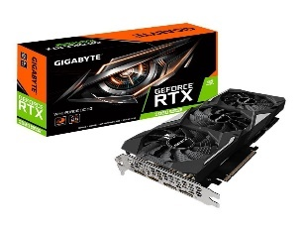  £699.99 | Bus Type: PCI Express 3.0 x16  Core Clock: 1830 MHz  Max Resolution: 7680 x 4320 at 60 Hz  Interfaces: 3 x DisplayPort Â¦ HDMI  API Supported: DirectX 12, OpenGL 4.5
https://www.ebuyer.com/910627-gigabyte-geforce-rtx-2080-super-windforce-oc-8gb-graphics-card-gv-n208swf3oc-8gd?gclid=Cj0KCQjw-_j1BRDkARIsAJcfmTGMjTEyXKQpveSYYa4WVbd4Yl13xzMMkBFWm3qSAqcfmC5pjP06AXQaAimHEALw_wcB
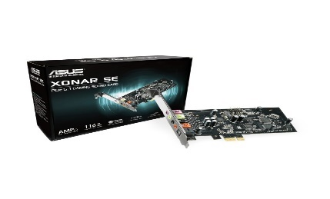  £39.95 | - 5.1 channel, 192kHz/24-bit Hi-Res audio with a 300ohm headphone amp for detailed, immersive sound with punchy, defined bass  - Realtek ALC1220X codec delivers a crystal clear 116dB signal-to-noise ratio (SNR)  - ASUS Hyper Grounding Technology ensures minimal audio distortion and interference  - Xonar Audio Center enables full audio control via an intuitive, spacious interface  - Included Low Profile Bracket allows the Xonar to fit perfectly into most systems
https://www.overclockers.co.uk/asus-xonar-se-5.1-pci-e-gaming-sound-card-with-192khz-24-bit-hi-res-audio-sc-03a-as.html?gclid=Cj0KCQjw-_j1BRDkARIsAJcfmTHlvgohd--Luin9X0ubdoiZccCskGWMCkMFYvu7eYrKWMMXqMlQkIwaAo5XEALw_wcB

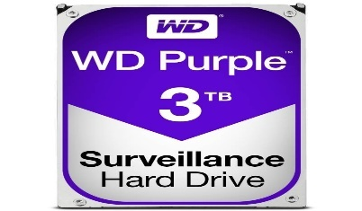  £73.95 | - WD Purple Surveillance Hard Drive WD30PURZ  - Hard drive  - 3 TB  - internal  - 3.5"  - 5400 rpm
https://www.ebuyer.com/788298-wd-purple-surveillance-3tb-internal-hdd-wd30purz-wd30purz?mkwid=s_dc&pcrid=51482414339&pkw=&pmt=&gclid=Cj0KCQjw-_j1BRDkARIsAJcfmTGH7sxcL9yHa2UnHg8FFRyu02IXylqZerQuVPD49rMcgBRXgt9RXcgaAvkUEALw_wcB

1. One of the things about this tower is the hard drive drawers. The drawers are stacked at the front of the tower away from all major heat sources and have little tabs we can pinch to slide out drives. Damaging a hard drive is arguably more detrimental than any other piece of hardware because of the valuable information store on PC
2. Ryzen 9 3900X. With 12 cores and 24 threads the 3900X delivers an amazing level of performance. It has a base clock speed of 3.8GHz with a maximum boost of up to 4.6GHz. It's seriously fast and Wraith Prism RGB cooler to keep your system running at maximum efficiency.
3. Motherboard ASRock X570 Pro4 supported processor AMD Ryzen 9.
This motherboard features onboard RGB headers and an addressable RGB header that allow motherboard to be connected to compatible LED devices such as strip, CPU fans, coolers, chassis and so on. This motherboard is capable of supporting DDR4 ECC un-buffered memory modules that delivers server-grade performance and rock-solid durability for high-end computing systems.

4. Memory (RAM) The HyperX DDR4-3600 C17 2x 16GB kit sports good timings and an XMP backup for boards that can't handle its high advertised speed.
High speeds combined with low latencies provide exceptional DDR4 performance.
Speeds up to 4000MHz, paired with fast times CL12 - CL19, help power system through games, video editing and broadcasting.
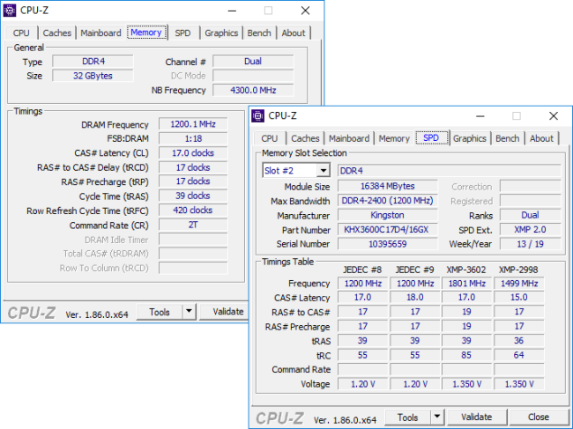

5. The WINDFORCE 3X cooling system features 3x 82mm unique blade fans, alternate spinning fan, 5 composite copper heat pipes, heat-pipe direct touch and 3D active fan functionality, together delivering an effective heat dissipation capacity for higher performance at lower temperatures.
6. The 970 EVO Plus reaches sequential read/write speeds up to 3,500/3,300 MB/s, up to 53%‡ faster than the 970 EVO. The latest V-NAND—which brings greater NAND performance and higher power efficiency—along with optimised firmware, a proven Phoenix controller and Intelligent TurboWrite boost.
7. The WD Purple 3 TB hard drive provides ample storage space for all information.
They are able to calculate optimal search speeds and this maintains low energy consumption. They are also designed to withstand high temperatures.
8. Built to deliver 80 PLUS Bronze with 88% power efficiency, the Smart BX1 series is available in 450W - 750W models. Constructed with a 120mm hydraulic bearing fan, Japanese main capacitors and other premium components to help deliver a continuous and stable power output at 40℃, near silent operation and reliable performance.
9. Anti-leak Tech Inside liquid cooling system equipped. 16.7 M true color RGB flowing light system with 5 in-built effects and 36 interchangeable lighting modes.
Motherboard and controller Addressable RGB SYNC control supported*
An optimized E-shaped micro water channel is designed to effectively enhance heat circulation efficiency and to enlarge heat contact areas.
Supports mainstream INTEL and AMD socket mounting, including TR4/AM4.
10. Xonar SE features the Xonar Audio Center software suite for full control over every aspect of sound, from equalization (EQ) to 5.1-speaker level-balancing, and provides a experience via an inviting and intuitive interface.
Delivers an exceptional audio signal with a 116dB signal-to-noise ratio (SNR) for 32-times greater clarity than average onboard audio chips.
11. This monitor is compatible with HDR10 to represent details in bright and dark parts of high dynamic range contents.
HDCP 2.2 Compatible
This LG 4K monitor is compatible with the latest HDCP 2.2 copy protection, so it will display video from 4K streaming services, game consoles and Ultra HD Blu-ray disc players.
RADEON FreeSync™
Radeon FreeSync™ reduces the tearing and stuttering that occur between a graphic card's frame rate and a monitor's refresh rate enabling smoother motion and less stuttering in demanding games.

Network storage
Network storage is one of the most preferred methods nowadays. It includes online servers, so-called NAS devices (Network-Attached Storage), and cloud storage.
In the first type, the files are stored on local servers, and everyone can control who has access to the information.
In turn, the NAS device is a computer that is used only as a data storage server. Its advantage is that it can be connected to a router and anyone who has access to the Internet could access and transfer files to it.
The third type is cloud storage, which is the most modern way of storing data. There are a number of platforms available today that allow you to upload files online and share them with friends. In practice, it works in the same way as NAS devices, but with the difference that here the management of information is done only online.
To conect with NAS I should try to keep two machines (NAS and PC) connected to the same switch or router. I plug my computer and NAS into the same switch and then connect my switch to the wireless router.
Most routers are also switches and technically you should get the same speeds as a dedicated switch. However, in my experience, a dedicated switch from Netgear or Cisco always tends to perform better than a wireless router that has built-in ports.
I should try to keep two machines (NAS and PC) connected to the same switch or router. I plug my computer and NAS into the same switch and then connect my switch to the wireless router.
Most routers are also switches and technically we need to get the same speeds as a special switch.
I have to make sure to using the Ethernet port to get the fastest speed possible.
I recommend https://www.freenas.org/

