Research Practises

Richard Magness
P144000

UTWSD
BA FILM AND TV PRODUCTION

LEVEL 5

Introduction

For this assignment we were tasked with researching into areas of interest in order to arrive at a question for our dissertation proposal. To do this I shall use various forms of media such as images and text to carry out research and then collaborate it together in order to arrive at a question. To do this I shall look at three key words these are ‘Racism, Equality and cultural events’ I shall attempt to find a correlation between the three words which will be the foundation of the question.

Racism

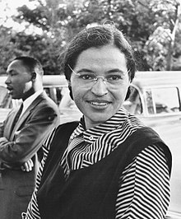

This is Rosa Parks (Called "the mother of the civil rights movement," Rosa Parks invigorated the struggle for racial equality when she refused to give up her bus seat to a white man in Montgomery, Alabama. Parks' arrest on December 1, 1955 launched the Montgomery Bus Boycott by 17,000 black citizens.
), Rosa Parks was the beginning of the end of racism however her spark ignited the flame which kept burning and still burns stronger and stronger every day. Racism can be traced back as early as 1805(Slavery can be traced back to the earliest records, such as the Mesopotamian Code of Hammurabi (c. 1860 BC)
) when the first group of African natives were taken as salves from their homeland. This was the beginning of a long and painful journey in which discrimination lead the way. This path would prove to be the same even in the light of Hollywood. (The Influence of African-Americans on the evolution and growth of the film industry is much less understood and appreciated). White actors and actresses were favoured by producers and directors over other ethnicities (Downey said he initially worried that his portrayal of a white actor playing a black man could hurt his career). For example, Robert Downey Jr played Kirk Lazarus in feature film Tropic Thunder. The character however was supposed to be of African American background however Robert Downey Jr is a white male and was preferred for the role and had his face painted to make him appear of African American ethnicity. Another example of Hollywood’s appalling lack of respect is (The second, more problematic degree is when a white actor is cast in a non-white role that has not been explicitly rewritten as white. So arguably both Ben Affleck and Clea DuVall in “Argo” are guilty here (the CIA officer Affleck’s character is based on is half-Mexican, DuVall’s is Japanese-American).).
It wouldn’t be until the 2000’s when people of different ethnic backgrounds would start to get big roles in Hollywood films the growth of acceptance and the need for change finally reached its climax when in February 2018 Black Panther was released in cinemas around the world. The reason for its uniqueness is the whole cast expect one or two were in fact not white completely flipping the norm on its head and showcasing some extraordinary talents and helping guide Hollywood into a new beginning for people of different ethnic backgrounds. Stats: 1.185billion USD made at the Box Office since March 2018.

However, the counter argument to this would be that these roles are far and few between and not enough this could be something to go into further when answering the question.

Discrimination and Cultural Events



Marvel has been the driving force of late at the Box Office on more than one occasion their creation of the Marvel Cinematic Universe (MCU) has allowed them not only to create expansive and imaginative storylines but they have addressed multiple cultural events and addressed issues within Hollywood itself such as equality. The MCU started out with a single Ironman film which did considerably better than anyone had anticipated however they had a character in Tony Stark that was likeable, but his boyish charm might be seen as discrimination to women in the way he objectifies women however flash forward 10 years later in the MCU his character is now settling down and more mature and gone with the days of objectification. Another example of Marvels ability to change perceptions was with the introduction of a character called Black Widow played by Scarlett Johansson in her first appearance she was very sexualised in terms of her looks and portrayal in the film however she would go on to become a strong independent female lead and have fans asking for a solo film which would be MCU first female lead film. Marvels president said this back in 2016 ("We have had gender inequality for some time. It wasn't always talked about .... In the past year, it bubbled up and it's no longer acceptable to women and some men. Change is needed and hopefully we can make a balanced Hollywood for the next generation. I don't want to be the only [woman] in the room. Our rooms should be 50/50. If any of you - men or women - can lift [women] up, we'll all be better for it."
) Not only does Marvel address current and relevant issues within the industry and within the world. For example, during a scene in Avengers Age of Ultron when the Hulk is fighting The Hulk Buster Tony Stark scans a building for life sights then buys it and crashes it down remonisant of 9.11 and by the end of the fight scene no one has died so again that is Marvel addressing the event. (Whedon sets his action continents away from Manhattan, in Africa, and the dust clouds are much closer and more ominous in the film than they were in the photo. Still, the echo is unmistakable.

Equality

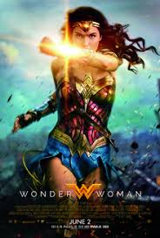
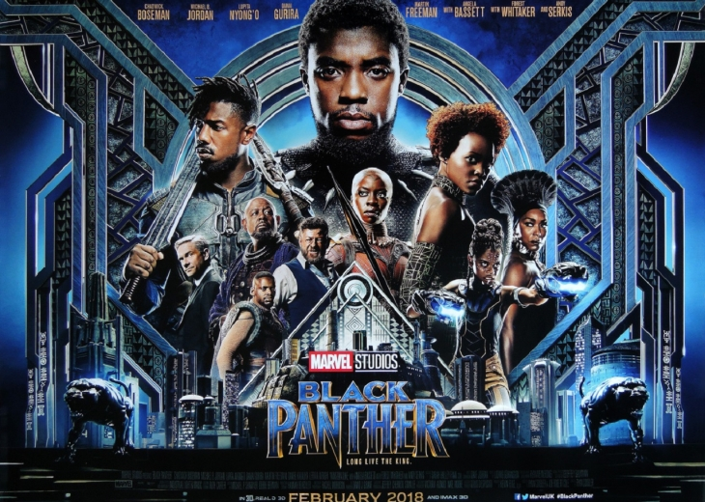

Equality by definition means to be equal, this is a subject that gets a lot of discussion and has evolved over the years in various forms such as the fight for Women’s rights (Gender equality has been a major topic of conversation over the last couple years in Hollywood.) to equality which began in 1848 and still has relevance today. Despite this though progress has slowly been made especially in the film industry. As a female woman were seen as secondary characters and lesser to their male counterpart this even reflected in the way they were portrayed (Example: bond Girls sexualised and objectified and paid considerably less (The films generalize women as bimbos, damsels in distress, or objectify women as a result of Bond's actions.) Flash forward to the 2008-2018 the increase in female leads rose dramatically example such as Jenifer Lawrence cast as the lead in Hunger Games and more recently Gal Gadot took the lead in DC’s Wonder Woman which not only did extremely well at the Box Office but was in fact director by another Lady called Patty Jenkins this would then be the beginning of a new age for women’s rights. (Yes, she is sort of naked a lot of the time, but this isn’t objectification so much as a cultural reset: having thighs, actual thighs you can kick things with, not thighs that look like arms, is a feminist act.)

Females have always been depicted as the lesser to their male counterpart on screen but that has evolved over the last ten years by making the female charters have more power about them for instance a Tv series called Pretty Little Liars did just that, they had 4 female leads and the show follows a series of crimes and set ups the girls are being stalked by someone and it turns out its another girl this goes against the norm in what a bad ‘guy’ Villain should be. Moving further forward in the Fast 8 the villain is played by a female character who is strong determined and not easily intimidated this is a good representation of how far female characters have come in Hollywood.

However though despite the news and press surrounding such roles the statistics still remain extremely questionable for example in the top 100 films made in 2017 only 4% were women. In the top 100 films women represented 29% of all solo protagonists. 76% of all female characters in the top 100 films were white. 14% were black and 6% were Asian American and 3% were Latina. This links the two subject matter racism and equality its shows that there is still a need for growth and development within equality in Hollywood at the moment.

Women Onscreen
Top 100 grossing films:
- Females comprised 29% of all sole protagonists, 37% of major characters, and 32% of speaking characters.
- 76% of all female characters were white.
- 14% of all female characters were black. 6% were Asian American. 3% were Latina.
- In films with at least one-woman director or writer, females comprised 57% of protagonists, 38% of major characters, and 38% of speaking characters.
- In films with exclusively male directors or writers, females accounted for 18% of protagonists, 30% of major characters, 29% of all speaking characters.
- Female protagonists were almost evenly split between studio (52%) and independent features (48%).
- Female protagonists were most likely to appear in comedies (28%), followed by dramas (24%), horror films (17%), animated features (14%), science fiction films (14%), and action films (3%).
- Most female characters were in their 20s (23%) and 30s (32%), while most male characters were in their 30s (31%) and 40s (30%).
- 54% of female characters had an unknown marital status (compared to 68% of males).
- 78% of female characters had an identifiable job or occupation (compared to 86% of males). A substantially larger portion of male characters were seen in their work setting, actually working (61% males vs. 45% females).
- Female characters were more likely to have goals related to their personal lives (46% vs. 25% males) and less likely to have work-related goals (54% vs. 75%).
Conclusion

After carefully examining each individual aspect and breaking each down to be able to find and form links between the key words the biggest link each have are they can all be seen visibly in the film industry because its Hollywood and everyone there is in the spot light. So, this would lead me to think many believe that Film is in the golden era, but the question must be asked with all the difficulties that are being hidden away and not fully addressed by all is it truly the Golden age of Film? My question moving forward therefore is ‘Discuss and argue as to if it is the Golden Era of Film’

BIBLIOGRAPHY

Dobuzinskis, A. (2008). Robert Downey Jr.'s risky role in. [online] U.S. Available at: https://www.reuters.com/article/us-blackface/robert-downey-jr-s-risky-role-in-tropic-thunder-idUSN1138604020080811 [Accessed 5 May 2018].
En.wikipedia.org. (n.d.). Black Panther (film). [online] Available at: https://en.wikipedia.org/wiki/Black_Panther_(film) [Accessed 2 May 2018].
En.wikipedia.org. (n.d.). History of slavery. [online] Available at: https://en.wikipedia.org/wiki/History_of_slavery [Accessed 21 May 2018].
Kiang, J. (2016). The 20 Worst Examples Of Hollywood Whitewashing. [online] IndieWire. Available at: http://www.indiewire.com/2016/02/the-20-worst-examples-of-hollywood-whitewashing-268110/ [Accessed 2 May 2018].
Manchel, F. (1990). Film study. London: Associated U P.
Nps.gov. (n.d.). International Civil Rights: Walk of Fame - Rosa Parks. [online] Available at: https://www.nps.gov/features/malu/feat0002/wof/rosa_parks.htm [Accessed 21 May 2018].
Nwhp.org. (n.d.). History of the Women’s Rights Movement | National Women's History Project. [online] Available at: http://www.nwhp.org/resources/womens-rights-movement/history-of-the-womens-rights-movement/ [Accessed 1 May 2018].
prezi.com. (2018). The Objectification of Women In James Bond. [online] Available at: https://prezi.com/gcfuwbk1ordb/the-objectification-of-women-in-james-bond/ [Accessed 21 May 2018].
VanDerWerff, T. (2016). Superhero movies have become an endless attempt to rewrite 9/11. [online] Vox. Available at: https://www.vox.com/2015/5/19/8577803/avengers-age-of-ultron-review-politics [Accessed 21 May 2018].
Williams, Z. (2017). Why Wonder Woman is a masterpiece of subversive feminism. [online] the Guardian. Available at: https://www.theguardian.com/lifeandstyle/2017/jun/05/why-wonder-woman-is-a-masterpiece-of-subversive-feminism [Accessed 21 May 2018].
Womenandhollywood.com. (2016). [online] Available at: https://womenandhollywood.com/resources/statistics/2016-statistics/ [Accessed 2 May 2018].

