Using and programming the 7-segment display prototype circuit.

Evidence Provided



Nathan Evans
Electronic & Electrical Engineering / Micros, Peripherals & Interfaces
Submitted to:
UWTSD – Waterfront Campus 15/05/23
Programming a 7-segment Display Prototype Circuit.

Contents Page:

The following report is based on a simulated proteus circuit that has been coded in assembly language. The report provides code and picture evidence – For the circuit.

 | Page Number
- Abstract | 3
- Part A: Circuit Components & their Functions | 4-6
- Part B: Further information on the PIC16F84A Microcontroller | 7-8
- Part C: Circuit analysis | 9-10
- Part D: Assignment Code | 11-15
- Reference List | 16

The work of this report completed under the supervision of (Gareth Jones). I declare that this report is the product of my own work and is not being submitted for any other degree etc.
N. Evans

Abstract

The following report includes the implementation of assembly language to allow a circuit to preform set instructions, coded using proteus. The report also contains detailed in-depth analysis of the components used for the circuit with refences provided. The student zones in on the PIC microcontroller used providing in depth information about the chip, such as, Its functions and features. Diagrams are shown for every component, labelled figure 1,2,3 etc.

Part A: Circuit Components & their Functions

2 Capacitors - 22nF – Capacitors have many applications. Its primary use is energy storage – This means that capacitors have the capability to store energy and dissipate it throughout the circuit when required. In addition, capacitors are used to block DC current while allowing AC current to flow through – [1] describes the process of blocking DC current while allowing AC to flow as “Coupling”. [1] Also states that capacitors are used on radio’s, usually connected to an LC oscillator.

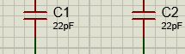

Figure 1 – Shows the 2 22pF capacitors used in the proteus circuit.

7 Resistors – 220Ohms – Resistors are a two pinned component which are essential in the world of electronics. They provide resistance (Ω). Arguably the main use for a resistor is to regulate the current in a circuit [2], divide voltages & block transmission signals. The relation of resistance, current and voltage is determined by Ohm’s law. Ohms law was created by German professor Georg Simon Ohm in 1827 [3]

2 Resistors – 10kOhms
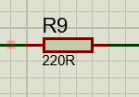
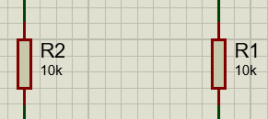

Figure 2 (Left) & 3 (Right) – Shows The 10kΩ and the 220Ω resistors used in the Circuit.

Part A: Circuit Components & their Functions

1 Crystal Oscillator – 4 Mhz Frequency – Arguably the most complex component in the circuit (excluding the PIC), an oscillator is implemented in many day-to-day electronic devices. An oscillator essentially converts DC signals to periodic AC signals then enabling users to set frequency – commonly used in any audio devices. The PIC the student has used during the project, has a internal oscillator. This makes the external oscillator as seen in figure 4, essentially obsolete. Though obsolete, the student used the circuit diagram for educational purposes. For example it gives insight to how the internal oscillator functions.

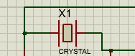

Figure 4 – Shows a Crystal Oscillator

1 PIC16F84A – The PIC16F84A, has 5 PORTA pins and 8 PORTB pins. One advantage when using this chip is its ability to set all PORTB pins to either Input or Output. This means all 8 pins can either sink or source current which is desirable for those who wish to fine tweak their circuits.
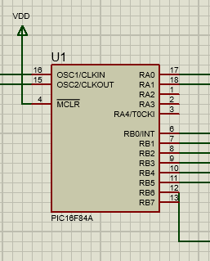

Figure 5 - shows the PIC Microcontroller

Part A: Circuit Components & their Functions

2 buttons – These buttons are placed to perform specific functions.

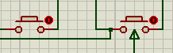

Figure 6: Shows the buttons used.
Power sources – These source point provide the power needed for the circuit components to operate.
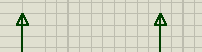

Figure 7: shows the power sources.
Ground sources – Every Circuit that involves electrical current must contain a ground source. Ground is a protective measure that protects the components and user from electric shock.
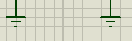

Figure 8: Shows the ground sources.

Part B: Further information on the PIC16F84A Microcontroller
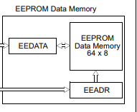
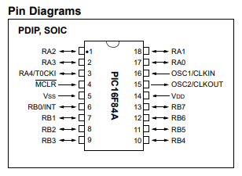

[4] Figure 9 (Left) & 10 (Right) – 9 Shows the name of each pin of the microcontrollers. Figure 10 shows the E²PROM memory.

The PIC microcontroller shown inn figure 8 is a favourite amongst engineers who want a small compact chip with a low power input. The PIC can perform basic functions but is highly efficient at the tasks it is able to perform. [5] Lists all the pic functions and features. The bellow bullet points list the main functions and features.
- 64 bytes of EEPROM
- 35 instruction capabilities
- Operates with Assembly and C language.
- Interrupt capabilities
- 1.75KB flash memory.

the pin diagram shows the input and output pins of the microcontroller. RA0 and RA1 are input pins and if the reader looked at the circuit diagram in figure() they would see the power sources are connected to RA0 & RA1. According to the circuit schematic, RB0/INT – RB6 are functioning as output pins going from the PIC directly to the 7 segment display with 220Ω resistors in between each connection.

The PIC has its own dedicated instruction set. This can be found in figure , on the next page.

Part B: Further information on the PIC16F84A Microcontroller

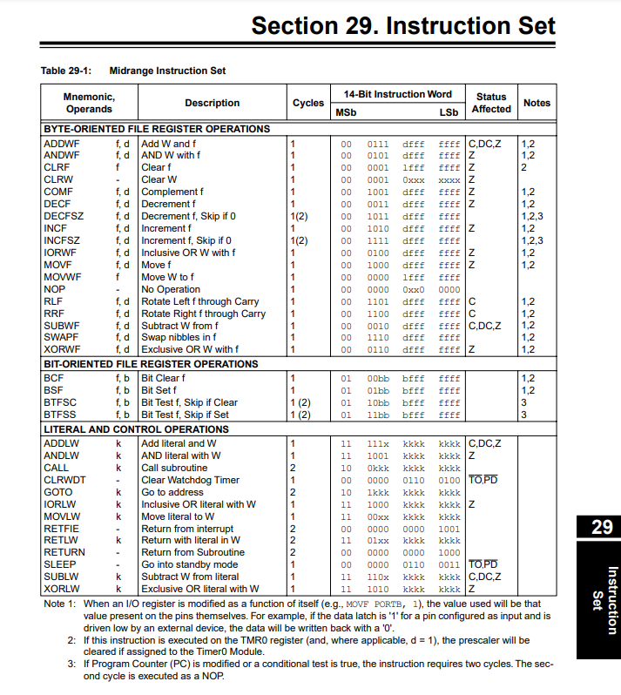

[6] Figure 11:The above image shows the instruction set for the PIC16F84A Microcontroller

Part C: Circuit analysis
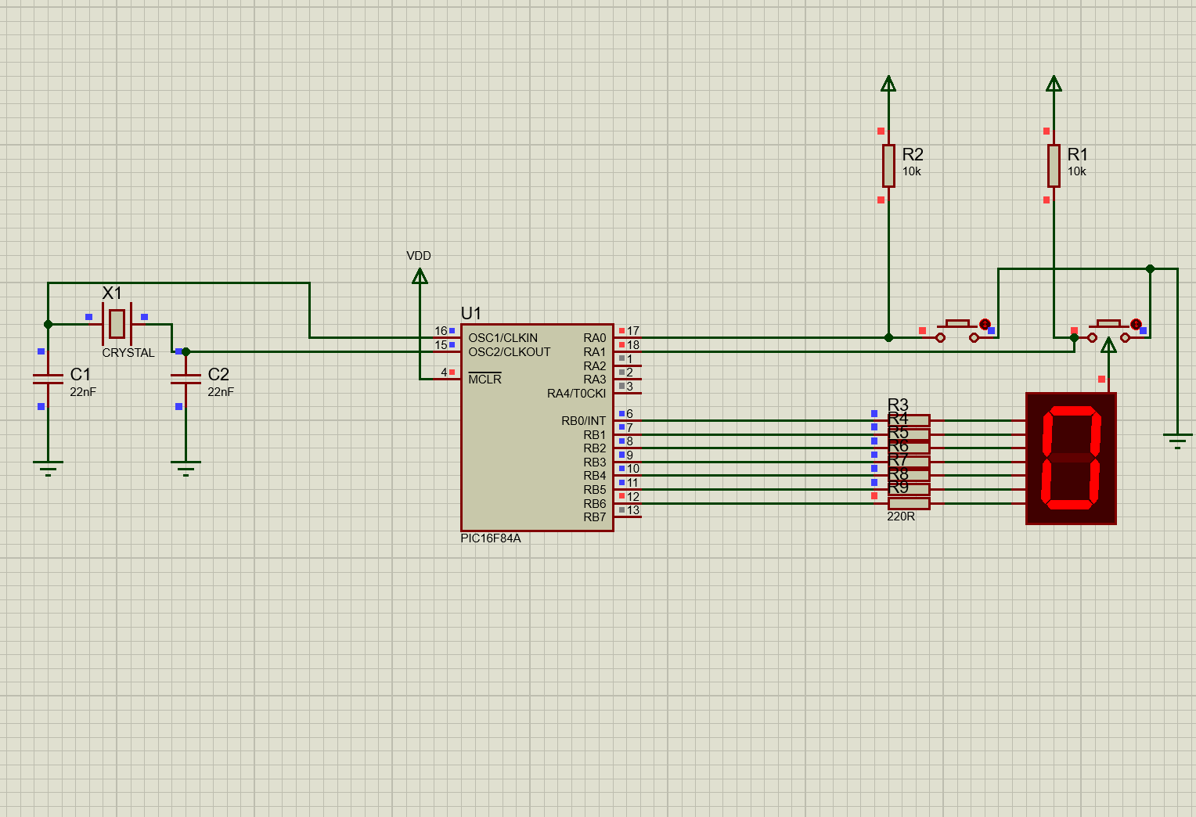

Figure 12: The above image shows the circuit in hand, displaying the components, PIC and 7 segment display.

The circuit above shows the components and microcontroller used, along with a 7 segment display. The circuit is set up in a specific way so which the PIC can send data to the display through its output pins. The information transferred is embedded in assembly language. Information on each component and the PIC is found in Part A. The circuit is designed to display a character on the 7 segments, furthermore, the user can press the buttons to activate an increment or decrement function which essentially tells the PIC to count up form a certain number or count down. There are two sets of resistors in this circuits. There are 2 pull up resistors that are placed to regulate the voltage between the button and PIC. These will only activate once the button is pressed. And the resistors attached to the output of the PIC are regulating the current between the PIC and LED display.

Part C: Circuit analysis

To program the 7 segement display, you must first understand the hexadecimal values foe the character you are trying to display. This circuit requires the common Anode Hex code. bellow shows the user which codes are needed. 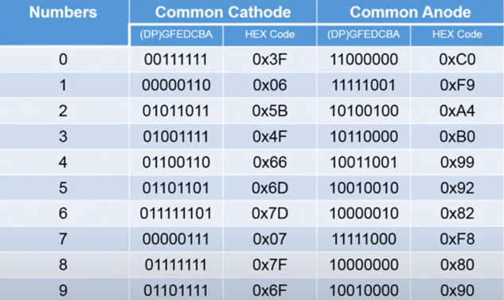[7] Figure 13: Common cathode Hex display values



Figure 14: Above is the Common anode Hex value to make the 7-segment display shine a Zero, this will load the program with 0

;====================================================================
; Main.asm file generated by New Project wizard
;
; Created: Mon Feb 12 2018
; Processor: PIC16F84A
; Compiler: MPASM (Proteus)
;====================================================================

;====================================================================
; DEFINITIONS
;====================================================================

#include p16f84a.inc ; Include register definition file

portB equ 0x06 ;port B address
trisb equ 0x06 ;trisB address in register bank 1

status equ 0x03 ;status register
RP0 equ 5 ;bit 5 of status register
RP1 equ 6 ;bit 6 of status register

count equ 0x0c ; counter 0 to 255
nCount equ 0x0d ; pause routine inner loop counter
mCount equ 0x0e ; pause routine outer loop counter
button1 equ 0X0F

;====================================================================
; VARIABLES
;====================================================================

;====================================================================
; RESET and INTERRUPT VECTORS
;====================================================================

; Reset Vector
RST code 0x0
goto Start

;====================================================================
; CODE SEGMENT
;====================================================================

PGM code
Start

bcf status,RP0 ; clear bank selection bits in the status reg
bcf status,RP1

bsf status,RP0 ; select bank 1
movlw 0xC0 ; load w with 0x00

movwf trisb ; load it into trisb to make portb all outputs
bcf status,RP0 ; reselect bank 0

clrf portB ; clear all lines low
clrf count ; initialize counter to 0
clrf button1 ; set button1 to 0

; LOOP STARTS HERE
loop
BTFSC button1,0
goto butdisp1
BTFSC button1,1
call butdisp2
call checkbuttons ; check if buttons are working correctly
goto loop

butdisp1
movlw 0xF9 ;load w with 0xF9 to display 1 on counter
movwf portB ; move w to the output to update the display
return

apressed
bsf button1,0 ; set apressed to 0
bcf button1,1 ; clear apressed
return

bpressed
bsf button1,0 ; set bpressed to 0
bcf button1,1 ; clear bpressed
return

get_count
movf count, w ; move count to W
BTFSS portA,0 ;
goto display2
movlw 0xF9
movwf portB
goto get_count
display2
movlw 0xA4
movwf portB ; move W to port B to update the display
goto get_count

;LOOP ENDS HERE
get_count
movf count, w ; move count to W

movwf portB ; move W to port B to update the display

addlw 1 ; add +1 to W

movwf count ; save W in count

call pause ; delay 200ms by subroutine
call pause
call pause
call pause
call pause ; five pause executions equals ~ 1 second

goto get_count ; repeat forever

;--------------------------------------------------------------------
;subroutine pause: lets waste some time....
;
;inputs: nothing
;outputs: nothing
;
;does: nothing but waste some time
;corrupts: register W
;
;description: two loops using "mCount" and "nCount" register files
; "mCount" is the outer loop counter (255 down to zero)
; "nCount" is the inner loop counter (255 down to zero)
;
;--------------------------------------------------------------------
pause
movlw 0xfff ; set w = 255 decimal
movwf mCount ; mCount = w: outer loop counter
loadN
movlw 0xff ; set w = 255 decimal
movwf nCount ; nCount = w: inner loop counter
decN
decfsz nCount, f ; nCount--
goto decN ; if nCount != 0 then repeat nCount--

decfsz mCount, f ; else decrement Count
goto loadN ; if mCount != 0 then
; reload nCount to 255 and decrement
return ; else exit subroutine

Loop
goto Loop

;====================================================================
END
Reference list

[1] “Selecting between an instrument’s AC and DC coupling options,” Thorlabs, Inc. - Your Source for Fiber Optics, Laser Diodes, Optical Instrumentation and Polarization Measurement & Control, https://www.thorlabs.com/newgrouppage9.cfm?objectgroup_id=14182#:~:text=AC%20and%20DC%20couplings%20are,as%20well%20as%20the%20AC.

[2] “Take online courses. earn college credit. Research Schools, Degrees & Careers,” Study.com | Take Online Courses. Earn College Credit. Research Schools, Degrees & Careers, https://study.com/learn/lesson/resistor-uses-purpose-examples.html

[3] N. H. M. F. Laboratory, “Georg Ohm,” Magnet Academy, https://nationalmaglab.org/magnet-academy/history-of-electricity-magnetism/pioneers/georg-ohm/#:~:text=Georg%20Simon%20Ohm%20had%20humble,electrical%20current%2C%20resistance%20and%20voltage.

[4] PIC16F84A - Microchip Technology, https://www.microchip.com/en-us/product/PIC16F84A

[5] PIC16F84A data sheet - microchip technology, https://ww1.microchip.com/downloads/en/devicedoc/35007b.pdf

[6] Section 29. instruction set - microchip technology, https://ww1.microchip.com/downloads/en/DeviceDoc/31029a.pdf

[7] “7 segment display interfacing with Pic Microcontroller,” openlabpro.com, https://openlabpro.com/guide/7-segment-display-interfacing-with-pic-microcontroller/

