Sustainability in the early years
ECEY6005

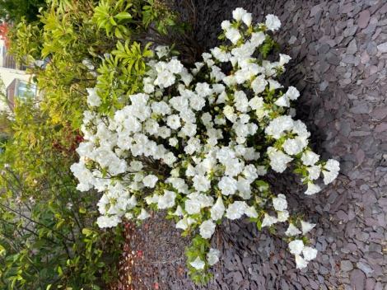
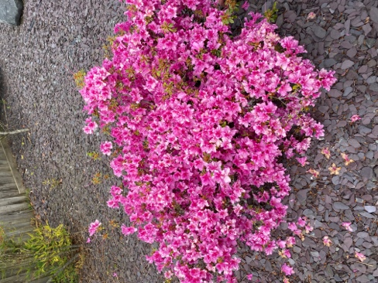
DISCOVER
I have had the opportunity since a young child of being able to discover my garden. My garden contains many wildlife such as insects, birds and flowers.

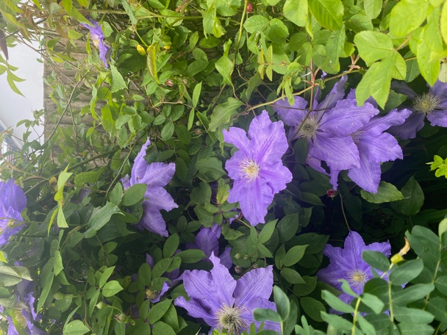
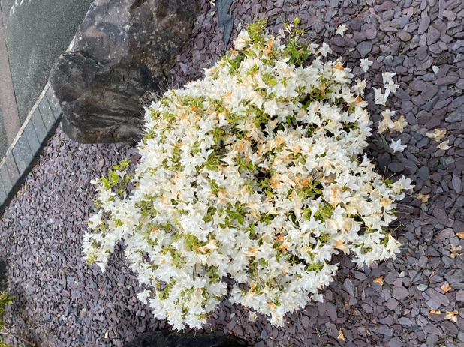
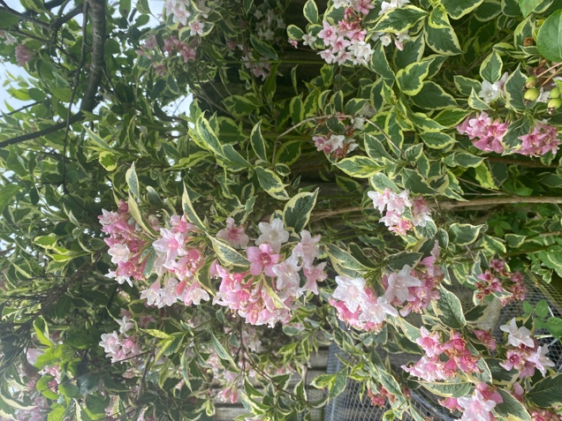

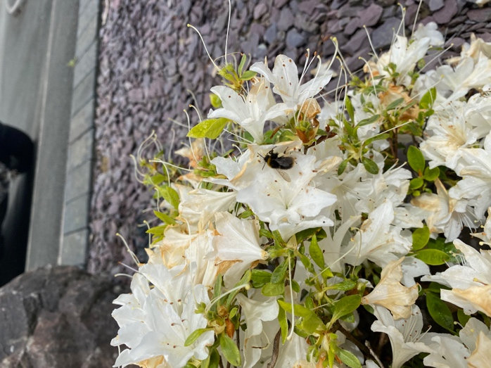
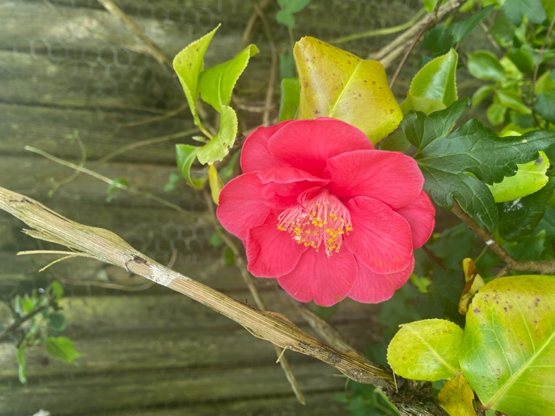
A bumble bee!!

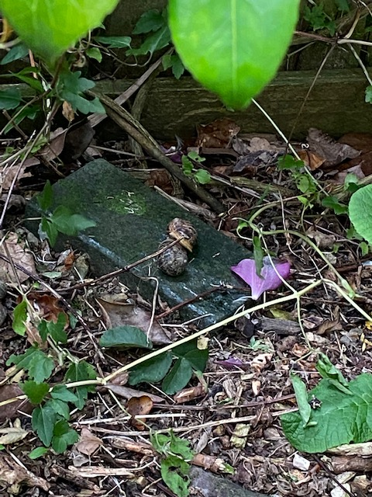
My garden consists of many trees, bushes and overgrown areas specifically left overgrown for wildlife. The noises of the birds in the trees makes me feel happy and appreciate wildlife.

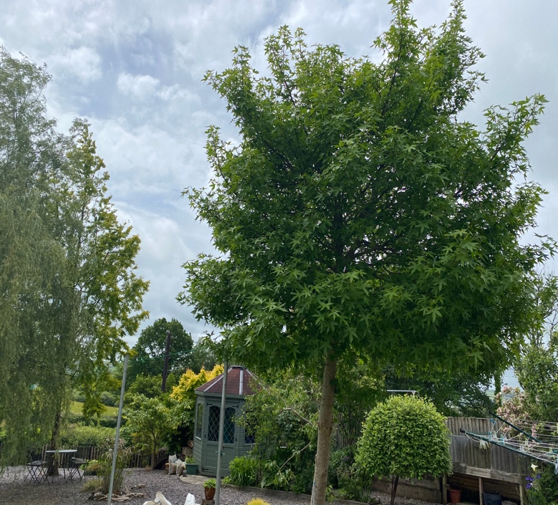
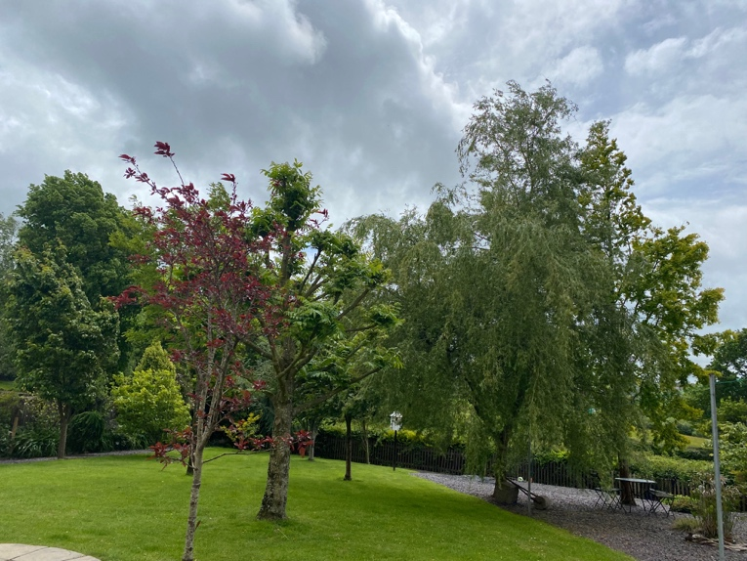
2 large snails in the untouched area

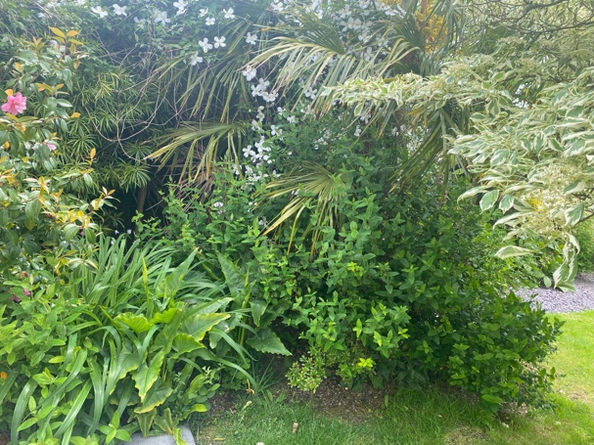
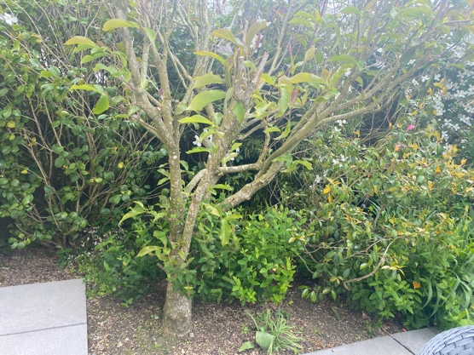
The overgrown area that is not touched to let wildlife live in peace.

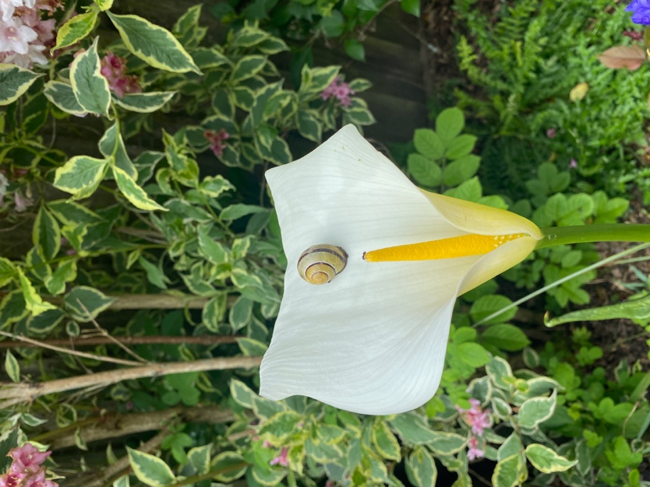
There are many insects that I discovered in my garden.
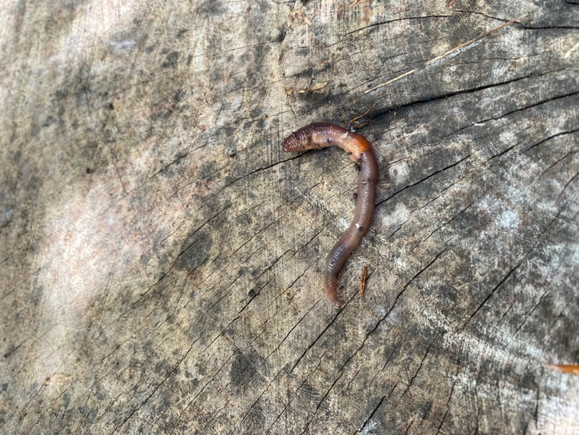

A lady bird.

A wiggly worm!
A snail on a Arum Lily flower.

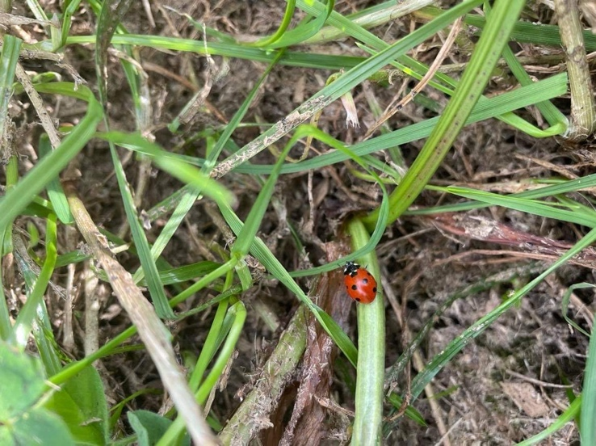
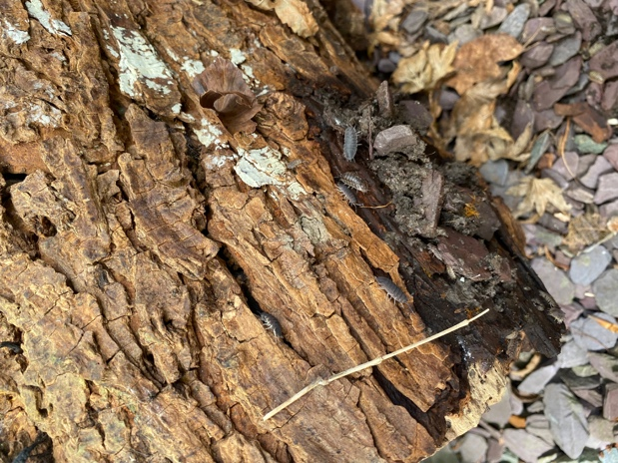

Lots of Woodlice under a tree log.

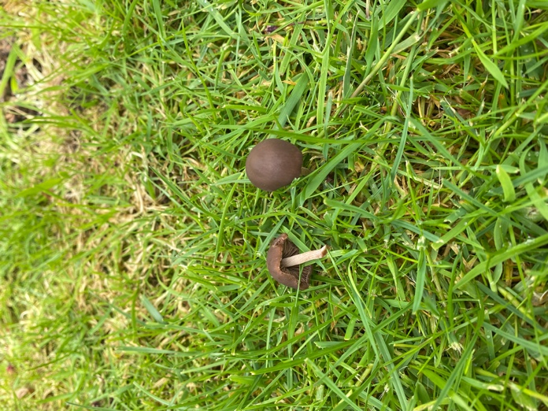
Explore
These mushrooms are called field mushrooms. These mushrooms are not edible and should be picked and disposed if found in the garden to avoid children and pets from eating them.
Whilst discovering my garden I came across many different types of fungi that is growing here. I have explored the names of these mushrooms and found some information about them.
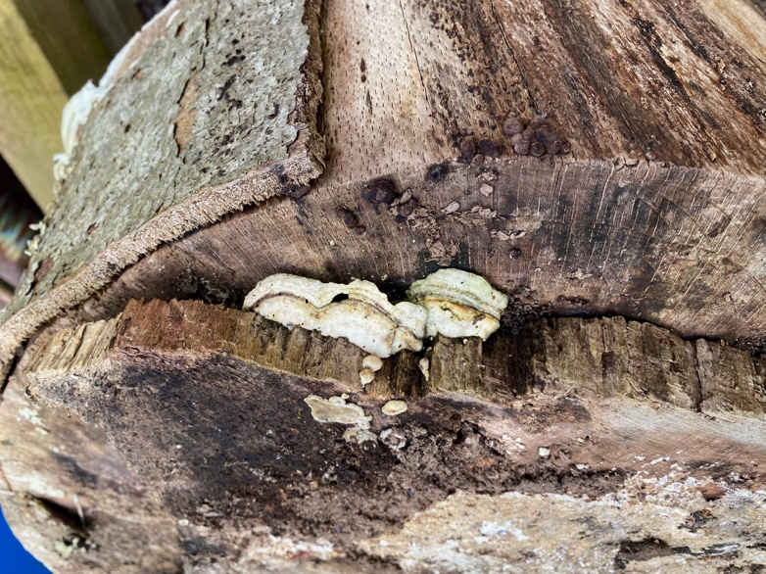
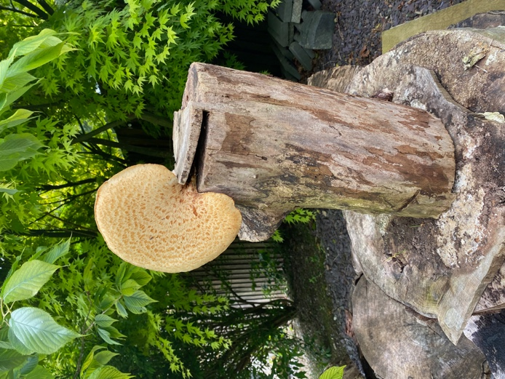
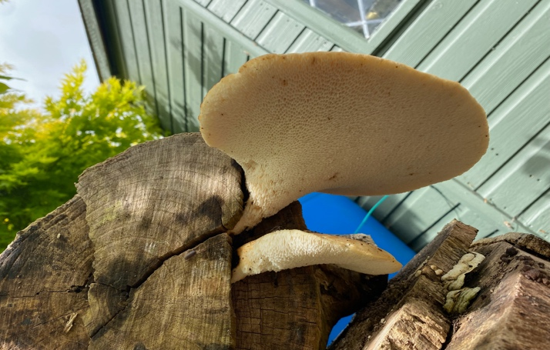
This mushroom is called a Sulphur Shelf mushroom. These mushrooms are also known to grow on rotting tree stumps.
These mushrooms are edible but must be cooked and not eaten raw. These are found in foods such as vegetable dishes and omelettes.
This mushroom is called a Oyster mushroom. This is normally found growing on dead or dying hardwood trees like beech and oak trees. This mushroom is edible and is found in foods such as soup, pasta and meat dishes.

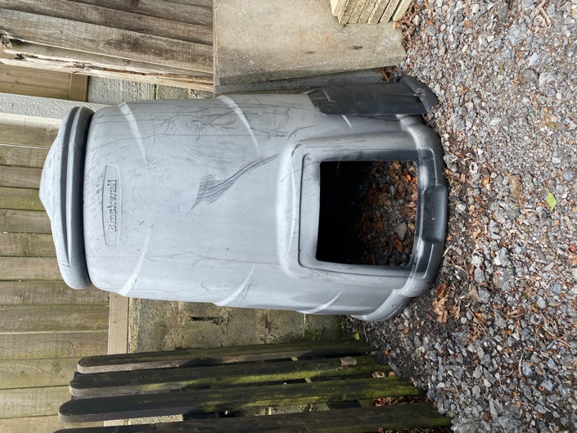
Conserve
An old compost that is no longer in use. I have put fruit and nuts in for wildlife, for example squirrels and hedgehogs.
By discovering and exploring my garden it has enabled me to protect the wildlife in my garden. These are some of the things I did to conserve the wildlife in my garden.

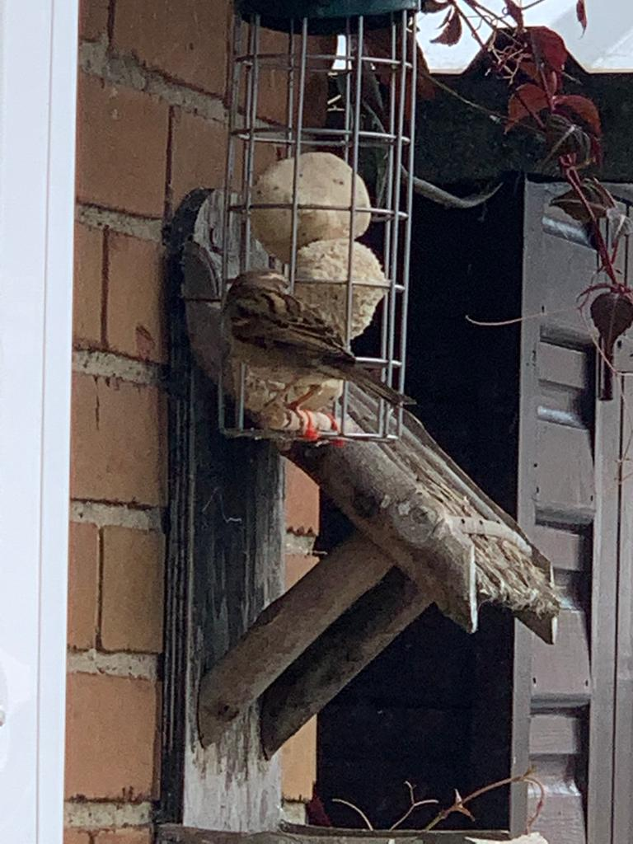
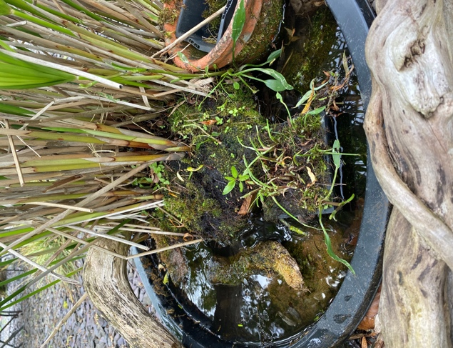
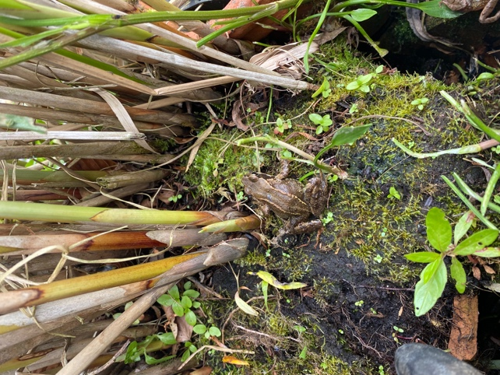
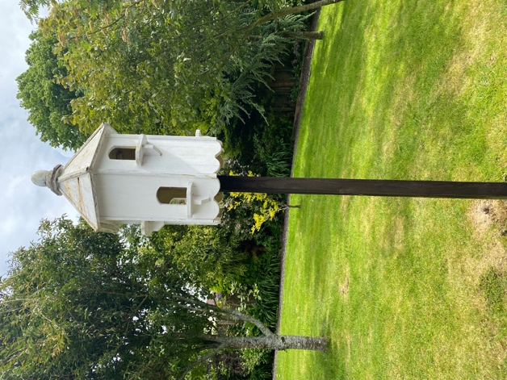
I put bird seeds in the bird house for the birds. In the second picture there is a sparrow that comes regularly to eat the bird seeds.
In the first picture you can see a frog. However, the pond water has evaporated due to a increase in temperature. I filled the pond up with fresh cold water for the frogs.
I will keep up to date with the water weekly.

