Module: Introduction to Public Health
Module Code: LCHS4008_BIRM
Name: Dilnawaz Khan
ID: 2435767
Lecturer: Vivian Osuchukwu
Assessment 2 – Report on a Health Issue

Contents:
- Introduction:……………………………………………………………………………………... 3
- Analysis and discussion:………………………………………………………………………. 4
2.1 Approaches used to measure and monitor dementia:…………………………………. 4
2.2 How dementia is controlled:………………………………………………………………. 5
2.3 Consequences of dementia for people in the community:…………………………….. 6
2.4 Health and social care support services required in the community:………………… 7
3. Conclusion:……………………………………………………………………………………….. 8
Reference list:……………………………………………………………………………………….. 9

- Introduction
Dementia is a progressive syndrome that is due to any diseases of the brain that affect memory, thinking, behavior, and the capability to perform daily tasks (World Health Organization (WHO), 2025). It is not an ordinary aspect of ageing yet there is a sharp rise in risk as age advances. Common symptoms in the earlier stages of the disease are forgetfulness, not knowing where they are, struggling to find words, poor judgement, struggling to do things they know well, mood change and social withdrawal (WHO, 2025; NHS, 2023a). Dementia is a health concern in the community because it is prevalent, incurring and chronic. In the year 2021 alone, 57 million individuals across the world lived with dementia and the number of new cases annually is almost 10 million (WHO, 2025). In the UK, it is estimated that 982,000 individuals are already living with dementia, and the numbers are expected to go to 1.4 million by 2040 (Alzheimer’s Society, 2024a). Dementia and Alzheimer’s disease are the two most common causes of death in the UK in 2024 (Alzheimer’s Society, 2025), and this is a primary cause of mortality as well.
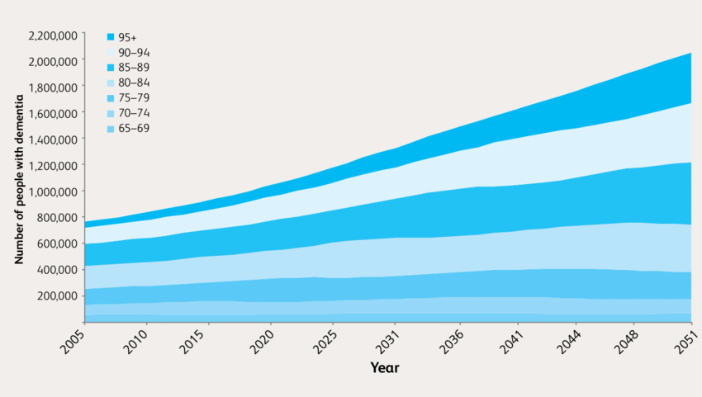
Figure 1: Projected increases in the number of people in the UK with late-onset dementia (Prince, M. et al. 2014)

- Analysis and Discussion
Ageing populations are associated with dementia, which is a significant issue in the field of health of the population. Increased life expectancy is putting a strain on health and social care systems by raising dementia prevalence. To plan the services and to enhance the care in the community, it is necessary to understand the way dementia is measured, monitored and managed.
2.1. Approaches used to measure and monitor dementia
Table 1: Main approaches used to measure and monitor dementia.
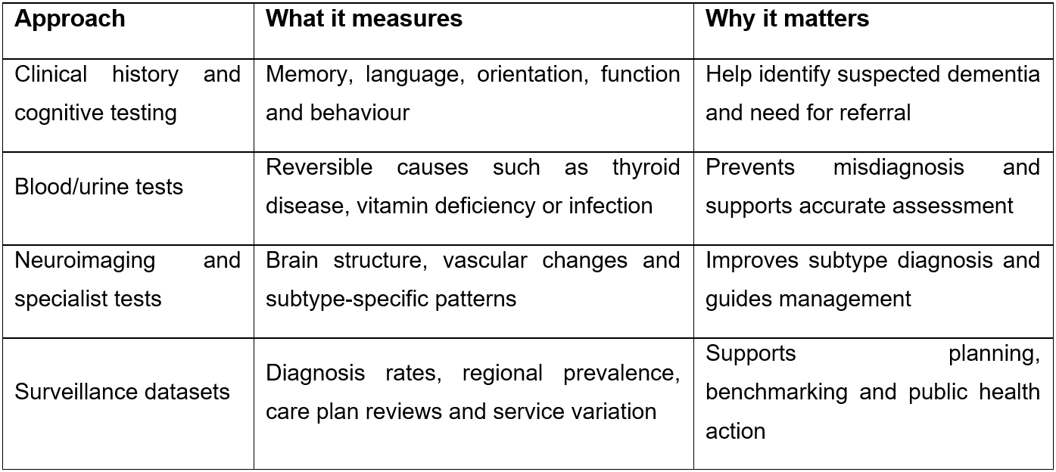
Dementia cannot be accurately measured or monitored simply by counting diagnosed cases, as many people living with the condition remain undiagnosed. Assessment for dementia usually begins in primary care, where a clinician gathers a detailed history from the individual and a family member or carer. This is then accompanied by physical examination and laboratory tests such as blood and urine tests to rule out reversible causes such as thyroid disorders, infections or vitamin deficiencies. Short-term cognitive evaluation is then administered with the help of the accepted tools that were suggested by NICE, such as the 10-point Cognitive Screener, the 6-item Cognitive Impairment Test, Mini-Cog and Test Your Memory (NICE, 2018). NICE, however, notes that dementia cannot be dismissed simply by the means of a normal test result. The NHS also mentions the fact that the diagnosis typically involves a mixture of cognitive testing, laboratory tests and brain scans since no one test can determine the presence of dementia (NHS, 2023b; NHS, 2023c).
When looking across the whole country, dementia is monitored using national surveillance systems and large health datasets. In England, the primary care posts of dementia collect the figures of individuals who are coded and the rate of diagnosis in people 65 and above (NHS England Digital, 2025). In July, 2025, the number of people with a recorded diagnosis of dementia was approximately 506,549 which is about 66.1 percent of the estimated number of cases in this age group (NHS England Digital, 2025). It is still difficult to monitor, as the symptoms build up over time and diagnosis is slowed down due to stigma, lack of awareness or access to specialist evaluation. As a result, the UK National Screening Committee does not support population screening (UK National Screening Committee, 2026).
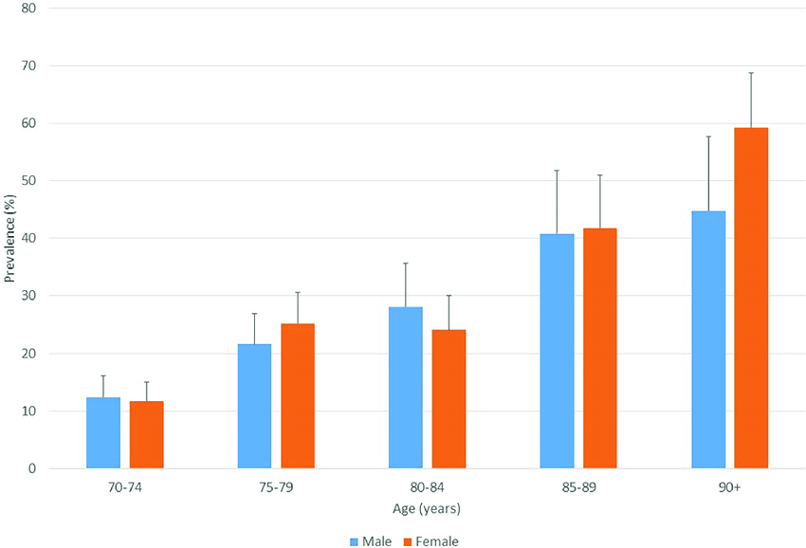
Figure 2: Dementia Prevalence by age group (Ramdass, et al. 2018)

2.2 How dementia is controlled
Although dementia is not typically curable, it can be managed from a public health perspective by focusing on prevention, early diagnosis, appropriate treatment, risk reduction, and long-term support. The process of control starts prior to diagnosis. The 2024 Lancet Commission identifies fourteen modifiable risk factors – spanning education, cardiovascular health, lifestyle behaviors (such as smoking, alcohol consumption and physical inactivity), and sensory impairments – that could prevent or delay a substantial proportion of dementia cases (Livingston et al, 2024). It means that the management of dementia also relies on broader policies of health promotion in the community that encourage cardiovascular health, cessation of smoking, healthy ageing, education and social inclusion.
The control of dementia is dependent on the timely diagnosis since the diagnosis provides access to treatment, planning and support. After the reversible causes have been evaluated, and dementia is suspected, NICE suggests referral to specialist dementia diagnostic services (such as memory clinics) (NICE, 2018). Treatment of the condition can include pharmacological and non-pharmacological methods after diagnosis. Acetylcholinesterase inhibitors recommended for the use include donepezil, galantamine and rivastigmine in mild to moderate forms of Alzheimer, and memantine in moderate to severe forms (NICE, 2018).
Medication is not used to prevent the progression of the disease, but it can be used to enhance symptoms. Regular review and coordinated care are also essential as dementia is frequently accompanied by frailty and other issues, which must be frequently assessed (NHS England Digital, 2025).

2.3 Consequences of dementia for people in the community
The impact of dementia on communities extends far beyond memory loss. For individuals, it gradually reduces independence and impacts communication, mobility, self-care, and the ability to manage daily tasks such as finances and medication. As symptoms develop, people may become vulnerable to issues such as malnutrition, falls, wandering, self-neglect, confusion, and safeguarding concerns. Dementia also brings significant psychological effects, including fear, frustration, depression, and a loss of identity. According to the World Health Organization, dementia has wide-ranging physical, psychological, social, and economic consequences for individuals, carers, families and society as a whole (WHO, 2025). These combined impacts highlight that dementia is not only a medical condition but a major public health challenge.
Unpaid carers and families can find themselves under a lot of pressure. The majority of them offer supervision, emotional support, personal care, transportation and managing appointments. These roles may have a detrimental impact on the physical health, psychological wellbeing, and the jobs and earnings of carers. According to Bamford et al. (2021), the key elements of a successful post-diagnostic support should focus on the emotional wellbeing of the patient, practical support and coordination of services. There is also the pressure of increasing prevalence on the community services, such as GP practices, memory clinics, district nursing, home care, respite services and care homes. As a result, late diagnosis of dementia creates significant financial pressures across both health and social care services.

2.4. Health and social care support services required in the community
To address these requirements, individuals with dementia will need collective health and social care services in the community. At the initial stage, primary care and memory services must ensure that individuals are identified, diagnosed, have their medications reviewed, and receive ongoing monitoring. Following diagnosis, individuals should have access to a multidisciplinary dementia or memory service, with a named professional or a clear pathway for re-entry if their needs change (NICE, 2018). Second, there is therapeutic support based on community. Occupational therapists may be involved in sustaining function and home modification; physiotherapists may be involved in minimizing falls; speech and language therapists may be involved in eating, drinking or communication impairment; mental health workers may be involved in supporting depression, anxiety or distress. Third, social care assistance is the focus. This also encompasses care needs assessments, home-based personal care, respite, day opportunities, assistive technologies, transport assistance, safeguarding, housing modifications as well as, where necessary, transition to care home or palliative care services.
Carer support is also obligatory and not optional. NICE suggests carers to receive psychoeducation and skills training, such as the information about dementia, communication, future planning, the services available, and their personal wellbeing (NICE, 2018). There is also the major role of voluntary-sector provision. Alzheimer Society offers dementia advisers, support groups and local service directories that may help decrease the feeling of isolation and enhance navigation support (Alzheimer Society, 2026). Practically, the professionals ought to evaluate early, plan regularly, inter-agency coordination, carer support, and anticipate deterioration and end-of-life care.

Conclusion
Dementia is a significant and increasing societal health concern due to the prevalence, progressive and expensive nature as well as a strong association with loss of autonomy. The condition is not only to be perceived as an individual clinical problem but rather as a community issue, which impacts families, services and policy. Clinical measurement of dementia is by structured assessment, cognitive testing, investigation of reversible causes and imaging, and at population level by measuring the prevalence of disease, mortality, and international systems, e.g. the Global Dementia Observatory. Treatment relies on the entire-pathway response: reduction of the risk factors that can be changed, enhancement of the prompt diagnosis, evidence-based treatment, the assessment of the needs and the organization of the long-term assistance. Community effects are far-reaching, thus the need to tackle them effectively must be based on integrated health and social responses, carer support and person-centered practice. With the increasing prevalence in the UK and the global population, the quality of dementia care will increasingly indicate the quality, equity and sustainability of the broader public health system.
Reference List
Alzheimer’s Society (2024a) How many people have dementia in the UK?’.
Available at: https://www.alzheimers.org.uk/blog/how-many-people-have-dementia-uk
(Accessed: 7 March 2026).
Alzheimer’s Society (2025) ‘Dementia is the UK’s leading cause of death’.
Available at: https://www.alzheimers.org.uk/about-us/dementia-UK-leading-cause-of-death
(Accessed: 7 March 2026).
Alzheimer’s Society (2026) Find support near you’.
Available at: https://www.alzheimers.org.uk/find-support-near-you
(Accessed: 7 March 2026).
Bamford, C., Wheatley, A., Brunskill, G., Booi, L., Allan, L., Banerjee, S., ... & PriDem Study
Team. (2021). Key components of post-diagnostic support for people with dementia and their
carers: A qualitative study. Plos one, 16(12), e0260506.
Chen, Y., Bandosz, P., Stoye, G., Liu, Y., Wu, Y., Lobanov-Rostovsky, S., ... & Brunner, E. J.
(2023). Dementia incidence trend in England and Wales, 2002–19, and projection for dementia
burden to 2040: analysis of data from the English Longitudinal Study of Ageing. The Lancet
Public Health, 8(11), e859-e867.
Livingston, G., Huntley, J., Liu, K. Y., Costafreda, S. G., Selbæk, G., Alladi, S., ... & Mukadam,
N. (2024). Dementia prevention, intervention, and care: 2024 report of the Lancet standing
Commission. The lancet, 404(10452), 572-628.
NHS (2023a) How to get a dementia diagnosis’. Available at:
https://www.nhs.uk/conditions/dementia/symptoms-and-diagnosis/diagnosis/
(Accessed: 7 March 2026).
NHS (2023b) ‘Tests for diagnosing dementia’. Available at:
https://www.nhs.uk/conditions/dementia/symptoms-and-diagnosis/tests/
(Accessed: 7 March 2026).
NHS (2023c) ‘Symptoms of dementia’. Available at:
https://www.nhs.uk/conditions/dementia/symptoms-and-diagnosis/symptoms/
(Accessed: 7 March 2026).

NHS England Digital (2025) ‘Primary Care Dementia Data, July 2025’.
Available at: https://digital.nhs.uk/data-and-information/publications/statistical/primary-caredementia-data/july-2025
(Accessed: 7 March 2026).
NICE (2018) Dementia: assessment, management and support for people living with dementia
and their carers (NG97). London: National Institute for Health and Care Excellence.
Available at: https://www.nice.org.uk/guidance/ng97/resources/dementia-assessment-management-and-support-for-people-living-with-dementia-and-their-carers-pdf-1837760199109
Office for Health Improvement and Disparities (2025) ‘Dementia profile: prevalence and supporting well topics statistical commentary, March 2025’.
Available at: https://www.gov.uk/government/statistics/dementia-profile-march-2025update/dementia-profile-prevalence-and-supporting-well-topics-statistical-commentary-march-2025 (Accessed: 7 March 2026).
Prince, M. et al. (2014) Projected increases in the number of people in the UK with late-onset
dementia (2012–2051). In: Dementia UK: Update. London: Alzheimer’s Society. Available at: https://www.researchgate.net/figure/Projected-increases-in-the-number-of-people-in-the-UK-with-late-onset-dementia_fig5_270904426
Ramdass, S., Lawrence, A. and Thomas, M. (2018) Dementia prevalence in a population at high
vascular risk: The Trinidad National Survey of Ageing and Cognition. Available at: https://www.researchgate.net/figure/Dementia-prevalence-by-age-and-gender-with-upper-95-CI_fig1_323373803 (Accessed: 7 March 2026).
UK National Screening Committee (2026) ‘Dementia’. Available at: https://view-health-screening-recommendations.service.gov.uk/dementia/ (Accessed: 7 March 2026).
World Health Organization (WHO) (2025) ‘Dementia’. Available at: https://www.who.int/news-room/fact-sheets/detail/dementia (Accessed: 7 March 2026).

