University of Wales Trinity Saint Davids
Wales Institute of Science & Art

Use of Energy Carriers; Legislation & Practicality Approach
ACHA6012

Ashley Lane
1903102
2nd April 2023

Contents
1 Introduction 3
2 Current and previous legislation 4
3 Immediate option for consumers 5
4 Improving the emissions of existing ICE 7
5 Current and Alternative Powertrains 9
5.1 Standard Internal combustion engines 9
5.2 Hydrogen 9
5.3 Biofuel blends 10
5.4 Electric vehicles 11
5.5 Liquefied Petroleum Gas 12
6 Hybrid systems 14
7 Influence of Motorsport 15
8 Summary 17
9 Bibliography 18

Figure 1 Electric VW UP! (Top-Gear-Team, 2020) 4
Figure 2 Catalytic converter (ClearMechanic, 2023) 6
Figure 3 Efficiency of a petrol fuelled vehicle (The-AAA, 2023) 8
Figure 4 Biodiesel Plant Production (GlobeCore, 2023) 9
Figure 5 Lithium mine (I-Seek-Plant, 2023) 10
Figure 6 Tidal Lagoon Swansea proposal (BBC-News, 2018) 11
Figure 7 LPG tank in a vehicle’s boot (Energy-Saftey-Division, 2020) 12
Figure 8 Volvo KERS (Holloway, 2014) 13
Figure 9 Formula E car in London (ABB-Group, 2021) 14

Introduction
The automotive industry directly influences the lives of millions of UK citizens everyday with an estimated 33.2 million vehicles recorded on the roads in September 2022. (Foundation, 2023). The introduction of the first legislation in 1992 to reduce the vehicles emissions began a tidal wave of other legislation (The-AA, 2017). The future legislation introduced, will prevent the sale of new sole Internal combustion engines by 2030, with hybrid vehicles also included in 2035, (GOV Transport, 2020) this seems unfeasible.
This report, which is aimed towards the department of transport, will investigate the alternative options available which will be much more achievable for the county, the consumers, and the carmakers. Alternative propulsion methods, as well as the standard Internal combustion engine will be investigated and evaluated.

Current and previous legislation
The Euro standards for emissions have been evolving since the introduction of the first regulations set out in 1992 (SSMT, 2023). Each standard comes with stricter emissions which are emitted out of the exhaust. The evolution of these regulations can be observed in the table 1 below.
Table 1 Euro Standards of emissions (SSMT, 2023)
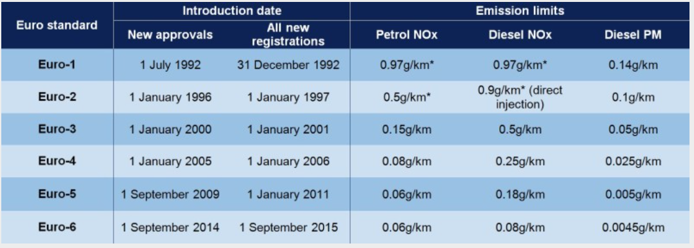
The current regulations of Euro 6 from Euro 5 are a focus primarily on diesel vehicles to reduce their NOX output. The EGR system has a large impact on these regulations, as will be mentioned later in the report. Other methods have also been introduced in the industry to further reduce the emissions.
The proposed Euro 7 standards will further regulate the emissions which a vehicle produces with the inclusion of tyres and break dust also included. With this new introduction it will include all vehicles with electric vehicles no exception (Nasemann, 2023). Questions could be raised surrounding electric bicycles too.

Immediate option for consumers
With the 2035 legislation, all consumers of new cars will be forced to adapt so they comply with the government regulations. As history has shown in the past, dictating to the masses what to do does not result in a positive uptake. If there was an alternative approach taken where it gives the pubic an opinion, where the alternative looks better, than the uptake from the UK population will be greater.
For consumers travelling 131 miles a week on average (YURDAY, 2023) and spending 146.63 pence per litre on petrol (RAC, Petrol and diesel prices in the UK | Latest fuel price data from the RAC, 2023) this equates to £81.12 every month with a 45MPG assumption. If they see a way to reduce these costs directly, then immediately there is going to be a widespread interest.
An innovatory scheme could be implemented within the UK to encourage the use of domestic solar panels. Solar panels with an energy storage system can be bought for the equivalent of £43.33 a month, with a 25-year performance warranty, (Solar, 2023). These have an output of 6KWH. An electric VW up! Can be leased for as little as £170 a month with maintenance and consumable aspects such as tyres and breaks covered too (leasing, 2023). Saving the average maintenance and breakdown costs which add up to £30 a month for vehicle ownership (Kwick-Fit, 2018). The battery capacity is listed as 36.8KWH for the VW UP! (Auto-Express, 2019). It would take 7 hours to charge to full, which would take place overnight in the majority of cases. An example of the electric VW UP! Can be viewed in figure 1.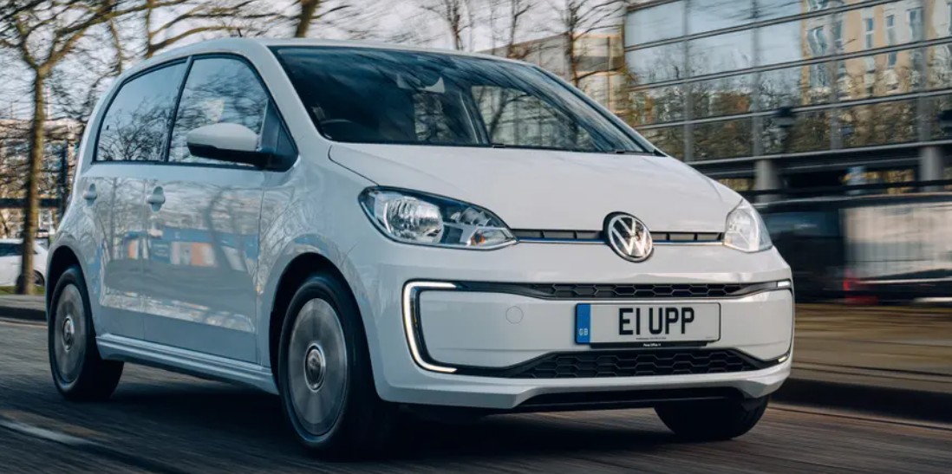
Figure 1 Electric VW UP! (Top-Gear-Team, 2020)
If a consumer is already willing to pay £81.12 + £30 maintenance every month to drive their petrol vehicle before the cost of the vehicle is included. Comparing the petrol VW UP! Which can be leased for £233 a month (Leasing, 2023). The total cost being £344.12. If the electric UP! Was leased along with the solar panels in a joint package at the mentioned costs, the financial savings would be £130.79 a month or £1569.48 a year. If the government was to advertise these packages to the average consumer who, wants a vehicle just for commuting from A to B then the projected appeal would be very high.

Improving the emissions of existing ICE
Development of existing propulsion systems has happened ever since the first petrol powered vehicle were created in 1886 (Benz, The first automobile 1885 - 1886, 2023). Improvements to power output for a reduction in consumer costs has always been a battle for carmakers, creating a strong market for the consumer. Diesel vehicles were introduced providing an alternative with a promised improved torque and reduced fuel consumption (HEARST-AUTOS-RESEARCH, 2022).
Opportunities of new technologies have been created for both petrol and diesel vehicles out of this competition for carmakers. For diesel engines, methods to produce cleaner emissions has resulted in producing an exhaust output which is cleaner than the air which goes in (Jupp, 2020). For vehicles to be at this stage in development is a great achievement. Catalytic converters have been a big contributor to this.
Catalytic converters require precious materials such as platinum or palladium in their construction, as figure 2 dictates. For a start this creates an opportunity of thieves, which is the immediate downfall. The metal helps increase the rate at which the chemicals of the exhaust react with oxygen (Brownell, 2020). Creating a reduction in the harmful gases of up to 90% (MULROY, 2023).
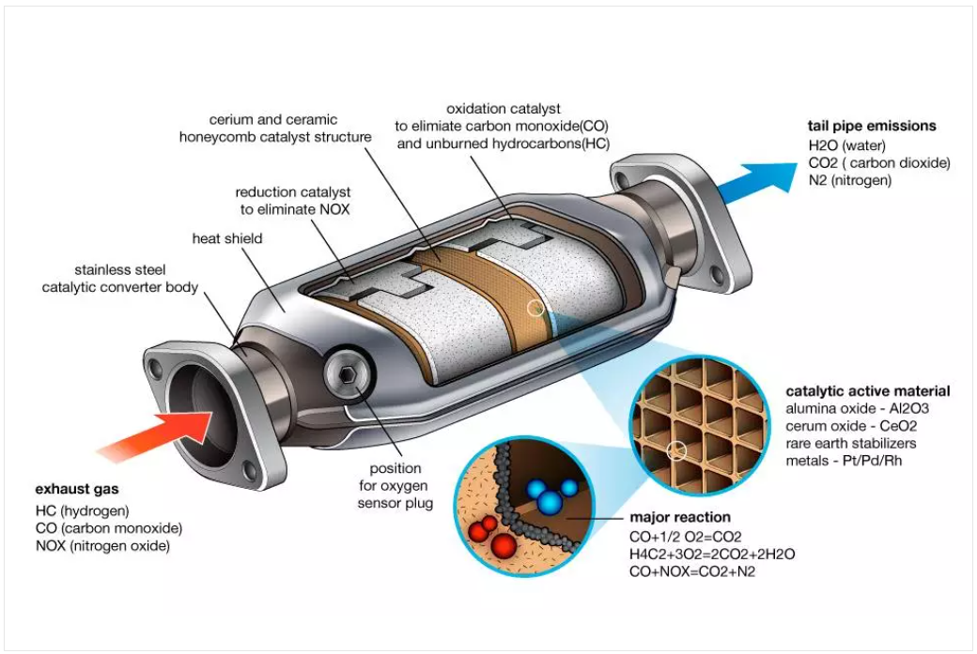
Figure 2 Catalytic converter (ClearMechanic, 2023)
Exhaust gas recirculation methods have meant that otherwise unburnt fuels are directed back into the combustion chamber, reducing the internal temperature, increasing the fuel economy and performance while reducing the emissions (Hodgkinson, 2021).
Most of these methods mentioned, can be developed further to be fitted on existing vehicles which would otherwise be producing worse emissions. This is only economically feasible with the development of new vehicles bringing the technology to the market. Once the ICE market comes to a holt these developments are also going to stop. This will create a period where existing vehicles will create a higher level of emissions then they potentially would have.

Current and Alternative Powertrains

Standard Internal combustion engines
Petrol and diesel vehicles are the standard propulsion method that has been used in the UK. The infrastructure has been developed since 1919 when the first petrol station was created in the UK (Historic-England, 2012). Petrol cars have an efficiency of around 30% with the majority of energy being lost to heat (The-AAA, 2023). Figure 3 shows where the energy output of petrol is distributed. 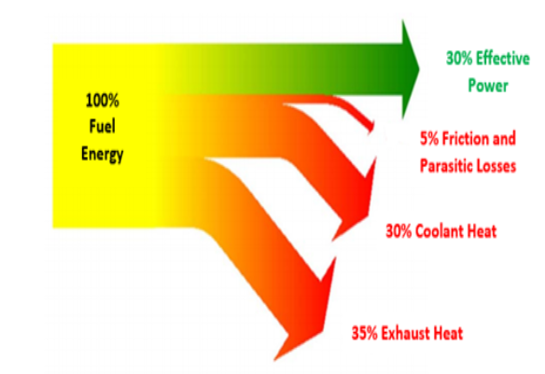
Figure 3 Efficiency of a petrol fuelled vehicle (The-AAA, 2023)
Diesel engines have an increased efficiency of up to 60% which is a large increase over petrol cars (Staffan, 2018).

Hydrogen
Hydrogen has been investigated as a potential form of propulsion since 1807 in the automotive industry (Benz, Forerunners of the automobile, 2023). In more recent times modern automotive companies have been developing their own systems with Hyundai producing a commercially available hydrogen car in 2013 (Burt, 2013). The two main areas of investigation with hydrogen fuelled vehicles is either combustion or using a fuel cell to turn chemical energy into electricity (Cummins, 2020).
Combustion hydrogen engines are essentially modified petrol or diesel engines. The main benefit of this is minimal changes would have to be made to existing vehicles and future vehicle designs. If these engines are not burning as efficiently as designed, then NOx emissions can still be a negative output from the exhaust. However, with the potential to reduce the greenhouse emissions for all commercial goods vehicles by a quarter the benefits seem to overcome the potential of NOx emissions (Nebergall, 2022). Hydrogen combustion engines achieve an efficiency output of up to 25% (Hosseini, 2019).
The method of using a hydrogen fuel cell can be compared to the operation of electric vehicles. However, the energy is sorted in the form of hydrogen gas. When under demanded the hydrogen is converted into electricity by the fuel cell. Producing no harmful emissions from the exhaust (U.S-Department-of-Energy, 2023). The main area which is putting carmakers off hydrogen fuel cell development is the ongoing increase of cost which is associated with hydrogen fuel cells (TWI-Global, 2022). However, hydrogen fuel cells do have a higher efficiency then hydrogen combustion at 60% which is the same as diesel engines (Viessmann, 2022).

Biofuel blends
A large problem with biodiesel is the fight for land in the UK. With current political issues the need to produce food in the country is high on many agendas (Global-Food-Security, 2023). Implementing the growing of biodiesel plants could cause controversy due to the loss of land which would otherwise be used for food (Elshou, 2019). As biodiesel won’t be used for human consumption then it could have the potential to be grown in areas otherwise written off, such as the land used to cover refuge dumps. Figure 4 shows an example of a biofuel refinement plant.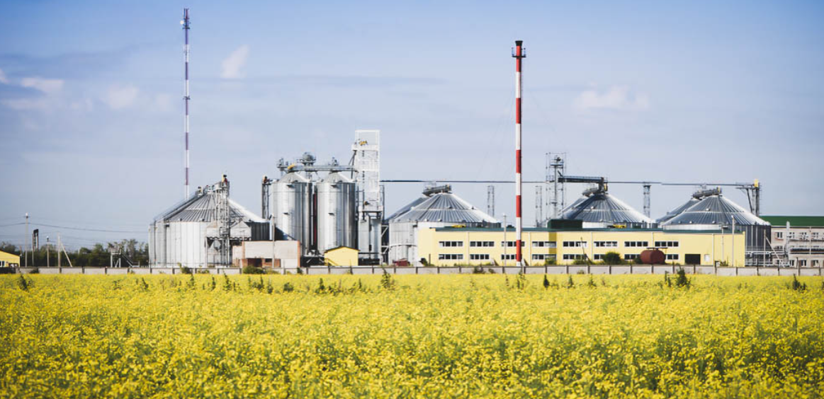
Figure 4 Biodiesel Plant Production (GlobeCore, 2023)
Genetically modified versions of the plants such as rapeseed, and sunflower oil (Association, 2023), would make the plants less susceptible to disease and the ever-changing climate too (GOULD, 2016). Production could be global with each crop modified for the individual climates, which has the potential to improve the wealth of poorer countries.
For vehicles to be powered by biodiesel requires minimal changes to the existing components. For a vehicle to run on a blend of 20% biodiesel and 80% diesel commonly requires no modifications. The efficiency of operating on 20% biodiesel doesn’t change compared to operating on standard diesel (U.S-Department-Of-Energy, Alternative Fuels Data Center, 2023). A similar alternative is available for petrol fuelled vehicles, with Bioethanol blends readily available at fuel stations in the UK E10 being the standard. The efficiency is expected to reduce marginally compared to running on pure petrol (U.S-Department-Of-Energy, Alternative Fuels Data Center, 2023).

Electric vehicles
Electric vehicles now seem to be the environmentally friendly alternative to transportation, they are in local villages and small towns. With the lack of an exhaust the exhaust emissions are of course zero. However, with the production of electric vehicles comes a change in the production methods for electric vehicles. In the life cycle of a standard ICE vehicle the production accounts for 48% of the total emissions. With electric vehicles this figure is raised to 60%. Lithium mining for batterie materials has created employment for poor counties but at the cost of natural areas and very poor working conditions (Euro-News, 2022). Opening giant pits, an example of which can be viewed in figure 5, across the world seems very destructive. Especially when compared to a small well in the middle of the ocean as used for petrol and diesel. 
Figure 5 Lithium mine (I-Seek-Plant, 2023)
To produce the electricity required for electric cars there are various methods which can be used. For the scale that the government requires, great changes in the UK infrastructure must happen. With the weaning out of fossil fuels, coal and natural gas can be eliminated. Biomass is currently used in multiple Power Stations in the UK (Wentworth, 2023). However, on a large-scale great deforestation would be required to create enough biomass to burn, to fully power the UK.
Natural power such as wind and solar is increasing, however the unpredictability which accompanies this source isn’t a viable solution. Both solutions also require a lot of land use which is often met with controversy of being an eyesore. Hydropower and tidal energy is more predictable and constant with large projects planned but not being fulfilled (UK-Government, 2018). The Swansea tidal lagoon project proposal can be observed in figure 6.
Figure 6 Tidal Lagoon Swansea proposal (BBC-News, 2018)
The solution which looks most viable is nuclear power, but this brings its own controversy. From nuclear accidents in Ukraine and Japan more reassurance for the public on its safety must be published to reduce the controversy. Power can be created on demand reducing the need for energy storage facilities (Stein, 2022). This creates the main benefits which doesn’t generally come from other sources.

Liquefied Petroleum Gas
Liquefied Petroleum Gas (LPG) vehicles were introduced and encouraged in the UK between 1990 and 2005. With the ending of the government’s incentives greatly reducing the public’s interest in the fuel (Motoway, 2023). LPG is seen as a more renewable fuel as it is a waste product from gas refinement which would otherwise be burned off (RAC, What is LPG and should I convert to it?, 2021).
The range of LPG can be expected to decrease compared to a petrol car, up to 15%. However, with a predicted reduction in harmful emissions of 7 times the amount a petrol vehicle outputs (Tallodi, 2022).
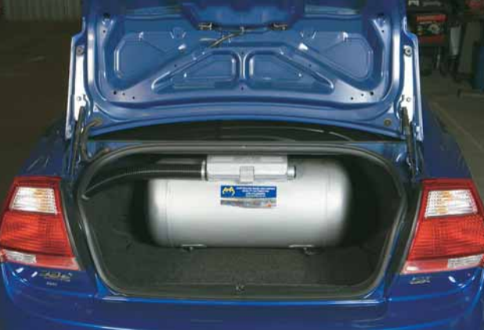
Petrol vehicles can easily be modified to run on LPG with the fitment of an additional fuel tank, taking up room and adding weight to the vehicle. It has been a cheaper alternative to petrol with a predicted annual saving of £800 (RAC, What is LPG and should I convert to it?, 2021). With the cost to convert a vehicle to run on LPG ranging between £1000 and £2500. Because of this, LPG would seem like an investment to the average consumer. If they could put up with the decrease in boot space, which would be the biggest downfall. An example of an LPG tank can be viewed in Figure 7 below.
Figure 7 LPG tank in a vehicle’s boot (Energy-Saftey-Division, 2020)

Hybrid systems
Hybrid technologies have a large potential within the automotive industry when used in unison with internal combustion engines. Current hybrid technologies include running on electric only (DonnellyGroup, 2023), this method could be useful when leaving home to reduce emissions in residential areas. A development could be introduced to use the hybrid power to pre heat the engine. This will reduce or even eliminate the need for the vehicle to operate in open loop conditions (X-Engineer, 2018)
Existing technologies such as kinetic energy recovery systems (KERS) are available currently which takes the otherwise wasted energy into an energy which can be reused in the vehicle normally as electricity or as an addition to the torque the vehicle produces (Jones, 2018). KERS have the potential to increase the fuel economy of road vehicles by up to 25% (The-Brake-Report, 2019). Even with the increase in weight with the system. The system which Volvo has developed can be viewed in figure 8.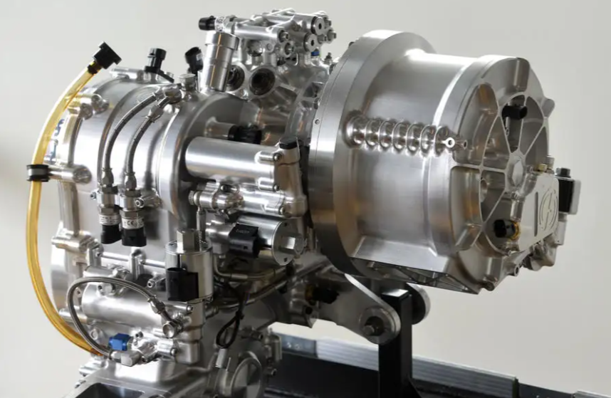
Figure 8 Volvo KERS (Holloway, 2014)

Influence of Motorsport
The highest levels of motorsport have always created and developed the latest technologies with the goal to win races over their competitors. The technology which is explored in motorsport is often projected down to consumer vehicles. Technologies as simple as the rear-view mirror and active suspension systems have been first produced due to motorsport (Lawrence, 2018).
The top levels of motorsport such as Formula one which use petrol combustion hybrid engines, will soon fall behind in terms of the latest innovation in technology. Unless great exploration into alternative fuels is developed. Why would an oblivious motorsport fan switch to an electric vehicle when their racing heroes are still using petrol?
If electric vehicles are to be pushed by the government, then greater advertisement and subsides of events such as Formula E will create a large impact. Street circuits in more cities which can have a large involvement with schools and colleges will showcase the capacity of electric vehicles early on. A Formula E car from the previous racing season can be viewed in figure 8.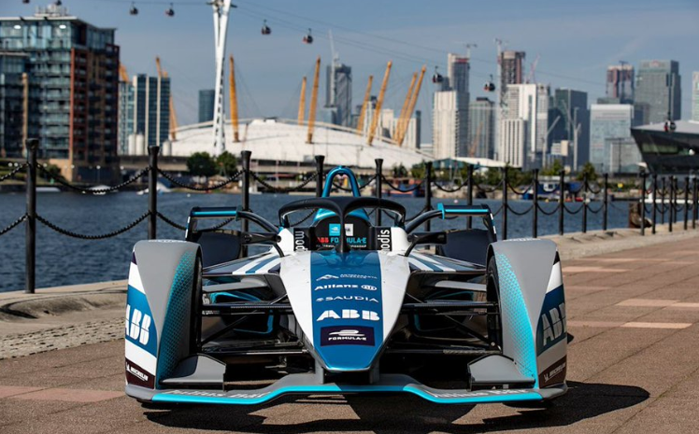
Figure 9 Formula E car in London (ABB-Group, 2021)
Lower streams of motorsports still using internal combustion have the standing to create explorations into renewable alternative fuels while keeping a large base of motorsport fans. This will retain the emerging technologies which may save the internal combustion engine.
With the future legislations in place, supercar manufacturers would have to cease production of their iconic cars in the UK. This would cause many manufactures to collapse. Even with 2035, 12 years away some luxury manufactures have pledged to keep producing their iconic vehicles (Glon, 2022). This will keep the wealthy and motorsport fans engaged but only in the countries where the regulations allow. This has the potential to keep wealthy business owners away from the UK, if they’re being dictated to on car choice. Reducing the development and economy of the UK would only be a negative.

Summary
For consumers who require a method of transportation for short distances around town, then electric vehicles have a strong potential. With methods readily available for the required energy to be produced domestically.
Domestic solar panels should be encouraged more greatly with schemes such as the one previously mentioned where you could potentially lease solar panels and an appropriate vehicle for a cost, less then what consumers would ordinarily pay. The infrastructure would have to be created for these which is very possible. If this is made as an option rather than compulsory, then the public’s uptake is likely to be higher.
For the consumers who require a vehicle for commuting longer distances out of town then ICE seems to be the current and future most appropriate method. Carmakers would continue to develop innovationary technologies. Naturally an industry target of reduction in emissions and an increase in efficiency would lead to the development of other technologies. Keeping many carmakers trading and creating a competitive market. A transition to different powertrains when the economy is ready would occur. Exclusive vehicle companies could still be able to produce luxury supercars.

Bibliography
ABB-Group. (2021).
Association, E. B. (2023, March 28). Biodiesel. Retrieved from EUBIA: https://www.eubia.org/cms/wiki-biomass/biofuels/biodiesel/#:~:text=Biodiesel%20is%20produced%20from%20vegetable,nut%2C%20Chinese%20tallow%20tree).
Auto-Express. (2019). Volkswagen e-up! review. Auto Express.
BBC-News. (2018).
Benz, M. (2023). Forerunners of the automobile. Mercedes Benz.
Benz, M. (2023). The first automobile 1885 - 1886. Mercedes Benz.
Brownell, L. (2020). DEPARTMENT OF CHEMISTRY AND CHEMICAL BIOLOGY. Harvard University.
Burt, M. (2013). Hyundai ix35 Fuel Cell 2013-2018 review. AutoCar.
ClearMechanic. (2023, March 30).
Cummins. (2020). Hydrogen Engines. Columbus: Cummins.
DonnellyGroup. (2023). The Definitive Guide to Plug-In Hybrid Vehicles (PHEVs). Donnelly Group.
Elshou, P. M. (2019). Global relative species loss due to first‐generation biofuel production for the transport sector. Bethesda: National Libary of Medicine.
Energy-Saftey-Division. (2020). Your Guide to Auto LPG saftey. Government of Western Australia.
Euro-News (Director). (2022). A Portuguese village pays the high price of low-carbon energy [Motion Picture].
Foundation, R. (2023). How many vehicles are there in the United Kingdom? London.
Global-Food-Security. (2023). Uk Threat. Global-Food-Security.
GlobeCore. (2023, March 30). BIODIESEL PLANT PRODUCTION.
Glon, R. (2022). Pagani ditches EV plans, pledges allegiance to the V12. AutoBlog.
GOULD, F. (2016). Genetically Engineeered Crops . North Carolina: National Academies of Sciences, Engineering, Medicine.
GOV Transport, D. o. (2020). Government takes historic step towards net-zero with end of sale of new petrol and diesel cars by 2030. London: Gov.uk.
HEARST-AUTOS-RESEARCH. (2022, April 18). Diesel vs. Gasoline: Everything You Need to Know. Retrieved from Car And Driver: https://www.caranddriver.com/research/a31515330/diesel-vs-gasoline/
Historic-England. (2012). When Did England's First Filling Station Open? Historic England.
Hodgkinson, P. (2021). What is an EGR Valve? Evans Halshaw.
Holloway, H. (2014, March 25). Volvo's new KERS system to reduce fuel use by 25 per cent.
Hosseini, S. E. (2019). An overview of development and challenges in hydrogen powered vehicles. Taylor and Francis Online.
I-Seek-Plant. (2023).
Jones, M. (2018). Why we need cars with KERS. TopGear Magzine.
Jupp, E. (2020). Can diesel engines CLEAN urban air? Motor Research.
Kwick-Fit. (2018). Motorists' Costs Running At £162 Per Month- Excluding Cost Of The Car. Kwick Fit.
Lawrence, E. (2018). This is how motorsports technology has changed your everyday car. RedBull.
leasing, S. c. (2023, March 27). Volkswagen e-Up Hatchback. Retrieved from Select Car Leasing: https://www.selectcarleasing.co.uk/car-leasing/volkswagen/e-up/hatchback/60kw-e-up-32kwh-5dr-auto?mileage=5000&term=24&initial_payment=9
Leasing, S. c. (2023, March 27). Volkswagen Up Hatchback. Retrieved from Select Car leasing: https://www.selectcarleasing.co.uk/car-leasing/volkswagen/up/hatchback/10-65ps-black-edition-5dr?mileage=5000&term=24&initial_payment=9
Motoway. (2023). LPG cars – the ultimate guide. Motoway.
MULROY, C. (2023). What is a catalytic converter? Why thieves are stealing them and how to protect yours. USA Today.
Nasemann, S. (2023). The new Euro 7 standard: What does this mean for brakes? TMD Friction explains. Leverkusen: TMD Friction.
Nebergall, J. (2022). HYDROGEN INTERNAL COMBUSTION ENGINES AND HYDROGEN FUEL CELLS. Columbus: Cummins.
RAC. (2021). What is LPG and should I convert to it? The RAC.
RAC. (2023). Petrol and diesel prices in the UK | Latest fuel price data from the RAC. RAC.
Solar, W. o. (2023, March 27). OUR PACKAGES. Retrieved from World of Solar: https://worldofsolar.com/our-packages.html
SSMT. (2023, March 30). Vehicle emissions testing. Retrieved from SSMT Driving The Motor Industry: https://www.smmt.co.uk/industry-topics/emissions/testing/
Staffan, D. (2018). FUEL USE - HOW LOW CAN YOU GO? Volvo.
Stein, A. (2022). Advancing Nuclear Energy. The Breakthrough.
Tallodi, J. (2022). What is an LPG car? CARWOW.
The-AA. (2017, December 11). Limits to improve air quality and health. Retrieved from The AA Driving advise: https://www.theaa.com/driving-advice/fuels-environment/euro-emissions-standards#:~:text=Euro%201%20(EC93)&text=The%20introduction%20of%20the%20Euro,carbon%20monoxide%20(CO)%20emissions.
The-AAA. (2023). How Efficient is Your Cars Engine. The AAA.
The-Brake-Report. (2019). Volvo Adding KERS to Production Cars in 2020. The Brake Report.
Top-Gear-Team. (2020, April 20). Volkswagen e-Up review.
TWI-Global. (2022). WHAT ARE THE PROS AND CONS OF HYDROGEN FUEL CELLS? TWI Global.
U.S-Department-Of-Energy. (2023). Alternative Fuels Data Center. U.S Department Of Energy.
U.S-Department-Of-Energy. (2023). Alternative Fuels Data Center. U.S Department Of Energy.
U.S-Department-of-Energy. (2023, March 30). Fuel Cell Electric Vehicles. Retrieved from Alternative Fuels data center: https://afdc.energy.gov/vehicles/fuel_cell.html#:~:text=What%20is%20a%20fuel%20cell,produce%20no%20harmful%20tailpipe%20emissions.
UK-Government. (2018). Swansea Lagoon; an unjust decision. The Welsh Agenda.
Viessmann. (2022). How efficient are hydrogen fuel cells? Viessmann.
Wentworth, J. (2023). Biomass for UK energy. UK-Parliment.
X-Engineer. (2018). Open loop vs. closed loop control systems (with Xcos simulations). X-Engineer.
YURDAY, E. (2023). Average Car Mileage UK . Nimblefans.

