University of Wales Trinity Saint David

School of Engineering

Reflective Project Report

ACMA5009 PART-TIME

Joshua Axon

2218372

22nd May 2024

Contents
1 Background 1
2 Project Plan & Gantt Chart 1
3 Project overview. 1
3.1 Review of current processes & definition of project scope 2
3.2 Design Conception 2
3.3 Project Charter & Capital AFE form 4
3.4 Initial Consultation/Concept Research & Feasibility Study 6
3.5 Risk assessment/further feasibility studies. 7
3.6 Concept presentation/final quotation. 7
3.7 Final sign off and closure. 8
3.8 Literature Review in Project Management/Change Management. 8
4 Project Analysis 11
4.1 Project Conceptualization 11
4.2 Planning 12
4.3 Execution 12
4.4 Termination 13
5 Application of Theories and techniques. 13
6 Conclusion 15
7 References 16

Background
Ledwood’s is a mechanical engineering firm that specialises in fabricating structural steel and high-pressure piping systems; part of the process of fabricating is welding, which is the process of fusing steel through a high-temperature electric arc. Most welding processes require shield gas to avoid oxidation & nitrogen absorption by the molten weld pool (Nguyen, et al., 2005). These can incur defects within the final product; because of this, Ledwood uses argon gas as an inert shielding gas in several welding processes employed at the firm, including tungsten inert gas welding or TIG for short. TIG welding is one of two primary welding processes used in pipework fabrication at Ledwood; because of this, Ledwood requires large quantities of argon. Often, this is supplied by BOC gases to Ledwood; the gas is supplied in cylinders or large amounts of arranged cylinders in manifold pallets. These comprise 15 cylinders and hold large quantities of gas. However, as BOC has supplied these manifold pallets and the cylinders within, they charge a monthly rental fee for manifold pallets & cylinders and a one-off charge to buy the gas. This project will look at how the current implementation of these manifold pallets can be improved to save on gas costs and the rental fee of the manifold pallets & cylinders.

Project Plan & Gantt Chart
The assignment consists of 5000 words. A Gantt Chart has been developed to complete this project (see below in Figure 1). This chart showcases a rough time scale for each of the different deliverables for this assignment and categorizes them into four categories, which tie into each of the different sections of this report. As this was undertaken as a part-time venture, no specific dates are part of the Gantt chart. A more general week period/duration for each section is provided, as the understanding that this was being done in conjunction with a full-time job and exact time frame was realistic as it wouldn’t be possible to stick to it.
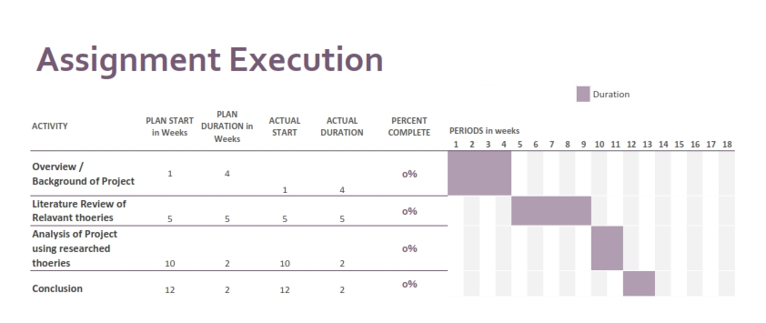

Figure 1 - Project Execution Gantt created by Document Owner.

Project overview.
Currently, the company spends large amounts of money on the rental of gas manifold pallets; the proposed project must find a way to reduce or eliminate these costs. Additionally, the solution shouldn’t be more labour or time-intensive in its day-to-day operation of supplying argon to the welders for the welding processes. If the solution requires an initial cost, there must be a payback/return on investment time analysis. Additionally, the company has no process to get large-scale improvement projects within the businesses signed off, specifically if they require a large budget. Currently, this is done on an ad hoc basis when needed. This project aimed to act as a test or flagship project with the hope of mapping the route out for future projects to improve aspects of the business and streamline and improve the project's life cycle to completion.

Review of current processes & definition of project scope
Currently, BOC is our gas supplier. They supply gases such as oxygen, acetylene, argon, and propane for all welding and burning activities. This project will look at how argon gas is employed within the company, specifically how it's stored and handled and how it costs.
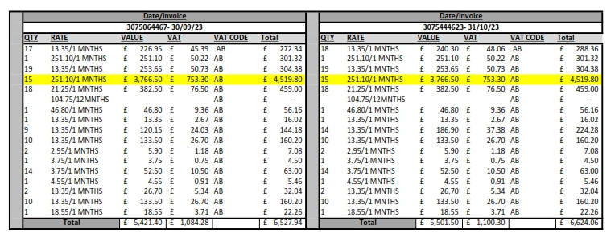
Manifold cylinder pallets are the cheapest method of buying gas as a typical WW size pallet contains 165.2 m2 of argon gas, which BOC sells for £2,431.44. This, however, isn't where all of the costs arise from as once the gas is purchased from BOC, they then charge rental on the cylinders, and one manifold cylinder pallet costs £251.10 a month to rent, which is approximately 10% of the cost of the gas. The fact that the manifold cylinder pallet contains so much gas and that fact that there are only 4 outlets and a welder needs a minimum of two means that only two welders end up using one manifold cylinder pallet; quite often, they are on-hire for extended periods. Additionally, the business operates a strategy of holding manifold cylinder pallets in reserve as a contingency if BOC cannot restock/replenish the supply. The company could have as many as 15 banks on rent in workshop B alone, costing £3,766.20 a month. This considerable cost is one of the driving factors behind the undertaking of this project. Below is a breakdown of the rental expenses for a two-month period.

Figure 2 - Cost breakdown of rental of cylinders and cylinder manifold pallets at Ledwood over a two month period, the highlighted yellow rows are for the size WW pallets used in workshop B.

Design Conception
Ledwood’s current system was borne out of the necessity of having large quantities readily available without frequent changeovers; as shown above, this came with some considerable drawbacks, particularly in terms of cost. If a new system is to be adopted, Ledwood stated some minimum requirements the new system should meet. This created some basic design requirements/specifications, as shown below in Table 1.
Table 1 - Basic design requirements
Requirement | Description
1 | The proposed solution must reduce or eliminate all the costs associated with renting the manifold cylinder pallets of Argon.
2 | The proposed solution must still provide ample pressure to the welders/weld set for welding / purging activities.
3 | Should remove reduce or remove manual handling activities.
4 | The proposed solution still needs to quickly and safely provide large quantities of argon gas to welders and weld sets.
5 | The new method of supplying gas should be safe and not introduce new or additional risks to welders or workshop personnel.

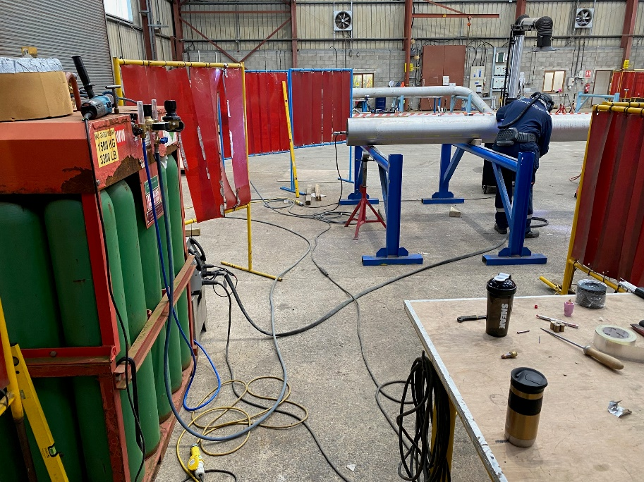
The first proposed system, drawn up in July of 2023, centred around a large external storage tank, which would be topped up via a browser. This solution seemed preferable once the tank was paid for; it would eliminate the need to rent banks or cylinders of argon. The welders/weld sets would then be supplied via an internal pipeline routed above their workstations and with drop-down sections on the workshop walls, which they could tap into to get gas. This proposed solution fully satisfies all five design requirements in Table 1. As there would no longer need to be any banks as the tank would replace them, space would be saved if the tank was placed outside and the pipework ran into the workshop.
Figure 3 - Picture taken in Workshop B of Ledwood with old system using WW size pallets next to welder/weld sets.

It wouldn’t have to have space taken up by banks next to workstations, and if correctly routed, it would stop tubing having to be routed along the floor, which created a tripping hazard, all issues the current system, which can be seen in Figure 3 does not address. Additionally, if an external tank were used, there would be no time lost manually handling empty banks back and forth once empty, as a gas supplier would fill it up via a bowser, and any handling costs would be eliminated from the company’s viewpoint. As this system significantly improved, the Ledwood project team pursued this concept.

Project Charter & Capital AFE form
Now that the project team had decided on their concept, the buy-in from the upper management and, critically, a project sponsor was required if the project was to receive funding, it was decided that as no system existed, and there was considerable cost to the project but also considerable benefits/payback. A more in-depth system was required to lay out the business case for improvement. It was decided to create one, and this project would be used as a flagship project to test this new system. Capital AFE form is seen below in Figure 4; this defined the project scope early on as well as a rough description of what was required, the business case for undertaking the project, and any objectives the project sought to have achieved by the end of the project.

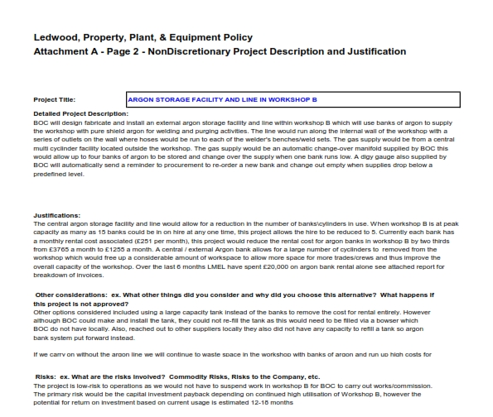
Figure 4 - Capital AFE form page 2 project description and justification.

Within the business case, the benefits of undertaking the project, the final costs, why the system has been chosen, and the potential payback for the project. As this was a controlling document, the project initiation/owner, HSE Manager, Engineering Manager, Finance Director, and managing director/sponsor would sign this form. Once all signatures were obtained, approval for expenditure was also received, and the project could move to the next stage. However, the company employed a new operational manager who wished to enforce a new form on the project team and forced them to abandon the Capital AFE form in favour of a project brief/project chart & Capital Expenditure Justification form that did essentially the same function but now in two separate forms the project brief/chart form seen below in figure 5.
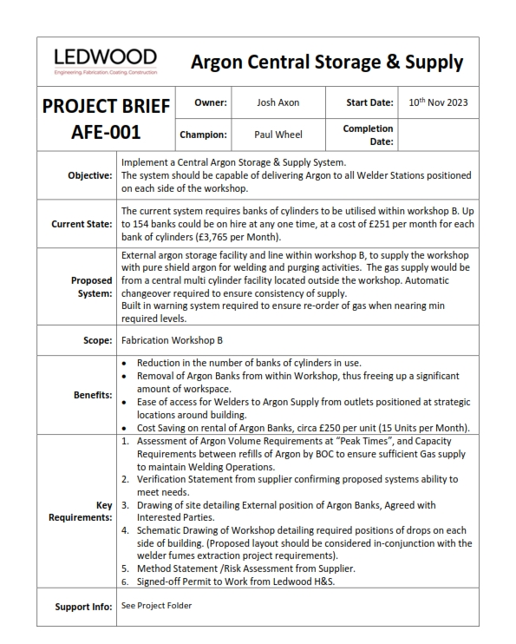
Figure 5 - Project brief/Project chart form created by Ledwood.

Initial Consultation/Concept Research & Feasibility Study
With a basic concept developed, project scope & key stakeholders identified through the use of a project AFE form, Ledwood now looked to consult with their principal gas supplier, BOC Gases, as they were a significant gas supplier and had considerable expertise with gas distribution it was thought they would be an excellent gauge to see if the use of an external argon tank was feasible. From initial discussions with BOC, it became apparent that while they did provide external tank solutions and could, in theory, supply in ‘bulk’, there were a couple of obstacles to enabling ‘bulk’ supply argon at Ledwood. The predominant issue is that argon needs to be kept in liquid form to be transported cost-effectively. Liquid argon is a cryogenic liquid that must be kept at -186 degrees Fahrenheit (Air Products and Chemicals INC, 2015). This presents challenges as a “standard” storage tank initially envisioned would not be sufficient; a more complex and robust cryogenic storage tank would be required. Outside cryogenic liquid storage, the liquid must be turned back into gaseous argon for welding. To do this, the system must incorporate one or more vaporisers, a pressure control manifold, and an associated transmission pipeline, potentially increasing associated costs and the project scope. Finally, while BOC did supply in bulk for argon, their current supply network does not reach our area.
In light of this, Ledwood contacted Air Products & Chemicals LTD, the only other major gas supplier/distributor in our area, to see if they could supply us with argon in ‘bulk’. They provided in bulk, but their current supply network did not reach our area. This essentially ruled out using an external tank because it could not be supplied. Ledwood then explored the option of reducing rental costs by changing supplier; however, Air Products & Chemical LTD providedare not competitive in their price for the gas or the rental of the manifold pallets, so this completes them out of supplying us with welding gases. Undeterred by the challenges, Ledwood continued its search for a suitable gas supplier. With the idea of bulk supply effectively ruled out due to supply network limitations, we re-engaged with BOC, our principal gas supplier, to explore alternative solutions.
The solution provided by BOC still used manifold cylinder pallets; however, they would now be stored externally and linked to an internal ring main in the workshop. The welder would then tie it into an outlet on the wall. This system only partially removes the costs of renting the manifold cylinder pallet. However, because they were centrally linked, the workshop could be provided gas from 2 as opposed to the 15 current on-hire, which significantly reduced the cost in terms of renting.

Risk assessment/further feasibility studies.
Within the project team and Ledwood, there were some sceptics about the proposed system by BOC; their main concern was whether just two manifold cylinder pallets could supply all the welders with argon. Ledwood looked to quantify the maximum volume of argon they would need on a given day to see if this system would be adequate for their needs.
Table 2 - Total volume of area that requires Purging based upon pipe size.
Pipe OD Size (“) | Radius in mm (r) | Height (h) in mm | Total Volume in mm3 (V) | Total Volume in m3 (V)
½” | 10.67 | 104 | 37,197.35 | 3.72x10-5
¾” | 13.335 | 104 | 58,099.08 | 5.81 x10-5
1” | 16.7 | 104 | 91,120.51 | 9.11 x10-5
2” | 30.15 | 104 | 297,000.95 | 2.97 x10-4
3” | 44.45 | 104 | 645,545.33 | 6.45 x10-4
4” | 57.15 | 104 | 1,067,125.95 | 1.07x10-3
6” | 84.15 | 604 | 13,436,775.22 | 1.34x10-2
8” | 109.55 | 604 | 22,772,545.32 | 2.30x10-2
10” | 136.5 | 604 | 35,355,103.59 | 3.54x10-2
12” | 161.95 | 604 | 49,767,831.28 | 4.98 x10-2
14” | 177.8 | 604 | 59,986,058.21 | 5.99 x10-2
16” | 203.2 | 904 | 117,264,274.64 | 0.12
18” | 228.6 | 904 | 148,412,593.8 | 0.15
20” | 254 | 904 | 183,225,424.44 | 0.18
22” | 279.5 | 904 | 221,861,491.16 | 0.22
24” | 305 | 904 | 264,190,977.61 | 0.26
30” | 381 | 904 | 412,257,204.99 | 0.41
36” | 457 | 904 | 593,131,109.64 | 0.59
40” | 500 | 904 | 709,999,939.71 | 0.71

Table 2 was used to do this. This outlines the total volume that would have to be purged of oxygen when welding, depending on the size of the pipe that would be welded. Based on historical data of peak output during a week in November 2023, 13 welders produced 1717 diameter inches(a cumulative figure of pipe OD used as a KPI in pipework fabrication). This works out at approximately 33” inches per welder per day. To simplify this, Ledwood used a scenario where all the welders did a 40” weld each day for a week; this would work out at 28.4 m3 per week. This still only equated to approximately 17% of the total volume of gas of just one of the manifold cylinder pallets; there had been a shortage of available replacement manifold cylinder pallets in the past, so it was decided to go with a 2x2 manifold, which would be capable supplying 330m3 of argon based on the above calculations enough gas to keep the workshop provided for 11 weeks or more. In addition, this system would still reduce the number of banks from 15 to 4, a 73% reduction in the number of manifold cylinder pallets at any one time.

Concept presentation/final quotation.
The proposal was formally submitted to each department manager and the managing director. Soon, an agreement was made to award £2000 in funding to get BOC’s engineer to visit Ledwood’s Pembroke facility to finalise the quotation. Once the visit had been completed, the final quotation was obtained in November, and a final price was given. It had risen by approximately £5k to £26,612. The project sponsor/managing director then negotiated the price back to the original quotation of £21,543.

Final sign off and closure.
With the final quotation received, the final action was to apply for the second funding phase by getting the sign-off on the Capital Expenditure Justification sheet. This involved getting the signature of each department manager and the final signature of the managing director, who has spending authority within the company. This process took from November of 2023 to March of the following year, a total of four months to achieve, and was the most significant delay to the project. The order went into effect once the project was signed off, and BOC was asked to undertake the required work. Ledwood now had a final review meeting of the project. The new capital AFE process was done, and it was confirmed during that meeting that this would be the process in the future if Ledwood wanted to undertake large capital projects.

Literature Review in Project Management/Change Management.
Project management is fundamentally about change, as projects are often considered agents driving the necessary challenges in society (Locatelli, et al., 2023). Change management in terms of project management involves using a systematic approach to dealing with changes within an organisation (Ibbs, et al., 2001). Kotters 8-step model is a well-established framework for providing a systemic approach to change, it based around 8 distinct step seen below in figure 6, chief of all of these key steps is to create a sense of urgency when acting change as without urgency came complacency (Kotter, 2008). Integrating practices of change management into project management is an essential tool to enabling project success (O'Leary, et al., 2017). By utilizing Kotter’s model Project Managers can navigating any complexities by establishing clear vision, engaging with shareholders, and ensuring the change implemented is sustainable (Methangkool, et al., 2019).

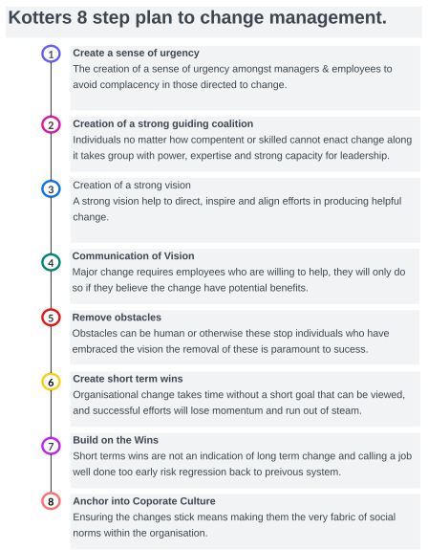
Figure 6 - Kotter's eight step model to change management diagram created by document owner information taken from (Kotter, 1996) & (Kotter, 2008).

The Project Management Institute (PMI) defines a ‘project’ as a temporary venture to create a bespoke project or service. (Maley C, 2012). Project lifecycle framework is critical to managing any project as it sets out essential practices, such as a project charter/scope, communication and management lines, WBS (work breakdown structure) critical path analysis, decision tree and risk management assessments (Jitapaidoon, et al., 2019). These essential practices are often further refined further into a project lifecycle phased approach which includes four distinct phases often named by conceptualization, planning, execution & termination (Jugdev & Müller, 2005).
Each of these phases is defined by key deliverables required to be completed at the end of each of these phases the conceptualization phase typically sees a project team draw up a Project charter (a controlling document that encompasses scope, objectives and key participants), stakeholder identification, risk assessments and feasibility study. These documents set the foundation for project management (Eadie, et al., 2013).
Next, the project planning phase key deliverables in this phase further scope definition, schedule development, resource planning or work breakdown structure (WBS), risk management planning, communication planning and quality planning that provide crucial guidance and control in the execution phase (Zou, et al., 2007).
The next focus is on project execution key deliverables in this phase include, task execution, resource management, quality assurance, stakeholder engagement and risk/issue management, this phase is defined by underscoring the importance of building on best practices implemented in the first two phases of the project (Willar, et al., 2020).
Project termination phase centres around the closure of the project so complete project documentation, post implementation review, release of resource and closure report all look to smoothly transition the project to closure (Jaber, et al., 2017).
The project lifecycle and the key deliverables in each of four distinct phases are formed from best practices and lessons learned from previous projects and give a fundamental framework to which more advanced project management techniques can be implemented (Xia, et al., 2017).
Within the industry, project management is now classed as a profession; it’s grown since the turn of the 20th century, first with the advent of Gantt charts in the 1920s and then in the 1950s with the introduction of critical path analysis, a vital tool in project management for construction projects (Burke, 2013).
As mentioned above, the Critical Path Method (CPM) is an effective project management method. This method involves identifying tasks as critical or non-critical and forming a pathway for project completion (Khan & Haider, 2017). In essence, the Critical Path Method (CPM) separates each aspect of a project into smaller deliverables. Then, using logical network paths (the next logical step), link each of these deliverables into a critical pathway that will take the project from project start to finish, ensuring resources are pooled into essential tasks to ensure the project team can manage and minimise risk due to delays (Wulandari, et al., 2018 ).
As mentioned above, the most significant danger to the project is delays, often called risk within the context of project management; risk management is another project management tool that is a systematic approach to the unknown. (Kutsch & Hall., 2005). There are two main categories of risk management techniques: preventative and remedial. The latter focuses on the foreseen/anticipated risks before the commencement of a project. As the name suggests, Remedial looks to manage risks, which looks to minimise risk during project execution. Risk management can contribute significantly to increasing the chances of success of a given project, defining project objectives, enhancing project control, strengthening communication lines between individuals during a project, and facilitating information decision-making (Obrová & Smolíková, 2013).
Finally, this report will look at motivational theories, as motivation can be the difference between the success and failure of planned change. Several theories of what motivates an individual exist, such as Maslow’s Need Hierarchy Theory. The idea that an individual's needs can be organised into a hierarchy is shown below in Figure 7.
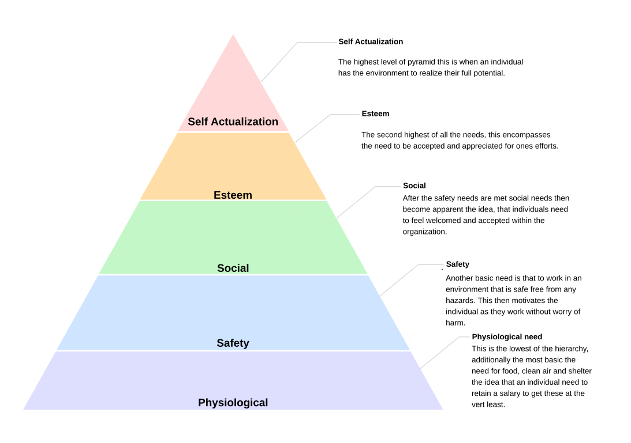
Figure 7 - Maslow's Need Hierarchy Theory diagram created by document owner information taken from (Kaur, 2013).

The purpose of the hierarchy is to breakdown what motivates humans to work into manageable individual-centred approach (Hill, 2015). The idea of Maslow’s theory is that by doing so, the very best can be extracted out of an individual or, as Maslow puts it, to realise ’self-actualisation’ (Kaur, 2013).

Project Analysis
This section of the report will look at how Ledwood's project management compares to current academic theories and techniques in project management. As shown in the literature review, the project lifecycle is a critical framework for any project and the basis for implementing additional project management techniques. Although the project undertaken by Ledwood can be applied retrospectively and actions taken can be divided into each of the four main phases, it can be said that Ledwood did not work to this lifecycle/plan during the project's duration.

Project Conceptualization
The project undertaken by Ledwood to update the supply of welding argon to individuals on the workshop floor was one of the most significant improvement projects conducted by Ledwood. Ledwood defined its project through the use of the capital AFE form, as seen in Figure 4; this document outlined the scope of the project, the business case, justification, and key stakeholders.
However, two additional controlling documents were introduced late into this development phase: a project brief and capital Expenditure Justification. The project brief can be seen in Figure 5. These documents again outlined the scope of the project, the business case, justification, and key stakeholders. Implementing two papers that do similar tasks caused delays and showed a lack of direction or plan initially, as these days were not highlighted at the time.
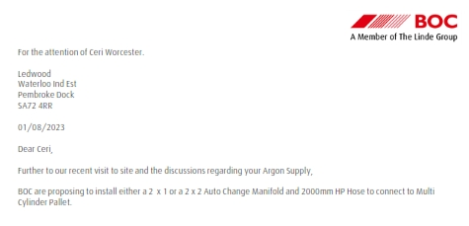

Figure 8 - Header of BOC initial quotation regarding argon supply (cannot show full document due to request from BOC).
Further illustrated by the above figure 8, the initial quotation was received two months before the controlling document outlining the project's scope was completed; this showcases a fractured approach to the project initially and its lack of direction.
This fractured approach led to significant project delays, which in turn, escalated the costs. As shown in Figure 2, the cost of cylinder/bank rental for the months of October and November, the period between the quotation and the project brief, was substantial. The sections highlighted in yellow represent the rental costs for all the banks for those months alone, totalling £9039.60. This is a considerable amount, considering the initial quotation was only for £21,543.00. In fact, this delay had already consumed large amounts of funds, approximately 40% of the total project expenditure for the argon line, a fact that cannot be ignored.
Additionally, common deliverables for a project are risk assessments and feasibility studies. Ledwood did not undertake any of these deliverables during this phase, and it would be another two months before the final feasibility study was completed, again highlighting the lack of direction the project was suffering from.

Planning
The next stage was to move on to planning how to enact this change/project within the company. Key deliverables during this stage often include a work breakdown structure. Ledwood again didn’t have this by the end of this phase, leading to multiple people picking up what actions they believed needed to be taken. This led to some regions of the project being ahead of others such as the feasibility study wouldn’t be completed for two months after the initial quotation was given. This lag between the different departments of the project team led to more fractured approaches and more delays.
Additionally, a communication plan is another key deliverable during the planning phase. If Ledwood had this in place, they would’ve had the communication channels to escalate any delays during the project to the executive leadership team/project sponsor. Paramount to all this is another key deliverable at this stage, which is the creation of a risk register. This document would’ve highlighted all the missing deliverables mentioned above and in the previous section and the likelihood of them impacting the schedule. This document alone could’ve allowed Ledwood to implement remedial risk management techniques to avoid further delays; without this key deliverable at this stage, Ledwood incurred unforeseen delays for the rest of the project.

Execution
During the BOC engineer's visit, the project moved into the third phase of the project lifecycle. The execution phase to get to this stage could said to have been a small win as the project, although fractured, was still progressing in the right direction, a key part of Kotter's model and Maslow's hierarchy of needs as individuals would've felt they'd had minor success key at this stage as the project was now in it's eighth month. At this stage, as already established, Ledwood did not have a lot of these key deliverables in place; the most significant delay in the project took in this phase when the final phase of funding had to be applied for there was a four-month gap from the final quotation based off the engineers visit and the approval of the financing for said quotation. There is no data on how many manifold cylinder pallets were hired during these months; it can be expected to be around 15, based on Figure 2. This puts the cost at £3,766 per month per month, a total of £15,064. Put into context, this sum is 70% of the total quotation price/funding that was being applied for. Additionally, if there hadn't been a delay during this period and the project was implemented, the number of banks could've been reduced, and the total cost could've been reduced to £4017.60 for the same period, again, a reduction of 73% of costs for the period.
This clearly demonstrates a real lack of urgency within the project team during this phase, and as Kotter defines, a lack of urgency creates complacency. The project's drawn-out length could've been a factor.

Termination
Once the final funding phase had been completed and BOC had undertaken work to install the argon line, the project entered its final phase, the closure phase. Key deliverables in this phase revolve around getting the project completed and over the line agreed upon and signed off by all relevant shareholders and any lesson learnt recorded. Ledwood did this by holding a post-implementation review meeting at the end of the project; this went over the process of getting large capital projects applied for funding within the organisation, and it didn’t focus heavily on implementing the first project. The outcome of the meeting was that the current process was adequate for Ledwood’s needs, and five additional capital approval-based projects have been drafted since that meeting. However, it’s important to note that none of the five have progressed past the conceptualisation phase, and none have progressed much since their inception, marred with delays and slow progress. This could result from a lack of understanding or learning from the first project. Kotter stated that the final step of change management is to anchor all changes into the corporate culture. Ledwood, once they had finished the project, did not undertake a lesson learnt register, nor did they create standard operating procedures for any of the processes they had developed. As a result, the other projects do not have a clear path to move forward.
Now, many of the project teams suffer from low motivation. Maslow’s theory shows this could be in part due to the need for esteem already mentioned in this report. However, in this case, as there is little progress in many of these projects, many undertaking them likely struggle to see worth in work as it’s felt there is little achievement in undertaking many of the actions.

Application of Theories and techniques.
This section will look at if any of these techniques were applied at the start of the project what in terms of quantitative and qualitative savings the company could’ve made. The first area that Ledwood should’ve look to define in the early phases of the project is a clear time-frame/scale this can be done using a Gantt Chart which can been seen below in figure 9.
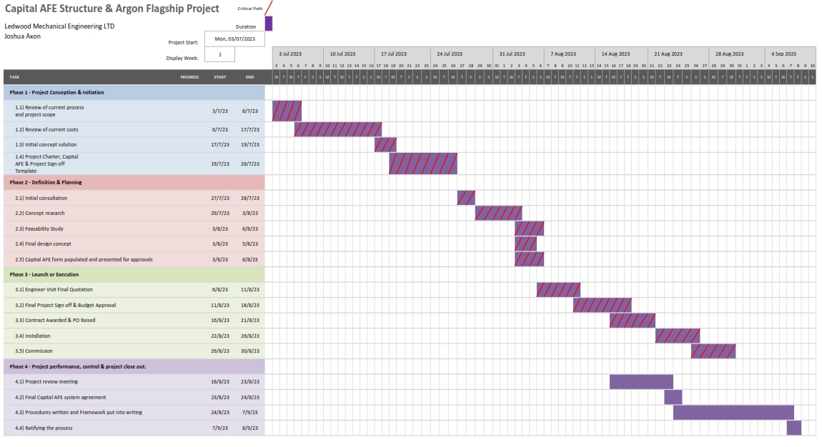
Figure 9 - Project gantt chart created by document owner.

As each task is now arranged into a project lifecycle, the four distinct phases follow each other, and the project now has a clear direction and flow. Additionally, note the red hatch sections. These are critical path activities; all activities in the final phase have been defined as non-critical path activities, which can be worked on in the background and do not hold up the project installation or commissioning. This theoretically allows better resource allocation and the project can be finished earlier, at the end of August.
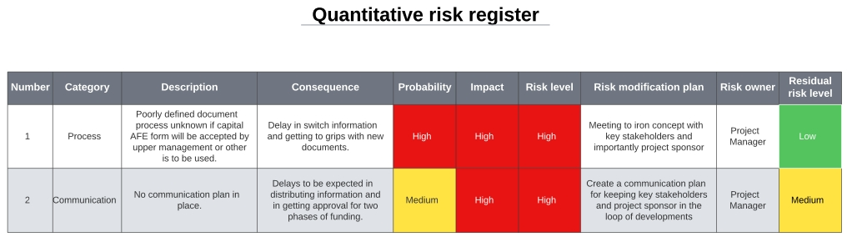
It should be noted that this is a baseline schedule and does not incorporate any delays or risks; if risk management is applied, the below matrix can be developed to outline these potential risks. An example can be seen below in Figure 10.

Figure 10 - Quantitative risk register created by document owner.

The register allows for mapping out potential problems and producing a plan to mitigate any risks before they occur, an example of preventative risk management. As shown in the figure above, a communication plan was not in place. Figure 11 is an example of one.
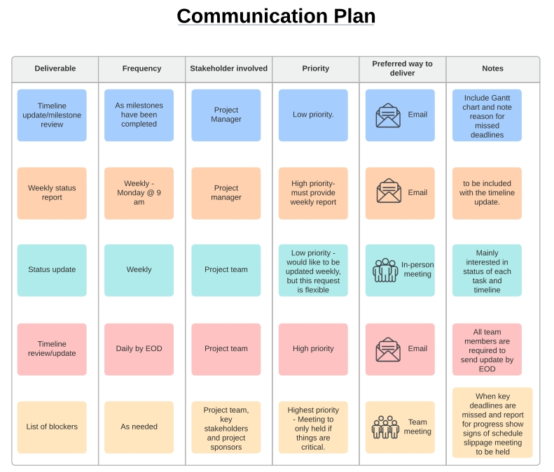

Figure 11 - Communication plan created by document owner.

With all of these different techniques implemented by Ledwood, it's been shown that Ledwood could've reduced the project duration by six months and, with more project management techniques, provided some level of protection against further delays. Based on Ledwood's costs for renting manifold cylinder pallets, a figure of £3,766.50 can be attached to each month of the project. With a shorter duration, Ledwood could've saved a total of £22,599.00 by implementing the project sooner.

Conclusion
Ledwood had a fractured and disorganised approach to the internal improvement project to save the company money on gas manifold cylinder pallet rental. This project was shown to have many delays due to a lack of project management. The absence of critical deliverables meant no mechanism to safeguard against delays, and the project suffered. Additionally, the lack of planning and document changes caused more delays. If the application of a project lifecycle phased approach was used in conjunction with risk management and critical path analysis, the project could’ve and should’ve avoided these delays; in the study of this, it was shown that the project could’ve been done in ¼ of the time and the resulting time saved would’ve saved the company over £22k a vital note when the projects total costs were around that exact figure. To conclude, Ledwood spent the same amount of money on renting manifold cylinder pallets during the project as the actual total cost of the project to stop or reduce rental costs.

References
ADEACA, 2020. What is the project lifecycle. [Online]
Available at: https://www.adeaca.com/blog/faq-items/what-is-the-project-lifecycle/
[Accessed 05 April 2024].
Air Products and Chemicals INC, 2015. Safetygram 8 Liquid Argon , s.l.: Air Products and Chemicals INC.
Burke, R., 2013. In: Project Management: Planning and Control Techniques. s.l.:John Wiley & Sons, p. 11.
Eadie, R. et al., 2013. BIM implementation throughout the UK construction project lifecycle: An analysis. Automation in Construction, 36(36), pp. 145-151.
Hill, S., 2015. Critical analysis of Maslow’s hierarchy of need. The STeP Journal (Student Teacher Perspectives), 2(4), pp. 54-57.
Ibbs, C. W., Wong, C. & Kwak, Y., 2001. Project Change Management System. Journal of Management in Engineering, 17(3), pp. 159-165.
Jaber, H., Marle, F., Vidal, L. & Didiez, L., 2017. Criticality and propagation analysis of impacts between project deliverables. Reasearch in Engineering Design , 29(1), pp. 87-106.
Jitapaidoon, J., Smith, S. & Gu, Q., 2019. Critical Success Factors Affecting Project Performance: An Analysis of Tools, Practices, and Managerial Support. Project Management Journal , 50(3), pp. 271-287.
Jugdev, K. & Müller, R., 2005. A Retrospective Look at Our Evolving Understanding of Project Success. Project Management Journal , 36(4), pp. 19-31.
Kaur, A., 2013. Maslow’s Need Hierarchy Theory: Applications and Criticisms. Global Journal of Management and Business Studies. , 3(10), pp. 1061-1064.
Khan, U. A. & Haider, S. F., 2017. Impact of Quantitative Analysis Techniques in Enhancing Time Management. International Journal of Innovative Research in Engineering & Management, pp. 749-752.
Kotter, J., 1996. Leading Change. s.l.:Business Havard Press.
Kotter, J., 2008. A sense of urgency. s.l.:Havard Business Press.
Kutsch, E. & Hall., M., 2005. Intervening conditions on the management of project risk: Dealing with uncertainty in information technology projects. International Journal of Project Management , 23(8), pp. 591-599.
Locatelli, G. et al., 2023. A Manifesto for project management research. European Management Review, 20(1), pp. 1-158.
Maley C, H., 2012. In: Project Management Concepts, Methods, and Techniques. s.l.:CRC Press, p. 3.
Methangkool, E., Tollinche, L., Sparling, J. & Agarwala, A., 2019. Communication: Is There a Standard Handover Technique to Transfer Patient care?. International Anesthesiology Clinics, 57(3), pp. 35-47.
Nguyen, T., Weckman, D., Johnson, D. & Kerr, H., 2005. The humping phenomenon during high speed gas metal arc welding. Science and Technology of Welding and Joining, 10(4), pp. 447-459.
Obrová, V. & Smolíková, L., 2013. The Comparison of Selected Risk Management Methods for Project Management. Environmental Software Systems. Fostering Information Sharing, pp. 517-524.
O'Leary, C., Collins, A., Henman, M. & King, F., 2017. Introduction of a dose-banding system for parenteral chemotherapy on a haematology–oncology day ward. Journal of Oncology Pharmacy Practice, 25(2), pp. 351-361.
Sebestyén, Z., János, E. & Dina, E., 2021. Impact of Methodologies and Standards on the Owner's Economic Benefit in Projects. SSRN Electronic Journal, 8(2).
Willar, D., Waney, E., Pangermanan, D. & Mait, R., 2020. Sustainable construction practices in the execution of infrastructure projects. Smart and Sustainable Built Environment, 10(1), pp. 106-124.
Wulandari, A. et al., 2018 . Scheduling of Empennage Structure Design Project of Indonesia’s Aircraft with Critical Path Method (CPM). MATEC Web of Conferences, Volume 248, p. 03012.
Xia, N. et al., 2017. Lifecycle cost risk analysis for infrastructure projects with modified Bayesian networks. Journal of Engineering, Design and Technology, 15(1), pp. 79-103.
Zou, P., Zhang, G. & Wang, J., 2007. Understanding the key risks in construction projects in China. International Journal of Project Management, 25(6), pp. 601-614.
Table of figures;
Figure 1 - Project Execution Gantt created by Document Owner. 1
Figure 2 - Cost breakdown of rental of cylinders and cylinder manifold pallets at Ledwood over a two month period, the highlighted yellow rows are for the size WW pallets used in workshop B. 2
Figure 3 - Picture taken in Workshop B of Ledwood with old system using WW size pallets next to welder/weld sets. 3
Figure 4 - Capital AFE form page 2 project description and justification. 4
Figure 5 - Project brief/Project chart form created by Ledwood. 5
Figure 6 - Kotter's eight step model to change management diagram created by document owner information taken from (Kotter, 1996) & (Kotter, 2008). 8
Figure 7 - Maslow's Need Hierarchy Theory diagram created by document owner information taken from (Kaur, 2013). 10
Figure 8 - Header of BOC initial quotation regarding argon supply (cannot show full document due to request from BOC). 11
Figure 9 - Project gantt chart created by document owner. 13
Figure 10 - Quantitative risk register created by document owner. 14
Figure 11 - Communication plan created by document owner. 14

Table of tables;
Table 1 - Basic design requirements 3
Table 2 - Total volume of area that requires Purging based upon pipe size. 7

