  Component One:  What are the key skills required when working in the housekeeping team? 750 words (+/- 10%)  Contribution to Overall Module Assessment: 25% | Student No: | 2130690
 | Module Title: | Operating Hotel Facilities
 | Module Code: | BMIH4006
 | Lecturer: | Laurence Blake
Housekeeping personnel play an essential part in ensuring the health and safety of Premier Inn's guests by keeping the hotel spotless at all times. But, being a housekeeper entails more than just I picking up clutter and putting things in their proper places; it also necessitates a number of important abilities to I do the job effectively and quickly (Rode et al., 2018).

The ability to efficiently manage one's time is crucial for any housekeeping personnel. Depending on their role, they may be expected to clean numerous rooms at once or work I under strict time constraints. Successfully finishing their shifts depends on their ability to effectively manage their time and they should always be ready for the day ahead.

Discipline oneself is a necessary skill as well. Housekeepers are expected to deal with unpleasant and repetitive jobs on a daily basis, and I must always provide 100% no matter who is watching. Their dependability and uniformity in performance are crucial to the hotel's success in serving the needs of its visitors (Rode et al., 2018).

Maintaining a spotless and I tidy home requires a great deal of attention to detail. Throughout their shifts, they must wear many hats, from washing bedding to vacuuming carpets, to guarantee that the facility is spotless. It's important for the hotel's reputation and for keeping customers happy (Oishi,2021).

Housekeepers must be trustworthy because they have access to guests' personal items and information. They must maintain secrecy and as I act with honesty and credibility at all times.

Housekeepers must be able to take in a lot of information from guests and coworkers, thus attentive listening is a necessary quality. They should anticipate their clients' demands and reply I bquickly to their inquiries (Oishi,2021).

Housekeeping workers I need to be able to communicate well with others because they often work in teams. They need to be able to work well with others and keep the lines of communication open so that the work gets done smoothly.

Housekeepers need to be physically fit because they often have to bend down and pick up or handle heavy items. I working in an office setting often requires bending over and twisting the body, thus physical fitness is an asset.

Keeping track of several tasks and responsibilities, as well as their own supplies and equipment, requires excellent organisational skills on the part of cleaning employees. They are able to provide excellent service because they are exceptionally organised.

Housekeeping is responsible for keeping the hotel clean and tidy by performing everyday duties such as sweeping and mopping. Cleaning the hotel's rooms and furniture from dust is also essential (Cortés and pan, 2019).

Housekeeping employees have an important duty to maintain the guest rooms, including changing the linens. Everything needs to be cleaned and made to look inviting, so they need to get rid of the old linens and put in the new ones.

The housekeeping staff's duties also include doing laundry, which primarily entails washing the patients' personal items. In order to I do my jobs effectively, they need to know the fundamentals of personal hygiene, including proper hand washing.

Finally, housekeepers need a strong stomach because they often have to deal with unpleasant jobs, such as wiping up blood and other bodily fluids, especially in a hospital setting. To do their job well, they need to have a voracious appetite for the kind of work they do.

To sum up, the housekeeping staff at a Premier Inn Hotel is responsible for more than just keeping the place I tidy; they must also possess a number of other talents in order to do their jobs effectively and efficiently. Time management, physical stamina, organisational prowess, the capacity to communicate effectively, and similar qualities are all examples of such transferable traits. Housekeepers who have these abilities are better I able to satisfy customers, uphold the hotel's reputation, and care for its physical structure (Cortés and pan, 2019).

Word Count

Component Two:
Contribution to Overall Module Assessment: 25%
In this scenario – you have just been promoted to team leader for a floor within the hotel. A guest complains that on their arrival, their room had not been properly cleaned. Create an action plan and answer the following questions.

Problem | Why did it happen? | What are you going to do? | How will you prevent this from happening in the future? | What measures would you introduce to improve team effectiveness?
A guest complains that on their arrival, their room had not been properly cleaned. Create an action plan and answer the following questions. | There are many possible explanations for a dirty guest room. Possible causes include:  Housekeeping workers are only human, therefore it is possible that they will miss a stain or neglect to give a certain area a thorough cleaning.  Untrained housekeeping workers may not know how to clean certain areas or may not be familiar with the hotel's particular cleaning requirements.  Rooms may not be cleaned correctly if the hotel does not supply sufficient cleaning products and equipment for its housekeeping personnel.  Housekeeping employees may not be able to provide each room a thorough cleaning if they are pressed for time and expected to clean several rooms in a short amount of time (Cortés and pan, 2019).  There may have been a misunderstanding between the front desk and housekeeping about how thoroughly to clean a guest's room.  Finding and fixing the root of the problem is essential for ensuring it doesn't crop up again in the future. | It is crucial to act quickly when a guest reports that their room was not cleaned adequately before their arrival. It's possible to proceed in the ways listed below:  Guest apologies should be the first step in correcting a situation where a guest has complained about a poorly cleaned room. This demonstrates to the visitor that their worries have been heard and is being addressed, and it also calms their agitation.  The next step is to research the problem and find out why the room wasn't cleaned correctly. Checking the work order or communicating with the cleaners who serviced the room may be necessary.  Give the guest an answer: There are a variety of answers available, depending on the nature of the problem. As an illustration, the hotel may provide the visitor with a free upgrade or a room cleaning. The hotel may issue a full or partial refund to the guest depending on the circumstances.  It is crucial to check in with the guest once the problem has been fixed to make sure they are happy with the outcome. This not only demonstrates to the guest that their feedback was considered, but also discourages future occurrences of the same problem.  Notate the problem: Recording the problem and my solutions is crucial. This is useful for spotting recurring problems with the housekeeping service and preventing them from happening again in the future.  Following these procedures, the hotel will be able to satisfy the guest's needs and guarantee a pleasant stay. It's useful for figuring out whether there are any hidden problems with the housekeeping that are harming the service as a whole. | Many steps can be made to ensure that this never happens again:  Be sure the cleaning team has received adequate training in accordance with established industry standards for cleanliness. This will guarantee that they have clear goals to strive towards and an understanding of how to achieve them.  Make advantage of checklists by requiring the housekeeping staff to check off each item on a detailed cleaning checklist before a guest checks in. The bathroom, bedding, and other comforts should all be included on the checklist.  Assign a supervisor to keep an eye on the cleaning crew and make sure they're following the checklists. The supervisor should examine the room at random intervals to make sure it is being cleaned properly.  For the sake of quality control, have a mechanism in place whereby guests can rate the cleanliness of their accommodation via a survey or a comment form. The hotel administration can then fix the problems and refine their cleaning procedures.  Service: Keep all brooms and vacuums in good working order by giving them the TLC they need on a regular basis. Rapidly replacing worn out machinery is essential.  Facilitate interaction between the housekeeping workers and the guests. Urge visitors to the hotel to report any problems with their accommodation to the front desk as soon as they are noticed (Cortés and pan, 2019).  The hotel may ensure that its housekeeping team is well-prepared to give excellent service and a spotless environment to its visitors by enacting the aforementioned policies and procedures. Guests will be happier as a result, and there will be fewer complaints about the cleanliness of the rooms. | There are a number of methods that could be implemented to boost the efficiency of a team. Several instances are listed below.  Training and development: Provide my staff regular chances to learn and grow, both technically and in terms of "soft skills" like communication and teamwork. Team members will be better able to collaborate and keep up with industry developments if they have access to this information.  Establish distinct roles and duties for each team member, taking into account their individual skillsets and areas of expertise. This will help keep everyone on the same page and make sure everyone has something useful to contribute to the team.  Open and honest communication should be fostered within the team, and mechanisms for regular feedback and discussion should be established. Having everyone on the same page will make it easier to spot problems and possibilities for growth.  Setting defined team goals and objectives and implementing accountability measures to assure success goes hand in hand. This will ensure that everyone on the team is accountable for their work and help the group zero in on what's most crucial.  Create a way to publicly acknowledge and recognize team members for their efforts and successes. This will contribute to a more upbeat and productive mood inside the group (Firth, 2021).  Group outings and other social gatherings are great examples of the kind of team-building activities that may be planned on a regular basis to assist employees get to know one another and feel more comfortable working together. As a result, team members will be able to work together more effectively and develop stronger bonds with one another.  Overall, improving team effectiveness requires a holistic approach that addresses both individual and team-level factors. The management of a hotel may foster a high-performing workforce that provides outstanding service to customers by allocating resources to training and development, open lines of communication, clear objectives, positive reinforcement, and team-building exercises.

Component Three:
Contribution to Overall Module Assessment: 50%
My task is to create and prepare a presentation following the detailed scenario provided below.

As the floor housekeeping manager and given the recent guest complaints my need to put together a basic training presentation for my colleagues within the housekeeping team to get the best out of them, ensure that brand standard is being achieved and that Health and Safety procedures are also being followed.

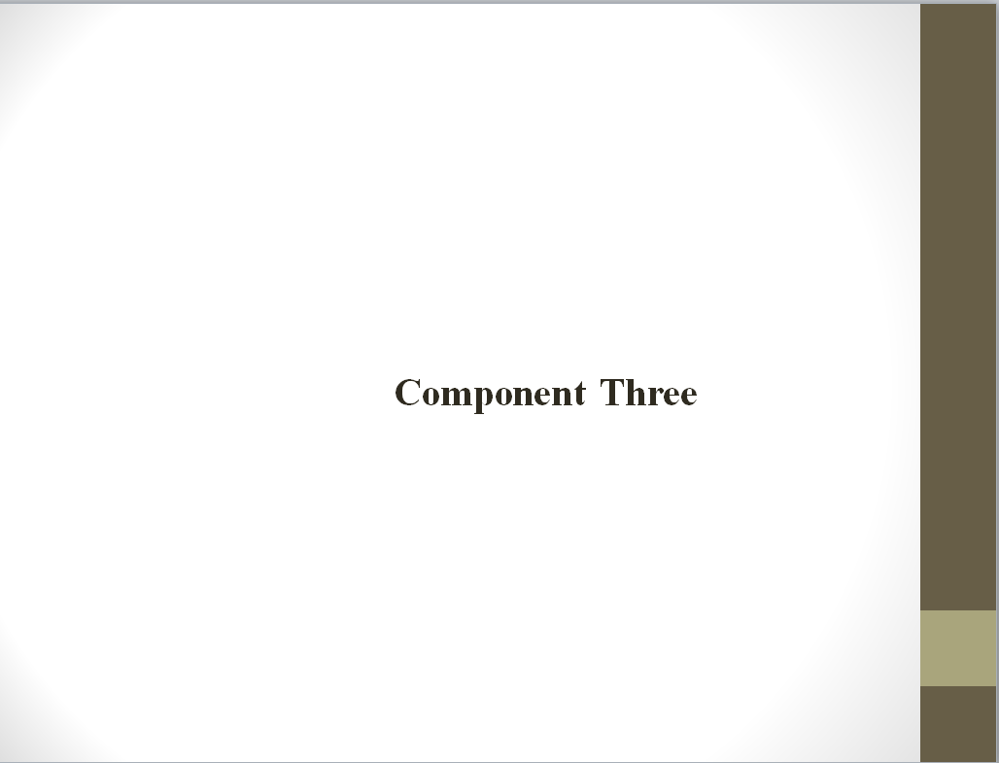

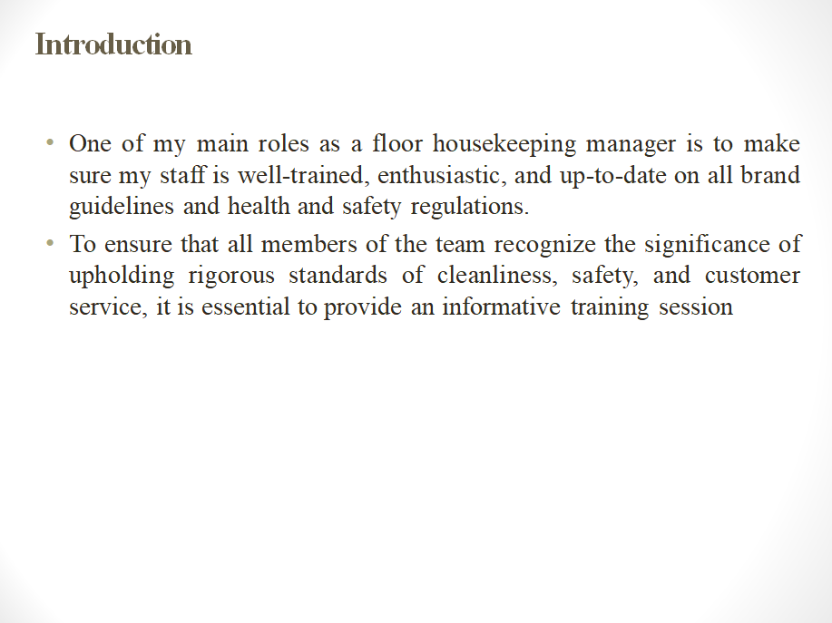

Speak for note
One of my main roles as a floor housekeeping manager is to make sure my staff is well-trained, enthusiastic, and up-to-date on all brand guidelines and health and safety regulations. To ensure that all members of the team recognize the significance of upholding rigorous standards of cleanliness, safety, and customer service, it is essential to provide an informative training session (Morgan et al., 2014).
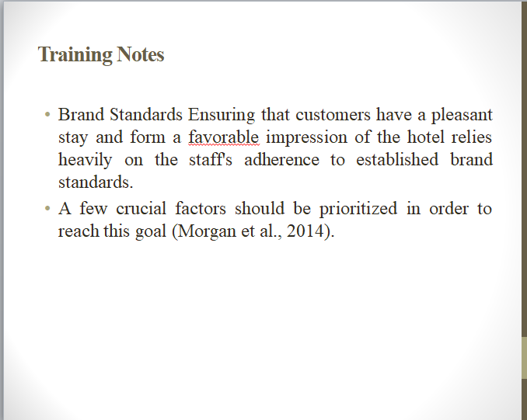

Speak for note

Brand Standards Ensuring that customers have a pleasant stay and form a favorable impression of the hotel relies heavily on the staff's adherence to established brand standards. A few crucial factors should be prioritized in order to reach this goal (Morgan et al., 2014).

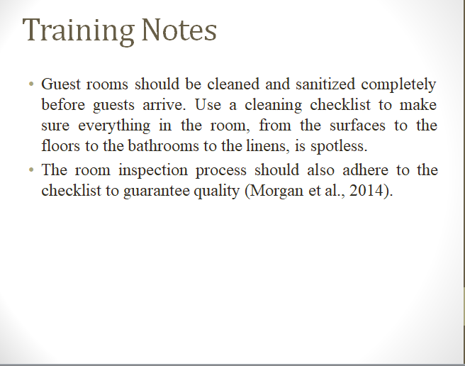

Speak for note
Guest rooms should be cleaned and sanitized completely before guests arrive. Use a cleaning checklist to make sure everything in the room, from the surfaces to the floors to the bathrooms to the linens, is spotless. The room inspection process should also adhere to the checklist to guarantee quality (Morgan et al., 2014).

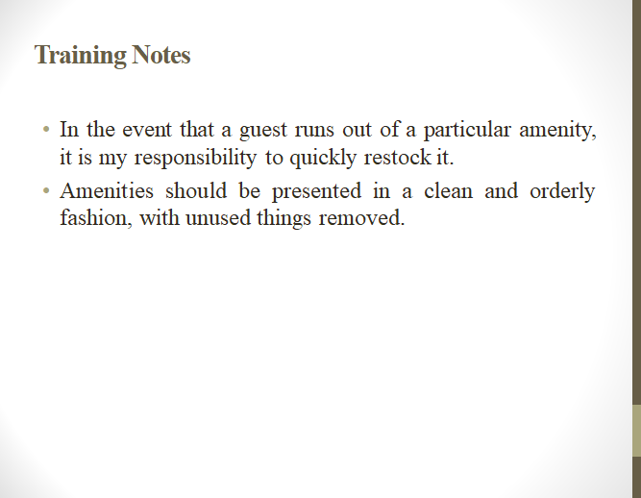
Speak for note

In the event that a guest runs out of a particular amenity, it is my responsibility to quickly restock it. Amenities should be presented in a clean and orderly fashion, with unused things removed.

All the room's furnishings and appliances must be in perfect functioning order. Report and repair any broken or malfunctioning equipment.
Speak for note
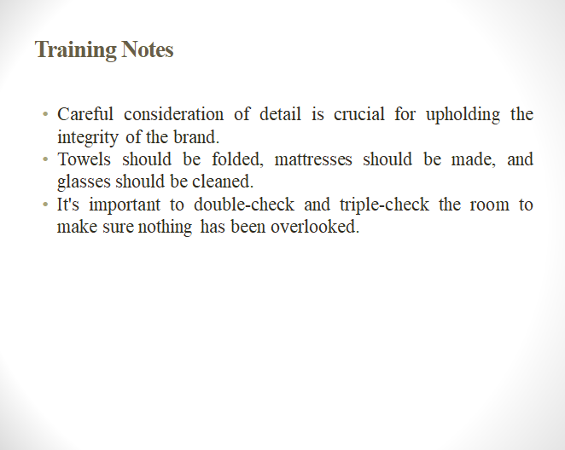
Speak for note
Careful consideration of detail is crucial for upholding the integrity of the brand. Towels should be folded, mattresses should be made, and glasses should be cleaned. It's important to double-check and triple-check the room to make sure nothing has been overlooked.
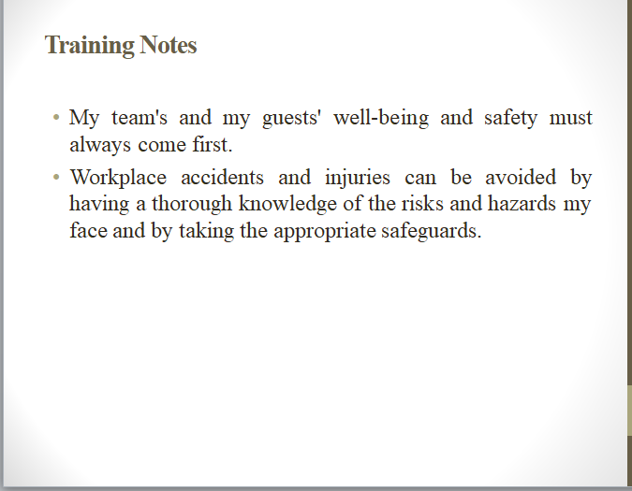
Speak for note
My team's and my guests' well-being and safety must always come first. Workplace accidents and injuries can be avoided by having a thorough knowledge of the risks and hazards my face and by taking the appropriate safeguards. Among the most important things to consider are:
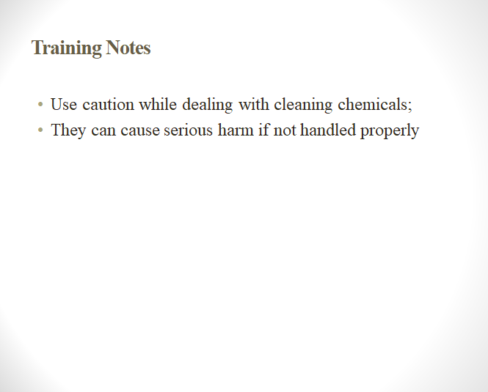
Speak for note
Use caution while dealing with cleaning chemicals; they can cause serious harm if not handled properly. Members of the team should be given instructions on how to properly store and handle cleaning chemicals, and they should always take precautions when doing so.
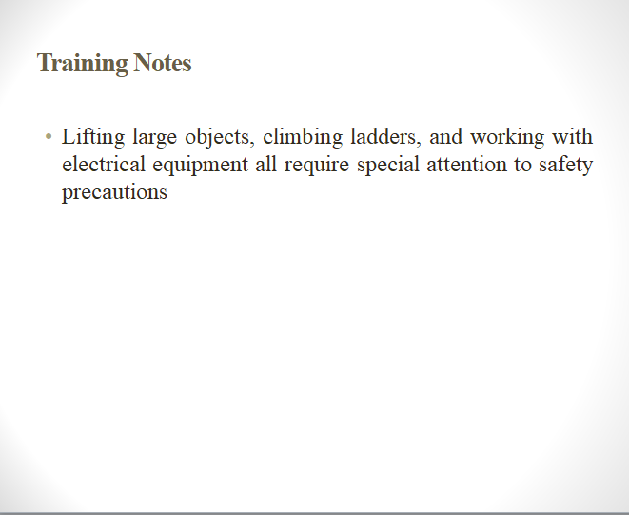
Speak for note
Lifting large objects, climbing ladders, and working with electrical equipment all require special attention to safety precautions. In order to reduce the possibility of damage, it is important that all team members be educated on the best practices for doing these activities.
Everyone on the team needs to know what to do in the event of an emergency, such as how to put out a fire, administer first aid, and evacuate the building. Emergency procedures should be practiced on a regular basis to ensure that everyone is prepared (Friberg, 2018).
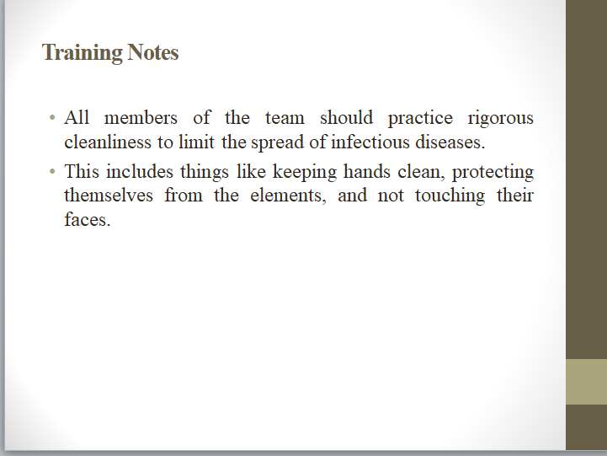
Speak for note
All members of the team should practice rigorous cleanliness to limit the spread of infectious diseases. This includes things like keeping hands clean, protecting themselves from the elements, and not touching their faces.

The cleaning staff's ability to provide excellent customer service is essential to the success of the business. Maintaining a high level of customer satisfaction and a stellar reputation for the hotel requires putting the guests' needs first at all times. Among the most important things to consider are:

Excellent customer service hinges on my ability to communicate with my clients. Each member of the team is responsible for listening to guests, taking notes, and then providing appropriate responses in a timely manner (Friberg, 2018).
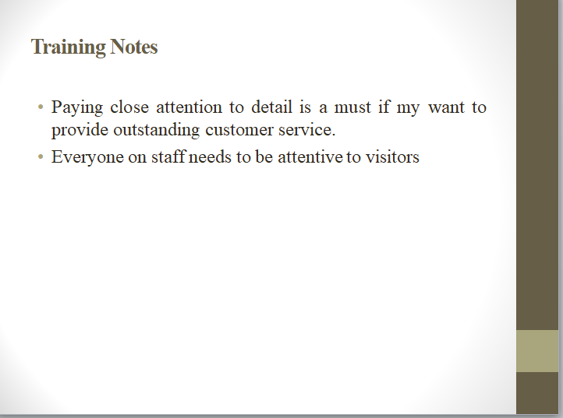
Speak for note
Paying close attention to detail is a must if my want to provide outstanding customer service. Everyone on staff needs to be attentive to visitors and do what they can to make their stay pleasant and satisfying no matter what those preferences or demands may be.

Team members should never enter a guest's room without first obtaining permission from the guest, and guests' personal space should always be respected. Furthermore, they need to make sure that the guests' personal items are not tampered with.

The bottom line is that, as a manager of the floor's cleaning staff, it is my duty to see that everyone on the team has all they need to do their job successfully (Friberg, 2018).
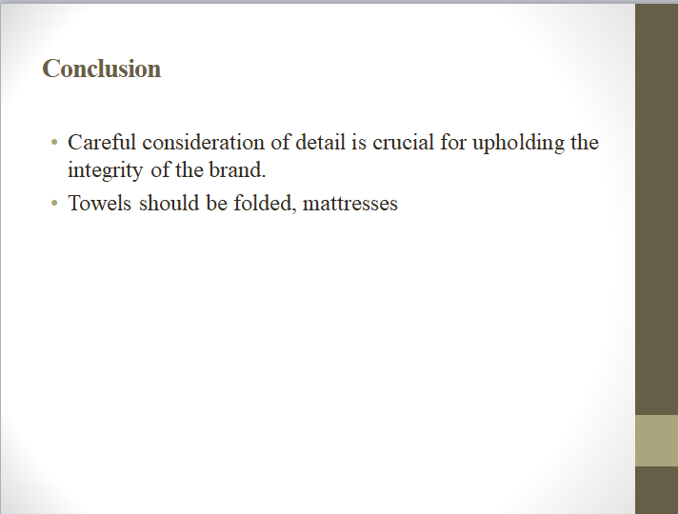
Speak for note
Careful consideration of detail is crucial for upholding the integrity of the brand. Towels should be folded, mattresses should be made, and glasses should be cleaned. It's important to double-check and triple-check the room to make sure nothing has been overlooked. and form a favorable impression of the hotel relies heavily on the staff's adherence to established brand standards.

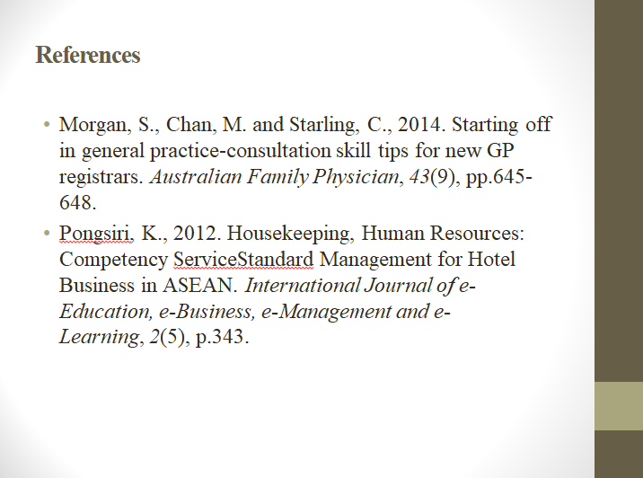


References

Rode, J.A. and Poole, E.S., 2018, May. Putting the gender back in digital housekeeping. In Proceedings of the 4th Conference on Gender & IT (pp. 79-90).
Oishi, N., 2021. Skilled or unskilled?: The reconfiguration of migration policies in Japan. Journal of Ethnic and Migration Studies, 47(10), pp.2252-2269.
Cortés, P. and Pan, J., 2019. When time binds: Substitutes for household production, returns to working long hours, and the skilled gender wage gap. Journal of Labor Economics, 37(2), pp.351-398.
Firth, R., 2021. Housekeeping among Malay peasants. Routledge.
Morgan, S., Chan, M. and Starling, C., 2014. Starting off in general practice-consultation skill tips for new GP registrars. Australian Family Physician, 43(9), pp.645-648.
Pongsiri, K., 2012. Housekeeping, Human Resources: Competency ServiceStandard Management for Hotel Business in ASEAN. International Journal of e-Education, e-Business, e-Management and e-Learning, 2(5), p.343.
Kennedy, J., Nansen, B., Arnold, M., Wilken, R. and Gibbs, M., 2015. Digital housekeepers and domestic expertise in the networked home. Convergence, 21(4), pp.408-422.
Murray, B., Peng, H., Barbier‐Torres, L., Robinson, A.E., Li, T.W., Fan, W., Tomasi, M.L., Gottlieb, R.A., Van Eyk, J., Lu, Z. and Martínez‐Chantar, M.L., 2019. Methionine adenosyltransferase α1 is targeted to the mitochondrial matrix and interacts with cytochrome P450 2E1 to lower its expression. Hepatology, 70(6), pp.2018-2034.
Friberg, J.H. and Midtbøen, A.H., 2018. Ethnicity as skill: Immigrant employment hierarchies in Norwegian low-wage labour markets. Journal of ethnic and migration studies, 44(9), pp.1463-1478.
Knox, A., Warhurst, C., Nickson, D. and Dutton, E., 2015. More than a feeling: Using hotel room attendants to improve understanding of job quality. The International Journal of Human Resource Management, 26(12), pp.1547-1567.
Olimovich, D.I., Bakhtiyorovich, T.M. and Salimovna, N.G., 2020. Improving of personnel training in hotel bussines. Academy, (2 (53)), pp.18-19.

