Exercise 1:

What is a Mind Map?
A mind map is a partly-graphical method of representing data pertaining to a particular question. Mind maps are often highly colourful and contain both text and graphics.

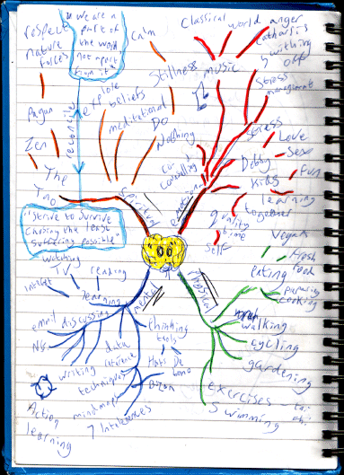

Example mind map

Mind maps are a very good way of taking notes in lectures, meetings, presentations and so on, as they show not only the material presented, but also the logical and thematic links between the information.

Various software applications, both commercial and open source, exist for making mind maps.
How to Make a Mind Map
- Start in the centre with an image of the topic, using at least 3 colours.
- Use images, symbols, codes and dimensions throughout your Mind Map.
- Select key words and print using upper or lower case letters.
- Each word/image must be alone and sitting on its own line.
- The lines must be connected, starting from the central image. The central lines are thicker, organic and flowing, becoming thinner as they radiate out from the centre.
- Make the lines the same length as the word/image.
- Use colours – your own code – throughout the Mind Map.
- Develop your own personal style of Mind Mapping.
- Use emphasis and show associations in your Mind Map.
- Keep the Mind Map clear by using Radiant hierarchy, numerical order or outlines to embrace your branches.

Exercises
1. On paper, create a mind map to answer one of the following questions
- Fake News – What is it?
- Brexit – A good thing or a bad thing?
- Climate Change – Man-made or simply part of a complex natural cycle?
- Genetically Engineered Foods – a good idea or just scientists playing God?

References
Wikipeida – Mind Map
http://en.wikipedia.org/wiki/Mind_map

How to use mind maps
http://www.jcu.edu.au/studying/services/studyskills/mindmap/howto.html

FreeMind – Open Source mind mapping software
http://freemind.sourceforge.net/wiki/index.php/Main_Page

Docear – Open Source academic literature organiser (more powerful that FreeMind in that it also allows you to add academic references to your mind map and track documents and sections within them).
http://www.docear.org/

