

Title: Marketing Management Assessment-2

Course: MBA- Masters of Business Administration

Name: Vimal Kumar

ID number: 2214033

Table of Contents
Part A:

- Introduction | 3
- Brief background information about the company | 3
- Macro environment or PESTLE factors | 4
- Porter's 5 Forces model | 7
- SWOT analysis of the company | 8
- Segmentation, targeting, and positioning of the company | 11
- Describe the marketing mix strategies (4Ps or 7Ps) of the company | 12
- Include a conclusion | 13
Part B:

- Recommendations for future marketing strategies | 14
References | 16

Part- A:

Introduction

This study mainly focused on marketing analysis through the macro environment or PESTLE factors, Porter's five forces model, SWOT analysis, Segmentation, Targeting and Positioning (STP) and marketing mix strategies where the researcher has chosen the Hewlett Packard (HP) Company. This study can provide detailed information about marketing management.

Brief background information about the company


HP Logo
(Source: https://www.hp.com)

Hewlett Packard (HP) is a global American information technology business headquartered in Palo Alto, California. Bill Hewlett and David Packard founded the company in a one-car garage in Palo Alto in 1939, producing electronic test and measurement equipment.

The mission of HP:

"We earn customer admiration and loyalty by consistently offering the highest quality and value," according to HP's mission statement. We make enough money to support expansion, provide value to our shareholders, and satisfy corporate goals.

- Macro environment or PESTLE factors

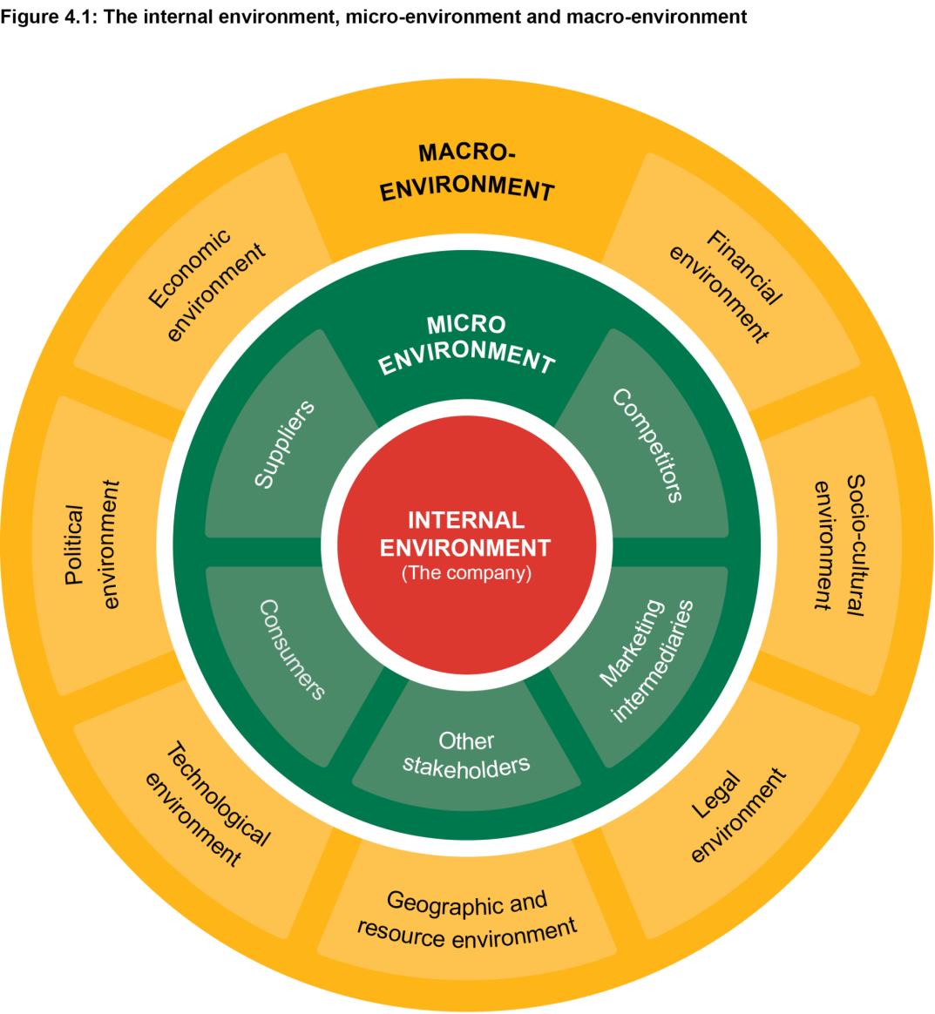
Diagram: The Micro and Macro Environment
(Source: https://openbooks.uct.ac.za)

- Social/Cultural forces

When a tech giant like HP needs to start its operations throughout a particular country. Societal concerns are critical for a company's growth in a given country. A country's demographics, educational level, culture, and social structure all directly and indirectly impact HP's operations.

- Legal forces

Legal factors can be termed as one of the most dominant parts in developing various factors in the segment of the business environment scenario. In this case, HP has to abide by the data laws of the specific country; for example, India can be segregated. China and the EU can be the most prominent factors in this case. Data problems are preferred to be solved in this country in particular. Consumer protection laws are the most prominent and dominant factor in states like the US, UK, EU, and India.

- Economic forces

The various forces of economic factors have the most important and deep relation with the business of HP and the financial performance of HP. HP has to evaluate and understand the country's proper economic environment and scenery before entering the country's Arena. The various economic factors influence the growth of HP. These factors include the inflation rate of the country, GDP growth, financial stability, and labour costs.

- Political forces

The political forces and environment can be most significant for developing a particular business. In this segment, the company of a PC brand such as HP has been discussed. Political stability in the previous nations was vital for the development of these types of companies. The effective level of the distribution system and proper supply chain management has to work globally in stable economic zones. With an effective and stable political environment, the distribution system and supply chain will be more stable accordingly.

- Technological forces

As a Tech Giant, HP can be most affected by the various types of technological factors. The rapid advancement of technology is the most prominent in developing HP’s growth in the global arena. HP can be termed and determined as a technology company, and it cannot exist without technological innovation. HP also makes significant investments in research and development.

- Environmental

Environmental factor is favourable to HP because it has ranked first throughout diverse environmental-sustainability-indexes for many years. The particular company publishes a report on global responsibility. The report focuses on HP's usage mechanism inside the product. On the other hand, HP has effective promotional services from which humanity could be benefitted. In this segment, HP has become and achieved the factors of zero level of deforestation results. the Hp product packaging and result is the most important factor in this aspect.

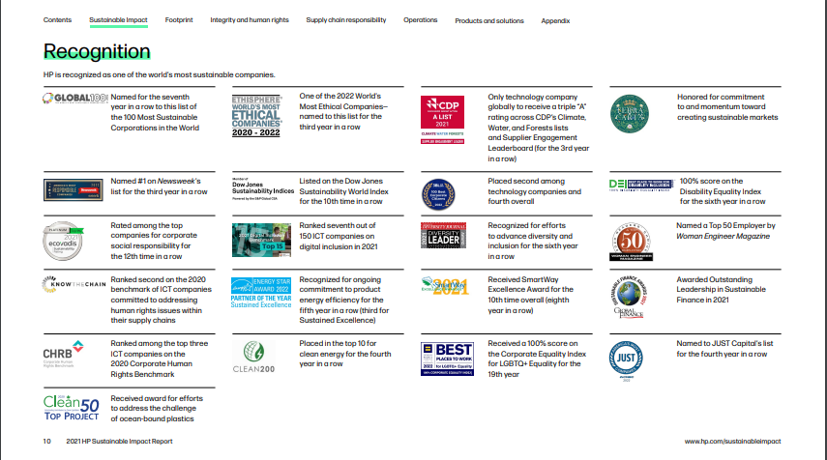
HP Sustainable Impact Report 2021
(Source: https://hp.com)

Conclusion

- Environmental scanning

The primary goal of environmental scanning is to determine a company's prospects.

- Environmental type of analysis

Environmental assessments help firms discover possible factors that may provide a hazard or an opportunity. This prepares the business mechanism for changes in their environment.

Porter's 5 Forces Model

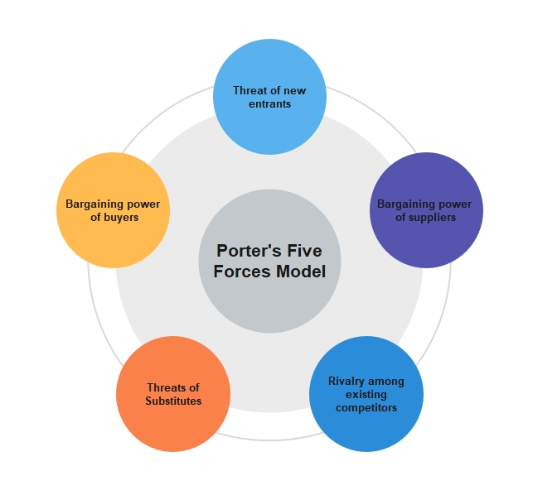

Diagram: Porter’s Five Forces model
(Source: https://www.edrawmind.com)

The threat of entry
The threat factors are very low in the case of the HP organisation. This factor can be said to be prominent because of its significant level of investments and other prominent factors. In the PC industry, establishing a new and strong brand takes time.

- Bargaining power of suppliers

HP has strict quality and sustainability guidelines for its suppliers. Because of its size and potential, HP wields enormous power over a diverse segment of suppliers. Overall, the bargaining power of the suppliers is very low.

- Bargaining power of the buyer's

HP has the most effective and strong brand image. The products of HP are very reliable. They have the most effective image of being technologically advanced. Customer loyalty to a brand remains strong if it provides excellent customer service and after-sales support. HP is an expert in all of these areas. Their overall bargaining power is considered low to moderate.

- Threat of substitutes

HP faces a moderate threat from substitute products. The PC business has been in a downward spiral for some years. Demand has been influenced by the advancement of mobile technologies as well as changing client preferences.

- Industry rivalry

The level of competitive rivalry between existing PC brands is extremely high. In the global market, the top players compete. Lenovo's rise, particularly in Asian markets, has posed a threat to brands such as HP, Dell, and even Apple.

5. SWOT analysis of the company

1. STRENGTHS

- Product Innovation

HP always has provided the finest performance and productivity from its products to its clients. It was only feasible because of extensive study and development. HP has spent roughly 1.4 billion dollars on R&D in 2018.

- Effective Brand Value

HP has won its consumer's confidence by offering high-quality services and products and trying to strengthen its brand reputation. It ranks among the most recognized Laptop and PC brands in the entire world.

- Large workforce

HP has a very large workforce of approximately 35,000n sets of employees. These factors enable the company to perform very effectively in the segments and areas of the service of consumers and so on.

- Increasing Sales

In the previous year, HP's revenue increased by 6.91%. Its revenue for 2020 is expected to be $56.639 billion.

2. WEAKNESS

- Decreasing demand
Demand for laptops and PCs is decreasing as demand for smartphones and tablets rises.

- Operational costs

The company's operational costs have been increasing year after year, but have recently decreased to $ 56.177 billion in 2020.

- Limited level of success outside the core level of business
HP has experienced a very limited level of success in businesses other than its core business. Let us now look at HP's Opportunities.

3. OPPORTUNITIES

- New technologies
Technological advancement allows the particular host company to implement diverse levels of pricing strategies towards the market segment. This factor aids the company in maintaining its most effective loyal level of the custom bases.
- Managed print services (MSP) Market

The MSP market can be expected to go up to the $94.9 billion level of rupee market value by the year 2024. This factor is a significant opportunity for HP for expanding in the targeted market.

- Economic recovery

HP may have more opportunities and customers in the market as consumer spending on new technology increases.

4. THREATS

- Competitors
In terms of pricing, the company faces stiff competition from other players. As consumers are becoming more valued, HP is under increasing pressure to give more capabilities at a cheaper cost.

- Currency fluctuations
Because HP can operate in various countries, currency fluctuations can cause some types of issues.

- Rising costs of raw materials and labour
The growing price of labour and raw materials will raise the prices of manufacturing the items. This facto will result in a hike in the price of the product, which will have a negative impact on the company's sales.

Advantages of SWOT Analysis
- Strengthens the organisation.
- Reverse its shortcomings.
- Increase its ability to respond to opportunities.
- Overcome threats to the organisation.

Disadvantages of SWOT Analysis
- Issues are not prioritised.
- Does not offer any solutions or alternatives.
- Too many ideas are generated.
- Subjective Evaluation.

6. Segmentation, targeting, and positioning of the company

Segmentation:

Demographic

The segmentation of people based on their family, gender, religion, income, and so on. For example, HP provides laptops for children to play games, with powerful hardware and an eye-catching design, as well as laptops for the professional population. These laptops can measure the effective durability, security, and the most effective design management levels.

Geographic

Since potential clients have various cultures, interests, and administrative systems, geographic level of segmentation is highly successful for HP in overseas markets.

Targeting:

- Undifferentiated

HP offers products that meet the detailed needs of their targeted customer in the marketing domain. These laptops HP-All-in-one C417 can be used for school projects, homework, and other types of activity management. The all-day level of models is the most effective with these laptops.

- Differentiated

It can be termed as the market coverage strategy by which the organisation decides to go targeting the diverse levels of the market elements. Because each customer requires a unique product based on its intended use, HP products are also available in customised forms.

- Concentrated

HP anticipates that the release of its HP 2133 Mini-Note PC will provide significant opportunities for reseller and retailer partners in the education and business sectors. According to HP's Market-development manager, Simon Molloy, there is more opportunity in the general consumer market, but the majority of demand is expected to come from niche markets.

Positioning:

For target-based positioning, HP organisations employ a price-based strategy and the market mix.

- Celebrity endorsement

In marketing campaigns HP uses celebrity endorsements to promote products.
HP has launched its award-winning #BendTheRules campaign for promoting the Pavilion x360 and collaborated with pop star Meghan Trainer to create the music video.

- Pro-environment

HP had established broad independent-sustainability pledges amongst the large level of enterprises and technology makers. HP undertakes several actions to continuously enhance its effect, ranging from the way the firm develops the products to the services it offers to effectively support them.

7. Describe the marketing mix strategies (4Ps or 7Ps) of the company.

- Product

HP's strategy revolves around problem-solving, from consumers to enterprises. Their products assist customers in completing tasks and making their lives easier. In this segment, the product level of the portfolio of HP includes PCs, various high-standard servers, networking levels of equipment, various printers, plotters, scanners, and other types of image products. HP uses product lifecycle models to manage the life cycle of the product.

- Price

Hewlett Packard has a pricing policy that is both fair and competitive. The company considers all relevant factors such as costing, distribution, promotion, and competitor prices before determining an appropriate selling price.

- Place

HP uses both direct and indirect channels of marketing strategy. HP sells its products almost everywhere electronics are sold, including BestBuy, Wal-Mart, Staples, Amazon, and Flipkart. In addition to their product selling process in the various types of stores, the company allows the customers to purchase the products through the website. In this way, the products can be delivered and shipped throughout various countries through their outlets.

- Promotion

HP as an organisation heavily invested in the product and effective level of the brand and product value management. The company in this case uses diverse types of media promotion techniques, various print advertisements, diverse segments of television types of advertisements, and various other methods of promotion and advertisement policies. Besides these segments, the brand has also used various types of unique levels of technology for the brand and image promotion in the marketing campaign levels. HP has also spent a lot of money promoting its SPECTRE and ENVY notebooks.

8. Include a conclusion

Hewlett-Packard is one of the best companies for laptops, desktops, and printers, and to keep customers interested and purchasing their products, they must continue to develop new products. The primary goal of Hewlett-Packard is to provide customers with high-quality products at a reasonable price.

Part B:

1. Recommendations for future marketing strategies

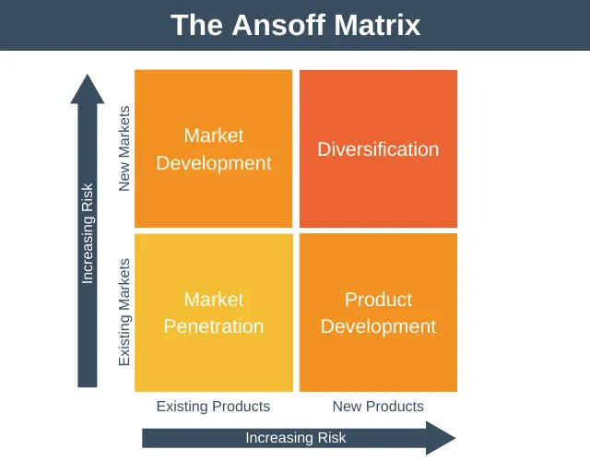
Ansoff Matrix
(Source: https://expertprogrammanagement.com)

Product development
Product development is when the targeted company seeks to expand the targeted levels of business growth inside the diverse types of existing markets by introducing new types of products. HP drives product-developmental scenarios through diverse policy management.

Modifications to existing products
the company can make effective levels of improvements and changes for the targeted existing types of product management. The new types of the improved levels of options are the most significant in this scenario.

Launch new products
HP can effectively engage in changing and implementing the R&D series of activity management of effective levels of identification for targeting the diverse types of consumer demand points management. the company effectively possesses through the management of the NPD. Through this process, the company launches diverse types of new series of products inside its consumer dominion.

Product quality
The targeted company can also effectively engage in developing a series of products and effectively introduce the diverse other domain of quality products in the same market.

Diversification
Diversification can be termed the most important factor in the market segment. HP uses this factor through the most innovative approach and management. HP’s key skills are most competent, competitive, and relevant. The customers most often attract the company for these types of dynamic skills.

Vertical diversification
The vertical levels of diversification are the most common in this case. The vertical diversification factor plays a very much vital role in the effective level of business development management. The new product introduction is the most prominent one in this case.

Horizontal diversification
Horizontal diversification proceeds when HP aggressively introduces and participates in new types of product development attributes and launches that are unrelated to the existing product series.

Diversification towards a new business
Diversification is the most prominent one in HP’s introduction of new types of business ideas. Through this process and mechanism, HP entails various types of innovation ideas and management. Growth and development are the most prominent ones in this case.

References

Perera, R. (2018) The PESTLE Analysis. 2.0. Independently published.
Abhishek Gupta (2013) “Environmental and pest analysis: An approach to external business environment,” Merit Research Journal of Art, Social Science Humanities, 1(2), pp.13-17.

Yüksel, I. (2012) “Developing a Multi-Criteria Decision Making Model for PESTEL Analysis,” International Journal of Business and Management, 7(24). Available at: https://doi.org/10.5539/ijbm.v7n24p52.

Baltrusaitis, J. (2021) Apple trails HP and Dell as the third most popular laptop brand in the U.S. Available at: https://finbold.com/apple-trails-hp-and-dell-as-the-third-most-popular-laptop-brand-in-the-u-s/.

Hako, B. (1972) “Strategies for diversification,” Long Range Planning, 5(2), pp. 65–69. Available at: https://doi.org/10.1016/0024-6301(72)90048-9.

Chiu, Y.-C.et al. (2006) “An evaluation model of new product launch strategy,” Technovation, 26(11), pp. 1244–1252. Available at: https://doi.org/10.1016/j.technovation.2005.09.002.

Grant, R. (2021) Contemporary Strategy Analysis. 11th edn.Wiley.
Hill, C., Jones, G. and Schilling, M. (2014) Strategic Management: Theory: An Integrated Approach.11th edn.Cengage Learning.

About Us (2022) About Us | HP® Official Site. Available at: https://www.hp.com/us-en/hp-information.html (Accessed: December 11, 2022).
Friesner, A.T. (2015) Hewlett Packard Marketing Mix, Marketing Teacher. Available at: https://www.marketingteacher.com/hewlett-packard-marketing-mix/ (Accessed: December 11, 2022).
HP Computer Marketing Concept - 1620 words: Essay example (2020) Free Essays. Available at: https://ivypanda.com/essays/hp-computer-marketing-concept/ (Accessed: December 11, 2022).

