Student Name : Kumari Kanak
Student ID : 2239372
Module : Marketing Management
Module Code : LCMB7001
Lecturer : Efua Adams

Table of Contents
Introduction 3
Task 1: Effectiveness of marketing theories and strategies used by Marriott International 3
Concept and Importance of Marketing during Pandemic 3
SWOT analysis 5
Analysis of marketing strategies and their effect on stakeholders 7
Competitive analysis of the strategies during the COVID crisis 8
Impact of technology on the strategies implemented during the crisis 8
Identifying measurement metrics and evaluation of success strategies 9
Task 2: Managerial Implication on Marketing Strategies 9
Task 3: Recommendations for improving marketing strategy 12
Conclusion 16
Reference list 17

Introduction
The emergence of the global Covid-19 pandemic has negatively affected the travel and tourism industry. The pandemic situation also hit the hospitality sector with the hotel businesses struggling to generate revenues. Marriott International has been operating its business in the hospitality sector, which is inextricably intertwined with the travel and tourism industry. The responses of the company to the crisis during the Covid-19 pandemic era will be discussed by analysing the managerial implications of the marketing strategies adopted during that economy. The strengths and weaknesses of Marriott International will also be discussed through SWOT analysis while evaluating the feasibility of their business strategies during the Covid-19 pandemic era.

Task 1: Effectiveness of marketing theories and strategies used by Marriott International

Concept and Importance of Marketing during Pandemic
The Covid-19 pandemic forced the hospitality industry to rethink its strategy based on organisational marketing campaigns. Altering the existing marketing campaigns is considered a practical approach associated with Marriott management to tackle the threats involved with reduced customers and Covid-19 restrictions (Boiral et al. 2021). The introduction of engaging customers based on social media platforms is none of the effective alterations associated with existing marketing campaigns associated with Marriott’s operations.
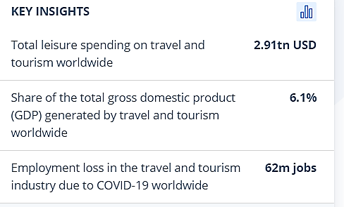
Figure 1: Critical Statistics involving the effects of the Covid-19 pandemic on the hospitality industry
(Source: Statista Research Department, 2022)
Figure 1 s highlights the critical statistics involving the issues faced by management authorities associated with the hospitality industry due to the sudden emergence of a pandemic. Approx. 62m jobs were lost across the travel industry, creating significant issues for the company managers involved with the hospitality industry (Statista Research Department, 2022). The decrease in the number of customers combined with the changes in the internal business environment across the industry forced the Marriott management to make effective alterations in their existing marketing campaigns. Changing the internal business processes based on the industry regulations and highlighting the changes across different marketing channels was essential for Marriott management to improve their position in the hospitality industry (Khatri, 2019). Targeting new guests based on the new modification within the company business strategy is considered a critical aspect of the marketing strategies associated with Marriott International.
For example, Marriott International management used social media platforms to monitor the trends and business environment across the hospitality industry. Focusing on hash tags and “geophone across hotel locations” allowed the company management to monitor the organisation's presence across different locations (Marketline, 2020). Personalised messages and interactions across social media platforms were effective approaches that helped Marriot management to interact with their customers.
The company management introduced “a real-time Marketing command centre named M live studios” to monitor the demands of the target customers across social media platforms. Monitoring the customers' demands and requirements across the social media platforms helped the Marriott management to create a positive impact on increasing its brand value in the modern business environment. Improvements in organisational brand value based on the demands of the customers helped to increase the sustainability levels of the organisation across the new business environment (Irbo and Mohammed, 2020). The changes in organisational marketing campaigns (social media campaigns) during pandemic were essential for sustaining the company's position across the hospitality industry.

SWOT analysis
Table 1 is developed to provide an effective understanding of the critical strengths and weaknesses involved with Marriott operations
Strengths | Weaknesses
- Diversified brand Portfolio consisting of 30 brands (Marketline, 2020)  - Positive brand image across 130 countries (Marriott, 2023)  - “Large cash reserves” combined with different funding channels (Marketline, 2020)  - Effective operational network (Gourtsilidou, 2022)  - The organisational presence across North America | - Successive strikes of the company employees under the union named Unite Here (Marketline, 2020)  - Unplanned expenditure of company portfolio due to recent complexities associated with a global pandemic  - Present debt associated with Marriott businesses  - Fixed-rate debt associated with Marriott operations was close to $676 million at the end of FY 2022 (Marriott, 2023)
Opportunities | Threats
- “Extensive Development Pipeline” associated with Marriott operations (Marketline, 2020)  - International Joint ventures for improving customer experiences  - Using the existing digital communication platforms for creating an environment for constant improvements (Udovita, 2020) | - Competitive threats from similar large hospitality operations such as Accor, Hilton and Hyatt (Marketline, 2020)  - Furloughing of organisational employees is creating operational difficulties for company management  - Insolvency threats based on the impact of the pandemic (Marketline, 2020)
Table 1: SWOT analysis of Marriott International
A global presence for Marriott across 130 countries combined with more than 30 brands (Referred to Figure 2) is enabling the organisation to create an extensive cash reserve for its operations.
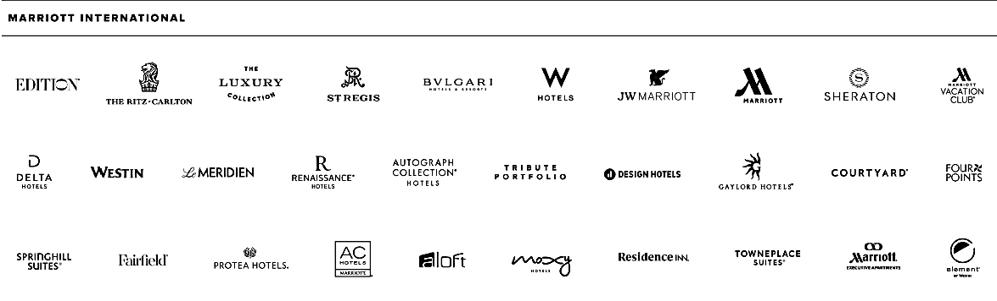
Figure 2: Marriott International brands
(Source: Marriott, 2023)
The organisational network consists of different operational approaches, which are enabling the company to create a strong international presence across North America and China (Marketline, 2020). However, competition from similar large hospitality chains such as Hilton, Hyatt and Accor combined with insolvency due to the global pandemic is creating operational difficulties for the company management to increase its business operations amid the global pandemic (Marriott, 2023). Employee Union-related issues combined with the present debt associated with Marriott businesses are considered effective weaknesses involved with the brand.

Analysis of marketing strategies and their effect on stakeholders
Internal stakeholders
There are several internal stakeholders associated with its business, which contributes a large section of shares in the company. These internal stakeholders include business owners, project managers, employees and the board of directors. Due to the COVID-19 pandemic effect, the travel and tourism industry has gone through a severe transition phase in recent times. As far as the marketing strategies of Marriot International are concerned, they follow the 4P of marketing mix strategy throughout their business. During the outbreak of COVID-19, a wide range of losses occurred in Marriot's business, which affects the internal stakeholders of the company (Leroi-Werelds et al. 2021). For this, Marriot has reduced the costs of the programs in terms of changing investment plans. Moreover, the business owners have incurred huge losses and to minimise its effect they have developed a visible and transparent marketing strategy in their business.
External Stakeholders
The potential external stakeholders include customers, competitors, suppliers and investors, which can influence the tourism industry and hospitality business to a large extent. There are large and small investors that invest huge amounts in the marketing and business of the hospitality industry. There are suppliers and growing competitors rising in the global market, which creates huge concern for any restaurant company to maximise its profit. As far as Marriot's investment plan is concerned, they have eliminated the one-third share, which is worth $800 million in 2020 (Marriott 2023g). The main thing that is to be noted here is that with changing dynamics of the global hospitality business, Marriot has developed quality mitigation strategies to minimise the impact of the pandemic on its business. Moreover, there are serious efforts put by the company to promote the travel and tourism industry in terms of expanding their business and seeking high growth from the market.

Competitive analysis of the strategies during the COVID crisis
During the COVID crisis, Marriot has developed several strategies, which can be analysed by analysing the potentially influential factors that posed a significant impact on the hospitality business. The main thing that is to be noted here is that at the outbreak of the pandemic, there are huge losses incurred by Marriot along with all its brands and services that they provide to their customers (Guillet and Chu, 2021). Moreover, the global lockdown has decreased their profitability to a large extent and the tourism industry has gone through a severe transition in terms of its changing dynamics and volatile market forces. During a pandemic crisis, in order to minimise the impact of COVID-19, there are several strategies that had developed by Marriot to reduce human interaction, adhere the social distancing measures and provide food and beverages services at a lower cost than their standard prices (Marriott 2023f). Moreover, to create an occupancy level higher, they have started selling the equities and shares of the business to revamp the hospitality business and raise money to minimise the losses. They have also set the strategies to implement the reinvestment plan in its business to improve the cost management of the administration, shortening the unnecessary travel expenses and bringing efficiency to the organisation.

Impact of technology on the strategies implemented during the crisis
Digital Marketing
During the crisis, as the overall business has gone through a severe decline phase and incurred huge losses, there are the growing impact of technology that helps the company to revamp its business. Marriot has developed an integrated social media marketing strategy to focus on the customer. Moreover, the M-live studios that they developed helped the company to seek targeted customers by tracking their locations, in turn, improved the business standards (Marriott 2023e). They have made their digital marketing strategies in a way that can be effective in longer run by enabling the hospitality business to a large extent in the country.
Communication
As far as communication strategies are concerned, Marriot has developed effective communication strategies with their customers to boost social engagement and understand their needs and choices. Moreover, they have recently used several artificial intelligence tools and techniques in the communication system to enhance negotiation to a large extent (Kravariti et al. 2023). The main aim of developing quality interaction with the customers is to encourage the tourists by seeking their attention of them towards their business, improve the quality of the service, and brand loyalty of the hospitality industry.
Internationalization
The main thing about promoting internationalization is that it enables a company's global presence with optimum values and creates a strong market base in the global market. Marriot developed an omnichannel marketing strategy to develop a customer-oriented approach in terms of revamping the growth of the organization (Marriott 2023d). Moreover, with customised support and predictive analysis, they have sought an action plan related to reinvestment worth $b140 million in the upcoming years to boost their brand values internationally and promote their business to a greater extent.

Identifying measurement metrics and evaluation of success strategies
Marriot has developed highly competitive and effective success strategies in the aftermath of the COVID-19 pandemic effect. They have developed customized content through the upgradation of the existing technologies that are used in the hospitality business. Moreover, there are improvised quality hospitality services that Marriot offers to increase the range of quality in their services. Moreover, the key measurement metrics that lead to the company's growth in the market lie in critical thinking about the qualitative marketing strategy and effective design approach that fulfils the needs of the customers to a greater extent (Shin et al. 2021). The embraced design that Marriot has developed in its business led to increasing its brand values and improved the customer's loyalty to the company. Through various upgraded features and growing initiatives, Marriot can boost its hospitality business in an effective manner. The main thing that is to be noted here is that the upgraded features that Marriot developed will help to revamp their business growth with increasing efficiency and internationalize the brand values to a greater extent.

Task 2: Managerial Implication on Marketing Strategies
Reducing marketing costs by the marketing managers
The marketing department of Marriott International considered reducing marketing costs as one of the responses to the bad impacts of the Covid-19 era. The management of the company had to take necessary and drastic steps to minimise business overheads (Sharma et al. 2021). The marketing managers of Marriott International had adopted an integrated social media approach before the pandemic hit the areas where the company operates its businesses. The company even considered launching a real-time marketing command centre named "M Live Studios" in different locations for determining the impact of its social media marketing approach on the guests.
The lockdown measures imposed by the governments during the global Covid-19 pandemic have restricted travelling activities. Moreover, both domestic and international travellers were less likely to be receptive to the marketing messages of the hospitality chains as government bodies restricted their travelling activities. This justifies the reasons why the marketing managers of hospitality providers have considered cutting the marketing costs of the company. The principles of the "Elaboration Likelihood Model" is relevant to be discussed while analysing the reasons and feasibility of marketing cost cutting as it highlights the reasons for individuals to end up with a particular decision. According to 'Elaboration Likelihood Model", there is a peripheral route of persuasion where individuals make certain decisions based on the negative or positive impact of the stimulus (Volgger et al. 2021). The lockdown norms during the pandemic era have persuaded the managers of Marriott International to cut down the marketing costs and other business investments.
Cutting administrative costs
The management team of Marriott International also suffered the bad impacts of the global Covid-19 pandemic era where the salaries of the executive team within the company were cut by 50% during that era (Marketline, 2020). It can be general that the bottom-level employees suffer most when an organisation faces a crisis. However, Marriott International has considered cutting administrative costs while trying to minimise the business operational costs during the pandemic situation. The global hospitality chain has the strength of having a massive cash reserve but that strength seemed to be besmirched by the crisis during the global pandemic economy. Cutting business operational costs is one of the important aspects of the marketing strategies of organisations (Kim and Han, 2022). The CEO of Marriott International had to consider asking two-thirds of its headquartered staff to take unpaid leave because several departments of the company suffered the most during the pandemic era.
The principles of Maslow's hierarchy of needs are relevant to be discussed in this case as it highlights the needs that marketers need to consider while developing certain strategies. This justifies the act of cutting administrative costs by the CEO of Marriott International where the need of minimising business overheads resulted in that cost cutting. However, the company has managed to recuperate again in terms of having a dynamic management team in the post-pandemic economy (Marriott, 2023b). This further helps the company increase its performance in the hospitality sector.
Suspending brand standard audits
Marriott International has been emphasising the maintenance of strict brand guidelines by the Marriott franchises and hotels. However, the global hospitality chain considered suspending brand standards audits during the pandemic economy to provide management of those franchises and hotels more flexibility in business operations (Fu, 2023). The relaxations and suspensions in the brand audit have helped the company remove pressures from the hotel management employees. However, the global hospitality chain has made it clear that the Marriott franchises and hotels should not let the standard of the brand slip during the pandemic economy.
The management of Marriott International had to check the extents to which the hotels and franchises under the brand were performing during the pandemic economy. However, the management of the global hospitality service provider has focused on bringing back the brand standard audits after the pandemic economy (Abdelsalam et al. 2023). This management consideration can be justified by the principles of consistency theory as it depicts that individuals have the instinct of regaining the balance in a system. Thus, the Marriott franchises and hotels are again required to undergo the brand standard audits of the company.
Investing in the customer loyalty schemes
The marketing managers of Marriott International have considered investing more in customer loyalty schemes to increase its business revenue collection through its loyal customers. For example, the global hospitality service provider has launched a customer loyalty scheme named "Marriott Bonvoy" for getting the advantage of increasing business revenue through its loyal customers (Redjeki et al. 2021). This strategy has helped the company, as the customers were likely to stay in the hotels that they know in the post-pandemic economy. The principles of the Reciprocity Theory are relevant in this case, as it depicts that people are likely to repay kindness if they receive good from someone. Therefore, the values that Marriott provides to its customers have helped it attract loyal customers in a crisis.

Task 3: Recommendations for improving marketing strategy
Influencer Marketing
Marriott management is introducing effective alterations within their marketing strategies based on their effective marketing strategy across social media platforms. The inclusion of a “real-time data centre named M Live Studios” was introduced for monitoring the requirements associated with customers within the industry (Marketline, 2020). A new influencer strategy based on the different demands and marketing strategies associated with customers can be considered as an effective marketing strategy that will enable Marriott management to increase its brand value across the industry. Feedback regarding the existing Marriott operations combined with improvements in brand awareness is different advantages involved with influencer marketing (Sesar et al. 2021). The company management can use social media influencers based on their target customers across a specific section of the world.
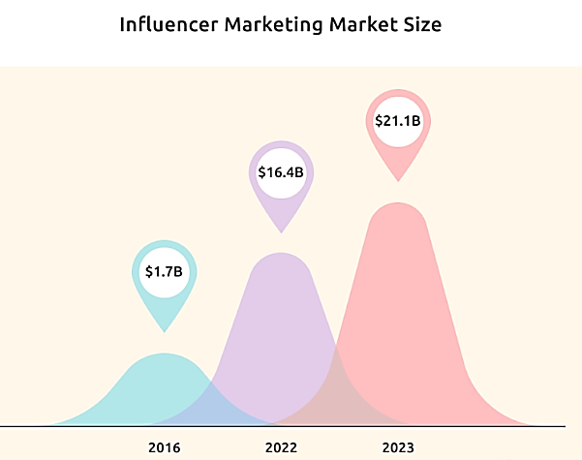
Figure 3: Influencer marketing statistics
(Source: Santora, 2023)
Figure 3 is indicating the post-pandemic impact of influencer marketing in developing future strategies involved with different organizations in the world. Within a 7-year span (From 2016-2023) the spending on influencer marketing increased drastically (From $1.7 billion in FY 2016 to $21.1 billion in FY 2023), which is indicating the positive impact of the influencer marketing strategy for Marriott businesses (Santora, 2023). The company management involved with Marriott can use social media influencers to highlight the new alterations within their hotel and customer service approaches. Collaborating with influencers regarding the areas to highlight within Marriott businesses amid the pandemic can help the company management to attract new customers within the company hotels.
Content marketing across social media platforms
The financial complexities involved with the new business environment are focusing organisations to adopt different marketing strategies for targeting their customers. Marriott's management was forced to reduce its marketing costs due to the changes marketing strategies in the industry amid the pandemic (Marketline, 2020). Content marketing can be considered as a viable option for company managers as it will allow the company to highlight the changes within their hotels based on the rules and regulations involved with its customers (Peter and Dalla Vecchia, 2021). Furthermore, Content marketing across social media platforms will enable the company to maintain constant communication with its customers, which is essential for increasing the brand reputation in the travel industry.
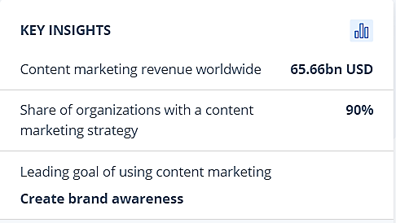
Figure 4: Key statics involving Content marketing strategy
(Source: Dencheva, 2023)
Figure 4 is highlighting the post-pandemic critical statistics involved with content marketing strategy as 90% of the global brands are using content marketing (across social media platforms) approaches for developing a sustainable environment for improving their brand awareness (Dencheva, 2023).
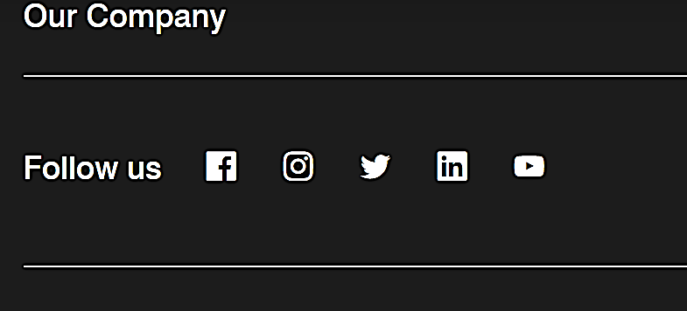
Figure 5: Different social media platforms used by Marriott management for conducting their social media marketing strategy
(Source: Marriott, 2023c)
Based on Figure 5, Facebook, Twitter, LinkedIn, Instagram, and YouTube are different social media platforms, which are used by the company management to create a strong online presence for its marketing campaigns (Marriott, 2023c). The digital content based on the company business processes and services offered for the new digital marketing campaigns can help the Marriot management to grab the attention of its target customers. The multi-language features across social media platforms can be used for communicating with customers from different backgrounds as well (Rahman and Reza, 2022). The company management can easily share the link to the videos associated with digital content across the different social media platforms for gaining the attention of its customers.
New subscription offers for customers
The incorporation of the modern business environment across hospitality industry is changing heavily in post-pandemic era as companies starting to make alterations in their offers and discount strategies for each customer. The inclusion of different travel and booking apps are introducing new pricing strategy for hotel organisations such as Marriott International. The new marketing strategies based on discounted prices are allowing the company to develop a competitive advantage over its competitors in the industry.

Figure 6: Modern marketing strategies involved with Marriott operations
(Source: Marriott, 2023c)
Figure 6 is proving a detailed analysis of the new marketing approaches associated with discounted prices used by Marriott organisation for completing their business activities (Marriott, 2023c). Similarly, during post-pandemic new business approaches based on effective subscription offers can be incorporated for creating a sustainable environment for managing the company operations across different locations in the world. The seasonal variance across different sections of the world is creating an effective opportunity for the company management to introduce new subscription offers for its customers (Gursoy et al. 2022). The discount on hotel prices and exclusive deals based on customer spending can be incorporated into the new subscription deal as well, which can help the company management to create a sustainable business environment for its future activities across the hospitality industry.

Conclusion
Marriott International has been one of the leading global hospitality chains providing value to customers through its services. Strong brand recognition and massive cash reserves are some of the strengths of the company. The Management of Marriot International has considered cutting down the marketing costs during the pandemic economy to minimize business overheads. Administrative costs were also cu within the company to survive the crisis during the Covid-19 pandemic. Customer loyalty schemes also helped the company to increase business revenue through loyal customers.

Reference list
Case study
Marketline, 2020. Marriott International: Marriott's response to the COVID crisis as the travel and tourism industry struggles. Marketline Case Studies. pp. 1-10
Other articles
Abdelsalam, O., Aysan, A.F., Cepni, O. and Disli, M., 2023. The spillover effects of the COVID-19 pandemic: Which subsectors of tourism have been affected more?. Tourism Economics, 29(2), pp.559-567.
Boiral, O., Brotherton, M.C., Rivaud, L. and Guillaumie, L., 2021. Organizations’ management of the COVID-19 pandemic: A scoping review of business articles. Sustainability, 13(7), p.3993.
Dencheva., V, 2023. Content marketing - statistics & facts.[Online].Available at: https://www.statista.com/topics/1650/content-marketing/.[Accessed 26th July 2023]
Fu, L., 2023. COVID-19 Impacts on and Responses of the Hotel Industry. Journal of Education, Humanities and Social Sciences, 7, pp.320-323.
Gourtsilidou., M, 2022. Top 10 major hotel companies in the world for 2022.[Online].Available at: https://ceoworld.biz/2022/01/03/top-10-major-hotel-companies-in-the-world-for-2022/.[Accessed 26th July 2023]
Guillet, B.D. and Chu, A.M.C., 2021. Managing hotel revenue amid the COVID-19 crisis. International Journal of Contemporary Hospitality Management, 33(2), pp.604-627.
Gursoy, D., Malodia, S. and Dhir, A., 2022. The metaverse in the hospitality and tourism industry: An overview of current trends and future research directions. Journal of Hospitality Marketing & Management, 31(5), pp.527-534.
Irbo, M.M. and Mohammed, A.A., 2020. Social media, business capabilities and performance: A review of literature. African Journal of Business Management, 14(9), pp.271-277.
Khatri, I., 2019. Information technology in tourism & hospitality industry: A review of ten years’ publications. Journal of Tourism and Hospitality Education, 9, pp.74-87.
Kim, J.J. and Han, H., 2022. Saving the hotel industry: Strategic response to the COVID-19 pandemic, hotel selection analysis, and customer retention. International Journal of Hospitality Management, 102, p.103163.
Kravariti, F., Jooss, S. and Scullion, H., 2023. Guest editorial: Talent management and COVID-19: lessons and opportunities. International Journal of Contemporary Hospitality Management, 35(8), pp.2685-2690.
Leroi-Werelds, S., Verleye, K., Line, N. and Bove, L., 2021. Value proposition dynamics in response to external event triggers. Journal of Business Research, 136, pp.274-283.
Marriott 2023d Good Travel Starts With Great Offers Available from: https://www.marriott.com/offers.mi?scid=fbf525ee-d507-49cd-bb9a-72e5f5ed1af5&gclid=Cj0KCQjwiIOmBhDjARIsAP6YhSWHpaxoC2hw7Dl7__yAIHSjWA-wMgUfsdvzKh5v5-lMO8Zo9qWg7iQaAsBKEALw_wcB&gclsrc=aw.ds [Accessed on: 27/07/2023]
Marriott 2023e We Are Marriott International Available from: https://www.marriott.com/marriott/aboutmarriott.mi [Accessed on: 27/07/2023]
Marriott 2023f Marriott Bonvoy™ Benefits Available from: https://www.marriott.com/loyalty.mi?scid=b1352c30-5a1a-4198-b954-aa03769e798d&gclid=Cj0KCQjwiIOmBhDjARIsAP6YhSV3_x9Xbg5GgWDJ9zhXrDDS4Di4UI20-eZZebw8dw9T51lvJ9wCJVkaAnAfEALw_wcB&gclsrc=aw.ds [Accessed on: 27/07/2023]
Marriott 2023g Discover Your Benefits Available from: https://www.marriott.com/loyalty/member-benefits.mi [Accessed on: 27/07/2023]
Marriott, 2023. Financial Reports & Proxy.[Online].Available at: https://marriott.gcs-web.com/annual.[Accessed 26th July 2023]
Marriott, 2023b. Leadership. Available at: https://news.marriott.com/leadership [Accessed on: 27.07.2023]
Marriott, 2023c. Deals: Get ‘em Before They’re Gone.[Online].Available at: https://www.marriott.com/default.mi?scid=0667389e-e015-4b1d-a8b6-1e1dfe8c6eef&gclid=Cj0KCQjwiIOmBhDjARIsAP6YhSU_qJ4r8kM6gN3zuLyJmmiS0XCEj9qBtH5Atx1V7BVOQj_3jNCO4L4aArqiEALw_wcB&gclsrc=aw.ds.[Accessed 26th July 2023]
Peter, M.K. and Dalla Vecchia, M., 2021. The digital marketing toolkit: a literature review for the identification of digital marketing channels and platforms. New trends in business information systems and technology: Digital innovation and digital business transformation, pp.251-265.
Rahman, M.S. and Reza, H., 2022. A systematic review towards big data analytics in social media. Big Data Mining and Analytics, 5(3), pp.228-244.
Redjeki, F., Narimawati, U. and Priadana, S., 2021. Marketing strategies used by hospitality businesses in times of crisis of the COVID-19 pandemic: Case study. ENDLESS: International Journal of Future Studies, 4(1), pp.121-131.
Santora., J, 2023. 17 Key Influencer Marketing Statistics to Fuel Your Strategy.[Online].Available at: https://influencermarketinghub.com/influencer-marketing-statistics/.[Accessed 26th July 2023]
Sesar, V., Hunjet, A. and Kozina, G., 2021. Influencer marketing in travel and tourism: literature review. Economic and Social Development: Book of Proceedings, pp.182-192.
Sharma, A., Shin, H., Santa-María, M.J. and Nicolau, J.L., 2021. Hotels' COVID-19 innovation and performance. Annals of Tourism Research, 88, p.103180.
Shin, H., Sharma, A., Nicolau, J.L. and Kang, J., 2021. The impact of hotel CSR for strategic philanthropy on booking behavior and hotel performance during the COVID-19 pandemic. Tourism Management, 85, p.104322.
Statista Research Department, 2022. Coronavirus: impact on the tourism industry worldwide - statistics & facts.[Online].Available at: https://www.statista.com/topics/6224/covid-19-impact-on-the-tourism-industry/#topicOverview.[Accessed 26th July 2023]
Udovita, P.V.M.V.D., 2020. Conceptual review on dimensions of digital transformation in modern era. International Journal of Scientific and Research Publications, 10(2), pp.520-529.
Volgger, M., Taplin, R. and Aebli, A., 2021. Recovery of domestic tourism during the COVID-19 pandemic: An experimental comparison of interventions. Journal of Hospitality and Tourism Management, 48, pp.428-440.

